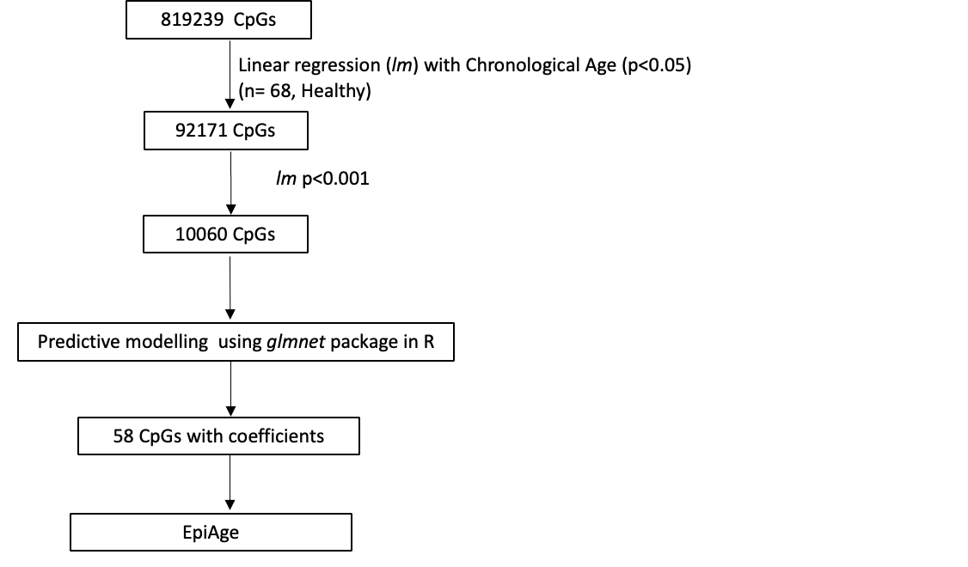

Suppl Fig 1: Steps in EpiAge clock development
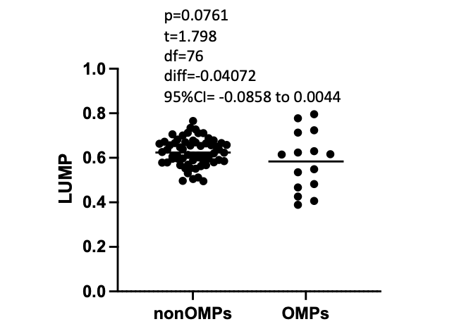
Suppl Fig 2: LUMP analysis between NAT of OMPs and non-OMPs
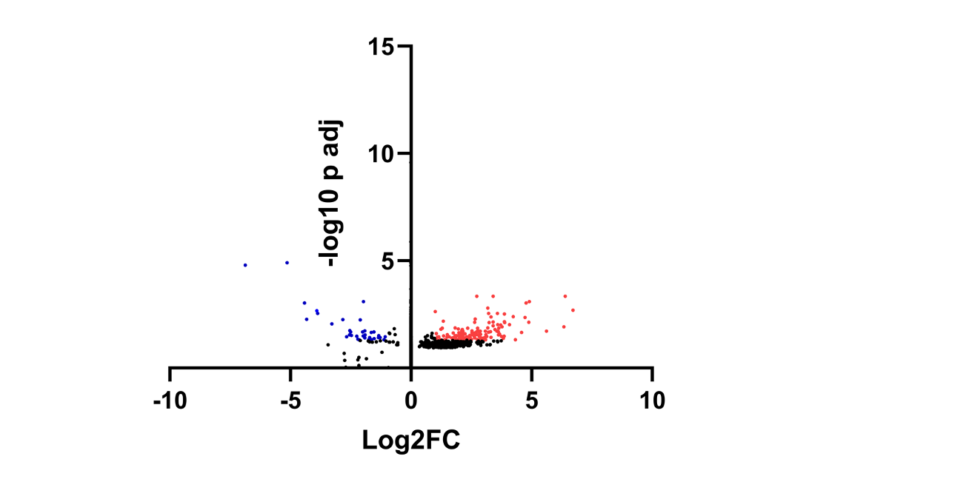
Suppl Fig 3: Differential expression analysis between OMPs and non-OMPs. x-axis denotes the log2fold change and y-axis shows –log₁₀ of p_{adjusted} . Red and blue symbols indicate the upregulated and downregulated genes in the OMP group.
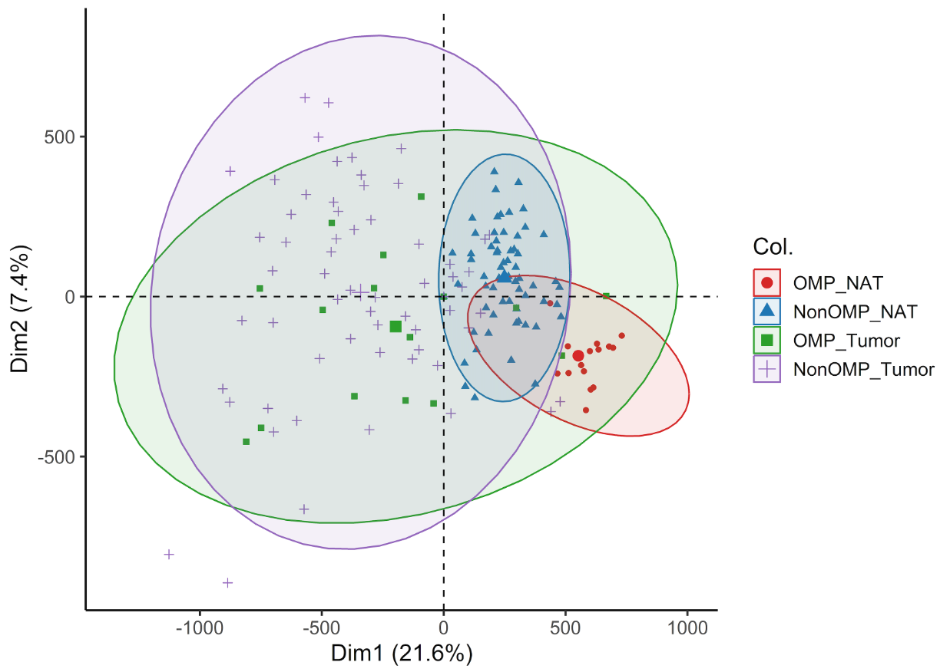
Suppl Fig 4: Principal component analysis of the cohort using 819,239 CpGs
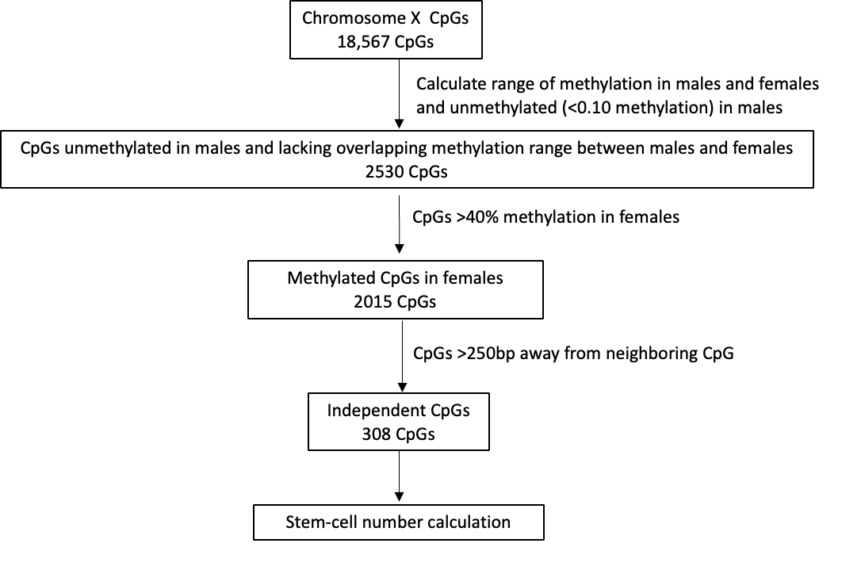
Suppl Fig 5: Filtering of chromosome X CpGs for stem-cell number calculation

Suppl Table 1: Demographic and clinical profile of the samples

All samples
 |  | Cancer (n=77) | Control (n=68) | P valueª
Age (Mean± Standard deviation) |  | 57.67± 9.68 | 56.81± 8.81 | 0.5757
Sex | Males | 38 | 33 | 1.0000
Sex | Females | 39 | 35 | 1.0000
Race | White | 35 | 34 | 0.6198
 | African American | 42 | 34 | 0.6198
Cancer
 |  | OMP (n=15) | non-OMP (n=62) | P valueª
Age (Mean± Standard deviation) |  | 58.68± 6.85 | 56.28± 10.17 | 0.5209
Sex | Males | 9 | 29 | 0.839
Sex | Females | 6 | 33 | 0.839
Race | White | 11 | 31 | 0.1804
Race | African American | 4 | 31 | 0.1804
Tumor location^{b} | Distal | 11 | 31 | 0.1189
Tumor location^{b} | Proximal | 2 | 27 | 0.1189
Tumor location^{b} | Transverse | 1 | 4 | 0.1189
Tumor grade | Grade I | 1 | 4 | 0.839
Tumor grade | Grade II | 11 | 45 | 0.839
Tumor grade | Grade III | 1 | 6 | 0.839
Tumor grade | Grade IV | 1 | 1 | 0.839
Tumor grade | Unknown | 1 | 6 | 0.839
Treatment status | Treatment naive | 12 | 51 | 1.000
Treatment status | Post treatment | 3 | 11 | 1.000

ªFisher exact test
^{b}One OMP with overlapping lesion excluded from analysis

Suppl Table 2: Differentially expressed genes in OMP

Suppl Table 2A: Upregulated genes in OMP

Gene | baseMean | log2FoldChange | lfcSE | pvalue | padj | Regulation
HOXD-AS2 | 32.1632695 | 2.73187402 | 0.59547593 | 2.44E-07 | 0.0004468 | Up
NNMT | 4167.88908 | 3.40566182 | 0.73079934 | 2.45E-07 | 0.0004468 | Up
SAA1 | 1014.2233 | 6.39326494 | 1.35642559 | 2.62E-07 | 0.0004468 | Up
CCL2 | 6041.05319 | 4.9006894 | 1.08591462 | 5.98E-07 | 0.00081683 | Up
CXCL2 | 776.511034 | 4.77674139 | 1.0831151 | 9.06E-07 | 0.00092811 | Up
VMO1 | 59.1001254 | 3.18451926 | 0.75618148 | 1.74E-06 | 0.00162272 | Up
XIRP1 | 300.407569 | 6.72057719 | 1.61458319 | 2.38E-06 | 0.00203121 | Up
FAM207A | 398.388871 | 1.01083262 | 0.25375398 | 3.17E-06 | 0.00232164 | Up
CCN1 | 13457.9828 | 3.57832231 | 0.89816456 | 5.05E-06 | 0.00289869 | Up
HSPA6 | 94.0621533 | 3.21150089 | 0.8110566 | 5.09E-06 | 0.00289869 | Up
LMCD1 | 1497.78434 | 3.87435765 | 0.97660716 | 5.44E-06 | 0.00300258 | Up
BABAM2-AS1 | 264.428847 | 4.23520393 | 1.10203169 | 8.89E-06 | 0.00400327 | Up
TWIST2 | 264.152711 | 3.3169284 | 0.87369247 | 9.53E-06 | 0.00415406 | Up
SERPINE1 | 7962.64711 | 4.73250379 | 1.24048211 | 1.10E-05 | 0.00442258 | Up
FST | 308.249918 | 2.65695279 | 0.72681004 | 1.49E-05 | 0.0051913 | Up
MAST4 | 591.663736 | 1.33380967 | 0.38183004 | 2.20E-05 | 0.00652859 | Up
ATP6V1FNB | 121.954784 | 3.87454751 | 1.08749612 | 2.43E-05 | 0.00701003 | Up
TMEM132C | 195.937667 | 3.40861602 | 0.96147112 | 2.54E-05 | 0.00711949 | Up
CCDC71L | 1196.84741 | 2.63643806 | 0.75487231 | 2.83E-05 | 0.00736137 | Up
IL6 | 1067.23366 | 4.88364167 | 1.37288802 | 2.79E-05 | 0.00736137 | Up
GALR2 | 41.5777169 | 3.8814541 | 1.11739402 | 2.98E-05 | 0.00763238 | Up
TNFSF9 | 89.5237298 | 3.23721526 | 0.93063513 | 3.03E-05 | 0.00763238 | Up
OSR1 | 711.585288 | 4.08878203 | 1.1970592 | 4.30E-05 | 0.0095696 | Up
S100A9 | 1013.42548 | 3.58961925 | 1.05549478 | 4.36E-05 | 0.00960878 | Up
SLC2A3 | 4030.77096 | 3.7173583 | 1.0948341 | 4.53E-05 | 0.00987374 | Up
LOC112268097 | 16.1472539 | 3.40612636 | 1.02715252 | 5.16E-05 | 0.01078532 | Up
S100A8 | 529.958897 | 3.76735621 | 1.13911236 | 6.02E-05 | 0.01209276 | Up
LDHC | 8.56507282 | 6.34041423 | 2.03033033 | 6.11E-05 | 0.01215633 | Up
ANGPTL4 | 1256.72174 | 3.17943181 | 0.97990609 | 7.08E-05 | 0.01338162 | Up
C1QA | 9232.38245 | 3.1822055 | 0.98071623 | 7.13E-05 | 0.01338162 | Up
CBR3 | 117.072715 | 1.8292028 | 0.57610631 | 7.04E-05 | 0.01338162 | Up
CEBPB | 2714.50414 | 2.35059074 | 0.73652099 | 7.70E-05 | 0.01378641 | Up
RNF227 | 96.2195879 | 1.28908374 | 0.41253319 | 7.80E-05 | 0.01378641 | Up
SNAI1 | 328.417547 | 3.64164158 | 1.130216 | 7.79E-05 | 0.01378641 | Up
THBS1 | 45221.8513 | 2.75708743 | 0.85980049 | 7.76E-05 | 0.01378641 | Up
EVA1B | 233.835009 | 1.95629689 | 0.62828835 | 9.00E-05 | 0.01512351 | Up
GNG11 | 559.888212 | 1.23490233 | 0.7043455 | 9.30E-05 | 0.0154912 | Up
P4HA3 | 91.8040764 | 3.47833039 | 1.11200711 | 0.00010138 | 0.01618738 | Up
SPHK1 | 225.585654 | 2.12990229 | 0.6885059 | 9.93E-05 | 0.01618738 | Up
MATN3 | 11.0513841 | 2.1099625 | 0.71793573 | 0.00012155 | 0.01804908 | Up
TMEM45A | 269.953644 | 2.77631881 | 0.91171817 | 0.00012585 | 0.01829071 | Up
PDPN | 729.952708 | 2.76568226 | 0.90996566 | 0.00012932 | 0.01852488 | Up
SRPX2 | 526.671498 | 2.53330015 | 0.83862946 | 0.00013189 | 0.01852488 | Up
OR51E2 | 130.690002 | 3.55944982 | 1.1729595 | 0.00013797 | 0.01884897 | Up
ARSI | 92.8177548 | 3.08543334 | 1.02111314 | 0.00014045 | 0.01885686 | Up
FGF7 | 754.247652 | 2.87125338 | 0.95281662 | 0.00014118 | 0.01885686 | Up
THBS2 | 1888.22322 | 3.55781623 | 1.17104548 | 0.00014009 | 0.01885686 | Up
HLA-DMB | 15.6320455 | 5.61862509 | 1.88360512 | 0.00014355 | 0.01888623 | Up
ZNF460 | 48.3940371 | 2.15214435 | 0.72340409 | 0.00014387 | 0.01888623 | Up
NFIL3 | 2449.67381 | 2.1094998 | 0.71206018 | 0.00015104 | 0.01934434 | Up
MT1L | 134.425915 | 2.10348042 | 0.71531348 | 0.00015823 | 0.01989178 | Up
COL3A1 | 51959.1576 | 3.29707305 | 1.01548144 | 0.00016403 | 0.02012735 | Up
PTGS2 | 1205.8217 | 3.62034693 | 1.21653748 | 0.00016849 | 0.02042981 | Up
MYC | 5933.17931 | 2.72088602 | 0.93249238 | 0.00018483 | 0.0210415 | Up
STEAP4 | 687.465502 | 3.21936411 | 1.10247582 | 0.00019107 | 0.02151367 | Up
SIX2 | 23.8350481 | 4.58666457 | 1.58233478 | 0.00020286 | 0.02231353 | Up
PTH1R | 141.559036 | 2.13079153 | 0.74806192 | 0.00020664 | 0.02252398 | Up
ADRB1 | 69.0760729 | 1.98511755 | 0.70407259 | 0.000215 | 0.02294644 | Up
MAGEL2 | 14.013107 | 2.52535098 | 0.88510805 | 0.00021765 | 0.02295915 | Up
MS4A7 | 653.591784 | 2.85193395 | 0.99815522 | 0.00022349 | 0.0233661 | Up
COLEC12 | 784.747411 | 2.63982799 | 0.9267658 | 0.0002254 | 0.0234466 | Up
SOD2 | 11266.7911 | 1.7551881 | 0.62705118 | 0.00023063 | 0.02351257 | Up
CREM | 869.472319 | 2.04461163 | 0.73269501 | 0.00024387 | 0.02425911 | Up
FUNDC2 | 2503.00297 | 1.04645774 | 0.38523698 | 0.00024986 | 0.02473515 | Up
LINC00346 | 50.3742913 | 2.23998437 | 0.81109535 | 0.00026824 | 0.02544834 | Up
LINC01436 | 30.0979067 | 2.21258522 | 0.80228253 | 0.00026708 | 0.02544834 | Up
ADAMTS4 | 2936.43145 | 3.67612519 | 1.31223024 | 0.00027877 | 0.02617212 | Up
C11orf96 | 3679.80871 | 2.8875646 | 1.04479605 | 0.00029641 | 0.02723778 | Up
APOLD1 | 1456.08397 | 2.72834583 | 0.99637357 | 0.00030992 | 0.02757945 | Up
FAM20C | 1306.00565 | 2.113873 | 0.77749443 | 0.00030763 | 0.02757945 | Up
HOMER1 | 94.107294 | 2.1355434 | 0.79151486 | 0.0003129 | 0.02757945 | Up
JUNB | 16379.0177 | 2.17530562 | 0.8040711 | 0.00031579 | 0.02757945 | Up
MYL3 | 13.209108 | 1.51039025 | 0.57788968 | 0.0003054 | 0.02757945 | Up
RASL10B | 97.084327 | 3.10353749 | 1.13511813 | 0.00030909 | 0.02757945 | Up
ANXA1 | 4773.4027 | 2.55571223 | 0.94956998 | 0.00034859 | 0.02856073 | Up
OTOA | 38.2712764 | 2.60876175 | 0.97889108 | 0.0003516 | 0.02856073 | Up
TNFAIP6 | 171.49517 | 3.62468917 | 1.34322676 | 0.00035483 | 0.02862689 | Up
HGF | 63.1336835 | 2.13462384 | 0.80949452 | 0.00036711 | 0.02927158 | Up
ST3GAL6-AS1 | 8.21037701 | 2.4357261 | 0.93004966 | 0.00038875 | 0.03052173 | Up
DUSP1 | 21717.4249 | 1.97795034 | 0.75428769 | 0.00039066 | 0.03055463 | Up
AMOTL2 | 1137.71822 | 1.87861893 | 0.72058346 | 0.00039675 | 0.03091325 | Up
CCN2 | 10970.2407 | 1.82951207 | 0.70650936 | 0.00040844 | 0.0312303 | Up
MAFF | 3463.88126 | 2.05317086 | 0.79151062 | 0.00042151 | 0.03152424 | Up
NFE2 | 11.800357 | 2.82615485 | 1.09547871 | 0.00043244 | 0.03172121 | Up
CTSL | 4123.86312 | 1.97908629 | 0.77315456 | 0.00044914 | 0.03229389 | Up
SERPINH1 | 3616.75304 | 1.86811574 | 0.72783415 | 0.00044894 | 0.03229389 | Up
TBX3 | 310.507714 | 1.3525449 | 0.53653672 | 0.00045583 | 0.03243346 | Up
SPINK6 | 18.2779185 | 3.85709229 | 1.48117527 | 0.0004682 | 0.03319856 | Up
LILRA6 | 8.46362894 | 3.75030502 | 1.44620207 | 0.0004888 | 0.0336241 | Up
CDO1 | 172.648248 | 2.83728432 | 1.11647887 | 0.00050685 | 0.03417634 | Up
RMRP | 251.915788 | 3.13573511 | 1.23448185 | 0.00051409 | 0.03440576 | Up
CCDC151 | 8.76405421 | 1.83137227 | 0.74217344 | 0.00052556 | 0.03466961 | Up
DCUN1D3 | 689.617533 | 1.57985902 | 0.63928776 | 0.00053238 | 0.03466961 | Up
SRPX | 1952.15124 | 2.62735348 | 1.03803701 | 0.0005288 | 0.03466961 | Up
TPGS1 | 68.3053852 | 1.14637737 | 0.47302197 | 0.00053294 | 0.03466961 | Up
F8 | 346.703736 | 2.31553341 | 0.9246836 | 0.0005418 | 0.03491377 | Up
CLCF1 | 796.892797 | 2.44778456 | 0.98178998 | 0.0005656 | 0.03577227 | Up
TGFBI | 3268.84103 | 1.48903055 | 0.61198601 | 0.0005781 | 0.03633848 | Up
C16orf46 | 32.2204533 | 1.09169816 | 0.46275884 | 0.00058408 | 0.03649046 | Up
HIC1 | 358.072877 | 1.8363699 | 0.75149957 | 0.00059735 | 0.03668648 | Up
PLAAT3 | 1029.83979 | 2.10684129 | 0.85654884 | 0.00059785 | 0.03668648 | Up
PLIN2 | 2944.38477 | 2.01832882 | 0.8187231 | 0.00059375 | 0.03668648 | Up
S100A12 | 49.1425877 | 3.31193604 | 1.34652982 | 0.00061175 | 0.03723914 | Up
SOCS3 | 15129.0394 | 3.05537344 | 1.23209769 | 0.00063283 | 0.03785754 | Up
SPON2 | 780.713091 | 1.76348634 | 0.73002995 | 0.00063367 | 0.03785754 | Up
ECHDC3 | 240.664584 | 2.11769735 | 0.87280879 | 0.00063905 | 0.03795021 | Up
FNDC4 | 271.109025 | 2.37941168 | 0.98817707 | 0.00067856 | 0.03920742 | Up
FTL | 135291.068 | 2.25675778 | 0.93216914 | 0.00067922 | 0.03920742 | Up
PXDC1 | 1355.98877 | 2.18714928 | 0.90855506 | 0.00067614 | 0.03920742 | Up
CH25H | 153.0933 | 2.3989952 | 1.00370155 | 0.00070044 | 0.03965016 | Up
COL1A1 | 29799.3639 | 2.64254956 | 1.08872648 | 0.00069832 | 0.03965016 | Up
PYGL | 942.469893 | 1.68919657 | 0.71427854 | 0.0007154 | 0.04014271 | Up
VIM | 33510.0357 | 2.27043286 | 0.94617056 | 0.00071328 | 0.04014271 | Up
TFPI2 | 68.3518494 | 2.93286747 | 1.24069477 | 0.00073747 | 0.04095434 | Up
FAP | 124.671176 | 2.98799767 | 1.25245522 | 0.00074673 | 0.04113414 | Up
NRP1 | 1184.07552 | 2.24453548 | 0.94693877 | 0.00074581 | 0.04113414 | Up
LOC105374118 | 4.53702758 | 3.82674223 | 1.62563362 | 0.00076064 | 0.0414118 | Up
EBF3 | 106.521967 | 2.90592354 | 1.22970649 | 0.00077459 | 0.04166098 | Up
BATF3 | 94.0721237 | 2.13988067 | 0.91692072 | 0.00079425 | 0.04238492 | Up
ADAMTS12 | 99.9414337 | 2.21040743 | 0.94817113 | 0.00080258 | 0.04243548 | Up
IFITM3 | 13012.5019 | 1.84399182 | 0.79171223 | 0.00081264 | 0.042699 | Up
HOMER3 | 313.24715 | 1.75734481 | 0.76273177 | 0.00081744 | 0.04284135 | Up
DLC1 | 1867.80132 | 2.34190338 | 1.00123901 | 0.00082021 | 0.04287693 | Up
NAT8L | 95.4855865 | 3.01487391 | 1.29359397 | 0.00083991 | 0.0434201 | Up
VKORC1 | 1353.78229 | 1.03648043 | 0.46137647 | 0.00083948 | 0.0434201 | Up
CYP19A1 | 10.6913228 | 2.88157438 | 1.26196889 | 0.00084826 | 0.04367496 | Up
IGFBP4 | 19539.7614 | 1.72898751 | 0.76794976 | 0.0009153 | 0.04608446 | Up
CBARP | 27.0779711 | 2.51069474 | 1.11643311 | 0.0009397 | 0.04662534 | Up
ARID5B | 2040.38146 | 2.00887533 | 0.8909874 | 0.00095267 | 0.04704107 | Up
ISLR | 2220.587 | 2.11351821 | 0.93285182 | 0.00095241 | 0.04704107 | Up
LOC101928674 | 12.0276851 | 3.08616157 | 1.36181612 | 0.00095746 | 0.04716394 | Up
IRAIN | 4.11181212 | 1.93475301 | 0.87674284 | 0.00096072 | 0.0471922 | Up
HTRA3 | 1873.13666 | 2.75068042 | 1.21243662 | 0.00097381 | 0.04728746 | Up
PANX1 | 681.781886 | 1.20873999 | 0.55022637 | 0.00097339 | 0.04728746 | Up
PNRC1 | 2380.65709 | 1.39061593 | 0.6266423 | 0.00098116 | 0.04753153 | Up
BEST1 | 114.525373 | 1.43602353 | 0.65536938 | 0.0010051 | 0.04766206 | Up
C17orf107 | 73.1960639 | 1.93708457 | 0.87839212 | 0.00102173 | 0.04766206 | Up
CIDEA | 145.068284 | 4.32271944 | 1.94499663 | 0.00101237 | 0.04766206 | Up
COLEC11 | 80.5342377 | 2.34085235 | 1.04618147 | 0.0009986 | 0.04766206 | Up
KCNE1 | 6.68241777 | 3.00258462 | 1.31725327 | 0.00100382 | 0.04766206 | Up
LINC01116 | 76.63455 | 1.77443459 | 0.80503756 | 0.00100757 | 0.04766206 | Up
RGS16 | 528.490579 | 2.37817713 | 1.06689106 | 0.00102339 | 0.04766206 | Up
SNTB1 | 235.08775 | 1.06273843 | 0.49228204 | 0.00101891 | 0.04766206 | Up
SVEP1 | 1008.36002 | 2.40220557 | 1.06870678 | 0.00099475 | 0.04766206 | Up
ABL2 | 1250.42258 | 1.93566053 | 0.87250107 | 0.0010323 | 0.04796787 | Up
C1R | 10569.5417 | 1.99684052 | 0.89723244 | 0.001042 | 0.04810127 | Up
LOC100506188 | 3.38174298 | 2.95222753 | 1.33492031 | 0.00104299 | 0.04810127 | Up
TREM1 | 151.783186 | 3.09303387 | 1.40032132 | 0.00105565 | 0.04839476 | Up
WDR86-AS1 | 32.6861563 | 2.02513869 | 0.92751165 | 0.00105863 | 0.0484228 | Up

Suppl Table 2B: Downregulated genes in OMP
Gene | baseMean | log2FoldChange | lfcSE | pvalue | padj | Regulation
SLC15A1 | 791.053551 | -5.1431188 | 1.00191875 | 3.08E-09 | 1.25E-05 | Down
PRAC1 | 764.573186 | -6.8675654 | 1.39317385 | 5.55E-09 | 1.62E-05 | Down
CRACR2A | 217.826853 | -1.9772501 | 0.46926871 | 6.16E-07 | 0.00081683 | Down
ISL1 | 15.8799093 | -4.4211436 | 0.98281329 | 8.58E-07 | 0.00092811 | Down
LOC102724800 | 32.7698748 | -3.9099394 | 1.04305416 | 2.60E-06 | 0.00213255 | Down
SFTPA2 | 34.968353 | -3.8774853 | 1.1046636 | 4.76E-06 | 0.00289869 | Down
TTLL6 | 349.615589 | -4.3243658 | 1.39512141 | 1.61E-05 | 0.0054255 | Down
LOC105379521 | 13.6652128 | -2.8308248 | 0.83674603 | 1.70E-05 | 0.00554388 | Down
UNC5CL | 65.5961829 | -2.1088147 | 0.63117468 | 1.76E-05 | 0.00563656 | Down
PLEKHS1 | 244.252273 | -3.2836986 | 1.12326422 | 3.92E-05 | 0.00882078 | Down
NAPSA | 32.6146854 | -2.5375979 | 0.92385356 | 0.00011837 | 0.01796824 | Down
LOC105372860 | 20.2445693 | -1.9136506 | 0.70329496 | 0.00013372 | 0.01864007 | Down
H3C6 | 33.6380158 | -2.0016696 | 0.77617901 | 0.00017838 | 0.02066066 | Down
LINC01123 | 78.9799958 | -2.510954 | 1.01521003 | 0.00017402 | 0.02066066 | Down
NLRC5 | 1325.55489 | -1.5356247 | 0.59154874 | 0.00017846 | 0.02066066 | Down
KLLN | 42.7671029 | -1.6515431 | 0.63372013 | 0.00019626 | 0.02185755 | Down
SULT1C2 | 80.8502698 | -2.5555064 | 1.1760533 | 0.0003463 | 0.02856073 | Down
UNC5B | 1330.9772 | -1.9094194 | 0.85246818 | 0.00035172 | 0.02856073 | Down
DIAPH3 | 44.6787067 | -2.4746679 | 1.14349986 | 0.00038452 | 0.03052173 | Down
ARID3B | 432.521848 | -1.3432244 | 0.59477627 | 0.00041923 | 0.03146812 | Down
LOC642846 | 86.7869344 | -1.9797022 | 0.9380356 | 0.0004516 | 0.03233434 | Down
FIBCD1 | 72.5348723 | -2.2550178 | 1.1095427 | 0.00047149 | 0.03331627 | Down
NAA40 | 606.913814 | -1.0765508 | 0.49264044 | 0.00053702 | 0.03471465 | Down
TICRR | 57.3268662 | -2.6740383 | 1.43309537 | 0.00054992 | 0.03532581 | Down
XRCC3 | 185.28135 | -1.2862811 | 0.61780946 | 0.00062469 | 0.03776138 | Down
CENPO | 249.954062 | -1.3483401 | 0.65859127 | 0.00064263 | 0.03795021 | Down
STARD5 | 501.687275 | -1.7202641 | 0.87572145 | 0.00063806 | 0.03795021 | Down
ATP2A3 | 7828.88153 | -1.9169856 | 1.03461868 | 0.00069964 | 0.03965016 | Down
COX1 | 3018681.61 | -1.5286131 | 0.82127446 | 0.00080435 | 0.04243548 | Down
SEMA4G | 2832.04718 | -2.2067581 | 1.4002897 | 0.00088593 | 0.0450485 | Down
CENPE | 83.0269838 | -1.7473281 | 1.02115913 | 0.00098977 | 0.04766206 | Down
HECTD3 | 3503.10385 | -1.1186186 | 0.60760766 | 0.0009923 | 0.04766206 | Down
ND6 | 4052.21607 | -1.638114 | 0.96503587 | 0.0009969 | 0.04766206 | Down
GLDN | 539.069148 | -2.1434478 | 1.4944324 | 0.00107247 | 0.04883793 | Down

Suppl Table 3: Activated pathways in OMP group

Ingenuity Canonical Pathways | -log(p-value) | z-score
Interleukin-4 and Interleukin-13 signaling | 8.95 | 2.53
Pathogen Induced Cytokine Storm Signaling Pathway | 6.07 | 2.828
Tumor Microenvironment Pathway | 5.94 | 2.646
IL-17A Signaling in Fibroblasts | 5.11 | 2.236
Hepatic Fibrosis Signaling Pathway | 4.49 | 2.333
Binding and Uptake of Ligands by Scavenger Receptors | 4.23 | 2.449
Wound Healing Signaling Pathway | 4.05 | 2.828
IL-17 Signaling | 3.95 | 2.449
Cachexia Signaling Pathway | 3.57 | 2.828
Post-translational protein phosphorylation | 3.37 | 2.236
O-linked glycosylation | 3.26 | 2.236
Pulmonary Fibrosis Idiopathic Signaling Pathway | 3.18 | 2.646
Regulation of Insulin-like Growth Factor (IGF) transport and uptake by IGFBPs | 3.07 | 2.236
Regulation of the Epithelial Mesenchymal Transition by Growth Factors Pathway | 2.99 | 2.236
Response to elevated platelet cytosolic Ca2+ | 2.95 | 2.236
G alpha (i) signalling events | 2.37 | 2.449
Role of Tissue Factor in Cancer | 2.17 | 2.236
Neutrophil degranulation | 2.13 | 2.828
Immunoregulatory interactions between a Lymphoid and a non-Lymphoid cell | 2.06 | 2.236
NAFLD Signaling Pathway | 2.04 | 2.236
Cardiac Hypertrophy Signaling (Enhanced) | 1.88 | 2.449
Class A/1 (Rhodopsin-like receptors) | 1.86 | 2.449
Serotonin Receptor Signaling | 1.73 | 2.449
Irritable Bowel Syndrome Signaling Pathway | 1.59 | 2.236
S100 Family Signaling Pathway | 1.47 | 2.121
Estrogen Receptor Signaling | 1.05 | 2.236
Phagosome Formation | 0.98 | 2.449
NF1 RAS Signaling Pathway | 0.702 | 2.236
Breast Cancer Regulation by Stathmin1 | 0.575 | 2.236
Molecular Mechanisms of Cancer | 0.427 | 2.449

Suppl Table 4: DNA methylation-based predictors for lifestyle and biochemical traits calculated using MethylDetectR

 | OMP  Mean ±SD | Non_OMP  Mean ±SD | Mean Diff. | P Valueª
Alcohol | -10.99 ±0.37 | -11.64 ±0.36 | 0.6430 | <0.001
BMI | -0.14 ±0.13 | -0.05 ±0.13 | -0.08972 | 0.0253
Body Fat %_ | 3.49 ±5.06 | 2.53 ±4.75 | 0.9661 | 0.5030
Cholesterol | 1.82 ±0.26 | 1.89 ±0.17 | -0.07035 | 0.2213
Smoking | 3.97 ±0.47 | 4.73 ±0.28 | -0.7592 | <0.001
Waist:Hip ratio | -0.13 ±0.05 | -0.14 ±0.03 | 0.01108 | 0.2759

ªtwo-sided test

