Table S1. Patient characteristics of survival time for patients with IPF
 | Survival <3 year | Survival ≥3 year | p-value
 | n=75 | n=51
Age | 76.0 [48‒92] | 73.0 [40‒83] | 0.01
Male | 68 (90.7) | 45 (88.2) | 0.77
BMI, kg/m² | 21.4 [13.7‒31.5] | 24.8 [11.1‒32.4] | <0.001
Smoking status
Former/Current | 63 (84.0) | 38 (74.5) | 0.27
Past acute exacerbation | 11 (14.7) | 7 (13.7) | 1.00
Medication
Glucocorticoid | 19 (25.3) | 3 (5.9) | 0.004
Immunosuppressant | 3 (4.0) | 0 (0.0) | 0.27
Severity Ⅲ, Ⅳ | 39 (52.0) | 20 (39.2) | 0.047
mMRC 2‒4 | 33 (44.0) | 16 (31.3) | 0.06
Resting SpO₂ <95% ª | 30 (40.0) | 7 (13.7) | 0.003
LTOT | 17 (23.0) | 1 (2.0) | 0.001
Blood test
ALB, g/dL | 3.8 [2.9‒5.0] | 4.1 [3.2‒4.6] | <0.001
LDH, U/L | 225.0 [141.0‒818.0] | 212.5 [143.0‒346.0] | 0.037
CRP, mg/dL | 0.43 [0.01‒8.02] | 0.22 [0.03‒25.73] | 0.012
KL-6, U/mL | 850.0 [261.0‒3814.0] | 1009.0 [349.0‒4749.0] | 0.41
NLR | 3.0 [0.72‒37.60] | 2.2 [1.0‒8.4] | 0.01
PNI | 47.0 [33.2‒60.5] | 50.9 [36.8‒59.9] | 0.001
Pulmonary function test
%FVC | 63.4 [30.8‒109.8] | 81.1 [37.3‒131.2] | 0.001
%DLco | 50.2 [14.4‒80.1] | 61.4 [30.2‒108.0] | 0.047
Days from diagnosis to initiation of nintedanib | 477.0 [0‒3549] | 66.0 [0‒3036] | <0.001
Data are expressed as medians [ranges], or N (%).
%DLco, % diffusing capacity of the lungs for carbon monoxide; %FVC, % forced vital capacity; ALB, albumin; BMI, body mass index; CRP, C-reactive protein; IPF, idiopathic pulmonary fibrosis; KL-6, Krebs von den Lungen-6; LDH, lactate dehydrogenase; LTOT, long-term oxygen therapy; mMRC, modified Medical Research Council; NLR, neutrophil-to-lymphocyte ratio; PNI, prognostic nutritional index; SpO₂, saturation of arterial oxygen.
ª Those who could not measure their resting SpO₂ with room air were included in resting SpO₂ <95%

Table S2. Patient characteristics of survival time for patients with PF-ILD
 | Survival <3 year | Survival ≥3 year | p-value
 | n=80 | n=55
Age | 74.0 [20‒91] | 69.0 [40‒84] | 0.001
Male | 57 (71.2) | 32 (58.2) | 0.14
BMI, kg/m² | 22.1 [8.2‒29.9] | 23.3 [13.3‒32.6] | 0.03
Smoking status
Former/Current | 57 (71.3) | 33 (60.0) | 0.13
Disease
IIPs | 36 (45.0) | 24 (43.6) | 0.91
CTD-ILD | 28 (35.0) | 21 (38.2)
PPFE | 9 (11.2) | 7 (12.7)
HP | 5 (6.2) | 3 (5.5)
CT pattern
UIP | 32 (40.0) | 17 (30.9) | 0.76
fNSIP | 33 (41.2) | 26 (47.3)
PPFE | 8 (10.0) | 7 (12.7)
Unclassifiable | 7 (8.8) | 5 (9.1)
Past acute exacerbation | 18 (22.5) | 7 (12.7) | 0.18
Medication
Glucocorticoid | 38 (47.5) | 23 (41.8) | 0.60
Immunosuppressant | 21 (26.2) | 15 (27.3) | 1.00
Severity Ⅲ, Ⅳ | 77 (96.3) | 36 (65.5) | 0.01
mMRC 2‒4 | 38 (47.5) | 16 (29.1) | 0.28
Resting SpO₂ <95% ª | 39 (48.8) | 12 (21.8) | 0.001
LTOT | 23 (28.7) | 10 (18.2) | 0.22
Blood test
ALB, g/dL | 3.7 [2.4‒4.6] | 4.0 [3.1‒4.6] | 0.001
LDH, U/L | 249.0 [139.0‒609.0] | 220.0 [149.0‒401.0] | 0.04
CRP, mg/dL | 0.32 [0.01‒4.25] | 0.18 [0.00‒12.34] | 0.01
KL-6, U/mL | 962.0 [310.0‒5570.0] | 983.0 [160.0‒2579.0] | 0.50
NLR | 3.2 [0.33‒25.4] | 2.7 [0.8‒14.4] | 0.27
PNI | 44.9 [27.5‒71.0] | 49.9 [37.1‒61.2] | 0.001
Pulmonary function test
%FVC | 59.3 [23.6‒112.7] | 73.5 [46.1‒116.9] | 0.005
%DLco | 53.2 [23.7‒112.6] | 54.4 [33.1‒96.6] | 0.91
Days from diagnosis to initiation of nintedanib | 742.0 [-302‒5096] | 900.0 [-1164‒5660] | 0.34
Data are expressed as medians [ranges], or N (%).
%DLco, % diffusing capacity of the lungs for carbon monoxide; %FVC, % forced vital capacity; ALB, albumin; BMI, body mass index; CRP, C-reactive protein; CTD-ILD, connective tissue disease-associated interstitial lung disease; fNSIP, fibrotic non-specific interstitial pneumonia; HP, hypersensitivity pneumonitis; IIPs, idiopathic interstitial pneumonias; KL-6, Krebs von den Lungen-6; LDH, lactate dehydrogenase; LTOT, long-term oxygen therapy; mMRC, modified Medical Research Council; NLR, neutrophil-to-lymphocyte ratio; PNI, prognostic nutritional index; PPFE, pleuroparenchymal fibroelastosis; SpO₂, saturation of arterial oxygen; UIP, usual interstitial pneumonia.
ª Those who could not measure their resting SpO₂ with room air were included in resting SpO₂ <95%

Table S3. Patient characteristics by FVC annual relative change after the initiation of nintedanib
 | FVC change ≥-1.37% | FVC change <-1.37% | p-value
 | n=107 | n=107
Age | 73.0 [38‒90] | 73.0 [20‒90] | 0.96
Male | 82 (76.6) | 78 (72.9) | 0.64
BMI, kg/m² | 23.9 [8.2‒31.4] | 22.3 [11.1‒36.8] | 0.005
Smoking status
Former/Current | 73 (68.2) | 78 (72.9) | 0.13
Disease
IPF | 42 (39.3) | 39 (36.4) | 0.80
IIPs | 29 (27.1) | 31 (29.0)
CTD-ILD | 27 (25.2) | 23 (21.5)
PPFE | 4 (3.7) | 9 (8.4)
HP | 4 (3.7) | 4 (3.7)
CT pattern
UIP | 60 (56.1) | 60 (56.1) | 0.36
fNSIP | 35 (32.7) | 35 (32.7)
PPFE | 3 (2.8) | 8 (7.5)
cNSIP | 2 (1.9) | 0 (0)
OP | 1 (0.9) | 0 (0)
Unclassifiable | 6 (5.6) | 4 (3.7)
Past acute exacerbation | 13 (12.1) | 12 (12.2) | 1.00
Medication
Glucocorticoid | 37 (34.6) | 24 (22.4) | 0.07
Immunosuppressant | 23 (21.5) | 10 (9.3) | 0.02
Severity Ⅲ, Ⅳ | 39 (36.4) | 40 (37.4) | 0.68
mMRC 2‒4 | 43 (40.2) | 43 (40.2) | 1.00
Resting SpO₂ <95% ª | 24 (22.4) | 24 (22.4) | 1.00
LTOT | 10 (9.3) | 13 (12.1) | 0.66
Blood test
ALB, g/dL | 3.9 [2.7‒4.7] | 4.0 [3.0‒4.6] | 0.96
LDH, U/L | 222.0 [142.0‒349.0] | 218.0 [156.0‒429.0] | 0.64
CRP, mg/dL | 0.20 [0.00‒11.94] | 0.20 [0.03‒12.34] | 0.92
KL-6, U/mL | 902.0 [169.0‒9450.0] | 988.5 [160.0‒5570.0] | 0.98
NLR | 2.46 [0.77‒30.30] | 2.35 [0.78‒23.50] | 0.70
PNI | 49.63 [29.65‒64.83] | 49.38 [36.24‒60.29] | 0.61
Pulmonary function test
%FVC | 72.7 [23.6‒131.2] | 74.6 [33.7‒126.6] | 1.00
%DLco | 54.2 [16.3‒119.8] | 59.0 [14.4‒105.5] | 0.51
Days from diagnosis to initiation of nintedanib | 343.0 [-37‒5307] | 593.0 [-1164‒4005] | 0.30
Data are expressed as medians [ranges], or N (%).
%DLco, % diffusing capacity of the lungs for carbon monoxide; %FVC, % forced vital capacity; ALB, albumin; BMI, body mass index; cNSIP, cellular non-specific interstitial pneumonia; CRP, C-reactive protein; CTD-ILD, connective tissue disease-associated interstitial lung disease; fNSIP, fibrotic non-specific interstitial pneumonia; HP, hypersensitivity pneumonitis; IIPs, idiopathic interstitial pneumonias; IPF, idiopathic pulmonary fibrosis; KL-6, Krebs von den Lungen-6; LDH, lactate dehydrogenase; LTOT, long-term oxygen therapy; mMRC, modified Medical Research Council; NLR, neutrophil-to-lymphocyte ratio; OP, organizing pneumonia; PF-ILD, progressive fibrosing interstitial lung diseases; PNI, prognostic nutritional index; PPFE, pleuroparenchymal fibroelastosis; SpO₂, saturation of arterial oxygen; UIP, usual interstitial pneumonia.
ª Those who could not measure their resting SpO₂ with room air due to oxygen administration were included in resting SpO₂ <95%
Table S4. Patient characteristics by acute exacerbation within 3 years after the initiation of nintedanib
 | Without acute exacerbation | With acute exacerbation | p-value
 | n=114 | n=62
Age | 75.0 [20‒92] | 75.5 [59‒91] | 0.30
Male | 89 (78.1) | 51 (82.3) | 0.56
BMI, kg/m² | 20.8 [8.2‒32.6] | 22.5 [14.2‒31.5] | 0.02
Smoking status
Former/Current | 89 (78.1) | 46 (74.2) | 0.68
Disease
IPF | 50 (43.9) | 32 (51.6) | 0.66
IIPs | 28 (24.6) | 15 (24.2)
CTD-ILD | 22 (19.3) | 10 (16.1)
PPFE | 9 (7.9) | 2 (3.2)
HP | 3 (2.6) | 3 (4.8)
CT pattern
UIP | 76 (66.7) | 40 (64.5) | 0.51
fNSIP | 24 (21.1) | 18 (29.0)
PPFE | 8 (7.0) | 2 (3.2)
Unclassifiable | 6 (5.3) | 2 (3.2)
Past acute exacerbation | 14 (12.3) | 17 (27.4) | 0.02
Medication
Glucocorticoid | 36 (31.6) | 28 (45.2) | 0.10
Immunosuppressant | 18 (15.8) | 10 (16.1) | 1.00
Severity Ⅲ, Ⅳ | 59 (51.8) | 26 (41.9) | 0.38
mMRC 2‒4 | 58 (50.9) | 30 (48.4) | 1.00
Resting SpO₂ <95% ª | 54 (47.4) | 22 (35.5) | 0.056
LTOT | 28 (24.6) | 15 (24.6) | 1.00
Blood test
ALB, g/dL | 3.8 [2.4‒5.0] | 3.7 [2.9‒4.6] | 0.76
LDH, U/L | 235.0 [139.0‒818.0] | 232.0 [142.0‒514.0] | 0.83
CRP, mg/dL | 0.39 [0.01‒25.73] | 0.30 [0.01‒4.12] | 0.20
KL-6, U/mL | 910.0 [261.0‒5570.0] | 1104.0 [310.0‒3278.0] | 0.15
NLR | 3.13 [0.33‒25.43] | 2.77 [0.77‒37.60] | 0.71
PNI | 46.10 [14.40‒80.10] | 58.00 [23.30‒112.60] | 0.32
Pulmonary function test
%FVC | 59.8 [23.6‒116.9] | 67.2 [40.9‒100.2] | 0.20
%DLco | 46.1 [14.4‒80.1] | 48.3 [33.4‒59.1] | 0.22
Days from diagnosis to initiation of nintedanib | 519.0 [-302‒5660] | 800.0 [0‒5096] | 0.10
Data are expressed as medians [ranges], or N (%).
%DLco, % diffusing capacity of the lungs for carbon monoxide; %FVC, % forced vital capacity; ALB, albumin; BMI, body mass index; CRP, C-reactive protein; CTD-ILD, connective tissue disease-associated interstitial lung disease; fNSIP, fibrotic non-specific interstitial pneumonia; HP, hypersensitivity pneumonitis; IIPs, idiopathic interstitial pneumonias; IPF, idiopathic pulmonary fibrosis; KL-6, Krebs von den Lungen-6; LDH, lactate dehydrogenase; LTOT, long-term oxygen therapy; mMRC, modified Medical Research Council; NLR, neutrophil-to-lymphocyte ratio; PF-ILD, progressive fibrosing interstitial lung diseases; PNI, prognostic nutritional index; PPFE, pleuroparenchymal fibroelastosis; SpO₂, saturation of arterial oxygen; UIP, usual interstitial pneumonia.
ª Those who could not measure their resting SpO₂ with room air due to oxygen administration were included in resting SpO₂ <95%
Table S5. Multivariate analysis of patient characteristics predicting acute exacerbation within 3 years after the initiation of nintedanib
 | Odds ratio | 95% confidence interval | p-value
Age | 1.020 | 0.99‒1.07 | 0.22
Male | 1.230 | 0.53‒2.85 | 0.63
BMI | 1.100 | 1.02‒1.19 | 0.02
Past acute exacerbation | 2.840 | 1.24‒6.55 | 0.01
BMI: body mass index.

Table S6. Nintedanib usage condition
 | Survival <3 year | Survival ≥3 year | p-value
 | n=155 | n=106
Starting dose
200mg/day | 60 (38.7) | 36 (34.0) | 0.52
300mg/day | 86 (55.5) | 66 (62.3)
Maximum dose
200mg/day | 58 (37.4) | 24 (22.6) | 0.03
300mg/day | 92 (59.4) | 79 (74.5)
Duration, days | 257.0 [1‒1108] | 1326.0 [13‒1822] | <0.001
Discontinuation | 69 (44.5) | 31 (29.2) | 0.01
Reason of discontinuation
Adverse event | 38 (55.1) | 18 (56.2) | 0.69
Worsening of ILD | 10 (14.5) | 3 (9.4)
Poor physical condition | 8 (11.6) | 2 (6.2)
Surgery, Pneumothorax, Injury | 4 (5.8) | 4 (12.5)
others | 9 (13.0) | 5 (15.6)
Data are expressed as medians [ranges], or N (%).
ILD, interstitial lung disease.

Supplementary Figure S1.
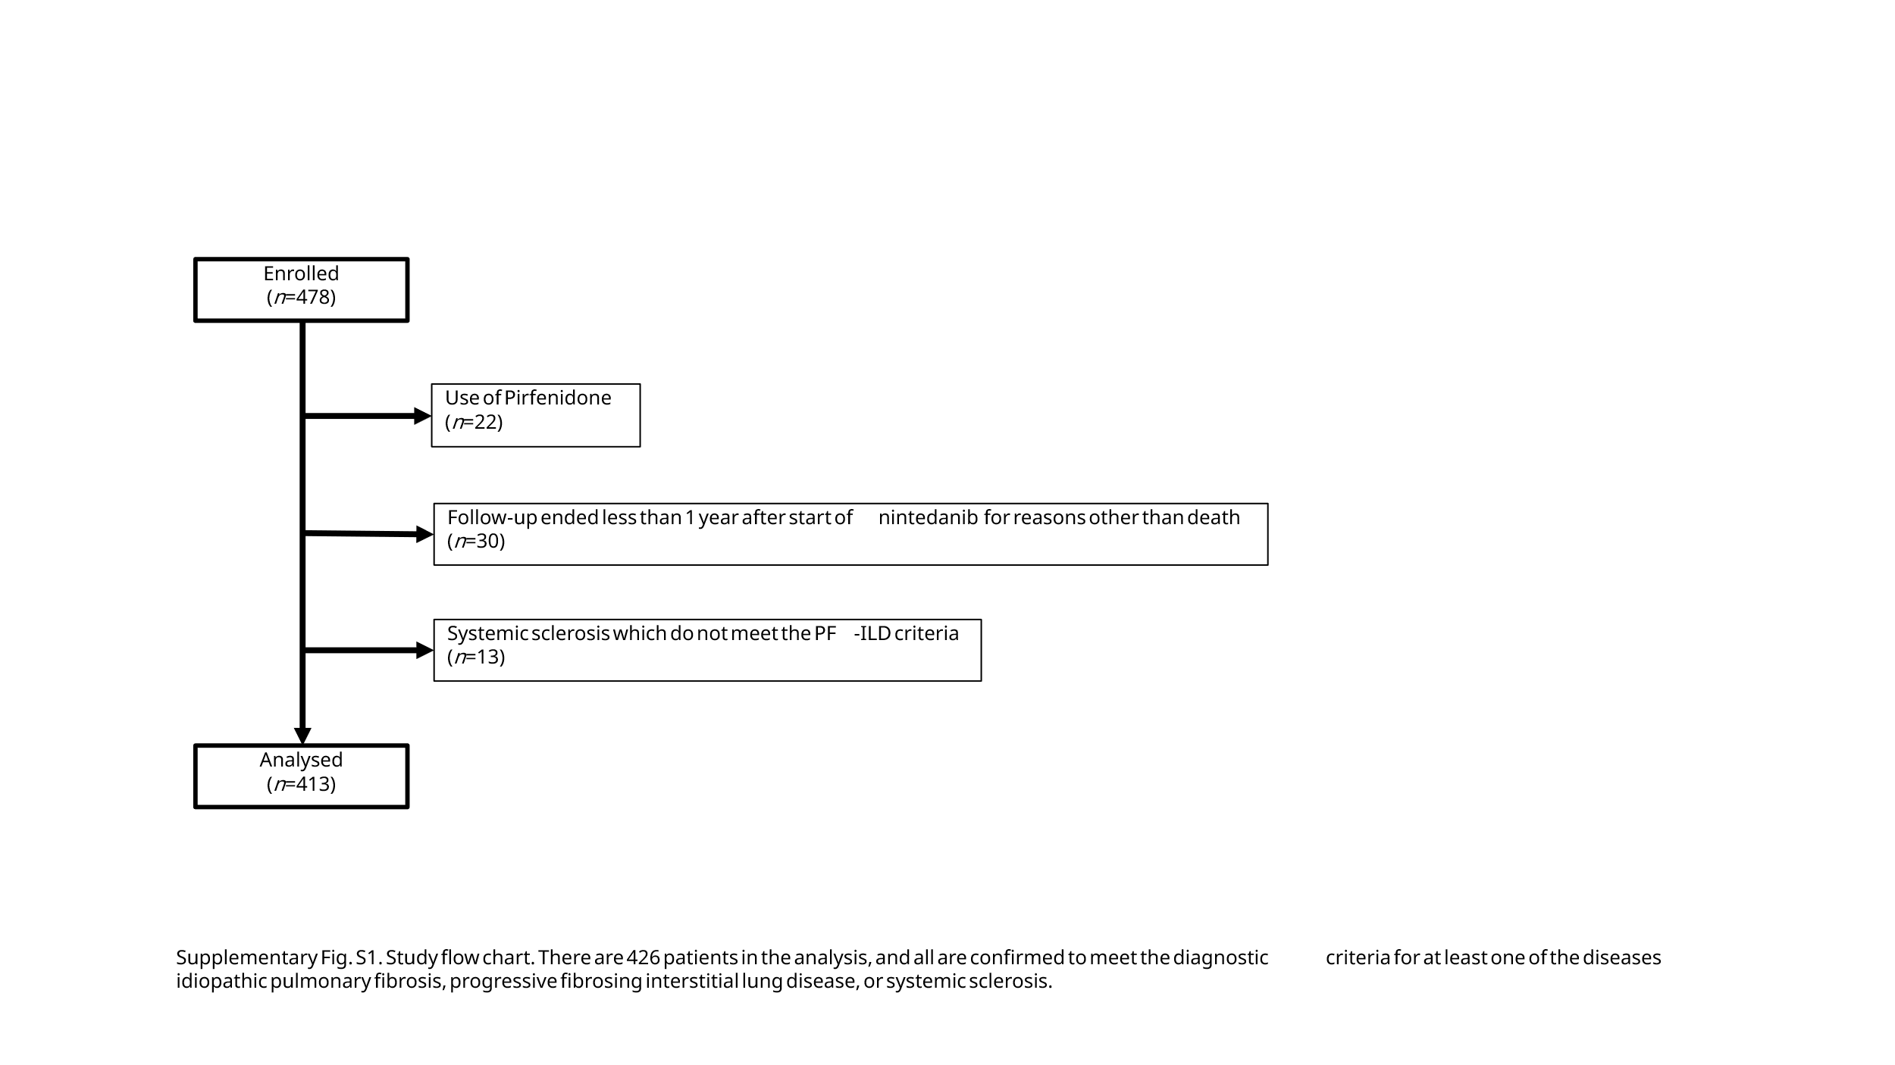

Supplementary Figure S2.
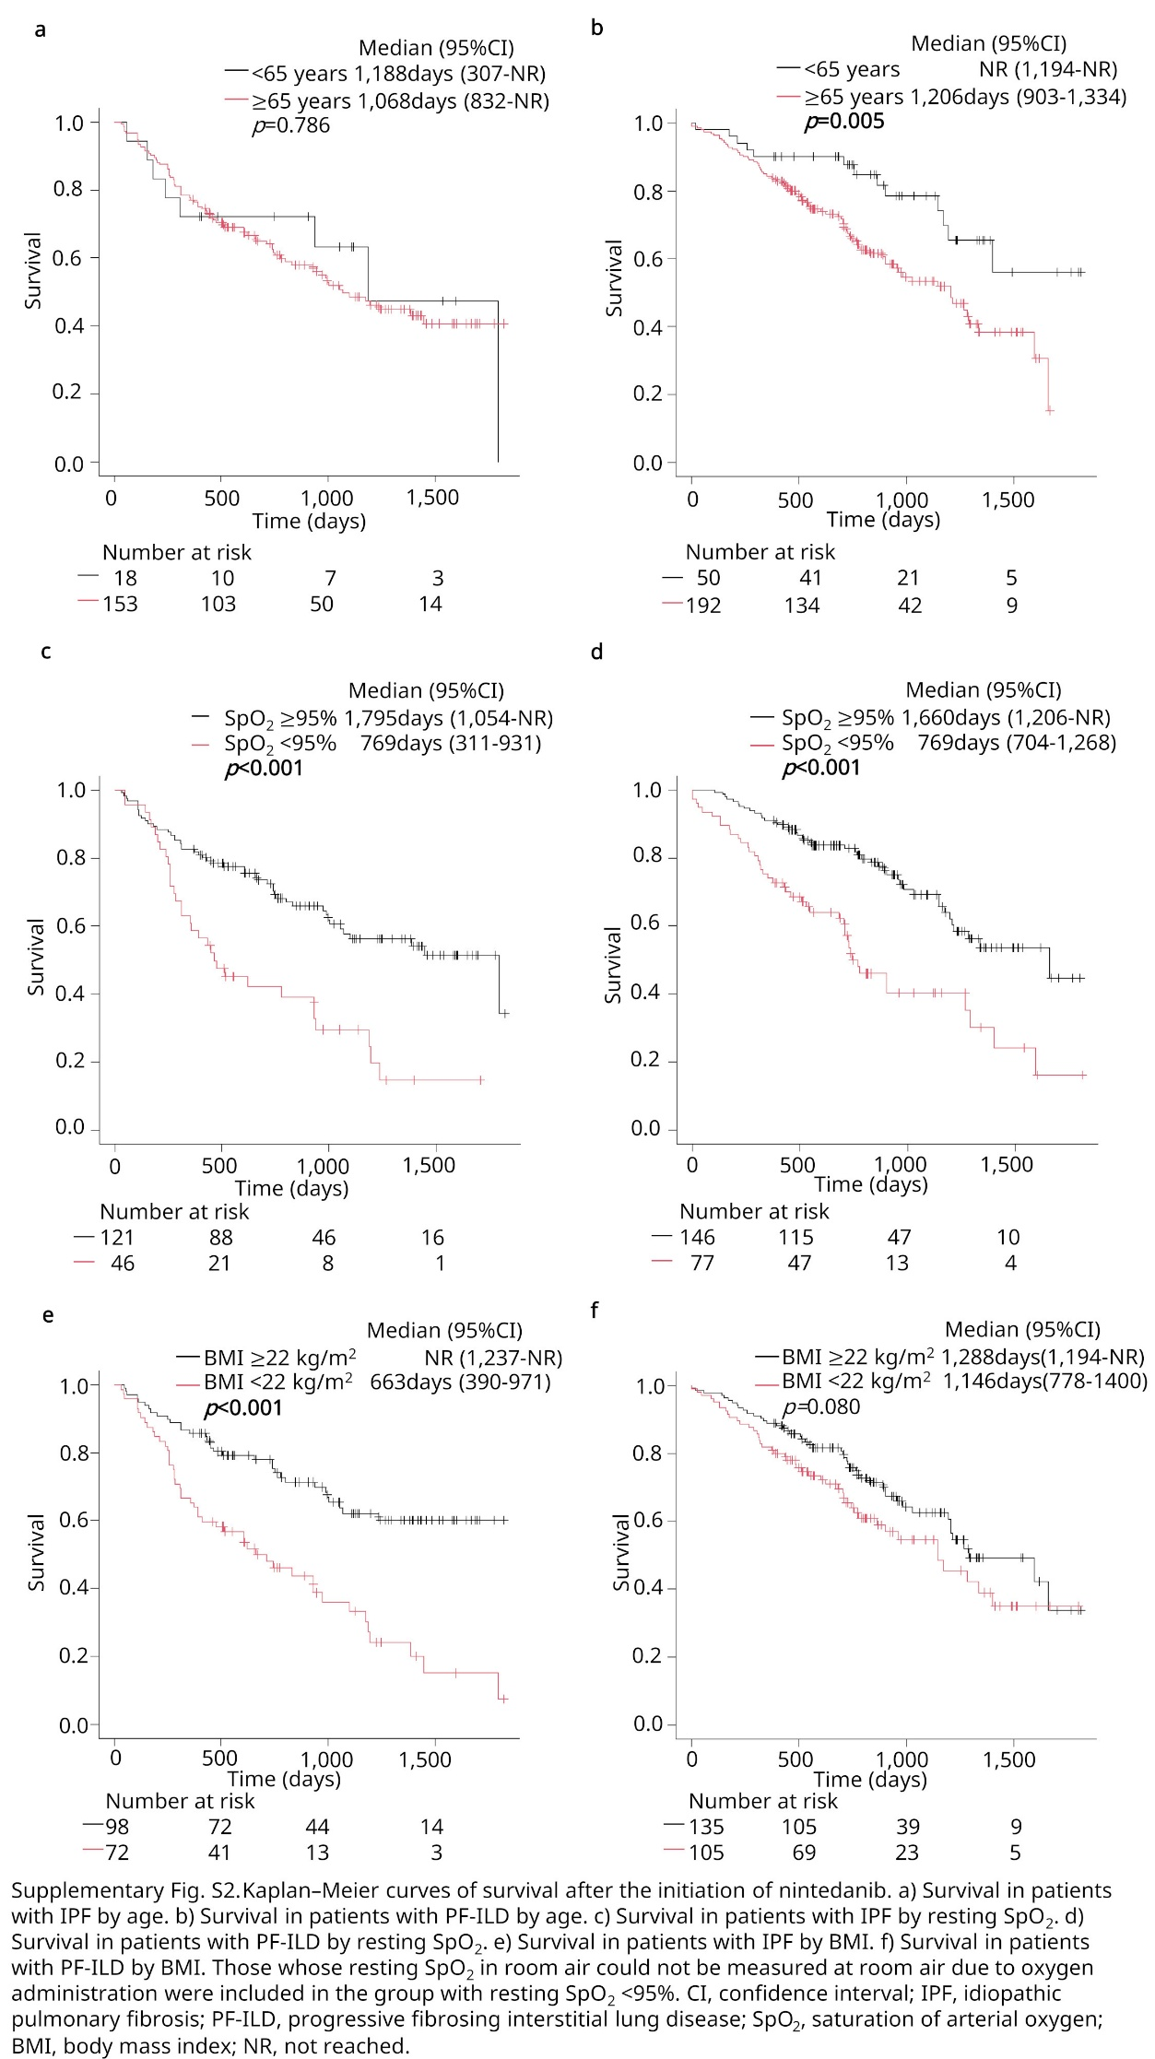
Supplementary Figure S3.
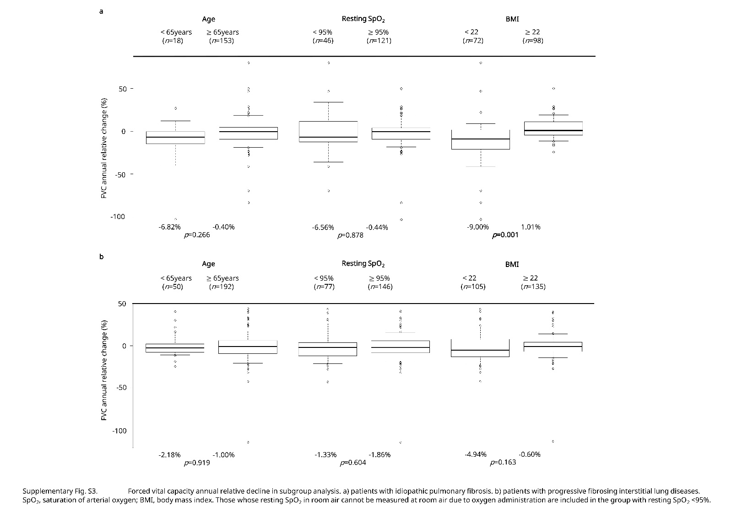

Supplementary Figure S4.
