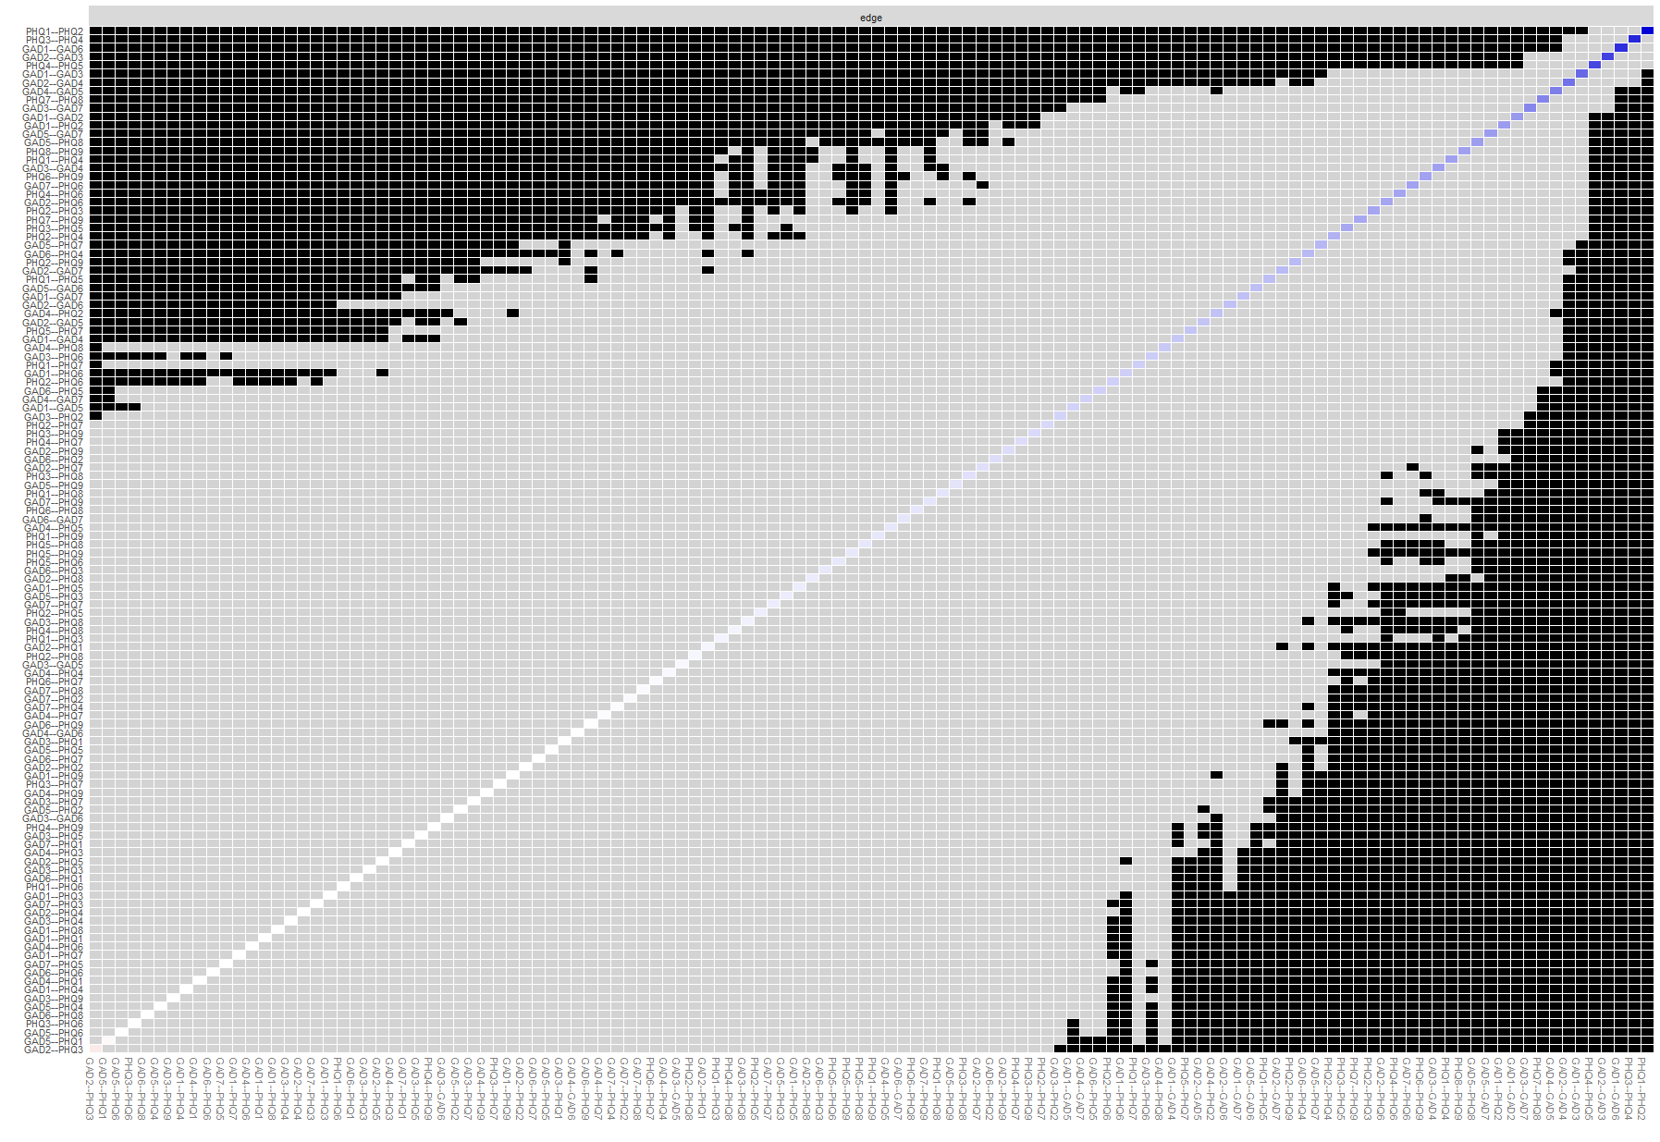
Supplementary Figure 1. Non-parametric bootstrapped difference test between edge-weights that were non-zero in the estimated network. Gray boxes indicate no difference between edge-weights, while black boxes indicate significant difference (α = 0.05).

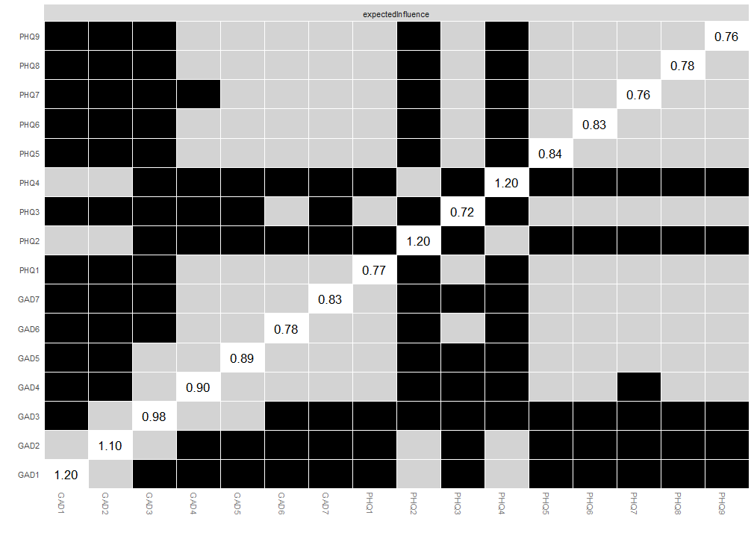
Supplementary Figure 2. Bootstrapped difference tests for Nodes’ expected influence

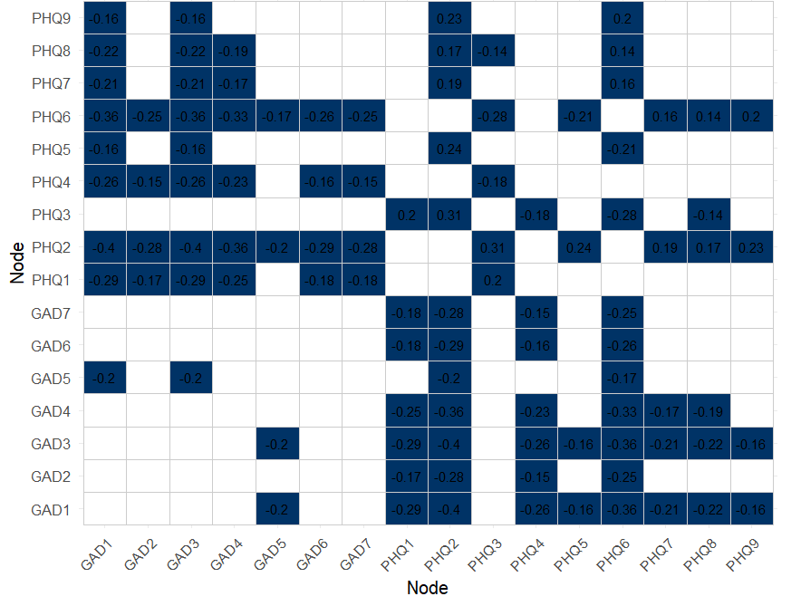
Supplementary Figure 3. Bootstrap-based difference testing of bridge expected influence

