Supplementary figures
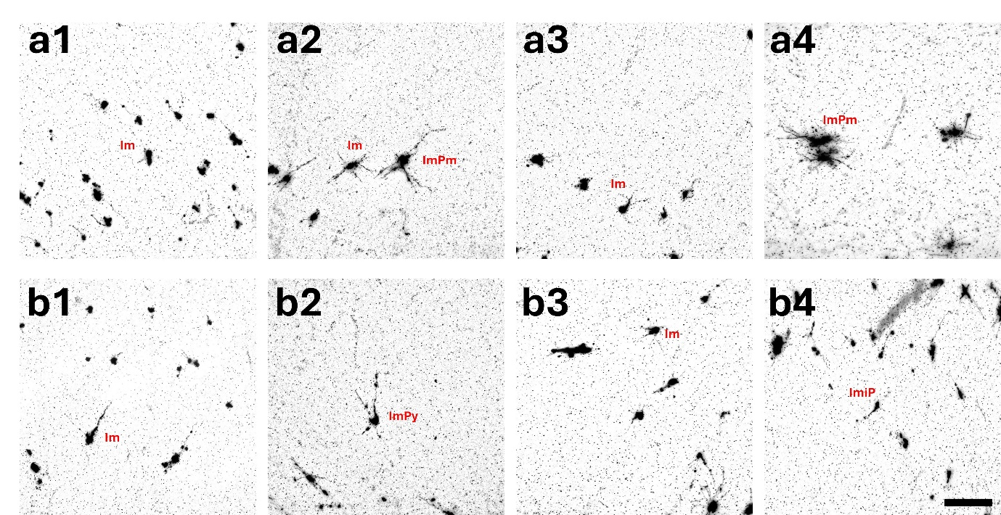Supplementary Figure 1. Golgi-stained SPNs in the sheep brain at GA70. (a1–a4) Golgi-stained photomicrographs of SPNs in the pre-gyral region, and (b1–b4) SPNs in the pre-sulcal region at GA70, both showed short, poorly developed neurites and limited dendritic extension. No consistent neuronal orientation is apparent at this stage. Abbreviations: GA, gestational age; Im, immature; ImPm, immature polymorphic; ImiP; immature inverted pyramidal; SPNs, subplate neurons. Scale bar = 100μm.

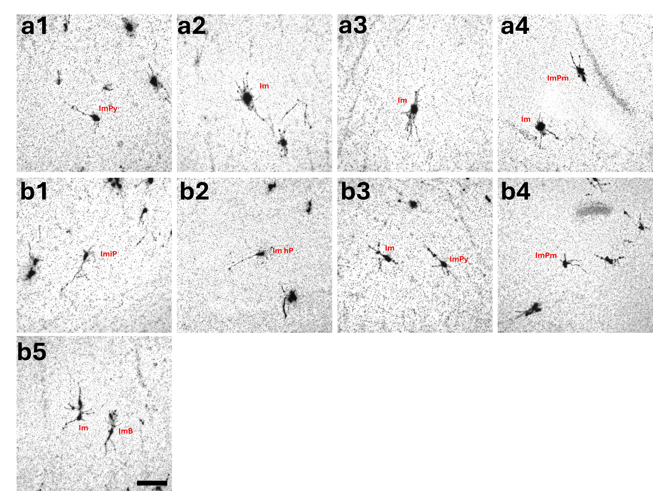Supplementary Figure 2. Golgi-stained SPNs in the sheep brain at GA80. (a1–a4) Golgi-stained photomicrographs of SPNs in the gyral region, and (b1–b5) SPNs in the sulcal region at GA80. Neurons showed slightly more dendritic/axonal processes compared to GA70, but overall remained relatively immature with short, simple neurites. Abbreviations: GA, gestational age; Im, immature; ImB, immature bipolar; ImHp, immature horizontal pyramidal; ImPm, immature polymorphic; ImPy, immature pyramidal neuron; SPNs, subplate neurons. Scale bar = 100μm.

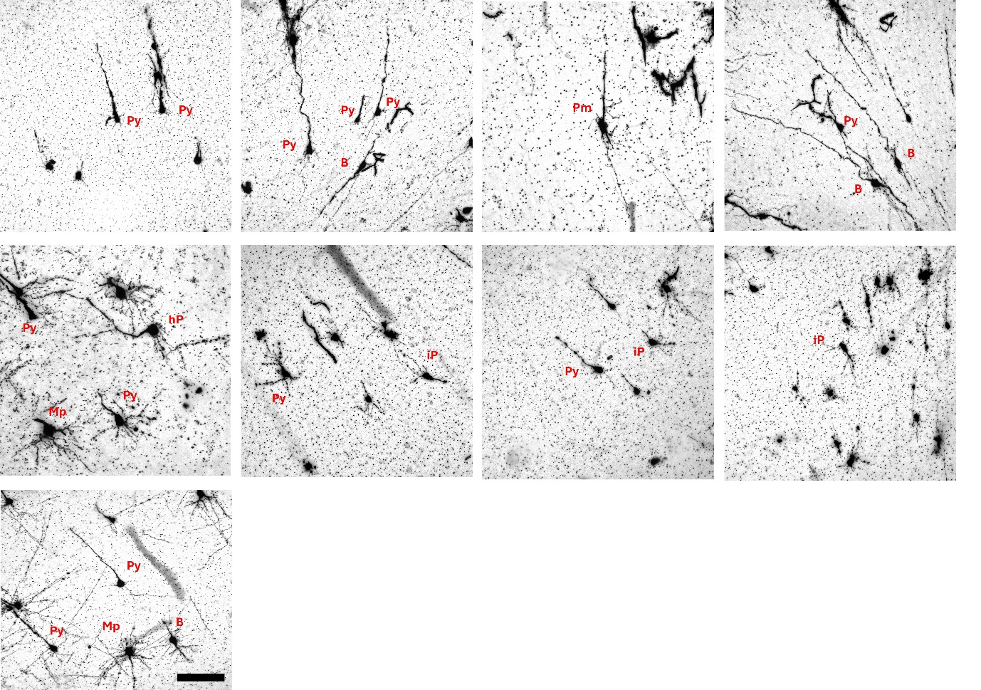Supplementary Figure 3. Golgi-stained SPNs in the gyral SP at GA90. Golgi-stained photomicrographs of SPNs in the gyral region at GA90. At this stage, SPNs exhibited more mature soma and clearer dendritic processes compared to GA80, with moderate dendritic branching and improved definition. Orientation in gyral regions appeared radial (sometimes slightly tangential), consistent with early gyral contouring. Abbreviations: B, bipolar neuron; GA, gestational age; hP, horizontal pyramidal neuron; iP, inverted pyramidal neuron; Mp, multipolar neuron; Py, pyramidal neuron; Pm, polymorphic; SP, subplate; SPNs, subplate neurons. Scale bar = 100μm.

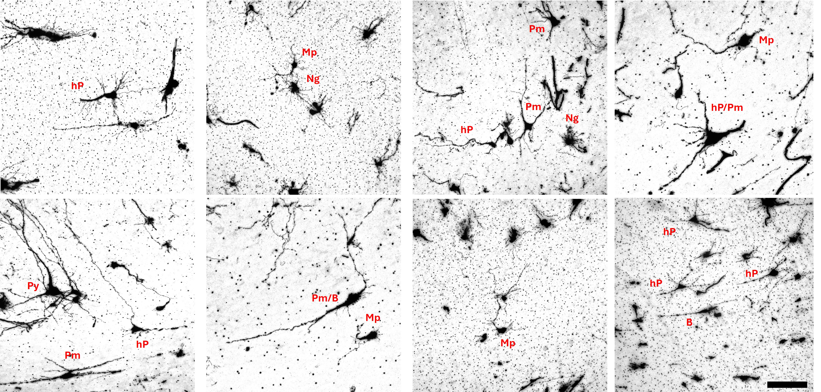Supplementary Figure 4. Golgi-stained SPNs in the sulcal SP at GA90. Golgi-stained photomicrograph of SPNs in the sulcal region at GA90. SPNs appear similarly developed to those in the gyral region at this age, with defined soma and dendritic definition. In sulcal regions, dendrites adopted more horizontal or slightly oblique orientation beneath the forming sulcal base. Abbreviations: B, bipolar neuron; GA, gestational age; hP, horizontal pyramidal neuron; iP, inverted pyramidal neuron; Mp, multipolar neuron; Ng, neurogliaform neuron; Py, pyramidal neuron; Pm, polymorphic; SP, subplate; SPNs, subplate neurons. Scale bar = 100μm.

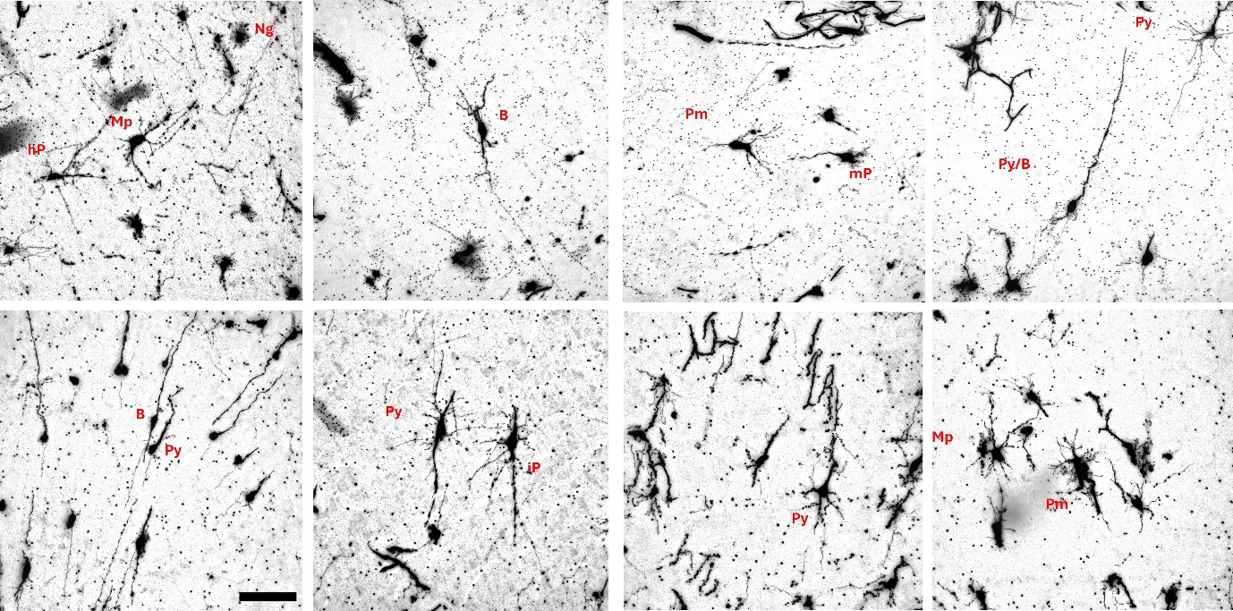Supplementary Figure 5. Golgi-stained SPNs in the gyral SP at GA110. Golgi-stained photomicrographs of SPNs in the gyral region at GA110. SPNs are more developed at this stage, showing well-formed soma and mature dendritic arbors. Dendrites in gyral regions commonly displayed radial or slightly tangential orientations. Abbreviations: B, bipolar neuron; GA, gestational age; hP, horizontal pyramidal neuron; iP, inverted pyramidal neuron; Mp, multipolar neuron; nG, neurogliaform neuron; Pm, polymorphic; Py, pyramidal neuron; SP, subplate; SPNs, subplate neurons. Scale bar = 100μm.

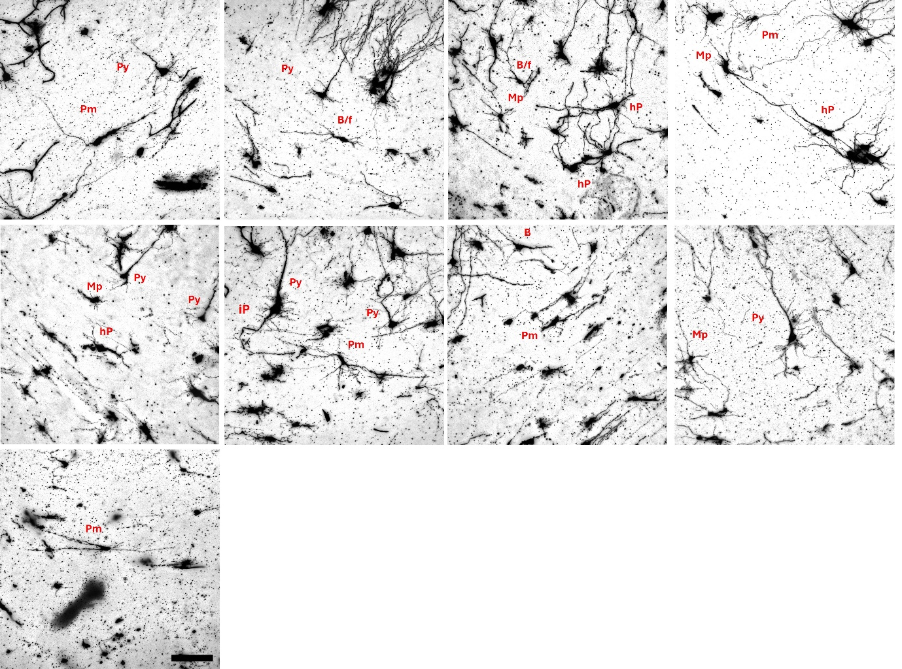Supplementary Figure 6. Golgi-stained SPNs in the sulcal SP at GA110. Golgi-stained photomicrographs of SPNs in the sulcal region at GA110. SPNs are similarly developed to those in the gyral region at this age, with mature defined soma and branching patterns. In sulcal regions, dendrites typically exhibited horizontal orientation beneath the established sulcal base. Abbreviations: B, bipolar neuron; f, fusiform; GA, gestational age; hP, horizontal pyramidal neuron; iP, inverted pyramidal neuron; Mp, multipolar neuron; Py, pyramidal neuron; Pm, polymorphic; SP, subplate; SPNs, subplate neurons. Scale bar = 100μm.

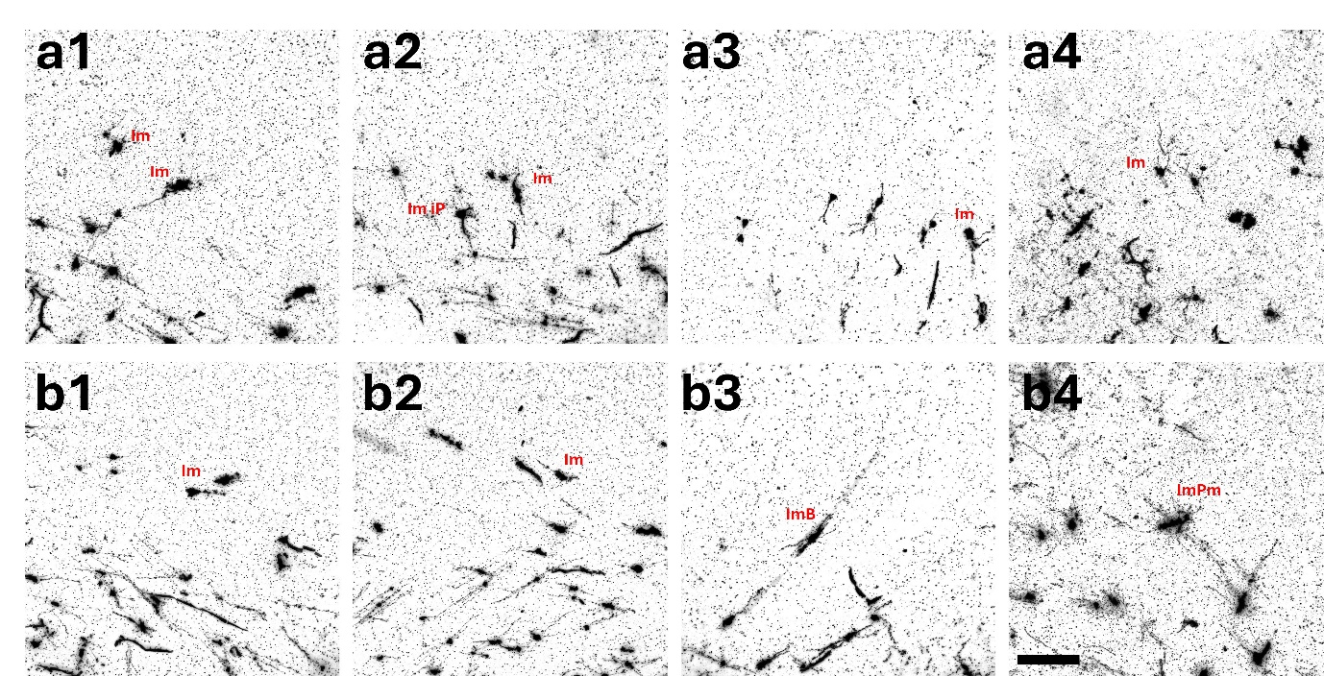Supplementary Figure 7. Golgi-stained SPNs in pre-gyral and pre-sulcal regions of the P5 ferret. (a1-a4) Golgi-stained photomicrographs of SPNs in gyral SP and (b1-b4) in sulcal regions at P5 prior to gyrification. At P5, SPNs in both pre-gyral and pre-sulcal regions are relatively immature, displaying small soma with short, poorly differentiated neurites. Abbreviations: ImB, Immature bipolar neuron; ImiP, inverted pyramidal neuron; ImPm, immature polymorphic; P, postnatal; SP, subplate; SPNs, subplate neurons. Scale bar = 100μm.

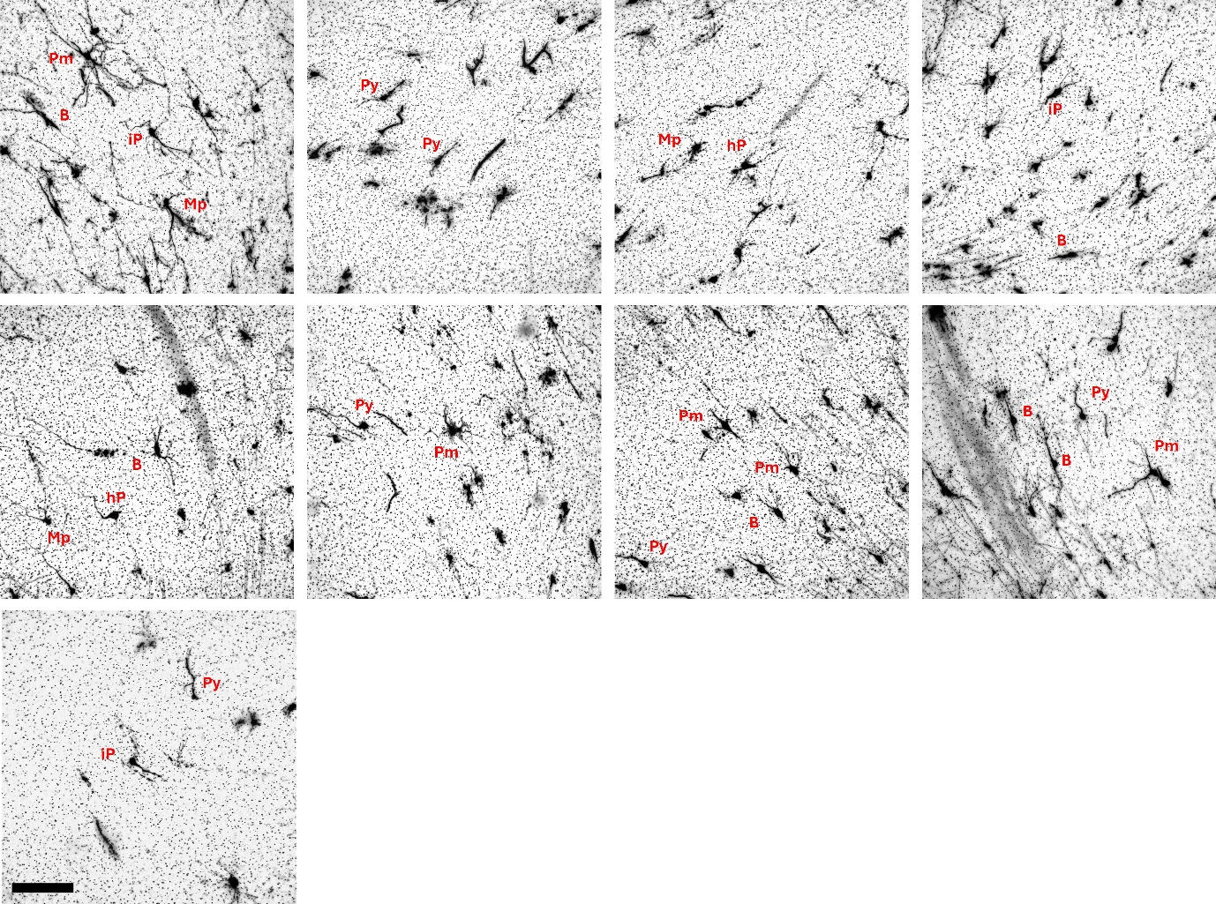Supplementary Figure 8. Golgi-stained SPNs in the gyral SP at P15. Golgi-stained photomicrographs of SPNs in the gyral region of the P15 ferret (mid-gyrification). Neurons exhibit a defined soma and more developed dendritic processes compared to P5, with orientations typically radial or slightly tangential. Abbreviations: B, bipolar neuron; hP, horizontal pyramidal neuron; iP, inverted pyramidal neuron; Mp, multipolar neuron; Py, pyramidal neuron; P, postnatal; SP, subplate; SPNs, subplate neurons. Scale bar = 100μm.

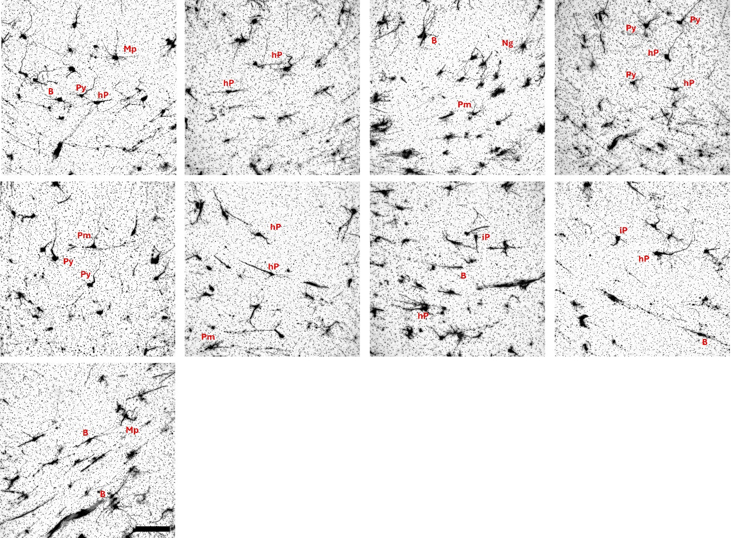Supplementary Figure 9. Golgi-stained SPNs in the sulcal SP at P15. Golgi-stained photomicrographs of SPNs in the sulcal region of the P15 ferret (mid-gyrification). SPNs at this stage displayed more mature morphologies, with dendrites oriented predominantly horizontally or slightly tangentially beneath the emerging sulcus. Abbreviations: B, bipolar neuron; CP, cortical plate; hP, horizontal pyramidal neuron; iP, inverted pyramidal neuron; Mp, multipolar neuron; Ng, neurogliaform neuron; Py, pyramidal neuron; P, postnatal; SP, subplate; SPNs, subplate neurons. Scale bar = 100μm.
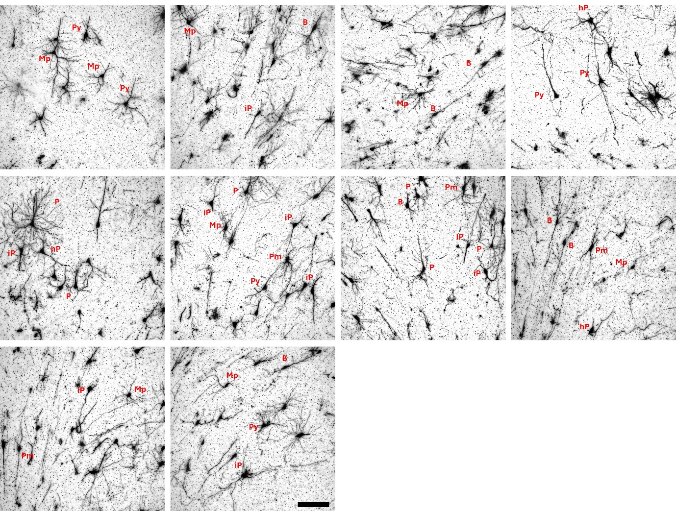Supplementary Figure 10. Golgi-stained SPNs in the gyral SP at P25. Golgi-stained photomicrographs of SPNs in the gyral region of the P25 ferret (late gyrification). SPNs showed well-defined somata and mature dendritic arbors, with orientations often radial or slightly tangential toward the cortical plate. Abbreviations: B, bipolar neuron; hP, horizontal pyramidal neuron; iP, inverted pyramidal neuron; Mp, multipolar neuron; Py, pyramidal neuron; Pm, polymorphic; P, postnatal; SP, subplate; SPNs, subplate neurons. Scale bar = 100μm.
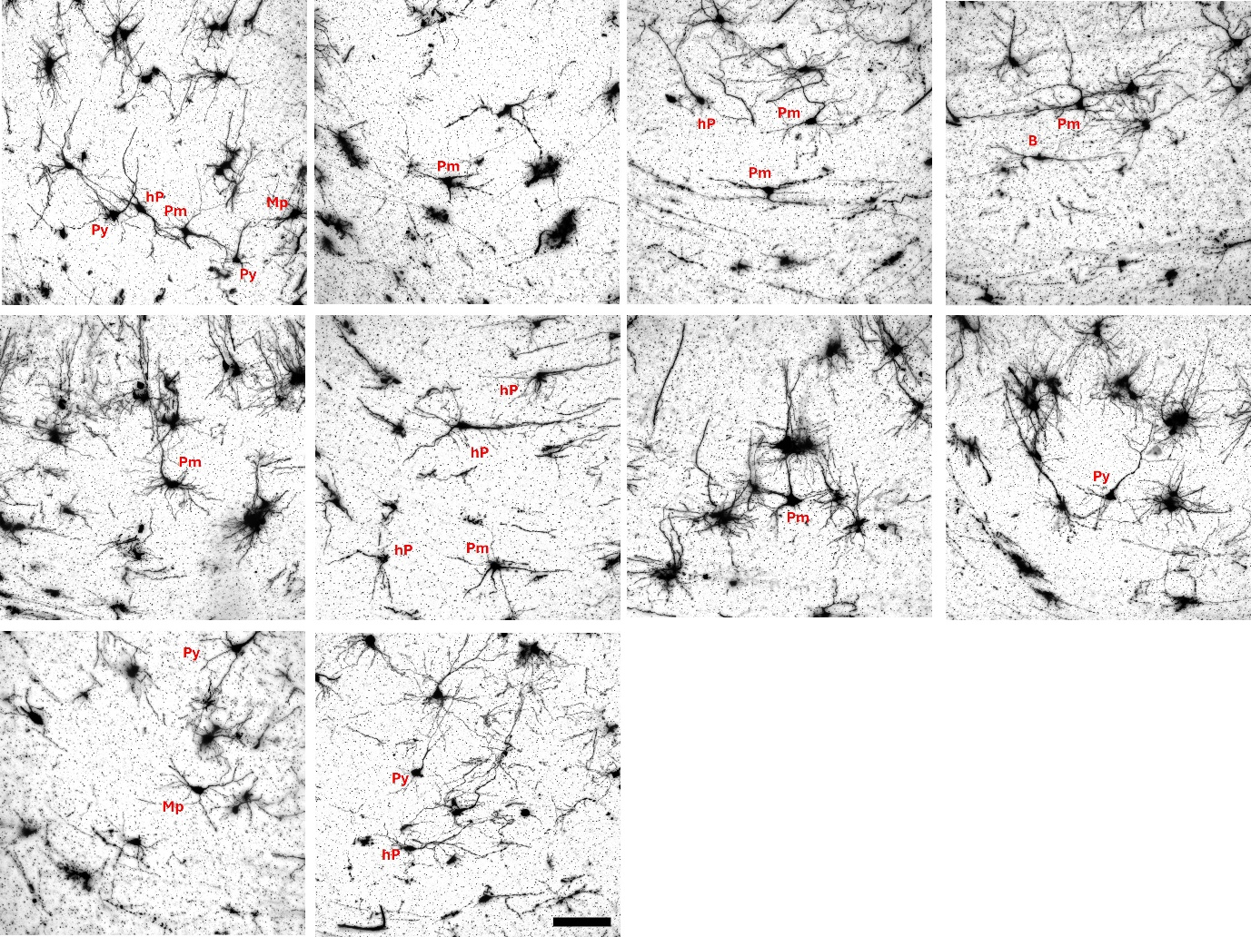Supplementary Figure 11. Golgi-stained SPNs in the sulcal SP at P25. Golgi-stained photomicrographs of SPNs in the sulcal region of the P25 ferret (late gyrification). SPNs displayed mature morphologies with predominantly horizontal dendritic orientations beneath the established sulcal base. Abbreviations: B, bipolar neuron; hP, horizontal pyramidal neuron; iP, inverted pyramidal neuron; Mp, multipolar neuron; Py, pyramidal neuron; Pm, polymorphic; P, postnatal; SP, subplate; SPNs, subplate neurons. Scale bar = 100μm.

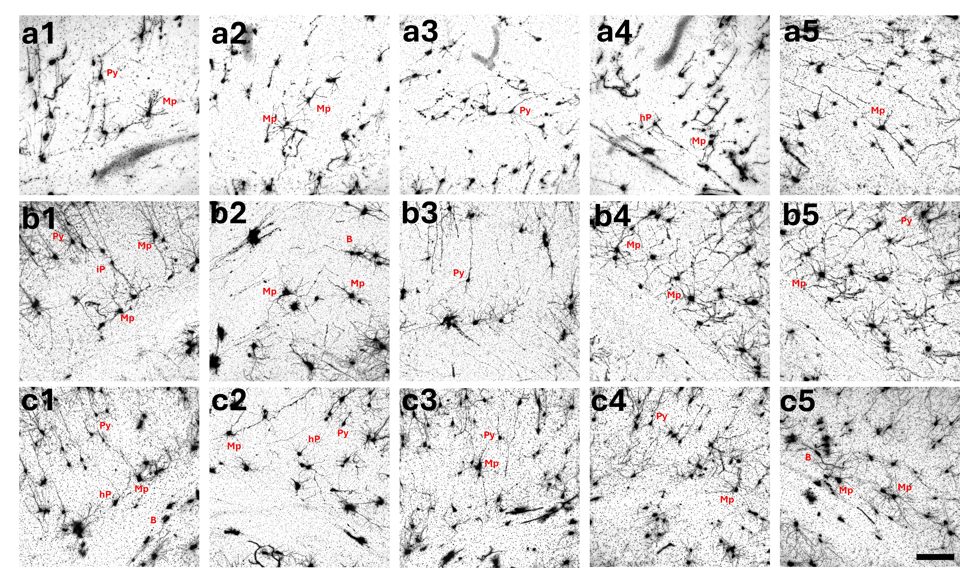Supplementary Figure 12. Golgi-stained subplate neurons in the spiny mouse across embryonic and early postnatal development. (a1–a5) Golgi-stained photomicrographs of SP neurons at E35 (embryonic day 35), showing well-defined soma and moderate dendritic arbors, consistent with the advanced prenatal maturation characteristic of this species. (b1–b5) SPNs at P1, were more mature than at E35 and exhibited modest increases in dendritic elaboration. (c1–c5) SPNs at P5 displayed morphologies similar to P1, with no major additional dendritic expansion, reflecting the relatively stable SPN morphology across these early stages. Abbreviations: B, bipolar neuron; hP, horizontal pyramidal neuron; mP, multipolar neuron; Py, pyramidal neuron; Pm, polymorphic; E, embryonic; P, postnatal; SPNs, subplate neurons. Scale bar = 100μm.

Supplementary Figure 13. Representative summary of differences in the morphology of SPNs between gyri and sulci in the P25 ferret brain. The processes of (a) CPLX3+ cells and (c) Golgi-stained cells below gyri follow a radial path. In contrast, the processes of (b) CPLX3+ cells and (d) Golgi-stained cells below sulci appear more tangential and multidirectional. The differences seen in SPNs morphology between gyri and sulci applies for both gyrencephalic species. Blue arrows indicate gyral SPNs, while red arrows indicate sulcal SPNs. Abbreviations: CP, cortical plate; P, postnatal; SP, subplate; SPNs, subplate neurons. Scale bars = 100µm.

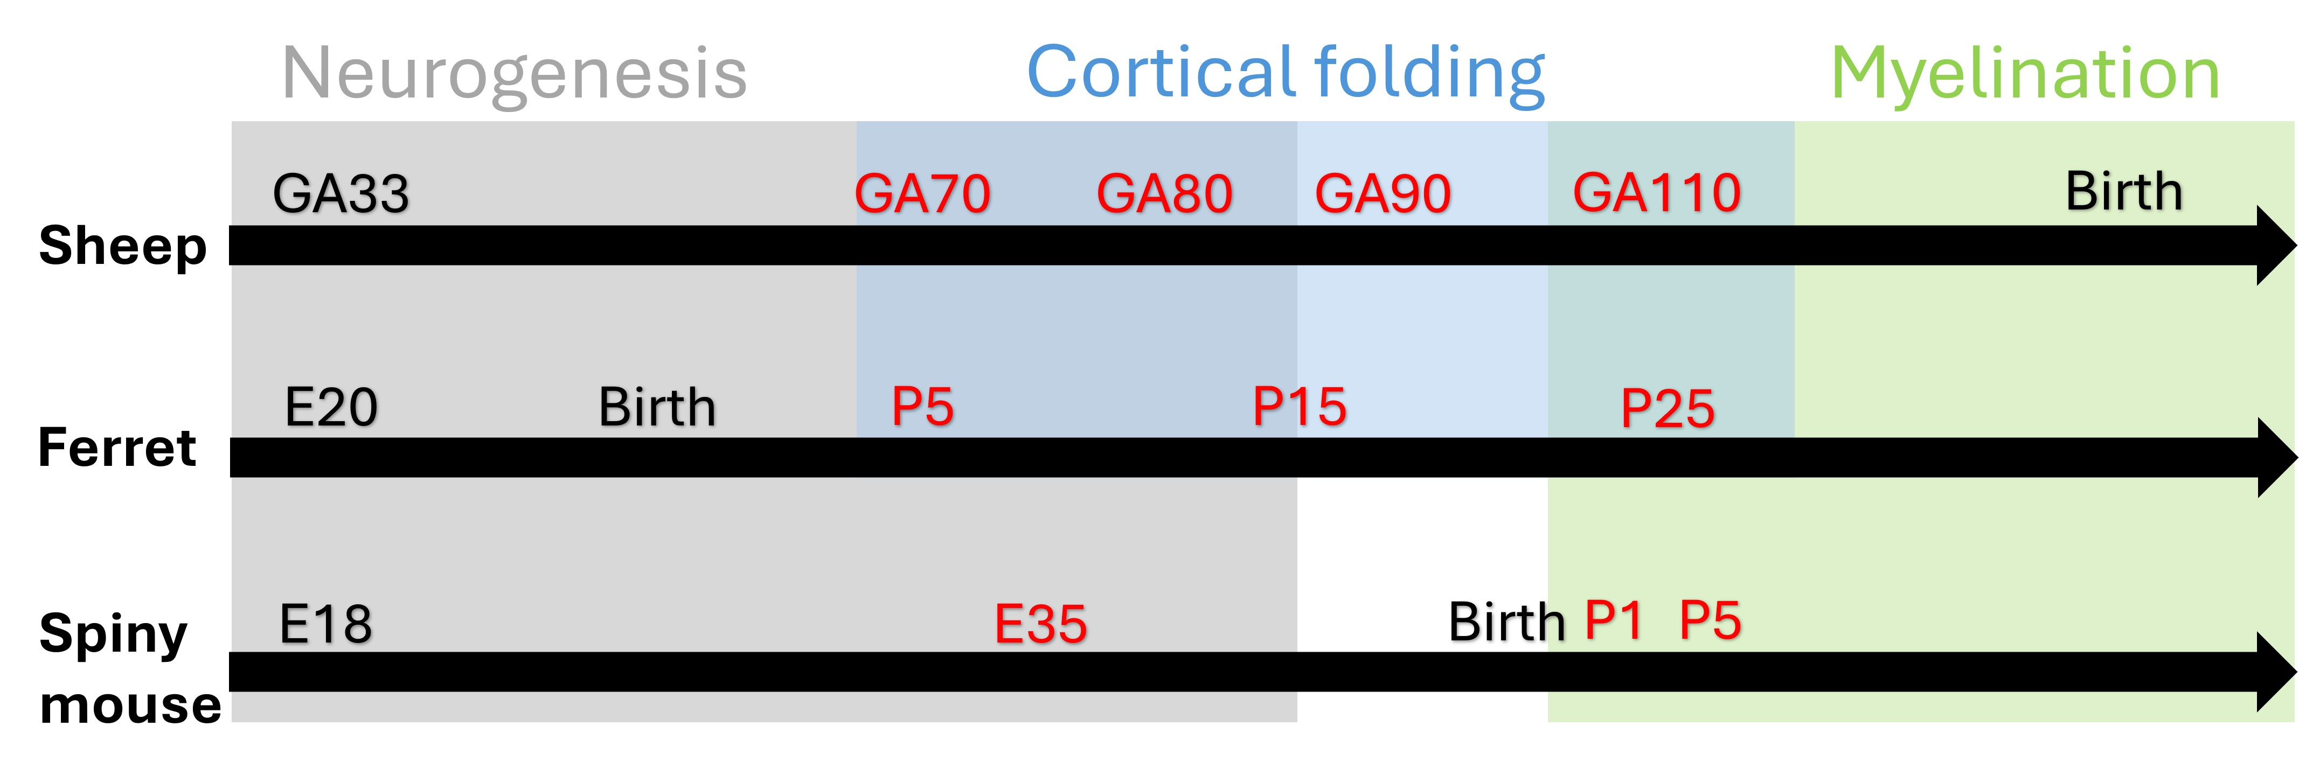Supplementary Figure 14. Schematic of the developmental equivalent timeline of neurogenesis, cortical folding and myelination in the sheep, ferret, and spiny mouse. Schematic representation of developmental progression in the sheep, ferret, and spiny mouse, and visualising an approximation of species equivalency. Red text denotes ages at which tissue was collected. Abbreviations: E, embryonic age; GA, gestational age; P, postnatal day. Sheep^{3,32,44-46,54}; ferret^{47-49,55}; spiny mouse^{30,60-64}.

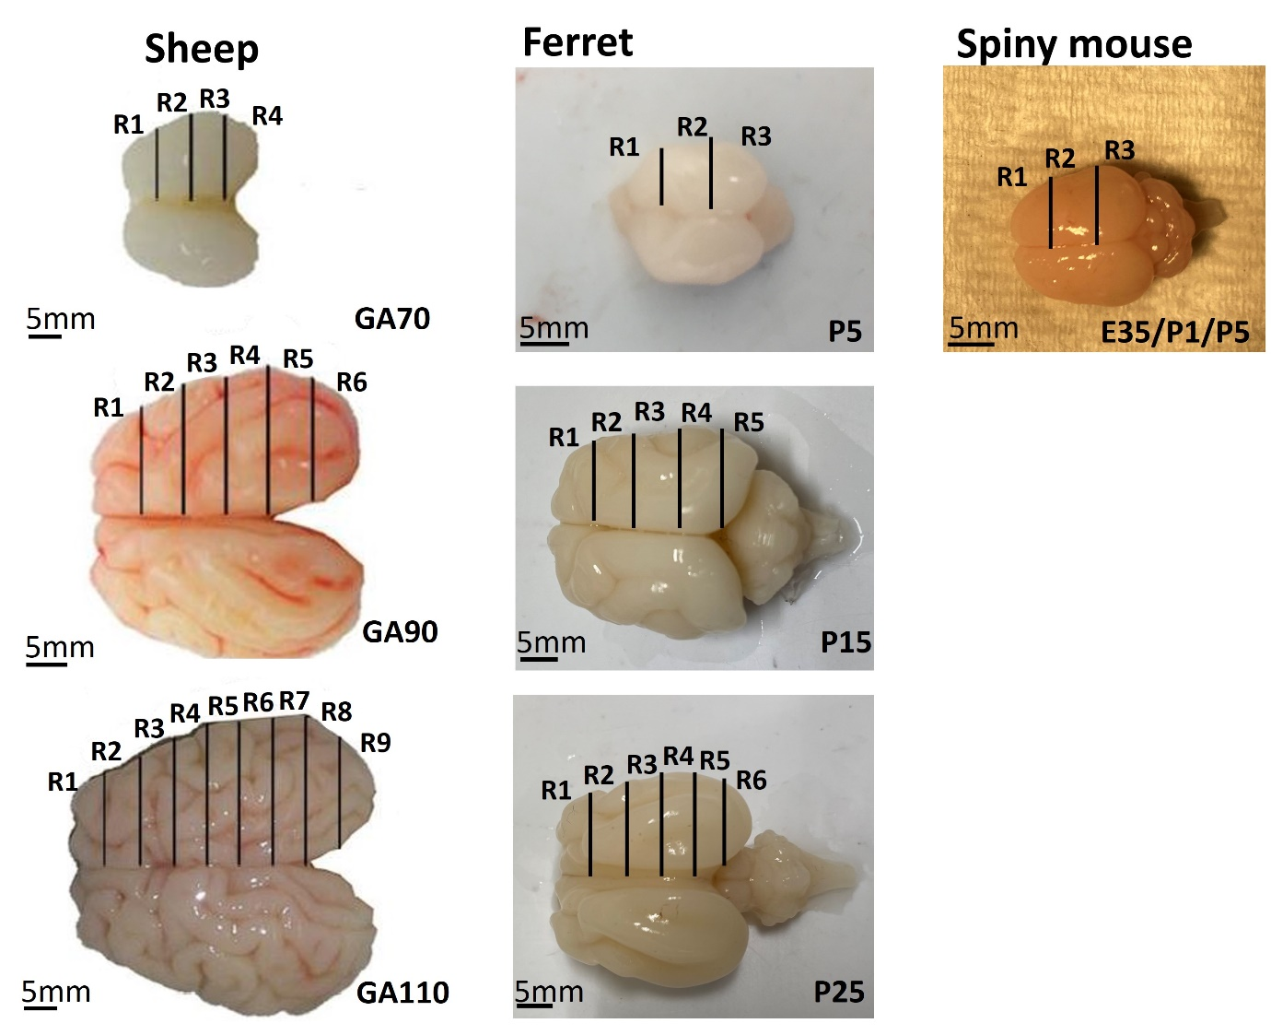Supplementary Figure 15. Dissection technique for sheep, ferret, and spiny mouse brains. Sheep and ferret brains were dissected into varying numbers of 5mm-thick coronal blocks or regions (R) depending on the size of the brain. For the lissencephalic spiny mouse brain at each age, the cerebral hemispheres were hemisected through the longitudinal fissure; an example is shown for P5 only. R2 in all species was used for Golgi staining and Sholl analysis. Abbreviations: E, Embryonic; GA, gestational age; R, region; P, postnatal. Scale bars = 5mm.

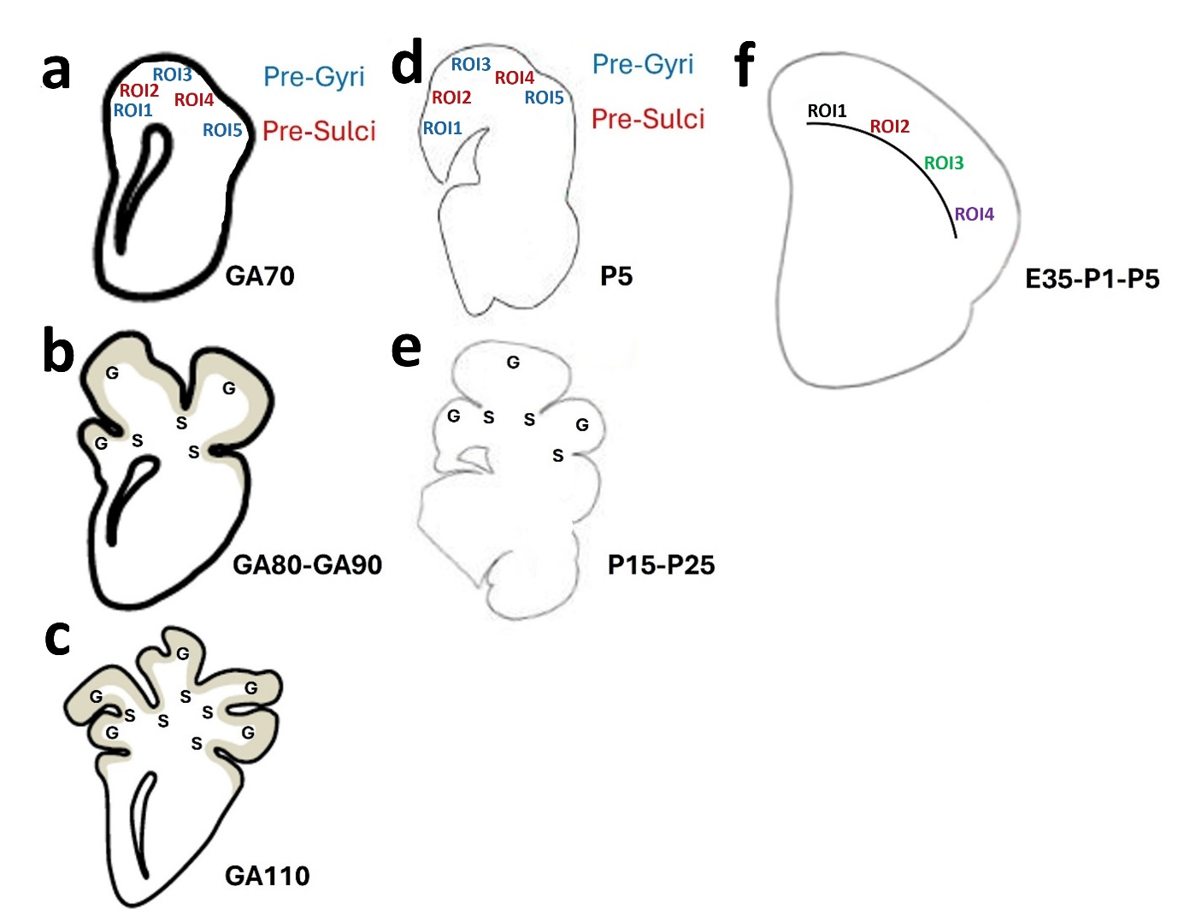Supplementary Figure 16. Schematic drawings of the regions of interest (ROI) chosen for the study. (a) Pre-gyrencephalic sheep brain at GA70. (b) Gyrencephalic sheep brain at GA80-90. (c) Gyrencephalic sheep brain at GA110. (d) Pre-gyrencephalic brain of a P5 ferret. (e) Gyrencephalic brain of a P15-25 ferret. (f) Lissencephalic spiny mouse brain from E35-P5. Diagrams are not to scale. In the pre-gyrencephalic brains (a, d), 5 ROIs were chosen mediolaterally and divided into pre-gyral (ROI1, ROI3, ROI5) and pre-sulcal (ROI2, ROI4) regions. In the gyrencephalic brains (b, c, e), ROIs corresponding to gyri and sulci were chosen mediolaterally as shown above. In the lissencephalic spiny mouse brain (f), 4 ROIs were chosen extending mediolaterally at all developmental ages as shown above (ROI 1-4). Abbreviations: E, embryonic age; GA, gestational age; G, gyrus; P, postnatal day; S, sulcus.

