Supplementary information

Biochemical characterization of the α-1,3-mannosidase AnGH92A from Aspergillus nidulans

Ryutaro Nishigaki¹, Hiromitsu Suzuki¹, Ryohei Tsukada¹, Ken Miyazawa², Masashi Kato¹, and Motoyuki Shimizu¹*

¹ Faculty of Agriculture, Meijo University, Nagoya, Japan
² Department of Fungal Infection, National Institute of Infectious Diseases, Japan Institute for Health Security, Tokyo, Japan

*Corresponding author
Motoyuki Shimizu
Faculty of Agriculture, Meijo University,
Nagoya, Japan
moshimi@meijo-u.ac.jp
(ORCID; 0000-0002-6907-6367)

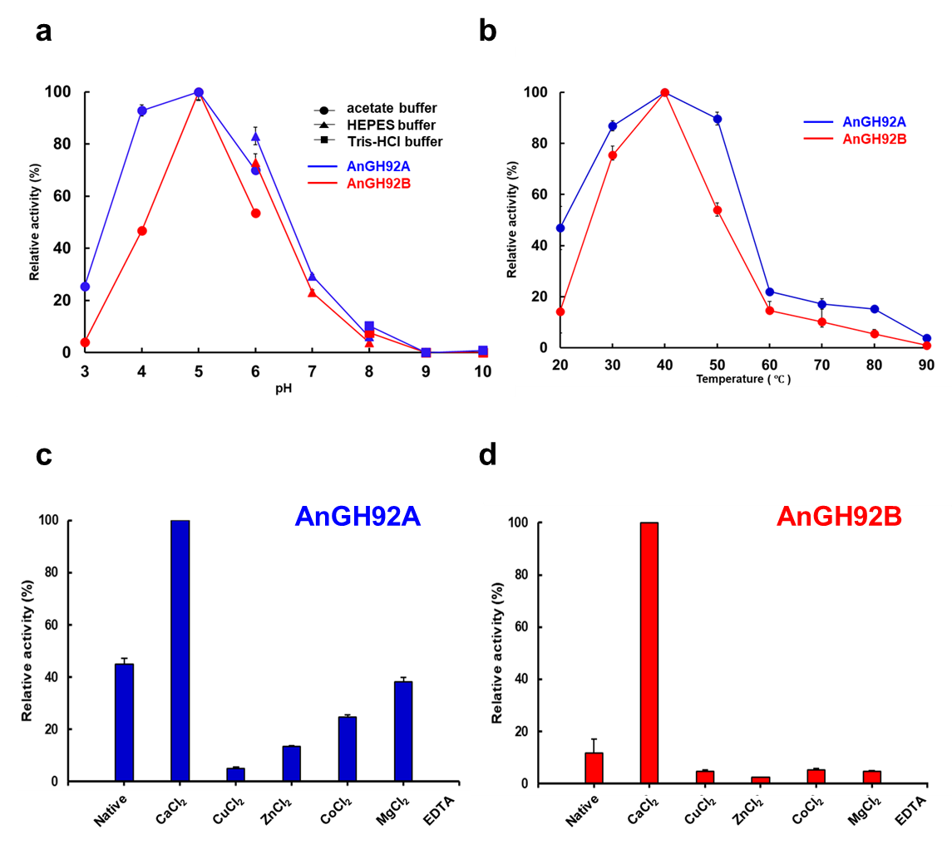

Fig. S1. Optimal conditions for AnGH92A and AnGH92B.
(a) Optimal pH profiles of AnGH92A (blue) and AnGH92B (red). Enzyme reactions were performed across pH 3.0–10.0 using 50 mM sodium acetate (pH 3.0–6.0; ●), 50 mM HEPES-NaOH (pH 6.0–8.0; ▲), and 50 mM Tris-HCl (pH 8.0–10.0; ■).
(b) Optimal temperature profiles of AnGH92A (blue) and AnGH92B (red), assessed at 20–90 °C.
(c, d) Effects of metal ions on AnGH92A (c) and AnGH92B (d). Enzymes were preincubated with the indicated additives at 4 °C for 24 h, and residual activity was measured at pH 5.0 and 37 °C for 30 min. Activity in the absence of additives was set to 100%. All activities were assayed using 4NP-Man as the substrate. Values represent the mean ± standard error of three independent experiments.

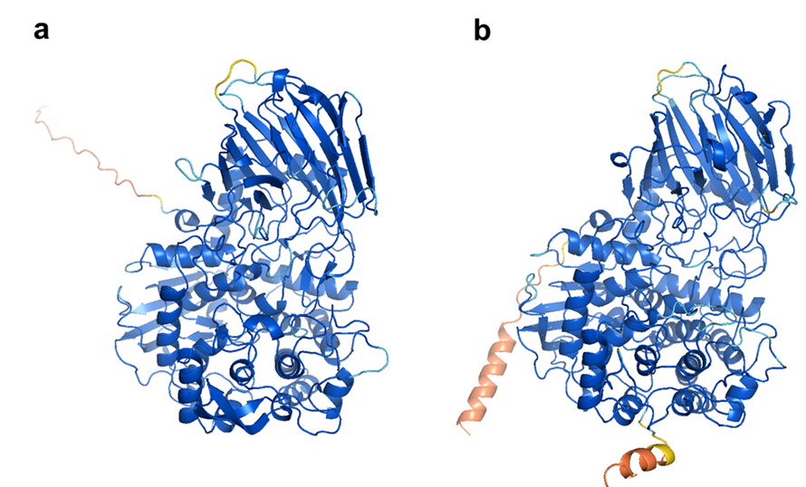
Fig. S2. Structural comparison of AnGH92A and AnGH92B.
Predicted structural models of (a) AnGH92A and (b) AnGH92B generated using AlphaFold2. Structural confidence is indicated by pLDDT scores: navy blue (<100), cyan (<90), yellow (<70), orange (<50).

Fig. S3. Amino acid sequence alignment of GH92 enzymes.
Multiple sequence alignment of GH92 enzymes from Aspergillus nidulans (AnGH92A–E), along with AnGH92A-clade orthologs from Penicillium digitatum (QQK46283.1), Aspergillus oryzae (BAE65809.1), and Aspergillus niger (CAK40038.1), as well as three Candida species: C. albicans SC5314 (AOW31314.1), C. dubliniensis CD36 (CAX40133.1), and C. parapsilosis CDC317 (CCE42865.1). Representative bacterial GH92 enzymes were also included: α-1,3-mannosidases (BT3130, BT3994, NixK, HMPREF1534_02484, BT3773, Sca2/3Man2693), α-1,2-mannosidases (BT3990, EfMan-I, NnGH92, BT3962, BT3784), and α-1,4-mannosidases (BT4073, BT3965). Alignments were generated using ClustalW. Conserved residues and characteristic motifs are highlighted as follows: catalytic residues (magenta), Ca²⁺-binding residues (yellow), α-1,2-mannosidase-conserved motifs (green), GH92-common residues in bacteria (pink), GH92-common residues in fungi (blue), residues conserved across all GH92 enzymes (gray), residues shared among α-1,3-mannosidases (purple), bacterial α-1,3-mannosidase-specific residues (orange), and the unique motif of AnGH92A (cyan).

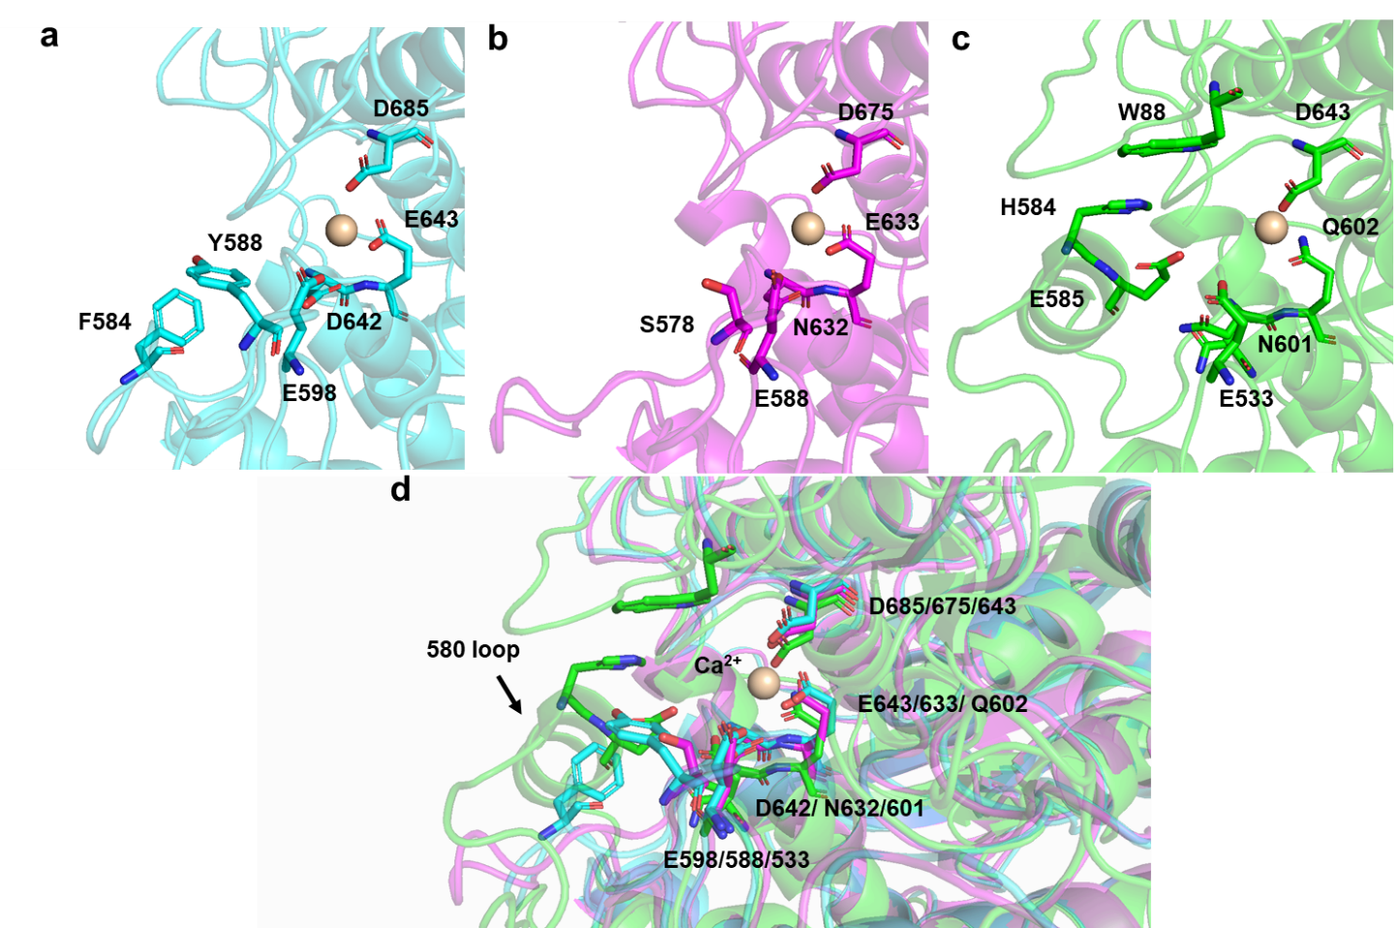

Fig. S4. Structural comparison of AnGH92A, AnGH92B, and bacterial α-1,2-mannosidase BT3990
Enlarged views (a–c) and superimposed structures (d) of AnGH92A (cyan), AnGH92B (magenta), and the bacterial α-1,2-mannosidase BT3990 (green; PDB ID: 2WW1). Structural models of AnGH92A and AnGH92B were generated using AlphaFold2. Ca²⁺ was positioned based on the coordinates of the BT3990 crystal structure (PDB ID: 2WW1). Conserved Ca²⁺-binding residues and catalytic residues are indicated. Structural differences in the loop regions surrounding the predicted +1 subsite are highlighted to illustrate structural variations among these GH92 enzymes.

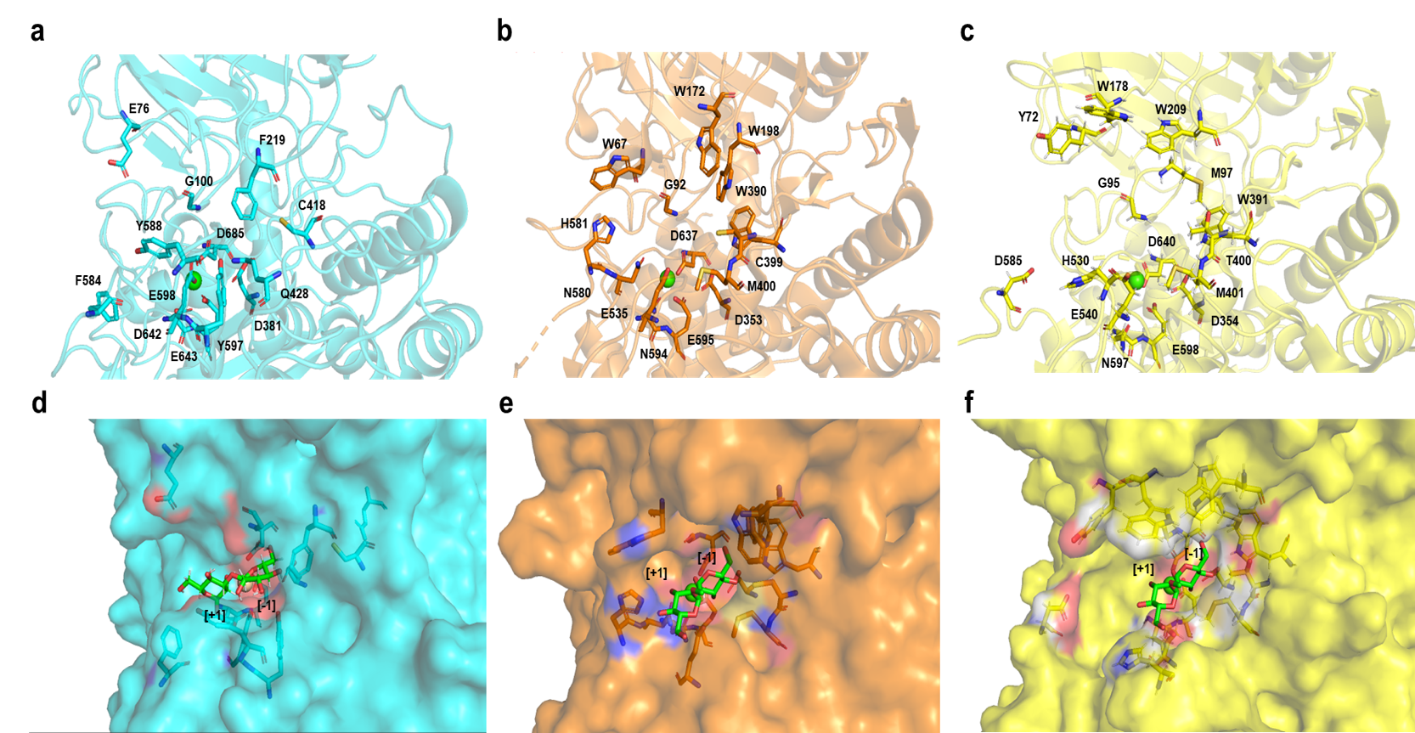
Fig. S5. Structural comparison of AnGH92A and bacterial α-1,3-mannnosidases
Enlarged views of AnGH92A (cyan) compared with the bacterial α-1,3-mannosidase BT3130 (orange; PDB ID: 6F8Z) and B035DRAFT_03340^{GH92} (yellow; PDB ID: 7ZGM) ligand-free (a–c) and ligand-bound (d–f) states. The structural model of AnGH92A was generated using AlphaFold2. A Ca²⁺ ion was positioned based on the coordinates of the BT3990 crystal structure (PDB ID: 2WW1), and docking simulations were performed using the Ca²⁺-bound AnGH92A model.

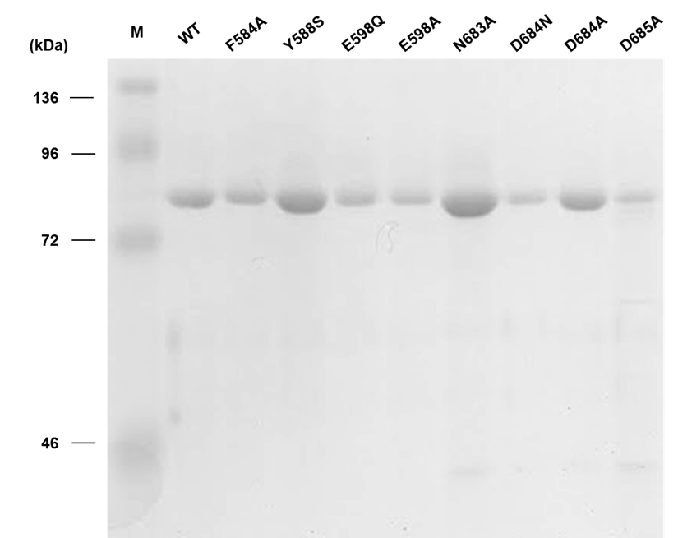
Fig. S6. SDS–PAGE analysis of purified AnGH92A variants.
Lane M, protein molecular mass markers; purified wild-type AnGH92A (WT) and variants F584A, Y588S, E598Q, E598A, N683A, D684N, D684A, and D685A.
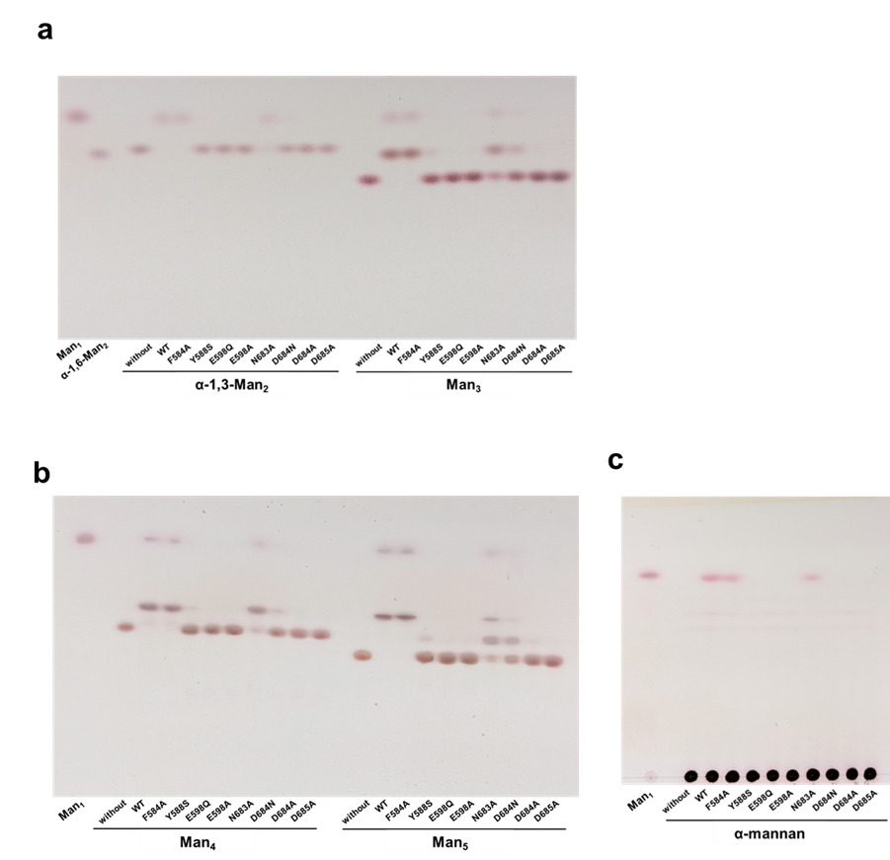
Fig. S7. TLC analysis of reaction products from α-manno-oligosaccharides and α-mannan hydrolyzed by AnGH92A variants.
(a, b) Reaction products generated from α-manno-oligosaccharides; (c) reaction products generated from α-mannan. Reactions were performed at 40 °C and pH 5.0 for 30 min. Mannose (Man₁) is indicated. Substrates: α-1,2-mannobiose (α-1,2-Man₂); α-1,3-mannobiose (α-1,3-Man₂); α-1,4-mannobiose (α-1,4-Man₂); α-1,6-mannobiose (α-1,6-Man₂); O-α-d-mannopyranosyl-(1→3)-O-[α-d-mannopyranosyl-(1→6)]-α-d-mannopyranose (Man₃); O-α-d-mannopyranosyl-(1→3)-O-[α-d-mannopyranosyl-(1→6)]-O-α-d-mannopyranosyl-(1→6)-d-mannose (Man₄); O-α-d-mannopyranosyl-(1→3)-O-[α-d-mannopyranosyl-(1→6)]-O-α-d-mannopyranosyl-(1→6)-O-[α-d-mannopyranosyl-(1→3)]-d-mannose (Man₅). “Without” indicates reactions performed in the absence of enzymes.

Table S1. Primers used in this study.
Primer name | Gene ID | Primer sequence (5′→3′)
Primers used to clone GH92 genes
AnGH92A_Fw | ANIA_10672 | AGAGAGGCTGAAGCTGGGCGAAAACTCCGCAGCGA
AnGH92A_Rv | ANIA_10672 | CGGCCGGCTGGGCCACGTGTTACGCATATTCCGAC
AnGH92B_Fw | ANIA_01197 | AGAGAGGCTGAAGCTGGGAGCGGTCTCAGCGCC
AnGH92B_Rv | ANIA_01197 | CGGCCGGCTGGGCCACGTGTCACAACACATCCGAA
AnGH92C_Fw | ANIA_03054 | AGAGAGGCTGAAGCTGGGGCAGTGGATTATTCTC
AnGH92C_Rv | ANIA_03054 | CGGCCGGCTGGGCCACGTGTCAGACTTCGACATGT
Primers used for site-directed mutagenesis (AnGH92A variants)
AnGH92A_F584A_Fw | ANIA_10672 | AGCCCGCTATTGAACGCCACGTCCTGCTATCTG
AnGH92A_F584A_Rv | ANIA_10672 | CAGATAGCAGGACGTGGCGTTCAATAGCGGGCT
AnGH92A_Y588S_Fw | ANIA_10672 | AACTTCACGTCCTGCAGTCTGAATGCCGACGGG
AnGH92A_Y588S_Rv | ANIA_10672 | CCCGTCGGCATTCAGACTGCAGGACGTGAAGTT
AnGH92A_E598Q_Fw | ANIA_10672 | GGGCACGAGACTTATCAGGGTAGTTGCTGGCTT
AnGH92A_E598Q_Rv | ANIA_10672 | AAGCCAGCAACTACCCTGATAAGTCTCGTGCCC
AnGH92A_E598A_Fw | ANIA_10672 | GGGCACGAGACTTATGCGGGTAGTTGCTGGCTT
AnGH92A_E598A_Rv | ANIA_10672 | AAGCCAGCAACTACCCGCATAAGTCTCGTGCCC
AnGH92A_N683A_Fw | ANIA_10672 | TCTGGCATCCCCGGTGCCGACGACAGCGGCGCA
AnGH92A_N683A_Rv | ANIA_10672 | TGCGCCGCTGTCGTCGGCACCGGGGATGCCAGA
AnGH92A_D684N_Fw | ANIA_10672 | GGCATCCCCGGTAACAACGACAGCGGCGCAATG
AnGH92A_D684N_Rv | ANIA_10672 | CATTGCGCCGCTGTCGTTGTTACCGGGGATGCC
AnGH92A_D684A_Fw | ANIA_10672 | GGCATCCCCGGTAACGCCGACAGCGGCGCAATG
AnGH92A_D684A_Rv | ANIA_10672 | CATTGCGCCGCTGTCGGCGTTACCGGGGATGCC
AnGH92A_D685A_Fw | ANIA_10672 | ATCCCCGGTAACGACGCCAGCGGCGCAATGGGC
AnGH92A_D685A_Rv | ANIA_10672 | GCCCATTGCGCCGCTGGCGTCGTTACCGGGGAT
Primers used for cloning and site-directed mutagenesis of GH92 genes. Gene-specific primers were designed based on the Aspergillus nidulans genomic sequence available from the Joint Genome Institute (https://mycocosm.jgi.doe.gov/Aspnid1/Aspnid1.home.html).

Table S2. Accession numbers and organisms of GH92 sequences used for phylogenetic analysis in Fig. 1.
Accession No. | Annotation | Organism
AAO79095.1 | mannosyl-oligosaccharide α-1,2-mannosidase | Bacteroides thetaiotaomicron VPI-5482
AAO77306.1 | mannosyl-oligosaccharide α-1,2-mannosidase | Bacteroides thetaiotaomicron VPI-5482
AAO78633.1 | α-mannosidase | Bacteroides thetaiotaomicron VPI-5482
AAO79067.1 | α-1,2-mannosidase | Bacteroides thetaiotaomicron VPI-5482
AAO78889.1 | α-1,2-mannosidase | Bacteroides thetaiotaomicron VPI-5482
AAO77736.1 | α-mannan α-1,2-mannosidase | Bacteroides thetaiotaomicron VPI-5482
AAO79197.1 | α-1,2-mannosidase | Bacteroides thetaiotaomicron VPI-5482
AAO76985.1 | α-1,3-mannosidase | Bacteroides thetaiotaomicron VPI-5482
AAO78236.1 | α-1,3-mannosidase | Bacteroides thetaiotaomicron VPI-5482
AAO79099.1 | mannosyl-oligosaccharide α-1,3-mannosidase | Bacteroides thetaiotaomicron VPI-5482
AAO79068.1 | α-mannosidase | Bacteroides thetaiotaomicron VPI-5482
AAO78878.1 | α-1,3-mannosidase | Bacteroides thetaiotaomicron VPI-5482
AAO79096.1 | mannosyl-oligosaccharide α-1,3-mannosidase | Bacteroides thetaiotaomicron VPI-5482
AAO76876.1 | mannosyl-oligosaccharide α-1,3-mannosidase | Bacteroides thetaiotaomicron VPI-5482
AAO76139.1 | α-mannosidase | Bacteroides thetaiotaomicron VPI-5482
AAO79198.1 | α-1,4-mannosidase | Bacteroides thetaiotaomicron VPI-5482
AAO78963.1 | mannosyl-oligosaccharide α-1,3-mannosidase | Bacteroides thetaiotaomicron VPI-5482
AAO79178.1 | α-1,4-mannosidase | Bacteroides thetaiotaomicron VPI-5482
AAO79070.1 | α-1,4-mannosidase | Bacteroides thetaiotaomicron VPI-5482
AAO77218.1 | α-mannosidase | Bacteroides thetaiotaomicron VPI-5482
AAO78636.1 | α-1,4-mannosidase | Bacteroides thetaiotaomicron VPI-5482
AFK83605.1 | [N-glycan] (Man-1-Pi-6-Man-specific) uncapping α-mannosidase | Cellulosimicrobium cellulans
AFK83606.1 | α-mannosidase | Cellulosimicrobium cellulans
AFK83608.1 | mannosyl-oligosaccharide α-1,2-mannosidase | Cellulosimicrobium cellulans
EOK07369.1 | exo-α-1,2-mannosidase | Enterococcus faecalis ATCC 10100
AAO81948.1 | [N-glycan] exo-α-1,2-mannosidase | Enterococcus faecalis V583
BAA76709.1 | α-1,2-mannosidase / exo-α-1,2-mannosidase | Microbacterium sp. M-90
CAD7619346.1 | exo-α-1,2-mannosidase | Neobacillus novalis
WP_005941513.1 | mannosyl-oligosaccharide α-1,3-mannosidase | Phocaeicola massiliensis
AFD08953.1 | mannosyl-oligosaccharide α-1,2/1,3-mannosidase | Solitalea canadensis DSM 3403
AAK76202.1 | mannosyl-oligosaccharide α-1,2-mannosidase | Streptococcus pneumoniae TIGR4
AAM42166.1 | [N-glycan] α-1,3-mannosidase | Xanthomonas campestris pv. campestris str. ATCC 33913
QGN17649.1 | hypothetical protein FIM1_4856 | Kluyveromyces marxianus
CCE42865.1 | hypothetical protein CPAR2_205080 | Candida parapsilosis
CAX40133.1 | α-1,2-mannosidase, putative | Candida dubliniensis CD36
AOW31314.1 | hypothetical protein CAALFM_CR06030CA | Candida albicans SC5314
QMW47886.1 | hypothetical protein G4B11_011404 | Aspergillus flavus
QMW48457.1 | hypothetical protein G4B11_011975 | Aspergillus flavus
QMW46420.1 | hypothetical protein G4B11_009875 | Aspergillus flavus
QMW44975.1 | hypothetical protein G4B11_008395 | Aspergillus flavus
QMW38730.1 | hypothetical protein G4B11_001966 | Aspergillus flavus
QMW37742.1 | hypothetical protein G4B11_000978 | Aspergillus flavus
BCS07710.1 | hypothetical protein ALUC_20080A | Aspergillus luchuensis
BCS09855.1 | hypothetical protein ALUC_30672A | Aspergillus luchuensis
BCS11709.1 | hypothetical protein ALUC_41049A | Aspergillus luchuensis
BCS15002.1 | hypothetical protein ALUC_70235A | Aspergillus luchuensis
BCS13071.1 | hypothetical protein ALUC_51117S | Aspergillus luchuensis
CAK45343.1 | unnamed protein product | Aspergillus niger
CAK40038.1 | unnamed protein product | Aspergillus niger
CAK41526.1 | unnamed protein product | Aspergillus niger
CAK48516.1 | unnamed protein product | Aspergillus niger
CAK48600.1 | unnamed protein product | Aspergillus niger
BAE55274.1 | unnamed protein product | Aspergillus oryzae RIB40
BAE62692.1 | unnamed protein product | Aspergillus oryzae RIB40
BAE64139.1 | unnamed protein product | Aspergillus oryzae RIB40
BAE65809.1 | unnamed protein product | Aspergillus oryzae RIB40
BAE66337.1 | unnamed protein product | Aspergillus oryzae RIB40
XP_050468271.1 | α-1,2-mannosidase family protein, putative (AnGH92A) | Aspergillus nidulans FGSC A4
XP_050469023.1 | α-1,2-mannosidase family protein, putative (AnGH92B) | Aspergillus nidulans FGSC A4
XP_050468469.1 | α-1,2-mannosidase family protein, putative (AnGH92C) | Aspergillus nidulans FGSC A4
XP_659929.1 | α-1,2-mannosidase family protein, putative (AnGH92D) | Aspergillus nidulans FGSC A4
XP_661368.1 | α-1,2-mannosidase family protein, putative (AnGH92E) | Aspergillus nidulans FGSC A4
QQK43990.1 | α-1,2-mannosidase, putative | Penicillium digitatum
QQK46811.1 | α-1,2-mannosidase family protein, putative | Penicillium digitatum
QQK46283.1 | putative α-1,2-mannosidase | Penicillium digitatum
EAA31188.1 | α-1,2-mannosidase subfamily | Neurospora crassa OR74A
WZH40817.1 | glycosyl hydrolase | Fusarium acuminatum
CEI67665.1 | unnamed protein product | Fusarium venenatum
UKZ85342.1 | hypothetical protein TrAFT101_001206 | Trichoderma asperellum
UKZ85555.1 | hypothetical protein TrAFT101_001410 | Trichoderma asperellum
UKZ87297.1 | hypothetical protein TrAFT101_003105 | Trichoderma asperellum
UKZ94676.1 | hypothetical protein TrAFT101_009528 | Trichoderma asperellum
UKZ86424.1 | hypothetical protein TrAFT101_002256 | Trichoderma asperellum

Table S3. Specific activities of wild-type and variant AnGH92A enzymes.
Enzyme | Activity (µmol·min⁻¹·mg⁻¹)
WT | 15 ± 4.6
F584A | 8.9 ± 1.8
Y588S | 0.46 ± 0.19
E598Q | NA*
E598A | NA
N683A | 0.98 ± 0.19
D684N | 1.4 × 10⁻³ ± 4.5 × 10⁻⁵
D684A | 1.1 × 10⁻³ ± 4.5 × 10⁻⁵
D685A | NA
α-Mannosidase activities of the AnGH92A wild type and its variants (F584A, Y588S, E598Q, E598A, N683A, D684N, D684A, and D685A) were measured using 4-nitrophenyl α-d-mannopyranoside (4NP-Man) as the substrate. Activities are expressed as specific activity (µmol·min⁻¹·mg⁻¹ protein). Values represent the mean ± standard error from three independent experiments.
*NA: No detectable activity.

