Appendix A
Abbreviations:
Abbreviation/Acronym | Full Form
IMUs | Inertial Measurement Units
EMG | Electromyography
N | Newton

Appendix B: Signal Processing Equations and Calibration
Filtering & Preprocessing Details
Data processing involved a three-stage pipeline: (1) Signal preprocessing — IMU data were low-pass filtered (4th-order Butterworth, 6 Hz cutoff), EMG signals were rectified and smoothed using RMS (100 ms window); (2) Feature extraction — biomechanical parameters including joint angles, angular velocities, %MVC, and asymmetry indices were computed per trial; (3) Modeling — a two-branch machine learning framework was used: a feedforward neural network for static stress estimation (MSE loss, R² evaluation) and an LSTM model for sequential injury risk prediction (accuracy, precision, recall, F1-score, and AUC-ROC as evaluation metrics). Data sources included 50 athlete datasets collected at Dring Stadium, Bahawalpur (December 2023), covering running, lifting, jumping, and strength activities, each with synchronized IMU and sEMG recordings.
Calibration and Inverse Kinematics:
Calibration was performed in two stages:
- Static calibration in an anatomical reference pose to align sensor frames to body segment coordinate systems.
- Functional calibration via repeated flexion–extension and abduction–adduction cycles to refine joint axis alignment.
Inverse kinematics was performed using the OpenSim IK solver with a weighted least-squares optimization to minimize orientation error across sensors. A penalty weighting scheme prioritized accuracy in knee and lumbar joint angles due to their relevance in injury risk assessment.
Mathematical Modeling of Biomechanical Stress:
The estimation of biomechanical stress (σ) is fundamental to risk prediction in this study. The basic equation used to model static stress is:
$$σ=F/A$$
Where:
- $σ$ = stress $(N/m²)$
- $F$ = applied muscle or joint force $(N)$
- $A$ = cross-sectional area of the muscle or joint segment $(m²)$
For dynamic activities, the rate of stress change is evaluated over time as:
$$dσ/dt$$
This dynamic derivative helps monitor rapid increases in biomechanical load, often associated with fatigue or risk-prone movements.
To enhance predictive accuracy, a neural network model is implemented to estimate stress from multimodal sensor input. The model is defined as:
$$σ=N(X;W)$$
Where:
- $N$ represents the trained neural network function
- $X$ is the input feature vector, including joint angles $(θ)$, angular velocities $(ω)$, and estimated force $(F)$
- $W$ is the weight matrix learned during training
These formulations ensure consistency between observed biomechanical variables and risk predictions derived from the sensor network.
The time-derivative of stress $(dσ/dt)$ was used to identify high-risk transitions during dynamic movements. Rapid spikes in stress over time are commonly linked with increased injury susceptibility [49], allowing for early fatigue detection and proactive intervention.

Optimization Algorithm Pseudocode
Algorithm 1: Biomechanical Risk Optimization
Input: Sensor data $D_{i}$, actual stress $S_{actual}^{t}$
Output: Optimized parameters $θ$
1. Initialize neural network parameters $θ$
2. Set optimization parameters: learning rate α, regularization parameter $λ$
3. repeat
4. for $i$ in 1 to $N$ do
5. Compute predicted stress: $S_{predicted}^{t}$ ← $f(D_{i}; θ)$
6. Update parameters using gradient descent:
7. $θ$ ← $θ$ - $α∇_{θ}((S_{predicted}^{t}- S_{actual}^{t})² + λR(θ))$
8. end for
9. until Convergence criterion is met
10. Return: Optimized parameters$θ=0$

STable 1: Software Tools Used:
Software Tool | Version | Purpose | Official Link
Samsung Health SDK | v1.6.0 | Sensor data acquisition | https://developer.samsung.com/health
MATLAB | R2023a | Signal preprocessing & analysis | https://www.mathworks.com/products/matlab.html
IBM SPSS Statistics | v29.0 | Statistical testing | https://www.ibm.com/products/spss-statistics
TensorFlow | 2.14.0 | Neural network-based risk modeling | https://www.tensorflow.org/
Python | 3.11 | Data processing & visualization | https://www.python.org/
Matplotlib | v3.8.0 | Plotting & graphs | https://matplotlib.org/
Seaborn | v0.12.2 | Statistical visualization | https://seaborn.pydata.org/

Appendix C: Supplementary Exploratory Analyses and Non-Core Datasets
STable 2: Framework for Differentiating Risky vs. Normal Movement Deviations
Step | Description | Example Criteria | Output
1. Baseline Profiling | Establish intra-individual variability in non-fatigued state | 10 repetitions of each task | Mean ± SD for kinematic/kinetic measures
2. Variability Classification | Differentiate good vs. bad variability | Functional asymmetry vs. maladaptive compensation | Preliminary categorization
3. Statistical Control Limits | Apply control limits to detect outliers | ±2 SD from baseline mean | Outlier detection
4. Biomechanical Thresholds | Apply literature-based injury risk cut-offs | Knee valgus >10°, GRF >6× BW | High-risk flag
5. Expert Labeling | Label trials as safe or risky | Consensus of 2 bio-mechanists | Training dataset for ML

(a) Pie Chart – Average Joint Angle Distribution
(b) Bar Plot – Average Joint Angles by Activity
(c) Line Graph – Trend of Average Joint Angles
SFigure 1: Comparative visualization of average joint angles during various athletic activities. (a) Pie-chart distribution showing percentage contribution of joint angles per activity; (b) bar-plot comparison illustrating the magnitude of joint angles across exercises; and (c) line-graph trend depicting the variation pattern among activities. The combined visualization highlights that running (125°) and jumping (110°) exhibit the largest joint flexions, while tricep extension (80°) and bicep curl (85°) represent the smallest ranges, consistent with expected motion demands.
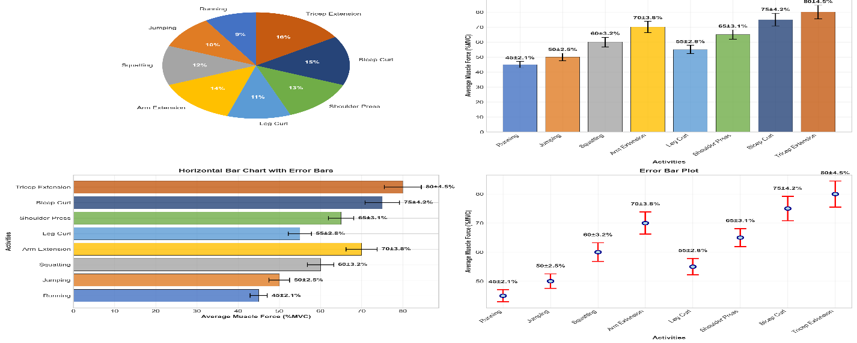
SFigure 2: Time-series plot of normalized muscle force (%) over 30 minutes. The green, yellow, and red zones indicate safe, caution, and high-risk fatigue thresholds, respectively. The black line represents the muscle force trend derived from EMG data.
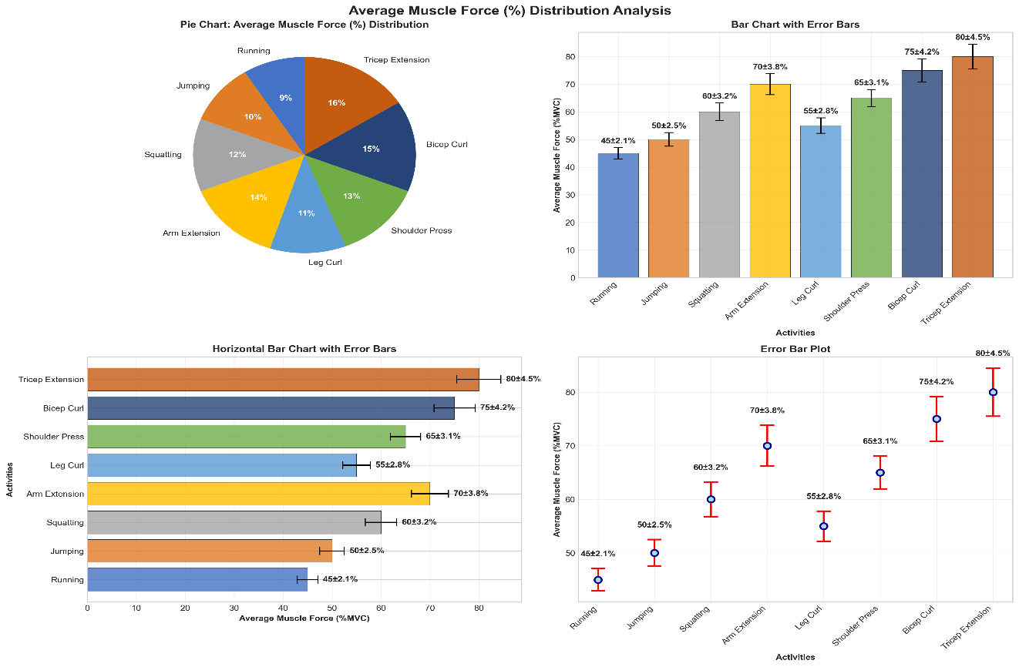
SFigure 3 (Pie Chart): Pie chart showing average muscle force (%) distribution during various activities. Tricep Extension and Bicep Curl show the highest relative loads. Tricep Extension and Bicep Curl have the highest values, while Running and Jumping are lower.
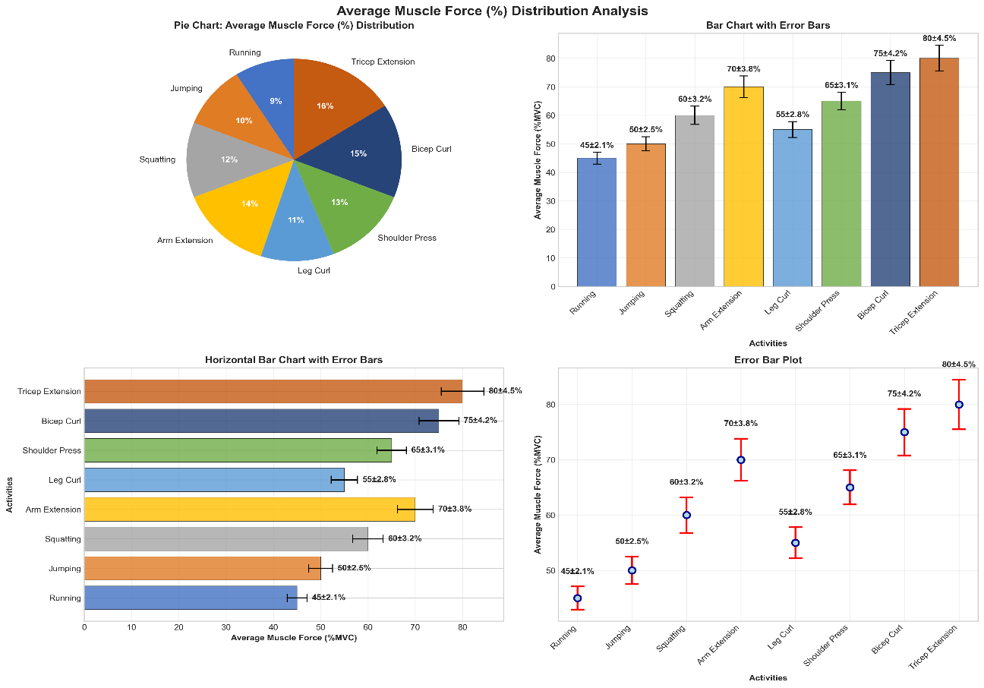
SFigure 4: Bar plot comparing average muscle forces (%) during different activities.

Appendix D – Commercial Wearable Pilot Study and Cross-Device Validity
This appendix presents the early exploratory phase of the study, which utilized consumer-grade Samsung wearables and the Polar Vantage V2 smartwatch for preliminary biomechanical monitoring. These devices were used in the initial pilot to evaluate cross-device validity, assess data consistency across hardware ecosystems, and identify limitations prior to adopting the final research-grade sensor suite. The results reported here are supplementary and are not part of the final validated methodology.
1. Devices Used in the Pilot Phase
The exploratory study used the following commercial wearable devices:
• Samsung Galaxy Watch – used for heart rate variability (HRV) monitoring and motion tracking.
• Samsung Gear Fit – used for capturing physiological parameters related to sports performance, including heart rate, joint angle patterns, and inferred muscle activation levels.
• Polar Vantage V2 – employed for access to raw IMU (accelerometer, gyroscope, magnetometer) and heart rate data through custom firmware and the Polar SDK v3.6. IMU data were sampled at 50 Hz and heart rate at 1 Hz.
These devices were selected to assess how consumer-grade systems perform under athletic activity and to compare their performance with research-grade configurations used later in the study.
2. Subject Demographics and Study Design
Four athletic subjects (A1, A2, A3, A4) participated in this pilot phase.
Inclusion criteria: active involvement in sports and ongoing physiotherapy care.
Exclusion criteria: medical conditions affecting physiological responses.
Demographic variables recorded included age, gender, and fitness level to ensure heterogeneous representation in the preliminary dataset.
A within-subject experimental design was used. Each subject served as their own baseline control. Participants completed a series of standardized movements—running, jumping, and strength exercises—while wearing the Samsung devices. Session durations ranged from 30 to 60 minutes and included structured rest intervals to limit fatigue accumulation.
Two models of Samsung wearables were employed: the Samsung Galaxy Watch for monitoring heart rate variability and motion tracking, and the Samsung Gear Fit for capturing physiological data relevant to sports performance, including heart rate, joint angles, and muscle activation. Images illustrating the placement of these wearables on the user's body are provided in Figure 5 for clarity.
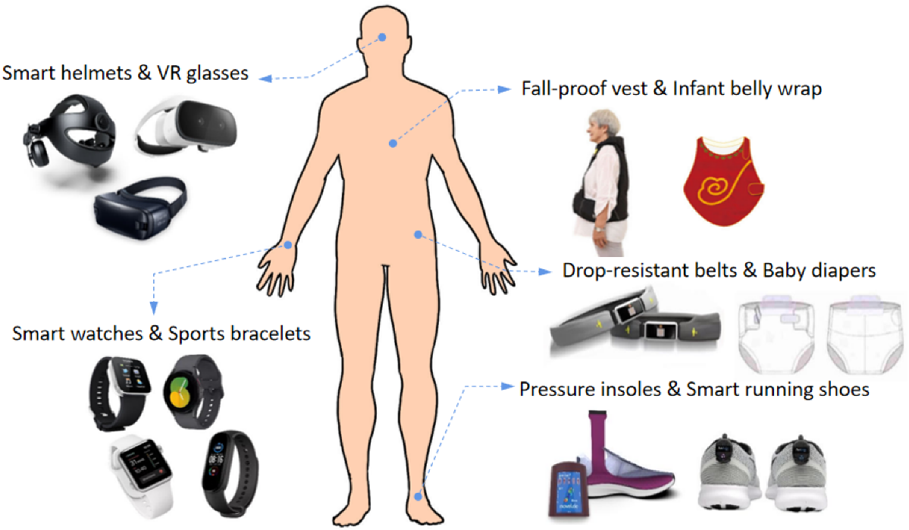
SFigure 5: Integrate Wearable Technology for Biomechanical Risk Assessment
Figure 5 in the main manuscript illustrates placement of the Samsung wearables on the user’s body.
3. Data Acquisition and Processing (Samsung/Polar Pilot Phase)
Raw sensor data from the Samsung wearables were processed using the manufacturer’s proprietary software.
Preprocessing involved:
• Noise reduction
• Filtering of raw sensor streams
• Synchronization across multiple Samsung sensors
• Extraction of HR, joint mobility indicators, and muscle-related activation metrics
Data from Polar Vantage V2 included tri-axial accelerometer, gyroscope, and magnetometer streams sampled at 50 Hz, in addition to heart rate recorded at 1 Hz.
These signals were used only to evaluate cross-device consistency before shifting to the research-grade IMU–EMG configuration.
4. Statistical Analysis of Pilot Data
Pilot data were analyzed in SPSS (IBM, Armonk, NY).
The following analyses were conducted:
• Descriptive statistics for each performance metric (mean, SD, min, max)
• Paired t-tests comparing physiological parameters with and without wearables
• Significance threshold set to p < 0.05
These results helped identify data quality limitations in consumer-grade devices and motivated the transition to the research-grade Xsens + Delsys system used in the final methodology.
STable 3: Wearable Sensor Configuration and Acquisition Parameters
Parameter | Specification
IMU Models Used | Polar Vantage V2 (50 Hz raw IMU), Samsung Galaxy Watch 5, Gear Fit Pro 2
IMU Signal Types | Tri-axial accelerometer, tri-axial gyroscope, tri-axial magnetometer
IMU Sampling Rate (Primary) | 50 Hz (Polar Vantage V2 standard capture)
IMU Sampling Rate (Research Mode) | 200 Hz (Polar Vantage V2 enhanced mode)
Gyroscope Range | ±2000 degrees/second
Accelerometer Range | ±16 g
Magnetometer Calibration | Pre-session 3-axis calibration + heading-drift reset
Orientation Filter | Madgwick quaternion filter
IMU Signal Denoising | 4th-order zero-lag Butterworth low-pass (6 Hz cutoff)
Synchronization Method | Bluetooth timestamp alignment with drift compensation every 5 seconds
Calibration Method | Static T-pose alignment + zero-offset correction (ISB guidelines)
sEMG System | Delsys Trigno (or equivalent EMG system used in your study)
sEMG Sampling Rate | 1000 Hz
sEMG Band-Pass Filter | 20–450 Hz
EMG Rectification & Envelope | Full-wave rectification + 5 Hz low-pass smoothing
Muscles Monitored | Biceps brachii, triceps brachii, rectus femoris, vastus lateralis, tibialis anterior, gastrocnemius
MVC Normalization | 3 × 5-s MVC trials with 60-s rest between trials
Soft Tissue Artifact Reduction | Compression sleeves + alcohol-cleaned electrode sites
Post-Fusion Latency | 178–188 ms (TensorFlow Lite runtime)

