Supplementary Figure S1. Sex and Age Independency of the fMRI results: Changed vs Same Pre-Choice periods contrast
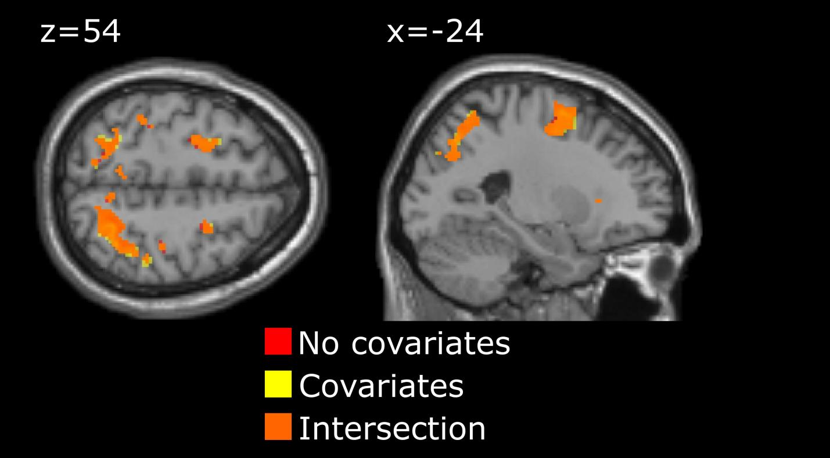
T-test maps of changed vs same segment pre-choice periods contrast without (dark red) and with (yellow) additional covariates of no interest (sex and z-transformed age). Orange – intersection of the maps. p=0.001 unc., k>5.

Supplementary Table S2. Changed vs Same Pre-Choice periods, common activation in contrasts without and with additional covariates of no interest: sex and z-transformed age
# K Peak MNI Peak T
1 392 -32 -76 24 5.0
2 346 30 -58 58 6.1
3 234 -24 -4 50 5.3
4 204 -38 -40 40 5.4
p=0.001 unc., cluster # corresponds to that of the Table 1 in the main manuscript.
Supplementary Figure S3. Sex and Age Independency of the fMRI results: Early vs Late ball movement periods
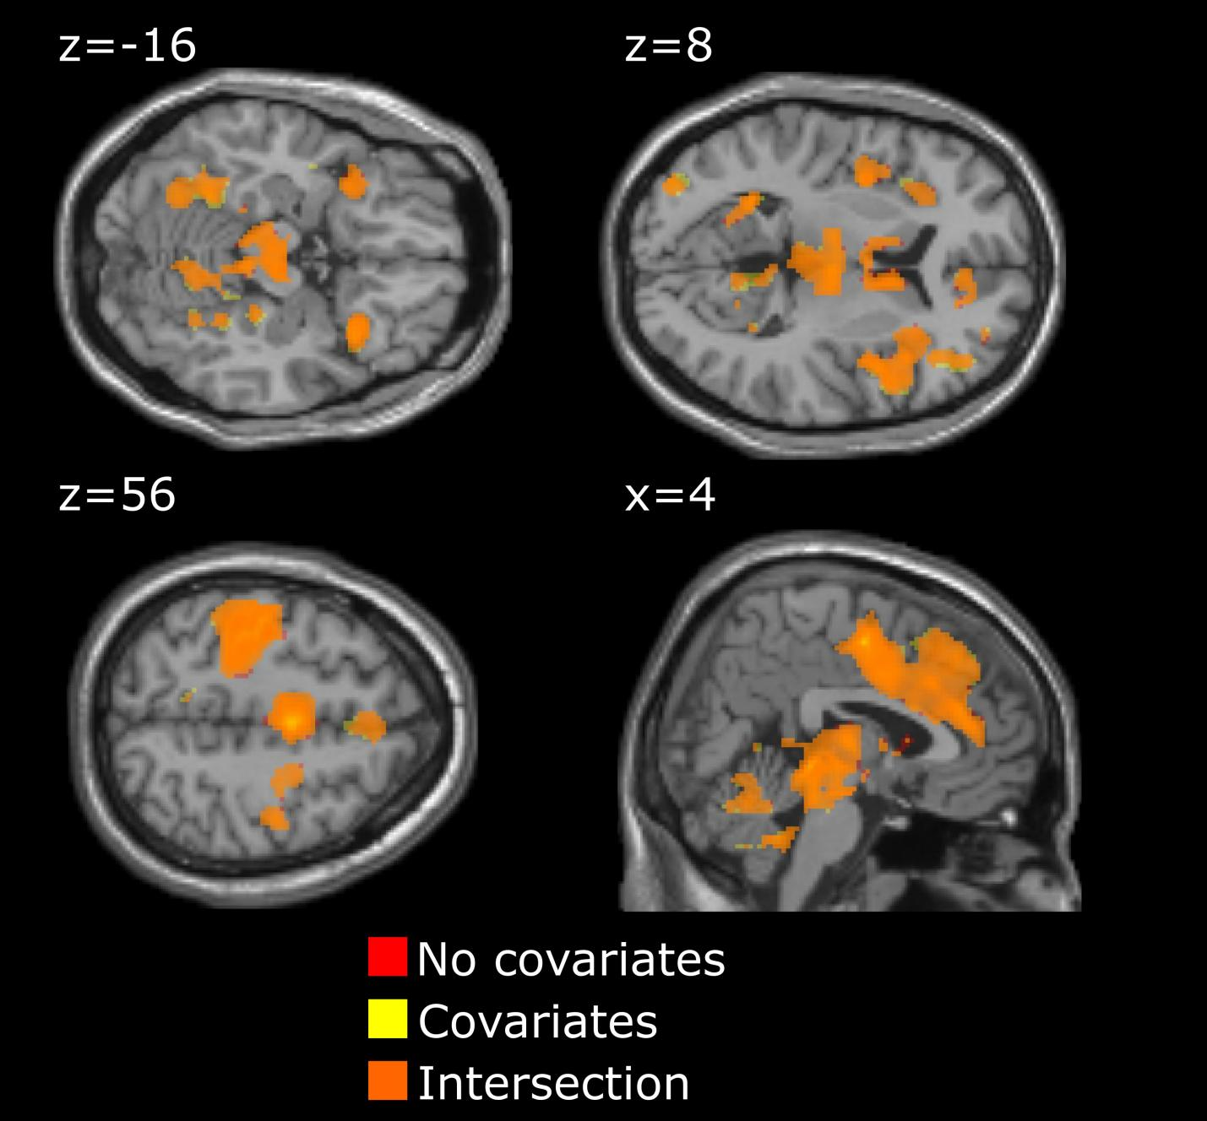
T-test maps of late vs early ball movement contrast without (dark red) and with (yellow) additional covariates of no interest (sex and z-transformed age). Orange – intersection of the maps. p=0.001 unc., k>5.

Supplementary Table S4. Early vs Late periods of the ball movement, common activation in contrasts without and with additional covariates of no interest: sex and z-transformed age
# K Peak MNI Peak T
Positive contrast
1 7097 2 -6 52 11.5
2 5231 6 -32 -6 9.7
3 4350 36 20 -6 9.4
4 1307 -32 22 -2 7.5
Negative contrast
1 335 -20 10 12 5.4
2 212 14 -86 -10 6.5
3 165 26 10 2 5.9

p=0.001 unc., cluster # corresponds to that of the Table 1 in the main manuscript.
Supplementary Figure S5. Sex and Age Independency of the fMRI results: Positive vs Negative feedback
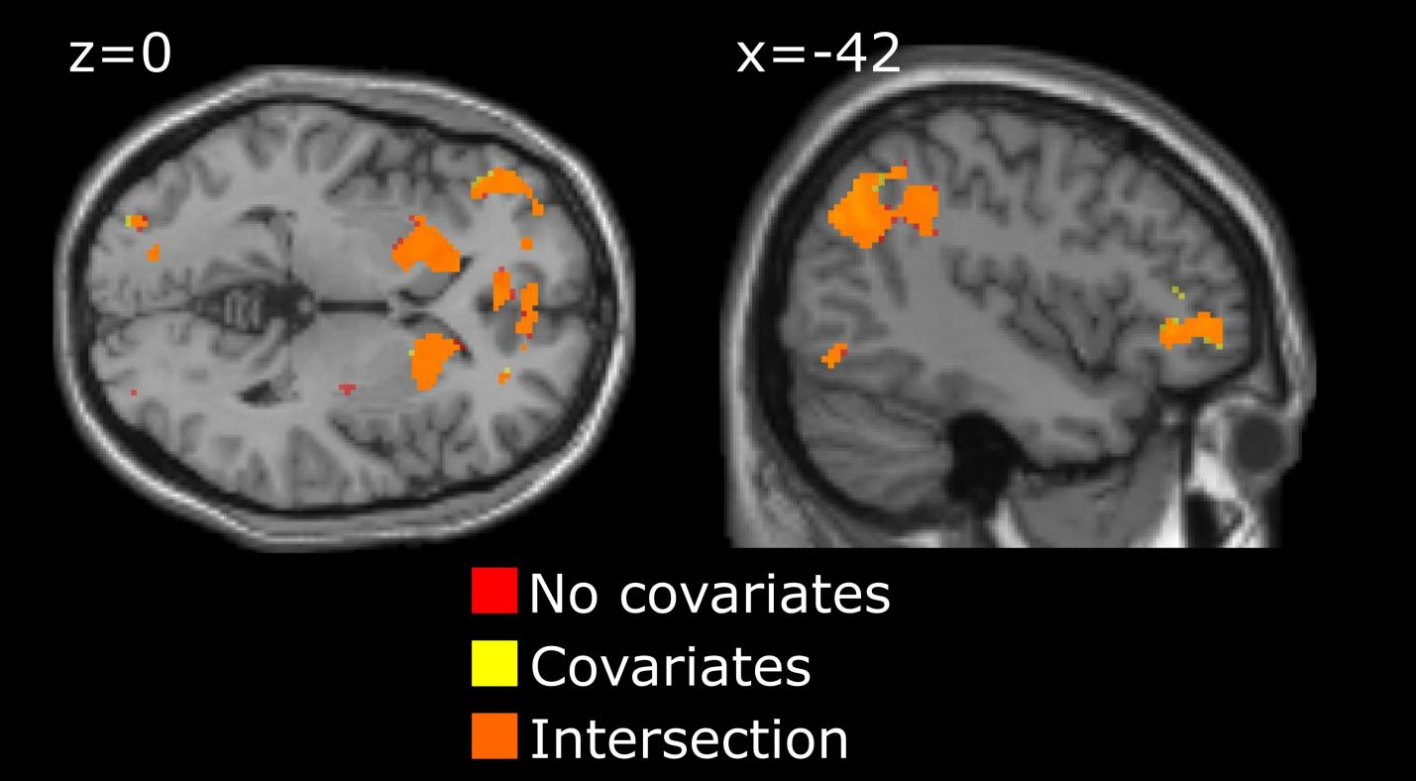
T-test maps of positive vs negative feedback contrast without (dark red) and with (yellow) additional covariates of no interest (sex and z-transformed age). Orange – intersection of the maps. p=0.001 unc., k>5.

Supplementary Table S6. Positive vs negative feedback, common activation in contrasts without and with additional covariates of no interest: sex and z-transformed age
# K Peak MNI Peak T
1 938 -44 -64 34 5.8
2 754 -18 10 -4 6.7
3 430 0 54 4 5.3
4 471 20 16 -6 6.8
5 278 -18 38 44 5.8
6 159 -4 6 26 5.4
7 185 -48 42 0 5.1
8 165 40 -72 -12 5.1

p=0.001 unc., cluster # corresponds to that of the Table 2 in the main manuscript.
Supplementary Figure S7. Sex and Age Independency of the fMRI results: Regression, Positive vs Negative feedback × z-transformed Exploration index
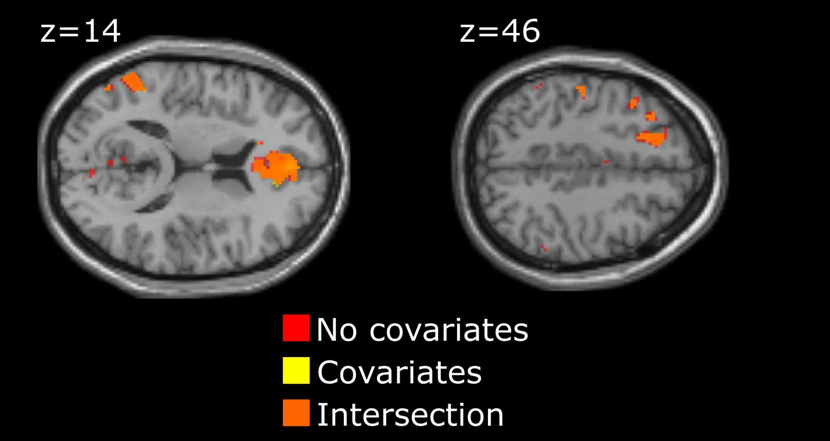
Multiple regression without (dark red) and with (yellow) additional covariates of no interest (sex and z-transformed age). Orange – intersection of the maps. p=0.001 unc., k>50.

Supplementary Table S8. Regression analysis results, common effects without and with additional covariates of no interest: sex and z-transformed age
# K Peak MNI Peak T
1 630 -2 48 10 6.7
2 196 -58 -56 18 6.9
3 120 -16 28 44 5.1

p=0.001 unc., cluster # corresponds to that of the Table 3 in the main manuscript.

Supplementary Figure S9. Intersection of the Positive vs Negative feedback t-contrast and Regression results
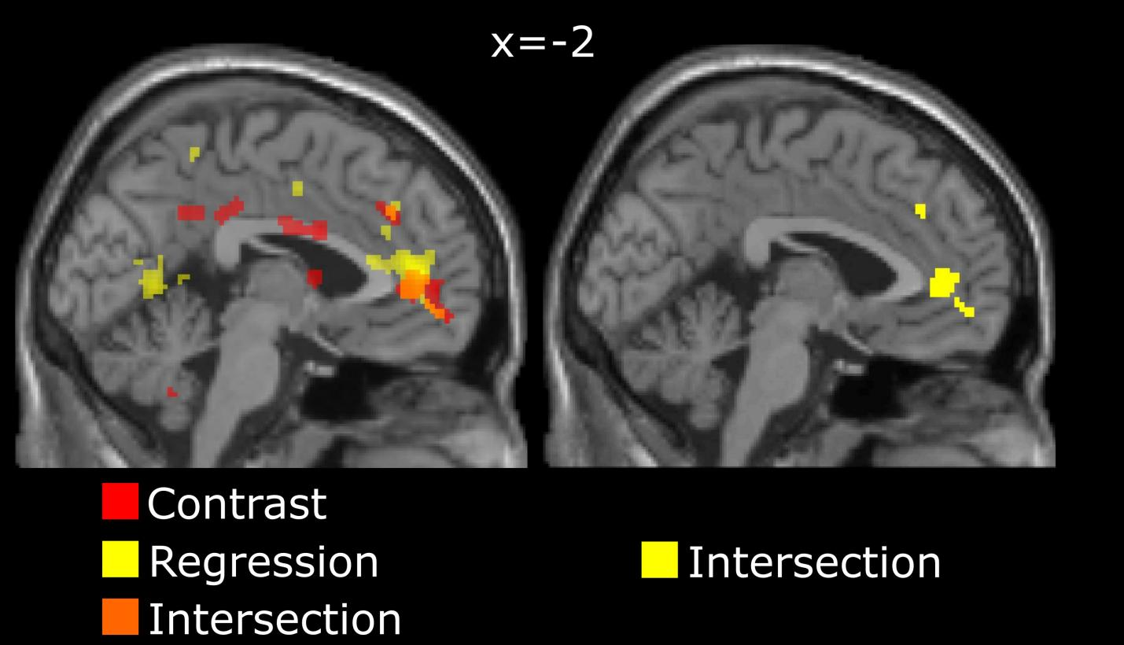
Left panel – Positive vs Negative feedback contrast (yellow), Multiple regression results (dark red), intersection – orange; Right panel – intersection area alone. p=0.001 unc., k>5.

Supplementary Table S10. Intersection of the Positive vs Negative feedback t-contrast and Regression analysis results
# K Peak MNI Peak T
1 111 -2 48 8 6.6
2 - - -
3a 61 -18 36 44 5.0
3b 2 -34 28 46 3.7

p=0.001 unc., cluster # corresponds to that of the Table 3 in the main manuscript.

Supplementary Example of EI Calculation S11.
To illustrate the calculation of the Exploration Index (EI), we simulated two hypothetical participants performing 15 rounds of the task under identical initial conditions. Both start by choosing sector 1 for the first five rounds and achieve five successful outcomes. During rounds 6–10, both switch to sector 3, whose empirical success rate remains below 0.75; therefore, the benchmark (optimal) choice remains sector 1 for both participants.
From round 11 onward, their strategies diverge.
- Participant 1 adjusts by moving to sector 2 in round 13, after which the optimal expected return shifts accordingly.
- Participant 2 continues selecting sector 3 through the remaining rounds.

n | 1 | 2 | 3 | 4 | 5 | 6 | 7 | 8 | 9 | 10 | 11 | 12 | 13 | 14 | 15 | $$\text{E}\left(\text{∙}\right)$$
m | 1 | 1 | 1 | 1 | 1 | 3 | 3 | 3 | 3 | 3 | 2 | 2 | 2 | 2 | 2 | 2
outcome | 1 | 1 | 1 | 1 | 1 | 0 | 0 | 0 | 1 | 0 | 0 | 1 | 1 | 1 | 1 | 0.67
$${\text{C}}_{\text{k}}^{\text{∗}}$$ | 1 | 1 | 1 | 1 | 1 | 1 | 1 | 1 | 1 | 1 | 1 | 1 | 1 | 2 | 2 | 1.13
$${\text{P}}_{\text{opt}}$$ | 1 | 1 | 1 | 1 | 1 | 1 | 1 | 1 | 1 | 1 | 1 | 1 | 1.3 | 1.5 | 1.6 | 1.09
gain | 1 | 1 | 1 | 1 | 1 | 0 | 0 | 0 | 3 | 0 | 0 | 2 | 2 | 2 | 2 | 1.07
Table 1 Participant 1

n | 1 | 2 | 3 | 4 | 5 | 6 | 7 | 8 | 9 | 10 | 11 | 12 | 13 | 14 | 15 | $$\text{E}\left(\text{∙}\right)$$
m | 1 | 1 | 1 | 1 | 1 | 3 | 3 | 3 | 3 | 3 | 3 | 3 | 3 | 3 | 3 | 2.3
outcome | 1 | 1 | 1 | 1 | 1 | 0 | 0 | 0 | 1 | 0 | 0 | 0 | 1 | 0 | 0 | 0.47
$${\text{C}}_{\text{k}}^{\text{∗}}$$ | 1 | 1 | 1 | 1 | 1 | 1 | 1 | 1 | 1 | 1 | 1 | 1 | 1 | 2 | 2 | 1.13
$${\text{P}}_{\text{opt}}$$ | 1 | 1 | 1 | 1 | 1 | 1 | 1 | 1 | 1 | 1 | 1 | 1 | 1 | 1 | 1 | 1
gain | 1 | 1 | 1 | 1 | 1 | 0 | 0 | 0 | 3 | 0 | 0 | 0 | 3 | 0 | 0 | 0.73
Table 2 Participant 2
For Participant 1, the final ratio $\text{EI}\text{=}\frac{\text{1.07}}{\text{1.10}}\text{=0.97}$,
while for Participant 2, $\text{EI}\text{=}\frac{\text{0.73}}{\text{1.00}}\text{=0.73}$.

This example demonstrates that Participant 2, who persisted longer in an exploratory (suboptimal) strategy, achieved a substantially lower EI, indicating inefficient adaptation. Participant 1, by contrast, adjusted strategy earlier and maintained performance closer to the optimal benchmark.

