Supplementary Table S1. Sociodemographic characteristics of the study sample (N = 687)
Variable |  | N | %
Gender | Male | 344 | 50.1
Gender | Female | 343 | 49.9
Age  (M=25.8) | Early 20s (19–23) | 137 | 19.9
Age  (M=25.8) | Mid-20s (24–26) | 241 | 35.1
Age  (M=25.8) | Late 20s (27–29) | 309 | 45.0
Education State | High-school graduate | 204 | 29.7
Education State | Community College graduate | 87 | 12.7
Education State | University graduate | 355 | 51.7
Education State | Post-graduate school | 41 | 6.0
Occupational State | Office workers  /government employees | 241 | 35.1
Occupational State | Technician/Production employees | 40 | 5.8
Occupational State | Sales/Service employees | 45 | 6.6
Occupational State | Self-employed/entrepreneur | 23 | 3.3
Occupational State | Professional | 40 | 5.8
Occupational State | Agriculture/Forestry/Fishery/Livestock | 2 | 0.3
Occupational State | Student | 157 | 22.9
Occupational State | Unemployed | 128 | 18.6
Occupational State | Others | 11 | 1.6

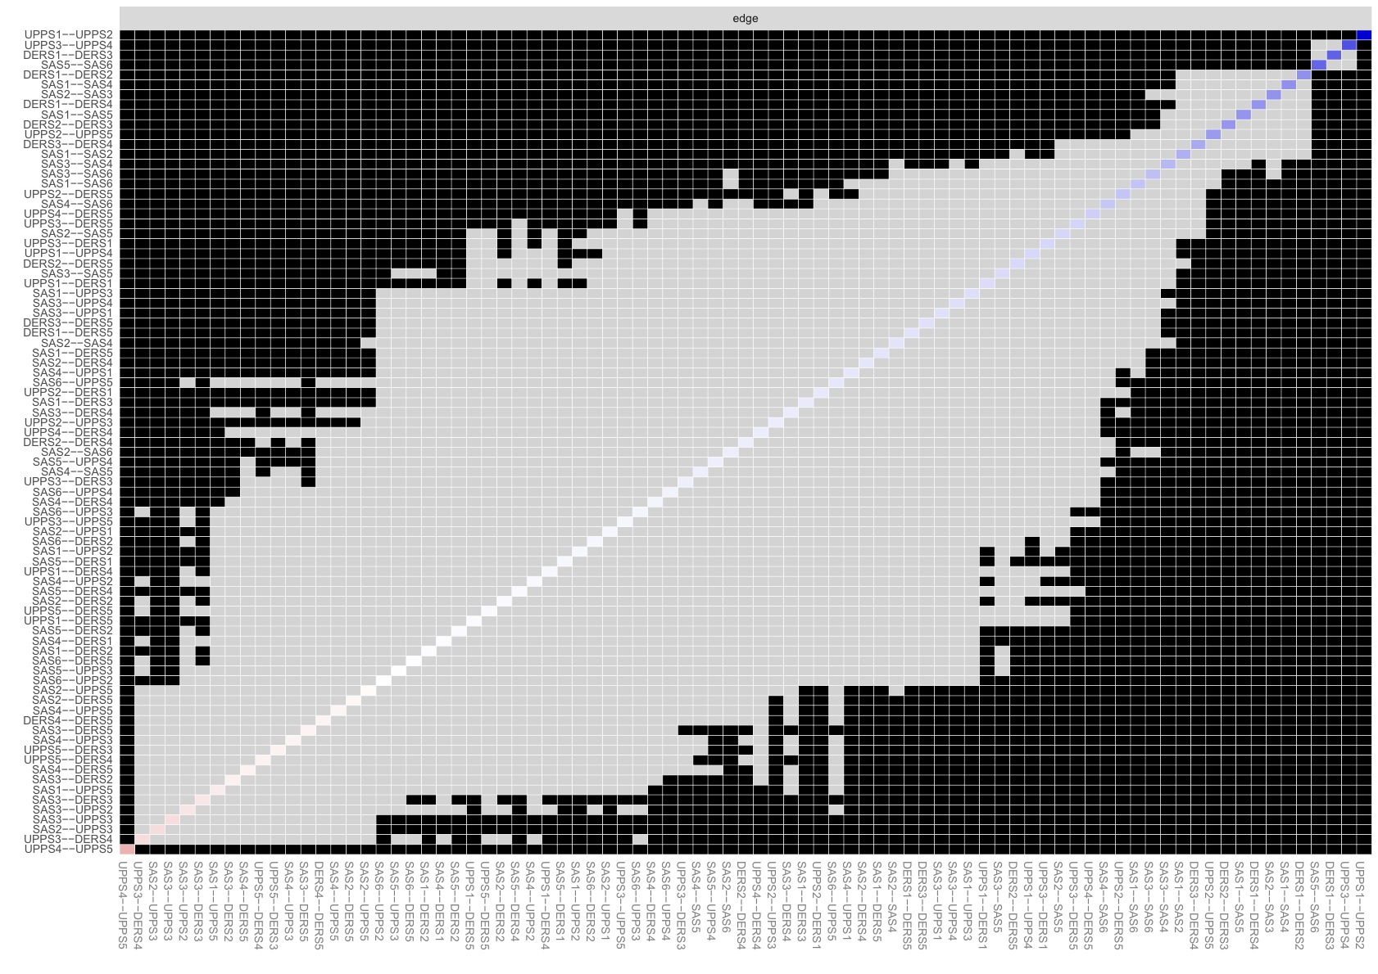
Supplementary Figure S1

Supplementary Figure S1. Edge weights difference graph in the smartphone overdependence-impulsivity-emotional dysregulation network.
Note. SAS1 = Salience; SAS2 = Mood Modification; SAS3 = Tolerance; SAS4 = Withdrawal; SAS5 = Conflict; SAS6 = Relapse; UPPS1 = Negative Urgency; UPPS2 = Positive Urgency; UPPS3 = Lack of Premeditation; UPPS4 = Lack of Perseverance; UPPS5 = Sensation Seeking; DERS1 = Impulse; DERS2 = Nonacceptance; DERS3 = Strategies; DERS4 = Goals; DERS5 = Understand. A black box indicates a significant difference in the edge weights of two nodes, while a gray box indicates no significant difference. The x and y axes of each graph represent the connected edges between nodes, and the shading of the diagonal boxes indicates the magnitude of the edge weights, with blue boxes indicating positive partial correlations and red boxes indicating negative partial correlations.

Supplementary Figure S2
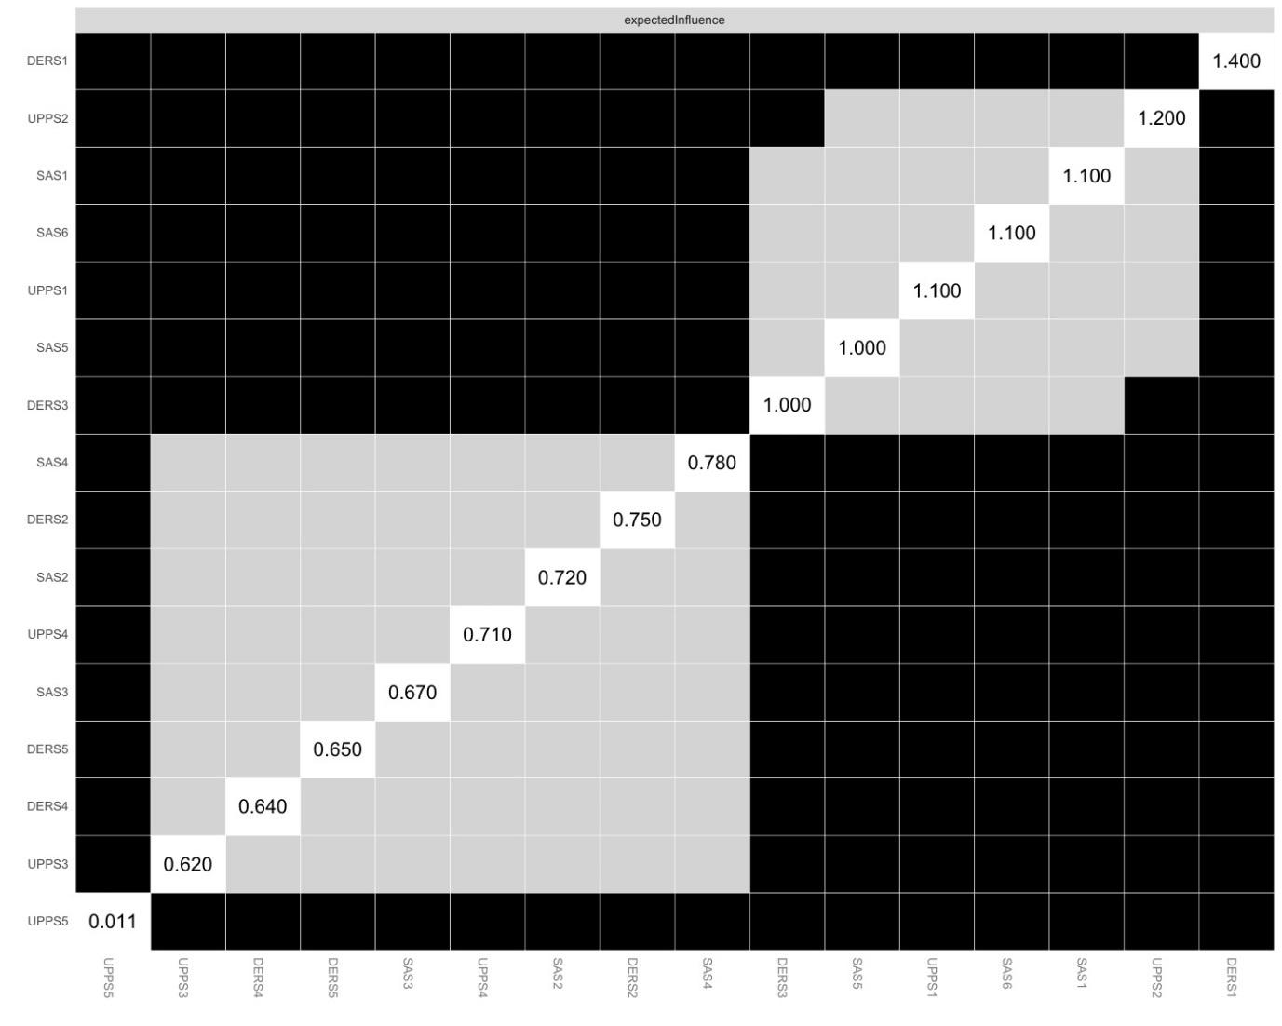
Supplementary Figure S2. Expected influence difference graph in the smartphone overdependence-impulsivity-emotional dysregulation network.
Note. SAS1 = Salience; SAS2 = Mood Modification; SAS3 = Tolerance; SAS4 = Withdrawal; SAS5 = Conflict; SAS6 = Relapse; UPPS1 = Negative Urgency; UPPS2 = Positive Urgency; UPPS3 = Lack of Premeditation; UPPS4 = Lack of Perseverance; UPPS5 = Sensation Seeking; DERS1 = Impulse; DERS2 = Nonacceptance; DERS3 = Strategies; DERS4 = Goals; DERS5 = Understand. A black box indicates a significant difference in expected influences metrices of two nodes, while a gray box indicates no significant difference. The x and y axes of each graph represent each node, and the numbers in the diagonal boxes represent the magnitude of the estimated expected influence.

