Genomic evidence of improved fertility and adaptation in Iranian domestic sheep attributed to introgression from Asiatic mouflon and Urial

Reza Khalkhali-Evrigh¹, Nemat Hedayat^{1*}, Reza Seyedsharif¹, Mirdarioush Shakouri¹, Eric N. Ponnampalam²

¹ Department of Animal Science, Faculty of Agriculture and Natural Resources, University of Mohaghegh Ardabili, Ardabil, Iran
² School of Agriculture, Food and Ecosystem Sciences, Faculty of Science, The University of Melbourne, Parkville, Victoria 3010, Australia

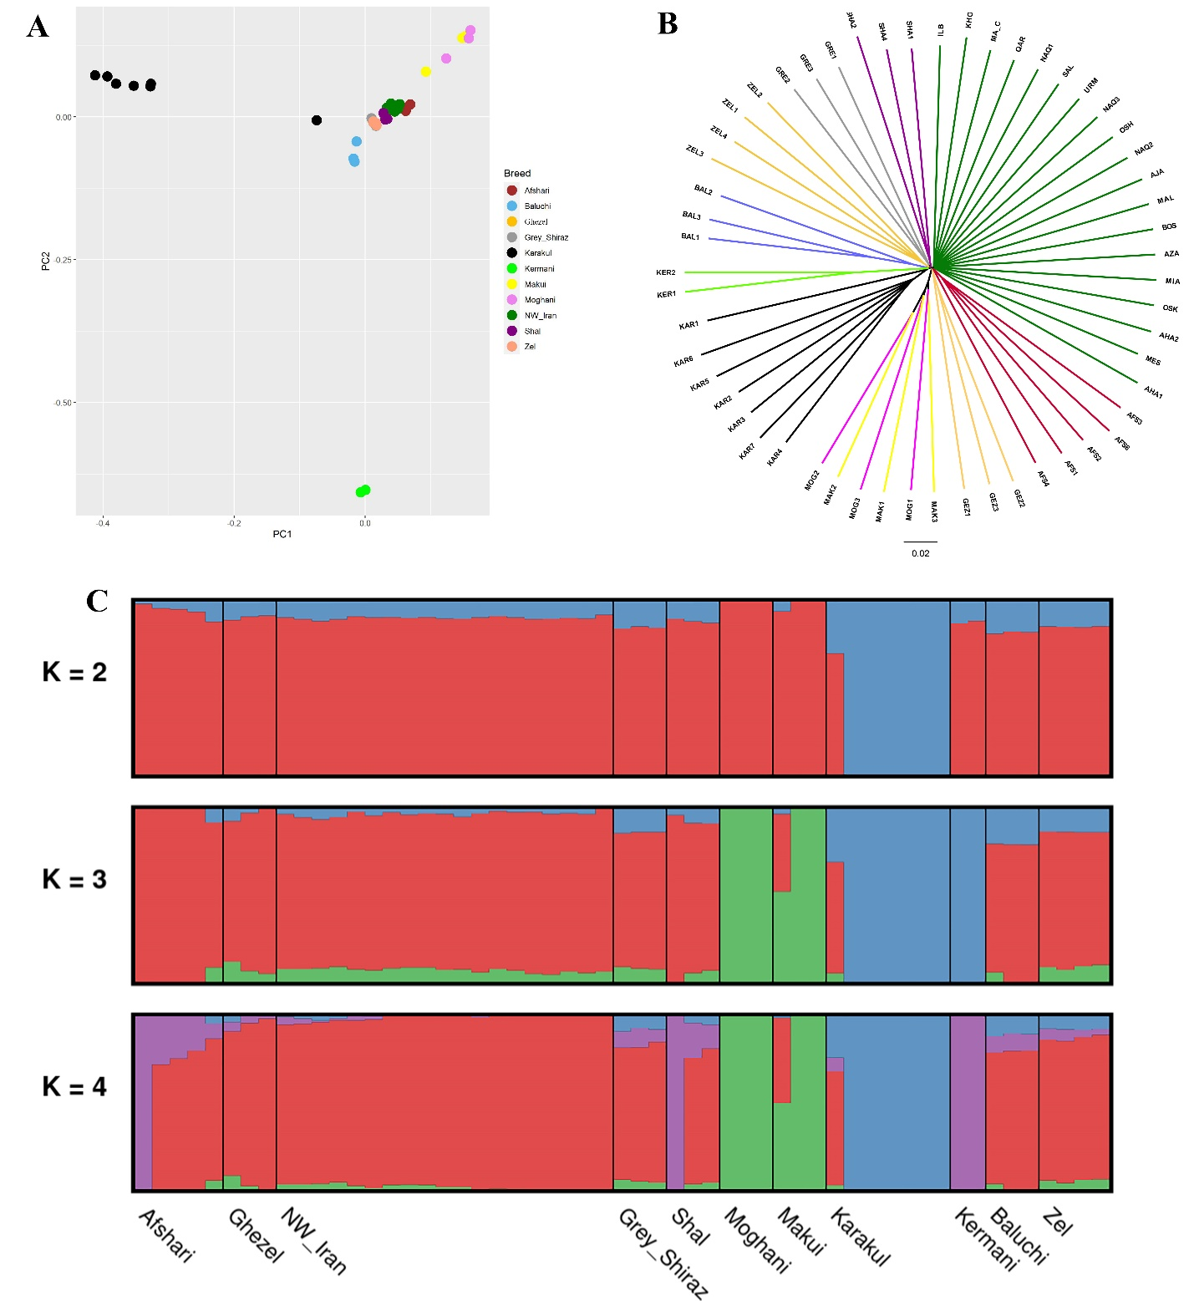
Figure S1. Population structure analysis results including PCA (A), phylogenetic tree (B) and ADMIXTURE (C) for Iranian domestic sheep breeds

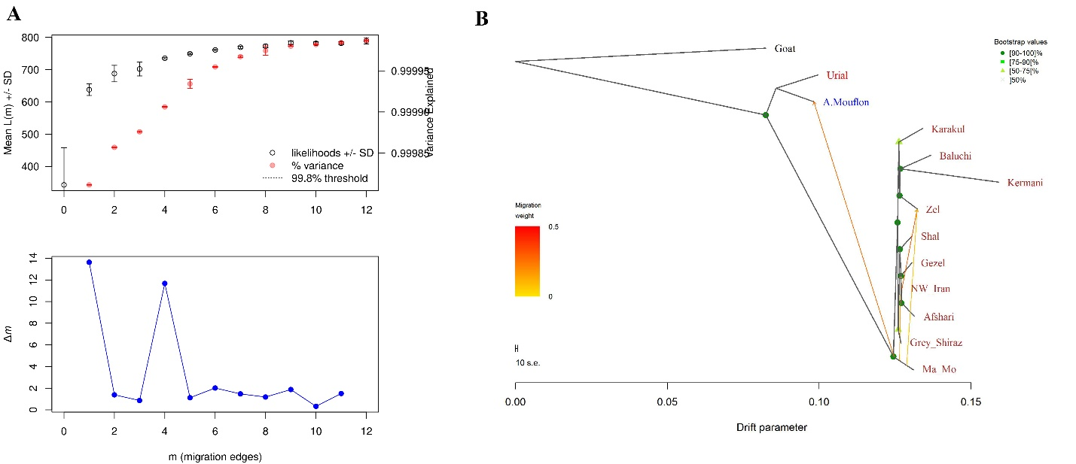
Figure S2. Estimation of the optimal number of migration edges by OptM (A) and Treemix analysis result with m = 4 (B)

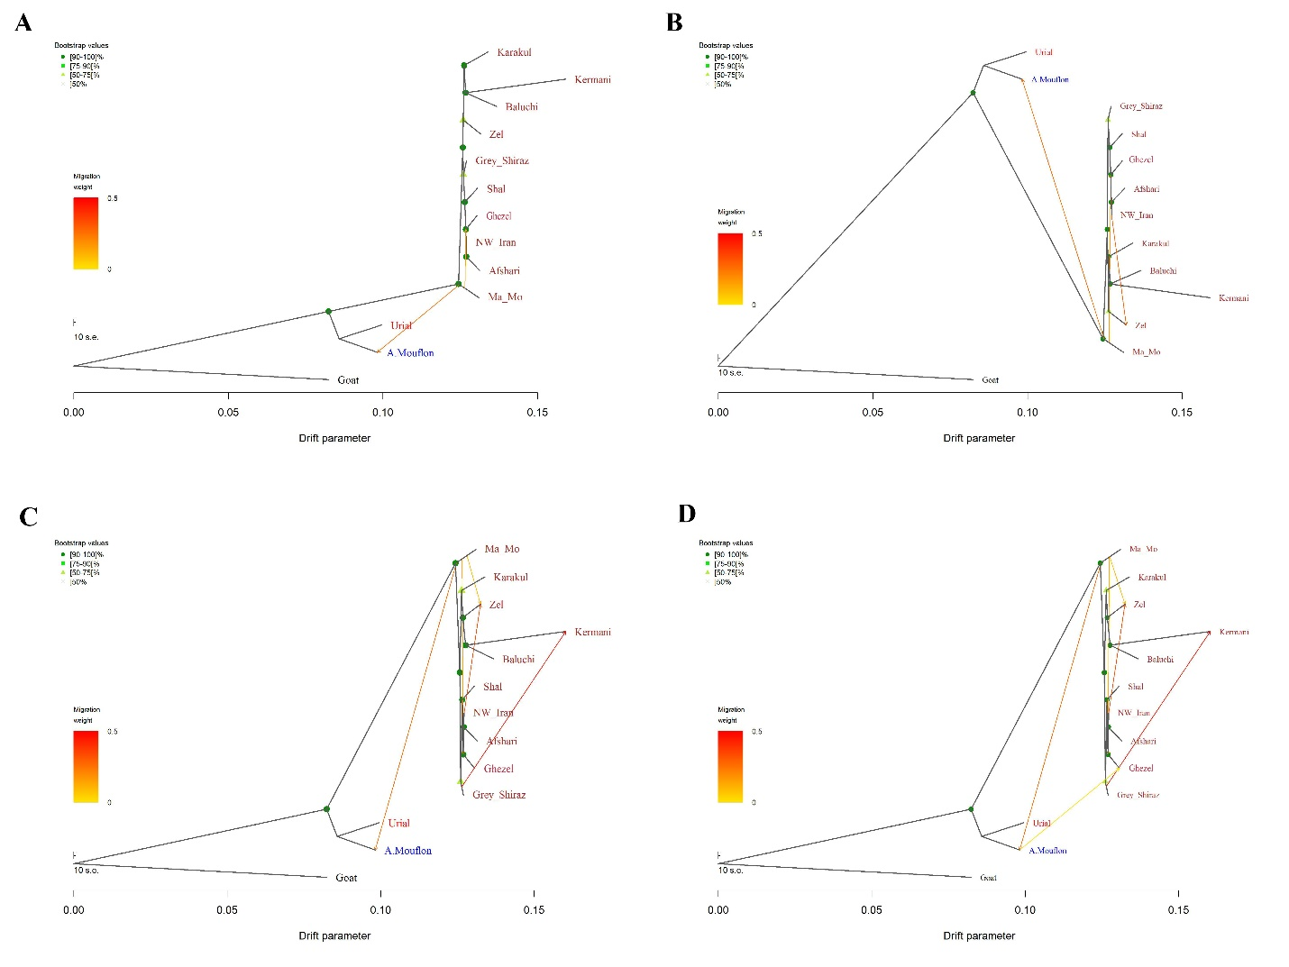
Figure S3. Treemix analysis results with m = 2 (A), m = 3 (B), m = 5 (C) and m = 6 (D)

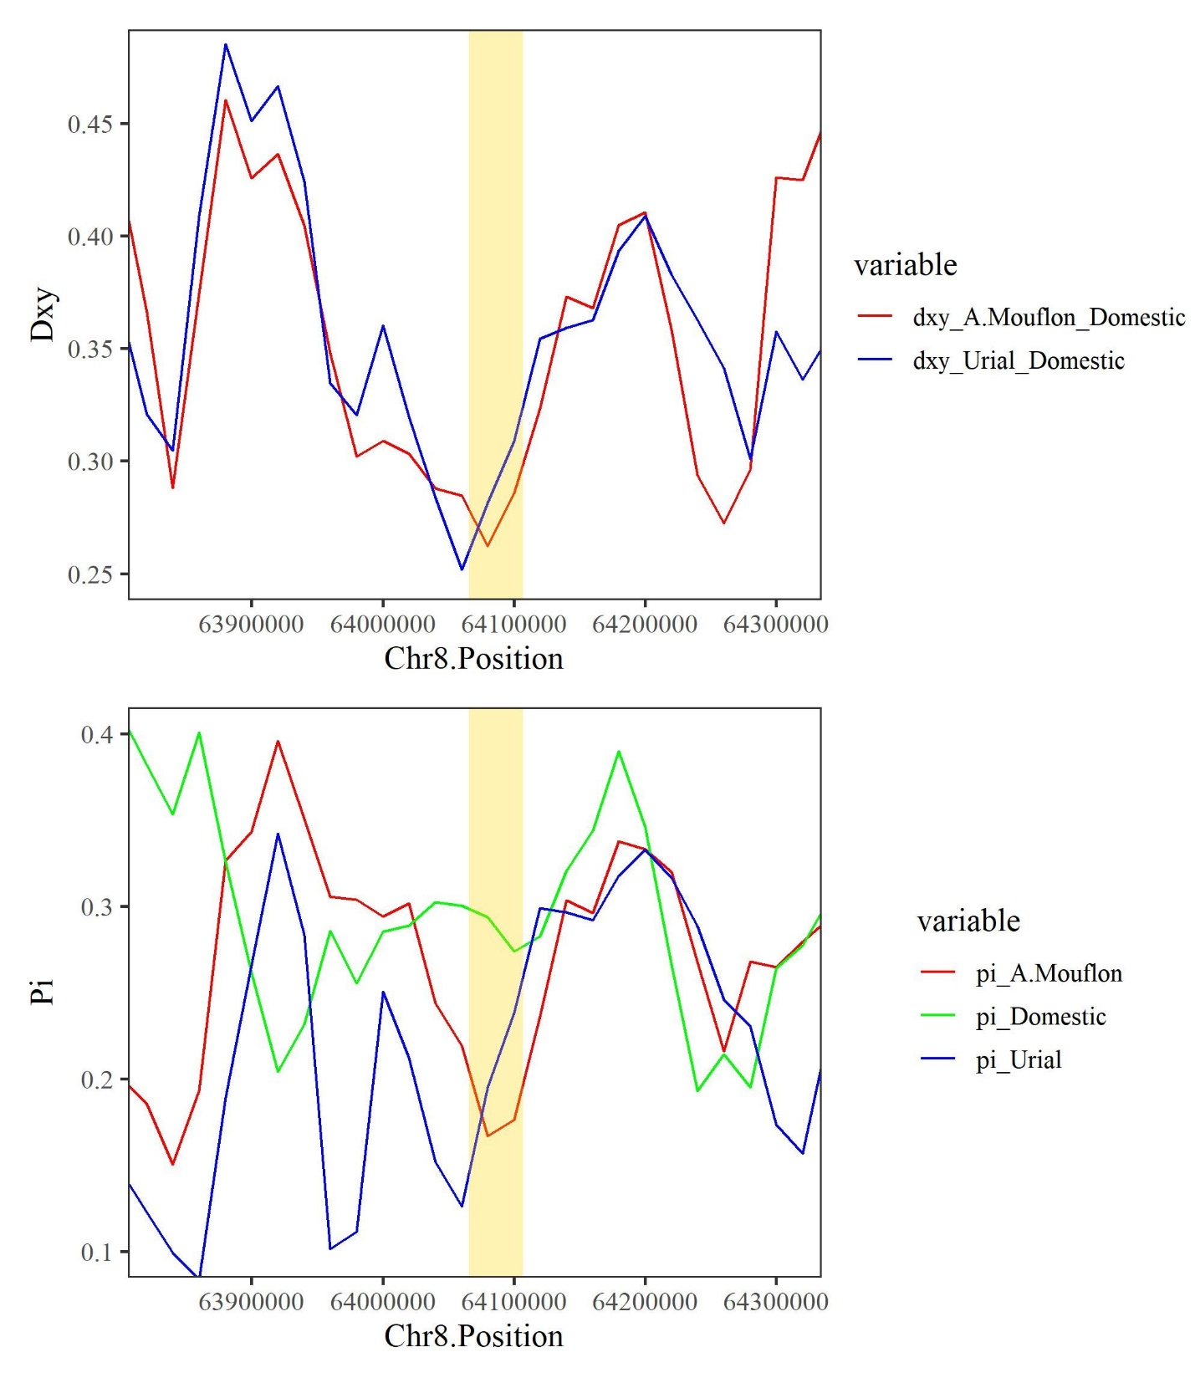
Figure S4. Dxy (top) and Pi (down) of the introgressed genomic region on chromosome 8 containing ABRACL gene in wild sheep compared to domestic sheep
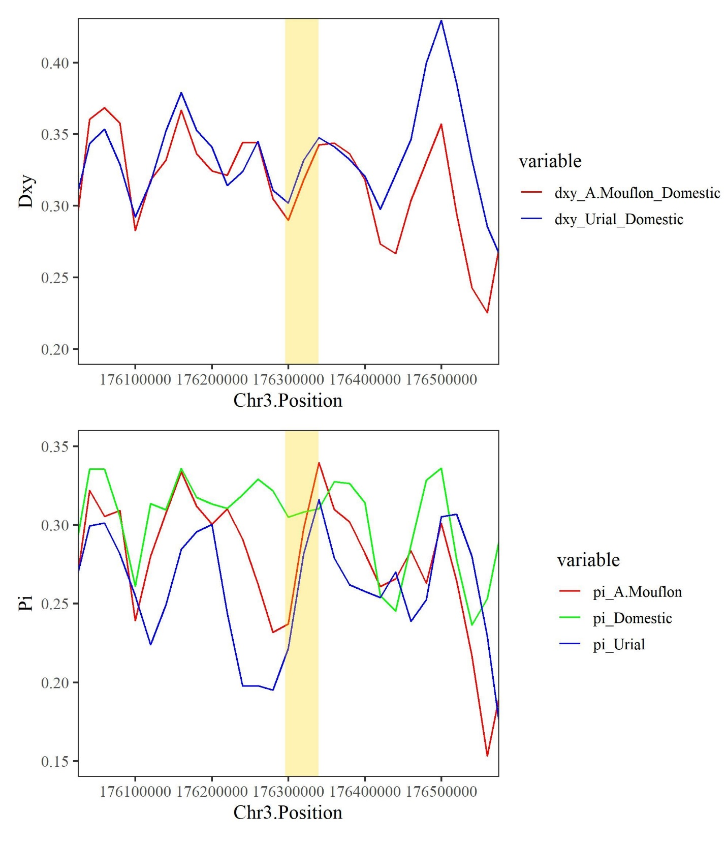
Figure S5. Dxy (top) and Pi (down) of the introgressed genomic region on chromosome 3 containing ABTB3 gene in wild sheep compared to domestic sheep
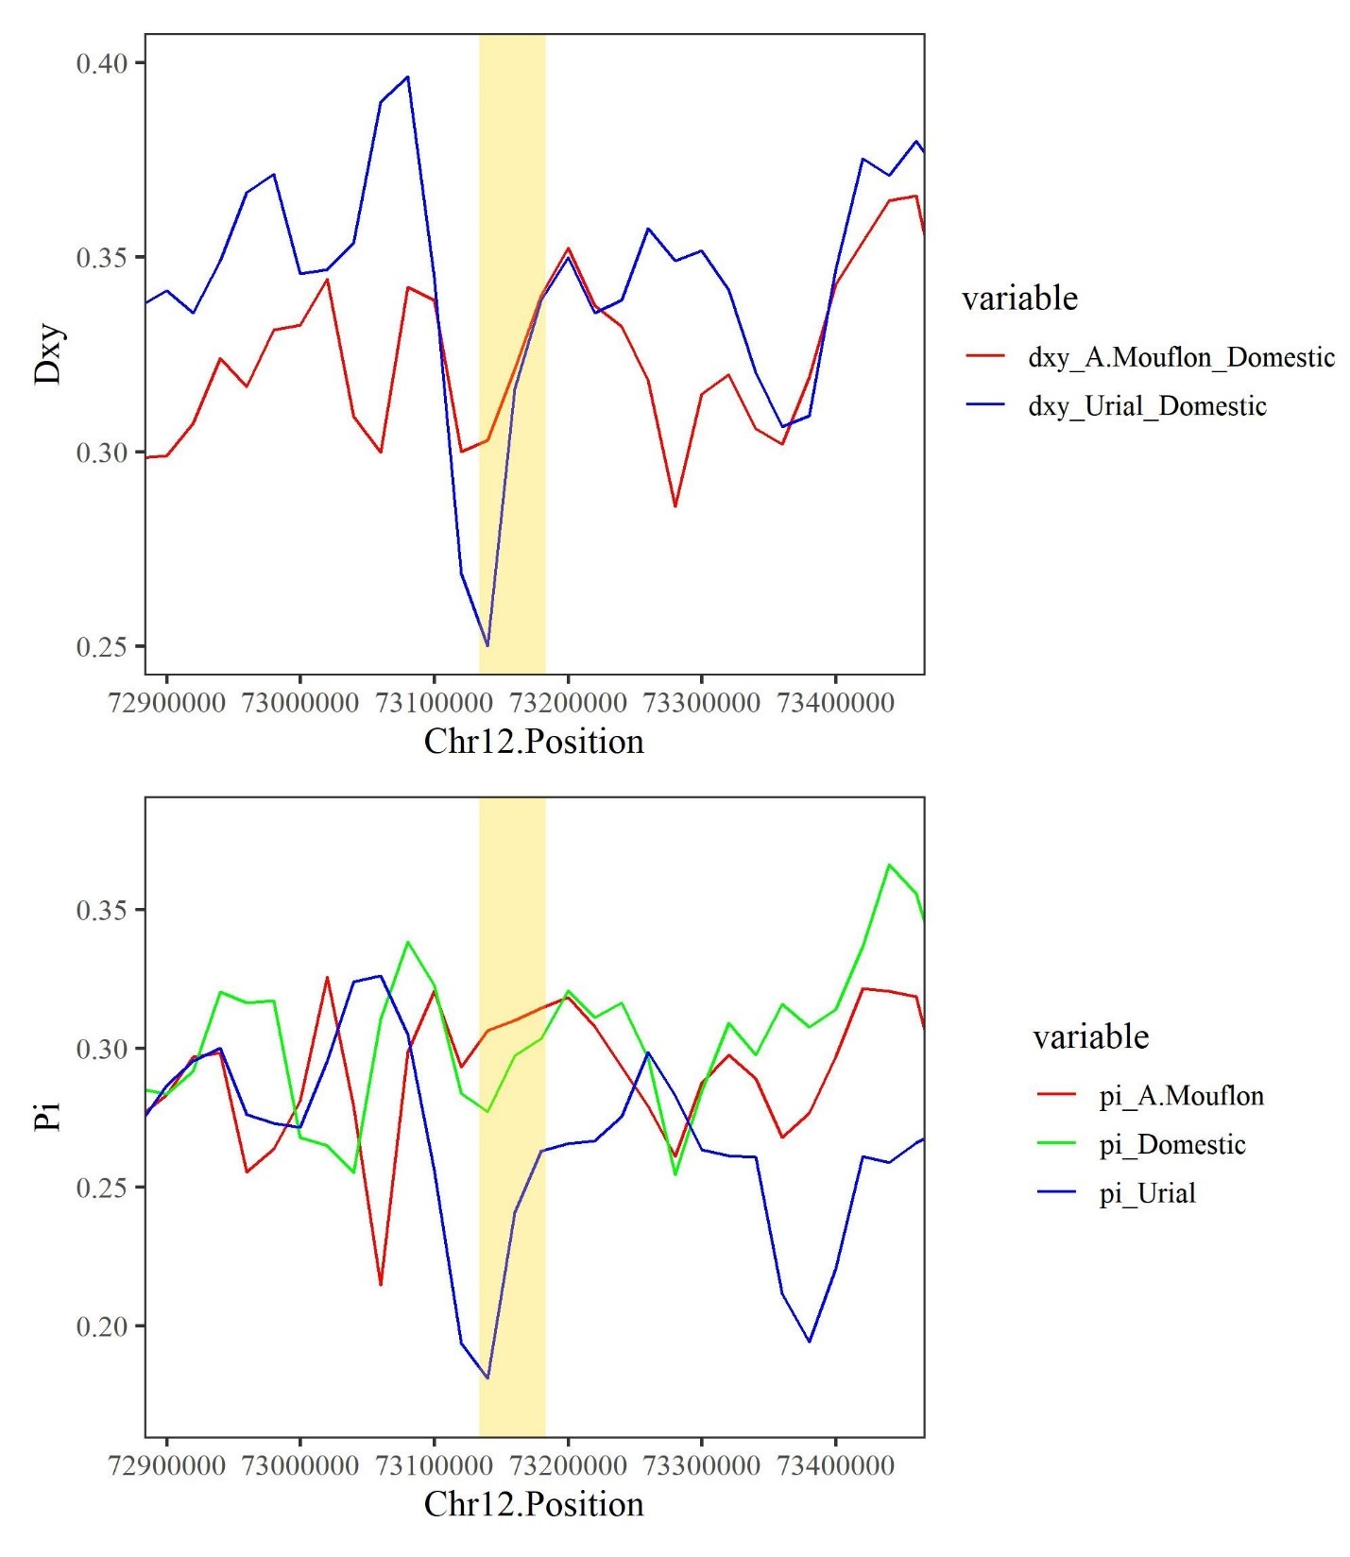
Figure S6. Dxy (top) and Pi (down) of the introgressed genomic region on chromosome 12 containing CAMK1G gene in wild sheep compared to domestic sheep
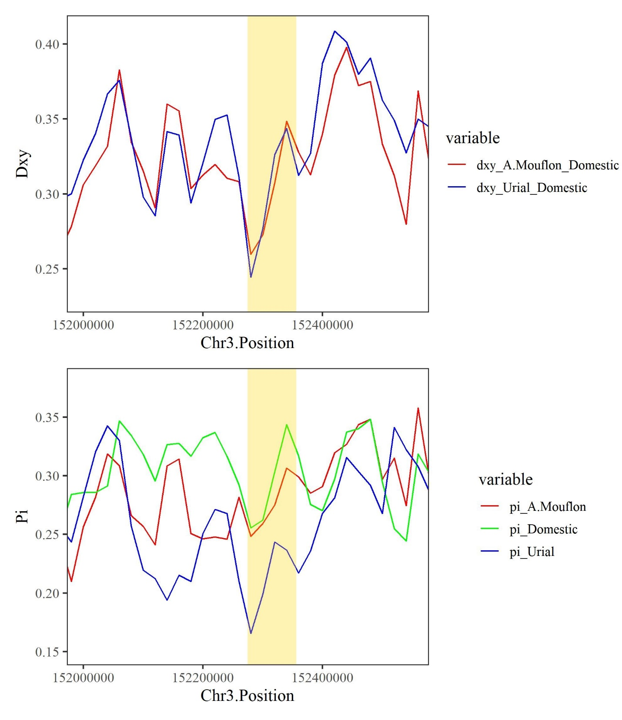
Figure S7. Dxy (top) and Pi (down) of the introgressed genomic region on chromosome 3 containing DYRK2 gene in wild sheep compared to domestic sheep
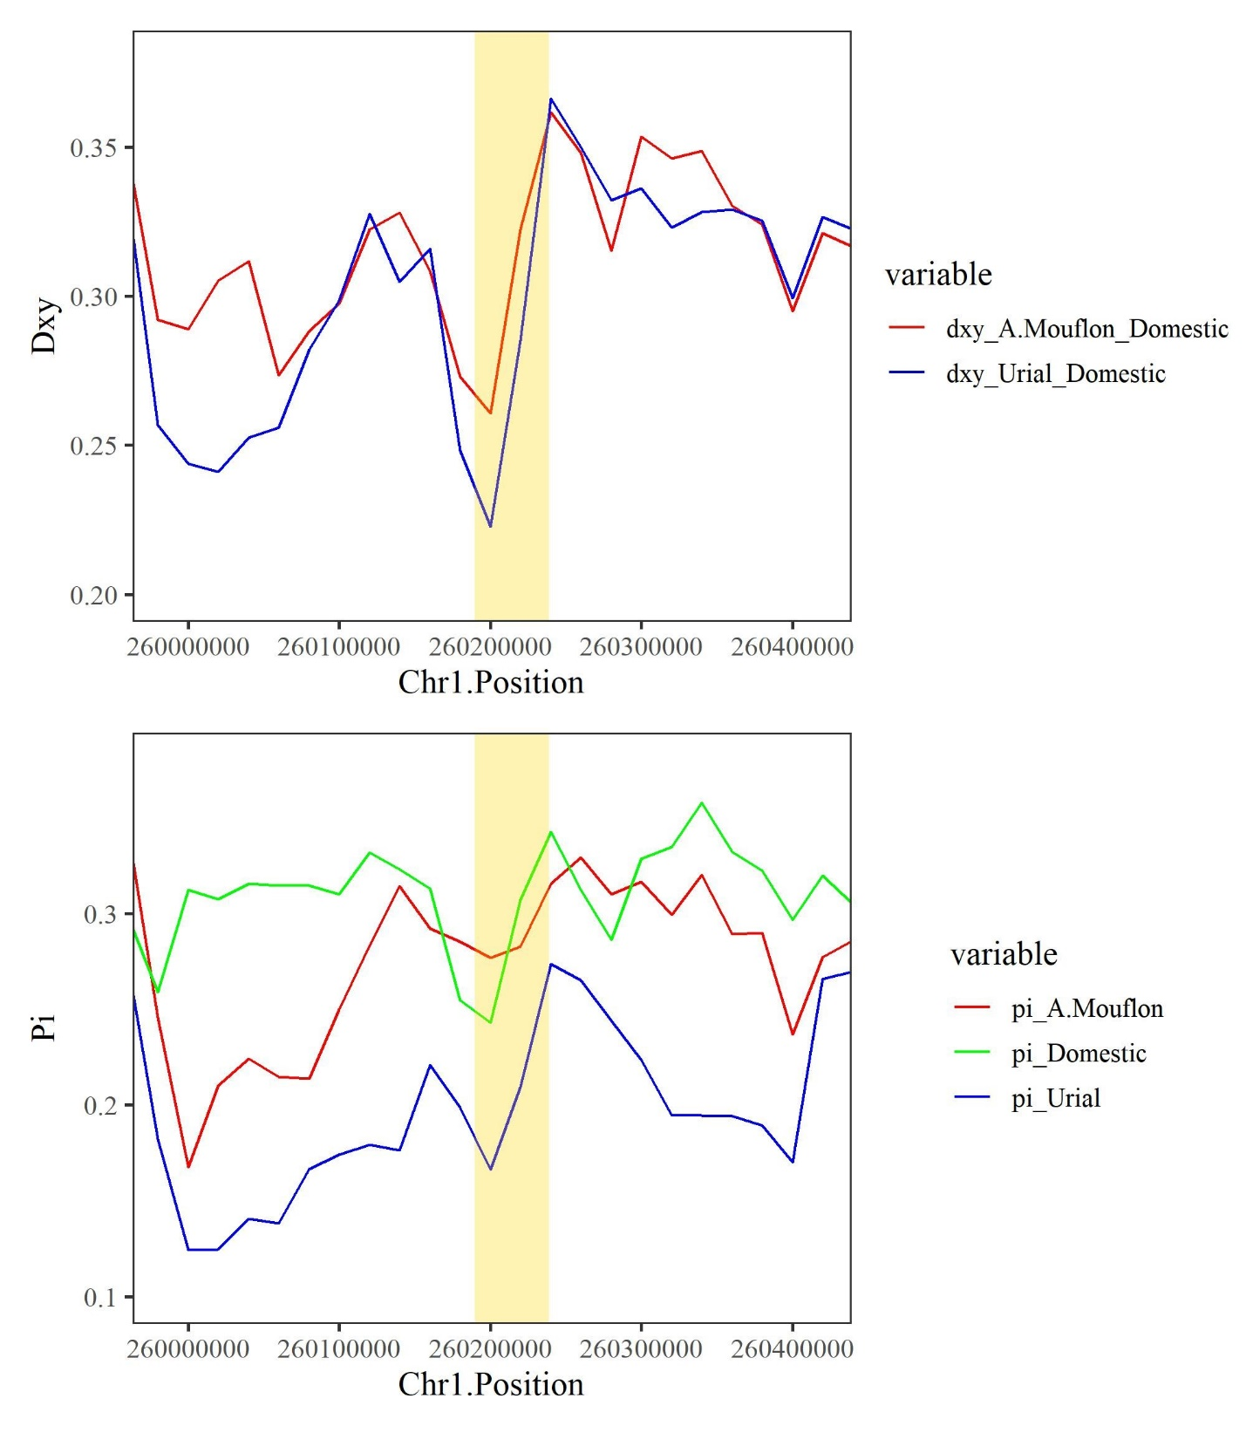
Figure S8. Dxy (top) and Pi (down) of the introgressed genomic region on chromosome 1 containing GET1 gene in wild sheep compared to domestic sheep
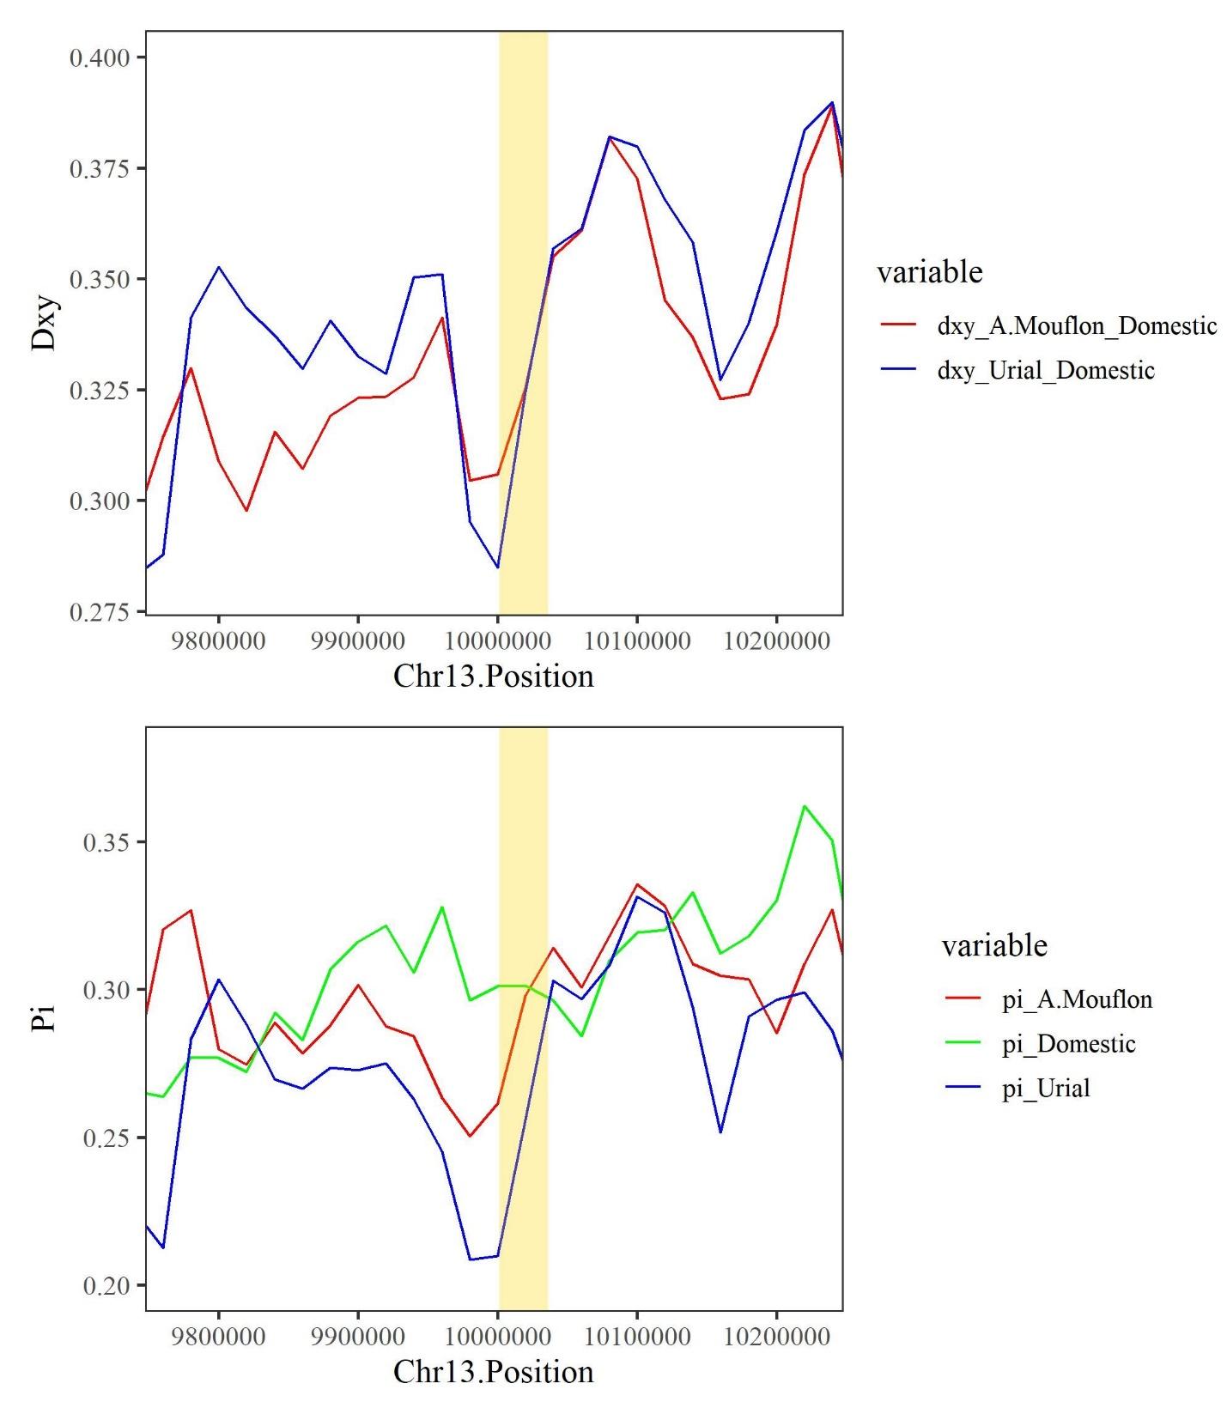
Figure S9. Dxy (top) and Pi (down) of the introgressed genomic region on chromosome 13 containing KIF16B gene in wild sheep compared to domestic sheep
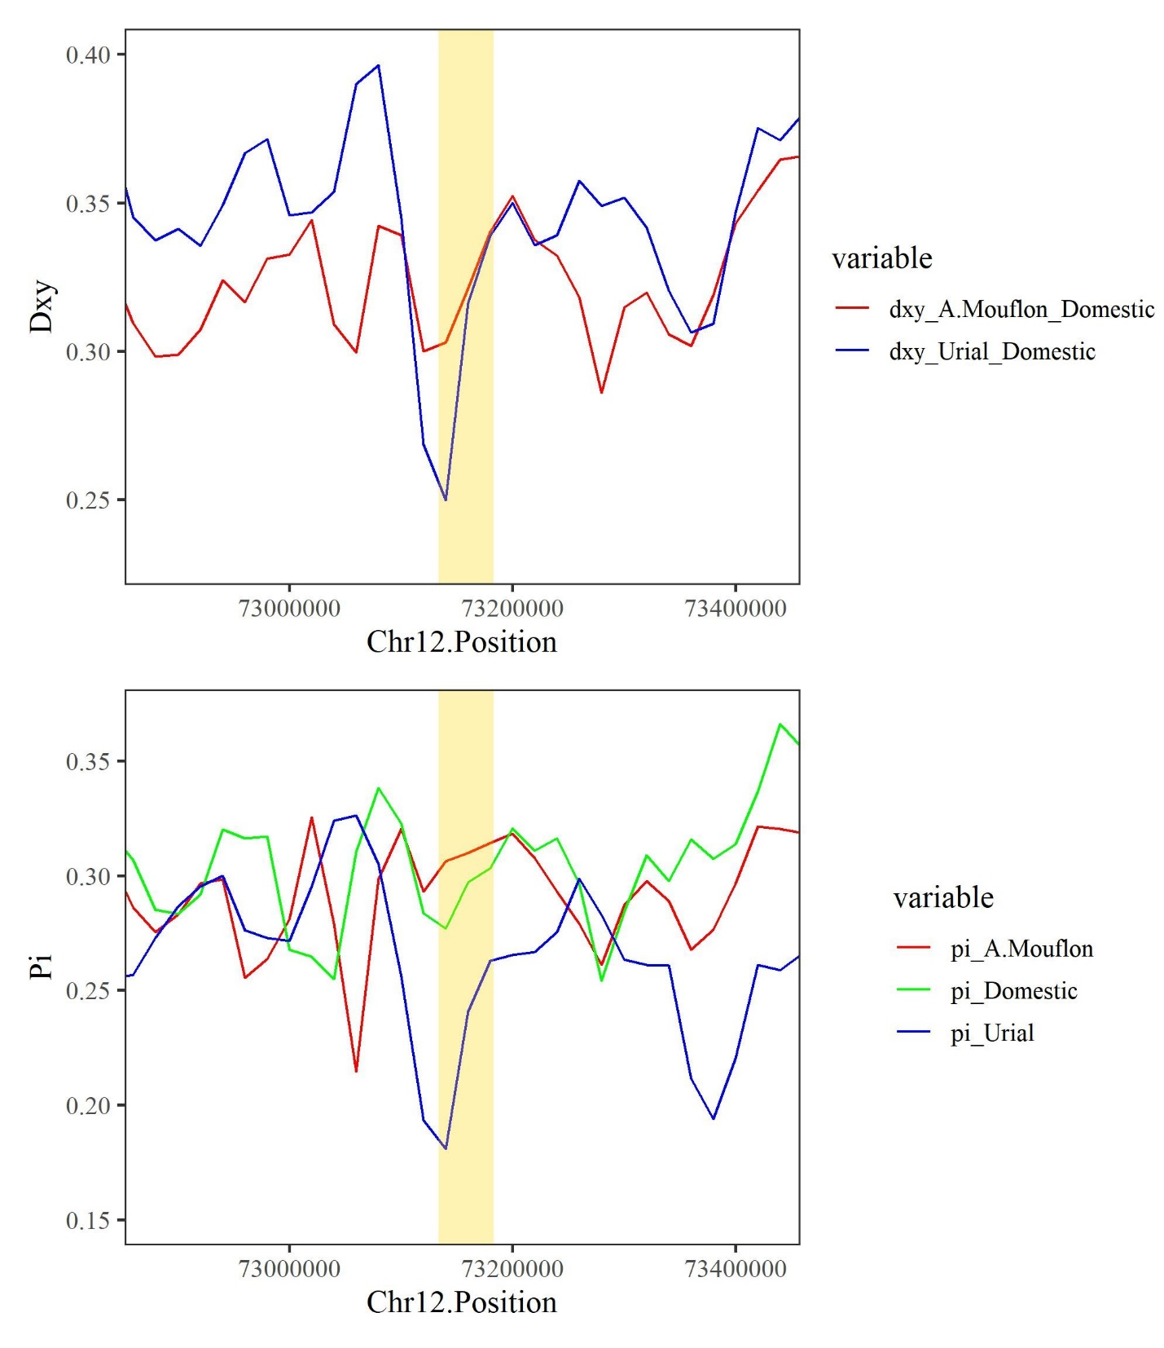
Figure S10. Dxy (top) and Pi (down) of the introgressed genomic region on chromosome 12 containing LAMB3 gene in wild sheep compared to domestic sheep
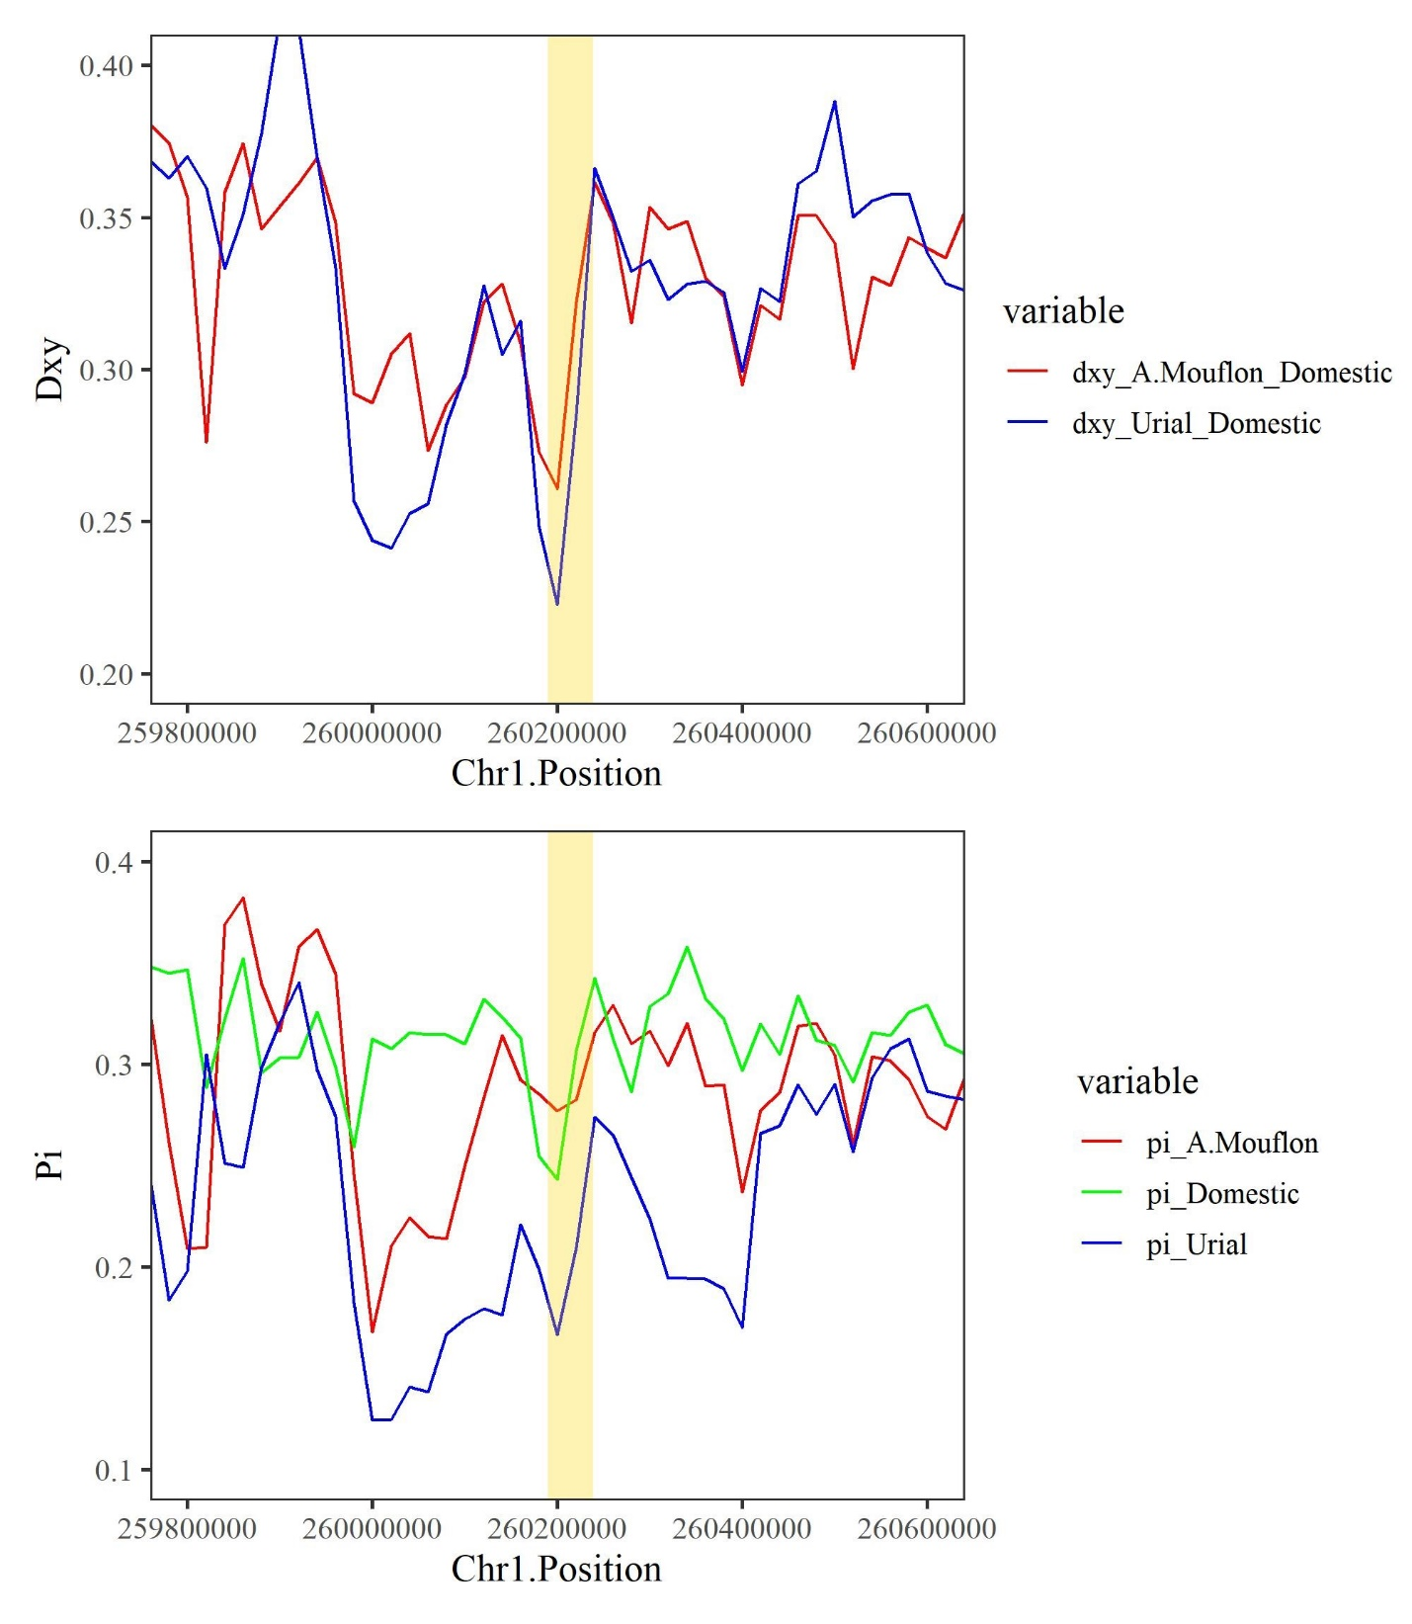
Figure S11. Dxy (top) and Pi (down) of the introgressed genomic region on chromosome 1 containing LCA5L gene in wild sheep compared to domestic sheep
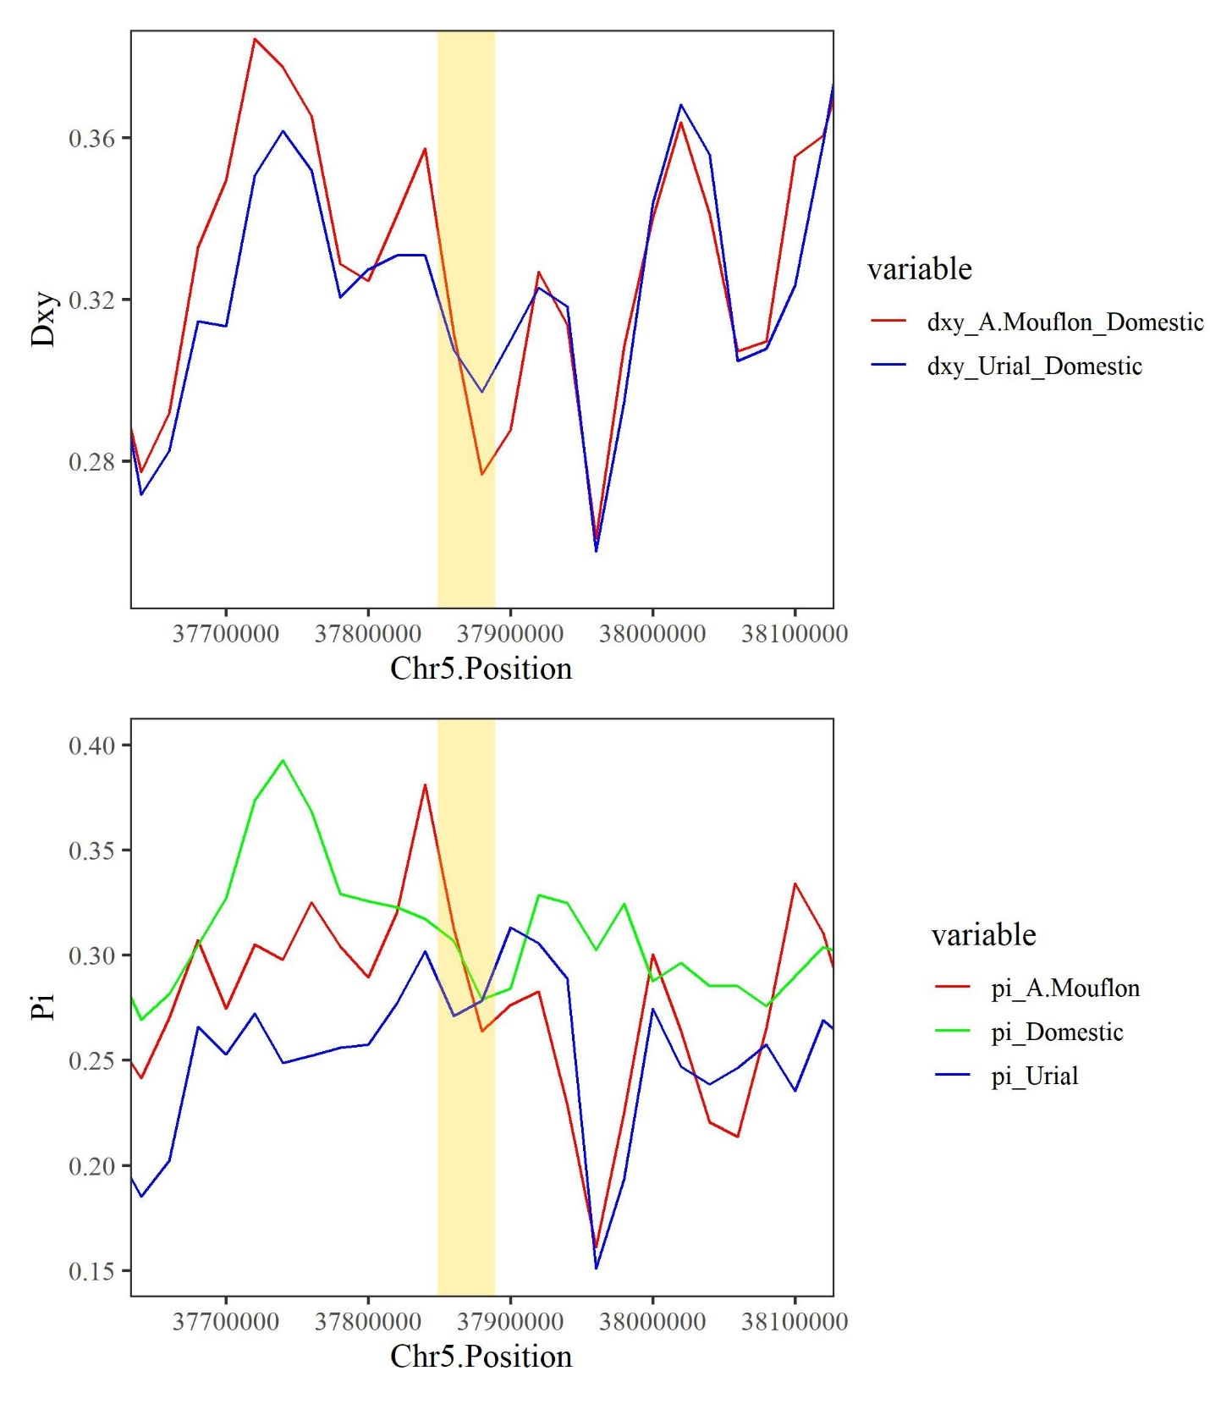
Figure S12. Dxy (top) and Pi (down) of the introgressed genomic region on chromosome 5 containing LOC101110674 and LOC101110938 genes in wild sheep compared to domestic sheep
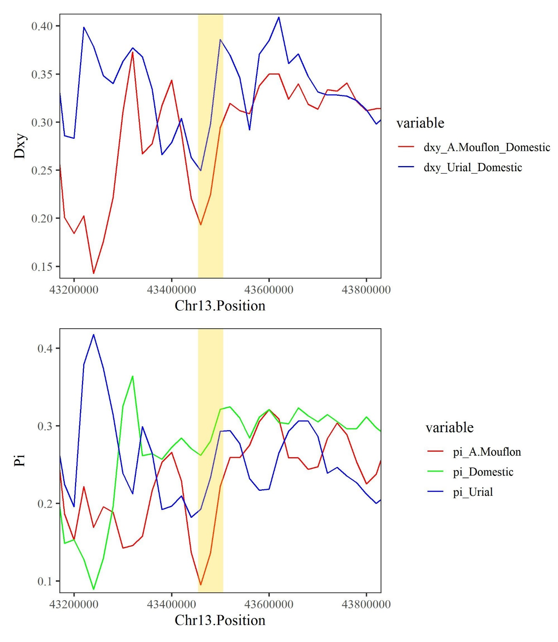
Figure S13. Dxy (top) and Pi (down) of the introgressed genomic region on chromosome 13 containing LOC101110693, LOC101111215 and AKR1E2 gene in wild sheep compared to domestic sheep

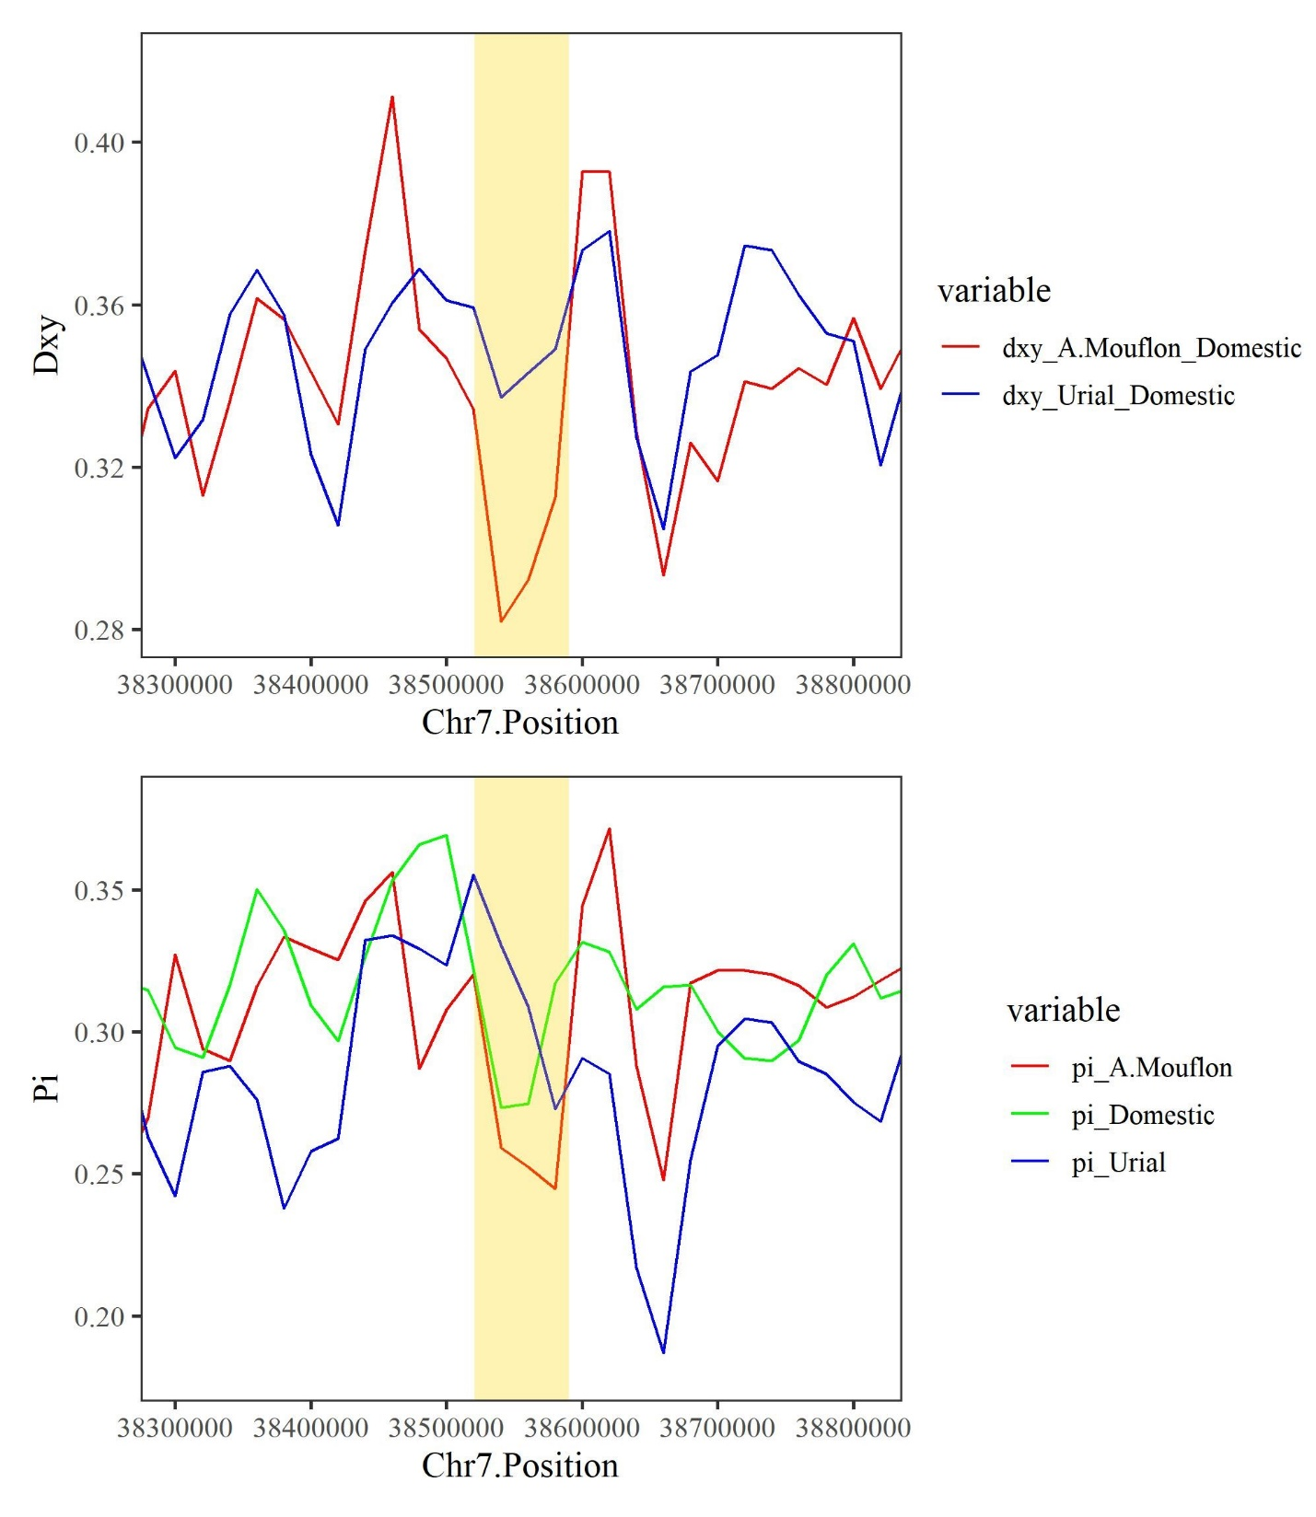
Figure S14. Dxy (top) and Pi (down) of the introgressed genomic region on chromosome 7 containing MDGA2 gene in wild sheep compared to domestic sheep
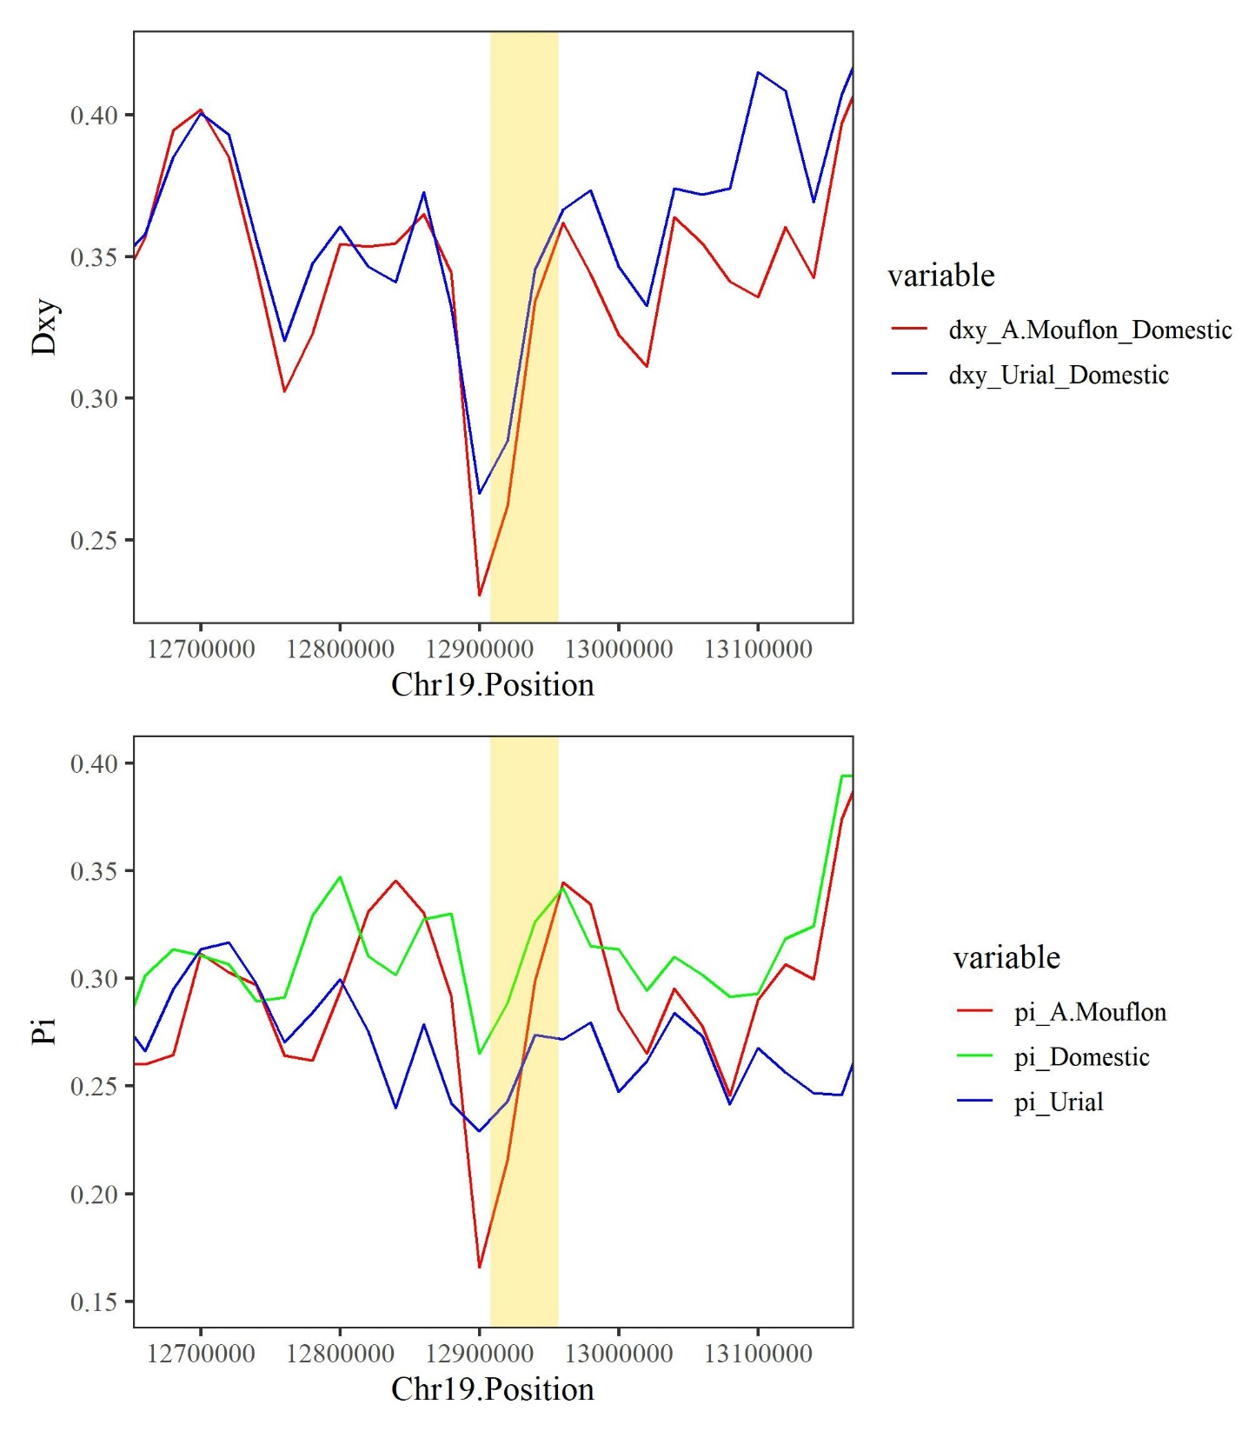
Figure S15. Dxy (top) and Pi (down) of the introgressed genomic region on chromosome 19 containing MYRIP gene in wild sheep compared to domestic sheep
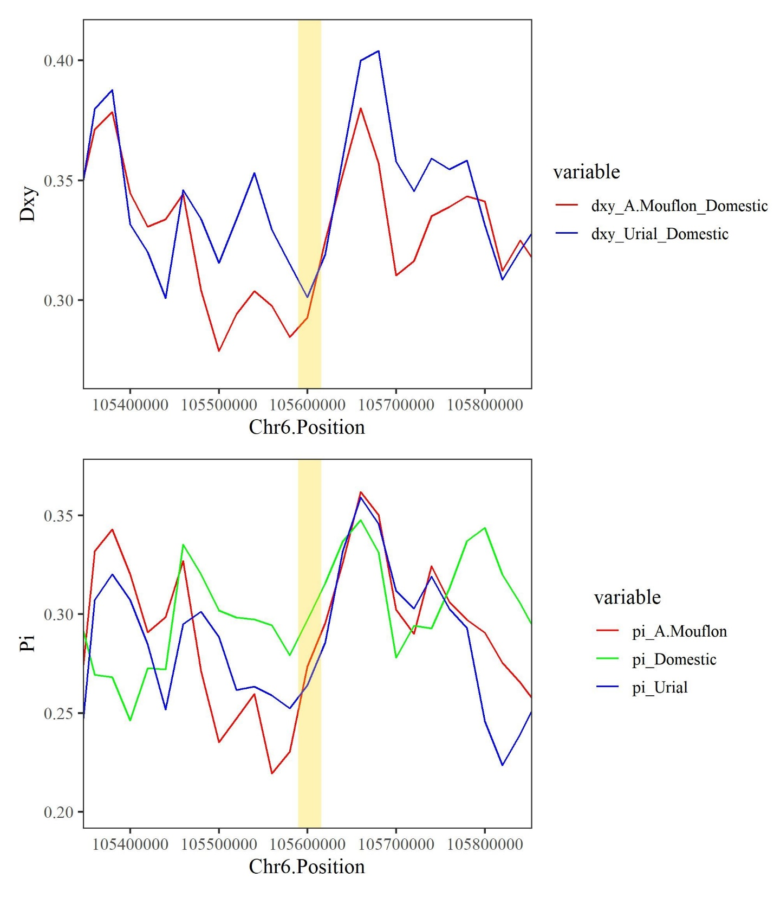
Figure S16. Dxy (top) and Pi (down) of the introgressed genomic region on chromosome 6 containing OTOP1 gene in wild sheep compared to domestic sheep
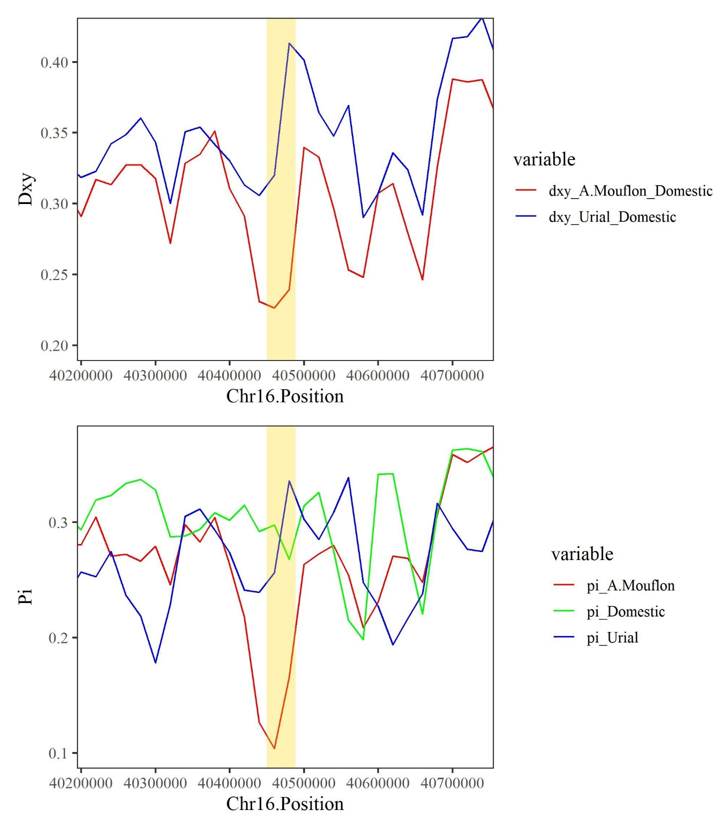
Figure S17. Dxy (top) and Pi (down) of the introgressed genomic region on chromosome 16 containing TARS1 gene in wild sheep compared to domestic sheep
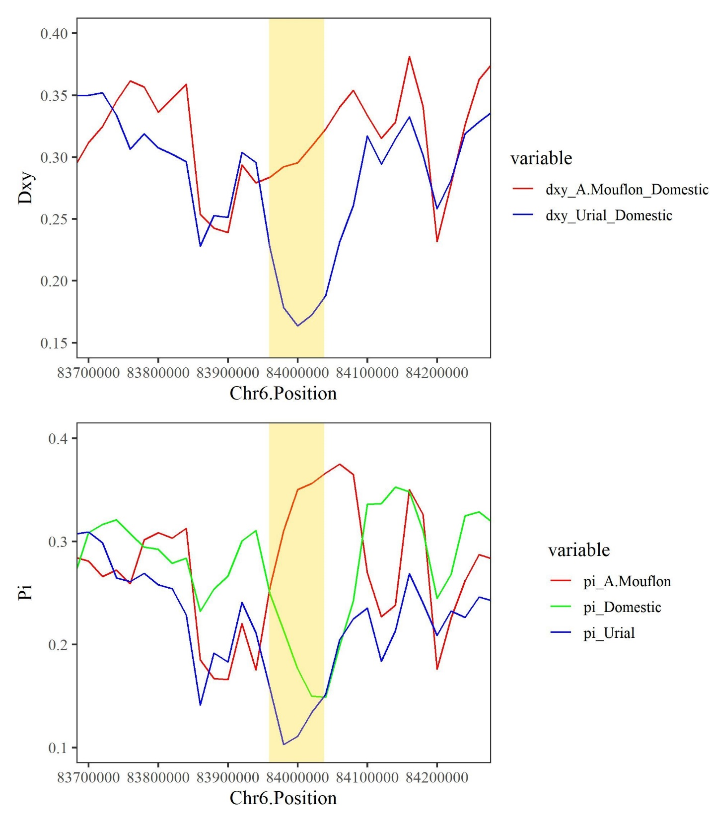
Figure S18. Dxy (top) and Pi (down) of the introgressed genomic region on chromosome 6 containing CENPC gene in wild sheep compared to domestic sheep
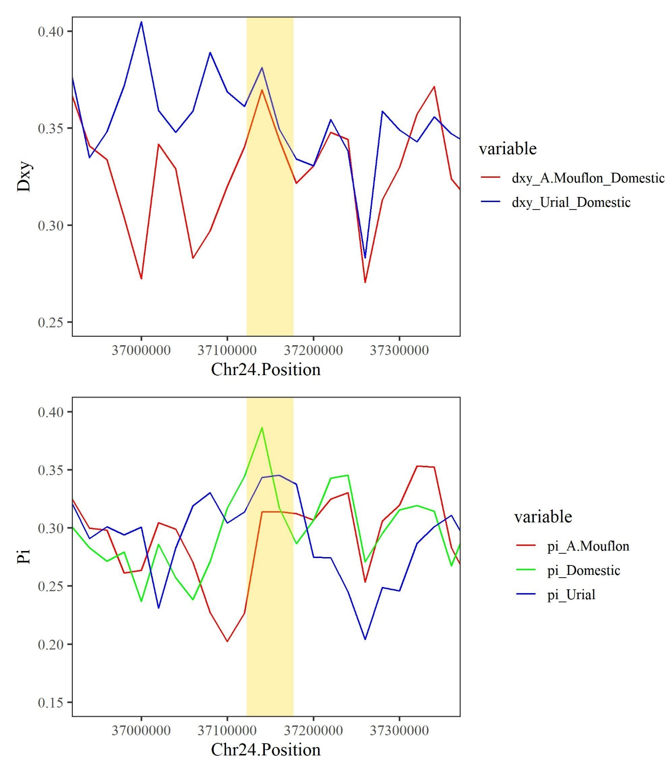
Figure S19. Dxy (top) and Pi (down) of the introgressed genomic region on chromosome 24 containing CYP3A24 gene in wild sheep compared to domestic sheep
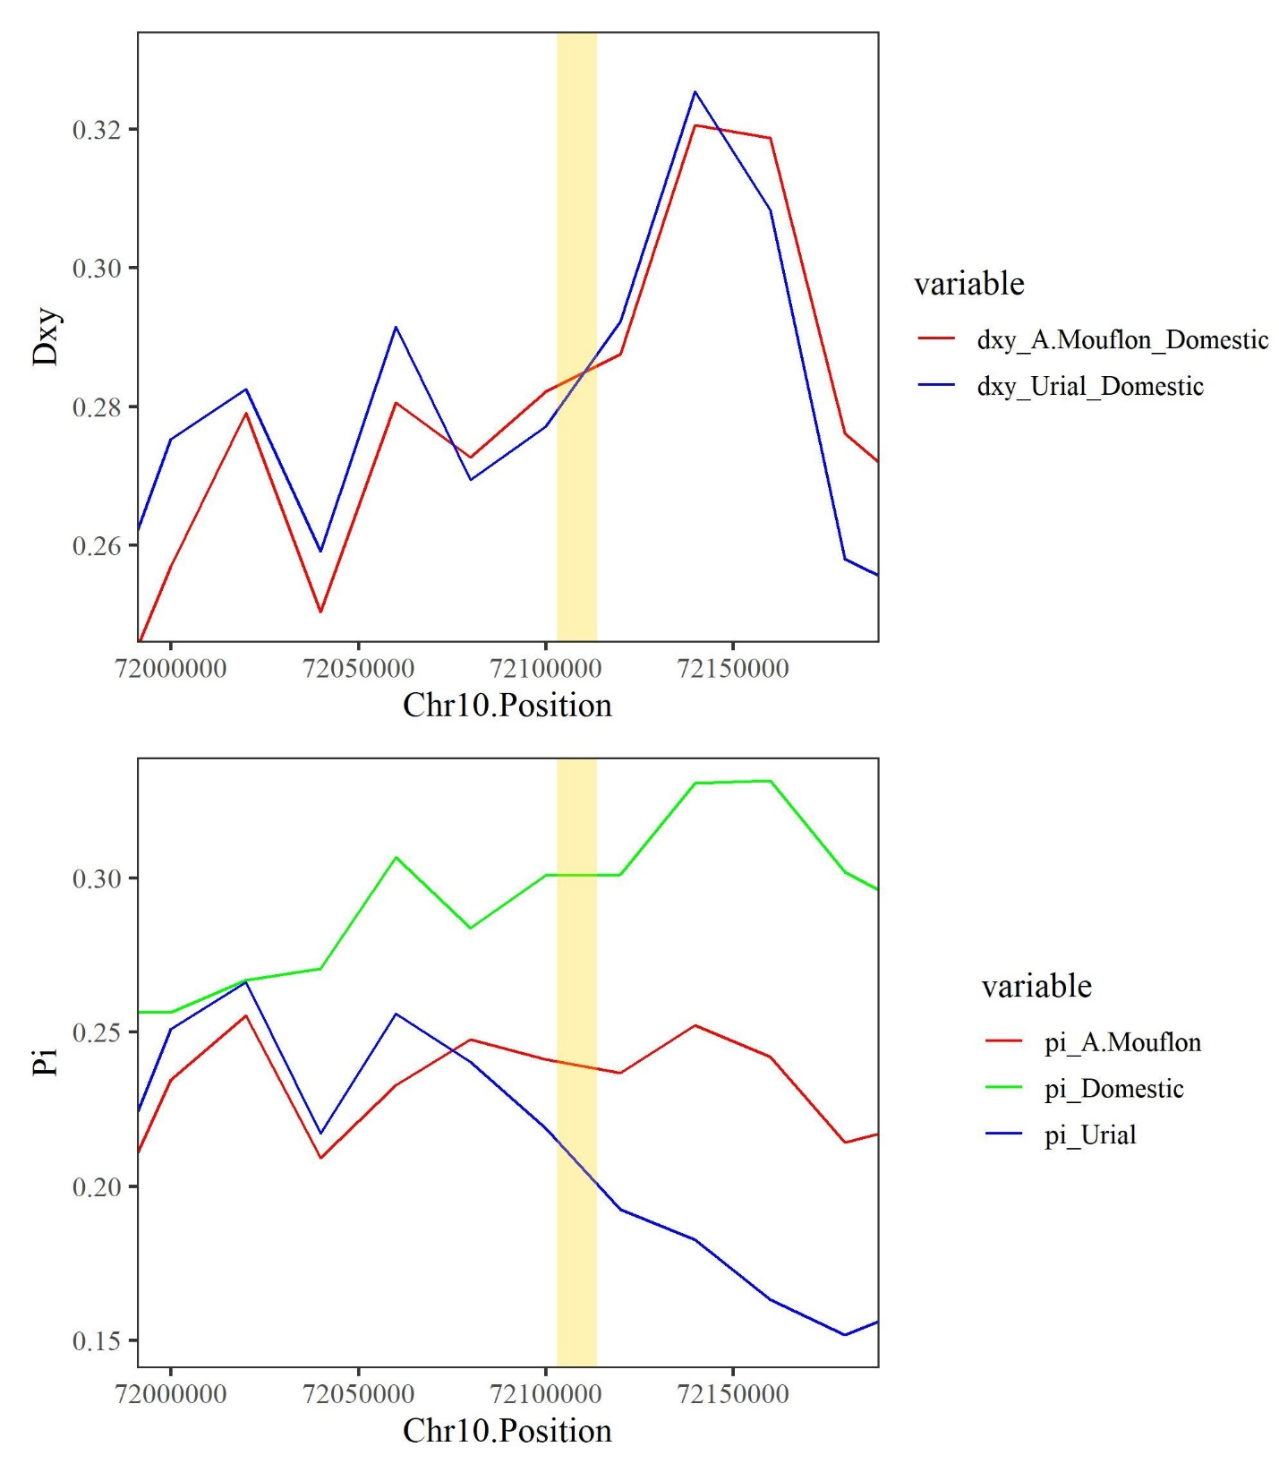
Figure S20. Dxy (top) and Pi (down) of the introgressed genomic region on chromosome 10 containing LOC101109890 gene in wild sheep compared to domestic sheep
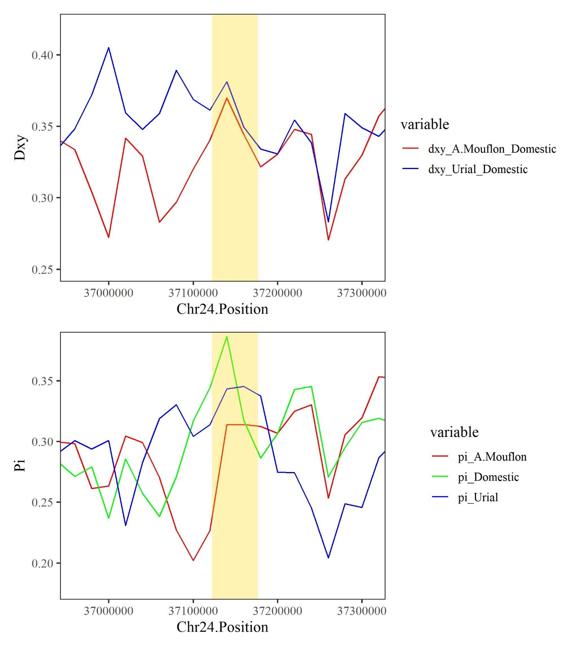
Figure S21. Dxy (top) and Pi (down) of the introgressed genomic region on chromosome 24 containing LOC114108597 and LOC121817857 genes in wild sheep compared to domestic sheep
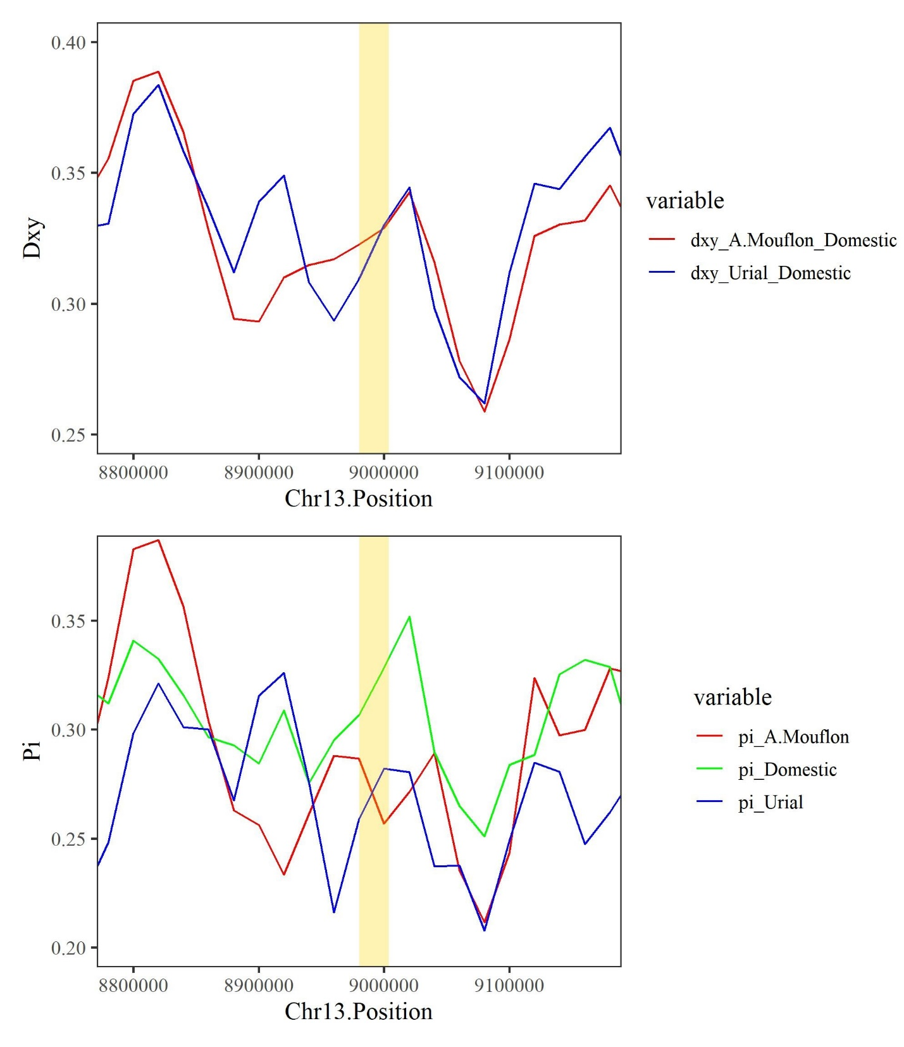
Figure S22. Dxy (top) and Pi (down) of the introgressed genomic region on chromosome 13 containing MACROD2 gene in wild sheep compared to domestic sheep
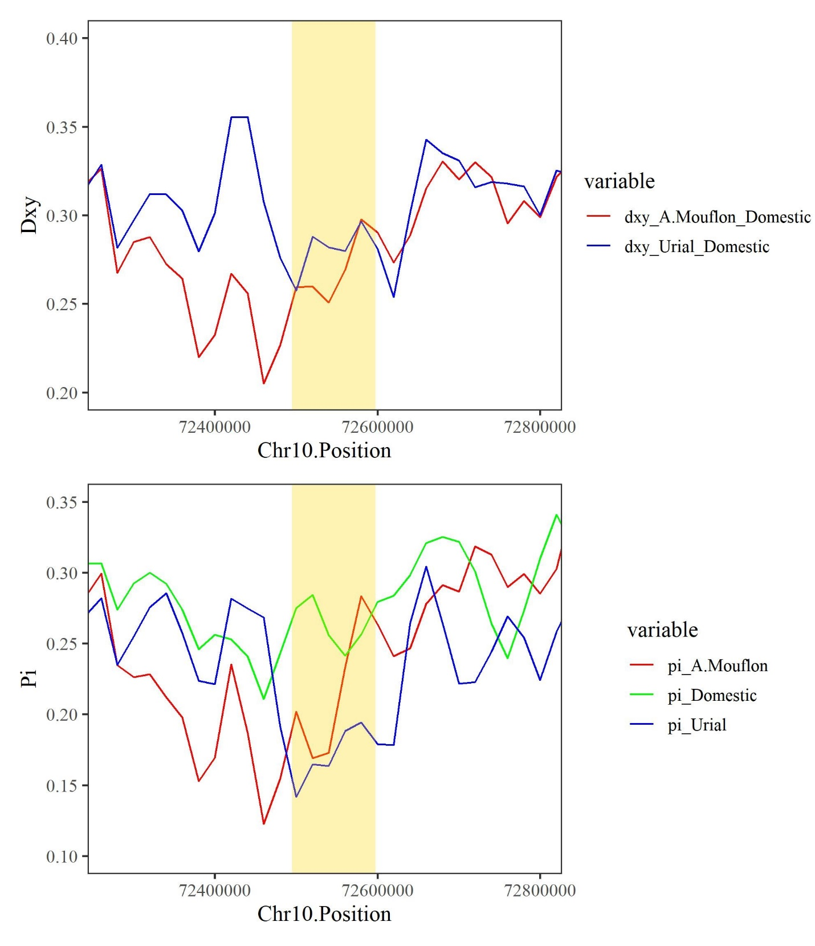
Figure S23. Dxy (top) and Pi (down) of the introgressed genomic region on chromosome 10 containing UGGT2 gene in wild sheep compared to domestic sheep

