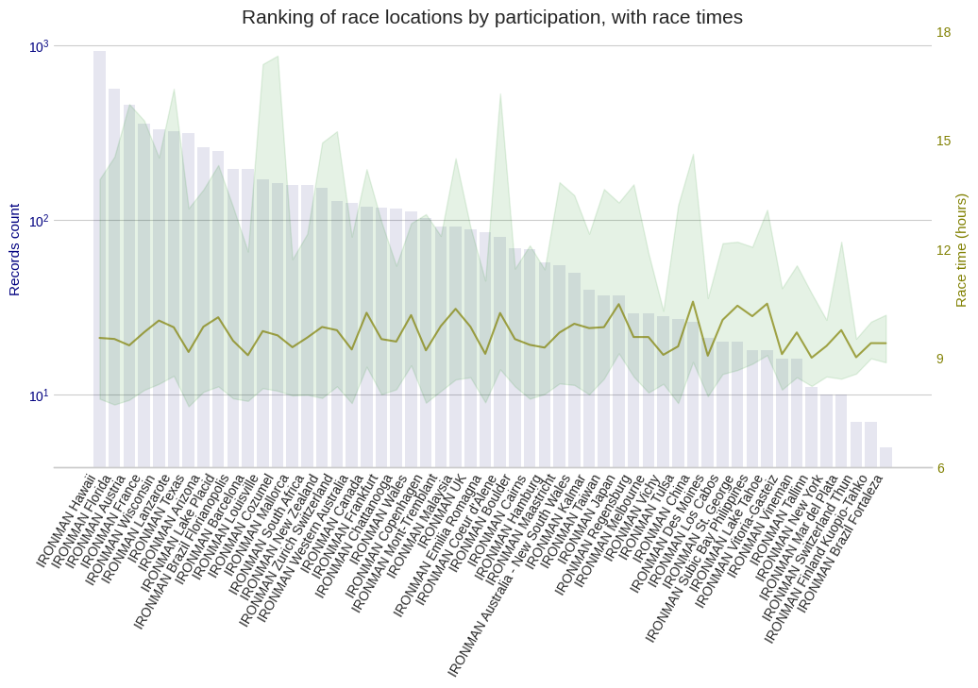
Supplementary Figure 2. Number of professional athletes by IRONMAN race locations between 2002 and 2022 and race time

