Two Chromatographic Methods for Analyzing Paracetamol in Spiked Human Plasma with N-acetyl parabenzoquinone Imine and N-acetyl-L-cysteine
Omar M El-Abassy, Michael Gamal Fawzy, Ebraam B. Kamel

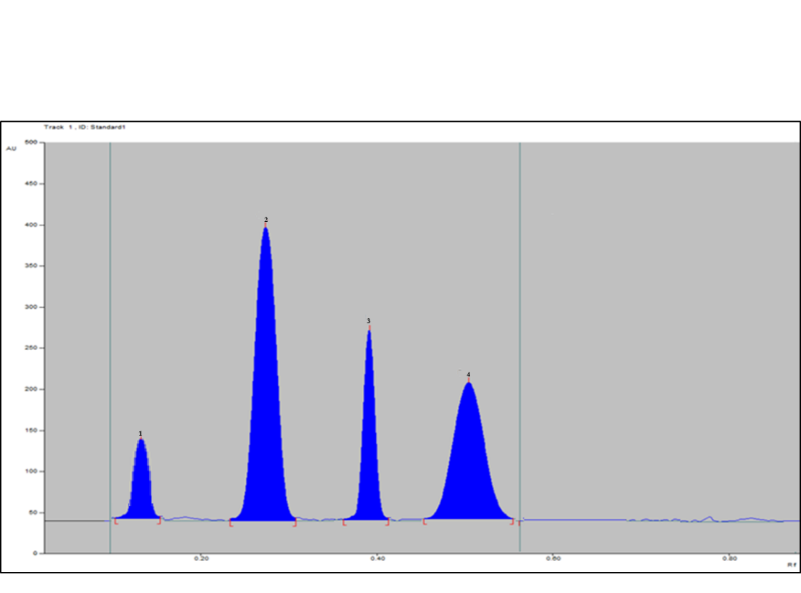
Plasma peak

Figure S1: 2 D HPTLC chromatogram of mixture of 5 µg mL⁻¹ APAP, 6 µg mL⁻¹ NAPQI and 16 µg mL⁻¹ NAC resolved from plasma peak
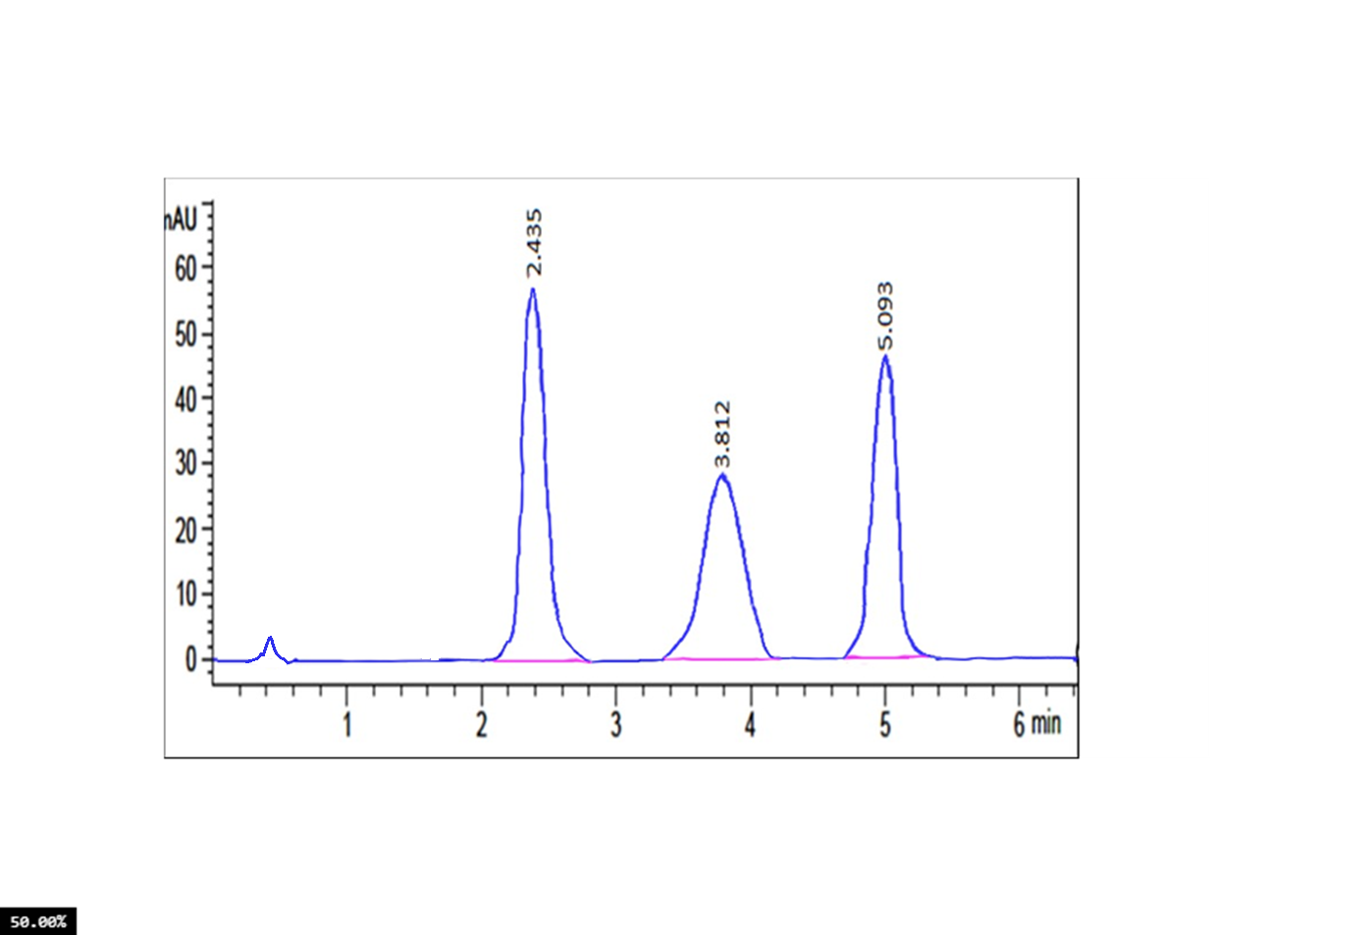
Plasma peak
Figure S2: HPLC chromatogram of mixture of 5 µg mL⁻¹ APAP, 30 µg mL⁻¹ NAPQI and 20 µg mL⁻¹ NAC resolved from plasma peak

Table S1: Robustness results of the proposed HPLC and HPTLC methods
(%RSD) ª |  |  |  |  |  |  | Parameter
HPLC |  |  |  | HPTLC |  |  | Parameter
1.723 | 0.453 | 1.432 | Scanning wavelength (±1 nm) | 0.143 | 1.734 | 0.764 | Methanol ratio (±1%)
0.953 | 0.674 | 0.578 | Flow rate (±0.1 mL/min) | 1.232 | 0.863 | 0.945 | Distance travelled by the solvent (±0.5 cm)
 |  |  |  | 1.344 | 1.855 | 1.355 | Time of saturation (±5 min)

