Supplementary information

Effects of shapes and kinematics of hovering flapping wings on aerodynamic forces and vortex structures

Hyun Ki Kwon, Jo Won Chang*
Department of Aeronautical Science and Flight Operation, Korea Aerospace University; Goyang-si 10540, Republic of Korea.
*Corresponding author. Email: jwchang@kau.ac.kr

Supplementary Information contains:
Figs. S1-5
Table S1

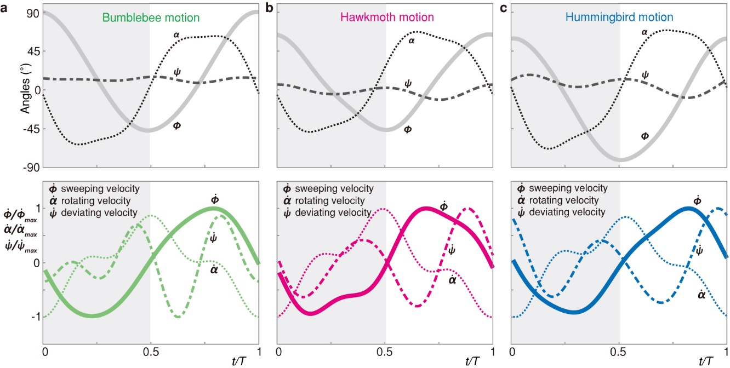
Fig. S1: Three-dimensional motion profiles and non-dimensional angular velocity of (a) bumblebee, (b) hawkmoth, and (c) hummingbird.

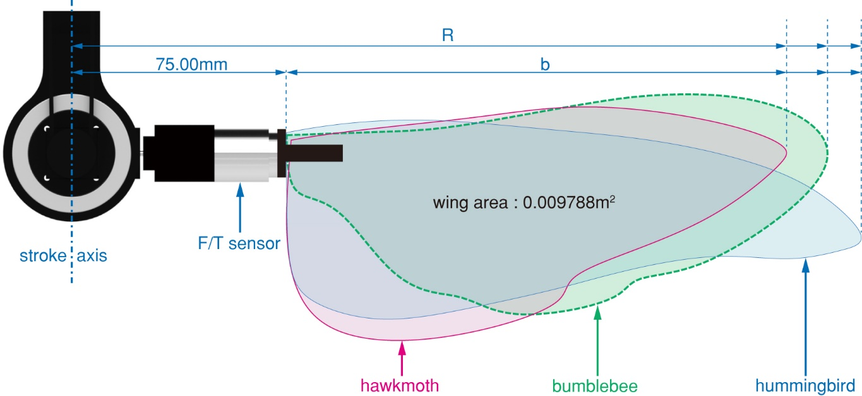
Fig. S2: Planform view of the three wing models. b ; Wing span (188.29mm for bumblebee, 174.0mm for hawkmoth, 200.0mm for hummingbird), R ; Distance from stroke axis to wing tip, Radius of the second moment of wing area (); ${\hat{r}}_{2}$=0.67 for bumblebee, ${\hat{r}}_{2}$=0.62 for hawkmoth, ${\hat{r}}_{2}$=0.61 for hummingbird). The experimental wing model has a gap between the stroke axis and the wing root due to F/T sensor attachment, which has a higher ${\hat{r}}_{2}$ value than the actual wing.

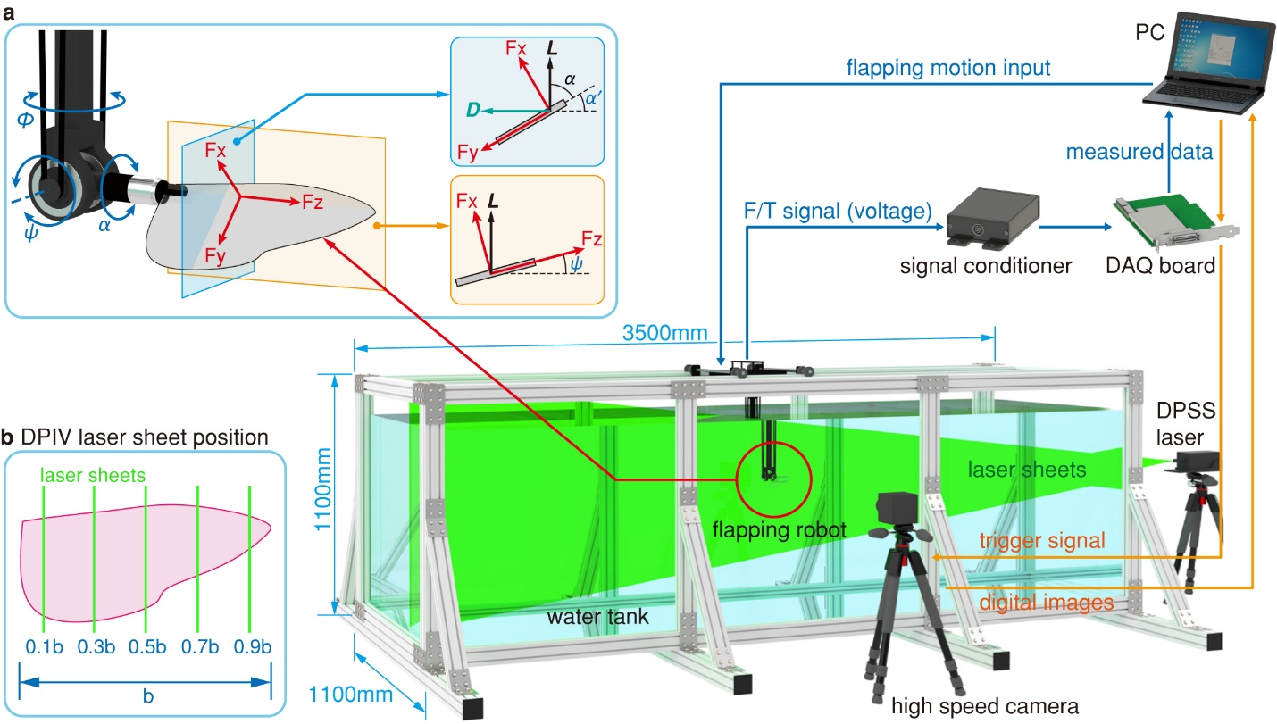
Fig. S3: Experiment setup. (a) 3DOF flapping robot and aerodynamics force axis. Lift (L) and drag (D) component values are measured from each sensor axis (Fx, Fy, and Fz). (b) DPIV laser sheet positions.

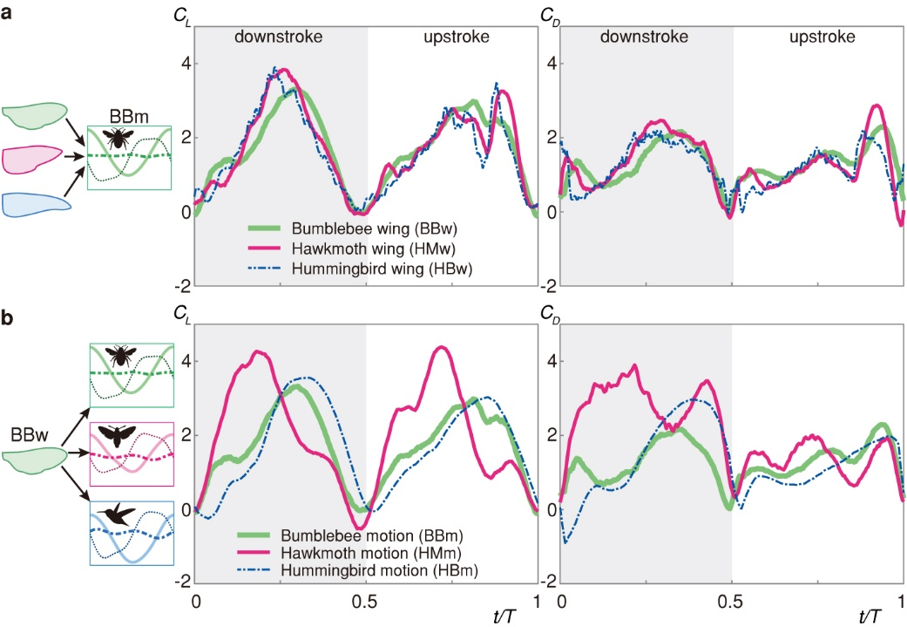
Fig. S4: Aerodynamics coefficient measurement results of bumblebee motion and wing planform case. (a) Comparison of the lift and drag coefficients (C_{L} and C_{D}) of the three different wing shapes at the same flapping motion (bumblebee motion). (b) Comparison of the C_{L}, and C_{D} of the three different flapping motions with the same wing shape (bumblebee wing).

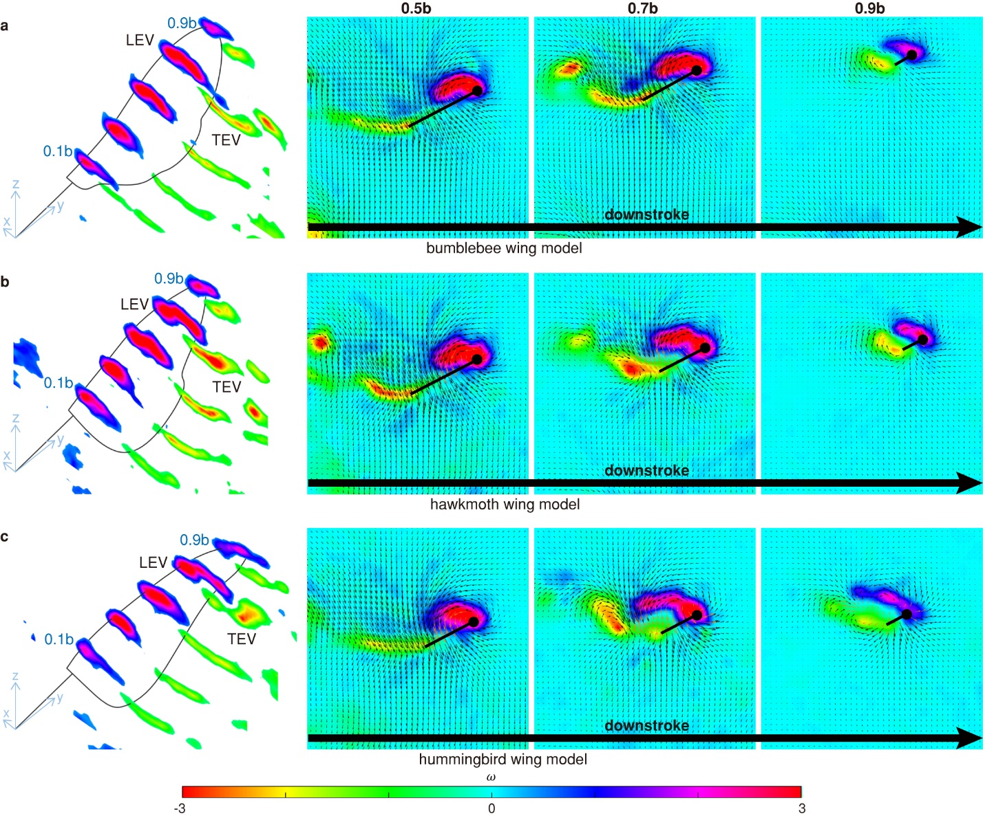
Fig. S5: Comparison of vortex structures of the three different wing shapes during the same flapping motion (hummingbird motion) at t⁄T=0.26 (down-stroke phase). It shows a side image of the 0.5b, 0.7b, and 0.9b position of cross section for each wing. The dimensionless vortex intensity ($\hat{ω}=ω\overline{c}/U_{tip}$) ranges from -3 to 3 where $ω$ is vorticity (s⁻¹). In these cross-sectional image, the black line is the wing cross-section, and the black circle is the leading edge of the wing. Leading edge vortex (LEVs), and trailing edge vortex (TEVs) were numbered in order of occurrence. Note the wing bending between (a) bumblebee wing model case, (b) hawkmoth wing model case, and (c) hummingbird wing model case.

Table S1. Non-dimensional spanwise flexural stiffness (EI_{non}), Re, aerodynamic force, and power coefficient measurement results in each experimental case.
a. Bumblebee motion
Wing Model | $$EI_{non}$$ | $$Re$$ | $${\overline{C}}_{L}$$ | $${\overline{C}}_{D}$$ | $${\overline{C}}_{P}$$ | $${\overline{C}}_{L}/{\overline{C}}_{D}$$ | $${\overline{C}}_{L}/{\overline{C}}_{P}$$
Bumblebee | 66.21 | ~2,760 | 1.7099 | 1.2869 | 1.6117 | 1.3287 | 1.0609
Hawkmoth | 49.91 | ~2,820 | 1.7277 | 1.2918 | 1.7052 | 1.3374 | 1.0132
Hummingbird | 22,696.19 | ~2,700 | 1.6295 | 1.2148 | 1.4917 | 1.3414 | 1.0924
Average |  | ~2,760 | 1.6890 | 1.2645 | 1.6029 | 1.3358 | 1.0555
b. Hawkmoth motion
Wing Model | $$EI_{non}$$ | $$Re$$ | $${\overline{C}}_{L}$$ | $${\overline{C}}_{D}$$ | $${\overline{C}}_{P}$$ | $${\overline{C}}_{L}/{\overline{C}}_{D}$$ | $${\overline{C}}_{L}/{\overline{C}}_{P}$$
Bumblebee | 103.35 | ~5,130 | 2.0183 | 2.0333 | 2.7278 | 0.9926 | 0.7399
Hawkmoth | 77.90 | ~5,070 | 2.0251 | 1.9597 | 2.7716 | 1.0334 | 0.7306
Hummingbird | 8,652.22 | ~5,110 | 1.7065 | 1.7276 | 2.3277 | 0.9878 | 0.7331
Average |  | ~5,100 | 1.9166 | 1.9069 | 2.6090 | 1.0046 | 0.7345
c. Hummingbird motion
Wing Model | $$EI_{non}$$ | $$Re$$ | $${\overline{C}}_{L}$$ | $${\overline{C}}_{D}$$ | $${\overline{C}}_{P}$$ | $${\overline{C}}_{L}/{\overline{C}}_{D}$$ | $${\overline{C}}_{L}/{\overline{C}}_{P}$$
Bumblebee | 88.54 | ~10,180 | 1.6873 | 1.2703 | 1.6943 | 1.3283 | 0.9959
Hawkmoth | 66.74 | ~10,060 | 1.7172 | 1.2603 | 1.8204 | 1.3625 | 0.9433
Hummingbird | 2,704.55 | ~10,150 | 1.6263 | 1.2006 | 1.6963 | 1.3546 | 0.9587
Average |  | ~10,130 | 1.6769 | 1.2437 | 1.7370 | 1.3485 | 0.9660

