Supplementary Information for the manuscript

“Production of abiotic or biogenic hydrocarbons on rock particles in the presence of H₂O and carbon compounds”
Young Sang Choa,*, In-Hwan Oh a, Ju Hee Kim a, Jae Ik Kim a, Kang-Bong Lee a, In Wook Naa,**
*To whom correspondence should be addressed. E-mail: yscho@kist.re.kr

Contents

- Supplementary Summary of the Main Conclusion

- Supplementary Methods

- Supplementary Experiments and Discussion

- Supplementary References

- Supplementary Tables

- Supplementary Figures and Legends

1. Supplementary Summary of the Main Conclusion

Solid acids such as SiO₂, Al₂O₃, CaCO₃, TiO₂ and ZnO can catalyze the synthesis of H₂ and hydrocarbons through reactions of H₂O and CO₂. GC/MS spectrograms of product gas samples obtained from experiments with solid acids revealed diverse hydrocarbon products, including aliphatic, aromatic , and cyclic hydrocarbons (Figure S1 and Table S1).
In a similar manner, H₂ and diverse hydrocarbons also formed over sedimentary rock particles (mudrock and limestone) as well as over igneous rock particles (basalt and granite) when H₂O, carbon compounds and thermal energy were provided. H₂O was dissociated on solid acid components of rocks into H and OH radicals1, and then the H radicals reacted with carbon compounds to produce H₂ and diverse hydrocarbons.
H radicals can reduce inorganic carbon compounds such as graphite and CO₂ to form unstable hydrocarbon species such as CH, CH₂, and CH₃ radicals2. These unstable hydrocarbons and H radicals reacted together to produce diverse hydrocarbons, including aliphatic, aromatic, and cyclic hydrocarbons. Approximately 2/3 of these hydrocarbon products were branched hydrocarbons, indicating that the above reactions occurred randomly without a specific rule (Figure S2).
H radical-induced dissociation of organic carbon compounds can produce C₃H₇, C₂H₅, and CH₃ radicals via the dissociation of C‒C bonds at a lower temperature than that for thermal pyrolysis of organic carbon compounds³. These hydrocarbon radicals and H radicals reacted together to produce diverse hydrocarbons, including aliphatic, aromatic, and cyclic hydrocarbons. Approximately 2/3 of these hydrocarbon products were also branched, indicating that these reactions occurred randomly without a specific rule (Figure S3).
More aromatic hydrocarbons than aliphatic hydrocarbons were produced when H₂O reacted with inorganic carbon compounds over solid acid-containing rock because of the limited supply of H radicals and H_{2,} whereas more aliphatic hydrocarbons than aromatic hydrocarbons were produced when H₂O reacted with hydrogen-rich organic carbon compounds (or biomass) over rock owing to the readily available H radicals and H₂.
All the hydrocarbons synthesized in the reactors were slowly converted into CH₄ regardless of the carbon source used. This tendency of all the higher hydrocarbons in the reactor to be converted into CH₄ is probably due to the continuous supply of H radicals from the dissociation of H₂O over the rock, followed by H radical-induced C‒C bond cleavage. Thus, the results of this study are consistent with the observed dominance of CH₄ and saturated hydrocarbons in natural hydrocarbons. Any O₂ produced from OH radicals was likely consumed during the oxidation of less-oxidized constituents in the rocks4, and no O₂ was detected during any of the experiments.

2. Supplementary Methods

2-1 Reactors and Materials
A flow-through reactor made of 316 stainless steel (Figure S5(a)) was used in the experiments to demonstrate the catalytic ability of solid acids. Two kinds of 316 stainless steel batch reactors were also used in the experiments described in the main text. A batch reactor with an internal volume of 4.77 L (Figure S5(b)) was used for relatively low-temperature and low-pressure reactions. In this case, small gas samples (200~300 mL/sample) were removed as many times as necessary to estimate the changes in the concentrations of product hydrocarbons. A batch reactor with an internal volume of 53 mL (Figure S5(c)) was used for reactions under supercritical conditions to prevent the product gas from leaking out. In this case, the final gas volume was measured, and one or two gas samples were taken at the end of the experiment.
The rocks used in this study were collected in South Korea and supplied by Aram Science Co. in Korea. For the rock classification step, the major compositions of the rocks were analyzed and are summarized in Table 1. An ICP‒AES instrument (Perkin-Elmer, USA) at the KIST Advanced Analysis and Data Center was used for elemental analysis. The oxygen content of the rock samples was not directly measured. Thus, the composition was calculated under the assumption that all major elements except for carbon were fully oxidized.
CO₂ and Ar in pressurized stainless steel containers were purchased from Shinyang Oxygen Co. (Korea). Both CO₂ and Ar had a purity of 99.999% and showed no significant peaks representing organic materials in the corresponding chromatograms obtained via gas chromatography with a flame ionization detector (GC/FID). The water used in this study was produced in our laboratory by distilling city water and then treating it with an ultrapure water system (Easypure LF, Barnstead International, USA). The GC/FID chromatogram of this distilled water likewise showed no significant peaks representing organic materials.

2.2 Analyses
A GC/FID instrument and a GC instrument equipped with a thermal conductivity detector (GC/TCD) were used to measure the concentrations of hydrocarbons, H₂ and CO₂ in the product gases. A GC mass spectrometry with a mass spectrometer detector (GCMS/MSD) system was also used to identify individual hydrocarbons by using the mass database in Wiley 7n, which is included in the GCMS system. Both the GC/FID and GC/TCD systems were obtained from Agilent Technologies (model 6890 N), and the GCMS/MSD system was also obtained from Agilent Technologies (model 5973 i). The GC/FID column was a 1/8” X 6’ stainless steel column filled with 60/80 mesh Carbopack B with 1 SP-1000, and the GC/TCD column was a 1/8” X 6’ stainless steel column filled with 60/80 mesh molecular sieve 5A with 10% 13X. The inner diameter and length of the capillary column (J&W Scientific Co.) under the brand name GS-GasPro for GCMS were 0.32 mm and 60 m, respectively.
The concentrations of H₂ and CO₂ in the product gas were calculated from the GC/TCD chromatograms, whereas the concentration of hydrocarbons in the product gas was calculated from the GC/FID chromatograms. The conversion factor used to calculate the concentration of an individual chemical from the integrated area under the respective GC peak was determined by averaging the conversion factors calculated at different concentration levels of the chemical. For example, the area under the peak representing H₂ was measured at concentrations of 20%, 40%, 60%, 80% and 100%. The H₂ peak areas were 23,825, 46,945, 69,954, 93,064, 116,802, respectively, and the conversion factors were calculated by dividing the area by the respective concentration to yield values of 1,191/%, 1,174/%, 1,166/%, 1,163/%, and 1,168/%, respectively. Thus, the average conversion factor for H₂ was 1,172/%, as determined by averaging the above conversion factors obtained at different concentrations of H₂. Similarly, the conversion factor for CO₂ was found to be 112/%.
Subsequently, the concentrations of individual hydrocarbons in the product gas samples were calculated from the integrated areas under the respective peaks in the GC/FID chromatograms with the aid of premeasured conversion factors. The premeasured conversion factors were as follows: 5.36/ppm for CH₄, 16.5/ppm for C₃H₈, 29/ppm for benzene, 32.4/ppm for n-hexane, and 35.1/ppm for toluene.
The concentration of individual hydrocarbons other than the above measured hydrocarbons in the product gas samples was calculated from the integrated area under the respective peak in the GC/FID chromatogram divided by the number of carbons in the individual hydrocarbon molecule since the calculated values for various hydrocarbons are similar when the concentrations of the hydrocarbons are the same. For example, the values resulting from dividing the integrated GC/FID peak area by the concentration for 100 ppm each of CH₄, C₃H₈, benzene, n-hexane, and toluene are 536, 550, 483, 540, and 501, respectively. Thus, the average conversion factor per carbon is 5.22/ppm, and the relative response factors per carbon for CH₄, C₃H₈, benzene, n-hexane and toluene compared with this average are 1.03, 1.05, 0.93, 1.03 and 0.96, respectively, indicating that the assumption used in this study for estimating hydrocarbon concentrations may be acceptable.
The total dry volume of gas in the reactor at the end of the experiment was calculated as V = (V_{void} + volume of CO₂ produced + volume of H₂ produced + volume of hydrocarbons produced), where V_{void} represents the initial void volume of the 4.77 L batch reactor packed with rock particles. For the experiments with a 4.77 L batch reactor (Figure S5(b)), Ar gas or CO₂ gas was used to pressurize the reactor to 20 bar at room temperature. The carbon conversion and H₂O split ratio in the reactor were calculated from the carbon and hydrogen balances and the total dry gas volume in the reactor.
In this study, the initial void volume of the reactor fully packed with rock particles was measured by using Ar gas. For example, Ar gas was put into the reactor containing 3.43 kg of basalt particles until the pressure of the reactor reached 10 bar, and then the Ar gas in the reactor was slowly removed and collected in a sampling bag until the pressure in the reactor dropped to 5 bar. The collected volume of Ar gas was measured to obtain an initial void volume of 17,998 mL/5 bar or 3,600 mL/bar. The void volumes for other rocks were also measured, and the obtained values were as follows: granite (3.43 kg): 18,002 mL/5 bar = 3,600 mL/bar; mudstone (2.4 kg): 19,735 mL/5 bar = 3,947 ml/bar; mudstone (1.72 kg): 21,630 mL/5 bar = 4,326 mL/bar; and limestone 17,885 mL/5 bar = 3,577 mL/bar.

3. Supplementary Experiments and Discussion

3-1 Hydrocarbon synthesis from H₂O and CO₂ on solid acid catalysts
For the experiment, the solid acids were pretreated by sintering at 820 K in a furnace for 1,000 min to remove volatile matter, immersing in water for 24 h to remove water-soluble matter, and drying at 373 K in an oven for 24 h. Finally, the materials were stored in a desiccator at 298 K. To prepare the main experiment, 80 g of pretreated solid acid was placed in a flow-through reactor (Figure S5(a)), and then CO₂ at 10 ml/min and H₂O (steam) at 4.0 g/h were fed into the reactor at room temperature for 2 h to allow CO₂ and H₂O to be adsorbed on the solid acid. Then, the temperature of the reactor was raised to 800 K, and the feed rates of the reactants were adjusted to 5 ml/min for CO₂ and 1.0 g/h for H₂O (steam), corresponding to a reactant gas residence time of approximately 8 minutes. The product samples for GC/MS analysis were taken 1 h after the beginning of the experiment (or approximately 20 min after the reaction temperature reached 800 K).

3-2 Hydrocarbon synthesis from H₂O and inorganic carbon compounds over rock

Graphite as a carbon source
In this experiment, 12,000 ppm H₂, 3,250 ppm CH₄, 836 ppm C₂H₆, 420 ppm C₃H₈, 140 ppm C₄₊ aliphatic hydrocarbons, 1,083 ppm benzene, 378 ppm toluene, and 375 ppm ethylbenzene were produced over a reaction time of 75 d (Table S2).
Thus, the total dry volume can be calculated by using V = (V_{void} + volume of CO₂ produced + volume of H₂ produced + volume of hydrocarbons produced) → V_{void} = 20 × 3,600 mL = 72,000 mL, V = (72,000 mL + 0.012V + 0.00649V) → V = 72,000 mL/0.98151 = 73,350 mL → hydrocarbons produced = 73,350 mL × 0.00649 = 476 mL
Total carbon conc. = 0.00325 (CH₄) + 2x0.000836 (C₂H₆) + 3x0.00042 (C₃H₈) + 4x0.00014 (C₄₊) + 6x0.001083 (benzene) + 7x0.000378 (toluene) +8x0.000375 (ethylbenzene) = 0.018886 → Volume of carbon produced = 73,350 mL × 0.018886 = 1,385 mL → 1,385 mL/22,400 (mL/mole) = 0.0618 mole = 0.0618 mole × 12 g/mole = 0.742 g → carbon conversion = 0.742/50 = 0.01484 =1.484%
Total H₂ conc. = (2x0.012 (H₂) + 4x0.00325 (CH₄) + 6x0.000836 (C₂H₆) + 8x0.00042 (C₃H₈) +10x0.00014 (C₄₊) + 6x0.001083 (benzene) + 8x0.000378 (toluene) + 10x0.000375 (ethylbenzene))/2 = 0.030024 → Volume of H₂ produced = 73,350 mL × 0.030024 = 2,200 mL → 2,200/22,400 = 0.098 mole → H₂O split ratio = 0.098x18/184 = 0.958%
CH₄ in hydrocarbons: 16x0.00325/(16x0.00325 + 30x0.000836 + 44x0.00042 + 58x0.00014 + 78x0.001083 + 92x0.000378 + 106x0.000375) x 100% = 19.8 wt.%
Aromatic hydrocarbons: (78x0.001083 + 92x0.000378 + 106x0.000375)/(16x0.00325 + 30x0.000836 + 44x0.00042 + 58x0.00014 + 78x0.001083 + 92x0.000378 + 106x0.000375) × 100% = 60.5 wt.%

CO₂ as a carbon source
In this experiment, 18,300 ppm H₂, 2,725 ppm CH₄, 714 ppm C₂H₆, 182 ppm C₄₊ aliphatic hydrocarbons, 1,198 ppm benzene, and 233 ppm toluene were produced over a reaction period of 53 d (Table S3).
V = (72,000 mL + 0.0183V + 0.00505V) → V = 72,000/0.97665 = 73,721 mL
hydrocarbons produced = 73,721x0.00505 = 372 mL
Total carbon conc. = 0.002725 (CH₄) + 2x0.000714 (C₂H₆) + 4x0.000182 (C₄₊) + 6x0.001198 (benzene) + 7x0.000233 (toluene) = 0.0137 → Volume of carbon produced = 73,721 mL x 0.0137= 1,010 mL = 0.0451 mole → carbon conversion = 0.0451/(72,000/22,400) = 0.01403 = 1.403%
Total H₂ conc. = (2x0.0183 (H₂) + 4x0.002725 (CH₄) + 6x0.000714 (C₂H₆) + 10x0.000182 (C₄₊) + 6x0.001198 (benzene) + 8x0.000233 (toluene))/2 = 0.03133 → Volume of H₂ produced = 73,721 mL × 0.03133 = 2,309 mL → 2,309/22,400 = 0.1031 mole → H₂O split ratio = 0.1031x18/308 = 0.603%
CH₄ in hydrocarbons: 16x0.002725/(16x0.002725 + 30x0.000714 + 58x0.000182 + 78x0.001198 + 92x0.000233) × 100% = 22.9 wt.%
Aromatic hydrocarbons: (78x0.001198 + 92x0.000233)/(16x0.002725 + 30x0.000714 + 58x0.000182 + 78x0.001198 + 92x0.000233) × 100% = 60.3 wt.%

3-3 Hydrocarbon synthesis from H₂O and organic carbon compounds over rock

Soybean oil (C_{17.76}H_{32.58}O₂) as a carbon source
In this experiment, 4.4% H₂, 1.63% CH₄, 1.51% C₂H₆, 1.41% C₃H₈, 0.662% C₄H₁₀, 0.136% benzene and 0.088% toluene were produced after 80 d of reaction, and 3.19% H₂, 14.13% CH₄, 10.09% C₂H₆, 4.75% C₃H₈, 0.45% C₄H₁₀, 0.11% C₂H₄, 0.14% benzene, and 0.12% toluene were produced after 180 d (Table S4).
V₈₀ = (72,000 mL + 0.044V₈₀ + 0.054V₈₀) → V₈₀ = 72,000/0.902 = 79,820 mL
Hydrocarbons produced after 80 d of reaction = 79,820x0.054 = 4,310 mL
V₁₈₀ = (72,000 mL + 0.2942V₁₈₀ + 0.0319V₁₈₀) → V₁₈₀ = 72,000/0.6702 = 106,840 mL
Hydrocarbons produced after 180 d of reaction = 106,840x0.2942 = 31,432 mL
Total carbon conc. = 0.1413 (CH₄) + 2x0.102 (C₂H₆) + 3x0.0475 (C₃H₈) + 4x0.0045 (C₄₊) + 6x0.0014 (benzene) + 7x0.0012 (toluene) = 0.5226 → Volume of carbon produced = 106,840 mL × 0.5226= 55,834 mL = 2.4926 mole → 2.4926 mole × 12 g/mole = 29.91 g → carbon conversion = 29.91/53.72 = 0.557
Overall, H₂ conc. = (2x0.0319 (H₂) + 4x0.1413 (CH₄) + 6x0.102 (C₂H₆) + 8x0.0475 (C₃H₈) + 10x0.0045 (C₄₊) + 6x0.0014 (benzene) + 8x0.0012 (toluene))/2 = 0.842 → Volume of H₂ produced = 106,840 mL × 0.842 = 89,959 mL → 89959/22,400 = 4.016 mole (2.49 mole from soybean + 1.73 mole from H₂O), soybean oil: C_{17.76}H_{32.58}O₂; H₂ from soybean = 2.4926 (converted carbon) × 32.58/2/17.76 = 2.2862 mole, H₂ from H₂O → 4.016-2.2862 = 1.7297 mole. Thus, H₂ was supplied from soybean oil (56.9%) and H₂O (43.1%) → H₂O splitting ratio = 1.7297/(390/18) = 0.07983 = 7.98%
CH₄ in hydrocarbons: 16x0.1413/(16x0.1413 + 30x0.102 + 44x0.0475 + 58x0.0045 + 78x0.0014 + 92x0.0012) x 100% = 28.6 wt.%
Aromatic hydrocarbons: (78x0.0014 + 92x0.0012)/(16x0.1413 + 30x0.102 + 44x0.0475 + 58x0.0045 + 78x0.0014 + 92x0.0012) × 100% = 2.78 wt.%

Kelp powder (C 29.4 wt.%, H 4.8 wt.%, O 34.1 wt.%) as a carbon source
In this experiment, 2.29% H₂, 9.1% CO₂, 2.61% CH₄, 0.22% C₂H₆, 0.02% C₃H₈, 0.04% benzene, and 0.01% toluene were produced over a reaction period of 5 d, while 2.64% H₂, 9.6% CO₂, 4.12% CH₄, 0.04% C₂H₆, 0.05% benzene, and trace amounts of C₃H₈ and toluene were produced over a reaction period of 40 d. Thus, after 40 days of reaction (Table S5).
V = (3,947x20 mL + 0.096V + 0.0264V + 0.00421V) → V = 78,940/0.8734 = 90,383 mL
Hydrocarbons produced = 90,383x0.0421 = 3,805 mL
Total carbon conc. = 0.096 (CO₂) + 0.0412 (CH₄) + 2x0.0004 (C₂H₆) + 6x0.0005 (benzene)) = 0.141 → Volume of carbon produced = 90,383 mL × 0.141= 12,744 mL = 0.5689 mole → 0.5689 mol × 12 g/mole = 6.827 g,
kelp powder: C 29.4 wt.%, H 4.8 wt.%, O 34.1 wt.% → C 2.45 mol, H 2.4 mol, O 2.13 mol in 100 g kelp powder → Carbon conversion → 6.827/(50x0.294) = 0.4644 or 46.44%
conversion to CO₂: 0.096/0.141= 68% → conversion to hydrocarbons 32% = 0.5689x032 = 0.112 mole → hydrogen from kelp: 0.112x2.4/2.45 = 0.1783 mole
Total H₂ conc. = (2x0.0264 (H₂)+ 4x0.0412 (CH₄) + 6x0.0004 (C₂H₆) + 6x0.0005 (benzene))/2 = 0.1115 → Volume of H₂ produced = 90,383 mL × 0.1115 = 10,077 mL → 10,077/22,400 = 0.45 mol (H₂O+kelp), H₂ from H₂O = 0.45- 0.1783 (from kelp) = 0.2716 mol
Thus, H₂ was derived from kelp (40%), and H₂O (60%)
H₂O splitting ratio: 0.2716x18/280 = 0.01746 = 1.746%
After 5 days of reaction:
CH₄ in hydrocarbons: 16x0.0261/(16x0.0261 + 30x0.0022 + 44x0.0002 + 78x0.0004 + 92x0.0001) × 100% = 78.4 wt.%
Aromatic hydrocarbons: (78x0.0004 + 92x0.0001/(16x0.0261 + 30x0.0022 + 44x0.0002 + 78x0.0004 + 92x0.0001) × 100% = 7.58 wt.%
After 40 days of reaction:
CH₄ in hydrocarbons: 16x0.0412/(16x0.0412 + 30x0.0004 + 78x0.0005) × 100% = 92.8 wt.%
Aromatic hydrocarbons: (78x0.0005)/(16x0.0261 + 30x0.0022 + 44x0.0002 + 78x0.0004 + 92x0.0001) × 100% = 5.49 wt.%

3-4 Reactions with H₂O and kelp powder on different rock particles
The 4.77 L batch reactor was initially pressurized at 2 MPa with Ar at room temperature.
The reaction temperature and duration were 523 K and 70 h, respectively.
The production rates of rocks were calculated as follows:
Basalt: 5,490 mL/(70 hx3.43 kg rock)x24 (h/day)/70 h/3.43 kg/22,400 mL/mol = 24.5 mmol/(day∙kg rock particles)
Granite: 5,040x24/70/3.43/22,400 = 22.49 mmol/(day∙kg rock particles)
Mudstone: 3,660x24/70/1.72/22,400 = 29.09 mmol/(day∙kg rock particles)
Limestone: 5,360x24/70/3.60/22,400 = 23.92 mmol/(day∙kg rock particles)
CH₄ vol.% in aliphatic hydrocarbons:
Basalt: 3.94/6.26 = 0.679 = 67.9%, Granite: 3.72/5.82 = 0.639 =63.9%,
Mudstone: 3.11/3.72 = 0.824 = 82.4%, Limestone: 3.58/5.65 = 0.634 = 63.4%

3-5 Hydrocarbon formation on rock catalysts under supercritical conditions
CH₄ vol.% in aliphatic hydrocarbons:
Graphite: 9.741/12.668 = 0.769 = 76.9%, CO₂: 11.72/15.325 = 0.765 = 76.5%,
Soybean oil: 424.2/924.2 = 0.459 = 45.9%, Kelp powder: 107.6/173.16 = 0.621 = 62.1%

3-6 Preliminary experiments for hydrocarbon formation with H₂O and inorganic carbon sources on rock catalysts
There are small amounts of intrinsic carbon in all kinds of rocks. In this study, the effect of intrinsic carbon in rocks on hydrocarbon production was preliminarily investigated via experiments with H₂O and inorganic carbon sources over rock catalysts. The first preliminary experiments were conducted with H₂O and CO₂ on basalt particles. Sixty-seven grams of basalt particles and 3.35 g of H₂O were mixed and placed in a small batch reactor (Figure S5(c)). Then, 1) no CO₂ was added, 2) 2 bar of CO₂ was added, or 3) 20 bar of CO₂ was added to the reactor. Additionally, Ar gas was added to the reactor until the pressure of the reactor reached 90 bar, after which the reaction temperature and pressure were raised to 663 K and approximately 300 bar and maintained for 72 h. The product gas samples were analyzed via GC/MS, and the concentration of hydrocarbons produced was 17.6 ppm for the case of no CO₂ addition, 28.6 ppm for the case of 2 bar CO₂ addition, and 36 ppm for the case of 20 bar CO₂ addition, indicating that CO₂ and the intrinsic carbon in the basaltic rock were involved in the reaction (Table S6).
The second preliminary experiments were conducted with H₂O and graphite over basalt, granite and limestone. Rock particles wetted with 5 wt.% H₂O were well mixed with graphite (1 wt.% rock) and placed in the same small batch reactor. A total of 2 bar of CO₂ was added to the reactor, and then Ar gas up to 90 bar was added to the reactor, after which the reaction temperature was raised to 663 K and maintained for 72 h. The resulting concentrations of hydrocarbons in the reactor were 24 ppm without graphite and 102 ppm with graphite over basalt, 46 ppm and 114 ppm over granite, and 18 ppm and 49 ppm over limestone, respectively, indicating that graphite actively participated in the reaction (Table S7).

4. Supplementary References

- Cho, Y. & Kim, J. Hydrogen production by splitting water on solid acid materials by thermal dissociation. International Journal of Hydrogen Energy 36, 8192-8202 (2011)
- Anpo, M., Yamashita, H., Ichihashi, Y. & Ehara, S. Photocatalytic reduction of CO₂ with H₂O on various titanium oxide catalysts. J. of Electroanalytical Chem. 396, 21-26 (1995).
- L. Xina, C. Liu, Y. Liu, Te. Huo, Q. Lia, X. Wanga, and Q. Cheng, Thermal decomposition mechanism of some hydrocarbons by ReaxFF-based molecular dynamics and density functional theory study, Fuel, 2020, 275, 117885.
- C. Lécuyer and Y. Ricard, Long-term fluxes and budget of ferric iron: implication for the redox states of the Earth’s mantle and atmosphere, Earth and Planetary Science Letters, 1999, 165, 197.

5. Supplementary Tables

Supplementary Table 1 A detailed list of the components of the synthesized hydrocarbons obtained with various solid acid catalysts

Retention  Time (min) | Compound name | Catalyst
Retention  Time (min) | Compound name | SiO₂ | CaCO₃ | TiO₂ | ZnO
9.135 | Propene | 𝈍 | 𝈍 | - | 𝈍
9.772 | Propane | - | - | - | 𝈍
13.098 | 2-Methyl propene | 𝈍 | - | 𝈍 | -
13.524 | 1-Propyne | - | - | - | 𝈍
13.689 | Cyclobutene | 𝈍 | - | - | -
13.719 | 1-Butene | - | - | - | 𝈍
13.773 | Methylcyclopropane | 𝈍 | - | - | -
13.867 | 1,3-Butadiene | - | - | - | 𝈍
15.005 | 1-Butene-3-yne | - | - | - | 𝈍
15.848 | Ethyl formate | - | - | 𝈍 | -
15.903 | Ethylcyclopropane | 𝈍 | - | - | -
16.209 | Cyclobutane-3,4-dione | - | - | 𝈍 | -
16.162 | Cyclopentene | 𝈍 | - | - | 𝈍
16.185 | 2-Bytenoic acid | - | - | - | 𝈍
16.300 | Cyclobutanol | - | - | 𝈍 | -
16.389 | Ethylene oxide | - | - | 𝈍 | 𝈍
16.913 | Furan | - | - | - | 𝈍
16.932 | Ethane | - | 𝈍 | - | -
17.071 | Ethanol | - | 𝈍 | - | -
17.172 | Formic acid propyl ester | - | 𝈍 | - | -
17.211 | 1,3-Cyclopentadiene | 𝈍 | - | - | 𝈍
17.317 | Ethoxy ethanol | - | - | 𝈍 | -
17.437 | 3-Methoxy cyclopentene | - | 𝈍 | - | -
17.479 | Ethyl glycolate | - | - | 𝈍 | -
17.513 | 2-Methyl-1,3-butadiene | 𝈍 | - | - | 𝈍
17.654 | 2-Butanol | - | - | 𝈍 | -
17.684 | 1,3-Pentadiene | 𝈍 | - | 𝈍 | 𝈍
17.756 | 1,4-Hexadiene | - | 𝈍 | - | -
17.883 | 1-Propanol | - | - | 𝈍 | -
18.075 | 1-Butanol | - | - | 𝈍 | -
18.273 | 1-Hexene | 𝈍 | - | - | -
18.334 | 2-Methoxy propane | - | - | 𝈍 | -
18.586 | 2-Hexene | 𝈍 | - | - | -
18.840 | Cyclobutene | 𝈍 | - | - | -
19.214 | Cyclohexene | 𝈍 | - | - | -
19.219 | 1,5-Hexadiene | - | - | - | 𝈍
19.496 | 1,3-Dioxolane-4-methanol | - | - | 𝈍 | -
19.851 | 5-Methyl-2-heptanol | - | - | 𝈍 | -
20.064 | Benzene | 𝈍 | 𝈍 | 𝈍 | 𝈍
20.230 | 1,3-Hexadiene-5-yne | 𝈍 | - | - | -
20.351 | 4-Methoxy-1-butyne | - | - | 𝈍 | -
20.354 | 1-Heptene | 𝈍 | - | - | -
20.550 | 1,2-Ethanediol diformate | - | - | 𝈍 | -
20.574 | 1-Hexanol | - | 𝈍 | - | -
20.604 | Acetaldehyde | 𝈍 | 𝈍 | - | 𝈍
20.815 | 2-Butenoic acid | - | - | 𝈍 | -
20.878 | 3-Heptyne | 𝈍 | - | - | -
21.031 | 2-Undecanol | - | - | 𝈍 | -
21.349 | 3-Mehtyl-cyclohexene | 𝈍 | - | - | -
22.380 | 1-Octene | 𝈍 | - | - | -
22.416 | 4-Octene | 𝈍 | - | - | -
22.700 | Toluene | 𝈍 | 𝈍 | 𝈍 | -
22.844 | 2-Propanal | - | - | - | 𝈍
24.775 | 1-Nonene | 𝈍 | - | - | -
25.148 | Ethylether | 𝈍 | - | - | -
25.245 | Ethyl benzene | 𝈍 | - | - | -
25.685 | Styrene | 𝈍 | - | - | -
25.890 | 2-Butanal | - | - | - | 𝈍
25.933 | ρ-Xylene | 𝈍 | 𝈍 | - | -
26.438 | 2,3-Dihydrofuran | - | - | - | 𝈍
26.564 | 2-Methyl-2-propanal | - | - | - | 𝈍
26.566 | Acetone | 𝈍 | - | 𝈍 | 𝈍
26.715 | 2-Bytenal | - | - | - | 𝈍
27.022 | 2-Methyl-propenal | - | - | - | 𝈍
27.911 | cis-4-Decene | - | - | - | -
28.031 | 1-Decene | 𝈍 | - | - | -
31.598 | 4,5-Dihydrofuran | - | - | - | 𝈍
32.959 | 1-Dodecanol | 𝈍 | - | - | -
40.884 | 1-Dodecene | 𝈍 | - | - | -
43.810 | Naphthalene | - | 𝈍 | 𝈍 | -
 | Number of Components | 32 | 12 | 22 | 24

1. Methane and C₂ hydrocarbons were excluded since the peaks representing methane and C₂ hydrocarbons overlapped with the peaks representing air and carbon dioxide.
2. The compounds were identified by using the mass database/Wiley 7n.

Supplementary Table 2 Changes in the concentrations of H₂ and hydrocarbon products from reactions of H₂O and graphite over basaltic rock during the 75-d reaction
Time  (days) | H2  (%) | CH4  (ppm) | C2H6  (ppm) | C3H8  (ppm) | C4+  (ppm) | Bz  (ppm) | Tol  (ppm) | Et Bz  (ppm) | C conv.  (%) | H2O split  (%)
7 | 0.438 | 672 | 290 | 119 | 83 | 45 | 150 |  | 0.2569 | 0.2586
12 | 0.4467 | 900 | 378 | 182 | 104 | 72 | 198 | 251 | 0.5076 | 0.3436
19 | 0.6414 | 1123 | 456 | 245 | 153 | 107 | 221 | 279 | 0.6147 | 0.4536
26 | 0.8184 | 1437 | 533 | 273 | 110 | 309 | 240 | 261 | 0.7392 | 0.5534
33 | 0.926 | 1757 | 609 | 309 | 119 | 434 | 246 | 278 | 0.8034 | 0.6372
40 | 0.944 | 2018 | 657 | 332 | 150 | 461 | 183 | 153 | 0.8603 | 0.6469
47 | 0.9636 | 2158 | 665 | 338 | 170 | 701 | 386 | 357 | 1.0931 | 0.7484
54 | 1.1015 | 2454 | 720 | 365 | 159 | 693 | 267 | 278 | 1.1766 | 0.7907
61 | 1.1256 | 2742 | 770 | 389 | 204 | 906 | 369 | 356 | 1.3496 | 0.8782
68 | 1.1489 | 2987 | 800 | 402 | 168 | 960 | 366 | 395 | 1.4138 | 0.9124
75 | 1.2027 | 3254 | 836 | 420 | 140 | 1083 | 378 | 378 | 1.4844 | 0.9584

Bz: benzene, Tol: toluene, Et Bz: ethylbenzene, C conv. : graphite conversion

Supplementary Table 3 Changes in the concentrations of H₂ and hydrocarbon products from reactions of H₂O and CO₂ over basaltic rock during the 53-d reaction

Time  (days) | H2  (%) | CH4  (ppm) | C2H4  (ppm) | C2H6  (ppm) | C3H8  (ppm) | C4+ (ppm) | Bz  (ppm) | Tol  (ppm) | C conv.  (%) | H2O split  (%)
1 | 0.0762 | 157 | 34 | 9 | 29 | 106 |  |  | 0.1132 | 0.0332
4 | 0.2595 | 220 | 48 | 47 | 70 | 162 | 13 | 32 | 0.1826 | 0.0859
8 | 0.4736 | 271 | 65 | 84 | 117 | 105 | 28 | 51 | 0.2207 | 0.1318
11 | 0.6398 | 314 | 86 | 108 | 171 | 86 | 44 | 62 | 0.2565 | 0.1712
15 | 0.8318 | 375 | 130 | 142 | 223 | 71 | 75 | 49 | 0.2869 | 0.217
18 | 0.9232 | 436 | 166 | 169 | 183 | 67 | 112 | 60 | 0.3772 | 0.2392
22 | 1.0222 | 520 | 179 | 206 | 176 | 77 | 169 | 83 | 0.4139 | 0.2588
25 | 1.0963 | 596 | 170 | 240 | 161 | 76 | 226 | 89 | 0.457 | 0.2907
29 | 1.2145 | 779 | 156 | 303 | 146 | 95 | 326 | 104 | 0.5662 | 0.3312
32 | 1.3121 | 938 | 131 | 358 | 126 | 104 | 383 | 111 | 0.6298 | 0.3615
36 | 1.4655 | 1166 | 102 | 422 | 101 | 120 | 534 | 139 | 0.7743 | 0.4132
39 | 1.5130 | 1364 | 85 | 472 | 85 | 132 | 571 | 139 | 0.8243 | 0.4322
43 | 1.4840 | 1616 | 63 | 521 | 63 | 141 | 678 | 183 | 0.9342 | 0.4764
46 | 1.7089 | 2027 | 53 | 606 |  | 160 | 956 | 210 | 1.170 | 0.5334
50 | 1.7801 | 2433 | 39 | 667 |  | 175 | 1114 | 224 | 1.315 | 0.5743
53 | 1.8313 | 2725 | 14 | 714 |  | 182 | 1198 | 233 | 1.403 | 0.6034

Bz: benzene, Tol: toluene, C conv. : CO₂ conversion

Supplementary Table 4. Changes in the concentrations of H₂ and hydrocarbon products from reactions of H₂O and soybean oil over basaltic rock during 180 d of reaction
Time (days) | H2  (%) | CH4  (%) | C2H6  (%) | C3H8  (%) | C4H10  (%) | C2H4  (%) | Benzene  (%) | Toluene  (%) | Total HCs  (%)
5 | 0.2373 | 0.015 | 0.006 | 0.0036 | 0.0059 | 0.0025 | 0.0029 | 0 | 0.0359
12 | 0.6696 | 0.0616 | 0.044 | 0.0304 | 0.0395 | 0.0114 | 0.0192 | 0.0138 | 0.2199
19 | 0.973 | 0.1148 | 0.0891 | 0.066 | 0.0769 | 0.019 | 0.0401 | 0.0279 | 0.4338
26 | 1.3296 | 0.1983 | 0.1393 | 0.1092 | 0.1149 | 0.015 | 0.0585 | 0.0405 | 0.6757
33 | 1.7208 | 0.2663 | 0.34 | 0.1691 | 0.1564 | 0.0313 | 0.0762 | 0.0528 | 1.0921
40 | 2.1262 | 0.3486 | 0.3965 | 0.2345 | 0.1969 | 0.0327 | 0.0915 | 0.0635 | 1.3642
47 | 2.4752 | 0.4448 | 0.4723 | 0.3121 | 0.245 | 0.0337 | 0.1111 | 0.0793 | 1.6983
54 | 2.8742 | 0.5833 | 0.594 | 0.422 | 0.3079 | 0.0386 | 0.1288 | 0.0891 | 2.1637
61 | 3.2866 | 0.7603 | 0.6347 | 0.6406 | 0.3795 | 0.0465 | 0.1482 | 0.0979 | 2.7077
68 | 3.6365 | 0.941 | 0.8143 | 0.7991 | 0.4454 | 0.0548 | 0.1481 | 0.09 | 3.2927
75 | 3.964 | 1.178 | 1.0625 | 1.0183 | 0.5296 | 0.0792 | 0.138 | 0.0752 | 4.0808
82 | 4.4028 | 1.6344 | 1.5061 | 1.406 | 0.6619 | 0.103 | 0.1326 | 0.0866 | 5.5306
89 | 4.5812 | 2.1175 | 2.003 | 1.827 | 0.8244 | 0.1104 | 0.1599 | 0.1269 | 7.1691
96 | 4.767 | 2.6963 | 2.6378 | 2.36 | 0.9985 | 0.1199 | 0.1439 | 0.1082 | 9.0174
103 | 4.5108 | 3.3066 | 3.2847 | 2.9097 | 1.1821 | 0.1186 | 0.1624 | 0.0837 | 11.0478
110 | 4.3782 | 4.0445 | 3.968 | 3.4437 | 1.3266 | 0.1244 | 0.1706 | 0.1058 | 13.1836
117 | 4.5547 | 4.6664 | 4.5627 | 3.8716 | 1.4175 | 0.0968 | 0.1221 | 0.1061 | 14.7981
124 | 4.327 | 5.5621 | 5.3103 | 4.476 | 1.5721 | 0.1014 | 0.1239 | 0.0659 | 17.2117
131 | 4.3333 | 6.5046 | 6.0608 | 5.0581 | 1.6832 | 0.0926 | 0.1238 | 0.1172 | 19.6744
138 | 4.1199 | 7.3377 | 6.5296 | 5.2612 | 1.5399 | 0.0862 | 0.1326 | 0.1169 | 20.9201
145 | 3.9447 | 8.6274 | 7.3638 | 5.6911 | 1.4374 | 0.0843 | 0.1299 | 0.1161 | 23.3266
152 | 3.9359 | 9.5077 | 7.8168 | 5.8182 | 1.3037 | 0.072 | 0.1339 | 0.1083 | 24.6593
159 | 3.6792 | 10.805 | 8.5962 | 5.934 | 1.1032 | 0.0676 | 0.1324 | 0.1158 | 26.6372
166 | 3.6285 | 11.8931 | 9.125 | 5.8323 | 0.8931 | 0.088 | 0.1346 | 0.1061 | 27.9173
173 | 3.4706 | 12.966 | 9.6952 | 5.6683 | 0.725 | 0.1036 | 0.1371 | 0.1165 | 29.2276
180 | 3.1908 | 14.126 | 10.090 | 4.7474 | 0.4453 | 0.1199 | 0.1403 | 0.1202 | 29.5952

HCs: hydrocarbons

Supplementary Table 5. Changes in the concentrations of H₂ and hydrocarbon products from reactions of H₂O and kelp powder over basaltic rock during 40 d of reaction

Time (days) | H2  (%) | CO2  (%) | CH4  (%) | C2H6  (ppm) | C3H8  (ppm) | Bz  (ppm) | Tol  (ppm) | Total HCs  (%)
5 | 2.294 | 9.1 | 2.612 | 2205.7 | 170.5 | 427 | 67.9 | 2.8994
11 | 2.452 | 9.3 | 3.398 | 1452.5 | 43 | 521 | 22.7 | 3.6019
18 | 2.642 | 9.27 | 3.704 | 944.7 | 21.6 | 548 | 13.4 | 3.6567
25 | 2.593 | 8.95 | 3.847 | 689.6 | 14.3 | 591 | 14.8 | 3.9780
33 | 2.626 | 10.2 | 3.931 | 537.8 | 10.3 | 536 | 7.8 | 4.0402
40 | 2.637 | 9.63 | 4.122 | 429.7 | 8.0 | 536.3 | 6.85 | 4.2201

Bz: benzene, Tol: toluene, HCs: hydrocarbons

Supplementary Table 6 Results of reactions involving CO₂ and prewetted basaltic rock under supercritical conditions in a batch reactor.

Partial Press. of CO₂ (MPa) | Reaction Condition |  |  | Product Concentration (ppm) |  |  |  |  |  |  | Total Hydrocarbons
Partial Press. of CO₂ (MPa) | Basaltic  Rock (g) | Press.  (MPa) | Vol.*  (ml) | H₂ | C₁ | C₂ | C₃ | C₄ | C₅ | Bz | Conc.  (ppm) | Vol.  (ml)
0 | 67 | 27.5 | 2,750 | 119 | 14.0 | 1.4 | 0.8 | 0.3 |  | 1.1 | 17.6 | 0.048
0.02 | 67 | 28.0 | 2,840 | 53 | 23.3 | 2.6 | 1.4 | 0.5 |  | 1.8 | 28.6 | 0.081
0.2 | 67 | 29.0 | 2,950 | 46 | 25.3 | 4.6 | 2.7 | 0.9 | 0.1 | 2.4 | 36.0 | 0.106

Reaction temperature: 663 K, reaction time: 72 hours, H₂O: 5 wt%
The reactor was initially pressurized with CO₂ to the value indicated in the table and with additional Ar to 9 MPa.
C_{n}: Hydrocarbon compounds having n carbon atoms, Bz: Benzene
Vol.*: Total gas volume in the reactor measured under ambient conditions
The carbon content of the basaltic rock was 0.1 wt%, or approximately 5600 ppm.

Supplementary Table 7 Results of reactions involving graphite and various prewetted rocks under supercritical conditions in a batch reactor.

Rock | Rock in the Reactor (g) | Graphite in the reactor (wt%) | Gas Volume (ml) | Product Concentration (ppm) |  |  |  |  |  |  | Total Hydrocarbons
 |  |  |  | H₂ | C₁ | C₂ | C₃ | C₄ | Bz | Tol | Conc.  (ppm) | Vol.  (ml)
Basaltic rock | 78 | 0 | 2620 | 61 | 18.4 | 3.2 | 0.6 | 0.8 | 1.1 | - | 24.1 | 0.063
Basaltic rock | 78 | 1 | 2320 | 85 | 69.8 | 7.1 | 4.3 | 2.3 | 12.8 | 5.6 | 101.9 | 0.236
Granitic rock | 72 | 0 | 2580 | 208 | 31.1 | 9.9 | 1.5 | 1.1 | 2.4 | - | 46.0 | 0.119
Granitic rock | 72 | 1 | 2270 | 546 | 92.4 | 5.1 | 3.0 | 1.1 | 8.8 | 3.3 | 113.7 | 0.258
Lime stone | 65 | 0 | 2350 | 41 | 11.9 | 3.3 | 1.2 | 0.7 | 0.7 | - | 17.8 | 0.042
Lime stone | 65 | 1 | 2120 | 156 | 32.6 | 3.6 | 2.5 | 1.9 | 5.8 | 2.3 | 48.7 | 0.103

The rocks used were wetted with 5 wt% H₂O. The pressure in the reactor was raised to 0.02 MPa with CO₂ and further raised to 9 MPa with Ar at room temperature.
Reaction temperature: 663 K, reaction pressure: approximately 30 MPa, and reaction time: 72 hours

Supplementary Figures & Legends

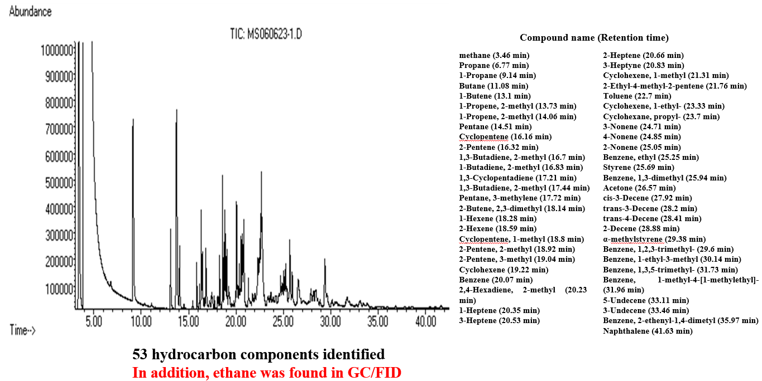
(a) silica (b) alumina
(c) calcium carbonate
(d) titanium oxide
(e) zinc oxide.

Figure S1 GC/MS chromatogram showing peaks representing hydrocarbon components synthesized over Al₂O₃ using a 316 stainless steel flow-through reactor (Figure S5(a)). Al₂O₃ (80 g) in the reactor was wetted with 10 wt.% H₂O at 293 K prior to the experiment. The experiment began with raising the temperature of the reactor to 800 K and simultaneously feeding CO₂ at 5 mL/min and H₂O (steam) at 1.0 g/h into the reactor, resulting in a reactant gas residence time of approximately 8 minutes. Product samples for GC/MS analysis were taken approximately 20 min after the reaction temperature reached 800 K. A total of 53 hydrocarbon compounds, including 36 aliphatic compounds, 10 aromatic compounds and 7 cyclic hydrocarbons, were identified.

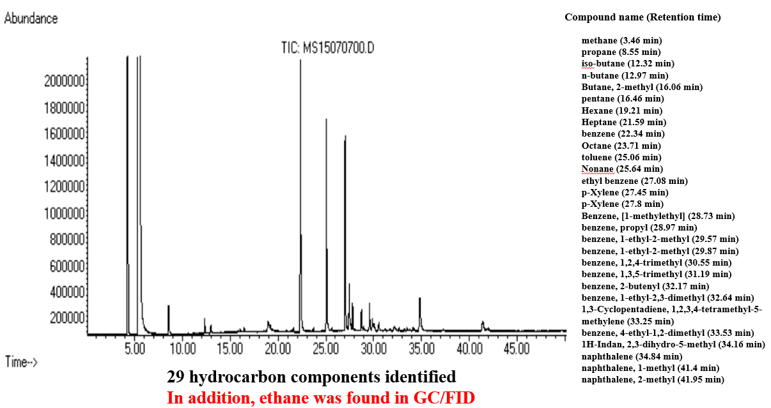

Figure S2 GC/MS chromatogram showing peaks representing hydrocarbon components synthesized over basalt using a 316 stainless steel batch reactor (Figure S5(c)). In the experiment, 85 g basalt and 4.5 g H₂O were placed in a small batch reactor (internal volume 53 mL), and the reactor was pressurized to 80 bar (38 bar CO₂ mixed with 42 bar Ar) at room temperature, after which the reaction temperature and pressure were raised to 673 K and 240 bar, respectively. Product samples were taken and analyzed by GC/MS after 27 days of hydrocarbon synthesis reactions in the reactor. A total of 29 hydrocarbon components, consisting of 10 aliphatic hydrocarbons, 17 aromatic hydrocarbons and 2 cyclic hydrocarbons, were identified.

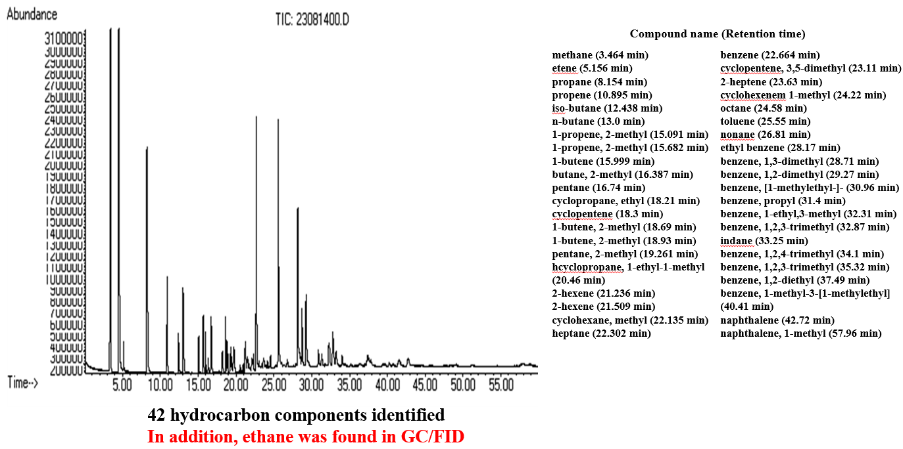

Figure S3 GC/MS chromatogram showing peaks representing hydrocarbon components synthesized over basalt using a batch reactor (Figure S5(c)). In the experiment, 60 g of basalt, 6 g of H₂O and 0.2 g of soybean oil were placed in the batch reactor, and then the reactor was pressurized to 80 bar with Ar at room temperature, after which the reaction temperature and pressure were raised to 673 K and 220 bar, respectively. Product samples were taken after 70 h of reaction and analyzed by GC/MS. A total of 42 hydrocarbon products consisting of 20 aliphatic hydrocarbons, 15 aromatic hydrocarbons and 7 cyclic hydrocarbons were identified.

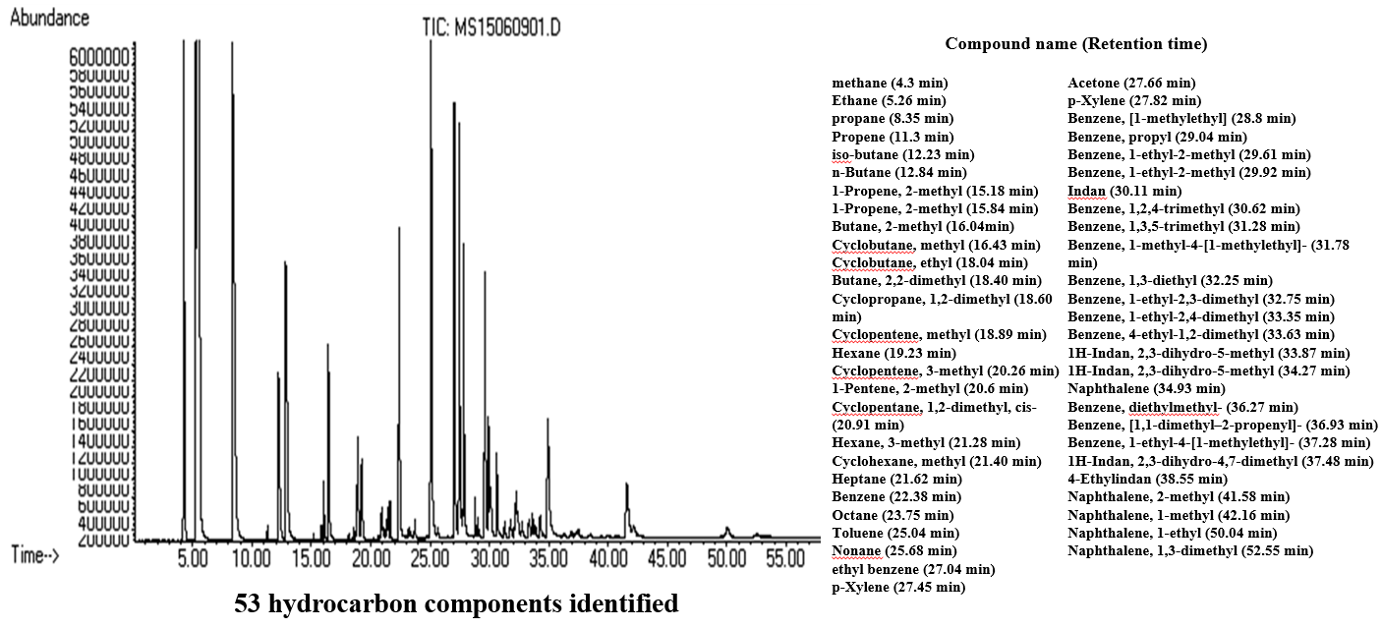

Figure S4 GC/MS chromatogram showing peaks representing hydrocarbon components synthesized over basalt using a batch reactor (Figure S5(c)). In the experiment, 85 g of basalt, 4.5 g of H₂O and 2.55 g of soybean oil were placed in the batch reactor, and then the reactor was pressurized to 80 bar (40 bar CO₂ mixed with 40 bar Ar) at room temperature, after which the reaction temperature and pressure were raised to 673 K and approximately 350 bar, respectively. Product samples were taken after 26 days of hydrocarbon synthesis reactions in the reactor and analyzed by GC/MS. A total of 53 hydrocarbon products, consisting of 17 aliphatic hydrocarbons, 24 aromatic hydrocarbons and 12 cyclic hydrocarbons, were identified.

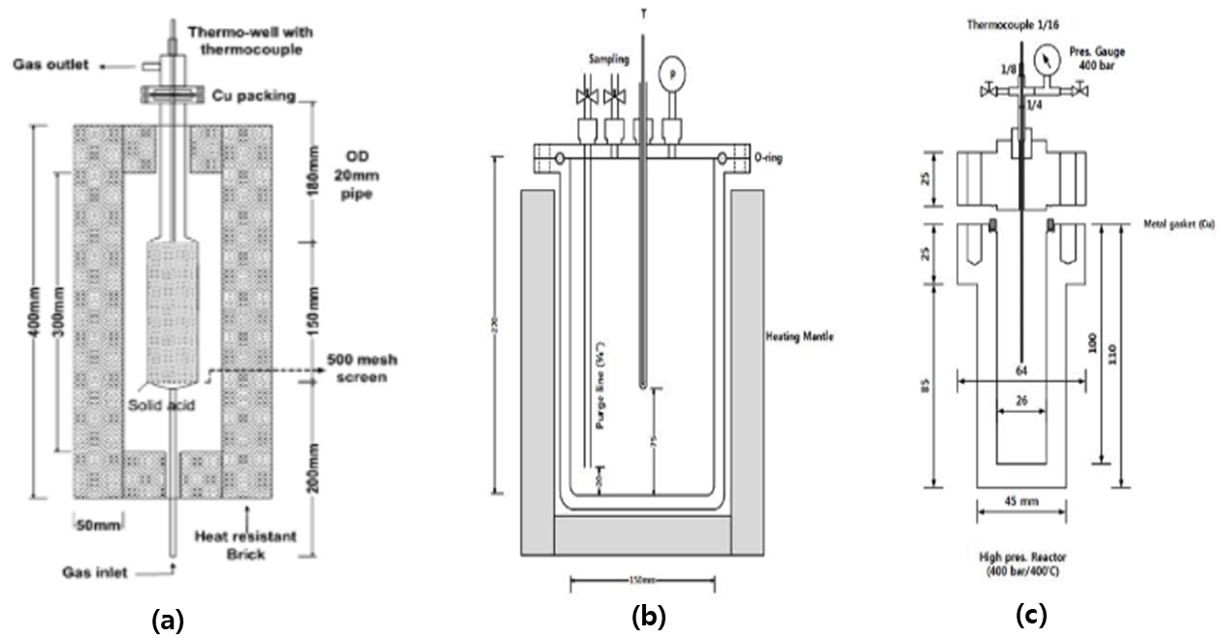

Figure S5 Schematic drawings of (a) the 316 stainless steel flow-through reactor, (b) the large 316 stainless steel batch reactor, and (c) the small 316 stainless steel batch reactor.

