Supplementary Fig.1
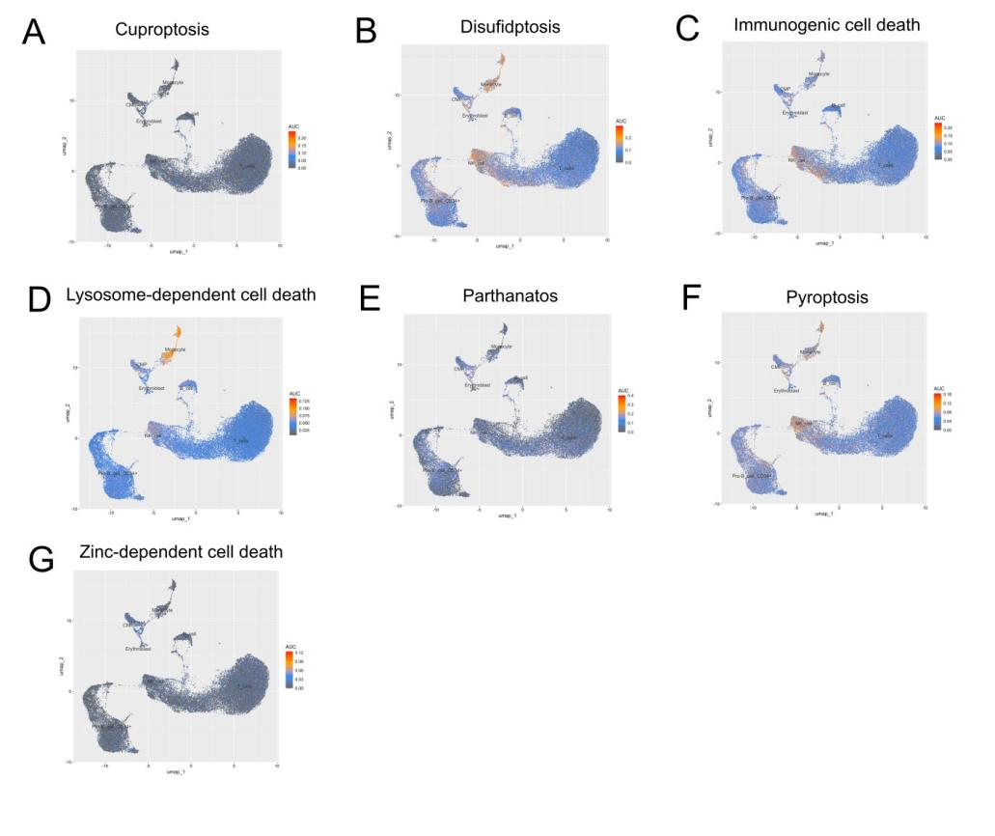
Supplementary Fig.1 The distribution of activity scores of cuproptosis(A), disufidptosis(B), immunogenic cell death(C), lysosome-dependent cell death(D), parthanatos(E), pyroptosis(F) and zinc-dependent cell death(G).

Supplementary Fig.2

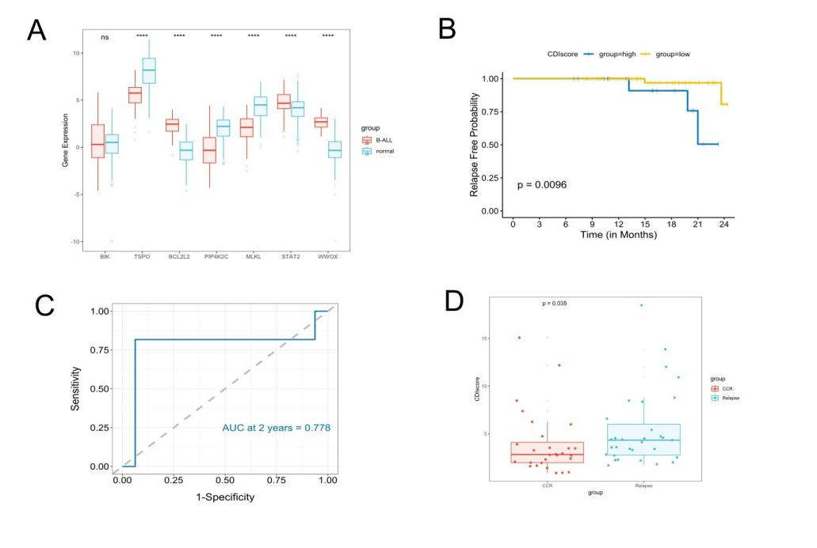
Supplementary Fig.2 Validation of CDI model. (A)Comparison of model gene expression levels between B-ALL and normal samples. (B)The Kaplan-Meier survival curves of the Nanfang cohort. (C)The time-dependent ROC curve of the Nanfang cohort. (D)Comparison of CDI scores between CCR and relapsed patients in GSE7440.

Supplementary Fig.3

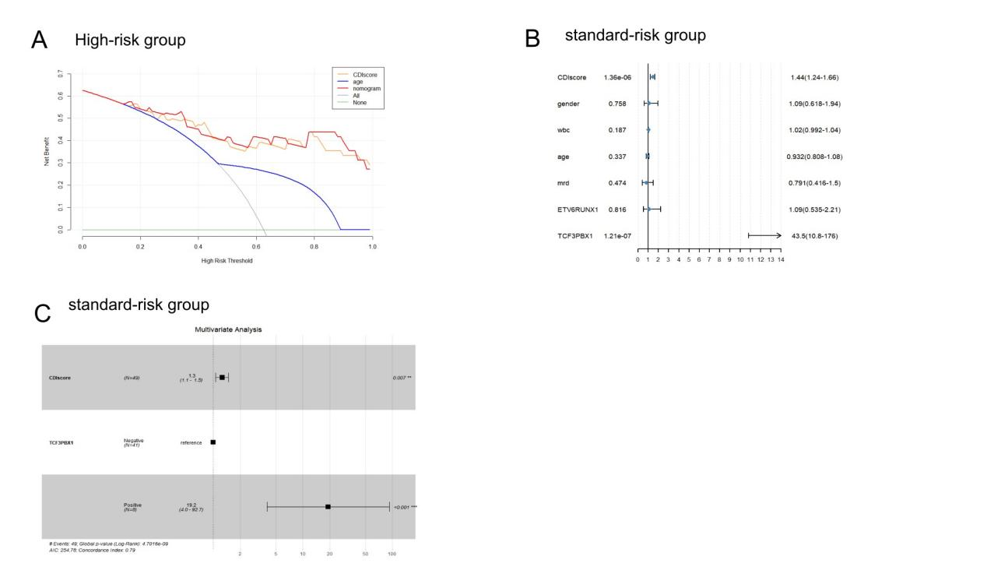
Supplementary Fig.3 (A) Decision curve according to the nomogram in high-risk group. (B) Univariate Cox regression analysis and (C) multivariate Cox regression analysis in standard-risk group.

