Supplementary Information
Supplementary Table
Supplementary Table 1. The primer sequences used in this study
KIND1 | Forward | 5'-ACTAATCCCTGTTGCCGATG-3'
KIND1 | Reverse | 5'-AGCCACCTGAGATGCAGAGT-3'
KIND1_CDS | Forward | 5’-AGAATTCATGCTGTCATCCACTGACTTTACA-3’
KIND1_CDS | Reverse | 5’-ATCTAGATCAATCCTGACCGCCGGTCAA-3’
GAPDH | Forward | 5’-GGCTGCTTTTAACTCTGGTA -3’
GAPDH | Reverse | 5’-ACTTGATTTTGGAGGGATCT-3’
CTNNB1 | Forward | 5’-GCAGAGTGCTGAAGGTGCTA-3’
CTNNB1 | Forward | 5’-TCTGTCAGGTGAAGTCCTAAAGC-3’
BIRC5 | Forward | 5’-GCCCTTTCTCAAGGACCACC-3’
BIRC5 | Reverse | 5’-GTTTCCTTTGCATGGGGTCG-3’
CCND1 | Forward | 5’-CAATGACCCCGCACGATTTC-3’
CCND1 | Reverse | 5’-AAGTTGTTGGGGCTCCTCAG-3’
PTGS2 | Forward | 5’-CTGTTGCGAGAAAGGAGTC-3’
PTGS2 | Reverse | 5’-TCATGGAAGATGCATTGGAA-3’
GLI1 | Forward | 5'-CTGAGCCTTATGGAGCGAGG-3'
GLI1 | Reverse | 5'-TTCAAGTCGAGGACACTGGC-3'
NOTCH1 | Forward | 5’-TCACACACGGAGGCATCCTA-3’
NOTCH1 | Reverse | 5’-CCCTCACTGGCATGACACA-3’
SMAD2 | Forward | 5’-GCTGGCCTGATCTTCACAGT-3’
SMAD2 | Reverse | 5’-CCAGAGGCGGAAGTTCTGTT-3’
CCND1_promoter site 1 primer | Forward | 5’-TAATTTGGGGCAGGTACTGTAA-3’
CCND1_promoter site 1 primer | Reverse | 5’-GTTACATGAGAGGGTCCCCA-3’
CCND1_promoter site 2 primer | Forward | 5’-TCAGGGATGGCTTTTGGGCT-3’
CCND1_promoter site 2 primer | Reverse | 5’-AACTTCAACAAAACTCCCCTGT-3’

Supplementary Table 2. Clinicopathological characteristics of the 359 cases
Characteristics | No. (%)
Age (mean, years) | 63.06±11.14
Sex
Male | 243 (67.7)
Female | 116 (32.3)
WHO grade
Well | 44 (12.3)
Moderate | 145 (40.4)
Poor | 170 (47.4)
Histologic type
Intestinal | 323 (90.0)
Diffuse | 36 (10.0)
Depth of invasion
EGC | 187 (52.1)
AGC | 172 (47.9)
pT classification
pT1 | 187 (52.1)
pT2 | 37 (10.3)
pT3 | 50 (13.9)
pT4 | 85 (23.7)
Lymphovascular invasion
Absent | 225 (62.7)
Present | 134 (37.3)
Perineural invasion
Absent | 255 (71.0)
Present | 104 (29.0)
Lymph node metastasisª
Absent | 206 (57.7)
Present | 151 (42.3)
Distant metastasis
Absent | 345 (96.1)
Present | 14 (3.9)
Stageª
I | 201 (56.3)
II | 43 (12.1)
III | 99 (27.7)
IV | 14 (3.9)
Recurrence
Absent | 290 (80.8)
Present | 69 (19.2)
Status
Alive | 311 (86.6)
Expire | 48 (13.4)
EGC, early gastric cancer; AGC, advanced gastric cancer.
ªCalculated with only 357 cases with available information.

Supplementary Figures
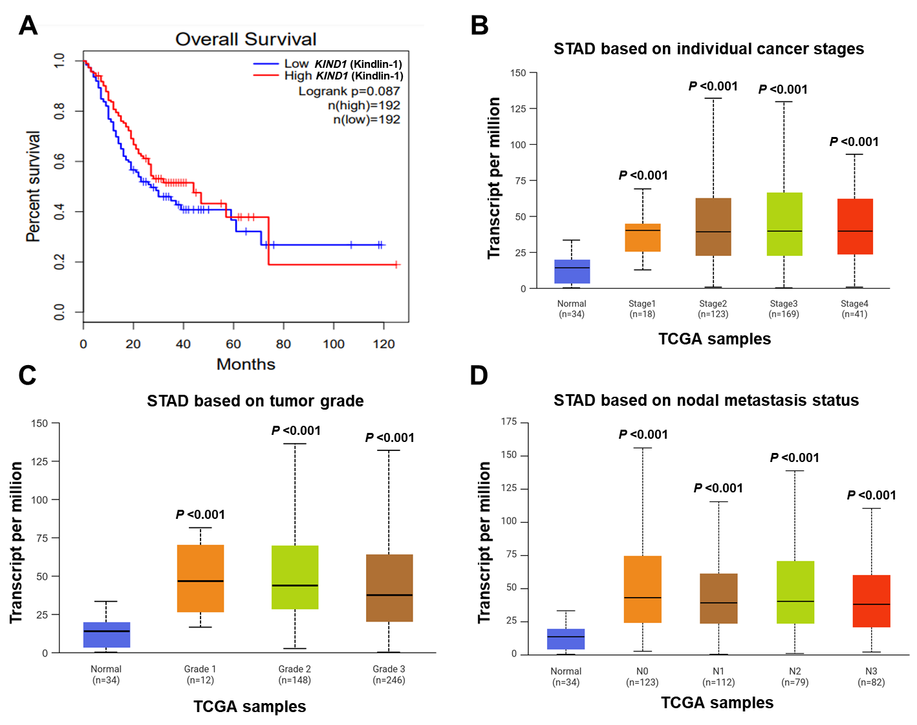
Supplementary Figure S1. Survival rate and stage-, grade-, and metastasis-status-specific analysis of Kindlin-1 expression using The Cancer Genome Atlas (TCGA) dataset. (A) Kaplan-Meier survival analysis demonstrating the impact of Kindlin-1 expression levels on overall survival in STAD patients. (B-D) Correlation between FERMT1 Expression and stage (n = 385), grade (n = 440), metastasis status (n= 430) of STAD Patients.
Supplementary Figure S2. The basal mRNA and protein expression levels of Kindlin-1 in gastric cancer cell lines. Kindlin-1 mRNA and protein expression levels in normal gastric epithelial cell (GES-1) and six human gastric cancer cell lines (AGS, MKN28, YCC-2, SNU-601, SNU-638, and SNU-668) were evaluated using RT-PCR and western blot analysis.
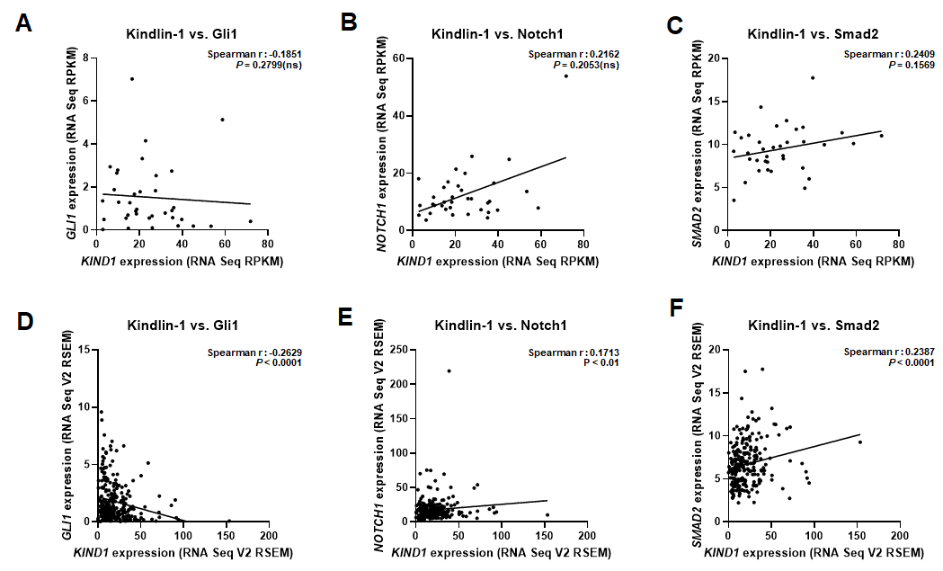
Supplementary Figure S3. Correlation between Kindlin-1 and three genes in patients with gastric cancer. Spearman correlation test showing the relationship between Kindlin-1 and three target gene in patients with gastric cancer. (A-C) mRNA expression data are obtained from TCGA (Firehose Legacy) RNA-seq RPKM (n = 36). (D-F) mRNA expression data are obtained from TCGA (Nature 2014) RNA-seq V2 RSEM (n = 258).
Supplementary Figure S4. Detection of mRNA and protein expression levels of Kindlin-1 with knockdown of CTNNB1. AGS and YCC-2 cell lines were transfected with scRNA or β-catenin-specific siRNA #1, #2 (β-catenin siRNA #1, #2). Silencing of β-catenin expression efficiency was performed ​by RT-PCR and western blot analysis.

Supplementary Figure S5. β-catenin–GSK3β protein interaction ability in Kindlin-1-overexpressed gastric cancer cells. SNU-601 cells were transfected with pcDNA_Empty or pcDNA_Kindlin-1. IP assay using anti-β-catenin and anti-GSK3β was performed to detect β-catenin interaction with GSK3β in SNU-601 cells.

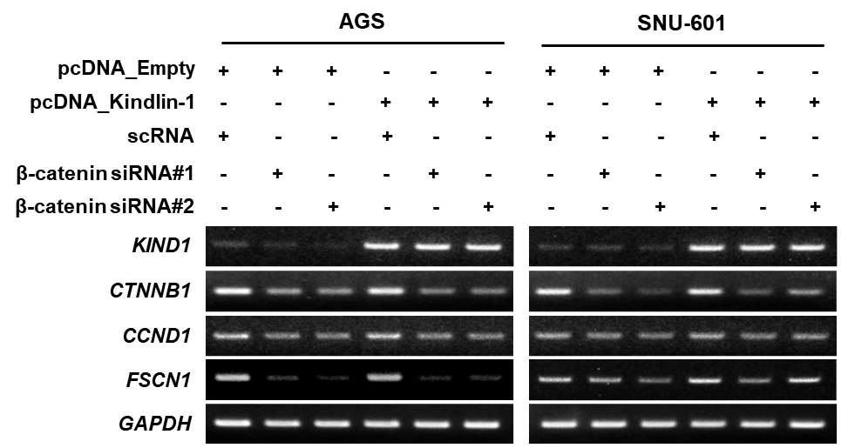

Supplementary Figure S6. Detection of mRNA expression of CCND1 and FSCN1 as a β-catenin target genes with Kindlin-1 overexpression and β-catenin Knockdown. Expression levels of β-catenin target genes were detected by RT-PCR in AGS and SNU-601 cells, which were transfected with kindlin-1 overexpression, and then followed by transfection with β-catenin siRNA or scrambled RNA as a negative control.

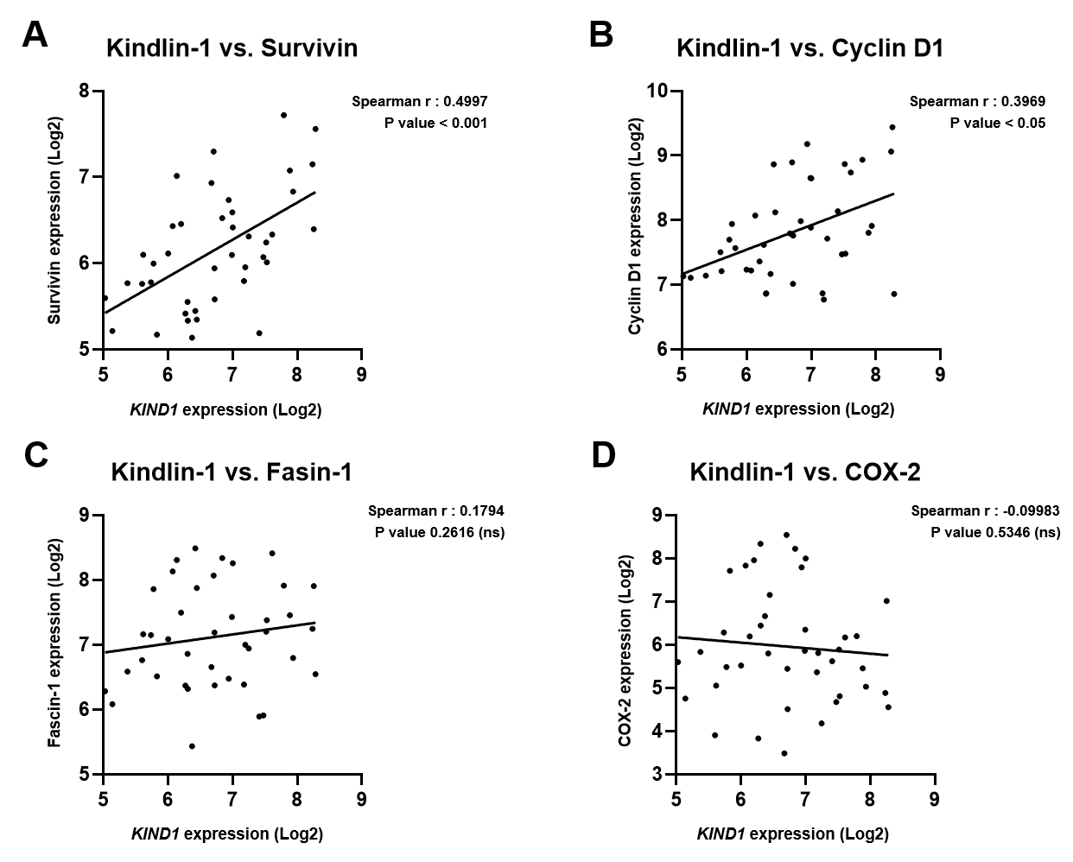
Supplementary Figure S7. Correlation between Kindlin-1 and β-catenin downstream target genes in patients with gastric cancer. (A-D) Spearman correlation analysis indicates the relationship between Kindlin-1 and fourβ-catenin downstream target genes in patients with gastric cancer based on data obtained from publicly available dataset, GSE63089 (n=41).

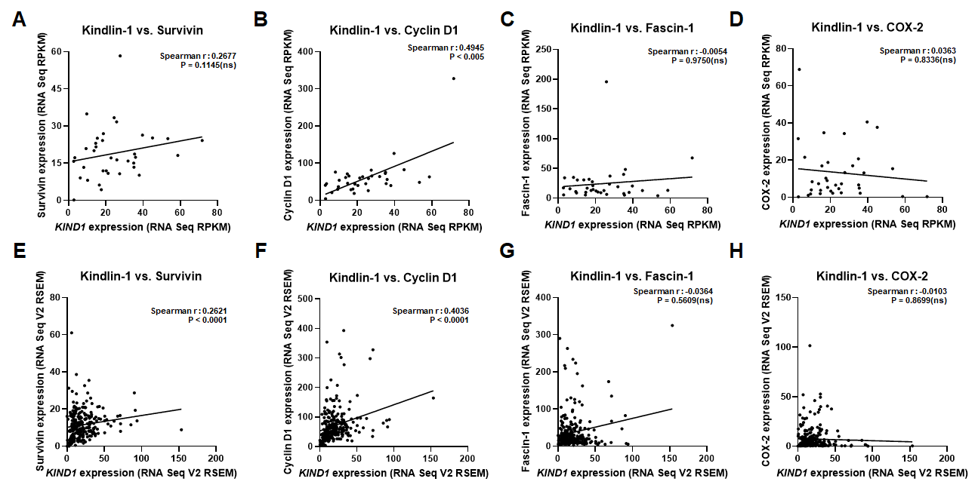
Supplementary Figure S8. Correlation between Kindlin-1 and β-catenin downstream target genes in patients with gastric cancer from TCGA dataset. Spearman correlation test showing the relationship between Kindlin-1 and β-catenin downstream target gene in patients with gastric cancer. (A-D) mRNA expression data are obtained from TCGA (Firehose Legacy) RNA-seq RPKM (n = 36). (E-H) mRNA expression data are obtained from TCGA (Nature 2014) RNA-seq V2 RSEM (n = 258).

