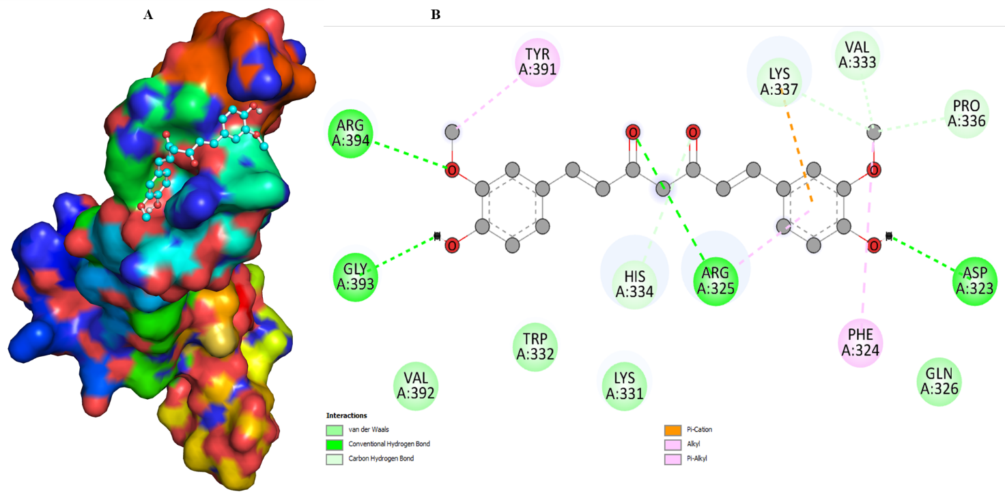
Figure S1: (A) Surface representation of TGFB3 protein and curcumin compound in ball-stick form. (B) 2D representation of TGFB3-curcumin interacting residues.
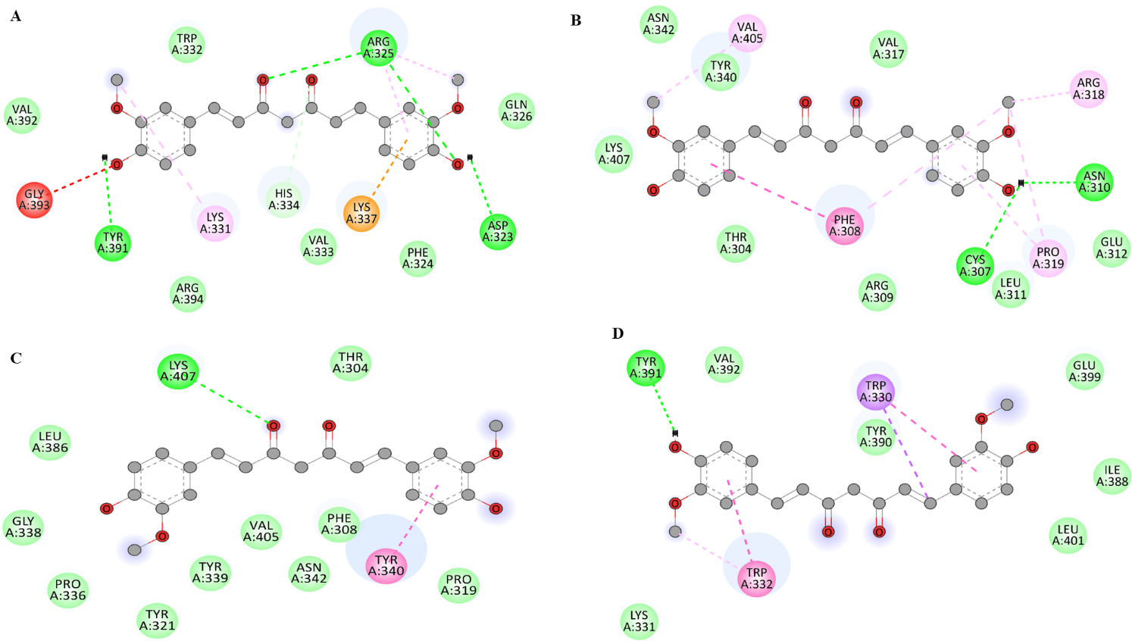

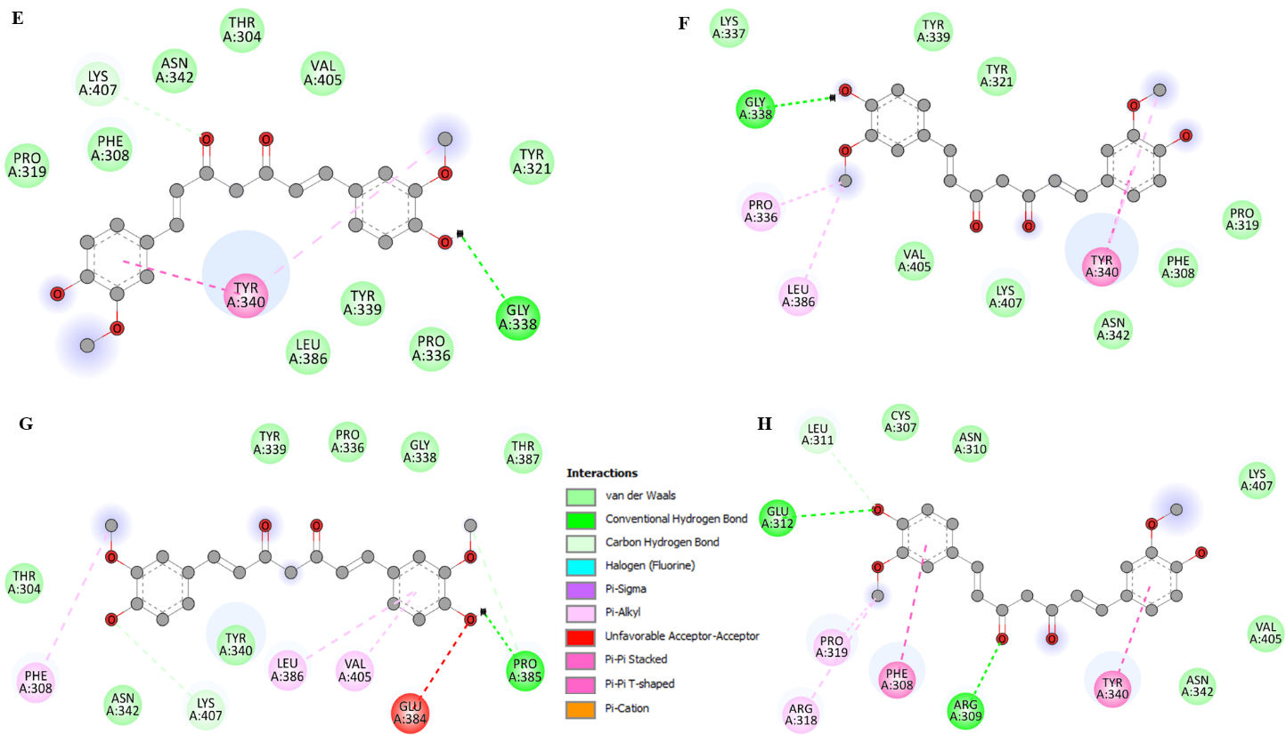
Figure S2: 2D interaction view of TGFB3 with curcumin’s 8 conformers.

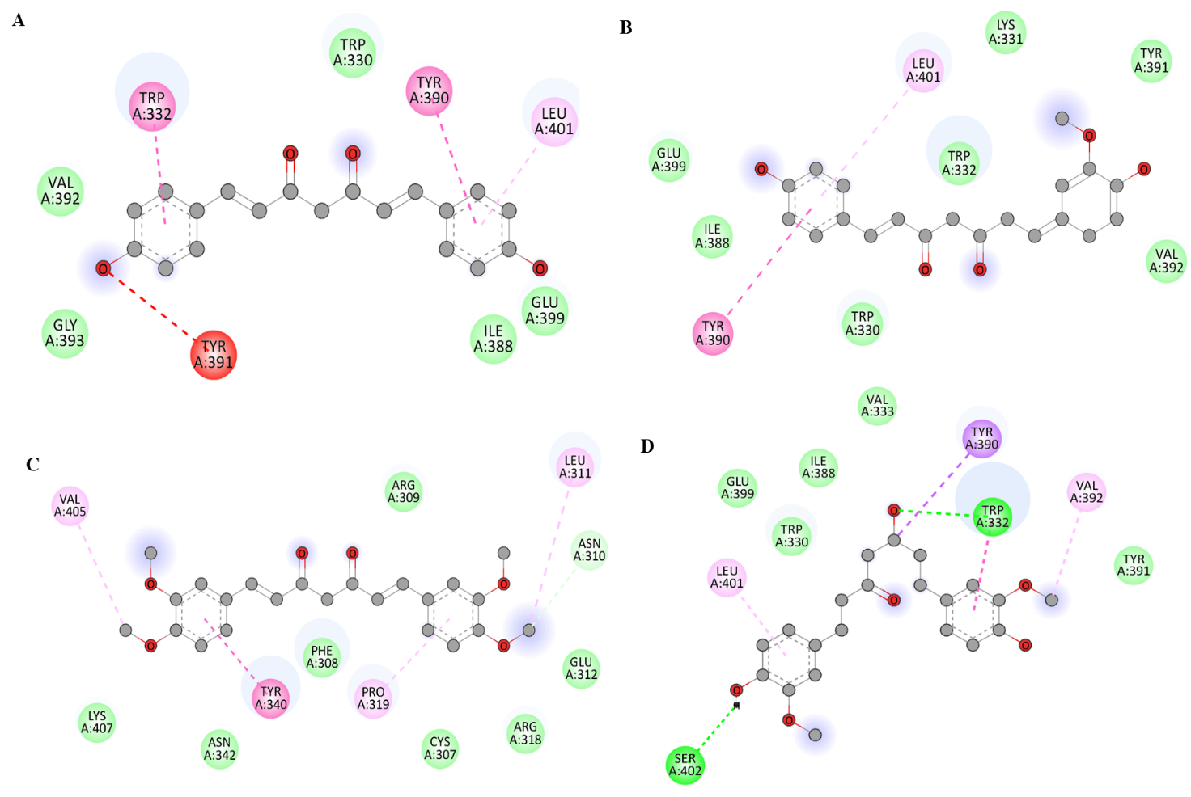
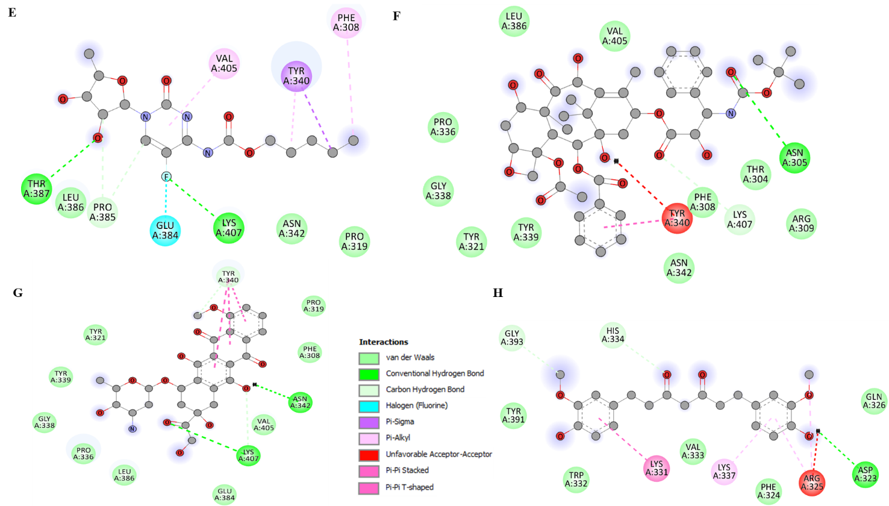
Figure S3: 2D representation of TGFB3 interacting with curcumin analogs and FDA approved drugs (A) Bisdemethoxycurcumin (B) Demethoxycurcumin (C) Dimethoxycurcumin (D) Hexahydrocurcumin (E) Capecitabine (D) Docetaxel (F) Doxorubicin and (G) Tetrahydrocurcumin

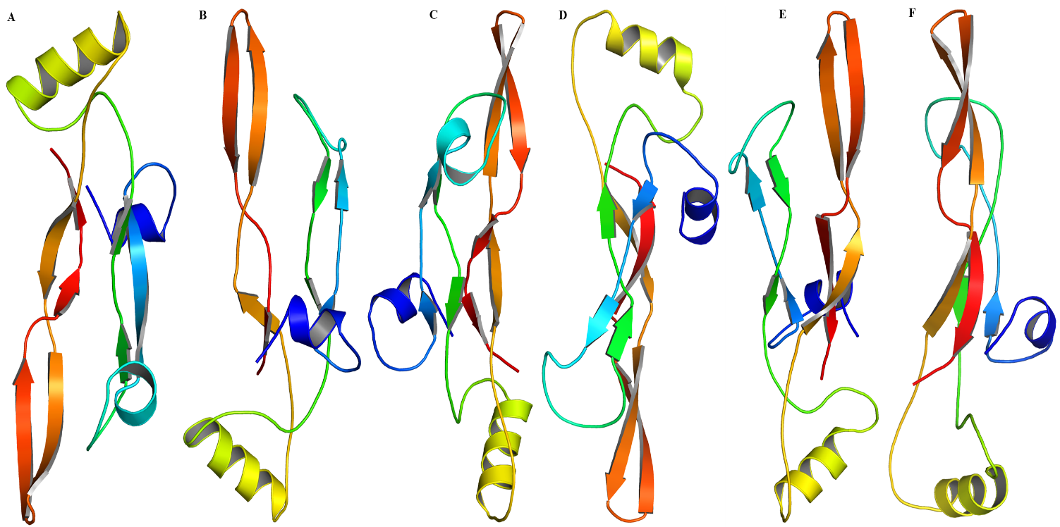
Figure S4: Snapshot of TGFB3 protein at different time period. (A) 0ns (B) 100ns (C) 200ns (D) 300ns (E) 400ns and (F) 500ns.
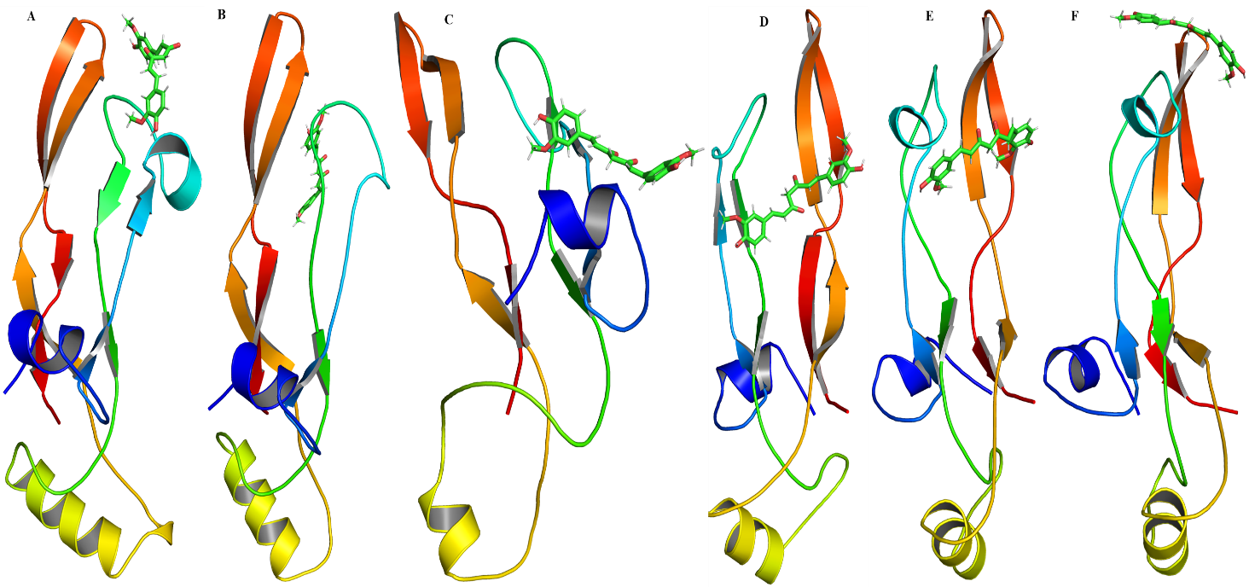
Figure S5: Snapshot of TGFB3-curcumin complex at different time period. (A) 0ns (B) 100ns (C) 200ns (D) 300ns (E) 400ns and (F) 500ns.

Table S1: Binding energy of Curcumin, its analogs and FDA approved drugs towards TGFB3 protein.
Protein | PubChem & Drug bank ID | Ligand | Binding Energy (kcal/mol) | pKi
TGFB3 | 969516 | Curcumin | -6.3 | 4.62
TGFB3 | DB00997 | Doxorubicin | -6.3 | 4.62
TGFB3 | 9952605 | Dimethoxycurcumin | -6.2 | 4.55
TGFB3 | 5315472 | Bisdemethoxycurcumin | -6.1 | 4.47
TGFB3 | 124072 | Tetrahydrocurcumin | -6.1 | 4.47
TGFB3 | 5318039 | Hexahydrocurcumin | -6.1 | 4.47
TGFB3 | DB01101 | Capecitabine | -5.9 | 4.33
TGFB3 | 5469424 | Demethoxycurcumin | -5.8 | 4.25
TGFB3 | DB01248 | Docetaxel | -5.5 | 4.03

Table S2: Predicted biological activity of curcumin with higher Pa value.
Compound | Pa | Pi | Activity
Curcumin | 0,814 | 0,004 | Antimutagenic
Curcumin | 0,677 | 0,019 | Anti-inflammatory
Curcumin | 0,672 | 0,031 | Antineoplastic
Curcumin | 0,611 | 0,012 | Anticarcinogenic
Curcumin | 0,494 | 0,015 | Antileukemic

