Tab1e 1 miRNA Primer Sequences
miRNA | Primer Sequences
hsa-mir-338-3p | 5'-UCCAGCAUCAGUGAUUUUGUUG-3'
hsa-mir-1250-5p | 5'-CCACGGTGCTGGATGTGGCCTTT-3'
hsa-mir-3605-5p | 5'-GCGCGCGTCAACAAAATCACTGATGCT-3'

A | 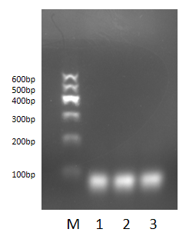 | B | 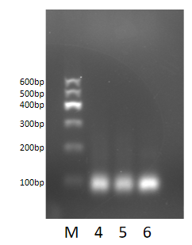
Fig.1 Gels images of miRNA and U6
PCR products were analyzed using agarose gel electrophoresis(1%) stained with Genegreen Nucleic Acid Dye. Gel images of miRNA and U6 were visualized. U6 was used as an internal reference.Lanes: M:Maker, (1)(2)(3) miRNA, (4)(5)(6)U6.

A | B
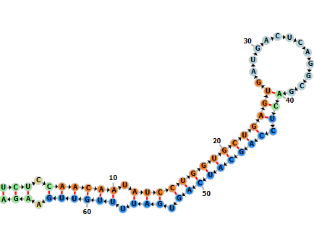 | 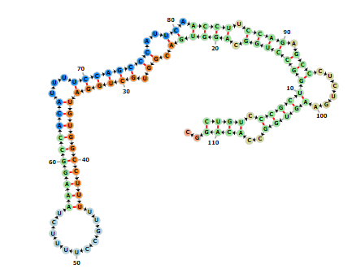
C
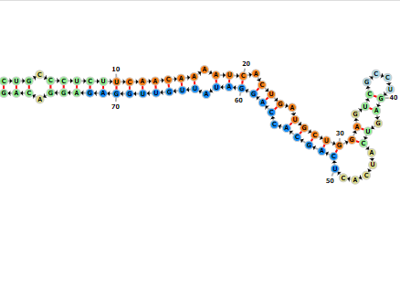
Fig.2 The predicted structure of miRNA-338, miRNA-1250 and miRNA-3065
A.miR-338(hsa-mir-338),B. miR-1250(hsa-mir-1250).C.miR-3065(hsa-mir-3065). miR-338, miR-1250 and miR-3065 are all locate in chr17.From miRCarta V1.1(https://mircarta.cs.uni-saarland.de/advanced _search/)
Tab1e 2 Demographic information, clinical characteristics
Variables | Experimental group  (n=83) | Control group  (n=50) | P
Age(mean±SD) | 62.5±10.6 | 60.0±7.0 | 0.107
Sex(men:women) | 52:31 | 34:16 | 0.532
Dyslipidemia, n（%） | 39（47.0%） | 20（40.0%） | 0.432
Course of disease | 2.6±2.8 | NA | NA
Admission NIHSS score | 6.3±7.1 | NA | NA
Discharge NIHSS score | 4.6±6.9 | NA | NA
Discharge MRS score | 1.8±1.7 | NA | NA
n: number of subjects,%: frequency, NIHSS: National Institutes of Health Stroke Scale, mRS: modified Rankin Scale,
Tab1e 3 The expression levels of miRNA-338-3p, miRNA-1250-5p, and miRNA-3065-5p between the experimental and control groups
miRNA | Experimental group  （n=83） | Control group  （n=50） | P
miRNA-338-3p | 1.87±0.22 | 1.25±0.11 | 0.309
miRNA-1250-5p | 2.04±0.22 | 1.54±0.33 | 0.002
miRNA-3065-5p | 6.41±2.17 | 1.42±0.24 | <0.001
miRNA-338-3p/miRNA-1250-5p/miRNA-3065-5p clusters | - | - | 0.008
Bold characters highlight all significant p-values
A | B | C
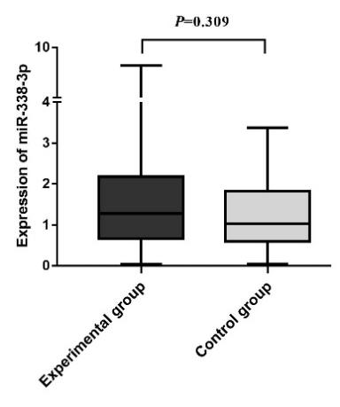 | 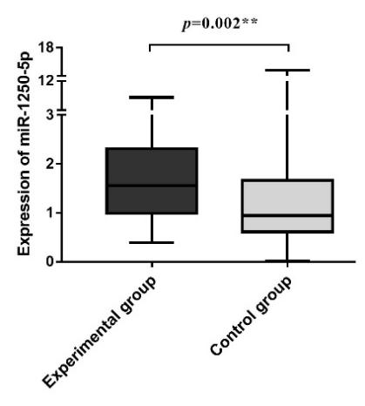 | 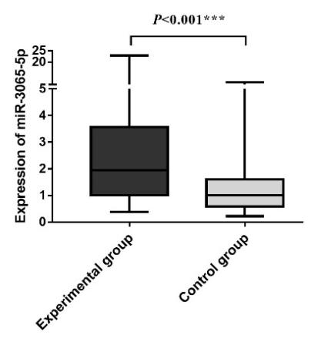
Fig.3 The expression levels of miRNA-338-3p, miRNA-1250-5p, and miRNA-3065-5p in PBMCs between the experimental and control groups.
(A) The expression level of miRNA-338-3p in the experimental group was higher than in the control group. However, this difference was not statistically significant. (B) The expression level of miRNA-1250-5p in the experimental group was higher than that in the control group, and the difference between the two groups was statistically significant. (C) The expression level of miRNA-3065-5p in the experimental group was also higher than in the control group, with a statistically significant difference observed between the two groups. *P<0.05,**P<0.01,***P<0.001

Tab1e 4 The analysis of the expression levels of miRNA-338-3p, miRNA-1250-5p, and miRNA-3065-5p in the experimental group
Variables |  | Experimental group（n=83）
 |  | miRNA-338-3p |  | miRNA-1250-5p |  | miRNA-3065-5p |  | P
 |  | ±s | P | ±s | P | ±s | P
Age | ≤45 year  (5,6.0%) | 2.0±1.0 | 0.248 | 1.1±0.7 | 0.126 | 2.6±0.9 | 0.533 | 0.714
Age | ＞45year  (78,94.0%) | 1.9±2.0 |  | 2.1±2.0 |  | 3.9±4.9
Course of disease | ≤24 hour  (50,60.2%) | 1.9±2.0 | 0.859 | 1.8±1.7 | 0.040 | 3.6±4.7 | 0.111 | 0.495
Course of disease | 7day≥and＞1day  (27,32.5%) | 2.0±2.1 |  | 2.7±2.4 |  | 4.7±5.3
Course of disease | 14day≥and＞7day  (6,7.2%) | 1.3±0.6 |  | 1.2±0.7 |  | 1.5±0.6
TOAST classification | LAA(33,39.8%) | 1.8±2.0 | 0.505 | 2.0±1.9 | 0.300 | 4.0±4.7 | 0.579 | 0.918
 | CE(37,44.6%) | 1.9±1.5 |  | 2.8±3.1 |  | 5.1±7.6
 | SAA(11,13.3%) | 2.0±2.2 |  | 2.0±1.6 |  | 3.4±3.9
 | SOE(2,2.4%) | 2.2±0.3 |  | 0.7±0.4 |  | 1.9±0.3
 | SUE(0,0.0%) | - |  | - |  | -
Length of stay | LOS≤14day(38,45.8%) | 1.8±1.9 | 0.909 | 2.0±2.0 | 0.725 | 3.6±5.1 | 0.113 | 0.979
 | LOS>14day (45,54.2%) | 1.9±2.1 |  | 2.1±2.0 |  | 4.0±4.5
admission NIHSS score | ≤3 (43,51.8%) | 1.6±2.0 | 0.209 | 2.0±1.8 | 0.594 | 1.6±2.0 | 0.209 | 0.252
admission NIHSS score | ＞3 (40,48.2%) | 2.1±2.0 |  | 2.1±2.1 |  | 2.1±2.0
discharge NIHSS score | ≤3(52,62.7%) | 1.6±1.9 | 0.030 | 2.1±2.1 | 0.735 | 3.3±4.4 | 0.049 | 0.156
discharge NIHSS score | ＞3(31,37.3%) | 2.4±2.1 |  | 2.0±1.6 |  | 4.6±5.3
discharge mRS score | ≤2 (53,63.9%) | 1.6±1.8 | 0.070 | 1.8±1.7 | 0.278 | 6.1±23.6 | 0.007 | 0.086
discharge mRS score | ≥3 (30,36.1%) | 2.4±2.2 |  | 2.4±2.4 |  | 7.0±10.3
All significant p-values are highlighted by bold chaeacters. TOAST: Trial of Org10172 in Acute Stroke Treatment, LAA: large artery atherosclerosis, CE: cardioembolism, SAA: small vessel occlusion, SOE: stroke of other etiology, SUE: stroke of unknown etiology

A | B
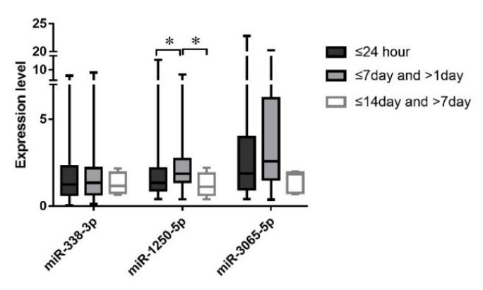 | 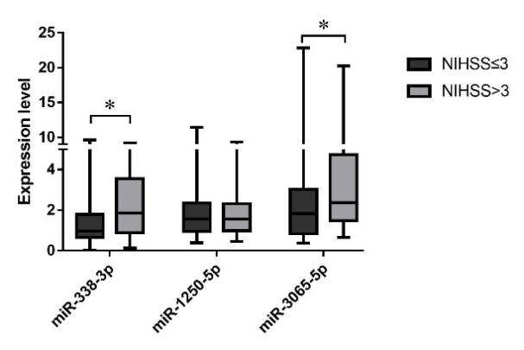
C
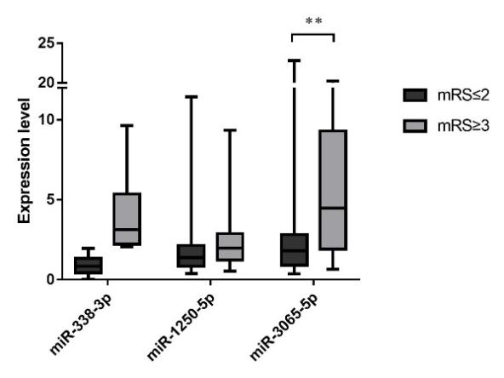
Fig. 4 The expression levels of miRNA-338-3p, miRNA-1250-5p, and miRNA-3065-5p in different groups.
(A)The expression levels of miRNA-338-3p, miRNA-1250-5p, and miRNA-3065-5p were analyzed between groups according to the stages of the disease. The difference in miRNA-1250-5p expression between groups was statistically significant. (B) The expression levels of miRNA-338-3p, miRNA-1250-5p, and miRNA-3065-5p were evaluated between groups based on the discharge NIHSS score. The differences in miRNA-338-3p and miRNA-3065-5p expression between groups were statistically significant. (C) The expression levels of miRNA-338-3p, miRNA-1250-5p, and miRNA-3065-5p were compared between groups according to discharge mRS scores. The difference in miRNA-3065-5p expression between groups was statistically significant. *P<0.05, **P<0.01, ***P<0.001.

Tab1e 5 The correlational analysis between miRNA-338-3p,miRNA-1250-5p,miRNA-3065-5p, and clinical parameters in patients with IS
Variables | Experimental group（n=83）
Variables | miRNA-338-3p |  | miRNA-1250-5p |  | miRNA-3065-5p
Variables | R | P | R | P | R | P
Age | -0.127 | 0.254 | 0.127 | 0.252 | 0.022 | 0.842
Gender(Female) | -0.100 | 0.365 | 0.005 | 0.963 | 0.060 | 0.591
Course of disease | 0.063 | 0.572 | 0.141 | 0.204 | 0.078 | 0.483
admission NIHSS score | 0.192 | 0.082 | 0.045 | 0.689 | 0.227 | 0.039
TOAST classification(LAA) | 0.129 | 0.244 | 0.051 | 0.644 | -0.118 | 0.287
Length of stay | 0.071 | 0.525 | 0.140 | 0.207 | 0.243 | 0.027
discharge NIHSS score | 0.189 | 0.086 | -0.044 | 0.696 | 0.207 | 0.060
discharge mRS score | 0.261 | 0.017 | 0.130 | 0.242 | 0.297 | 0.006
White blood cell count (×10⁹/L) | 0.095 | 0.395 | 0.105 | 0.346 | -0.048 | 0.667
Percentage of neutrophils(%) | 0.311 | 0.004 | 0.270 | 0.014 | 0.248 | 0.024
Percentage of mononuclear cells(%) | -0.123 | 0.267 | 0.095 | 0.391 | -0.120 | 0.279
Percentage of lymphocytes(%) | -0.415 | ＜0.001 | -0.314 | 0.004 | -0.219 | 0.046
haemoglobin(g/L) | -0.081 | 0.468 | -0.175 | 0.114 | -0.141 | 0.204
Red blood cell count (×10¹²/L) | -0.023 | 0.834 | -0.156 | 0.160 | -0.075 | 0.502
Platelet count(×10⁹/L) | -0.069 | 0.533 | -0.001 | 0.991 | -0.055 | 0.621
NIHSS: National Institutes of Health Stroke Scale, mRS: modified Rankin Scale, TOAST classification: Trial of Org10172 in Acute Stroke Treatment, R： Coefficient of correlation

Table 6 The correlational analysis between miRNA-338-3p,miRNA-1250-5p, and miRNA-3065-5p
Coefficient | Experimental group(n=83) |  |  | Total(n=133)
 | miRNA-338-3p  and miRNA-1250-5p | miRNA-338-3p  and miRNA-3065-5p | miRNA-1250-5p  and miRNA-3065-5p | miRNA-338-3p  and miRNA-1250-5p | miRNA-338-3p  and miRNA-3065-5p | miRNA-1250-5p  and miRNA-3065-5p
Correlation coefficient | 0.381 | 0.422 | 0.531 | 0.234 | 0.356 | 0.452
P | <0.001ª | <0.001ª | <0.001ª | 0.007ª | <0.001ª | <0.001ª
a Based on Spearman correlation, All significant p-values are highlighted by bold chaeacters

A | B
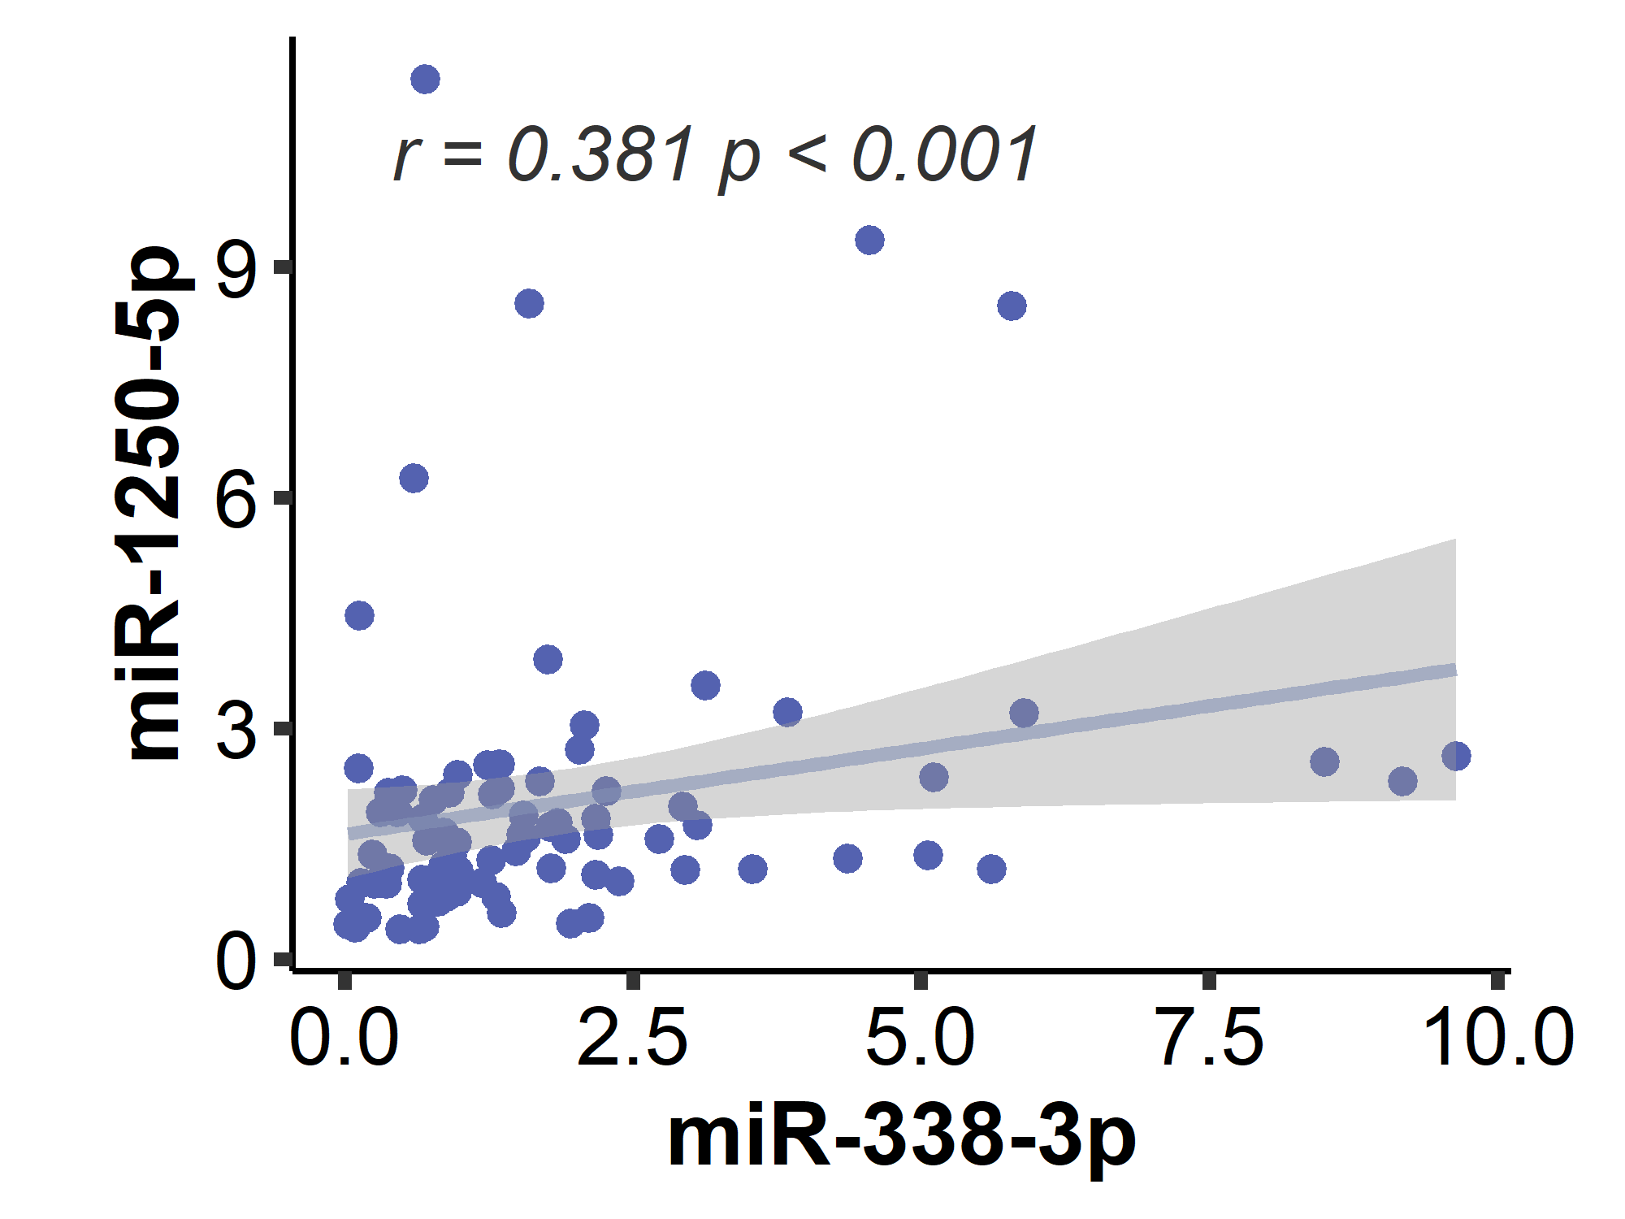 | 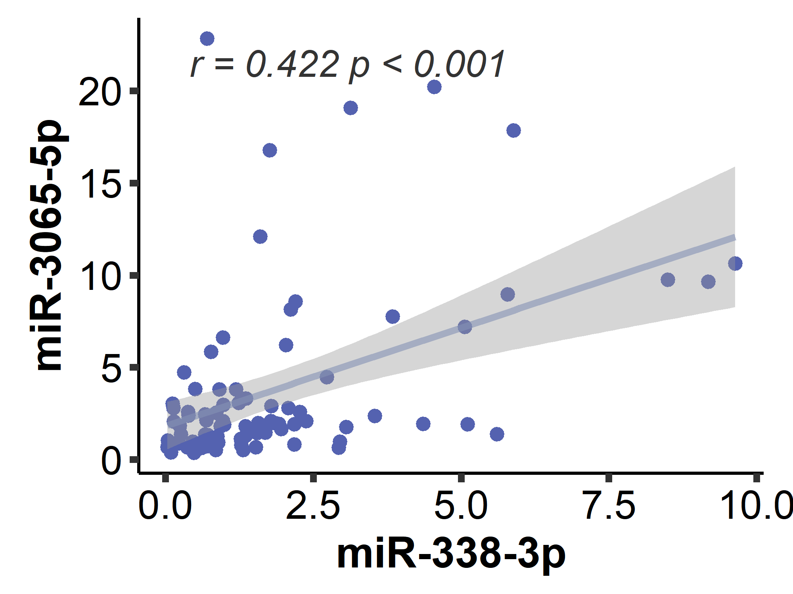
C | D
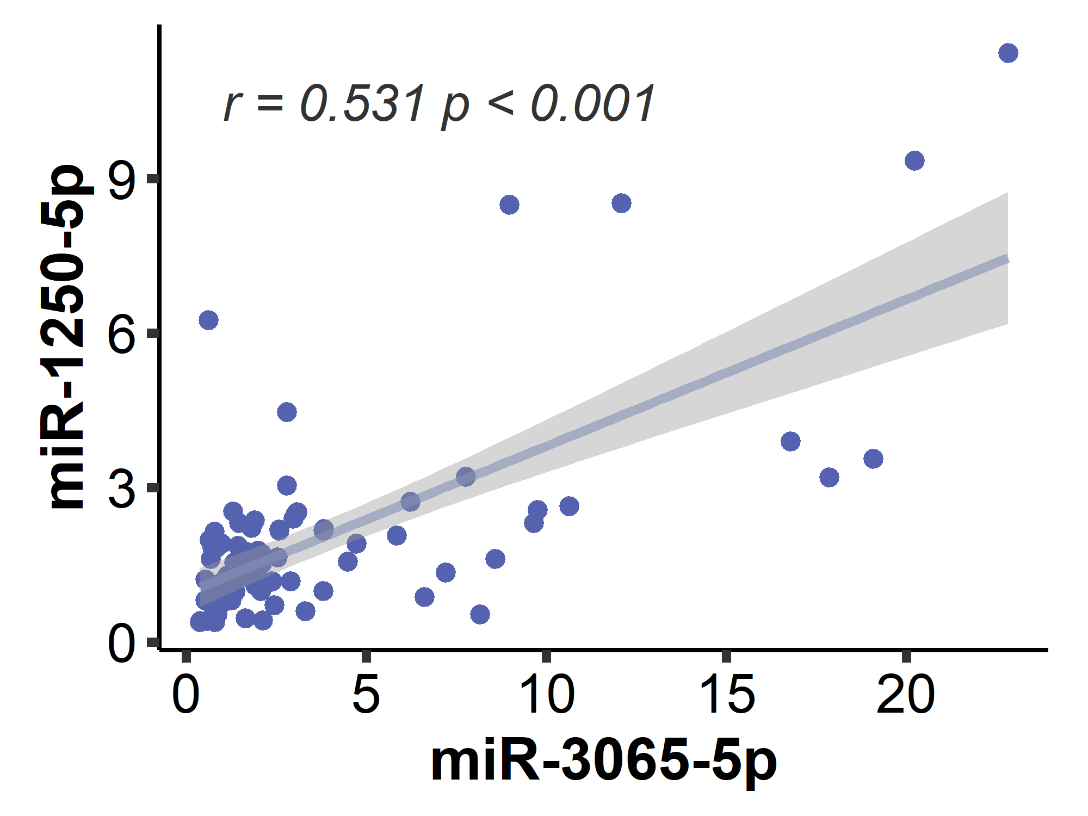 | 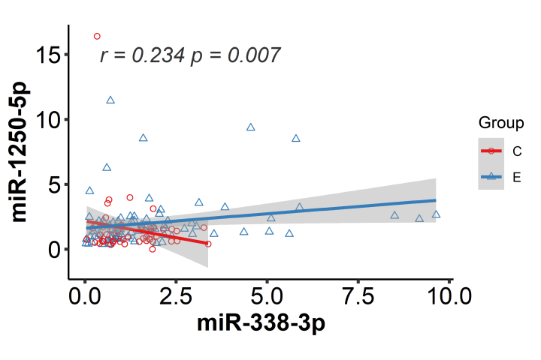
E | F
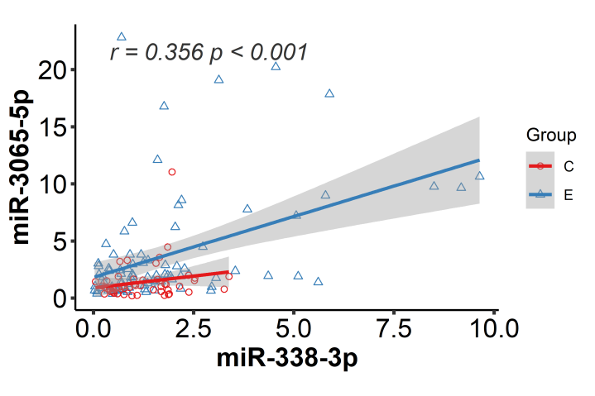 | 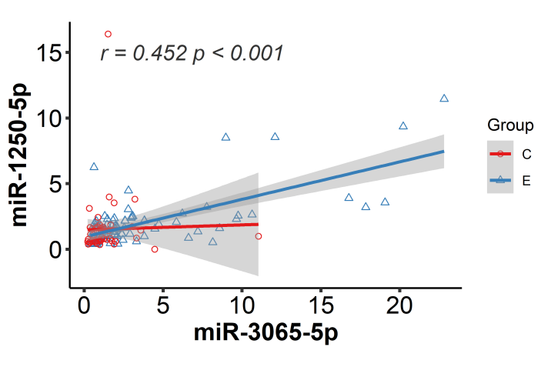
Fig.5 The correlational analysis between miRNA-338-3p,miRNA-1250-5p, and miRNA-3065-5p groups
E: Experimental group, C: Control group. (A), (B) and (C) illustrate the correlations between miRNA-338-3p, miRNA-1250-5p, and miRNA-3065-5p in the experimental group, while (D), (E), and (F) depict these correlations in the overall population. A: In the experimental group, miRNA-338-3p was positively correlated with miRNA-1250-5p (r=0.381, p<0.001). B: In the experimental group, miRNA-338-3p was positively correlated with miRNA-3065-5p (r=0.422, p<0.001). C: In the experimental group, miRNA-1250-5p was positively correlated with miRNA-3065-5p (r=0.531, p<0.001). D: In the experimental group, miRNA-338-3p was positively correlated with miRNA-1250-5p. In the control group, miRNA-338-3p was negatively correlated with miRNA-1250-5p, while a positive correlation was observed in the total population (r=0.234, p=0.007). E: miRNA-338-3p positively correlated with miRNA-3065-5p in the experimental, control group, and total population (r=0.356,p<0.001). F: miRNA-1250-5p was positively correlated with miRNA-3065-5p in the experimental group, control group, and total population (r=0.452,p<0.001).
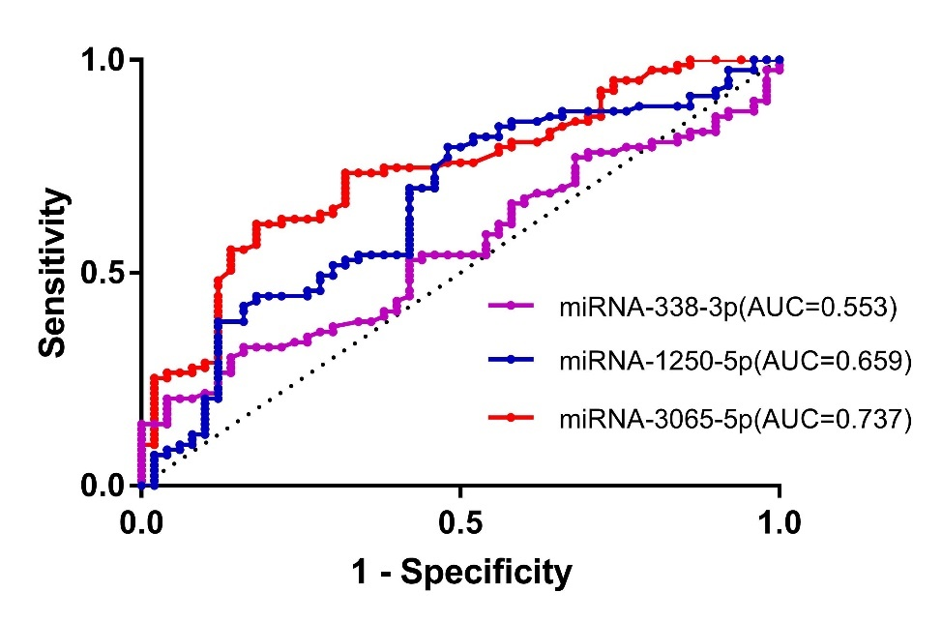
Fig.6 The ROC of miRNA-338-3p, miRNA-1250-5p and miRNA-3065-5p

Table 7. Summary of outcomes from the measurement of peripheral miR-338-3p/miRNA-1250-5p/miRNA-3065-5p in IS
Main Outcome | Studies | Experimental /Controls | p-Values
Lower miRNA-338-3p in experimental versus controls | Wei H et al.,[9] | 6/6 | P＜0.001
Lower miRNA-338-3p in experimental versus controls | Chen C et al.,[18] | 98/85 | P＜0.001
Lower miRNA-338-3p in experimental versus controls | Teng L et al.,[19] | 256/256 | P＜0.001
Higher miRNA-338-3p in experimental versus controls | Li L et al.,[17] | 8/8 | P＜0.05
Higher miRNA-338-3p in experimental versus controls | Peng G et al.,[15] | 72/51 | P=0.056
miRNA-1250-5p in IS | NA
miRNA-3065-5p in IS | NA

