Supplementary Material

Figure S1 Shift in rs-fc and dimensional treatment response in Cluster 2 (Ver6-L PreCG).

Table S1 Association between rs-fc shift (Cluster 2) and categorical treatment response (responder vs non-responder, based on ∆BAARS-IV>30%) when applying Bootstrapping (1000 iterations).

Table S2 Association between rs-fc shift (Cluster 2) and categorical treatment response (responder vs non-responder, based on ∆BAARS-IV>30%) while correcting for additional potential confounders (handedness and head motion).

Table S3 Pairwise comparisons between rs-fc in the total ADHD group (following placebo [PLC] and methylphenidate [MPH]), and the non-responders (NResp, n=16) and responders (Resp, n=40) within the ADHD group following PLC and MPH ;and the rs-fc baseline measure obtained in the neurotypicals (p-values are uncorrected).

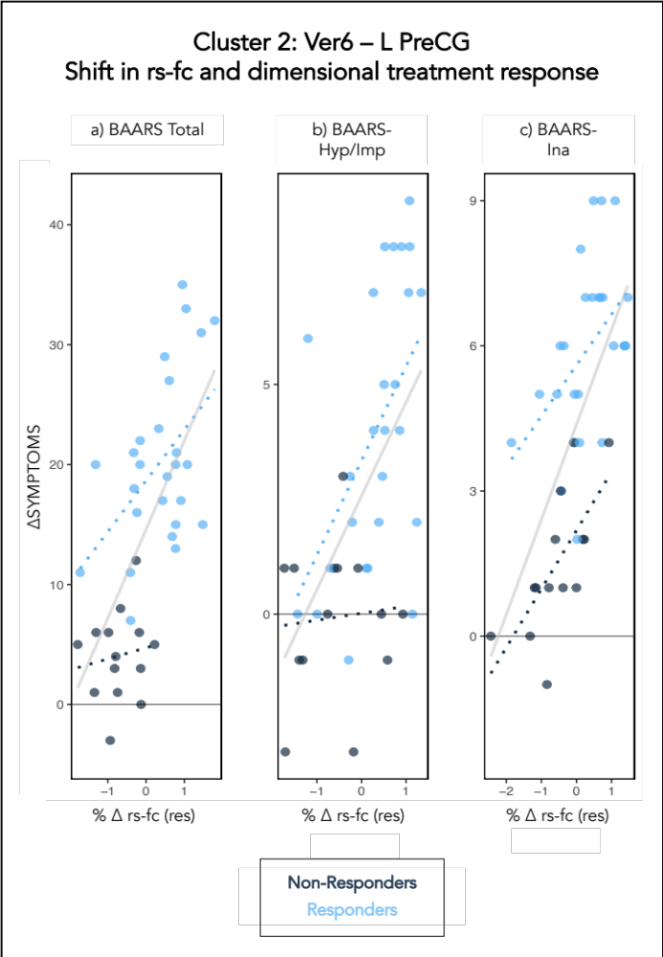
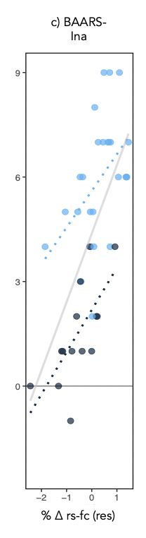
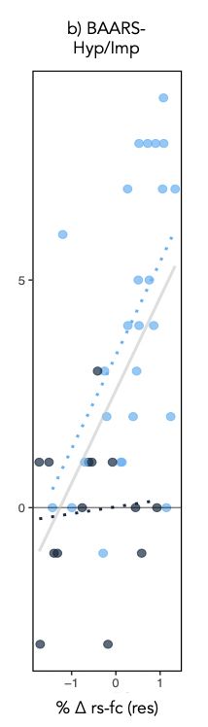
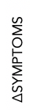

Figure S1 Shift in rs-fc and dimensional treatment response in Cluster 2 (Ver6-L PreCG). Each plot shows the drug-induced percentage-wise shift ((T2-T1)/T1) (residuals, i.e., corrected for confounders) (x-axis) in relation to the change in clinical symptoms (T2-T1) (y-axis) for the BAARS Hyperactivity/Impulsivity domain, and the BAARS Inattention domain for the non-responders (black) and responders (blue) within the ADHD group. Abbreviations: rs-fc, resting state functional connectivity; BAARS-Ina, Barkley Adults ADHD Rating Scale-Inattention; BAARS-Hyp/Imp, Barkley Adults ADHD Rating Scale- Hyperactivity/Impulsivity; res, residuals (corrected for age, baseline severity, dose, IQ, and weight).

Table S1 Association between rs-fc shift (Cluster 2) and categorical treatment response (responder vs non-responder, based on ∆BAARS-IV>30%) when applying Bootstrapping (1000 iterations). Specifically, the included connections are those between the Vermis 6 and the left postcentral gyrus; and between the Vermis 6 and the left precentral gyrus. Significantly contributing functional connections are highlighted in bold. b, unstandardized regression coefficient (beta); CI, confidence interval; Exp(B), odds ratio; FSIQ, full-scale IQ; Std, standard deviation. b=based on 998 samples
Model statistics | Independent variables | b | Bias | Std Error | Bootstrap  p | 95% CI Lower | 95% CI Upper
χ²(7)=22.740, p=.002, Nagelkerke R²=.597 | constant | -5.375 | -216.410^{b} | 1494.597^{b} | .171^{b} | -1883.170^{b} | 228.679^{b}
χ²(7)=22.740, p=.002, Nagelkerke R²=.597 | Age | 0.04 | 1.405^{b} | 24.034^{b} | .450^{b} | -15.102^{b} | 25.190^{b}
χ²(7)=22.740, p=.002, Nagelkerke R²=.597 | Baseline Severity | 0.035 | 1.653^{b} | 19.064^{b} | .267^{b} | -4.009^{b} | 12.260^{b}
χ²(7)=22.740, p=.002, Nagelkerke R²=.597 | Dose | -0.101 | -4.945^{b} | 21.722^{b} | .032^{b} | -42.895^{b} | .381^{b}
χ²(7)=22.740, p=.002, Nagelkerke R²=.597 | FSIQ | 0.025 | .563^{b} | 13.755^{b} | .346^{b} | -5.024^{b} | 10.967^{b}
χ²(7)=22.740, p=.002, Nagelkerke R²=.597 | Weight | 0.097 | 5.115^{b} | 20.030^{b} | .037^{b} | -.166^{b} | 51.708^{b}
χ²(7)=22.740, p=.002, Nagelkerke R²=.597 | Cl2 Ver6_LPostCG | -0.315 | -17.389^{b} | 124.038^{b} | .373^{b} | -272.243^{b} | 81.290^{b}
χ²(7)=22.740, p=.002, Nagelkerke R²=.597 | Cl2 Ver6_LPreCG | 1.825 | 77.743^{b} | 274.147^{b} | .012^{b} | .611^{b} | 575.488^{b}

Table S2 Association between rs-fc shift (Cluster 2) and categorical treatment response (responder vs non-responder, based on ∆BAARS-IV>30%) while correcting for additional potential confounders (handedness and head motion). Specifically, the included connections are those between the Vermis 6 and the left postcentral gyrus; and between the Vermis 6 and the left precentral gyrus. Significantly contributing functional connections are highlighted in bold. Abbreviations: b, unstandardized regression coefficient (beta); df, degrees of freedom; Exp(B), odds ratio; FSIQ, full-scale IQ; SE, standard error.
Predicted measure | Predictors | B | SE | Wald | df | Probability | Exp(B)
χ²(9)=24.115, p=.004, Nagelkerke R²=.624 | constant | -2.31 | 6.317 | 0.134 | 1 | 0.715 | 0.099
χ²(9)=24.115, p=.004, Nagelkerke R²=.624 | Age | 0.087 | 0.109 | 0.638 | 1 | 0.425 | 1.091
χ²(9)=24.115, p=.004, Nagelkerke R²=.624 | Baseline Severity | 0.035 | 0.055 | 0.404 | 1 | 0.525 | 1.036
χ²(9)=24.115, p=.004, Nagelkerke R²=.624 | Dose | -0.114 | 0.065 | 3.071 | 1 | 0.08 | 0.892
χ²(9)=24.115, p=.004, Nagelkerke R²=.624 | FSIQ | 0.011 | 0.043 | 0.067 | 1 | 0.795 | 1.011
χ²(9)=24.115, p=.004, Nagelkerke R²=.624 | Handedness | -0.048 | 0.063 | 0.574 | 1 | 0.449 | 0.953
χ²(9)=24.115, p=.004, Nagelkerke R²=.624 | QC mean motion | -5.662 | 6.551 | 0.747 | 1 | 0.387 | 0.003
χ²(9)=24.115, p=.004, Nagelkerke R²=.624 | Weight | 0.102 | 0.067 | 2.317 | 1 | 0.128 | 1.108
χ²(9)=24.115, p=.004, Nagelkerke R²=.624 | Cl2 Ver6_LPostCG | -0.444 | 0.529 | 0.702 | 1 | 0.402 | 0.642
χ²(9)=24.115, p=.004, Nagelkerke R²=.624 | Cl2 Ver6_LPreCG | 2.005 | 0.765 | 6.877 | 1 | 0.009 | 7.425

Table S3 Pairwise comparisons between rs-fc in the total ADHD group (following placebo [PLC] and methylphenidate [MPH]), and the non-responders (NResp, n=16) and responders (Resp, n=40) within the ADHD group following PLC and MPH;and the rs-fc baseline measure obtained in the neurotypicals (p-values are uncorrected).
Neurotypicals vs | ADHD  [PLC] | ADHD  [MPH] | NResp [PLC] | Resp [PLC] | NResp [MPH] | Resp [MPH]
p-value | p=.880 | p=.077 | p=.075 | p=.502 | p=.209 | p=.108
t-statistic | t(63)=  0.152 | t(63)=  -1.799 | t(29)=  1.844 | t(49)=  -0.648 | t(29)=  -1.284 | t(49)=  -1.639

