SUPPLEMENTARY MATERIALS
Figure S1: Graphical distribution of residuals of the model (Y = aD^{b}) for each regression method.
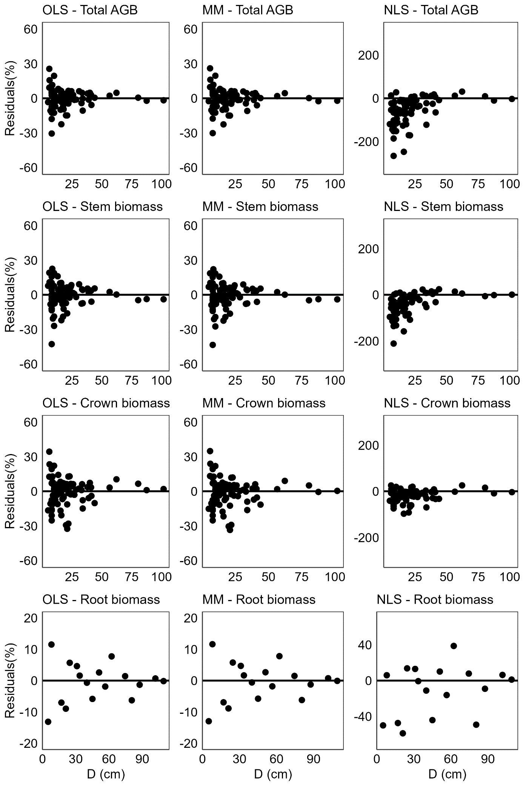
Figure S2: Residual distribution of each biomass allometric equation (BAE) computed using fitting data.
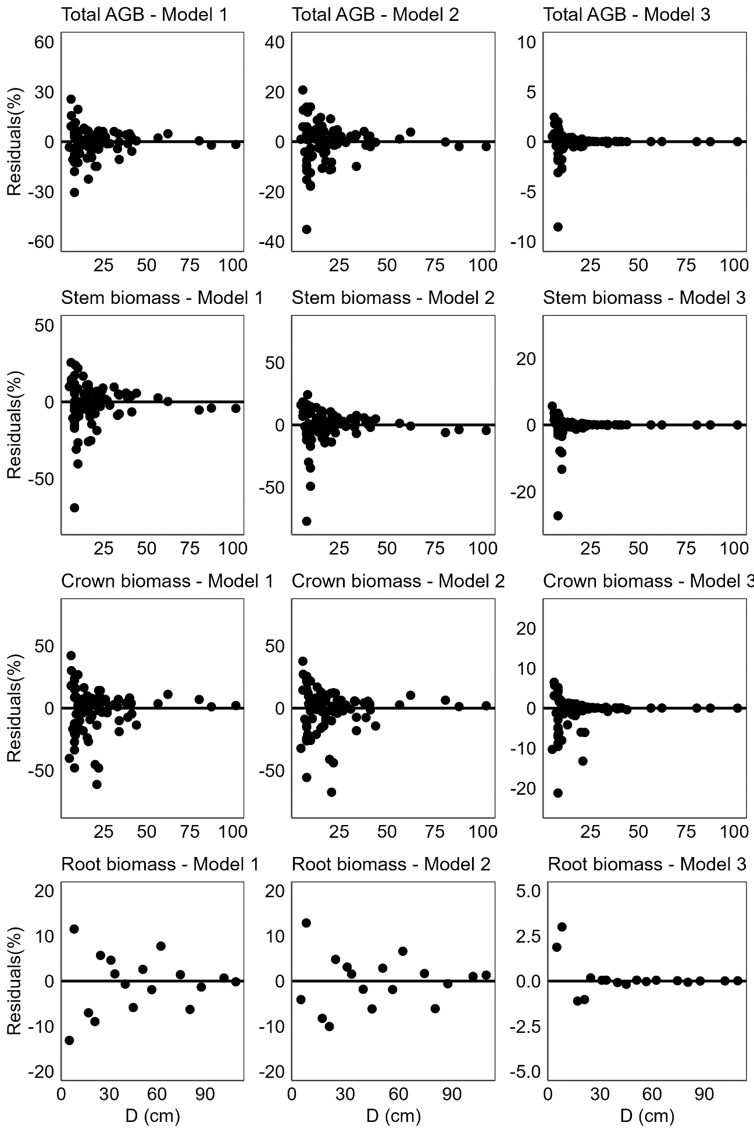
Figure S3: Evaluation of the H-D models in terms of fit to the data, models with 2 parameters and models with 3 parameters. In both cases, i.e. for the models with 2 and 3 parameters, were selected three models which their curves overlap with the fitting data.
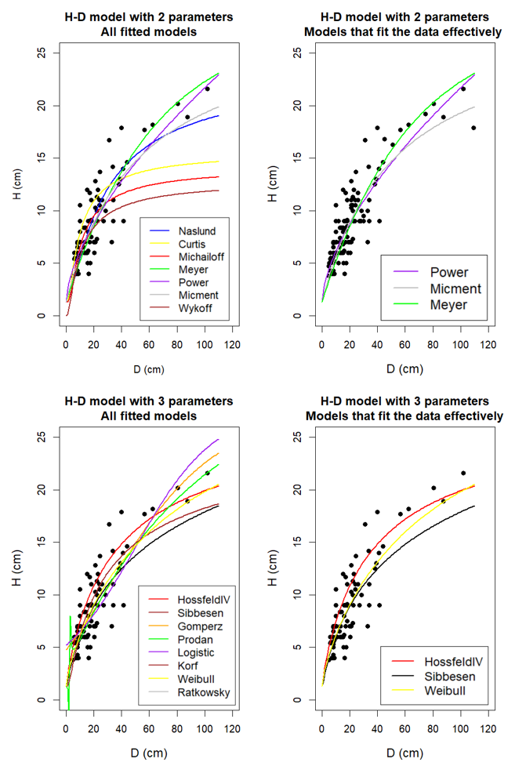
Figure S4: Residual distribution of each H-D model against D of fitting data.
