Design, Synthesis and Pharmacological Evaluation of 1,4-Naphthoquinone- 1,2,3-Triazole Hybrids as New Anticancer Agents with Multi-Kinase Inhibitory Activity

Pegah Mardaneh^{a,b}, Somayeh Pirhadi^{b}, Maryam Mohabbati^{b}, Mehdi Khoshneviszadeh^{a,b}, Zahra Rezaeiª, Luciano Saso^{c}, Najmeh Edraki^{b}*, Omidreza Firuzi^{b}*

ª Department of Medicinal Chemistry, School of Pharmacy, Shiraz University of Medical Sciences, Shiraz, Iran
^{b} Medicinal and Natural Products Chemistry Research Center, Shiraz University of Medical Sciences, Shiraz, Iran
^{c} Department of Physiology and Pharmacology "Vittorio Erspamer", Sapienza University of Rome, P. le Aldo Moro 5, 00185 Rome, Italy

* Corresponding authors:
Omidreza Firuzi, Phone: (+98)-71-3230-3872, Email: firuzio@sums.ac.ir
Najmeh Edraki, Phone: (+98)-71-3230-7869, Email: edrakin@sums.ac.ir
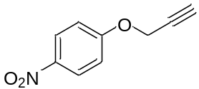
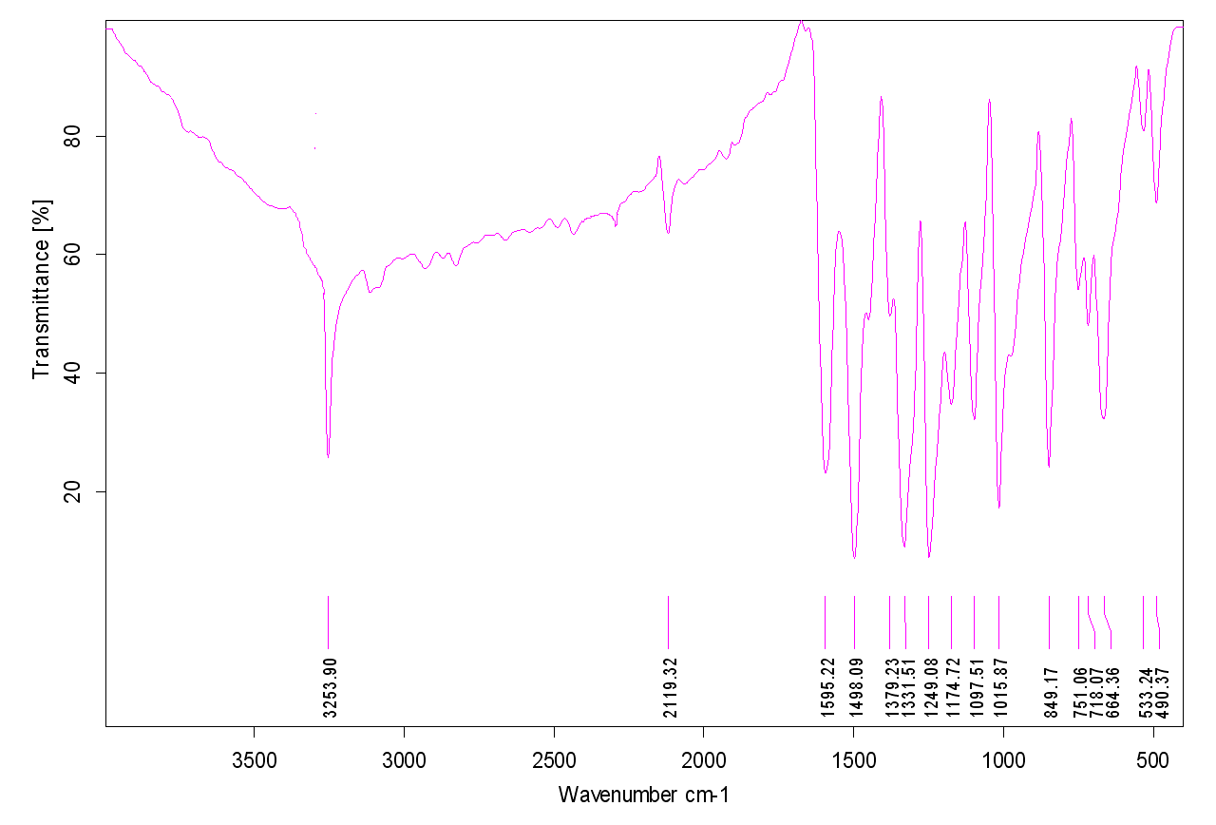
Figure1s. IR spectrum of compound (1).
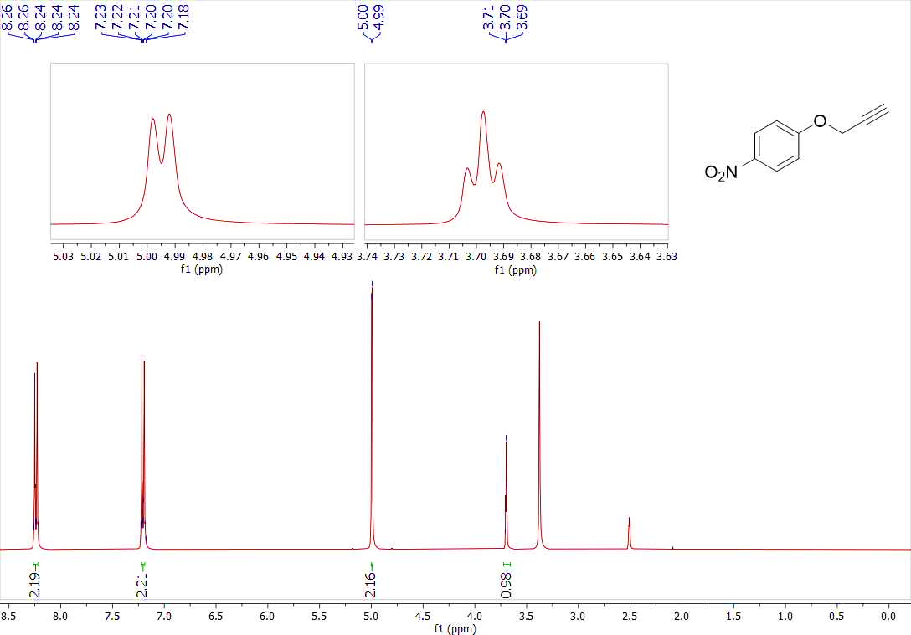
Figure 2s ¹H-NMR spectrum of compound (1)
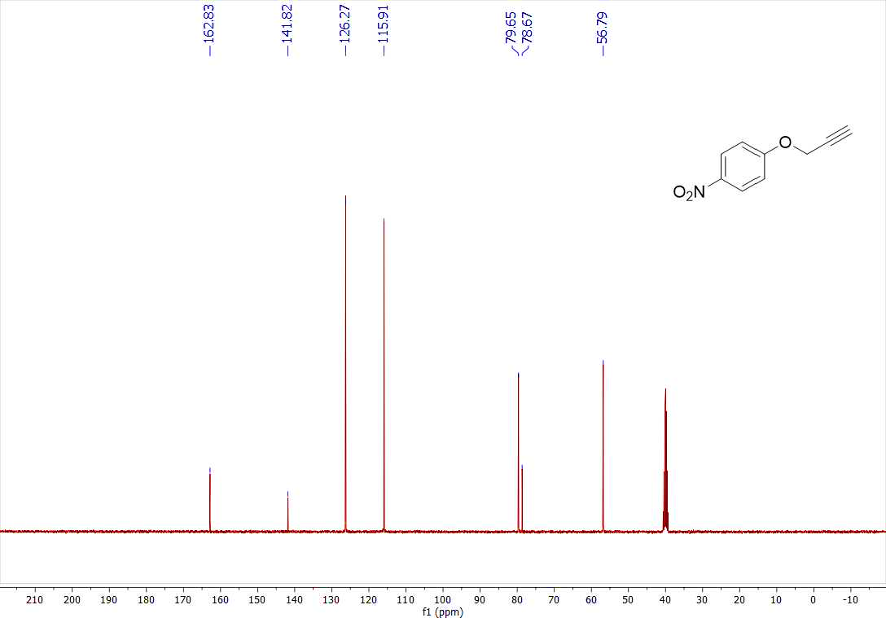
Figure 3s. ¹³C-NMR spectrum of compound (1)
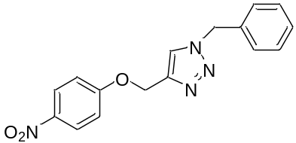
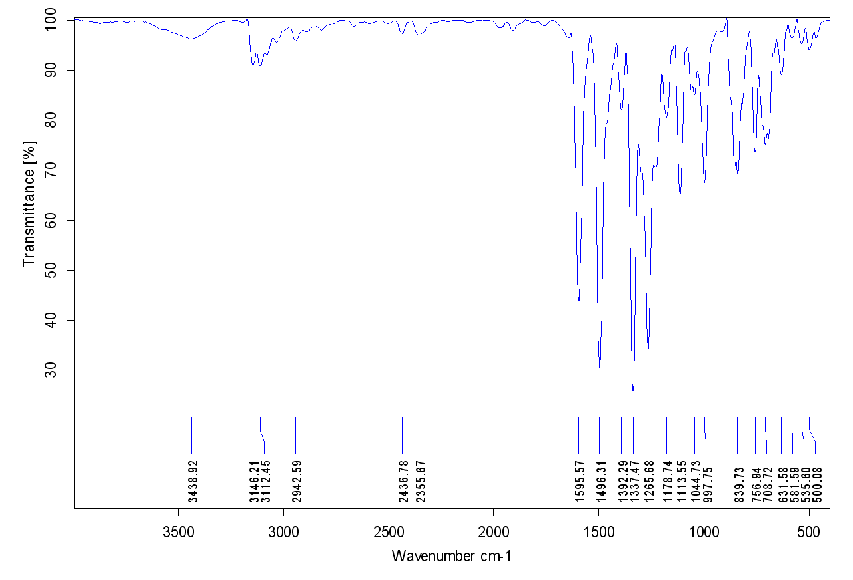
Figure 4s. IR spectrum of compound (2a).
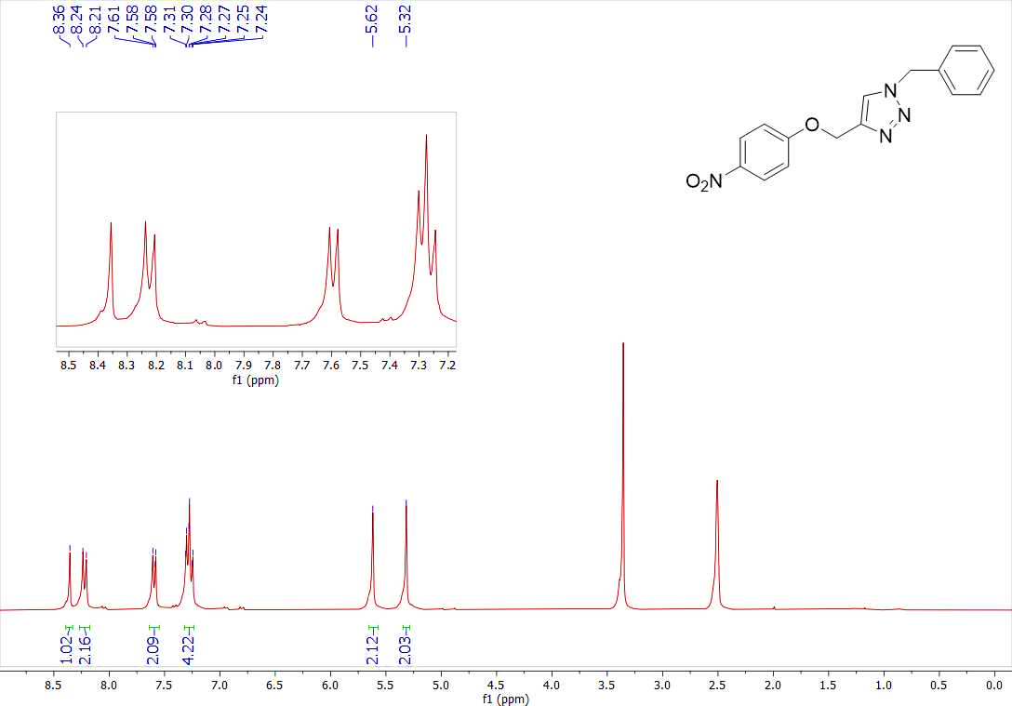
Figure 5s. ¹H-NMR spectrum of compound (2a)
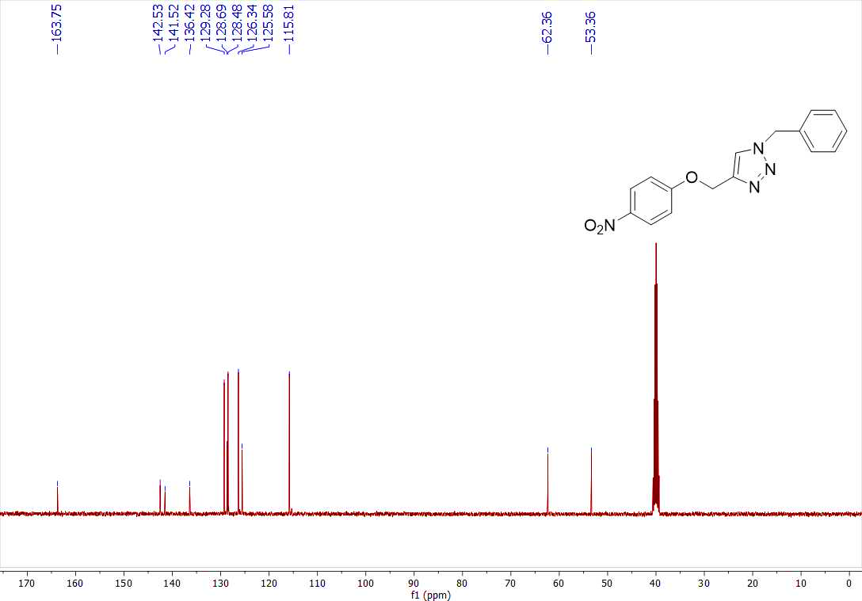
Figure 6s. ¹³C-NMR spectrum of compound (2a)
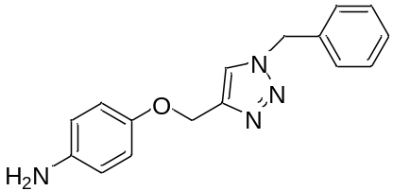
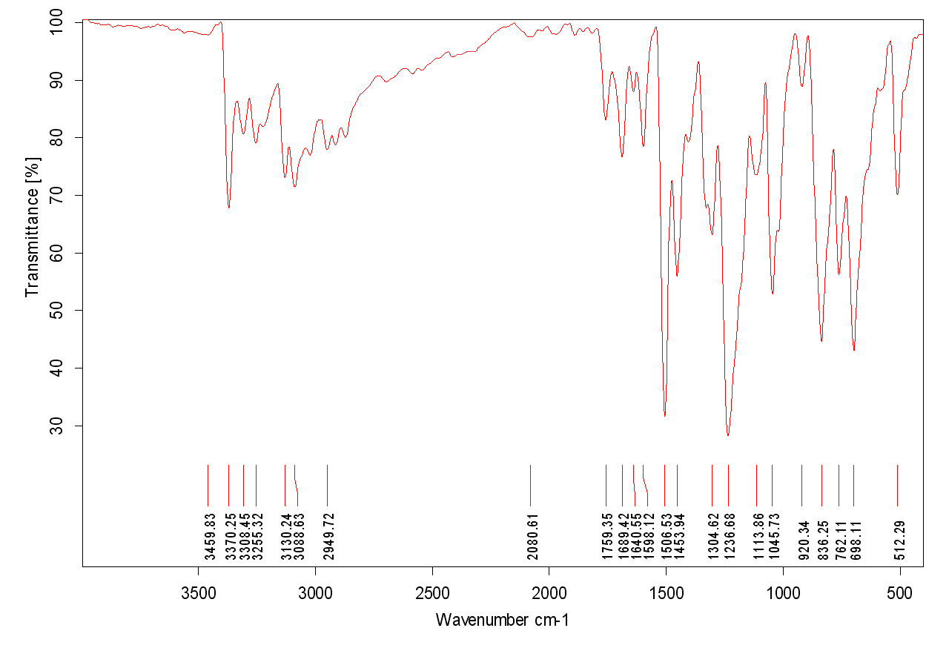
Figure 7s. IR spectrum of compound (3a).
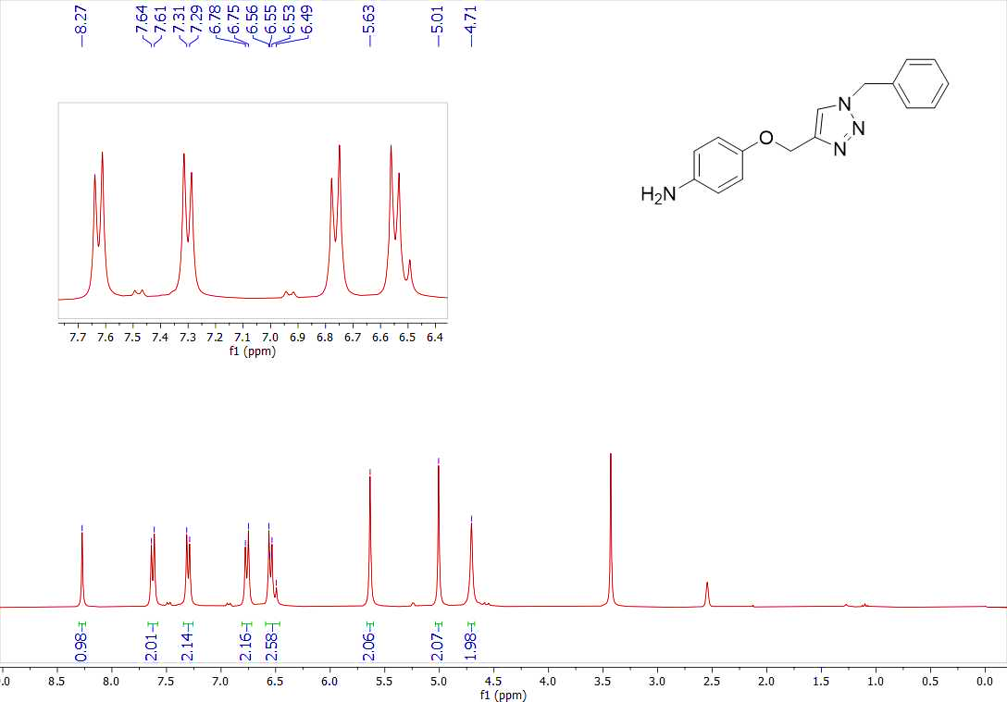
Figure 8s. ¹H-NMR spectrum of compound (3a)
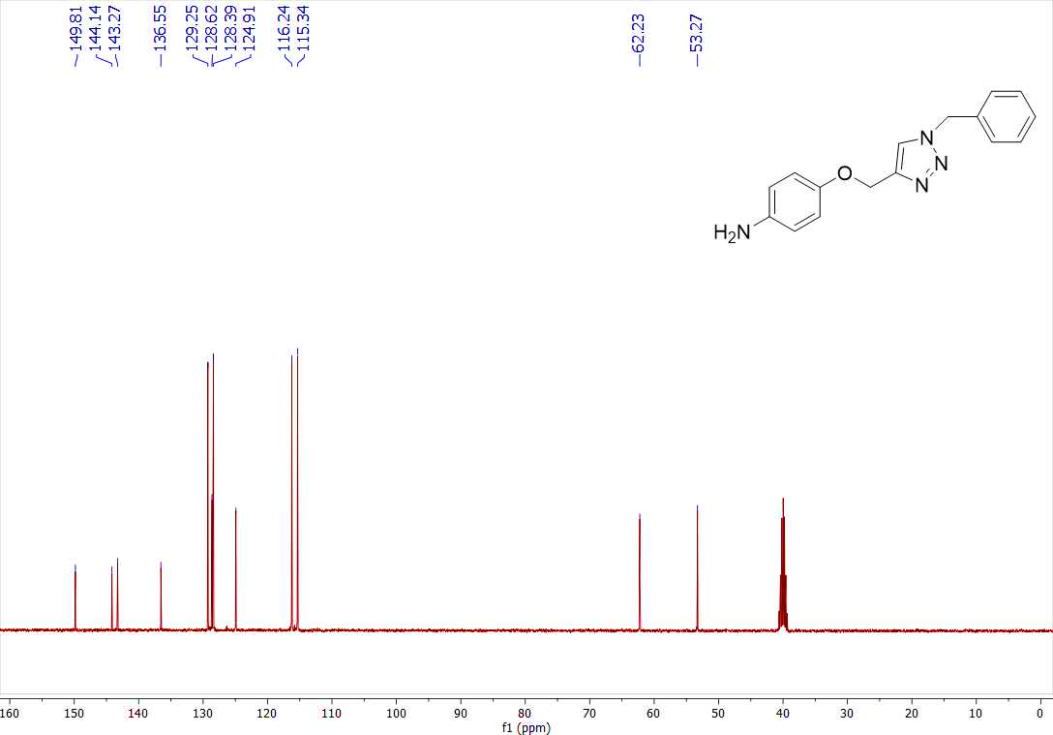
Figure 9s. ¹³C-NMR spectrum of compound (3a)
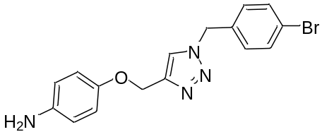
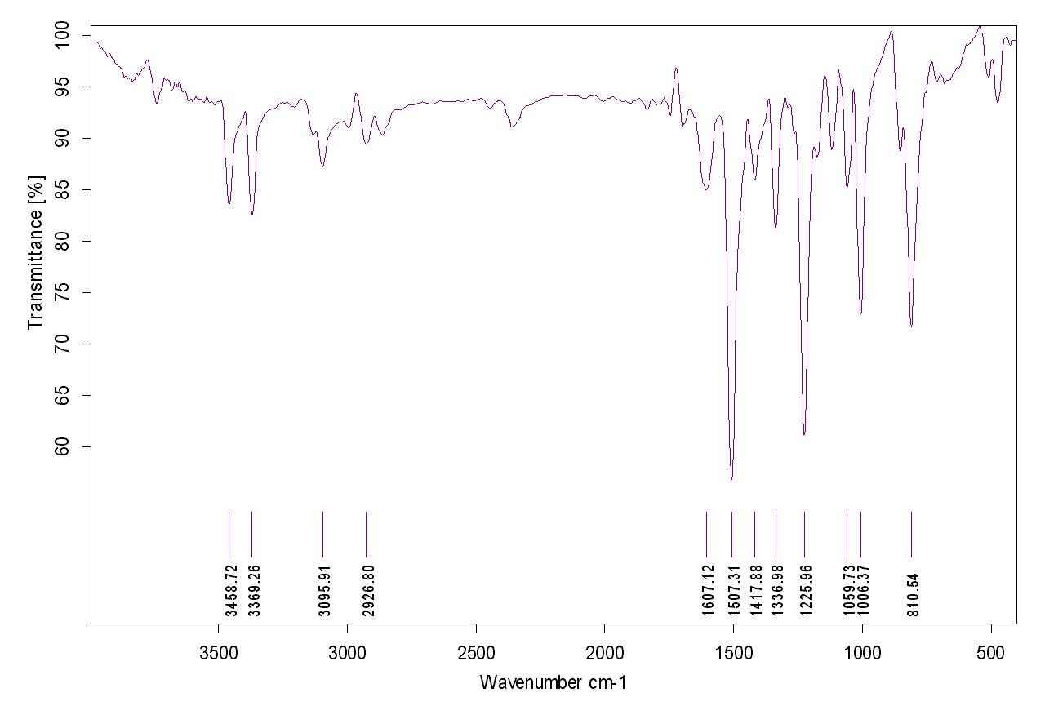
Figure 10s. IR spectrum of compound (3b)
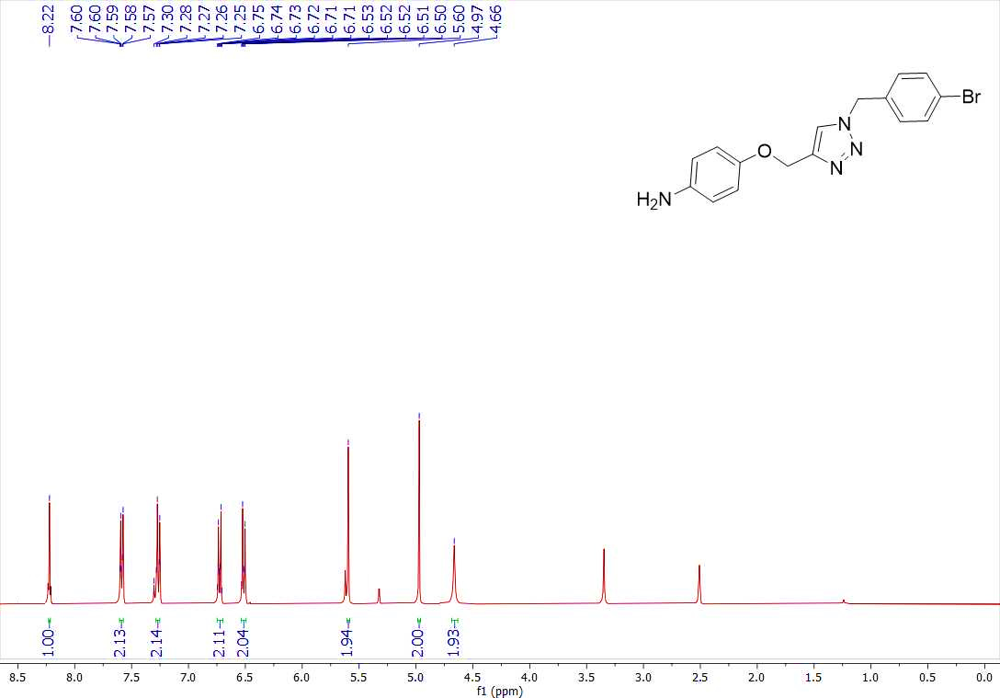
Figure 11s. ¹H-NMR spectrum of compound (3b)
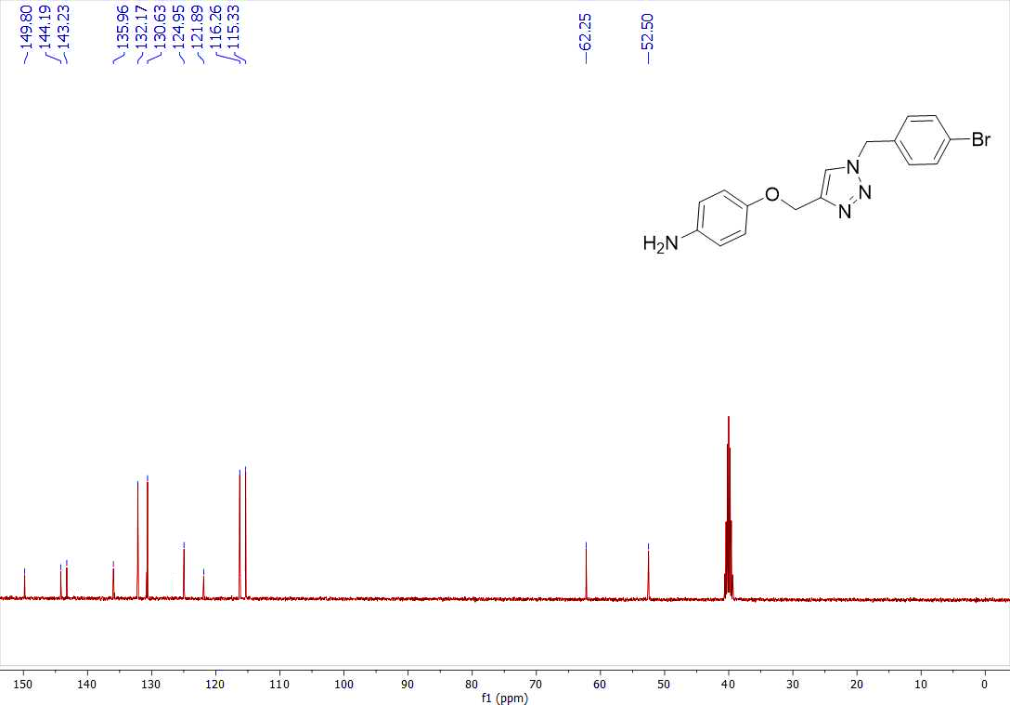
Figure 12s. ¹³C-NMR spectrum of compound (3b)
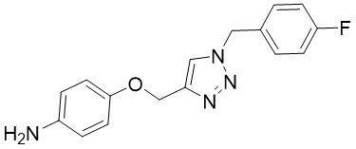
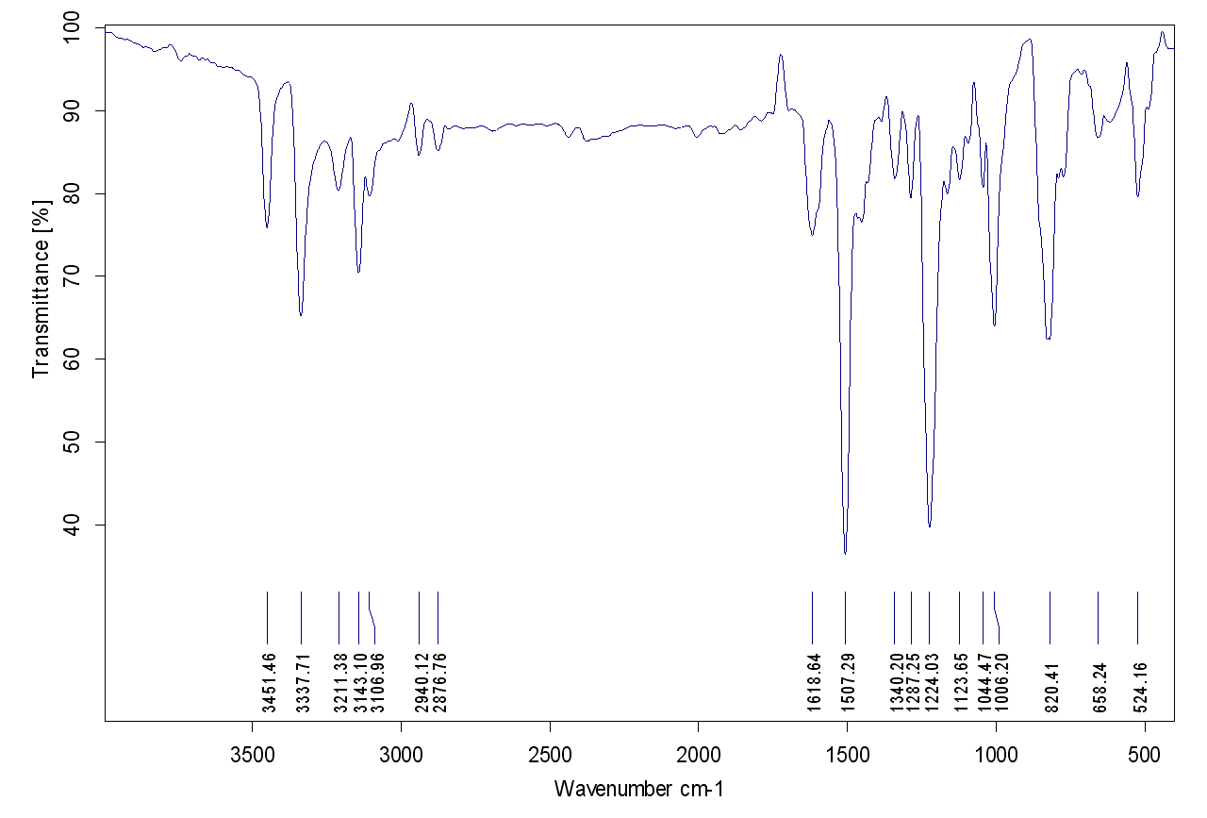
Figure 13s. IR spectrum of compound (3c)
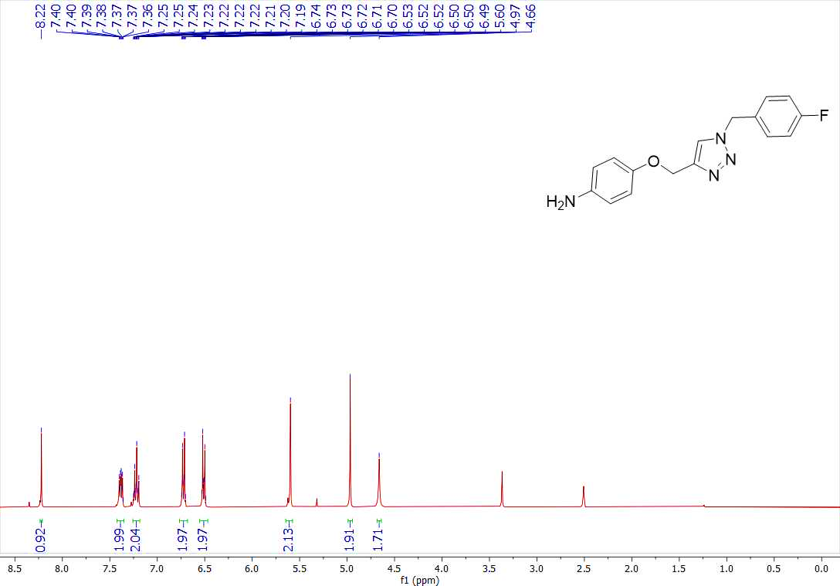
Figure 14s. ¹H-NMR spectrum of compound (3c)
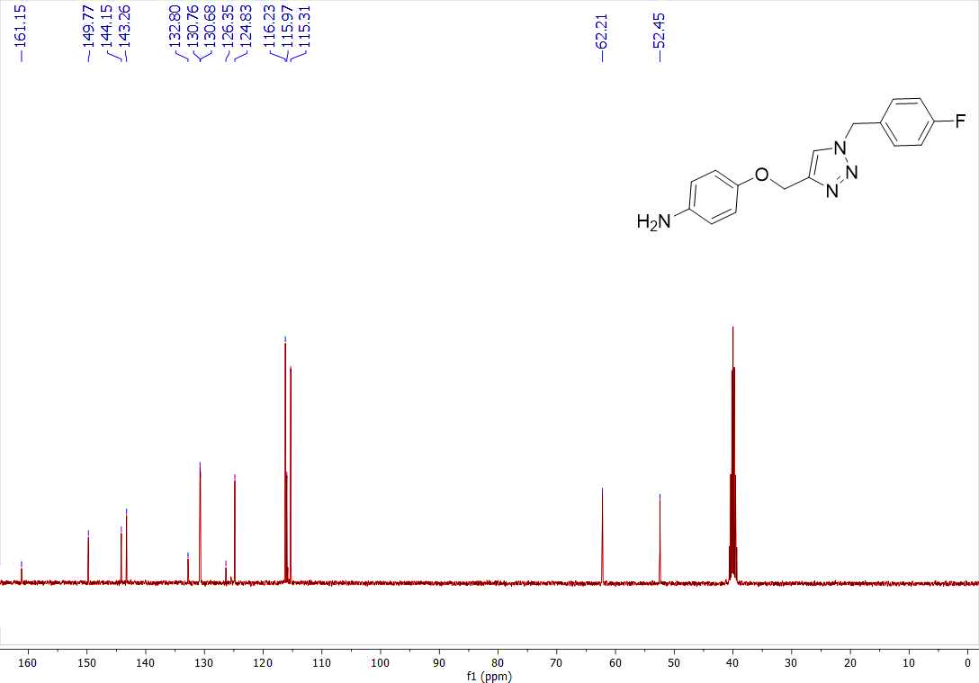
Figure 15s. ¹³C-NMR spectrum of compound (3c)
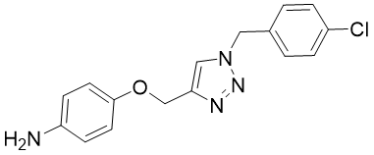
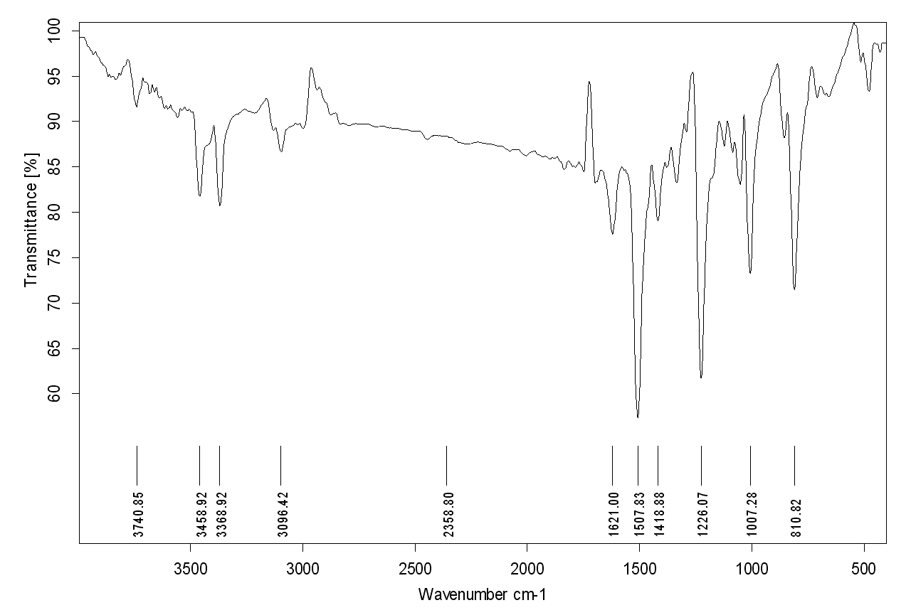
Figure 16s. IR spectrum of compound (3d)
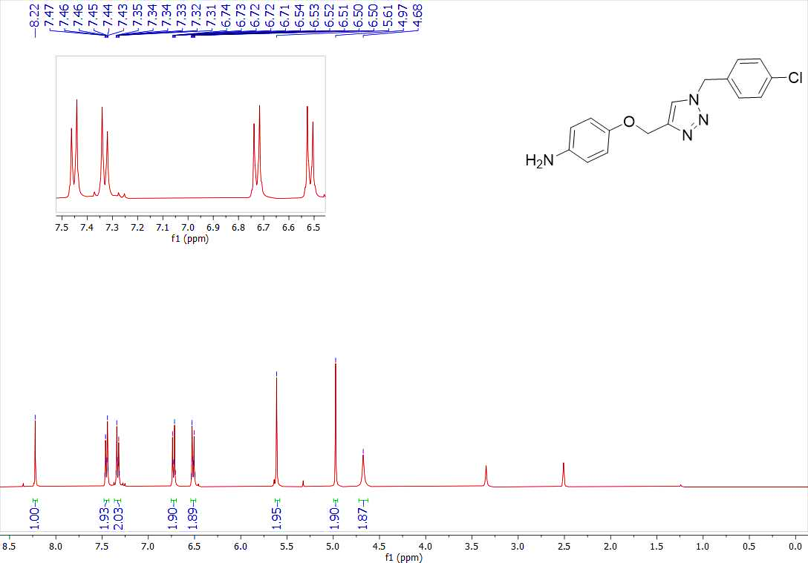
Figure 17s. ¹H-NMR spectrum of compound (3d)
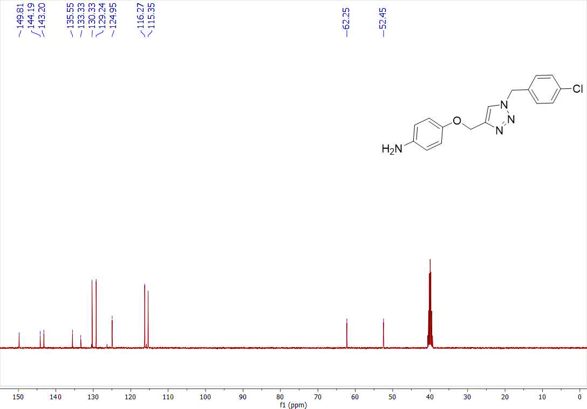
Figure 18s. ¹³C-NMR spectrum of compound (3d)
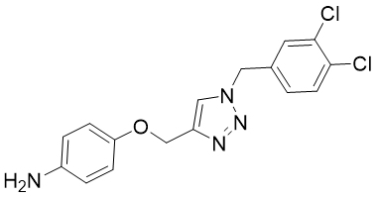
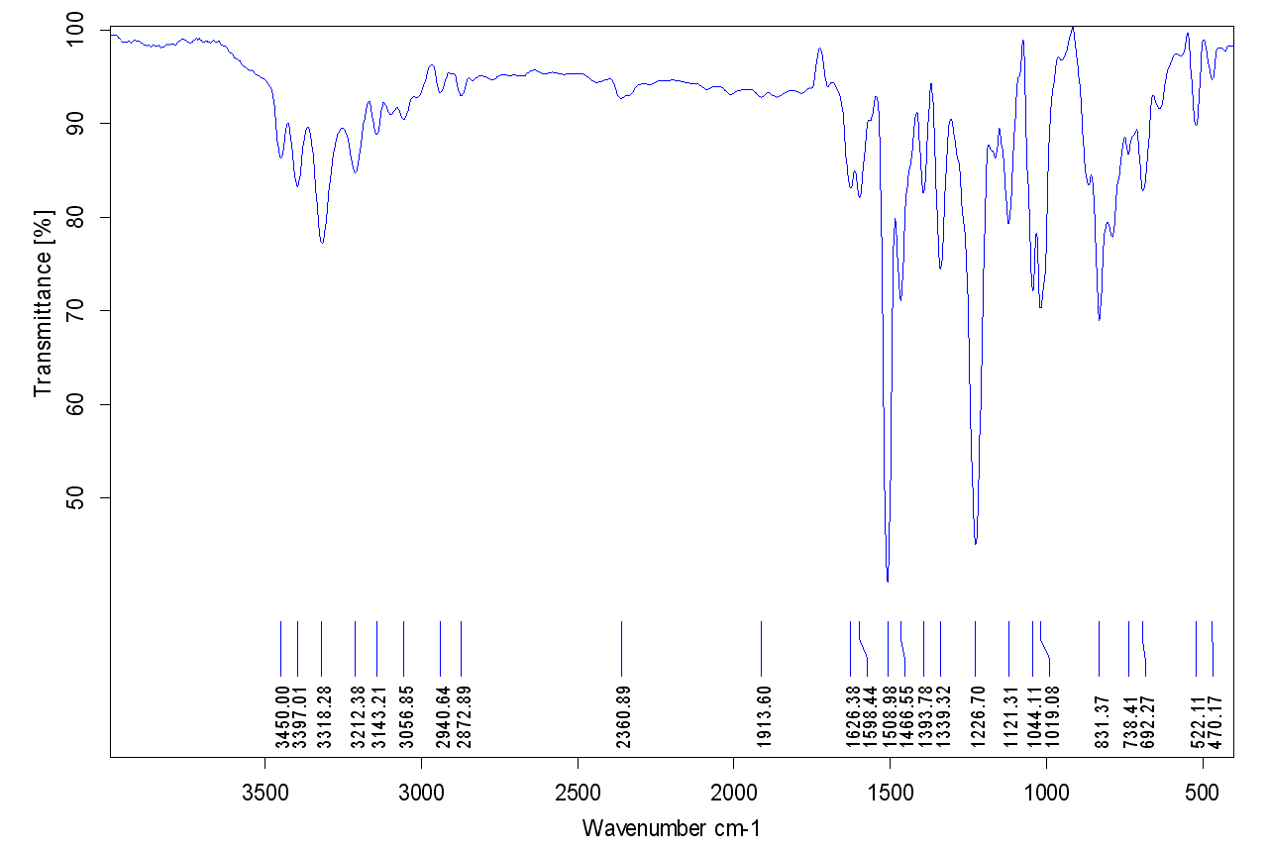
Figure 19s. IR spectrum of compound (3e)
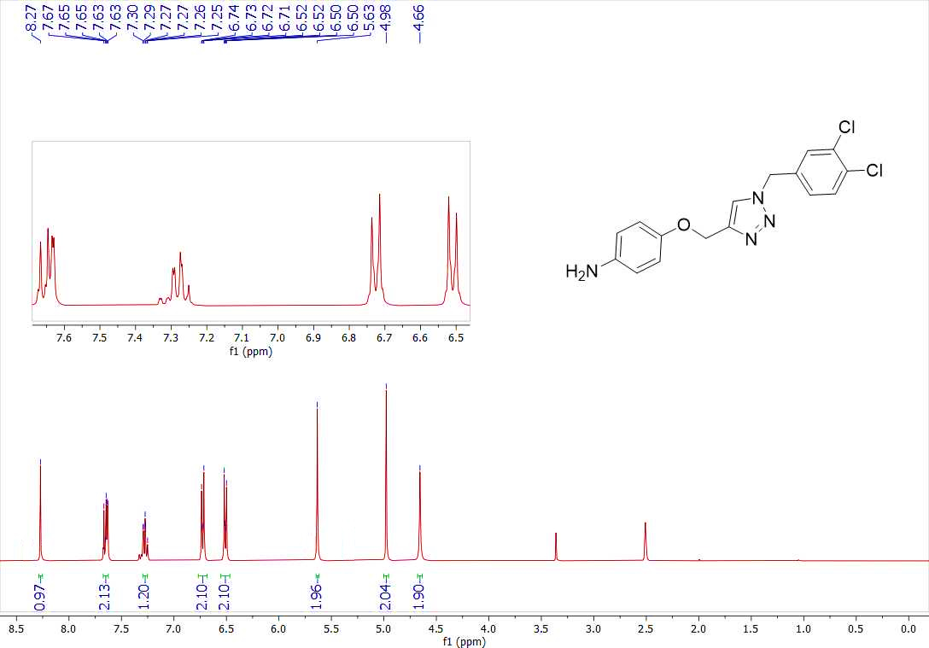
Figure 20s. ¹H-NMR spectrum of compound (3e)
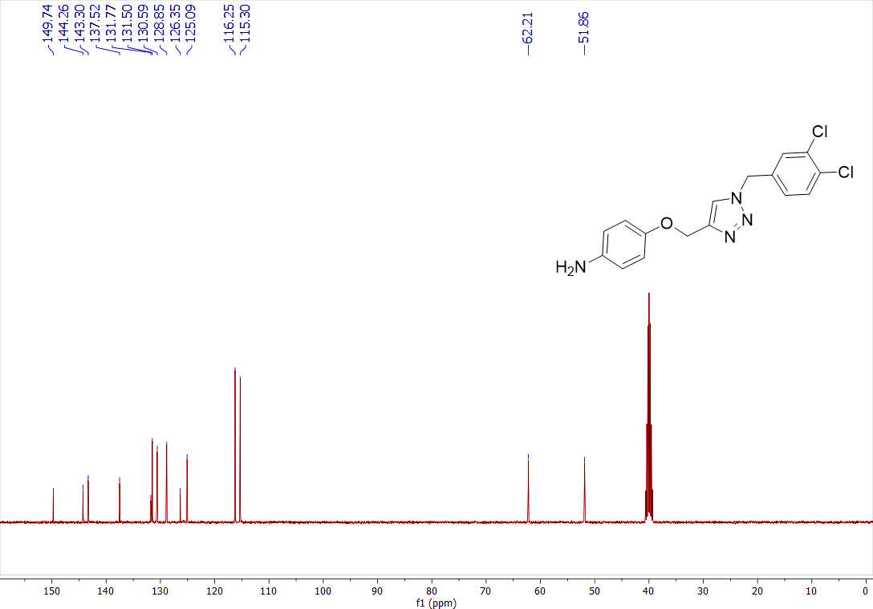
Figure 21s. ¹³C-NMR spectrum of compound (3e)
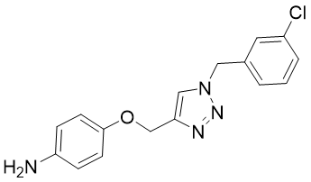
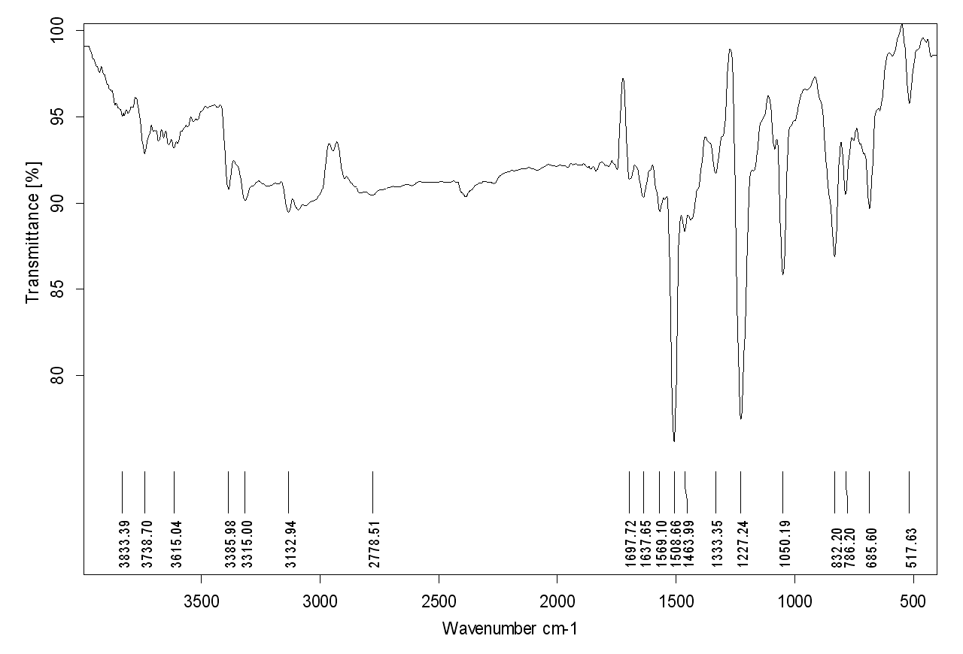
Figure 22s. IR spectrum of compound (3f)
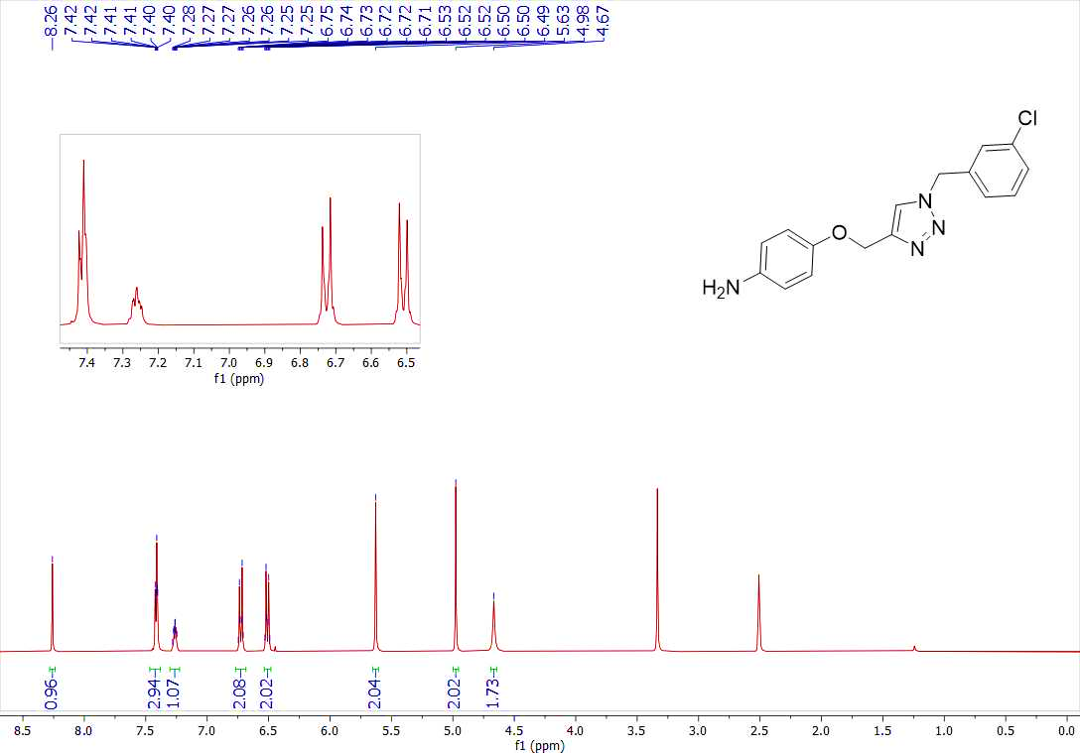
Figure 23s. ¹H-NMR spectrum of compound (3f)
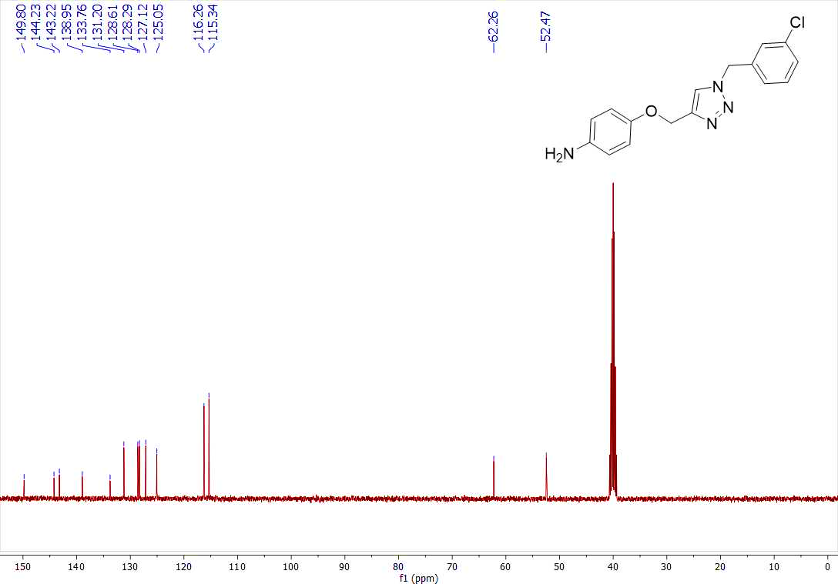
Figure 24s. ¹³C-NMR spectrum of compound (3f)
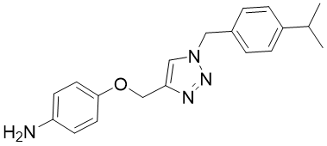
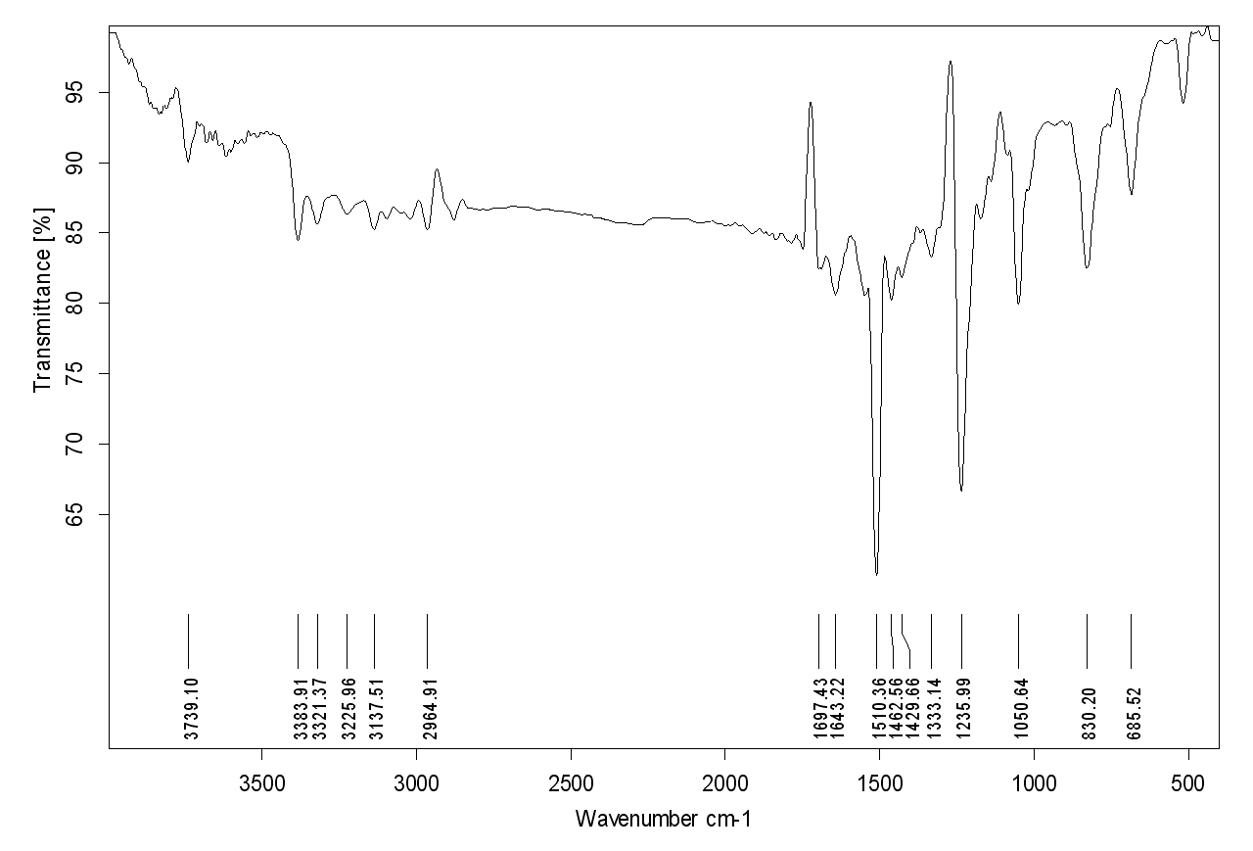
Figure 25. IR spectrum of compound (3g)
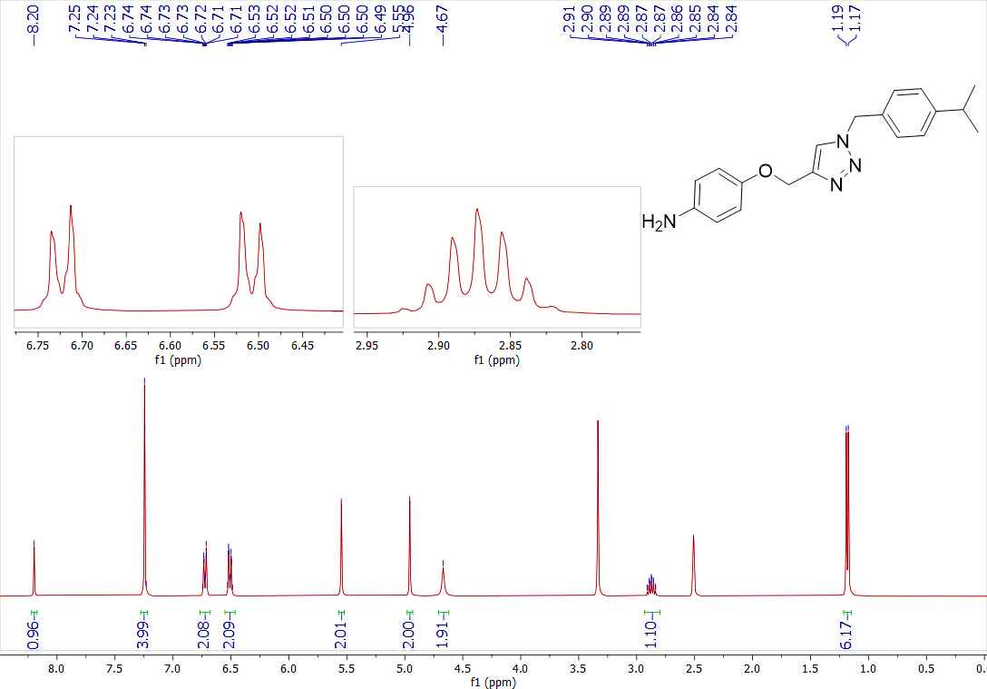
Figure 26s. ¹H-NMR spectrum of compound (3g)
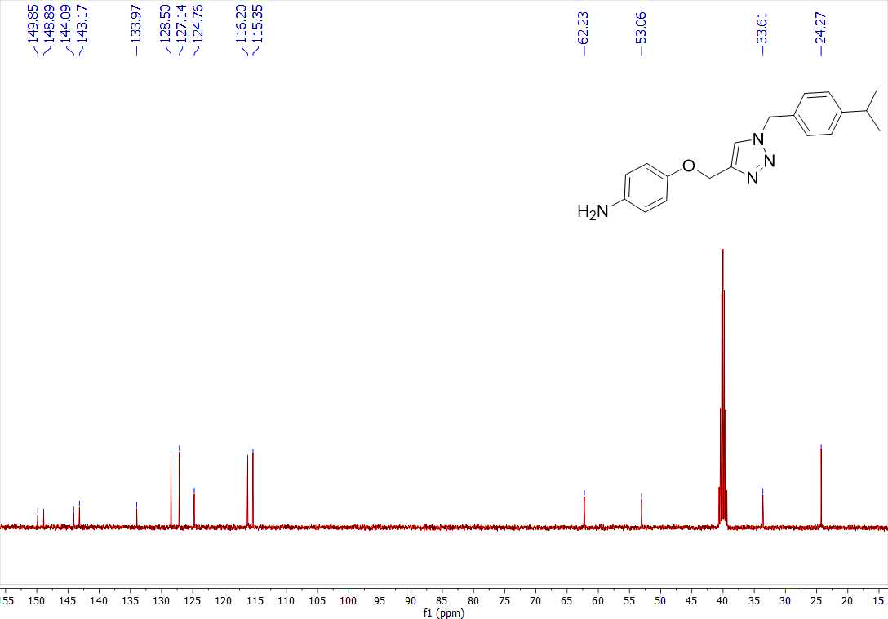
Figure 27s. ¹³C-NMR spectrum of compound (3g)
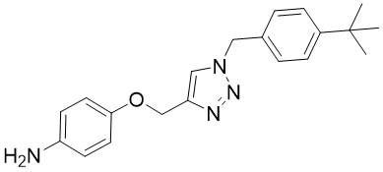
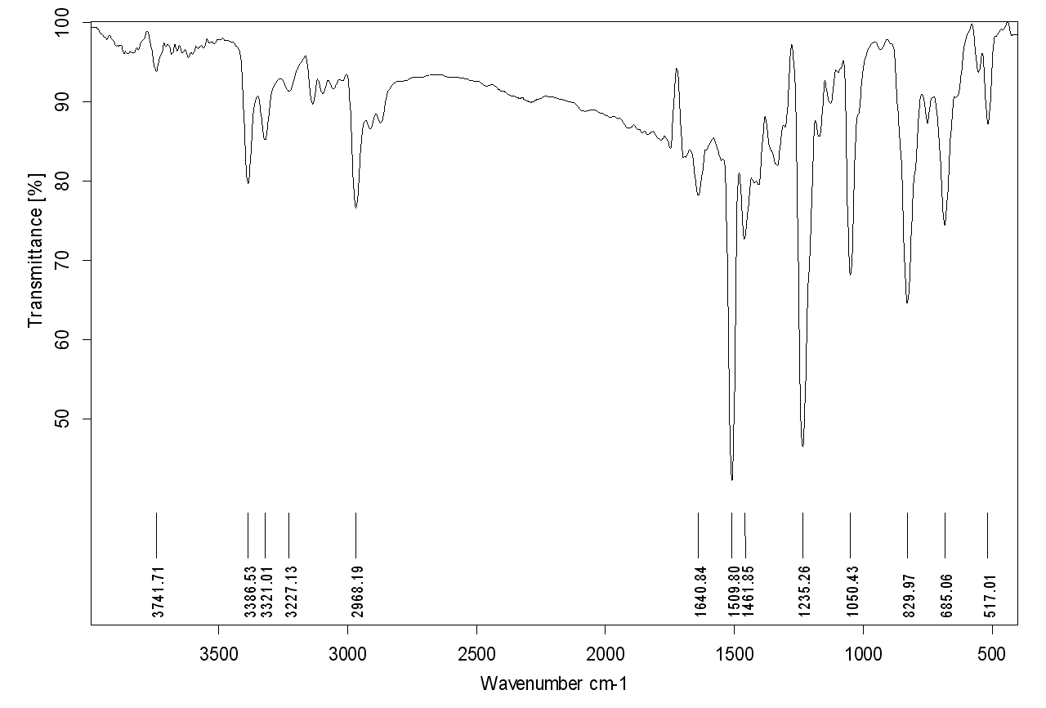
Figure 28s. IR spectrum of compound (3h)
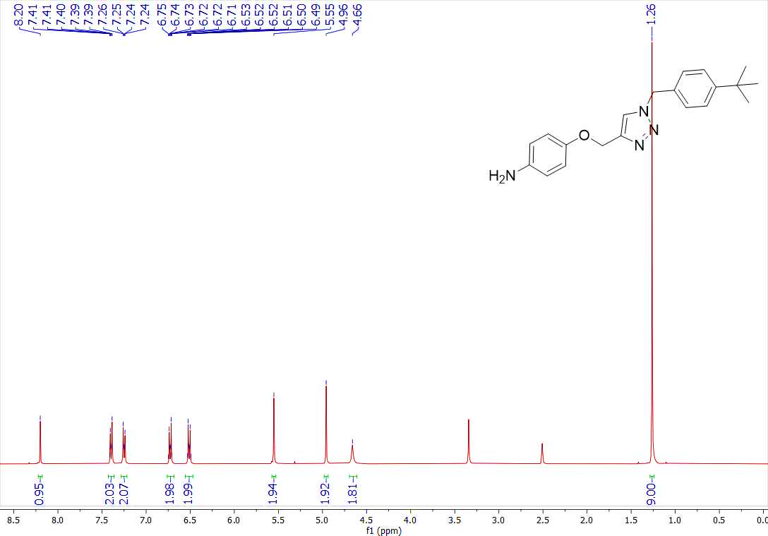
Figure 29s. ¹H-NMR spectrum of compound (3h)
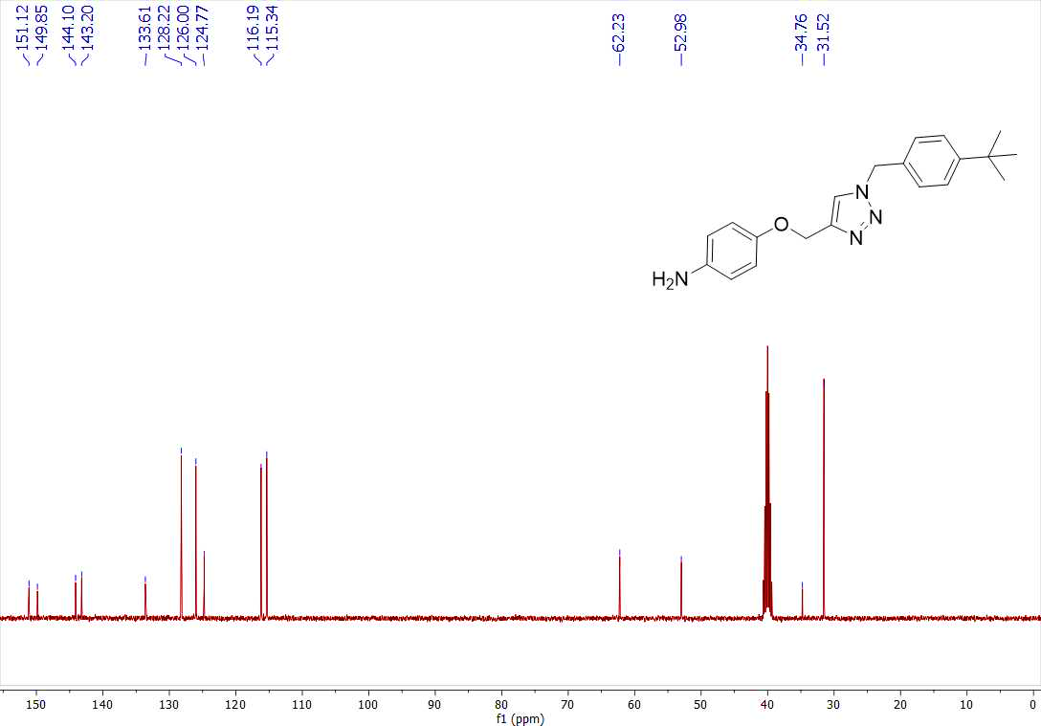
Figure 30s. ¹³C-NMR spectrum of compound (3h)
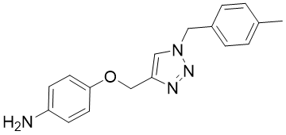
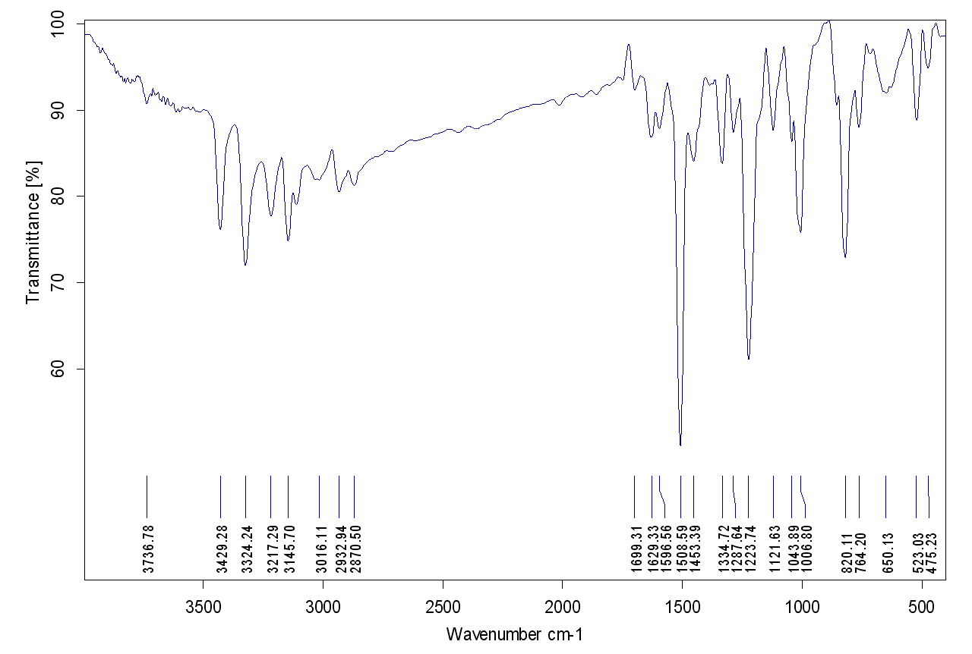
Figure 31s. IR spectrum of compound (3i)
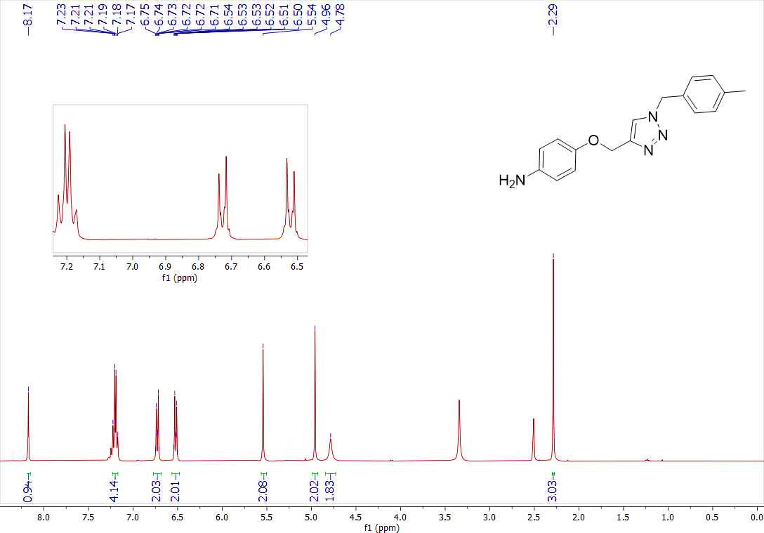
Figure 32s. ¹H-NMR spectrum of compound (3i)
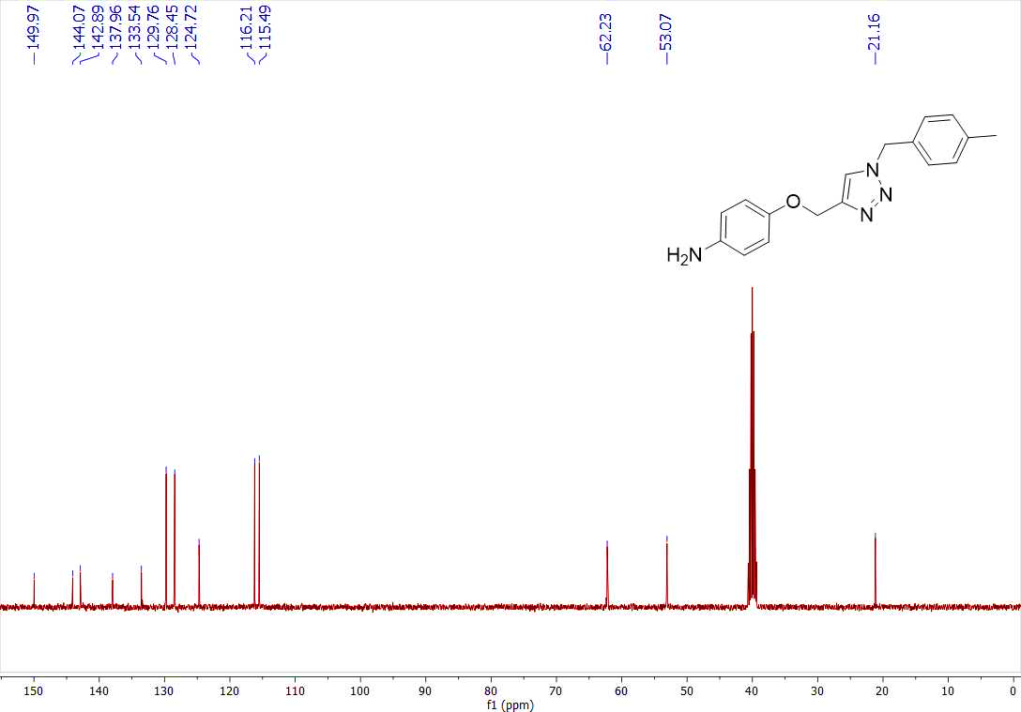
Figure 33s. ¹³C-NMR spectrum of compound (3i)
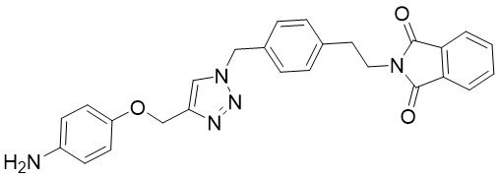
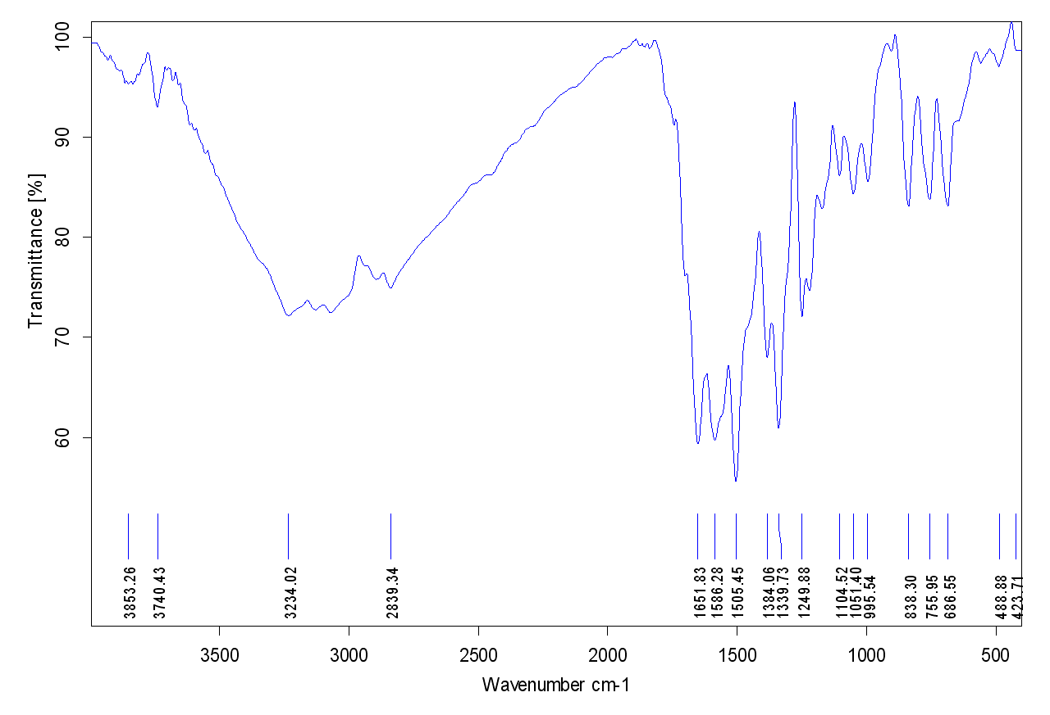
Figure 34s. IR spectrum of compound (3j)
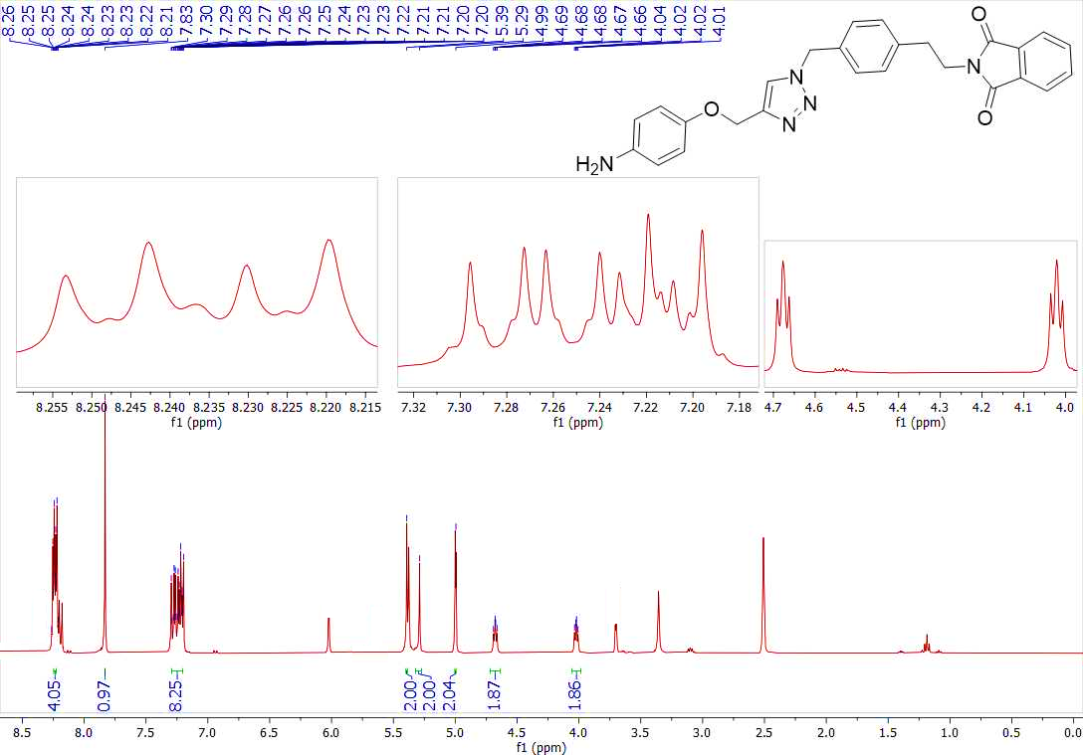
Figure 35s. ¹H-NMR spectrum of compound (3j)
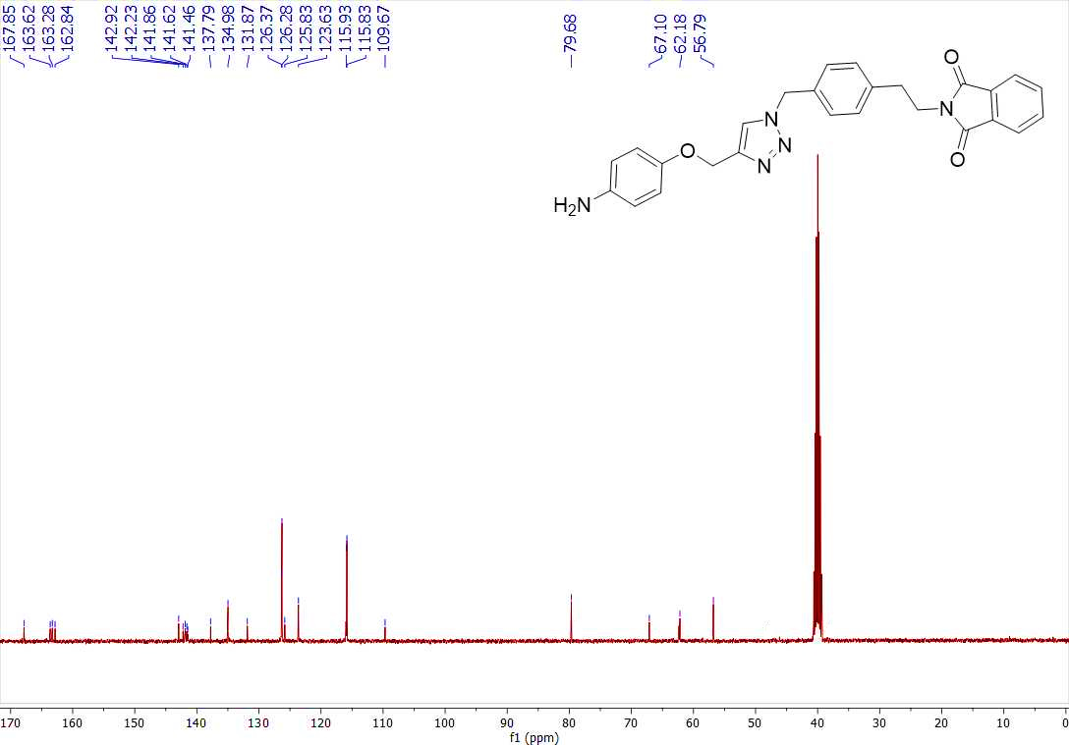
Figure 36s. ¹³C-NMR spectrum of compound (3j)
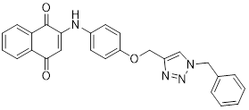
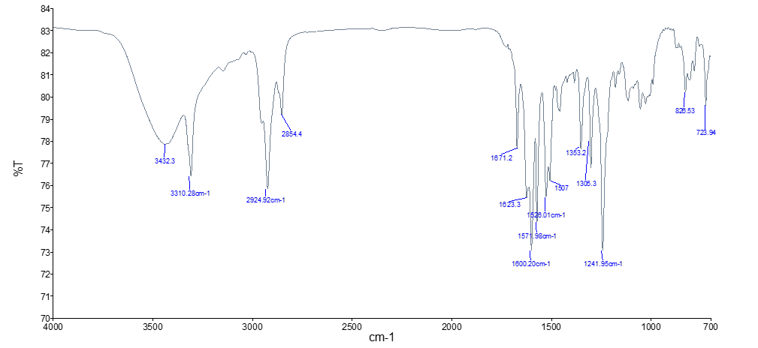
Figure 37s. IR spectrum of compound (4a)
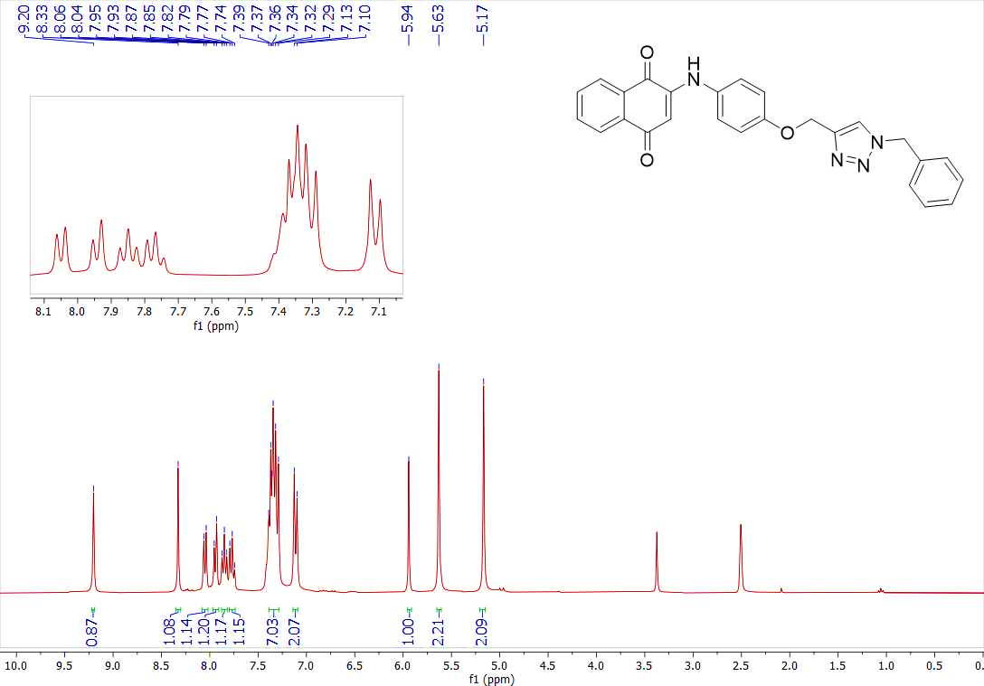
Figure 38s. ¹H-NMR spectrum of compound (4a)
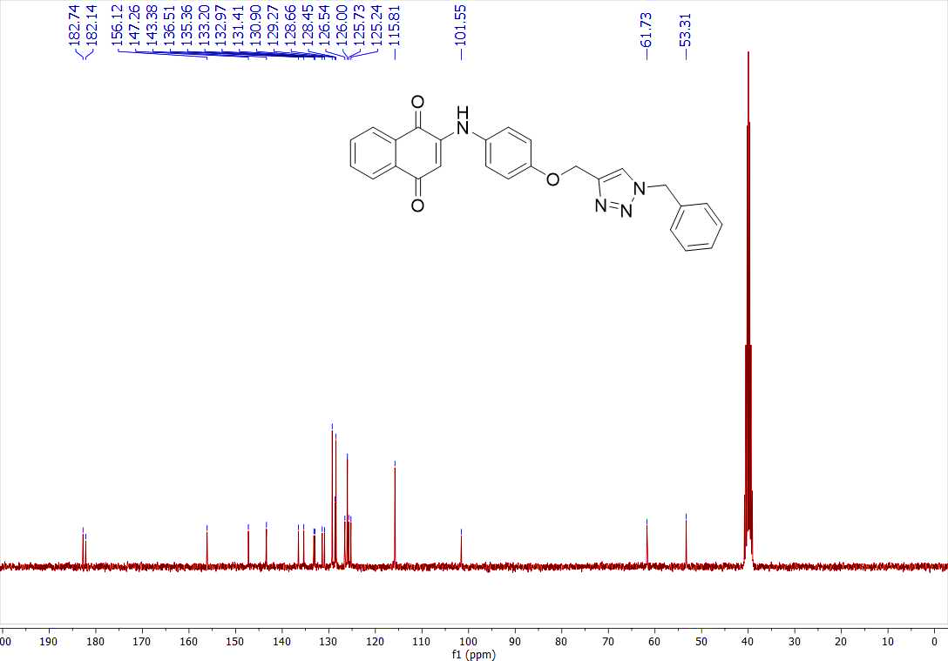
Figure 39s. ¹³C-NMR spectrum of compound (4a)
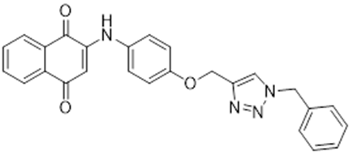
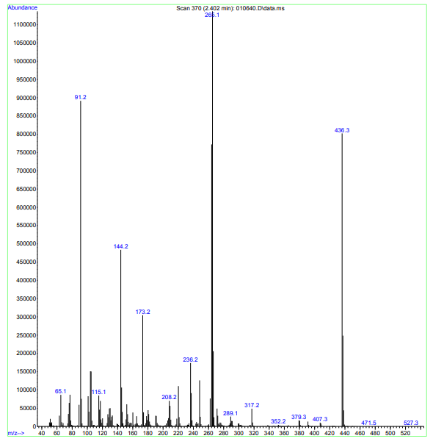
Figure 40s. MASS spectrum of compound (4a)
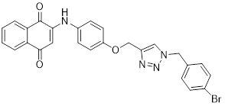
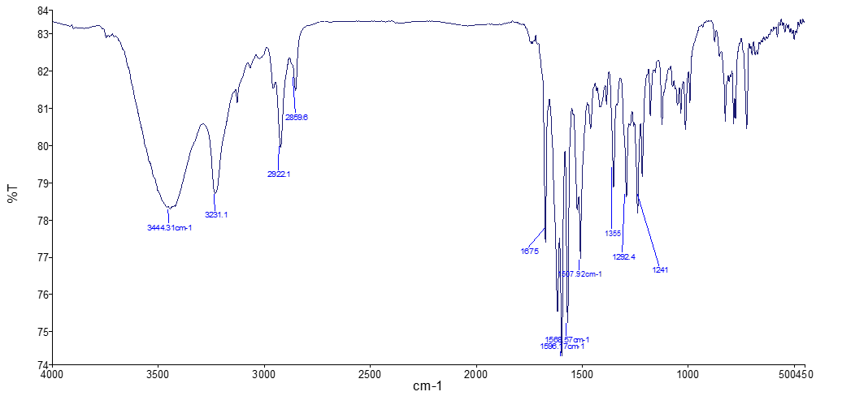
Figure 41s. IR spectrum of compound (4b).
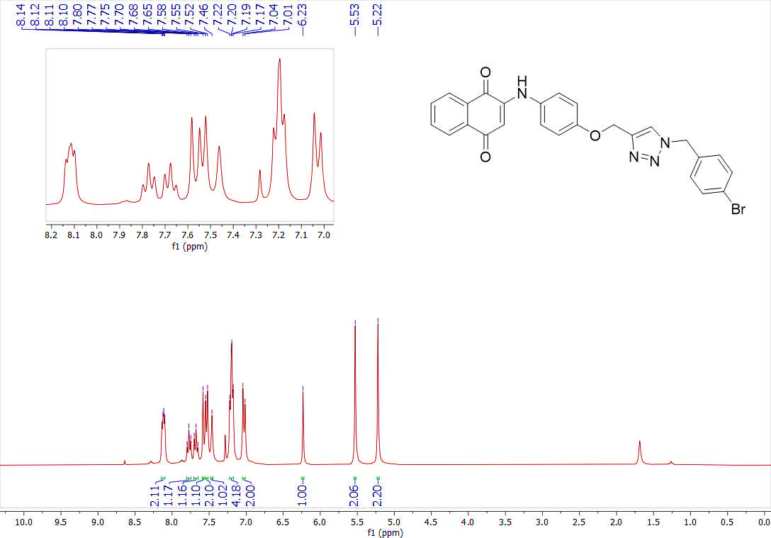
Figure 42s. ¹H-NMR spectrum of compound (4b)
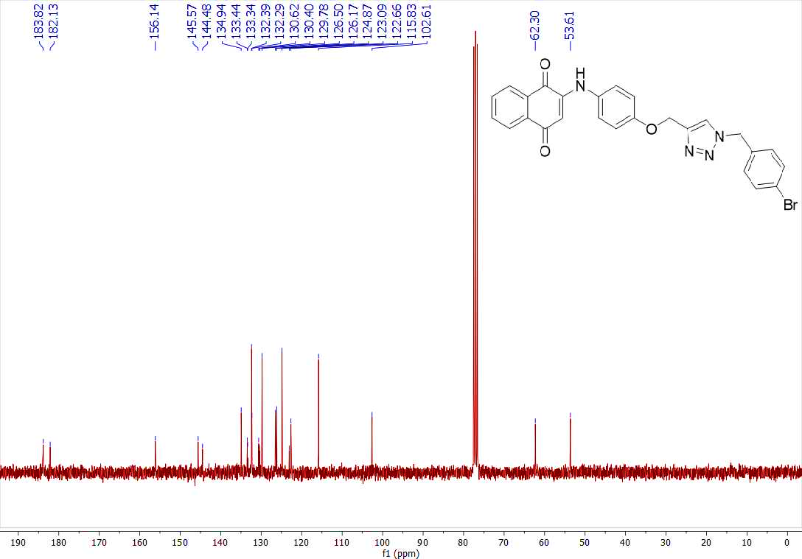
Figure 43s. ¹³C-NMR spectrum of compound (4b)
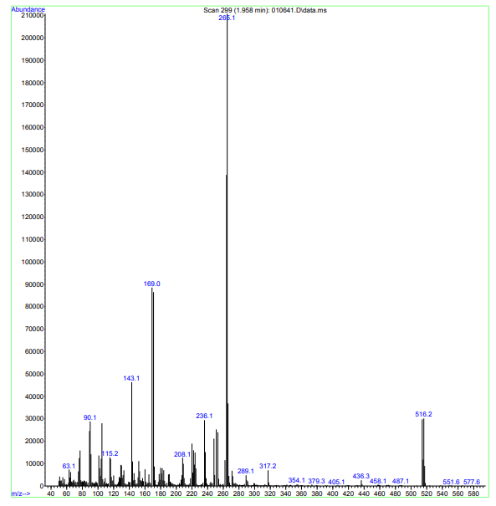
Figure 44s. MASS spectrum of compound (4b)
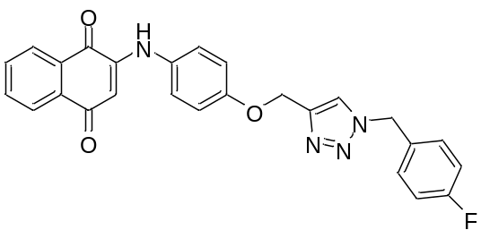
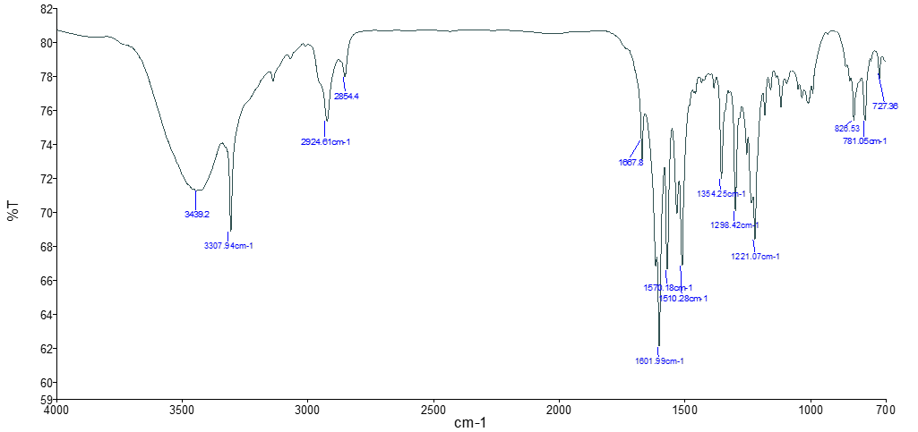
Figure 45s. IR spectrum of compound (4c).
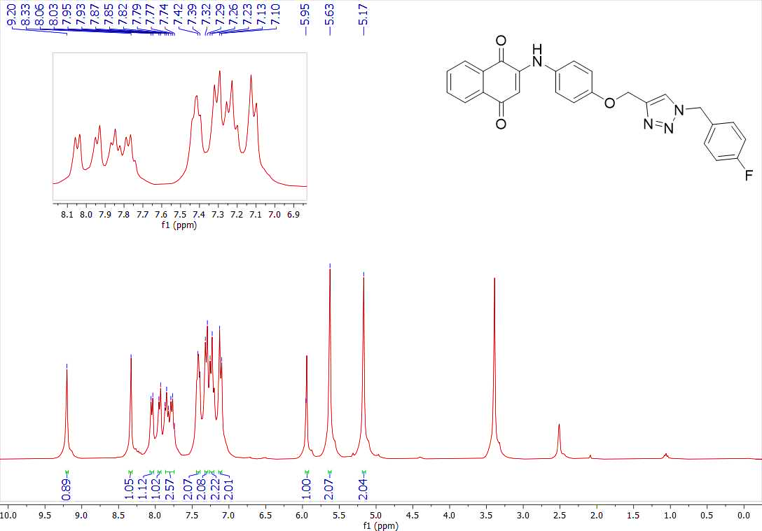
Figure 46s. ¹H-NMR spectrum of compound (4c)
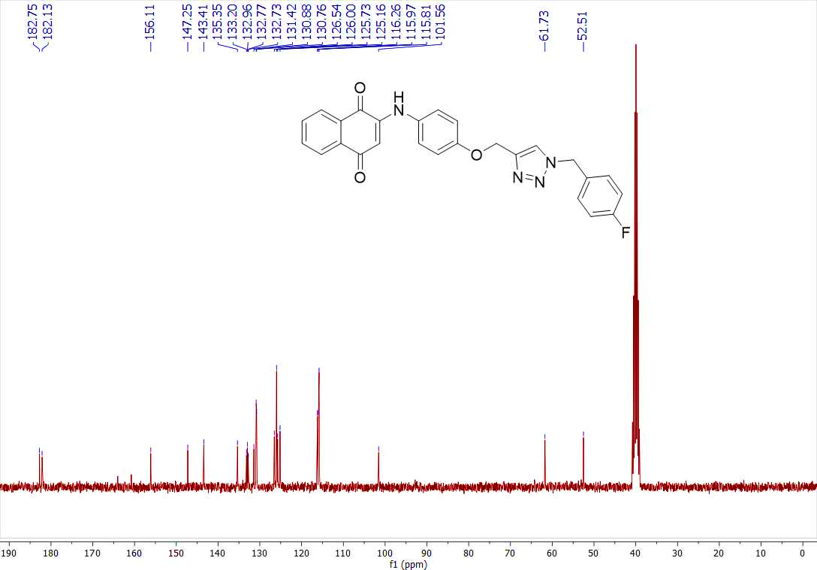
Figure 47s. ¹³C-NMR spectrum of compound (4c)
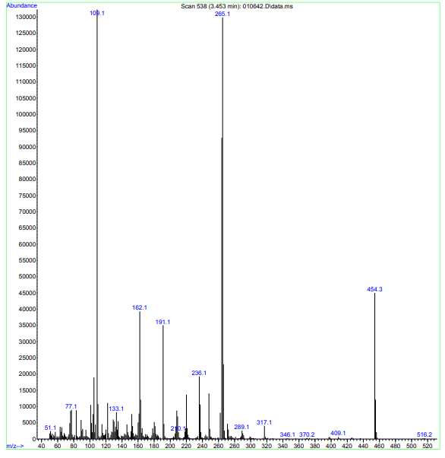
Figure 48s. MASS spectrum of compound (4c)

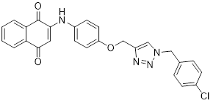
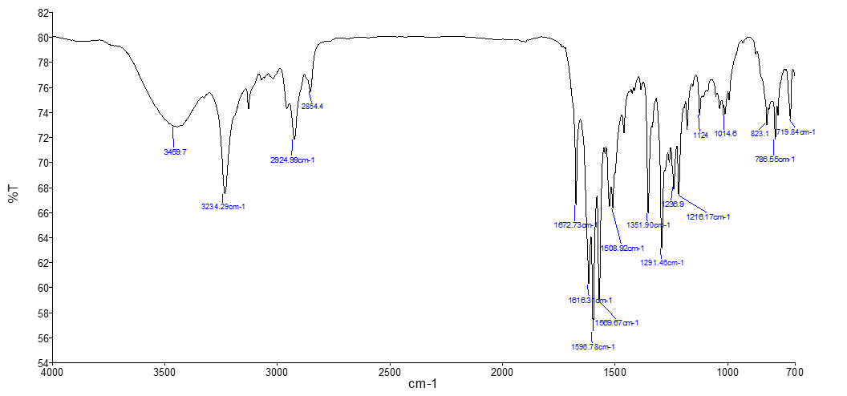
Figure 49s. IR spectrum of compound (4d).
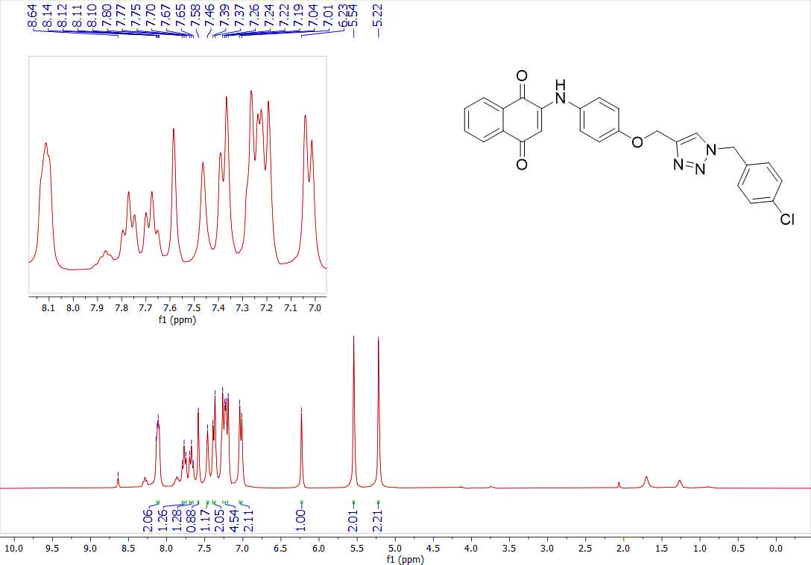
Figure 50s. ¹H-NMR spectrum of compound (4d)
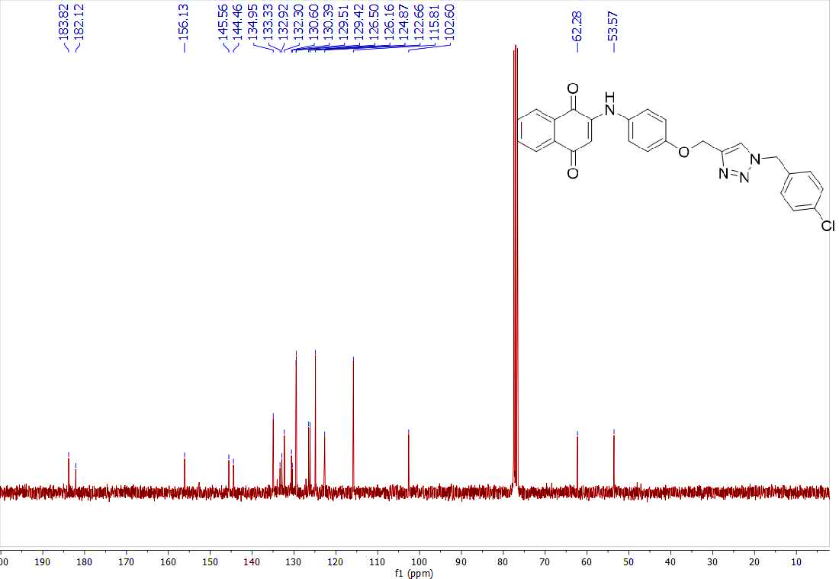
Figure 51s. ¹³C-NMR spectrum of compound (4d)
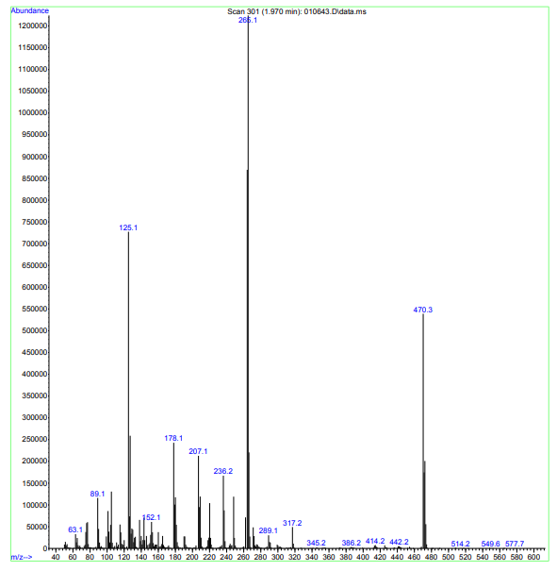
Figure 52s. MASS spectrum of compound (4d)
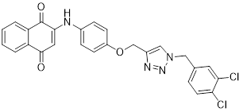
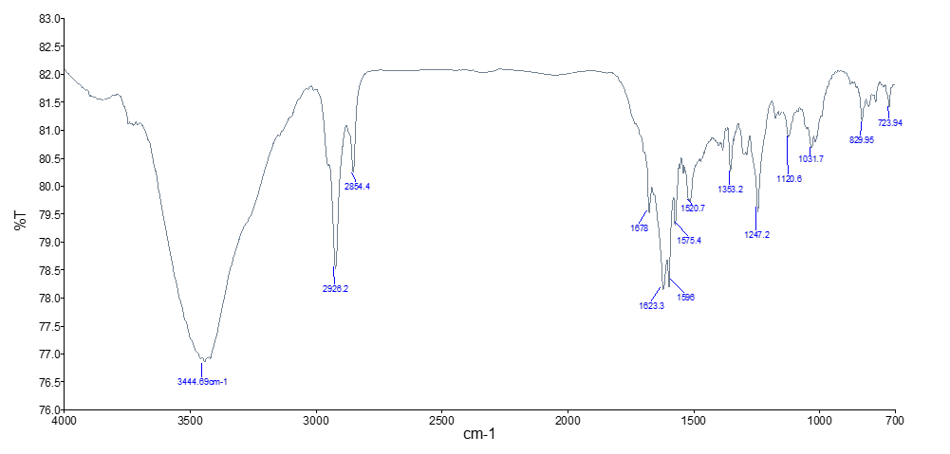
Figure 53s. IR spectrum of compound (4e).
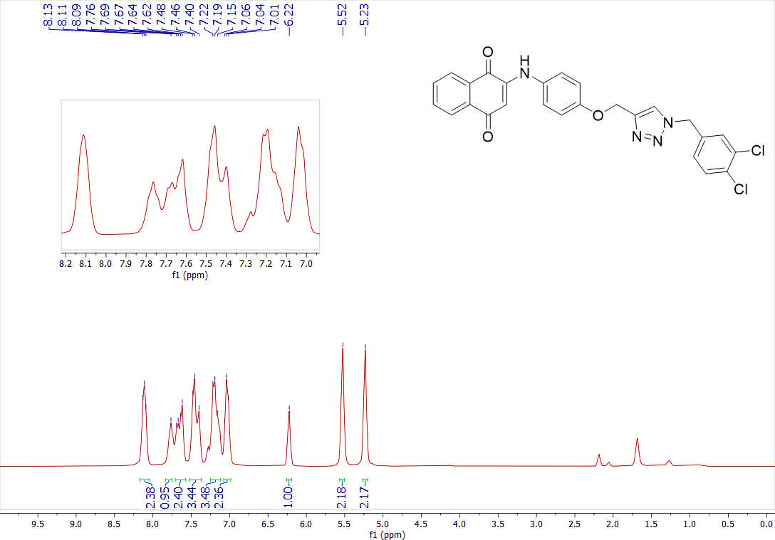
Figure 54s. ¹H-NMR spectrum of compound (4e)
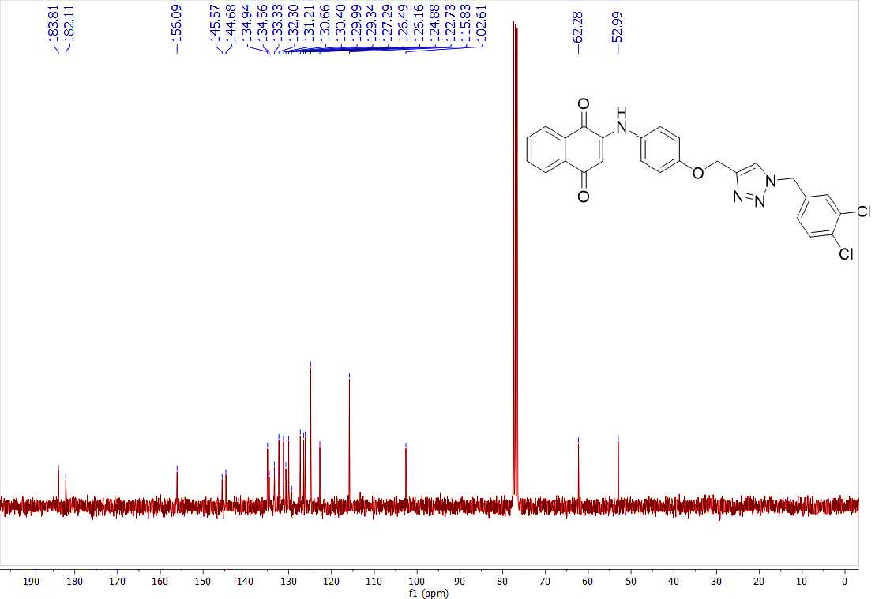
Figure 55s. ¹³C-NMR spectrum of compound (4e)
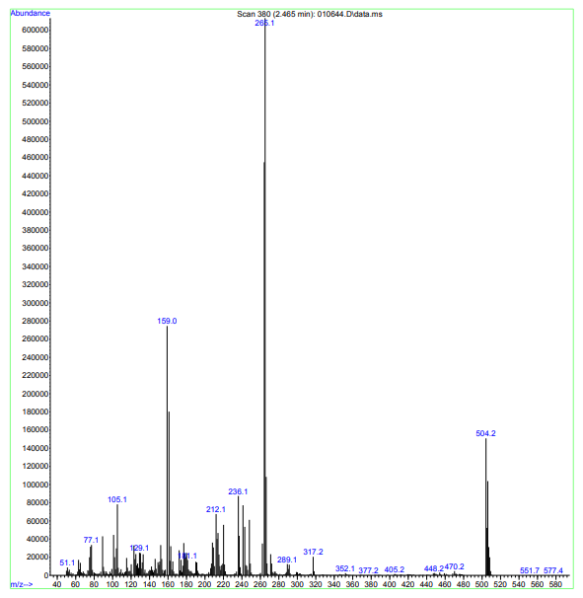
Figure 56s. MASS spectrum of compound (4e)
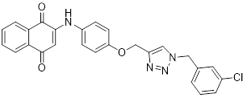
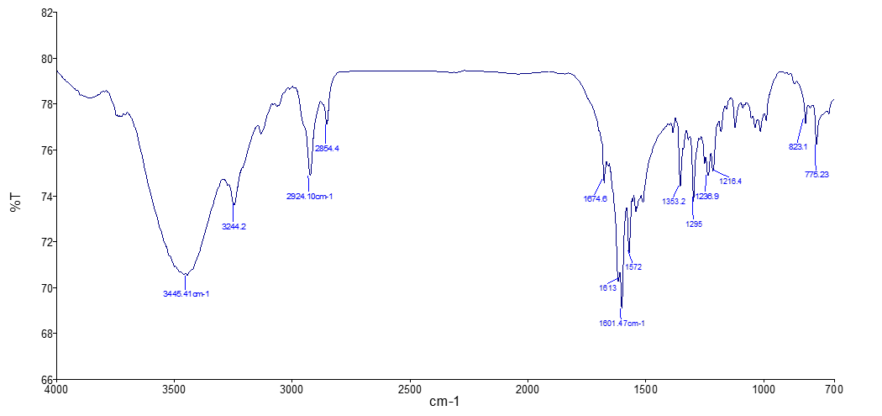
Figure 57s. IR spectrum of compound (4f).
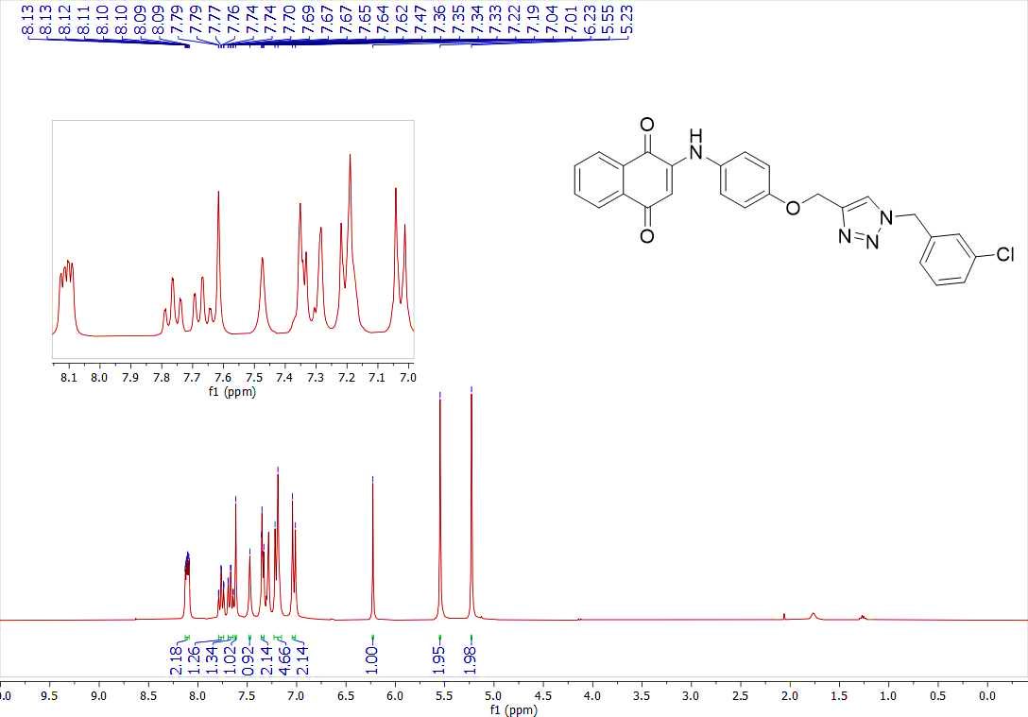
Figure 58s. ¹H-NMR spectrum of compound (4f)
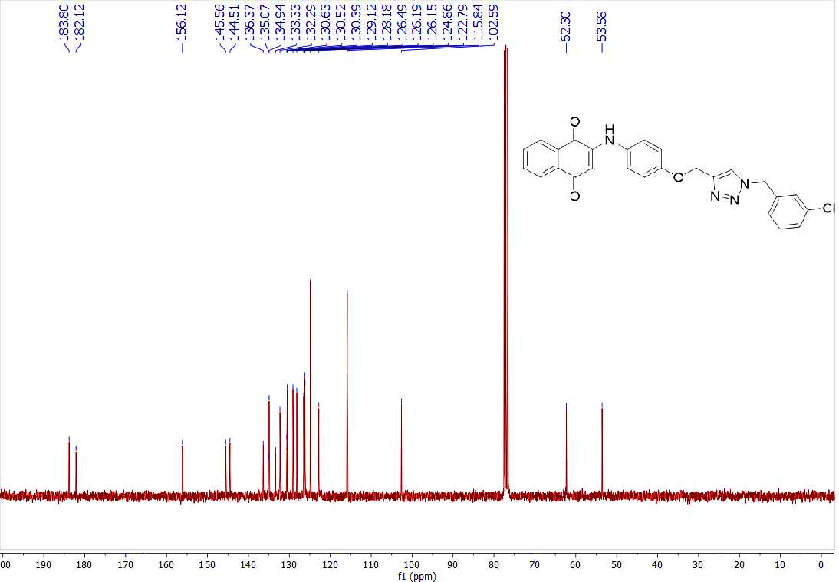
Figure 59s. ¹³C-NMR spectrum of compound (4f)
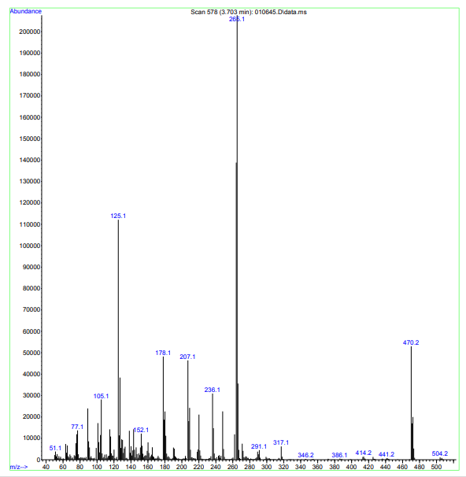
Figure 60s. MASS spectrum of compound (4f)
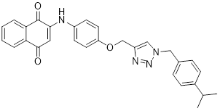
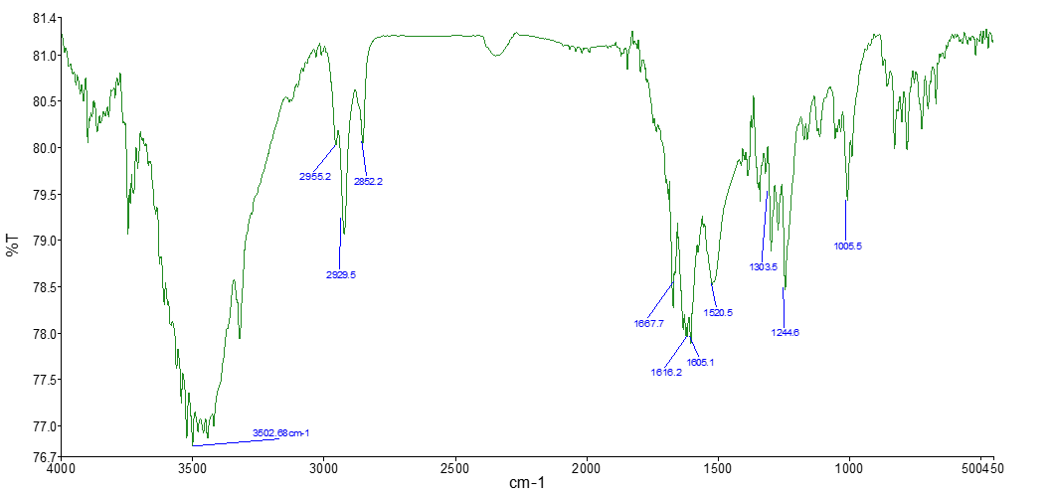
Figure 61s. IR spectrum of compound (4g)
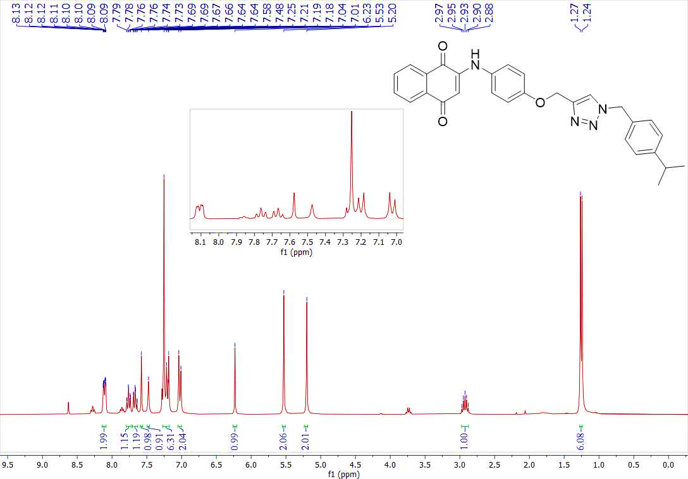
Figure 62s. ¹H-NMR spectrum of compound (4g)
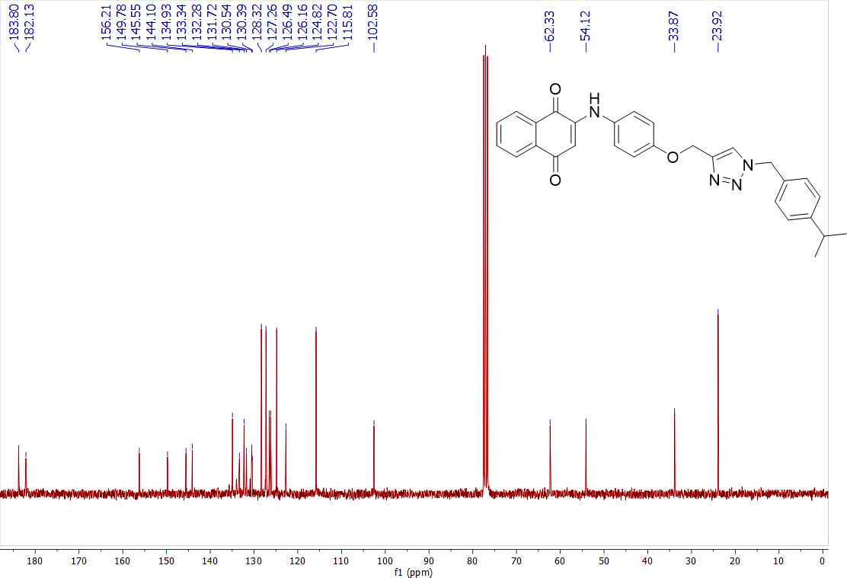
Figure 63s. ¹³C-NMR spectrum of compound (4g)
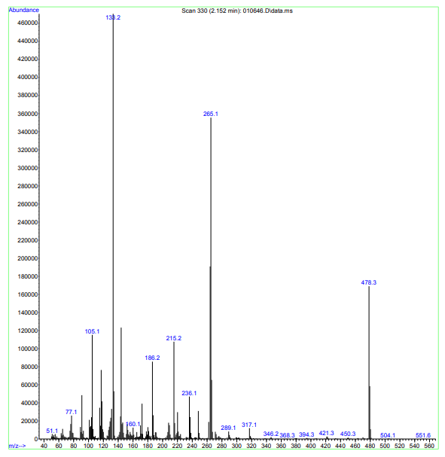
Figure 64s. MASS spectrum of compound (4g)
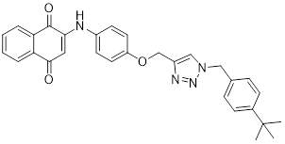
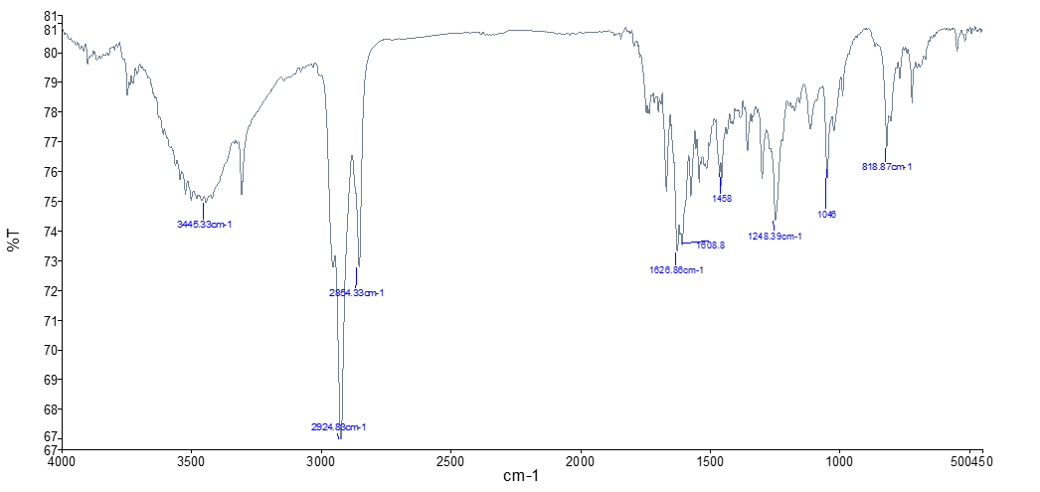
Figure 65s. IR spectrum of compound (4h)
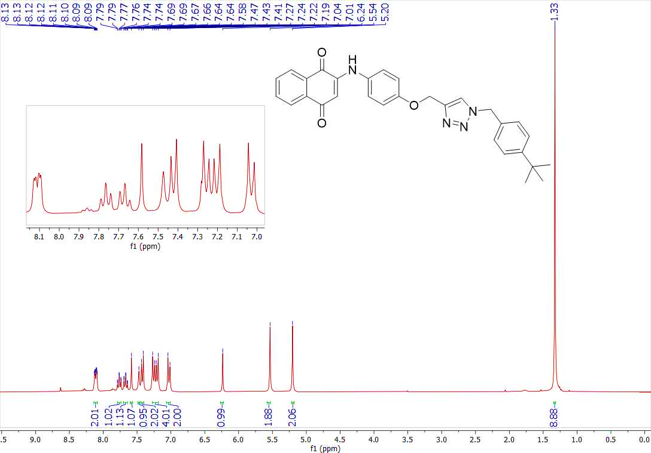
Figure 66s. ¹H-NMR spectrum of compound (4h)
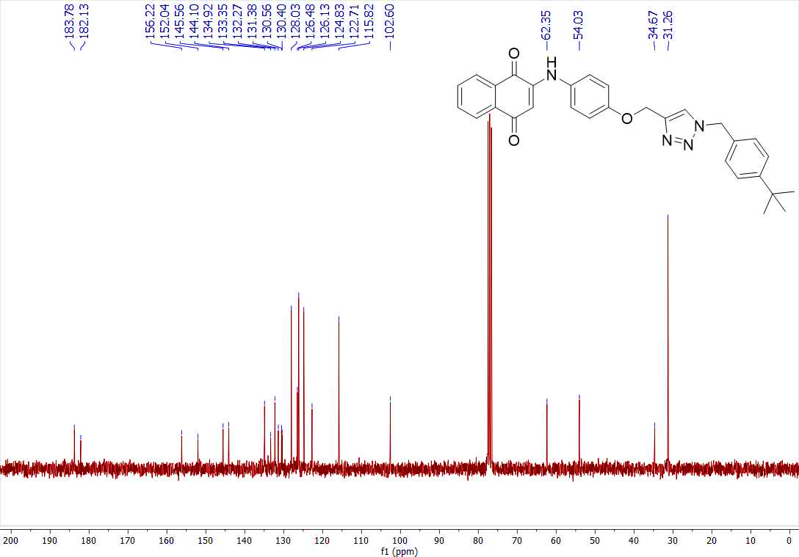
Figure 67s. ¹³C-NMR spectrum of compound (4h)
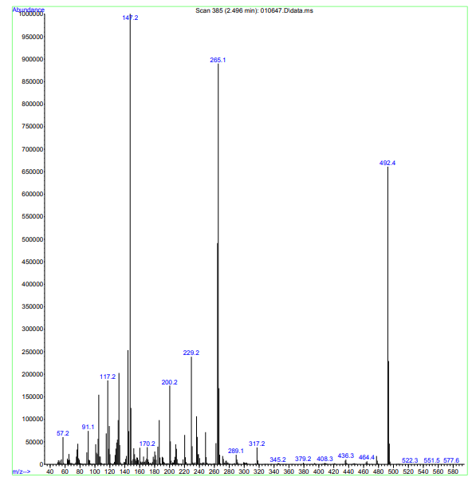
Figure 68s. MASS spectrum of compound (4h)
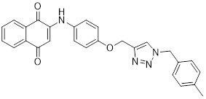
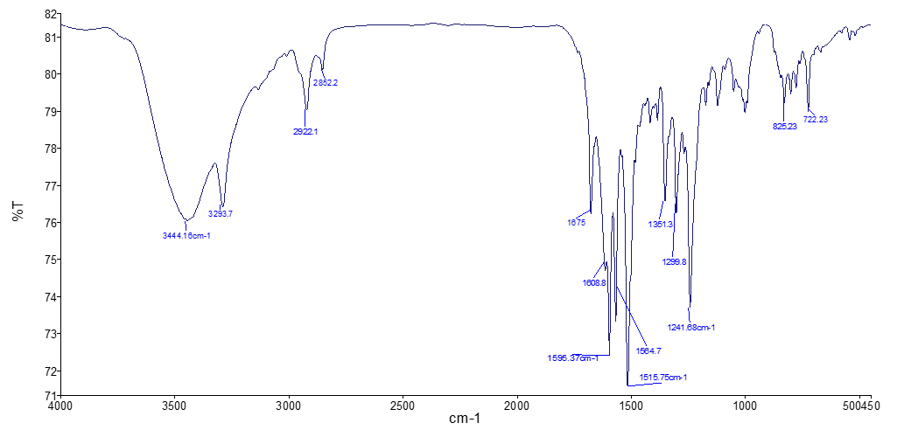
Figure 69s. IR spectrum of compound (4i)
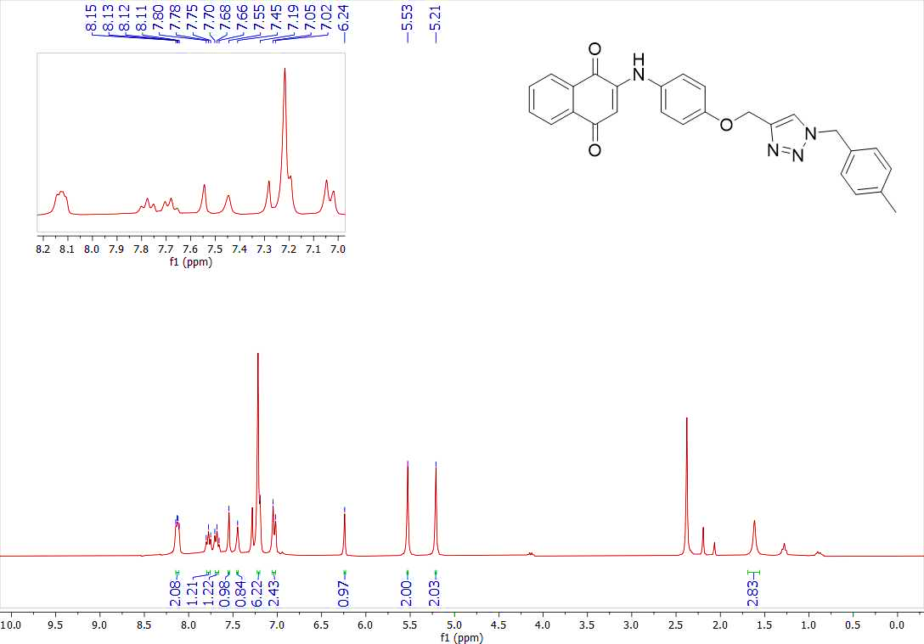
Figure 70s. ¹H-NMR spectrum of compound (4i)
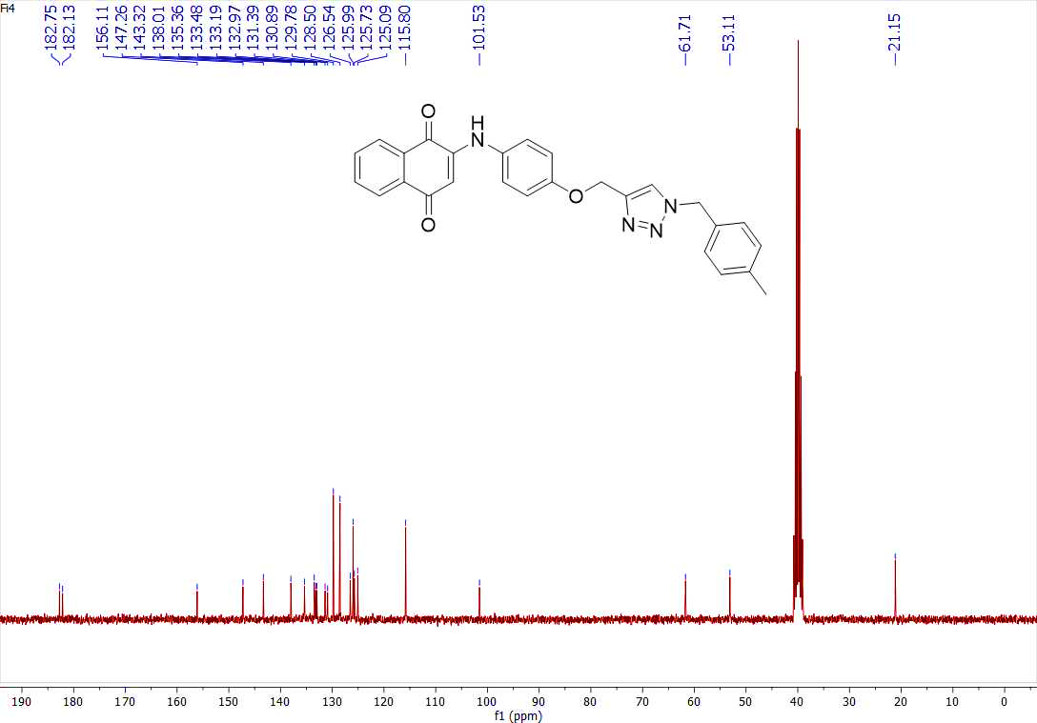
Figure 71s. ¹³C-NMR spectrum of compound (4i)
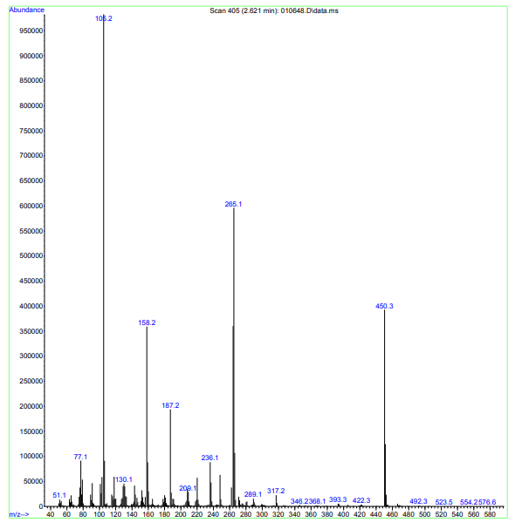
Figure 72s. MASS spectrum of compound (4i)
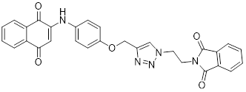
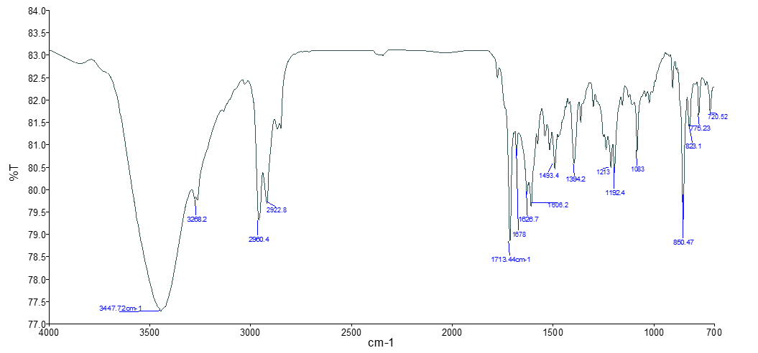
Figure 73s. IR spectrum of compound (4j)
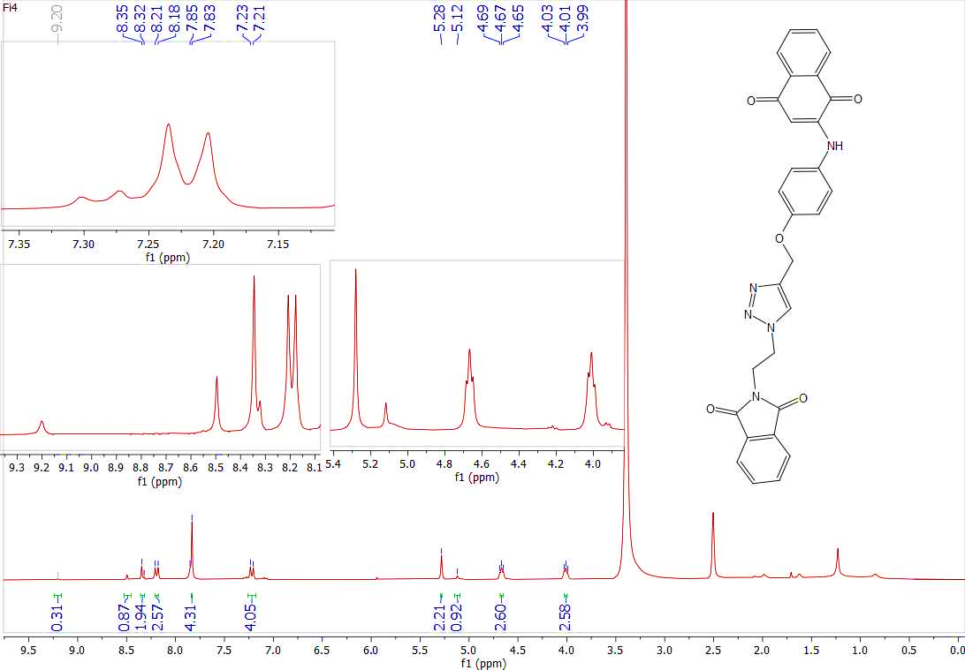
Figure 74s. ¹H-NMR spectrum of compound (4j)
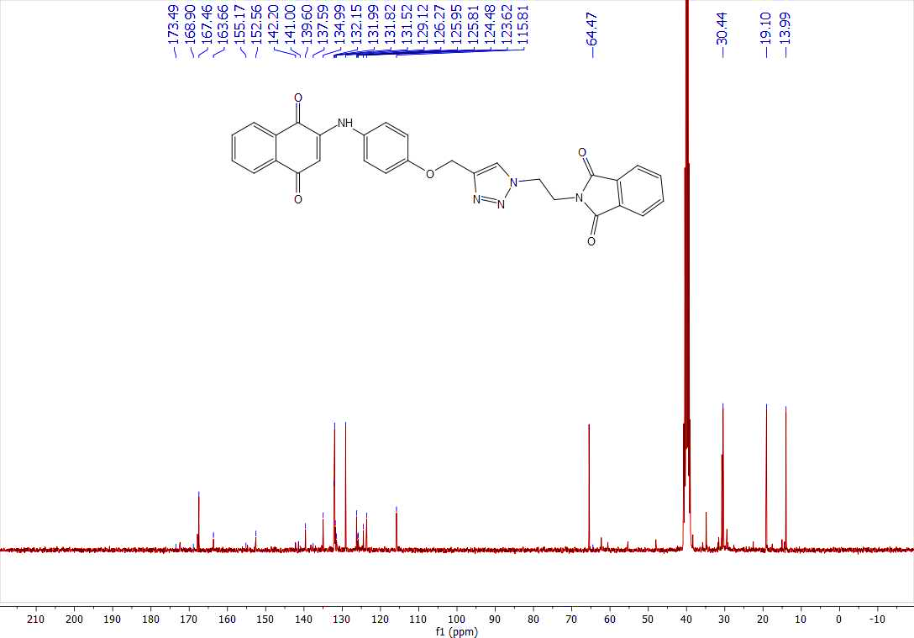
Figure 75s. ¹³C-NMR spectrum of compound (4j)
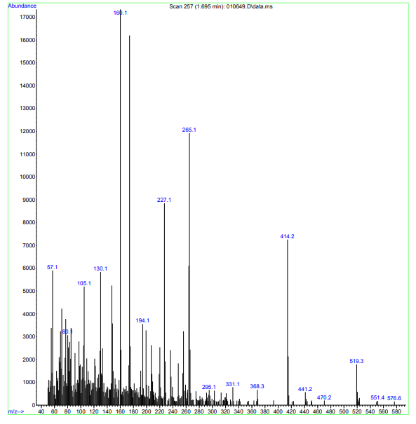
Figure 76s. MASS spectrum of compound (4j)
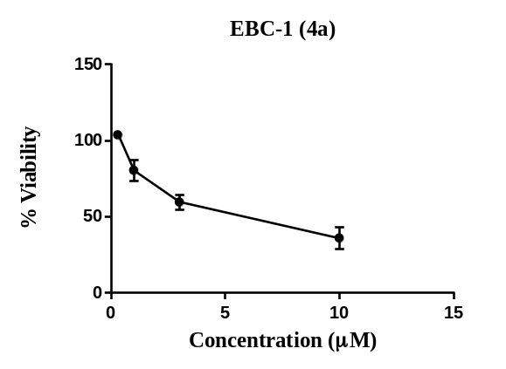 | 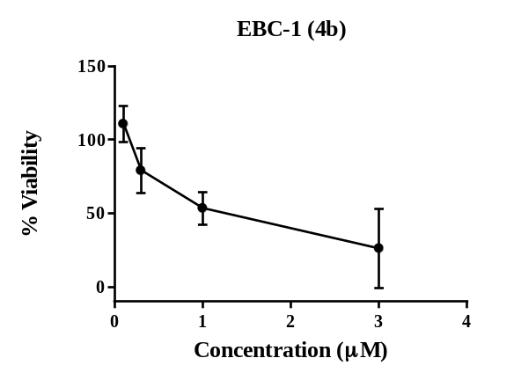
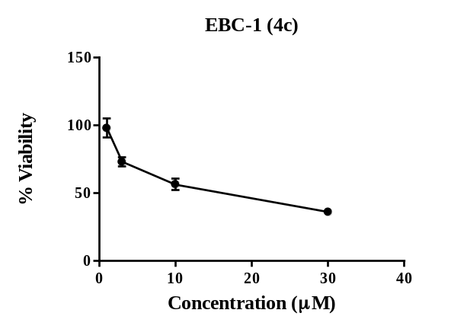 | 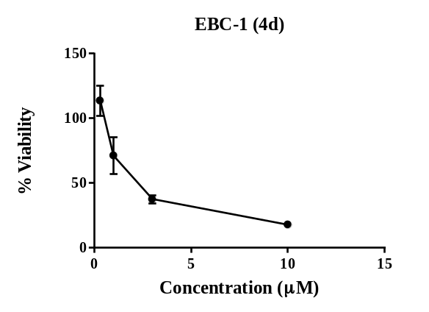
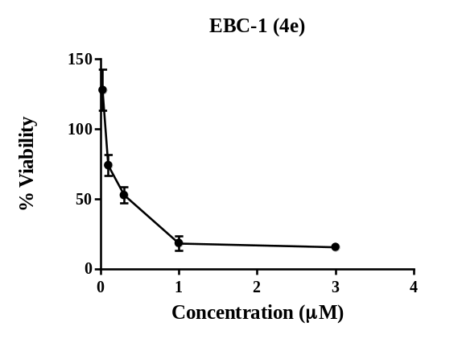 | 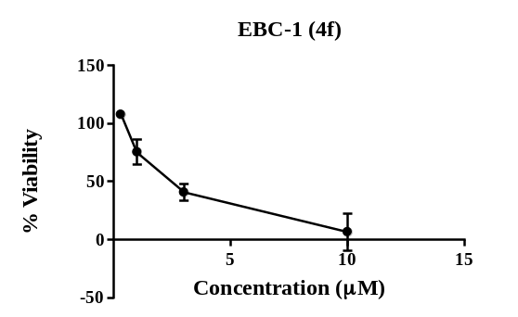
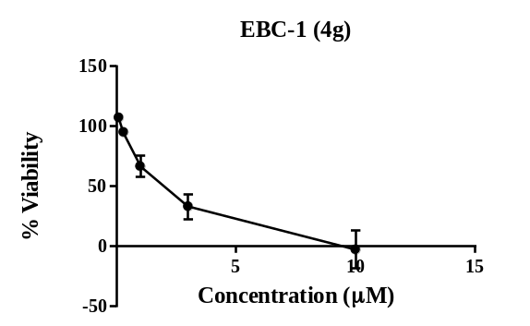 | 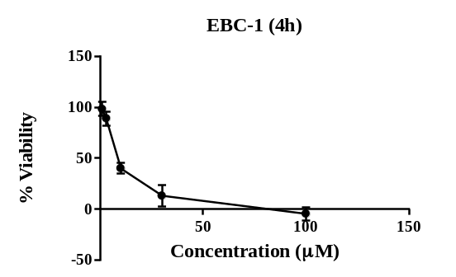
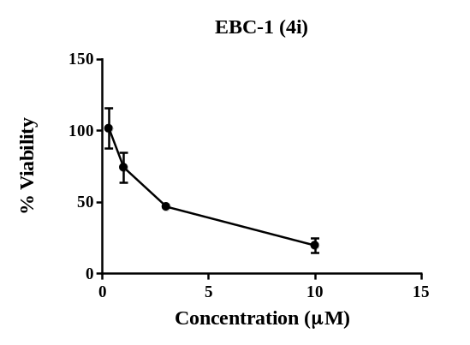 | 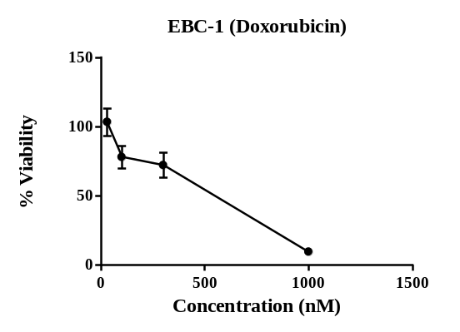
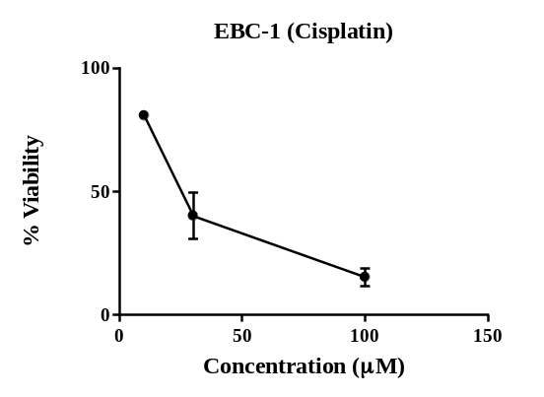 | 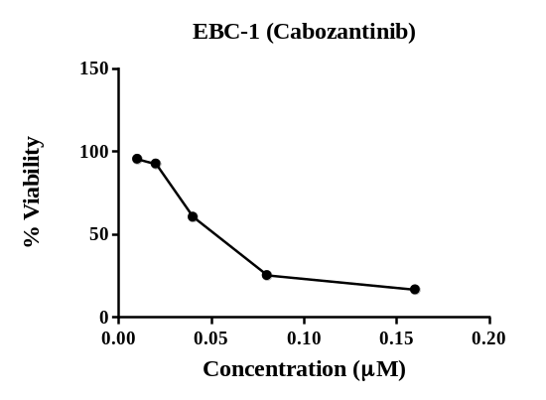
Figure 77s. The antiproliferative activity of synthetic and reference compounds against the EBC-1 cell line was measured using MTT assay.

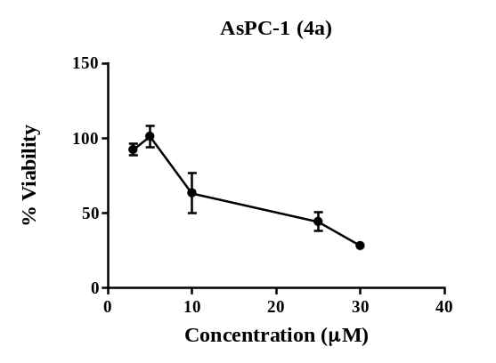 | 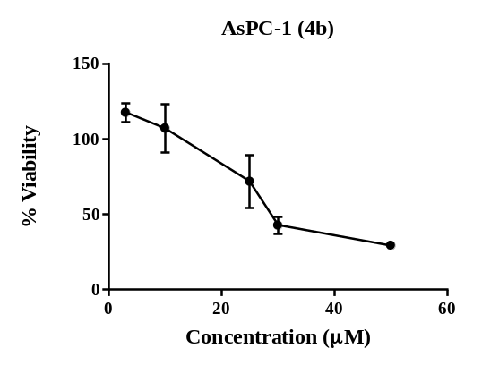
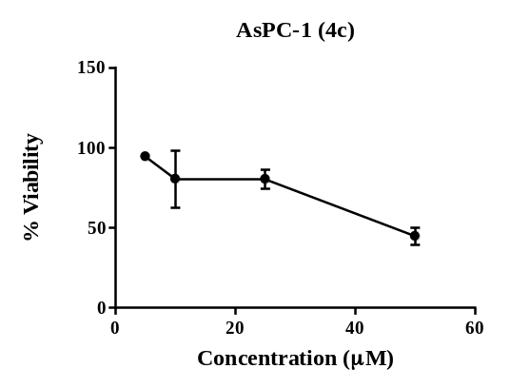 | 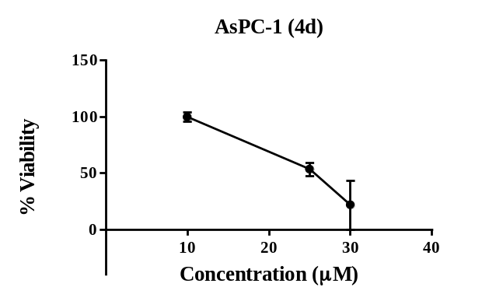
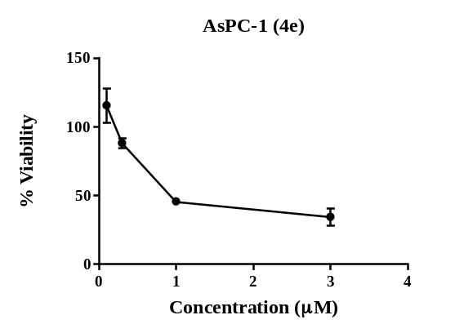 | 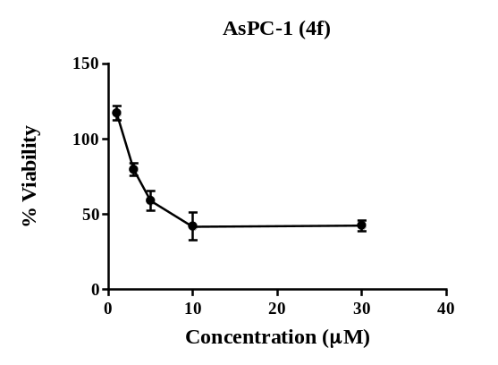
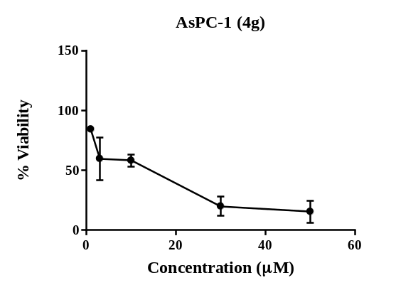 | 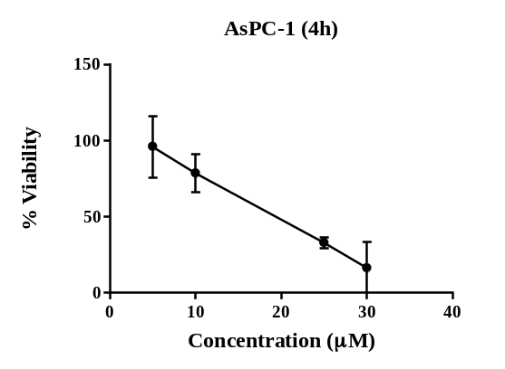
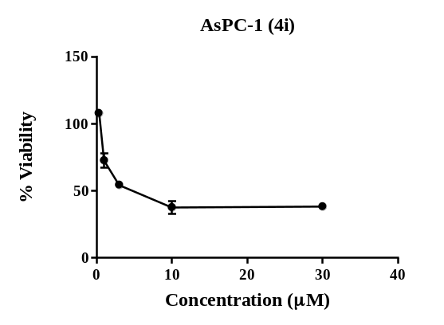 | 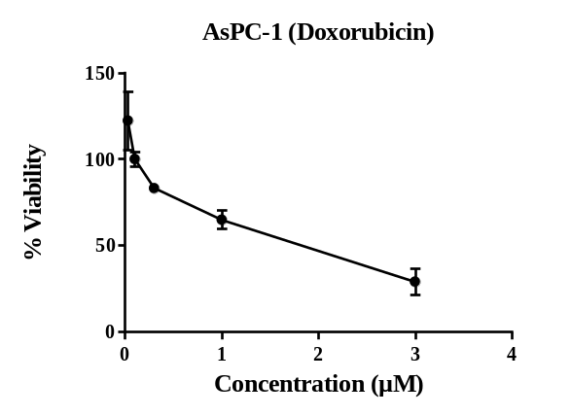
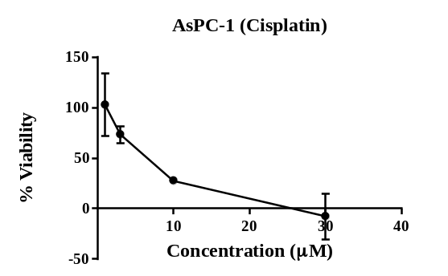 | 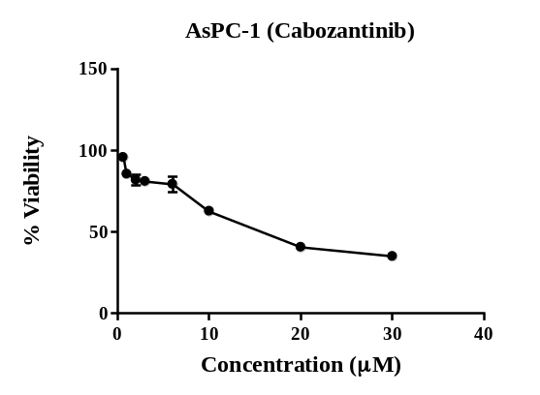
Figure 78s. The antiproliferative activity of synthetic and reference compounds against the AsPC-1 cell line was measured using MTT assay.

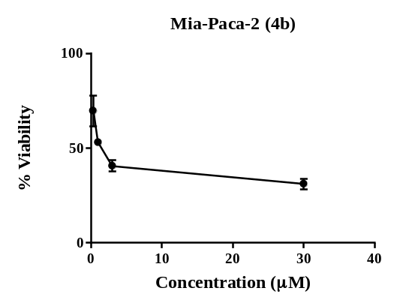 | 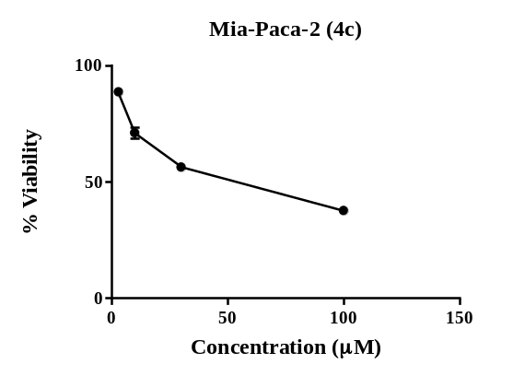
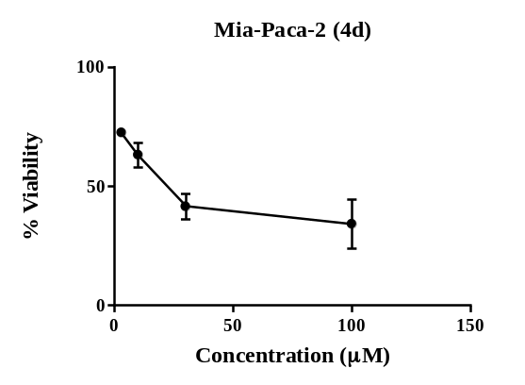 | 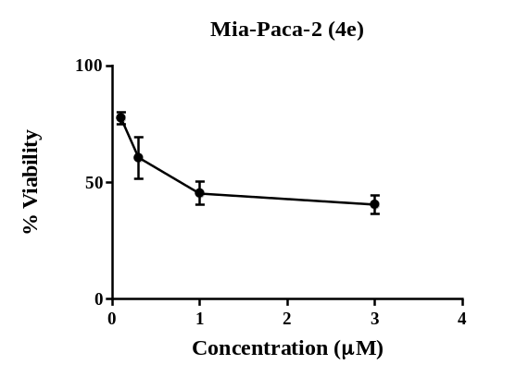
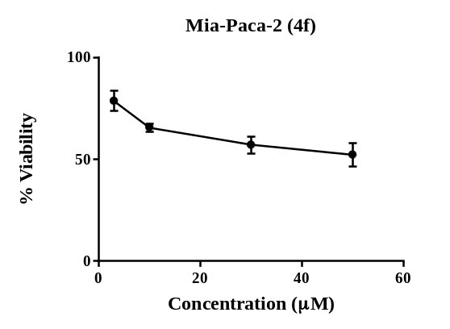 | 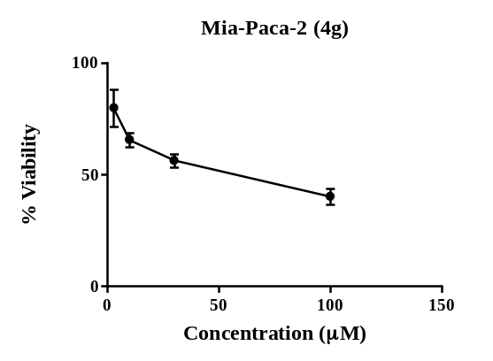
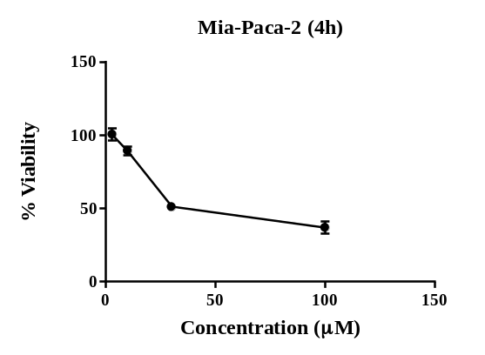 | 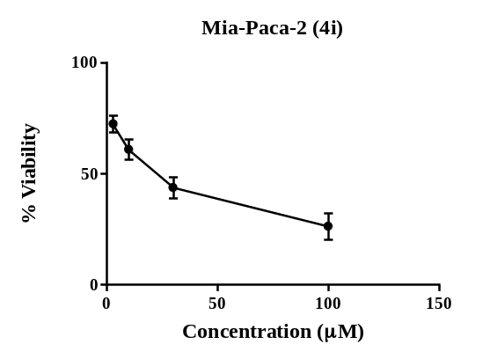
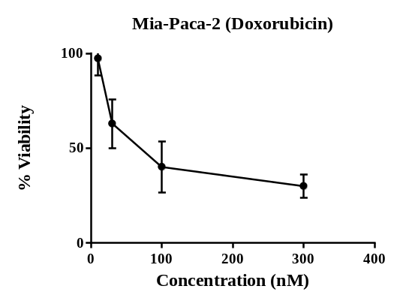 | 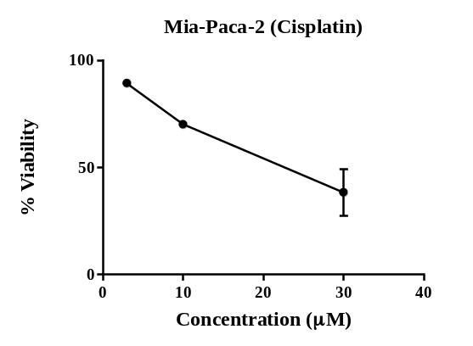
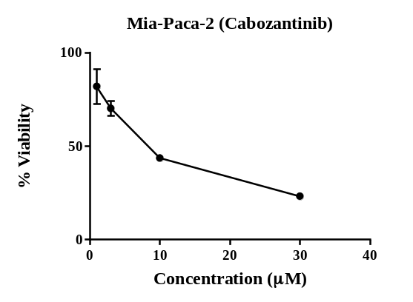
Figure 79s. The antiproliferative activity of synthetic and reference compounds against the Mia-Paca-2 cell line was measured using MTT assay.

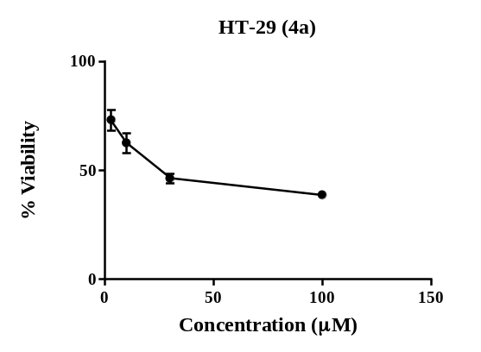 | 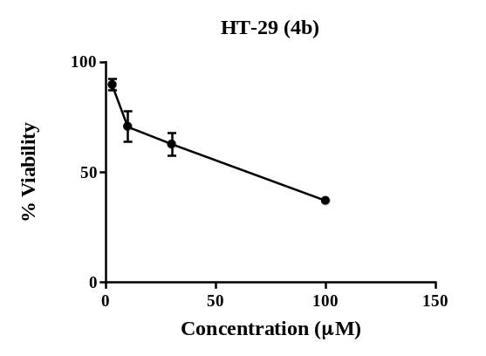
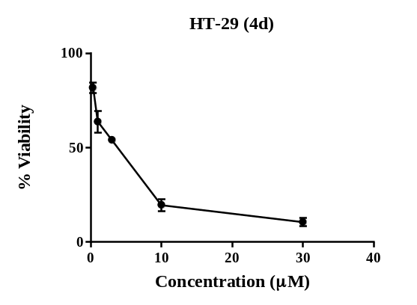 | 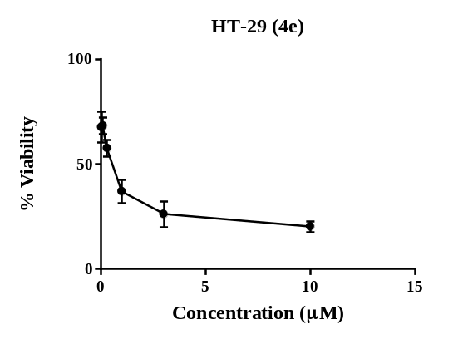
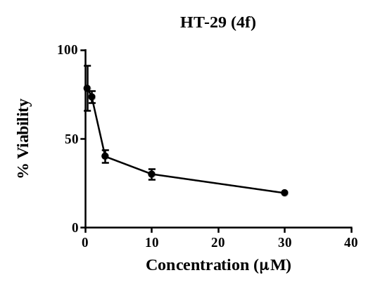 | 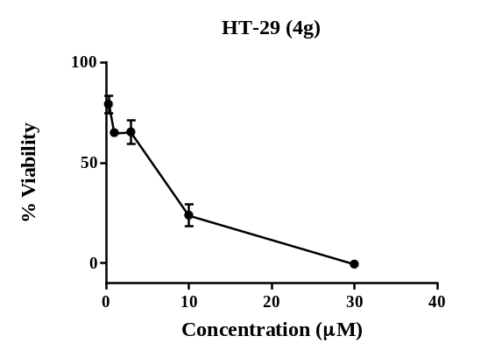
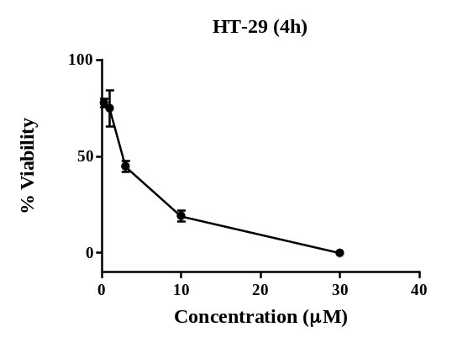 | 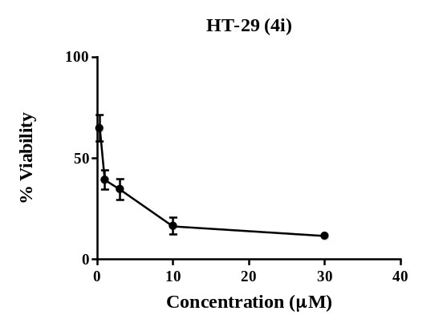
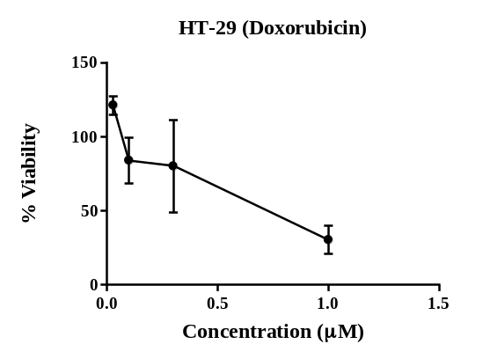 | 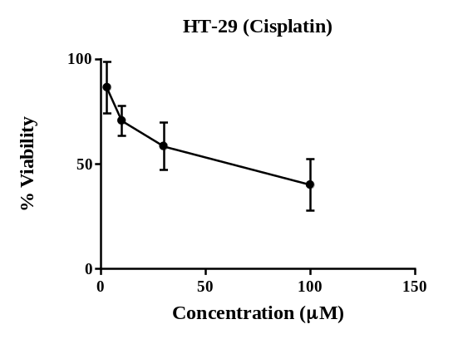
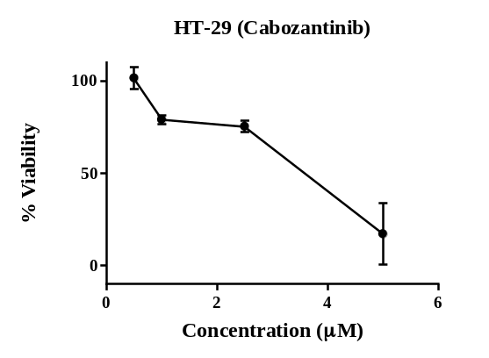
Figure 80s. The antiproliferative activity of synthetic and reference compounds against the HT-29 cell line was measured using MTT assay.
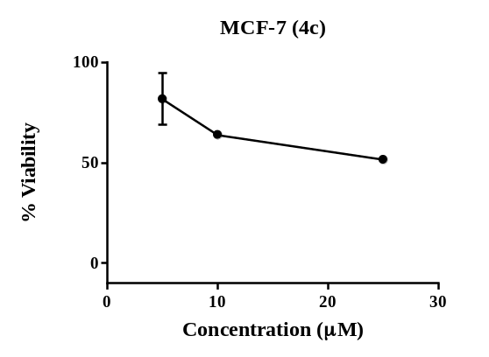 | 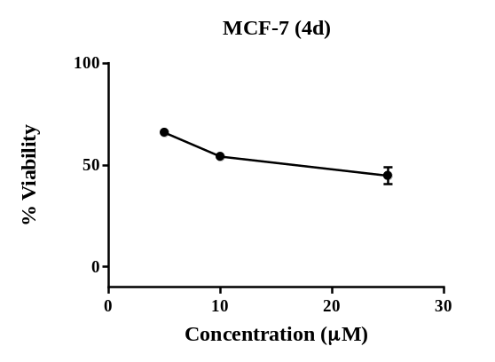
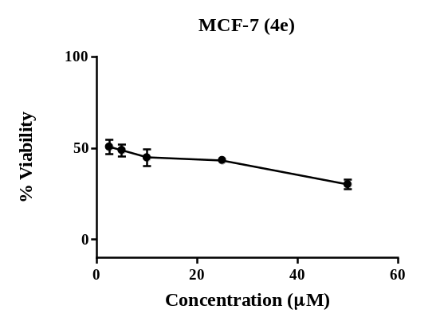 | 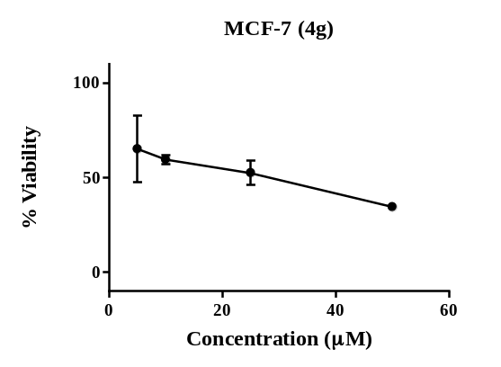
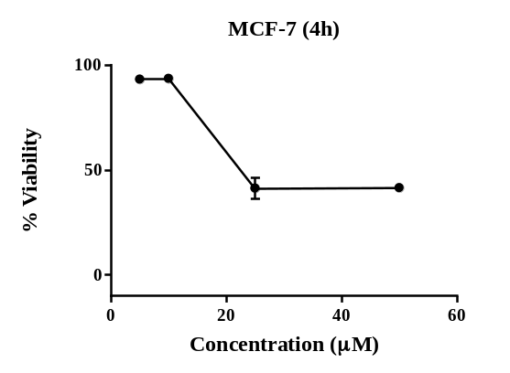 | 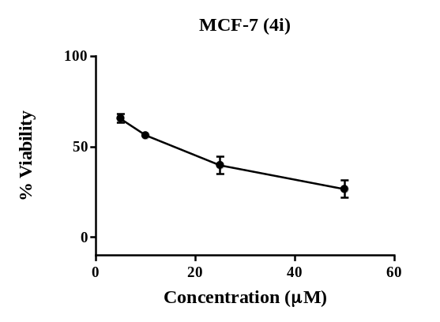
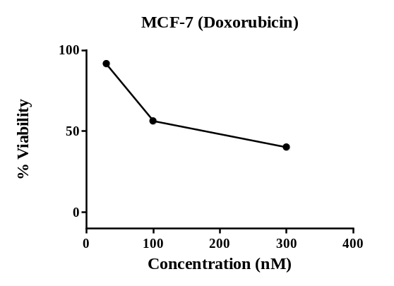 | 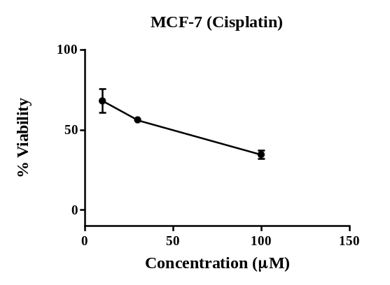
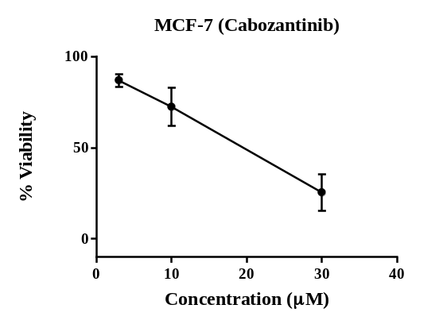
Figure 81s. The antiproliferative activity of synthetic and reference compounds against the MCF-7 cell line was measured using MTT assay.

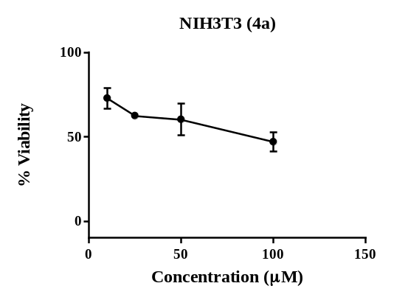 | 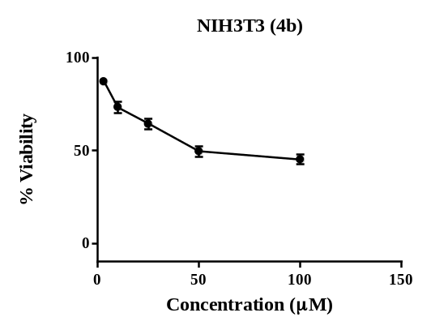
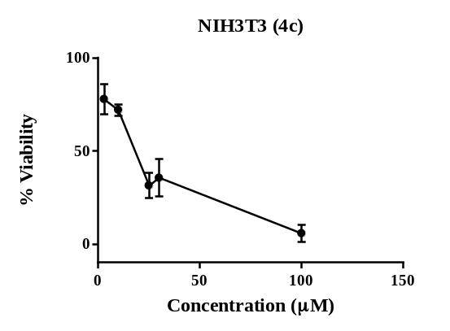 | 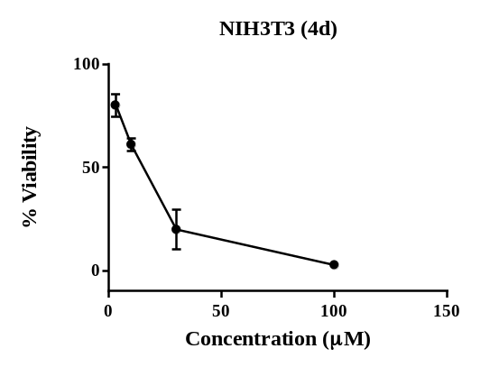
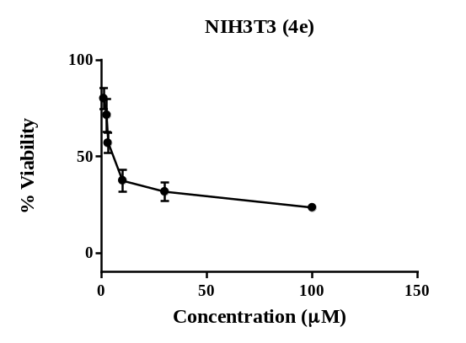 | 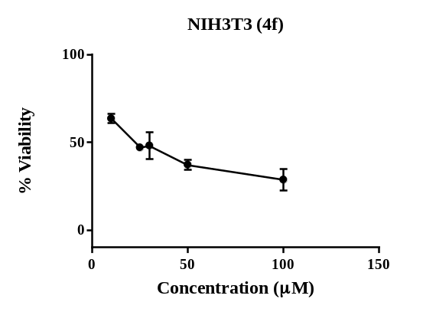
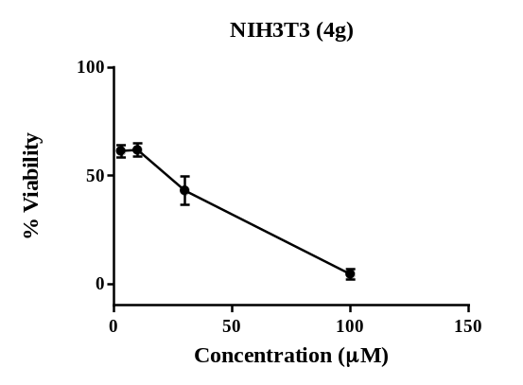 | 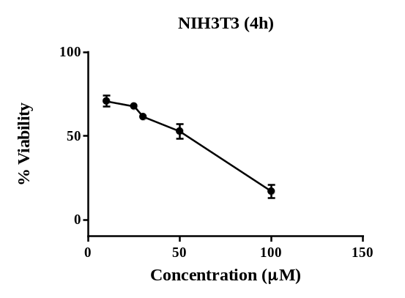
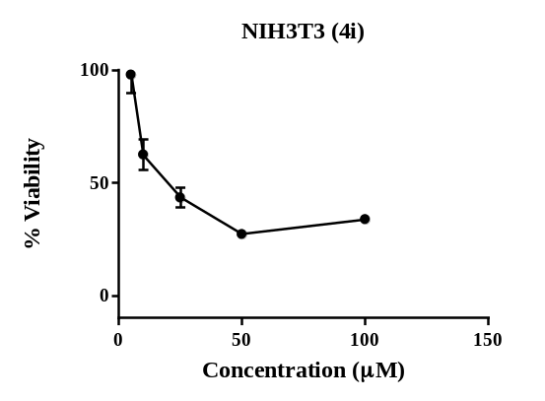 | 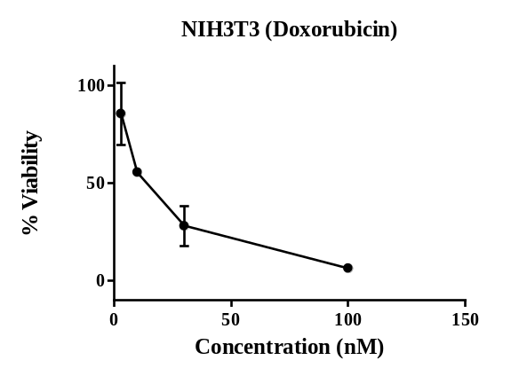
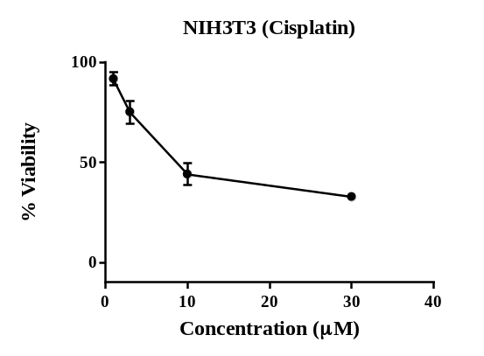
Figure 82s. The antiproliferative activity of synthetic and reference compounds against the NIH3T3 cell line was measured using MTT assay.

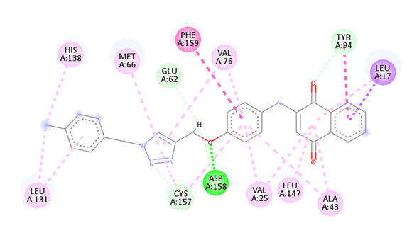 | 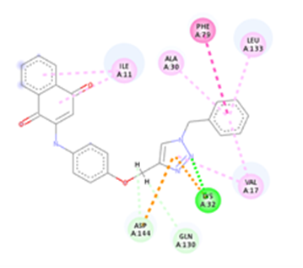
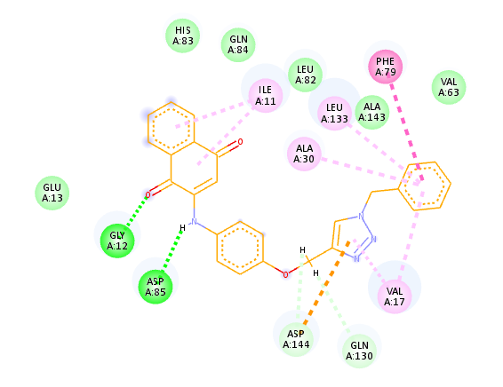
Cluster 3 (A)
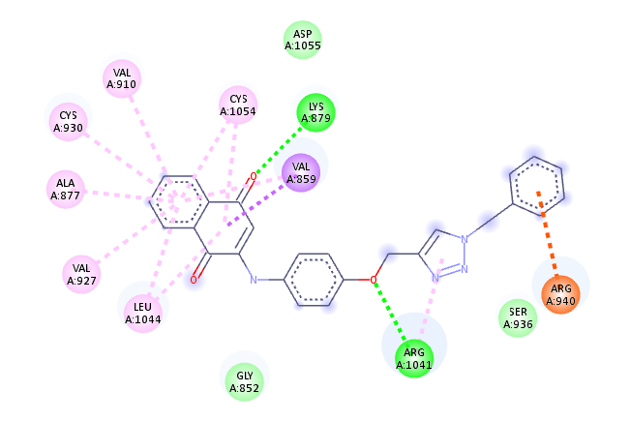
Cluster 1 (B)
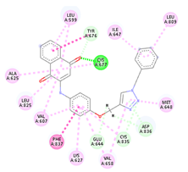  Cluster 1 (C) | 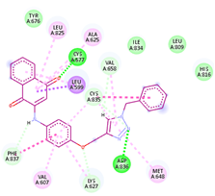  Cluster 2 (C)
Figure 83s. The interaction patterns within each cluster of 4a with CDK2(A), FLT4 (B), and PDGFRA receptors (C).
Cluster 2 (A)
Cluster 1 (A)

