Supplementary Figure 1.
Study design flowchart.
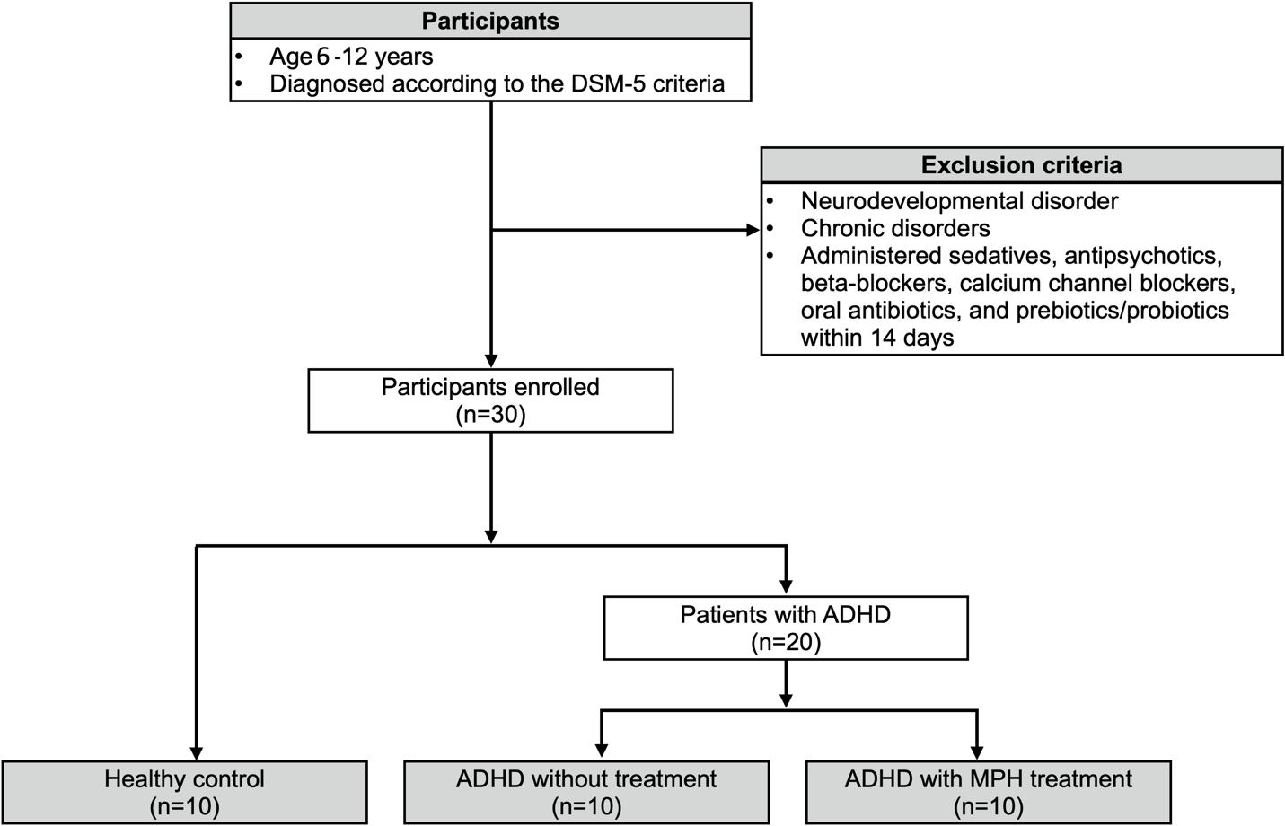

Flowchart illustrating the recruitment, grouping, and analysis steps followed in the study. ADHD children were categorized into medicated and unmedicated groups, and healthy controls were recruited for comparison. Fecal samples were collected, and gut microbiota and SCFA profiles were analyzed using 16S rRNA gene sequencing and targeted metabolomics, respectively.

