Supplementary Material

Morphological and functional analysis of colorectal cancer cell lines in 2D and 3D culture models

Seiichi Shinji^{1,2*}, Yutaro Ogawa¹, Takeshi Yamada¹, Akihisa Matsuda¹, Kay Uehara¹, Yasuyuki Yokoyama¹, Goro Takahashi¹, Takuma Iwai¹, Toshimitsu Miyasaka¹, Shintaro Kanaka¹, Koki Hayashi¹, Yuuki Shichi², Masakazu Fujiwara², Kimimasa Takahashi³, Tomio Arai⁴, Toshiyuki Ishiwata², and Hiroshi Yoshida¹

¹Department of Gastroenterological Surgery, Nippon Medical School 1-1-5 Sendagi, Bunkyo-ku, Tokyo 113-8603, Japan
²Division of Aging and Carcinogenesis, Research Team for Geriatric Pathology, Tokyo Metropolitan Institute for Geriatrics and Gerontology, 35-2 Sakae-cho, Itabashi-ku, Tokyo 173-0015, Japan
³Department of Veterinary Pathology, School of Veterinary Medicine, Nippon Veterinary and Life Science University, Tokyo 180-8602, Japan
⁴Department of Pathology, Tokyo Metropolitan Institute for Geriatrics and Gerontology, 35-2 Sakae-cho, Itabashi-ku, Tokyo 173-0015, Japan

*Corresponding author:
E-mail: s-shinji@nms.ac.jp

Figure S1. Experimental design.
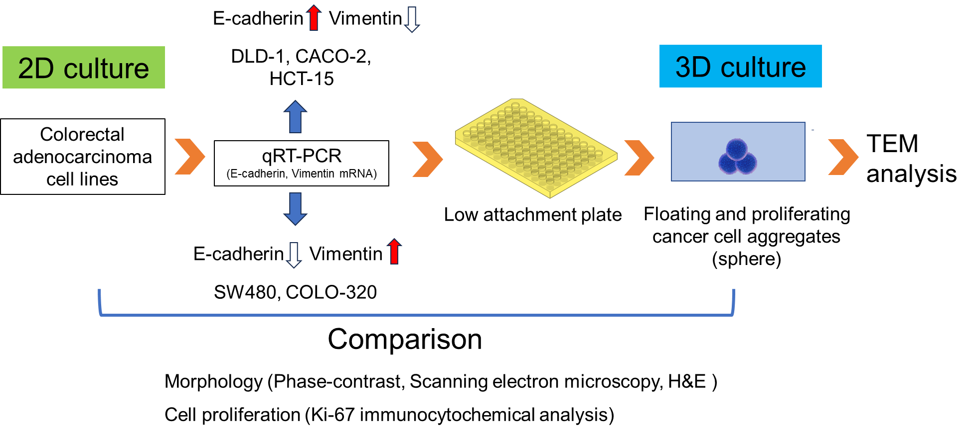

Colorectal Cancer Cell Line Classification and Culture
Colorectal cancer cell lines were classified into three epithelial types (DLD-1, CACO-2, and HCT-15) and two mesenchymal types (SW480 and COLO-320) based on the differences in the mRNA expression levels of E-cadherin and vimentin in 2D cultures. These cell lines were cultured in low-attachment plates to promote spheroid formation that proliferated while floating on medium.
Morphological and Proliferative Analysis
The morphology of the cell lines in both 2D and 3D cultures was examined using phase-contrast microscopy, scanning electron microscopy, and hematoxylin and eosin (H&E) staining of the cell blocks. The proliferative capacity was assessed using Ki-67 immunocytochemical staining of the cell blocks.
Transmission Electron Microscopy (TEM) Analysis of Spheroids
For spheroids formed in 3D culture, cross-sectional observations were performed using TEM to further analyze their structural characteristics.

Figure S2. Evaluation of Immunocytochemical Staining of E-cadherin and Vimentin in Colorectal Cancer Cell Lines using H-score
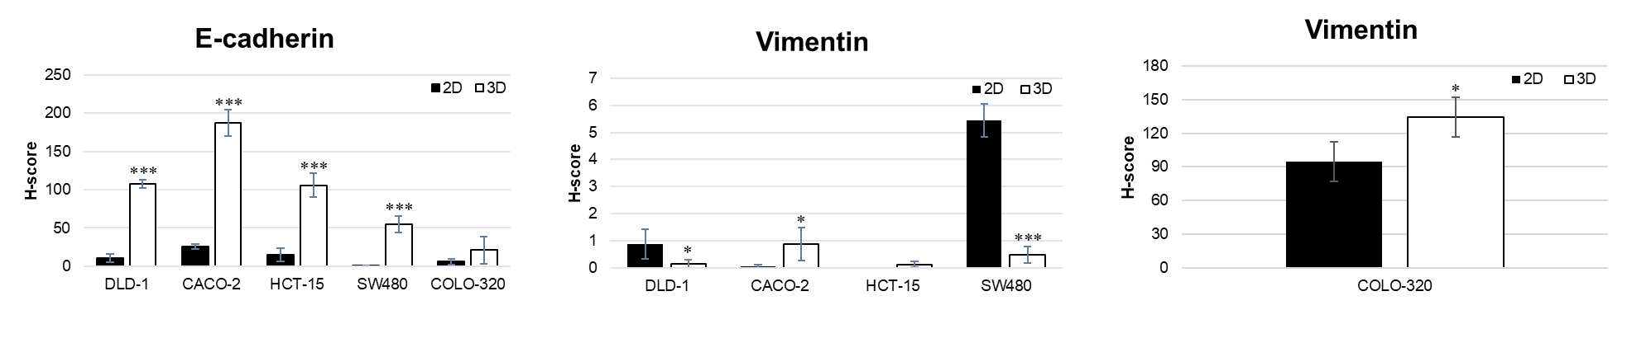
Immunostaining specimens of cell blocks from colorectal cancer cell lines were scored based on staining intensity and extent. E-cadherin was significantly higher in 3D culture than in 2D culture in cells (other than COLO-320). Vimentin was highly expressed in SW480 and COLO-320 cells, and the expression level was statistically higher in 2D culture for SW480 and in 3D culture for COLO-320. *p<0.05, **p<0.01, ***p<0.001

Figure S3. Western blot analysis of E-cadherin and Vimentin in Colorectal Cancer Cell Lines
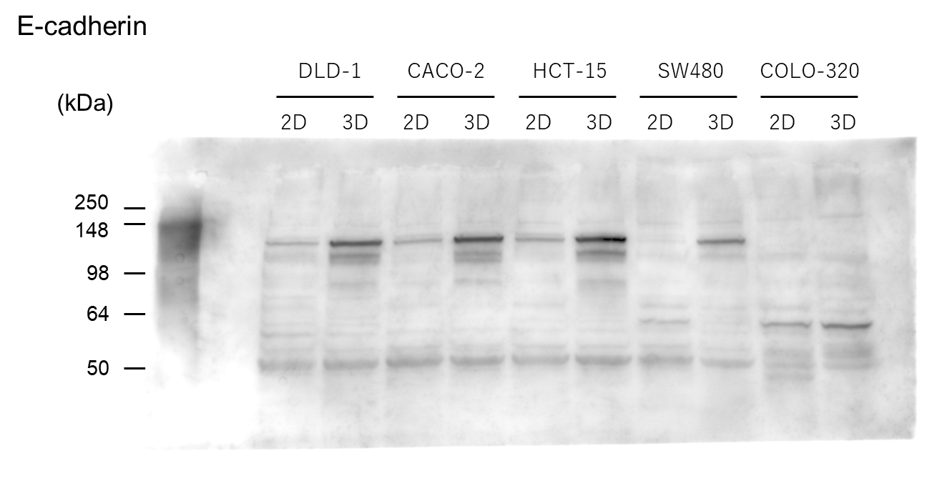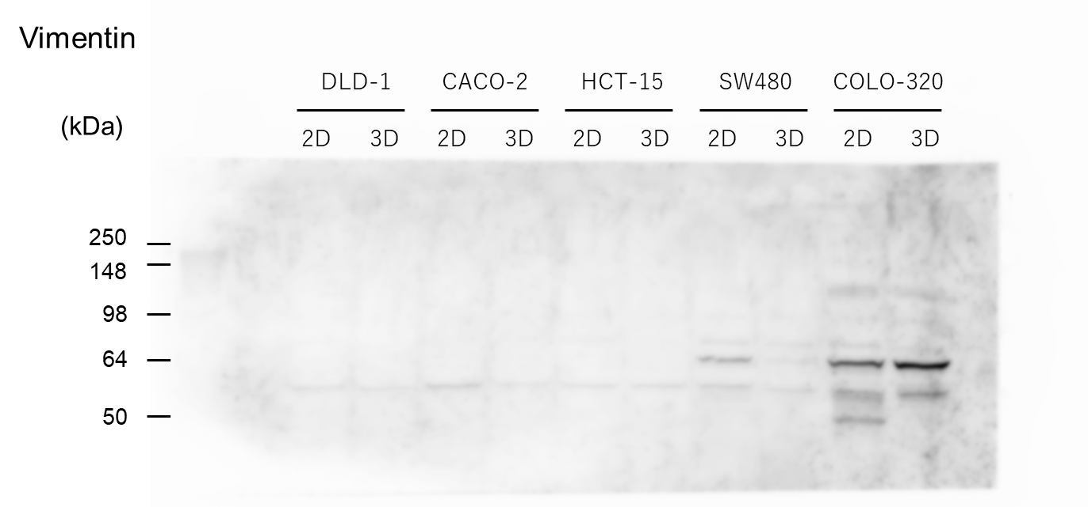
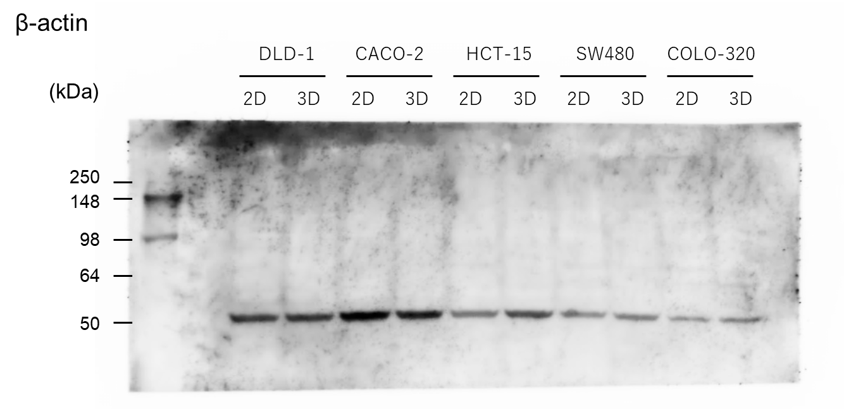
Western blot was performed using five colon cancer cell lines cultured in 2D and 3D. The figure shows an overall view of the membrane stained with anti-E-cadherin, anti-vimentin, and anti-β-actin antibodies.
Figure S4. Mucin and Glycogen Production in 2D Colorectal Cancer Cell Lines Cultures
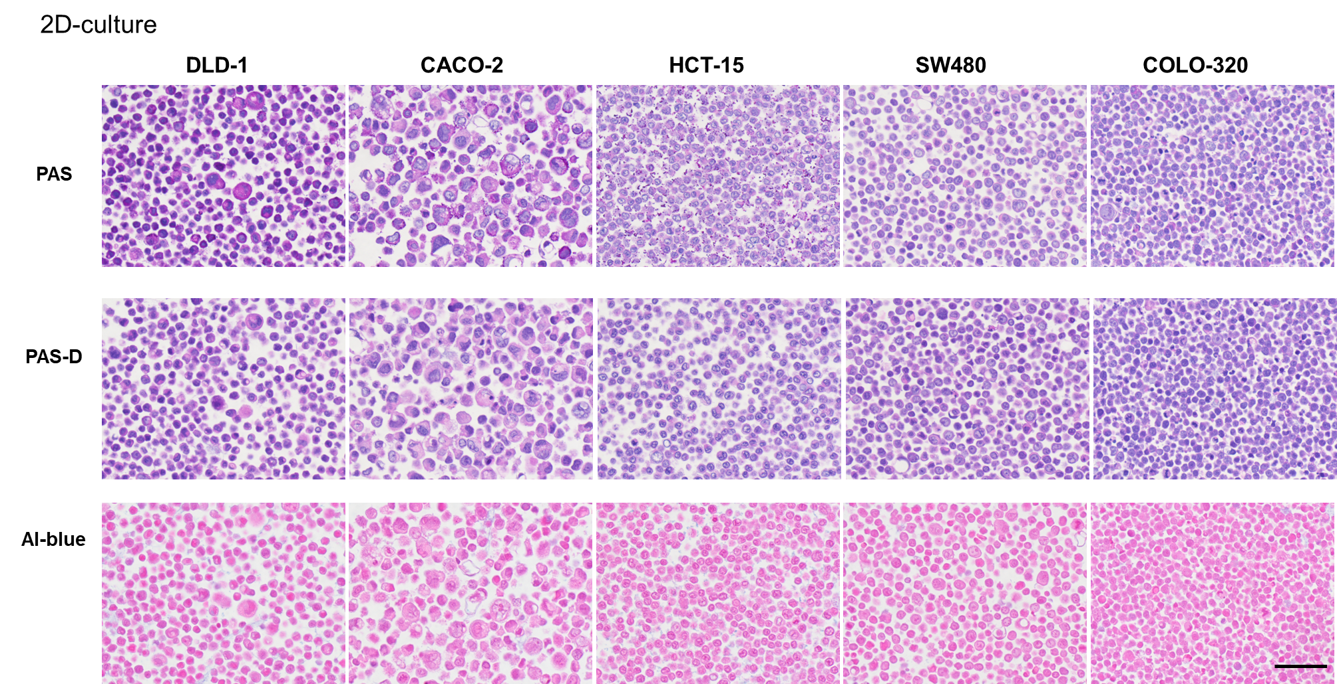
In the colorectal cancer cell lines DLD-1, CACO-2, and HCT-15, periodic acid-Schiff (PAS)-positive granules, indicative of glycogen digested by diastase, were observed. Alcian blue-positive cells, indicating mucin production, were rarely observed in any cell line. Scale bar = 50 μm.

Figure S5. Mucin and Glycogen Production in 3D Colorectal Cancer Cell Lines Cultures
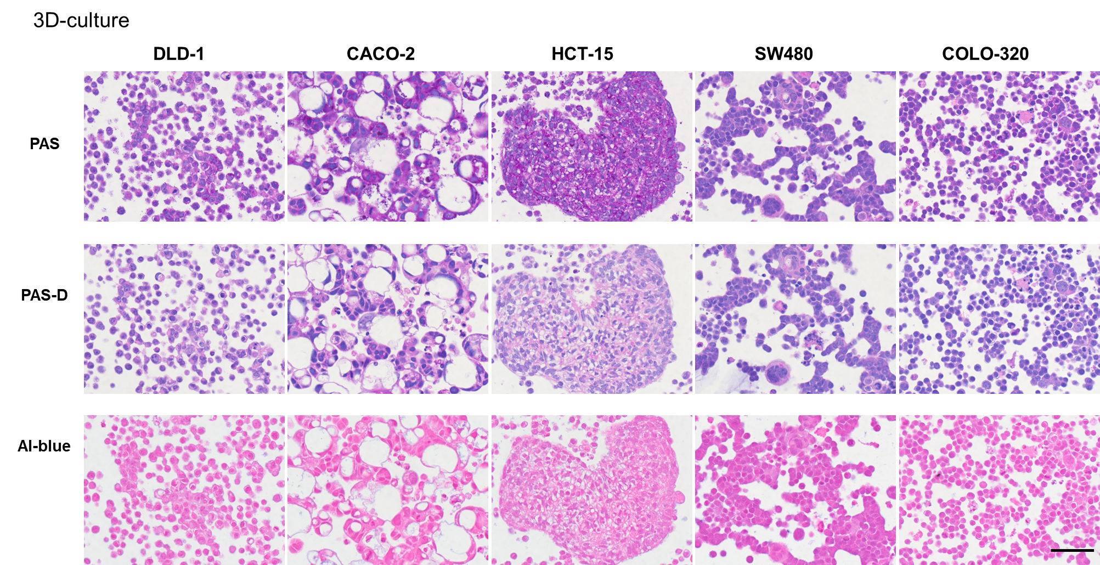
In 3D cultures of the colorectal cancer cell lines DLD-1, CACO-2, and HCT-15, PAS-positive granules indicative of glycogen, which were digested by diastase, were observed. However, no Alcian blue-positive cells were detected in any of the cell lines. Scale bar = 50 μm.

Figure S6. Graphical Summary of the Characteristics of 2D and 3D-cultured Colorectal Cancer Cell Lines
2D and 3D cultures of five colon cancer cell lines revealed differences in epithelial-mesenchymal features, proliferative potential, and cell morphology.

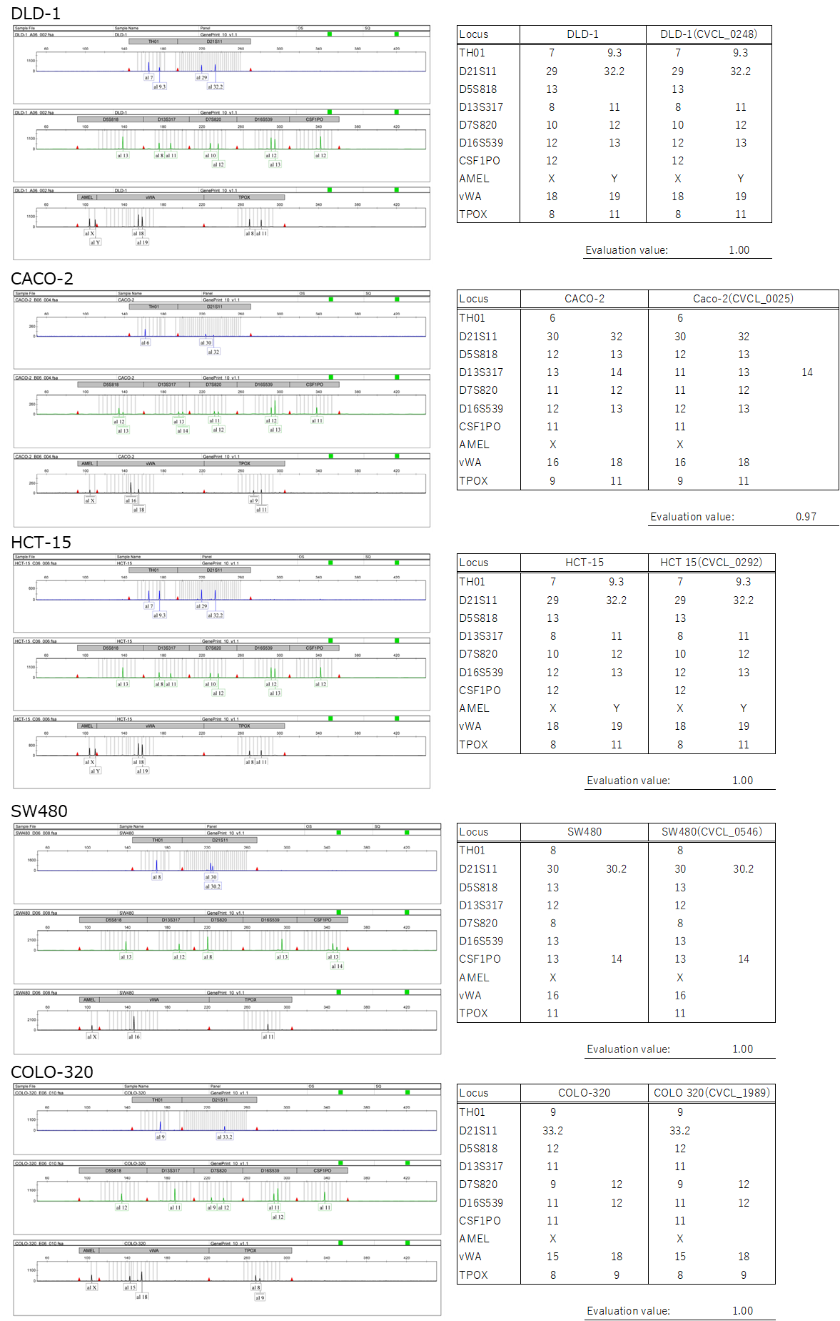
Figure S7. STR Profile Comparison of Colorectal Cancer Cell Lines with Cellosaurus Database Entries
The STR analysis results for each cell line were compared with the STR profiles registered in Cellosaurus. The STR profiles of DLD-1, HCT-15, SW480, and COLO-320 exhibited a perfect match with their respective entries. In contrast, the STR profiles of CACO-2 did not completely match with the registered profile for Caco-2 (CVCL_0025). However, the Evaluation Value (EV) between CACO-2 and Caco-2 (CVCL_0025) was 0.97, indicating a high degree of similarity. This value supports the conclusion that the STR profiles of CACO-2 and Caco-2 (CVCL_0025) represent the same cell line strain.

Table S1. Major Gene Mutations in the Five Human Colorectal Cancer Cell Lines Used in This Study
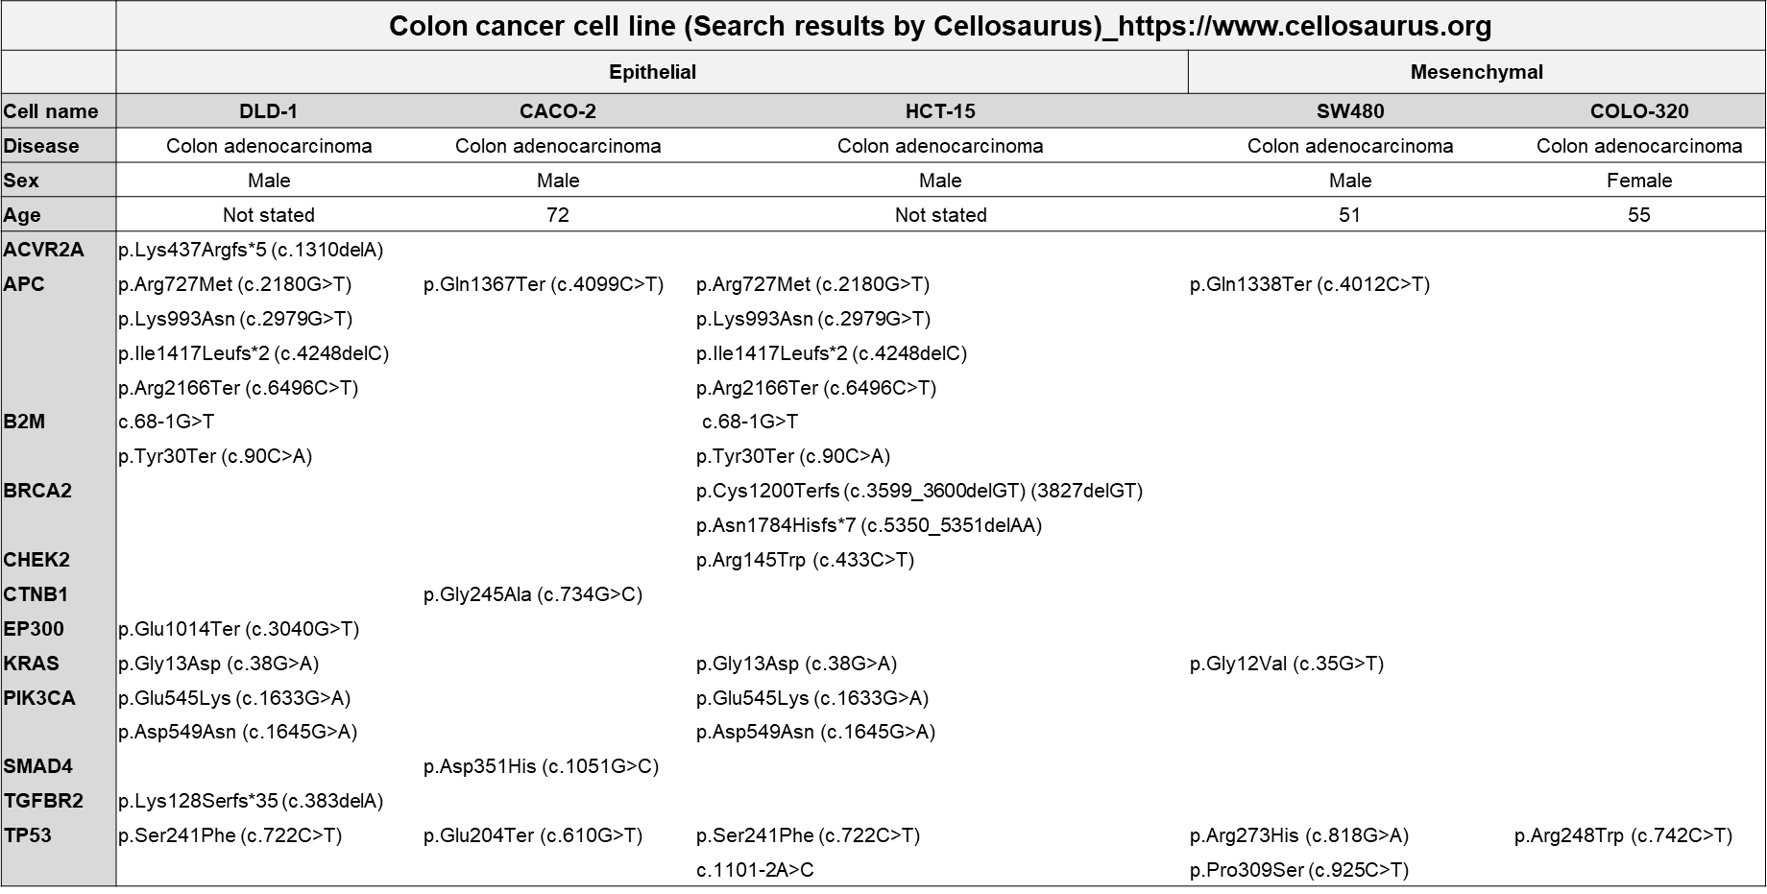
The major gene mutations in the five human colorectal cancer cell lines used in this study were identified using the Cellosaurus cell line database. Notably, the DLD-1 and HCT-15 cell lines were derived from the same patient, resulting in identical major gene mutations.

List of abbreviations
ACS: American cancer society
CRAC: Colorectal adenocarcinoma
CRC: Colorectal cancer
EMT: Epithelial-mesenchymal transition
IARC: International agency for research on cancer
MET: Mesenchymal-epithelial transition
NET: Neuroendocrine tumor
PDAC: Pancreatic ductal adenocarcinoma
qRT-PCR: Quantitative reverse transcription-polymerase chain reaction
SEM: Scanning electron microscopy
TEM: Transmission electron microscopy
2D: Two-dimensional
3D: Three-dimensional

