Supplementary materials: Lumley et al. Whole genome sequencing of hepatitis B virus using tiled amplicon (HEPTILE) and probe based enrichment on Illumina and Nanopore platforms

Supplementary material

Supplementary figures
Supplementary figure 1: Modifications to primer positions to take into account HBV genome structure.
Supplementary figure 2: Relationship between HBV genotype and performance of HEP-TILE Nanopore workflow.

Supplementary tables
Supplementary table 1: Sequencing metrics for mock HBV samples for capture-Illumina, HEP-TILE Nanopore and HEP-TILE Illumina workflows vs. no enrichment
Supplementary table 2: Metadata and sequencing outputs for clinical HBV samples sequenced with capture-Illumina, HEP-TILE Nanopore and HEP-TILE Illumina workflows.
Supplementary table 3: Number of sequences downloaded from publicly available sequence database HBVdb
Supplementary table 4: HBV probe sequences
Supplementary table 5: initial 8 amplicon scheme (hbv/500/v1.1.0)
Supplementary table 6: final 6 amplicon scheme (hbv/600/v2.1.0/)

Supplementary text

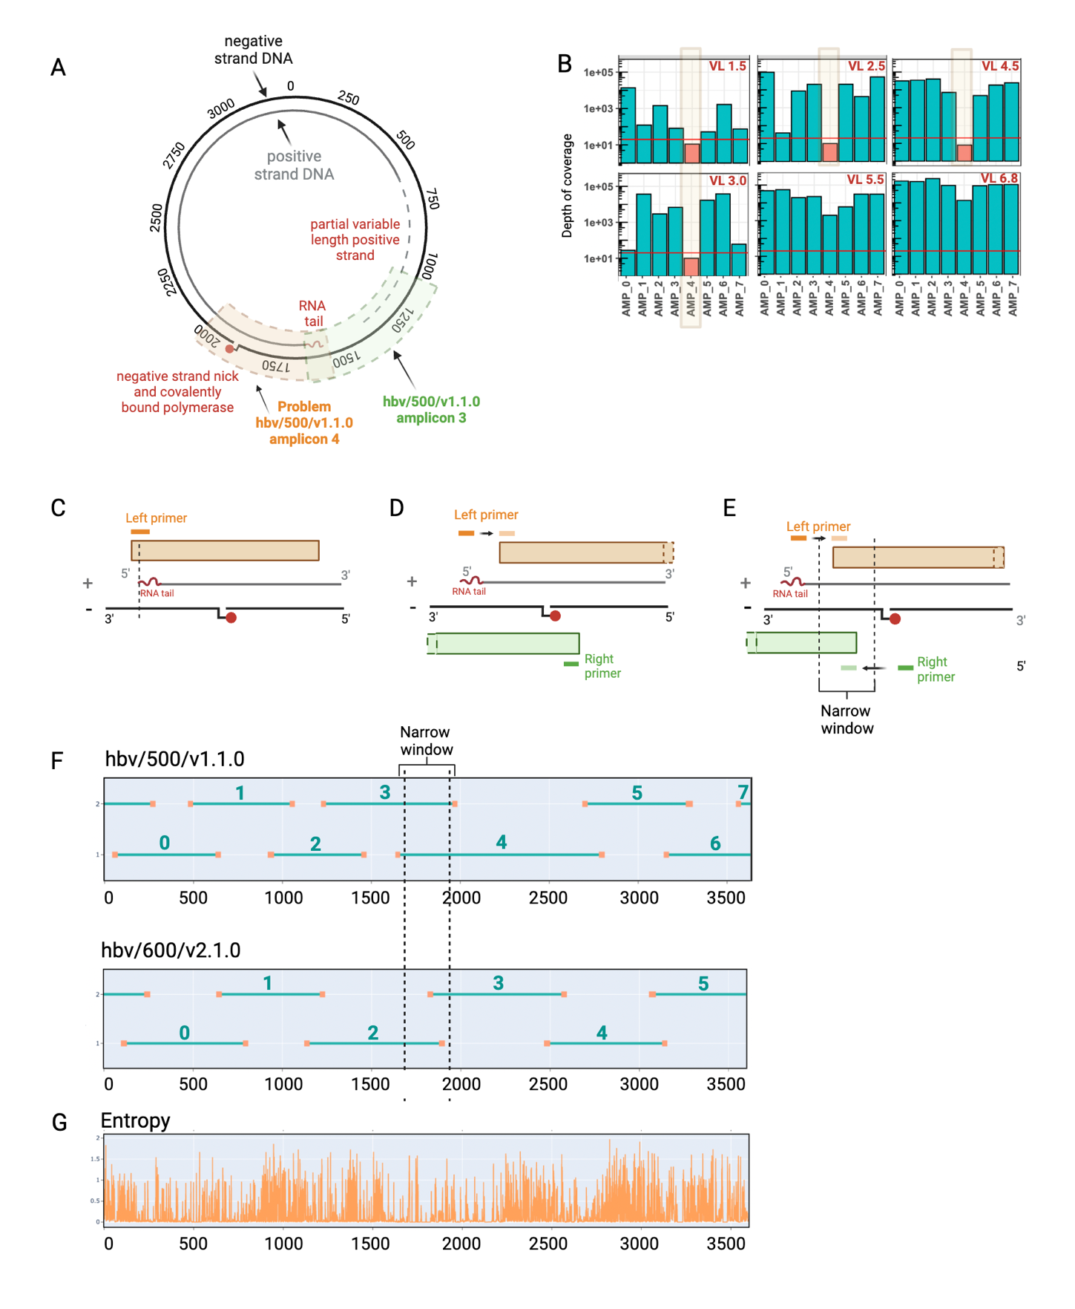
Supplementary figure 1: Modifications to primer positions to take into account HBV genome structure. (A) Schematic of HBV relaxed circular DNA (rc-DNA), the HBV partially dsDNA genome has 5’ modifications to both the positive DNA strand (RNA tail) and negative DNA strand (covalently bound polymerase). The negative strand is complete but not fully circular due to the presence of a ‘nick’ and covalently bound polymerase. The partial positive strand is variable in length. (B) Depth of coverage for amplicon scheme hbv/500/v1.1.0 - illustrating drop-out of hbv/500/v1.1.0 amplicon 4 in samples below a VL of 5 log₁₀ IU/ml (VL shown in red text). (C) hbv/500/v1.1.0 amplicon 4 drops out in low-medium viral load samples, the hypothesis is that neither the positive nor negative strands of the HBV relaxed circular genome are complete in that region. The left hand primer only partially overlaps the 5’ tail of the positive strand, the negative strand contains a nick. (D) Attempt to solve issue by moving the hbv/500/v1.1.0 amplicon 4 primer upstream, however this has the knock on effect of the Amplicon 3 right hand primer moving upstream, which now means amplicon 3 falls across a non-continuous DNA region. (E) Solution requires the left hand primer for amplicon 4 and right hand primer for amplicon 3 to be placed in a narrow 200bp window, to ensure green can be generated from the positive DNA strand, and orange from the negative DNA strand. (F) Locations and numbering of primers for initial 8 amplicon primer scheme (hbv/500/v1.1.0) and updated 5 amplicon primer scheme (hbv/600/v2.1.0) (G) Entropy across HBV genome. Created in BioRender. Lumley, S. (2024) BioRender.com/l10u171

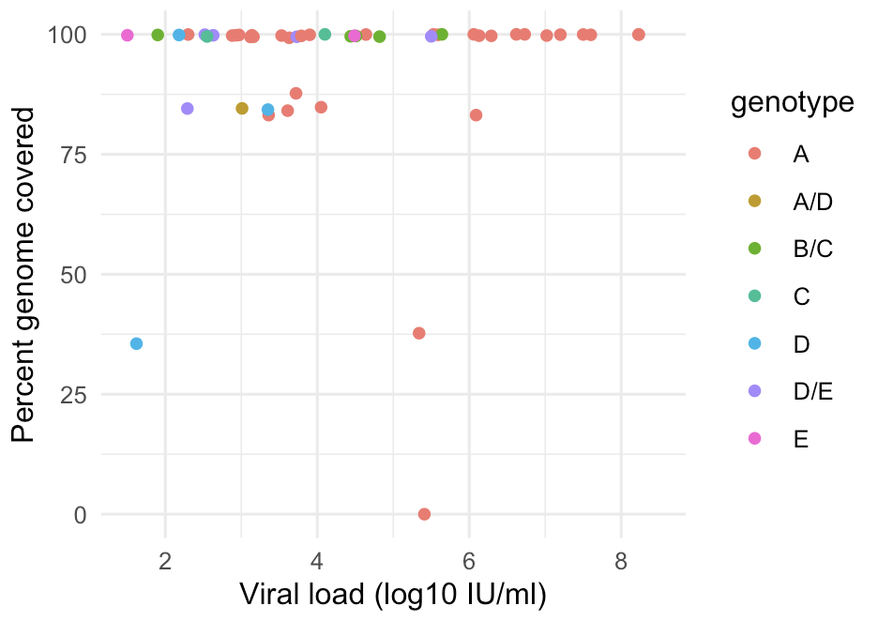
Supplementary figure 2: Relationship between HBV genotype and performance of HEP-TILE Nanopore workflow. Percentage genome coverage shown at x20 depth.

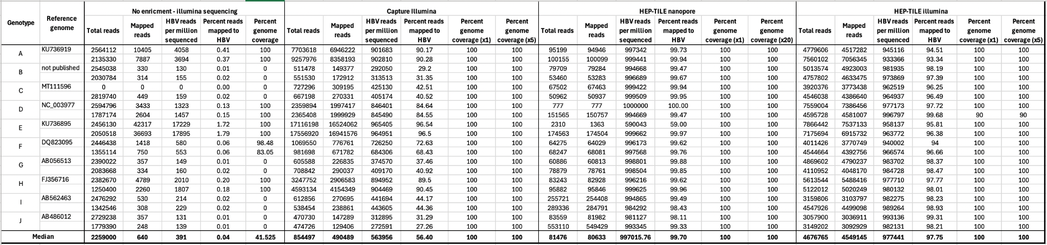

Supplementary table 1: Sequencing metrics for mock HBV samples for capture-Illumina, HEP-TILE Nanopore and HEP-TILE Illumina workflows vs. no enrichment
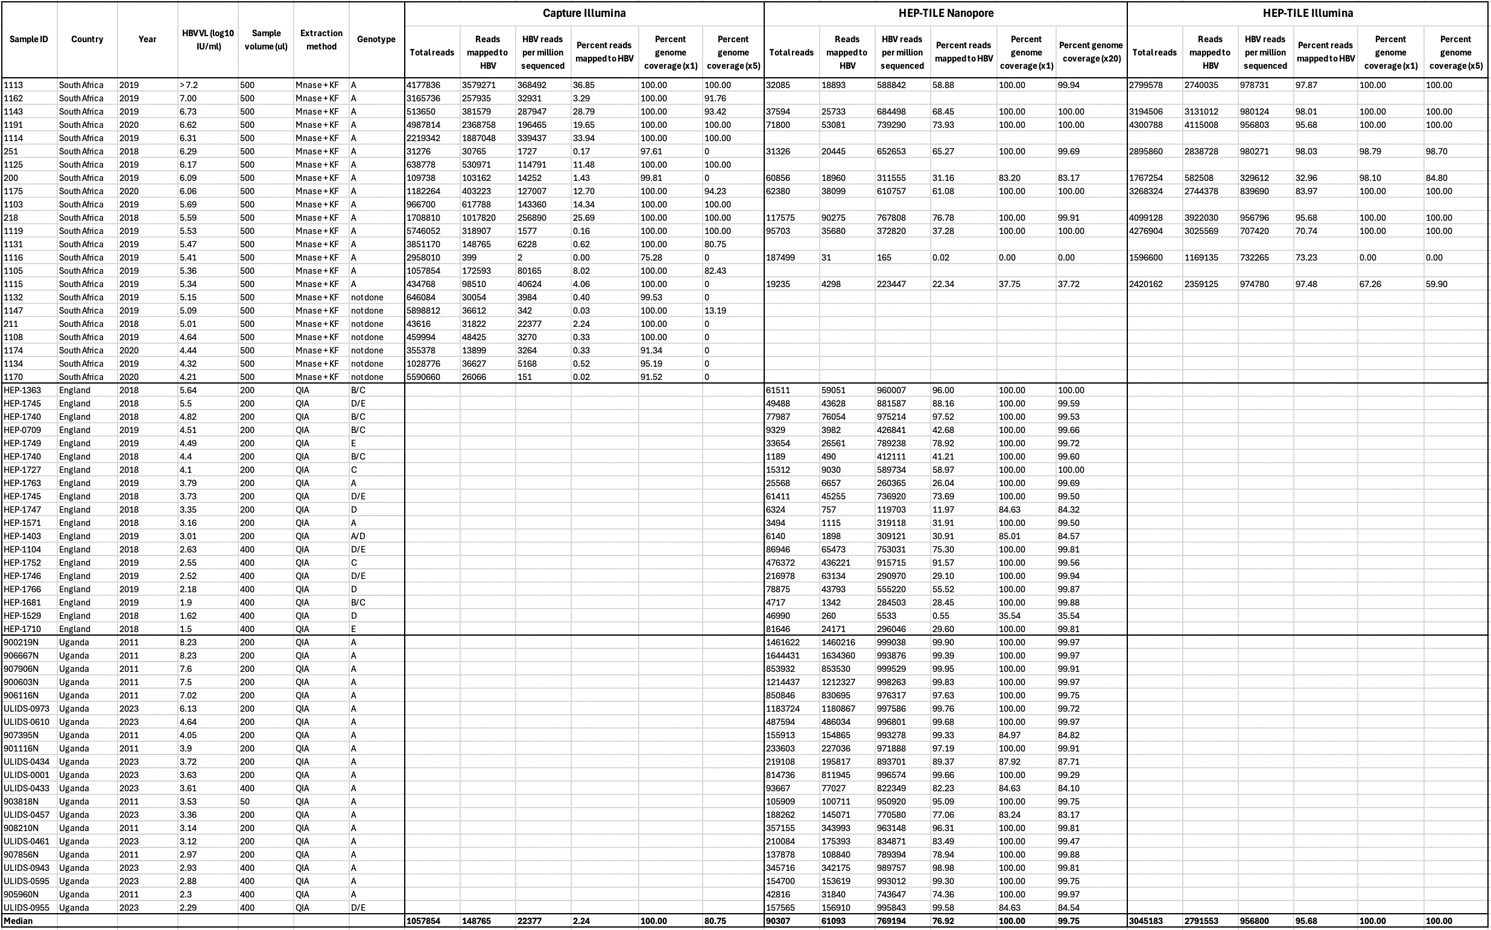

Supplementary table 2: Metadata and sequencing outputs for clinical HBV samples sequenced with capture-Illumina, HEP-TILE Nanopore and HEP-TILE Illumina workflows. Sequencing metrics for sequencing of HBV-positive clinical samples.
Key for extraction methods (see methods section for full details): “Mnase + KF” = host depletion with micrococcal nuclease followed by extraction on Kingfisher apex, “QIA” = QiaAMP MinElute virus spin kit. Viral load conversion example: 2log₁₀ IU/ml = 100 IU/ml, 3log₁₀ IU/ml = 1000 IU/ml.

Genotype | Capture  (2019 HBVdb download) |  | HEP-TILE  (2024 HBVdb download)
Genotype | Genomes in HBVdb | Genomes used | Genomes in HBVdb | Downsampled Genomes
A | 506 | 506 | 1066 | 559
B | 1218 | 1218 | 2018 | 1143
C | 1447 | 1447 | 3095 | 1764
D | 823 | 823 | 1523 | 920
E | 254 | 254 | 397 | 254
F | 197 | 197 | 304 | 156
G | 28 | 28 | 50 | 18
H | 26 | 26 | 28 | 17

Supplementary table 3: Number of sequences downloaded from publicly available sequence database HBVdb[20]

Supplementary table 4: HBV probe sequences

>probe_1
CTCAACACAGTTCCACCAAGCTCTGCAAGATCCGAGAGTAAGGGGCCTGTATTTTCCTGCTGGTGGCTCCAGTTCAGAAACAGAGAACCCTGTTCCGACTATTGCCTCTCTCACATCATC

>probe_2
TGGTGGCTCCAGTTCAGAAACAGAGAACCCTGTTCCGACTATTGCCTCTCTCACATCATCAATCTTCTCGAAGACTGGGGACCCTGCAATGAACATGGAGAACATCACATCAGGACTCCT

>probe_3
AATCTTCTCGAAGACTGGGGACCCTGCAATGAACATGGAGAACATCACATCAGGACTCCTAGGACCCCTGCTCGTGTTACAGGCGGGGTGTTTCTTGTTGACAAAAATCCTCACAATACC

>probe_4
AGGACCCCTGCTCGTGTTACAGGCGGGGTGTTTCTTGTTGACAAAAATCCTCACAATACCGCAGAGTCTAGACTCGTGGTGGACTTCTCTCAATTTTCTAGGGGGACCACCCGGGTGTCC

>probe_5
GCAGAGTCTAGACTCGTGGTGGACTTCTCTCAATTTTCTAGGGGGACCACCCGGGTGTCCTGGCCAAAATTCGCAGTCCCCAACCTCCAATCACTCACCAACCTCCTGTCCTCCAACTTG

>probe_6
TGGCCAAAATTCGCAGTCCCCAACCTCCAATCACTCACCAACCTCCTGTCCTCCAACTTGTCCTGGCTATCGCTGGATGTGTCTGCGGCGTTTTATCATCTTCCTCTTCATCCTGCTGCT

>probe_7
TCCTGGCTATCGCTGGATGTGTCTGCGGCGTTTTATCATCTTCCTCTTCATCCTGCTGCTATGCCTCATCTTCTTGTTGGTTCTTCTGGACTATCAAGGTATGTTGCCCGTTTGTCCTCT

>probe_8
ATGCCTCATCTTCTTGTTGGTTCTTCTGGACTATCAAGGTATGTTGCCCGTTTGTCCTCTAATTCCAGGATCCACAACCACCAGCACGGGACCCTGCAAAACCTGCACGACTCCTGCTCA

>probe_9
AATTCCAGGATCCACAACCACCAGCACGGGACCCTGCAAAACCTGCACGACTCCTGCTCAAGGAACCTCTATGTTTCCCTCATGTTGCTGTACAAAACCTTCGGACGGAAATTGCACCTG

>probe_10
AGGAACCTCTATGTTTCCCTCATGTTGCTGTACAAAACCTTCGGACGGAAATTGCACCTGTATTCCCATCCCATCATCTTGGGCTTTCGGAAAATACCTATGGGAGTGGGCCTCAGCCCG

>probe_11
TATTCCCATCCCATCATCTTGGGCTTTCGGAAAATACCTATGGGAGTGGGCCTCAGCCCGTTTCTCCTGGCTCAGTTTACTAGTGCAATTTGTTCAGTGGTGCGTAGGGCTTTCCCCCAC

>probe_12
TTTCTCCTGGCTCAGTTTACTAGTGCAATTTGTTCAGTGGTGCGTAGGGCTTTCCCCCACTGTCTGGCTTTCAGTTATATGGATGATGTGGTATTGGGGGCCAAATCTGTGCAGCATCTT

>probe_13
TGTCTGGCTTTCAGTTATATGGATGATGTGGTATTGGGGGCCAAATCTGTGCAGCATCTTGAGTCCCTTTATACCGCTGTTACCAATTTTCTGTTGTCTGTGGGTATACATTTAAACACT

>probe_14
GAGTCCCTTTATACCGCTGTTACCAATTTTCTGTTGTCTGTGGGTATACATTTAAACACTAACAAAACAAAAAGATGGGGTTATTCCCTAAATTTCATGGGTTATGTAATTGGAAGTTGG

>probe_15
AACAAAACAAAAAGATGGGGTTATTCCCTAAATTTCATGGGTTATGTAATTGGAAGTTGGGGGACATTGCCACAAGAACATATTGTACAAAAAATCAAAGAATGTTTTCGAAAACTTCCT

>probe_16
GGGACATTGCCACAAGAACATATTGTACAAAAAATCAAAGAATGTTTTCGAAAACTTCCTGTTAATAGGCCTATTGATTGGAAAGTCTGTCAACGAATTGTGGGTCTTTTGGGCTTTGCT

>probe_17
GTTAATAGGCCTATTGATTGGAAAGTCTGTCAACGAATTGTGGGTCTTTTGGGCTTTGCTGCCCCTTTTACCCAATGTGGTTATCCTGCTCTAATGCCTTTGTATGCATGTATTAAAGCT

>probe_18
GCCCCTTTTACCCAATGTGGTTATCCTGCTCTAATGCCTTTGTATGCATGTATTAAAGCTAAGCAGGCTTTTGCTTTCTCGCCAACTTACAAGGCCTTTCTCTGTAAACAATACATGAAC

>probe_19
AAGCAGGCTTTTGCTTTCTCGCCAACTTACAAGGCCTTTCTCTGTAAACAATACATGAACCTTTACCCCGTTGCTCGGCAACGGCCAGGCCTGTGCCAAGTGTTTGCTGACGCAACCCCC

>probe_20
CTTTACCCCGTTGCTCGGCAACGGCCAGGCCTGTGCCAAGTGTTTGCTGACGCAACCCCCACTGGCTGGGGCTTGGCCATTGGCCATCAGCGCATGCGTGGAACCTTTGTGGCTCCTCTG

>probe_21
ACTGGCTGGGGCTTGGCCATTGGCCATCAGCGCATGCGTGGAACCTTTGTGGCTCCTCTGCCGATCCATACTGCGGAACTCCTAGCAGCTTGTTTCGCTCGCAGCCGGTCTGGAGCGAAA

>probe_22
CCGATCCATACTGCGGAACTCCTAGCAGCTTGTTTCGCTCGCAGCCGGTCTGGAGCGAAACTTATCGGGACTGACAACTCTGTTGTCCTCTCTCGGAAGTACACCTCCTTTCCATGGCTG

>probe_23
CTTATCGGGACTGACAACTCTGTTGTCCTCTCTCGGAAGTACACCTCCTTTCCATGGCTGCTAGGCTGTGCTGCCAACTGGATCCTGCGCGGGACGTCCTTTGTTTACGTCCCGTCGGCG

>probe_24
CTAGGCTGTGCTGCCAACTGGATCCTGCGCGGGACGTCCTTTGTTTACGTCCCGTCGGCGCTGAATCCCGCGGACGACCCCTCTCGGGGTCGCTTGGGGCTCTATCGCCCCCTTCTCCGT

>probe_25
CTGAATCCCGCGGACGACCCCTCTCGGGGTCGCTTGGGGCTCTATCGCCCCCTTCTCCGTCTGCCGTTCCGGCCGACGACGGGGCGCACCTCTCTTTACGCGGACTCCCCGTCTGTGCCT

>probe_26
CTGCCGTTCCGGCCGACGACGGGGCGCACCTCTCTTTACGCGGACTCCCCGTCTGTGCCTTCTCATCTGCCGGACCGTGTGCACTTCGCTTCACCTCTGCACGTCGCATGGAGACCACCG

>probe_27
TCTCATCTGCCGGACCGTGTGCACTTCGCTTCACCTCTGCACGTCGCATGGAGACCACCGTGAACGCCCCTCAGAGCTTGCCAAAGGTCTTACATAAGAGGACTCTTGGACTTTCAGCAA

>probe_28
TGAACGCCCCTCAGAGCTTGCCAAAGGTCTTACATAAGAGGACTCTTGGACTTTCAGCAAGGTCAACGACCGGGATTGAGGAATACATCAAAGACTGTGTATTTAAGGACTGGGAGGAGT

>probe_29
GGTCAACGACCGGGATTGAGGAATACATCAAAGACTGTGTATTTAAGGACTGGGAGGAGTTGGGGGAGGAGATTAGGTTAAAGGTCTTTGTATTAGGAGGCTGTAGGCATAAATTGGTCT

>probe_30
TGGGGGAGGAGATTAGGTTAAAGGTCTTTGTATTAGGAGGCTGTAGGCATAAATTGGTCTGTGCACCAGCACCATGCAACTTTTTCACCTCTGCCTAATCATCTCTTGTTCATGTCCTAC

>probe_31
GTGCACCAGCACCATGCAACTTTTTCACCTCTGCCTAATCATCTCTTGTTCATGTCCTACTGTTCAAGCCTCCAAGCTGTGCCTTGGGTGGCTTTGGGGCATGGATAGAACAACTTTGCC

>probe_32
TGTTCAAGCCTCCAAGCTGTGCCTTGGGTGGCTTTGGGGCATGGATAGAACAACTTTGCCATATGGCCTTTTTGGCTTAGACATTGACCCTTATAAAGAATTTGGAGCTTCTGTGGAGTT

>probe_33
ATATGGCCTTTTTGGCTTAGACATTGACCCTTATAAAGAATTTGGAGCTTCTGTGGAGTTACTCTCGTTTTTGCCTTCTGACTTCTTCCCGTCTGTTCGGGACCTACTCGACACCGCTTC

>probe_34
ACTCTCGTTTTTGCCTTCTGACTTCTTCCCGTCTGTTCGGGACCTACTCGACACCGCTTCAGCCCTGTACCGGGATGCCTTAGAGTCACCTGAACATTGCACACCTAACCATACAGCACT

>probe_35
AGCCCTGTACCGGGATGCCTTAGAGTCACCTGAACATTGCACACCTAACCATACAGCACTCAGGCAAGCTATTCTGTGCTGGGGTGAGTTAATGACTCTGGCTACCTGGGTGGGCAATAA

>probe_36
CAGGCAAGCTATTCTGTGCTGGGGTGAGTTAATGACTCTGGCTACCTGGGTGGGCAATAATTTGGAAGATCCAGCAGCCAGGGATTTAGTAGTCAATTATGTCAATACTAATATGGGCCT

>probe_37
TTTGGAAGATCCAGCAGCCAGGGATTTAGTAGTCAATTATGTCAATACTAATATGGGCCTAAAAATCAGACAACTATTGTGGTTTCACATTTCCTGCCTTACTTTTGGAAGAGAAACTGT

>probe_38
AAAAATCAGACAACTATTGTGGTTTCACATTTCCTGCCTTACTTTTGGAAGAGAAACTGTTCTTGAGTATTTGGTGTCTTTTGGAGTGTGGATTCGCACTCCTCCTGCTTATAGACCACC

>probe_39
TCTTGAGTATTTGGTGTCTTTTGGAGTGTGGATTCGCACTCCTCCTGCTTATAGACCACCAAATGCCCCTATCCTATCAACACTTCCGGAAACTACTGTTGTTAGACGACGGGACCGAGG

>probe_40
AAATGCCCCTATCCTATCAACACTTCCGGAAACTACTGTTGTTAGACGACGGGACCGAGGCAGGTCCCCTAGAAGAAGAACTCCCTCGCCTCGCAGACGAAGATCTCAATCGCCGCGTCG

>probe_41
CAGGTCCCCTAGAAGAAGAACTCCCTCGCCTCGCAGACGAAGATCTCAATCGCCGCGTCGCAGAAGATCTCAATCTCCAGCTTCCCAATGTTAGTATTCCTTGGACTCATAAGGTGGGAA

>probe_42
CAGAAGATCTCAATCTCCAGCTTCCCAATGTTAGTATTCCTTGGACTCATAAGGTGGGAAACTTTACGGGGCTTTATTCTTCTACTGTACCTGTCTTTAATCCTGACTGGCAAACTCCTT

>probe_43
ACTTTACGGGGCTTTATTCTTCTACTGTACCTGTCTTTAATCCTGACTGGCAAACTCCTTCTTTTCCTGATATTCATTTGCATCAAGACATGATAAATAAATGTGAACAATTTGTAGGCC

>probe_44
CTTTTCCTGATATTCATTTGCATCAAGACATGATAAATAAATGTGAACAATTTGTAGGCCCTCTCACAGAAAATGAAAAGAGAAGATTAAAATTAATTATGCCAGCTAGATTTTATCCTA

>probe_45
CTCTCACAGAAAATGAAAAGAGAAGATTAAAATTAATTATGCCAGCTAGATTTTATCCTAACGTTACCAAATATTTGCCTTTGGATAAAGGTATTAAACCTTATTATCCAGAGAATGTAG

>probe_46
ACGTTACCAAATATTTGCCTTTGGATAAAGGTATTAAACCTTATTATCCAGAGAATGTAGTTAATCATTACTTCAAAACCAGACATTATTTACATACTCTATGGAAGGCGGGAATTCTAT

>probe_47
TTAATCATTACTTCAAAACCAGACATTATTTACATACTCTATGGAAGGCGGGAATTCTATATAAGAGAGAAACCACACGTAGCGCCTCATTTTGTGGGTCACCATATTCTTGGGAACAAG

>probe_48
ATAAGAGAGAAACCACACGTAGCGCCTCATTTTGTGGGTCACCATATTCTTGGGAACAAGAGCTACAGCATGGGAGCACCTCGGTCAACGCCTCGAAGGGGCATGGGAAAGAATCTTTCT

>probe_49
AGCTACAGCATGGGAGCACCTCGGTCAACGCCTCGAAGGGGCATGGGAAAGAATCTTTCTGTGCCCAATCCTCTGGGATTCTTTCCAGACCACCAGTTGGATCCAGCATTCAGAGCAAAT

>probe_50
GTGCCCAATCCTCTGGGATTCTTTCCAGACCACCAGTTGGATCCAGCATTCAGAGCAAATTCCAGCAGTCCAGATTGGGACTTCAACACAAACAAGGACAATTGGCCAGAGGCAAACAAG

>probe_51
TCCAGCAGTCCAGATTGGGACTTCAACACAAACAAGGACAATTGGCCAGAGGCAAACAAGGTAGGAGTGGGAGGCTTCGGTCCAGGGTTCACACCCCCACACGGAGGCCTTCTGGGGTGG

>probe_52
GTAGGAGTGGGAGGCTTCGGTCCAGGGTTCACACCCCCACACGGAGGCCTTCTGGGGTGGAGCCCTCAGGCACAGGGCATACTAACAACCTTGCCAGCAGATCCGCCTCCTGCCTCCACC

>probe_53
AGCCCTCAGGCACAGGGCATACTAACAACCTTGCCAGCAGATCCGCCTCCTGCCTCCACCAATCGGCGGTCAGGAAGGAAGCCAACCCCAGTCTCTCCACCTCTAAGAGACACTCATCCA

>probe_54
AATCGGCGGTCAGGAAGGAAGCCAACCCCAGTCTCTCCACCTCTAAGAGACACTCATCCACAGGCCATGCAGTGGAACTCAACACAGTTCCACCAAGCTCTGCAAGATCCGAGAGTAAGG

>probe_55
CAGGCCATGCAGTGGAACTCAACACAGTTCCACCAAGCTCTGCAAGATCCGAGAGTAAGGGGCCTGTATTTTCCTGCTGGTGGCTCCAGTTCAGAAACAGAGAACCCTGTTCCGACTATT

>Deletion_region1903_1939_removed probe
TCTTGTTCATGTCCTACTGTTCAAGCCTCCAAGCTGTGCCTTGGGTGGCTTTGGGGCATGGACATTGACCCTTATAAAGAATTTGGAGCTTCTGTGGAGTTACTCTCGTTTTTGCCTTCT

>Deletion_Genotype_D_region2897_2929_removed probe
ACGTAGCGCATCATTTTGCGGGTCACCATATTCTTGGGAACAAGAGCTACAGCATGGGAGCGAATCTTTCTGTTCCCAACCCTCTGGGATTCTTTCCCGATCATCAGTTGGACCCTGCAT

>H_cons_seq_s2035_e2154_ConS2035
CGAACATTGCACCCCCAACCACACTGCTCTCAGGCAAGCTATTTTGTGCTGGGGTGAGTTGATGACCTTGGCTTCCTGGGTGGGCAATAATTTAGAGGATCCTGCAGCAAGAGATCTAGT

>G_cons_seq_s2845_e2964_ConS2845
TTTGTGGGTCACCATATACTTGGGAACAAGATCTACAGCATGGGGCTTTCTTGGACGGTCCCTCTCGAGTGGGGAAAGAACCTTTCCACCAGCAATCCTCTAGGATTCCTTCCCGATCAC

>G_cons_seq_s1651_e1770_ConS1651
TATATAAGAGGACTCTTGGACTGTTTGTTATGTCAACAACCGGGGTGGAGAAATACTTCAAGGACTGTGTTTTTGCTGAGTGGGAAGAATTAGGCAATGAGTCCAGGTTAATGACCTTTG

>E_cons_seq_s1975_e2094_ConS1975
TTCAGTAAGAGATCTTCTAGATACCGCCTCAGCTCTGTATCGGGATGCCTTAGAATCTCCTGAGCATTGTTCACCTCACCACACTGCACTCAGGCAAGCCATTCTTTGCTGGGGGGAACT

>A_cons_seq_s391_e510_Target_seq391
TTTTATCATATTCCTCTTCATCCTGCTGCTATGCCTTAGCTCTGTATCGGTTCTTCTGAAGCCTTAGAGTCTCCAGAGCATTGCTCCCCTCACCTCAGGATCCACAACAACCAGTACGGG

>A_cons_seq_s2875_e2994_ConS2875
CCTCGCAAAGGCATGGGGACGAATCTTTCTGTTCCCAACCCTCTGGGATTCTTTCCCGATCATCAGTTGGACCCTGCATTCGGAGCCAACTCAAACAATCCAGATTGGGACTTCAACCCC

>Genotype_D_deletion_at_33_55
CACTCATCCTCAGGCCATGCAGTGGAACTCCACAACCTTCCACCAAACTCTGCAAGATCCCCCTGCTGGTGGCTCCAGTTCAGGAACAGTAAACCCTGTTCCGACTACTGTCTCTCCCAT

>D_cons_seq_s2956_e3075_ConS2956
AACAAGGACACCTGGCCAGACGCCAACAAGGTAGGAGCTGGAGCATTCGGGCTGGGATTCACCCCACCGCACGGAGGCCTTTTGGGGTGGAGCCCTCAGGCTCAGGGCATACTACAAACC

>B_cons_seq_s2095_e2214_ConS2095
AATGAATCTAGCCACCTGGGTGGGAAGTAATTTGGAAGATCCAGCATCCAGGGAATTAGTAGTCAGCTATGTCAACGTTAATATGGGCCTAAAAATCAGACAACTATTGTGGTTTCACAT

>B_cons_seq_s1711_e1830_Target_seq1711
AAGACTGTTTGTTTAAAGACTGGGAGGAGTTGGGTTTACTGATTGGGGAGTTGGGGGATGTTCTAAGGGGATGGAAGGCTAAATTGGTCTGTTCACCAGCACCATGCAACTTTTTCACCT

>C_cons_seq_s2990_e3109_ConS2990
ACAAGGATCACTGGCCAGAGGCAAATCAGGTAGGAGCGGGAGCATTCGGGCCAGGGTTCACCCCACCACACGGCGGTCTTTTGGGGTGGAGCCCTCAGGCTCAGGGCATATTGACAACAG

>C_cons_seq_s3080_e3199_ConS3080
GCCCTCAGGCTCAGGGCATATTGACAACAGTGCCAGCAGCACCTCCTCCTGCCTCCACCAATCGGCAGTCAGGAAGACAGCCTACTCCCATCTCTCCACCTCTAAGAGACAGTCATCCTC

>C_cons_seq_s2629_e2748_ConS2629
AATTAATTATGCCTGCTAGGTTCTATCCTAACCTTACCAAATATTTGCCCTTGGACAAAGGCATTAAACCTTATTATCCTGAACATGCAGTTAATCATTACTTCAAAACTAGGCATTATT

>C_cons_seq_s1651_e1770_ConS1651
TACATAAGAGGACTCTTGGACTCTCAGCAATGTCAACGACCGACCTTGAGGCATACTTCAAAGACTGTTTGTTTAAAGACTGGGAGGAGTTGGGGGAGGAGATTAGGTTAATGATCTTTG

>C_cons_seq_s3080_e3199_Target_seq3080
GCCCTCAGGCTCAGGGGACATTGACACCTCCGGCAGCCGCCCCTCCTCCTGCCTCCAGAAAACCTCCTTCAGGTTCTCCACCTACTCTAATTTCTCTTCCTCTAAGAGACAGTCATCCCA

>C_cons_seq_s3140_e3259_ConS3140
AACCTCCTTCAGGTTCTCCACCTACTCTAATTTCTCTTCCTCTAAGAGACAGTCATCCCAACGCCATACACTGCCACTCCACGCTATTCCACCAAGTTCTGCGAGATCCCTTAGTTGCGG

>C_cons_seq_s3200_e3319_ConS3200
AGGCCATGCAGTGGAACTCCACAACATTCCACCAAGCTCTGCTAGATCCCAGAGTGAGGGGCCTATACTTTCCTGCTGGTGGCTCCAGTTCCGGAACAGTAAACCCTGTTCCGACTACTG

Supplementary table 5: initial 8 amplicon scheme (hbv/500/v1.1.0)
NB each amplicon has a pool of left and right primers, some of which vary in start/end point by 1-2bp. The positions indicated in the table are a guide, exact locations for all primers are available on the github site. Numbering based on NC_003977.2 reference genome.

Amplicon  hbv/500/v1.1.0 | Pool | Strand | Start location | End location | Primer name | Primer sequence
0 | 1 | + | 36 | 60 | a1a7f2b2_0_LEFT_0 | AGAGTGAGGGGCCTATACTTTCCT
0 | 1 | + | 38 | 60 | a1a7f2b2_0_LEFT_1 | AGTCAGGGCCCTGTACTTTCCT
0 | 1 | + | 35 | 60 | a1a7f2b2_0_LEFT_2 | CAGAGTCAGGGGTCTGTATTTTCCT
0 | 1 | + | 35 | 60 | a1a7f2b2_0_LEFT_3 | CAGAGTGAGGGGCCTATATTTTCCT
0 | 1 | + | 34 | 60 | a1a7f2b2_0_LEFT_4 | CCAGAGTAAGAGGCCTGTATTTTCCT
0 | 1 | + | 34 | 60 | a1a7f2b2_0_LEFT_5 | CCAGAGTAAGGGGCCTATACTTTCCT
0 | 1 | + | 35 | 60 | a1a7f2b2_0_LEFT_6 | GAGGGTAAGGGCTCTGTATTTTCCT
0 | 1 | + | 37 | 60 | a1a7f2b2_0_LEFT_7 | GAGTCAGGGCTCTGTACTTTCCT
0 | 1 | + | 37 | 60 | a1a7f2b2_0_LEFT_8 | GAGTCAGGGGCCTGTATTTTCCT
0 | 1 | + | 37 | 60 | a1a7f2b2_0_LEFT_9 | GAGTGAGAGGCCTGTATTTCCCT
0 | 1 | + | 38 | 60 | a1a7f2b2_0_LEFT_10 | GGTGAGAGGCCTGTATTTCCCT
0 | 1 | - | 584 | 607 | a1a7f2b2_0_RIGHT_0 | GAATACAGGTGCAGTTTCCGTCC
0 | 1 | - | 584 | 608 | a1a7f2b2_0_RIGHT_1 | GGAATACAAGTGCAGTTTCCGTCC
0 | 1 | - | 584 | 608 | a1a7f2b2_0_RIGHT_2 | GGAATACAGGTGCAATTTCCGTCC
0 | 1 | - | 584 | 608 | a1a7f2b2_0_RIGHT_3 | GGAATACAGGTGCAGTTTCCATCC
0 | 1 | - | 584 | 609 | a1a7f2b2_0_RIGHT_4 | GGGAATACAAGTGCAATTTCCGTCC
0 | 1 | - | 584 | 609 | a1a7f2b2_0_RIGHT_5 | GGGAATACAGGTGCAATTTCCATCC
1 | 2 | + | 462 | 482 | a1a7f2b2_1_LEFT_0 | ATGTTGCCCGTGTGTCCTCT
1 | 2 | + | 459 | 482 | a1a7f2b2_1_LEFT_1 | GGTATGTTGCCCGTTTGTCCTCT
1 | 2 | + | 460 | 482 | a1a7f2b2_1_LEFT_2 | GTATGTTGCCCGTCTGTCCTCT
1 | 2 | - | 999 | 1022 | a1a7f2b2_1_RIGHT_0 | AGCAAAACCCAAAAGACCCACAA
1 | 2 | - | 999 | 1023 | a1a7f2b2_1_RIGHT_1 | CAGCAAATCCCAAAAGACCCACAA
1 | 2 | - | 999 | 1021 | a1a7f2b2_1_RIGHT_2 | GCAAAACCCAGAAGACCCACAA
1 | 2 | - | 999 | 1021 | a1a7f2b2_1_RIGHT_3 | GCAAACCCCAAAAGACCCACAA
1 | 2 | - | 999 | 1021 | a1a7f2b2_1_RIGHT_4 | GCAAAGCCCAAAAGACCCACAA
1 | 2 | - | 999 | 1021 | a1a7f2b2_1_RIGHT_5 | GCAAAGCCCAACAGACCCACAA
1 | 2 | - | 999 | 1021 | a1a7f2b2_1_RIGHT_6 | GCAAAGCCCAGAAGACCCACAA
1 | 2 | - | 999 | 1021 | a1a7f2b2_1_RIGHT_7 | GCGAACCCCAAAAGACCCACAA
2 | 1 | + | 881 | 906 | a1a7f2b2_2_LEFT_0 | GGATATGTAATTGGGAGTTGGGGCA
2 | 1 | + | 881 | 906 | a1a7f2b2_2_LEFT_1 | GGATATGTAATTGGGTGTTGGGGCA
2 | 1 | + | 880 | 906 | a1a7f2b2_2_LEFT_2 | GGGATATGTAATTGGAAGTTGGGGCA
2 | 1 | + | 880 | 906 | a1a7f2b2_2_LEFT_3 | GGGATATGTCATTGGAAGTTGGGGTA
2 | 1 | + | 880 | 906 | a1a7f2b2_2_LEFT_4 | GGGCTATGTCATTGGATGTTATGGGT
2 | 1 | + | 880 | 906 | a1a7f2b2_2_LEFT_5 | GGGGTATGTAATTGGAAGTTGGGGTA
2 | 1 | + | 880 | 906 | a1a7f2b2_2_LEFT_6 | GGGTTACATAATTGGAAGTTGGGGAA
2 | 1 | + | 880 | 906 | a1a7f2b2_2_LEFT_7 | GGGTTATGTAATTGGAAGTTGGGGGT
2 | 1 | + | 881 | 906 | a1a7f2b2_2_LEFT_8 | GGTTATGTTATTGGCAGTTGGGGAT
2 | 1 | + | 876 | 906 | a1a7f2b2_2_LEFT_9 | TCATGGGATATATAATTGGAAGTTGGGGTA
2 | 1 | + | 879 | 906 | a1a7f2b2_2_LEFT_10 | TGGGATATGTAATTGGAAGTTGGGGTA
2 | 1 | + | 879 | 906 | a1a7f2b2_2_LEFT_11 | TGGGATATGTAATTGGATGTTGGGGTA
2 | 1 | - | 1388 | 1408 | a1a7f2b2_2_RIGHT_0 | AGGATCCAGTTGGCAGCACA
2 | 1 | - | 1388 | 1411 | a1a7f2b2_2_RIGHT_1 | CGAAGGATCCAGTTGGCAGTACA
2 | 1 | - | 1388 | 1410 | a1a7f2b2_2_RIGHT_2 | GCAGGATCCAGTTGGCAGTACA
2 | 1 | - | 1388 | 1412 | a1a7f2b2_2_RIGHT_3 | GCGAAGAATCCAGTTGGCAGTACA
3 | 2 | + | 1173 | 1195 | a1a7f2b2_3_LEFT_0 | TCTGCCAAGTGTTTGCTGATGC
3 | 2 | + | 1175 | 1195 | a1a7f2b2_3_LEFT_1 | TGCCAAGTGTTTGCTGACGC
3 | 2 | + | 1173 | 1195 | a1a7f2b2_3_LEFT_2 | TGTGCCAAGTGTTTGCTGATGC
3 | 2 | - | 1681 | 1703 | a1a7f2b2_3_RIGHT_0 | CCTCAAGGTCGGTCGTTGACAT
3 | 2 | - | 1681 | 1704 | a1a7f2b2_3_RIGHT_1 | GCCTCAAGGTCGGTTGTTGACAT
4 | 1 | + | 1579 | 1600 | a1a7f2b2_4_LEFT_0 | TGTGCACTTCGCTTCACCTCT
4 | 1 | - | 2111 | 2136 | a1a7f2b2_4_RIGHT_0 | ATCTTCCAAATTAACACCCACCCAG
4 | 1 | - | 2111 | 2136 | a1a7f2b2_4_RIGHT_1 | ATCTTCCAAATTTACACCCACCCAG
4 | 1 | - | 2111 | 2134 | a1a7f2b2_4_RIGHT_2 | CGTCCAAATTACTTCCCACCCAG
4 | 1 | - | 2111 | 2134 | a1a7f2b2_4_RIGHT_3 | CTTCCAAATTACCACCCACCCAG
4 | 1 | - | 2111 | 2137 | a1a7f2b2_4_RIGHT_4 | GATCTTCCAAATTACTTCCCACCCAG
4 | 1 | - | 2111 | 2138 | a1a7f2b2_4_RIGHT_5 | GGATCTTCCAAATTATTACCCACCCAG
4 | 1 | - | 2111 | 2136 | a1a7f2b2_4_RIGHT_6 | GTCTTCCAAATTACTTCCCACCCAG
4 | 1 | - | 2111 | 2135 | a1a7f2b2_4_RIGHT_7 | TCTTCCAAATTACCTCCCACCCAG
5 | 2 | + | 2020 | 2042 | a1a7f2b2_5_LEFT_0 | AGGCCTTAGAGTCTCCGGAACA
5 | 2 | + | 2019 | 2042 | a1a7f2b2_5_LEFT_1 | GAAGCCTTAGAGTCTCCTGAGCA
5 | 2 | + | 2019 | 2042 | a1a7f2b2_5_LEFT_2 | GATGCCTTAGAGTCTCCTGAGCA
5 | 2 | + | 2018 | 2042 | a1a7f2b2_5_LEFT_3 | GGATGCCTTAGAATCTCCTGAGCA
5 | 2 | - | 2535 | 2564 | a1a7f2b2_5_RIGHT_0 | CCTGCAAATGAATGTTAGGAAAAGAAGGA
5 | 2 | - | 2535 | 2564 | a1a7f2b2_5_RIGHT_1 | CCTGTAAATGAATGTCAGGAAAAGAAGGA
5 | 2 | - | 2535 | 2564 | a1a7f2b2_5_RIGHT_2 | CCTGTAAATGAATGTTAGGAAAGGAGGGA
5 | 2 | - | 2535 | 2566 | a1a7f2b2_5_RIGHT_3 | CTCTTGTAAATGAATCTTAGGAAAGGAAGGA
5 | 2 | - | 2535 | 2567 | a1a7f2b2_5_RIGHT_4 | CTTGGTGTAAATGTATATTAGGAAAAGAGGGT
5 | 2 | - | 2535 | 2561 | a1a7f2b2_5_RIGHT_5 | GCAAATGAATGTGAGGAAAGGAGGGA
5 | 2 | - | 2535 | 2564 | a1a7f2b2_5_RIGHT_6 | GGTGCAAATGAATATCAGGAAAAGATGGA
5 | 2 | - | 2535 | 2568 | a1a7f2b2_5_RIGHT_7 | TCTTGGTGTAAATGTATATTAGGAAAAGAAGGT
5 | 2 | - | 2535 | 2568 | a1a7f2b2_5_RIGHT_8 | TCTTGGTGTAAATGTATATTAGGAAAAGATGGT
5 | 2 | - | 2535 | 2565 | a1a7f2b2_5_RIGHT_9 | TCTTTCAAATGAATGTGAGGAAAAGAAGGA
5 | 2 | - | 2535 | 2562 | a1a7f2b2_5_RIGHT_10 | TGCAAATGAATGTCAGGAAAAGAAGGA
5 | 2 | - | 2535 | 2562 | a1a7f2b2_5_RIGHT_11 | TGCAAATGAATGTTAGGAAAAGAGGGA
5 | 2 | - | 2535 | 2562 | a1a7f2b2_5_RIGHT_12 | TGTAAATGAATGTGAGGAAAGGAGGGA
5 | 2 | - | 2535 | 2563 | a1a7f2b2_5_RIGHT_13 | TTTCAAATGAATGTGAGGAAAAGAGGGA
6 | 1 | + | 2412 | 2435 | a1a7f2b2_6_LEFT_0 | CCGCGTCGCAGAAGATCTAAATC
6 | 1 | + | 2413 | 2435 | a1a7f2b2_6_LEFT_1 | CGCGTCGCAGAAGATCTCAATC
6 | 1 | - | 2949 | 2970 | a1a7f2b2_6_RIGHT_0 | AAGGGTCCTTGTTGGGGTTGA
6 | 1 | - | 2949 | 2970 | a1a7f2b2_6_RIGHT_1 | AGTTGTCCTTGTGCGGGTTGA
6 | 1 | - | 2949 | 2971 | a1a7f2b2_6_RIGHT_2 | CAGTGGTCCTTGATGGGGTTGA
6 | 1 | - | 2949 | 2972 | a1a7f2b2_6_RIGHT_3 | CCAGGTGTCCTTGTTGGGATTGA
6 | 1 | - | 2949 | 2972 | a1a7f2b2_6_RIGHT_4 | CCAGTGATCCTTGTTGGGGTTGA
6 | 1 | - | 2949 | 2972 | a1a7f2b2_6_RIGHT_5 | CCAGTTGTCCTTGTGTGGGTTGA
6 | 1 | - | 2949 | 2973 | a1a7f2b2_6_RIGHT_6 | GCCAATGATCCTTGTTGGGGTTGA
6 | 1 | - | 2949 | 2973 | a1a7f2b2_6_RIGHT_7 | GCCAATTGTCCTTGTGTGGATTGA
6 | 1 | - | 2949 | 2973 | a1a7f2b2_6_RIGHT_8 | GCCATTGATCCTTGTTGGGGTTGA
6 | 1 | - | 2949 | 2974 | a1a7f2b2_6_RIGHT_9 | GGCCAATTGTCCTTGTTTTTGTTGA
6 | 1 | - | 2949 | 2973 | a1a7f2b2_6_RIGHT_10 | TCCAGTGGTCTTTGTTGGGATTGT
7 | 2 | + | 2814 | 2838 | a1a7f2b2_7_LEFT_0 | CGGGTCACCATATTCTTGGGAACA
7 | 2 | + | 2815 | 2838 | a1a7f2b2_7_LEFT_1 | GGGTCACCATATTCCTGGGAACA
7 | 2 | + | 2814 | 2838 | a1a7f2b2_7_LEFT_2 | TGGGTCACCATATTCTTGGGAACA
7 | 2 | + | 2814 | 2838 | a1a7f2b2_7_LEFT_3 | TGGGTCACCTTATTCTTGGGAACA
7 | 2 | - | 248 | 272 | a1a7f2b2_7_RIGHT_0 | AGAGAAGTCCACCACGAGTCTAGA

Supplementary table 6: final 6 amplicon scheme (hbv/600/v2.1.0/)
Numbering based on X02763 reference genome

Amplicon  hbv/600/v2.1.0 | Pool | Strand | Start location | End location | Primer name | Primer sequence
0 | 1 | + | 97 | 123 | f3d7635a_0_LEFT_0 | AATACTGCCTCTGCCATATCATCAAC
0 | 1 | + | 98 | 123 | f3d7635a_0_LEFT_1 | ACACTGCCTCTTCCATATCGTCAAT
0 | 1 | + | 97 | 123 | f3d7635a_0_LEFT_2 | ACTACTGCCTCTCACATATCGTCAAT
0 | 1 | + | 97 | 123 | f3d7635a_0_LEFT_3 | ACTACTGCCTCTCACTTATCGTCAAT
0 | 1 | + | 97 | 123 | f3d7635a_0_LEFT_4 | ACTATTGCCTCTCACATCTCGTCAAT
0 | 1 | + | 100 | 123 | f3d7635a_0_LEFT_5 | ACTGCCTCACCCATATCGTCAAT
0 | 1 | + | 100 | 123 | f3d7635a_0_LEFT_6 | ACTGCCTCACTCATCTCGTCAAT
0 | 1 | + | 100 | 123 | f3d7635a_0_LEFT_7 | ACTGCCTCTCACATCTCGTCAAT
0 | 1 | + | 100 | 123 | f3d7635a_0_LEFT_8 | ACTGCCTCTGCCATATCGTCAAC
0 | 1 | + | 95 | 123 | f3d7635a_0_LEFT_9 | AGAATACTGCCTCTTCCATATCGTCAAT
0 | 1 | + | 95 | 123 | f3d7635a_0_LEFT_10 | AGAATACTGTCTCAGCCATATCGTCAAT
0 | 1 | + | 95 | 123 | f3d7635a_0_LEFT_11 | AGAATACTGTCTCTGCCATATCGTCAAT
0 | 1 | + | 95 | 123 | f3d7635a_0_LEFT_12 | CAAATATTGCCTCTCACATCTCGTCAAT
0 | 1 | + | 99 | 123 | f3d7635a_0_LEFT_13 | CACTGCCTCTCCCATATCGTCAAT
0 | 1 | + | 95 | 123 | f3d7635a_0_LEFT_14 | CGACTACTGTCTCTCACATATCGTCAAT
0 | 1 | + | 95 | 123 | f3d7635a_0_LEFT_15 | CGACTATTGCCTCTCTCACATCATCAAT
0 | 1 | + | 98 | 123 | f3d7635a_0_LEFT_16 | CTACTGCCTCTCCCATATCGTCAAT
0 | 1 | + | 98 | 123 | f3d7635a_0_LEFT_17 | CTACTGCCTCTCCCTTATCGTCAAT
0 | 1 | + | 96 | 123 | f3d7635a_0_LEFT_18 | GAATATTGCCTCTCACATCTCGTCAAT
0 | 1 | + | 96 | 123 | f3d7635a_0_LEFT_19 | GACTACTGTCTCTCCCATATCGTCAAT
0 | 1 | + | 102 | 123 | f3d7635a_0_LEFT_20 | TGCCTCTCCCACATCGTCAAT
0 | 1 | - | 737 | 760 | f3d7635a_0_RIGHT_0 | CCCCCAATACCACATCATCCACA
0 | 1 | - | 737 | 761 | f3d7635a_0_RIGHT_1 | GCCCCCAAAACCACATCATCCATA
0 | 1 | - | 737 | 761 | f3d7635a_0_RIGHT_2 | GCCCCCAATACCACATCATCCATA
0 | 1 | - | 737 | 761 | f3d7635a_0_RIGHT_3 | GCCCCCAATACCAGATCATCCATA
0 | 1 | - | 737 | 761 | f3d7635a_0_RIGHT_4 | GCCCCCAGTACCACATCATCCATA
0 | 1 | - | 737 | 762 | f3d7635a_0_RIGHT_5 | GGCCCCCAAAACCATATCATCCATA
0 | 1 | - | 737 | 762 | f3d7635a_0_RIGHT_6 | GGCCCCCAATACCAAATCATCCATA
0 | 1 | - | 737 | 762 | f3d7635a_0_RIGHT_7 | GGCCCCCAATACCACATCATCAATA
0 | 1 | - | 737 | 762 | f3d7635a_0_RIGHT_8 | GGCCCCCAATACCATATCATCCATA
1 | 2 | + | 588 | 614 | f3d7635a_1_LEFT_0 | AAATTGCACTTGTATTCCCATCCCAT
1 | 2 | + | 590 | 614 | f3d7635a_1_LEFT_1 | ACTGCACTTGTATTCCCATCCCAT
1 | 2 | + | 592 | 614 | f3d7635a_1_LEFT_2 | TGCACCTGTATTCCCATCCCAT
1 | 2 | - | 1168 | 1188 | f3d7635a_1_RIGHT_0 | AGCAAACACTTGGCACAGGC
1 | 2 | - | 1168 | 1191 | f3d7635a_1_RIGHT_1 | ATCAGCAAACACTTGGCAGAGAC
1 | 2 | - | 1168 | 1192 | f3d7635a_1_RIGHT_2 | CATCAGCAAACACTTGGCAAAGAC
1 | 2 | - | 1168 | 1192 | f3d7635a_1_RIGHT_3 | CGTCAGCAAACACTTGGCAAAGAC
1 | 2 | - | 1168 | 1192 | f3d7635a_1_RIGHT_4 | CGTCAGCAAACACTTGGCATAGAC
1 | 2 | - | 1168 | 1193 | f3d7635a_1_RIGHT_5 | GCATCAGCAAACACTTGGCATAGAC
1 | 2 | - | 1168 | 1191 | f3d7635a_1_RIGHT_6 | GTCAGCAAACACTTGGCAGAGAC
1 | 2 | - | 1168 | 1190 | f3d7635a_1_RIGHT_7 | TCAGCAAACACTTGGCAAAGGC
1 | 2 | - | 1168 | 1190 | f3d7635a_1_RIGHT_8 | TCAGCAAACACTTGGCACAGAC
2 | 1 | + | 1081 | 1106 | f3d7635a_2_LEFT_0 | AACAGGCTTTTACTTTTTCGCCAAC
2 | 1 | + | 1082 | 1106 | f3d7635a_2_LEFT_1 | ACAGGCTTTTACTTTCTCGCCAAC
2 | 1 | + | 1084 | 1106 | f3d7635a_2_LEFT_2 | AGGCTTTCACTTTCTCGCCAAC
2 | 1 | + | 1083 | 1106 | f3d7635a_2_LEFT_3 | CAGGCTTTCACTTTTTCGCCAAC
2 | 1 | + | 1083 | 1106 | f3d7635a_2_LEFT_4 | CAGGCTTTTGTCTTTTCGCCAAC
2 | 1 | + | 1082 | 1106 | f3d7635a_2_LEFT_5 | GCAAGCTTTCACTTTCTCGCCAAC
2 | 1 | + | 1082 | 1106 | f3d7635a_2_LEFT_6 | GCAGGCTTTTACTTTCTCGCCAAC
2 | 1 | + | 1083 | 1106 | de464cad_2_LEFT_7 | CAGGCTTTTGTTTTCTCGCCAAC
2 | 1 | - | 1692 | 1720 | f3d7635a_2_RIGHT_0 | ACACAGTCTTTGATGTATTCTTCGATCC
2 | 1 | - | 1692 | 1718 | f3d7635a_2_RIGHT_1 | ACAGTCTTTGAAGTAAGCCTCAAGGT
2 | 1 | - | 1692 | 1718 | f3d7635a_2_RIGHT_2 | ACAGTCTTTGAAGTATGCCTCAAGGT
2 | 1 | - | 1692 | 1716 | f3d7635a_2_RIGHT_3 | AGTCTTTGAAGTACGCCTCAAGGT
2 | 1 | - | 1692 | 1716 | f3d7635a_2_RIGHT_4 | AGTCTTTGAAGTAGGCCTCAAGGT
2 | 1 | + | 1692 | 1719 | de464cad_2_RIGHT_1 | CACAGTCCTTGAAGTATTTCTCCATCC
2 | 1 | + | 1692 | 1720 | de464cad_2_RIGHT_2 | ACACAGTCTTTGATGTATTCCTCAATCC
2 | 1 | + | 1692 | 1718 | de464cad_2_RIGHT_3 | ACAGTCCTTGAAGTATTTCTCCACCC
3 | 2 | + | 1640 | 1666 | f3d7635a_3_LEFT_0 | CCAACAGTCTTACATAAGCGGACTCT
3 | 2 | + | 1641 | 1666 | f3d7635a_3_LEFT_1 | CCAAGGTCTTACATAAGCGGACTCT
3 | 2 | + | 1641 | 1666 | f3d7635a_3_LEFT_2 | CCAAGGTCTTGCATAAGAGGACTCT
3 | 2 | + | 1640 | 1666 | f3d7635a_3_LEFT_3 | CCCAAGGTCTTACATAAGAGGACTCT
3 | 2 | + | 1639 | 1666 | f3d7635a_3_LEFT_4 | GCCAACAGTCTTACATAAGAGGACTCT
3 | 2 | + | 1639 | 1666 | f3d7635a_3_LEFT_5 | GCCCAAGGTCTTACATAAAAGGACTCT
3 | 2 | + | 1639 | 1666 | f3d7635a_3_LEFT_6 | GCCCAAGGTCTTACATAAGAGGACTAT
3 | 2 | + | 1639 | 1666 | f3d7635a_3_LEFT_7 | GCCCAAGGTCTTATATAAGAGGACTCT
3 | 2 | + | 1639 | 1666 | f3d7635a_3_LEFT_8 | GCCTAAGGTCTTACATAAGAGGACTCT
3 | 2 | + | 1638 | 1666 | de464cad_3_LEFT_9 | TGCCAAAGCAGTTATATAAGAGGACTCT
3 | 2 | + | 1639 | 1666 | de464cad_3_LEFT_10 | GCCAAGGCAGTTATATAAGAGGACTCT
3 | 2 | - | 2299 | 2325 | f3d7635a_3_RIGHT_0 | ATTGATAAGATAGGGGCATTTGGTGG
3 | 2 | - | 2299 | 2326 | f3d7635a_3_RIGHT_1 | CGTTGATAAGATAGGGGCATTTTGTGG
3 | 2 | - | 2299 | 2323 | f3d7635a_3_RIGHT_2 | GGATAGGATAGGGGCATTTGGTGG
3 | 2 | - | 2299 | 2325 | f3d7635a_3_RIGHT_3 | GTTGATAAGATAGGGGCATTTGCTGG
3 | 2 | - | 2299 | 2325 | f3d7635a_3_RIGHT_4 | GTTGATAAGATAGGGGCATTTGGAGG
3 | 2 | - | 2299 | 2325 | f3d7635a_3_RIGHT_5 | GTTGATAAGATAGGGGCATTTGGTGG
3 | 2 | - | 2299 | 2323 | f3d7635a_3_RIGHT_6 | TGATAGGATAGGGGCATTTGGTGG
3 | 2 | - | 2299 | 2324 | f3d7635a_3_RIGHT_7 | TGGATAAGATAGGGGCATTTGGTGG
3 | 2 | - | 2299 | 2326 | f3d7635a_3_RIGHT_8 | TGTTGATAAGATAGGGGCATTAGGTGG
3 | 2 | - | 2299 | 2326 | f3d7635a_3_RIGHT_9 | TGTTGATAAGATAGGGGCATTTGATGG
3 | 2 | - | 2299 | 2326 | f3d7635a_3_RIGHT_10 | TGTTGATAAGATAGGGGCATTTGTTGG
3 | 2 | - | 2299 | 2326 | f3d7635a_3_RIGHT_11 | TGTTGATAAGATAGGGGCATTTTGTGG
4 | 1 | + | 2204 | 2232 | f3d7635a_4_LEFT_0 | GGTTCCACATTTCCTGTCTTACTTTTGG
4 | 1 | + | 2204 | 2232 | f3d7635a_4_LEFT_1 | GGTTTCACATCTCCTGTCTTACTTTTGG
4 | 1 | + | 2204 | 2232 | f3d7635a_4_LEFT_2 | GGTTTCACATTTCCTGTCTTACCTTTGG
4 | 1 | + | 2204 | 2232 | f3d7635a_4_LEFT_3 | GGTTTCACATTTCCTGTCTTACTTTCGG
4 | 1 | + | 2204 | 2232 | f3d7635a_4_LEFT_4 | GGTTTCACATTTCCTGTCTTACTTTTGG
4 | 1 | + | 2204 | 2232 | f3d7635a_4_LEFT_5 | GGTTTCACATTTCTTGTCTCACTTTTGG
4 | 1 | + | 2202 | 2232 | f3d7635a_4_LEFT_6 | GTGGTTTCATATATCTTGCCTTACTTTTGG
4 | 1 | + | 2202 | 2232 | f3d7635a_4_LEFT_7 | GTGGTTTCATATTTCCTGTCTTACTTTTGG
4 | 1 | + | 2205 | 2232 | f3d7635a_4_LEFT_8 | GTTTCACACTTCTTGTCTCACTTTTGG
4 | 1 | + | 2205 | 2232 | f3d7635a_4_LEFT_9 | GTTTCACATTTCCTGCCTTACTTTTGG
4 | 1 | + | 2205 | 2232 | f3d7635a_4_LEFT_10 | GTTTCACATTTCCTGTCTCACTTTTGG
4 | 1 | + | 2205 | 2232 | f3d7635a_4_LEFT_11 | GTTTCACGTTTCTTGTCTCACTTTTGG
4 | 1 | + | 2203 | 2232 | f3d7635a_4_LEFT_12 | TGGTTTCACATTTCTTGTCTTACTTTTGG
4 | 1 | + | 2203 | 2232 | f3d7635a_4_LEFT_13 | TGGTTTCATATTTCTTGCCTTACTTTTGG
4 | 1 | + | 2204 | 2232 | de464cad_4_LEFT_14 | GGTTTCATATTTCCTGCCTTACATTTGG
4 | 1 | + | 2205 | 2232 | de464cad_4_LEFT_15 | GTTTCACATTTCCTGCCTTACATTTGG
4 | 1 | - | 2834 | 2855 | f3d7635a_4_RIGHT_0 | ATGCCGTAGCTCTTGTTCCCA
4 | 1 | - | 2834 | 2857 | f3d7635a_4_RIGHT_1 | CCATGCTGTAGCTCTTGTTCCCA
4 | 1 | - | 2834 | 2857 | f3d7635a_4_RIGHT_2 | CCATGCTGTAGCTTTTGTTCCCA
4 | 1 | - | 2834 | 2858 | f3d7635a_4_RIGHT_3 | CCCATGATGTAGCTCTTGTTCCCA
4 | 1 | - | 2834 | 2858 | f3d7635a_4_RIGHT_4 | CCCATGCTGTAGATCTTGTTCCCA
4 | 1 | - | 2834 | 2858 | f3d7635a_4_RIGHT_5 | CCCATGCTGTATCTCTTGTTCCCA
4 | 1 | - | 2834 | 2858 | f3d7635a_4_RIGHT_6 | GGTTTGCTGTAGCTCTTGTTCCCA
5 | 2 | + | 2768 | 2794 | f3d7635a_5_LEFT_0 | AAGGCGGGCATTCTATATAAGAGAGA
5 | 2 | + | 2769 | 2794 | f3d7635a_5_LEFT_1 | AGGCGGGCATCTTATATAAAAGGGA
5 | 2 | + | 2769 | 2794 | f3d7635a_5_LEFT_2 | AGGCTGGGATCCTATATAAGAGGGA
5 | 2 | + | 2764 | 2794 | f3d7635a_5_LEFT_3 | ATGGAAGGCGGGTATATTATATAAGAGAGA
5 | 2 | + | 2760 | 2794 | f3d7635a_5_LEFT_4 | CTTTATGGAAAGCAGGAATTCTATATAAGAGAGA
5 | 2 | + | 2767 | 2794 | f3d7635a_5_LEFT_5 | GAAGGCTGGGATTCTATATAAGAGGGA
5 | 2 | + | 2766 | 2794 | f3d7635a_5_LEFT_6 | GGAAGGCGGGAATCTTATATAAGAGAGA
5 | 2 | + | 2766 | 2794 | f3d7635a_5_LEFT_7 | GGAAGGCGGGCATCTTATATAAAAGAGA
5 | 2 | + | 2766 | 2794 | f3d7635a_5_LEFT_8 | GGAAGGCGGGGATCTTATATAAAAGAGA
5 | 2 | + | 2766 | 2794 | f3d7635a_5_LEFT_9 | GGAAGGCGGGTATCTTATATAAGAGAGA
5 | 2 | + | 2766 | 2794 | f3d7635a_5_LEFT_10 | GGAAGGCGGGTGTATTATATAAGAGAGA
5 | 2 | + | 2766 | 2794 | f3d7635a_5_LEFT_11 | GGAAGGCTGGCATTCTATATAAGAGAGA
5 | 2 | + | 2766 | 2794 | f3d7635a_5_LEFT_12 | GGAAGGCTGGTATTCTATATAAGAGGGA
5 | 2 | + | 2764 | 2794 | f3d7635a_5_LEFT_13 | GTGGAAGGCTGGTATTCTATATAAGAGAGA
5 | 2 | + | 2765 | 2794 | f3d7635a_5_LEFT_14 | TGGAAAGCTGGCATTCTATATAAGAGAGA
5 | 2 | + | 2765 | 2794 | f3d7635a_5_LEFT_15 | TGGAAGGCGGGAATTTTATATAAGAGAGA
5 | 2 | + | 2765 | 2794 | f3d7635a_5_LEFT_16 | TGGAAGGCGGGTATCTTATATAAAAGAGA
5 | 2 | + | 2765 | 2794 | f3d7635a_5_LEFT_17 | TGGAAGGCGGGTATTTTATATAAGAGAGA
5 | 2 | + | 2765 | 2794 | f3d7635a_5_LEFT_18 | TGGAAGGCTGGCATTCTATATAAAAGAGA
5 | 2 | + | 2765 | 2794 | f3d7635a_5_LEFT_19 | TGGAAGGCTGGCATTTTATATAAGAGAGA
5 | 2 | + | 2763 | 2794 | f3d7635a_5_LEFT_20 | TGTGGAAGGCTGGTATTTTATATAAGAGAGA
5 | 2 | + | 2763 | 2794 | f3d7635a_5_LEFT_21 | TTTGGAAGGCGGGTATTTTATATAAAAGAGA
5 | 2 | + | 2766 | 2794 | de464cad_5_LEFT_22 | GGAAGGCGGGTATTCTATATAAGAGAGA
5 | 2 | + | 2765 | 2794 | de464cad_5_LEFT_23 | TGGAAGGCAGGAATTCTATATAAGAGAGA
5 | 2 | - | 225 | 249 | f3d7635a_5_RIGHT_0 | AGACTCTGCGGTATTGTGAGGATT
5 | 2 | - | 225 | 254 | f3d7635a_5_RIGHT_1 | AGTCTAGACTCTTTGGTATTGTGAGGATT
5 | 2 | - | 225 | 253 | f3d7635a_5_RIGHT_2 | GTCTAGACTCTGTGGTATTGTGAGGATT
5 | 2 | - | 225 | 253 | f3d7635a_5_RIGHT_3 | GTCTAGACTCTTCGGTATTGTGAGGATT

Supplementary text

Determining HBV drug resistance and immune escape from sequences using HBV WGS
We were able to call polymorphisms at sites of previously reported resistance associated mutations (RAMs) and vaccine escape mutations (VEMs) as defined by geno2pheno[38]. Polymorphisms were detected in RT and HBsAg regions. In the HBsAg region, mutations associated with HBsAg escape from vaccines and detection were identified for example D144E (ULIDS-0610). All samples with polymorphisms had only been sequenced with a single method, HEP-TILE Nanopore.

