Nano-biopesticide Formulation Comprising of Silver Nanoparticles Anchored to Ocimum sanctum: A Sustainable Approach to Pest Control in Jute Farming
Avirup Ghosh¹, Dipanwita Majumdar², Himani Biswas³, Anupam Chowdhury⁴, Sanjoy Podder¹*
¹ Ecology and Allergology Lab, Department of Zoology, Golapbag Campus, The University of Burdwan, Burdwan, West Bengal, India-713104
² Department of Chemistry, Chandernagore College, Chandannagar, Hooghly, West Bengal, India-712136

³Post Graduate Department of Zoology, Krishnagar Govt. College, Krishnagar, West Bengal, India-741101

⁴Department of Physical Chemistry Section, Department of Chemistry, Jadavpur University, Kolkata, West Bengal, India-700032
*Corresponding Author’s Email Address: skpzoo2@rediffmail.com (S. Podder)
ORCHID ID: https://orcid.org/0000-0003-1316-164X

SUPPORTING INFORMATION

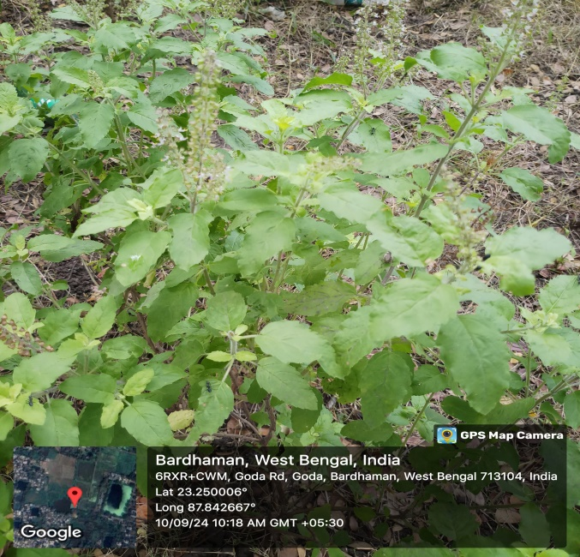
Figure-S1: Leaves of Ocimum sanctum plant collected and used for the preparation of Nano-biopesticide formulation

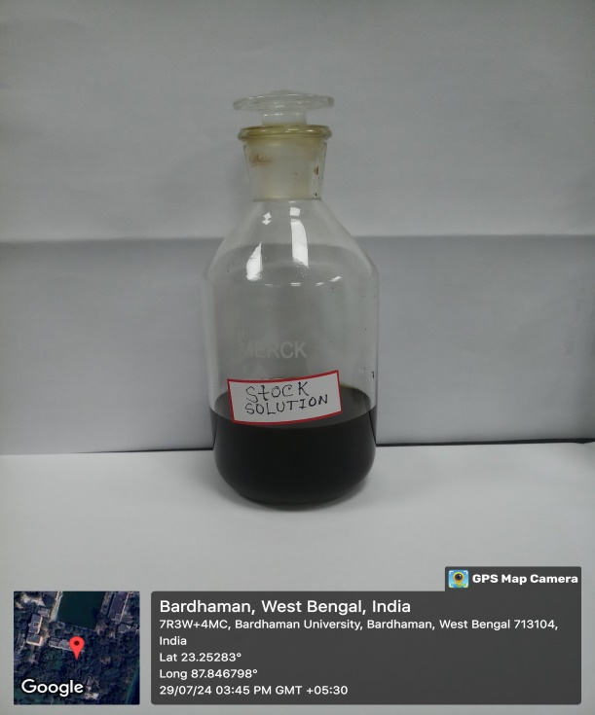
Figure-S2: Stock solution of crude Ocimum sanctum leaf extract
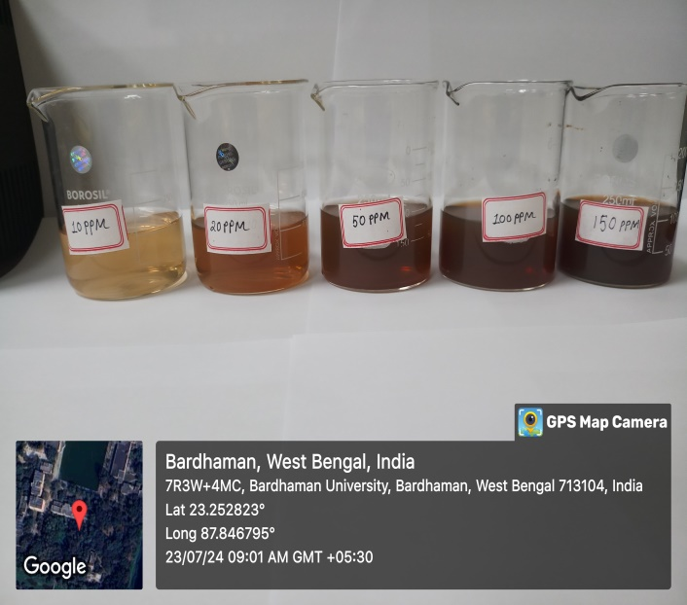
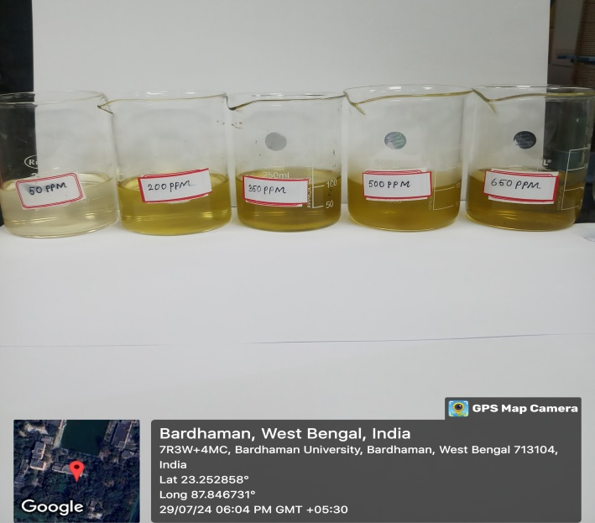

Figure-S3: Serial dilution of nano biopesticides and crude Ocimum sanctum leaf extract.

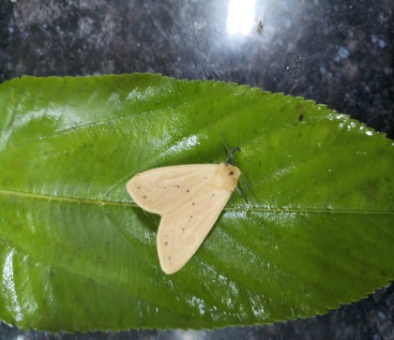
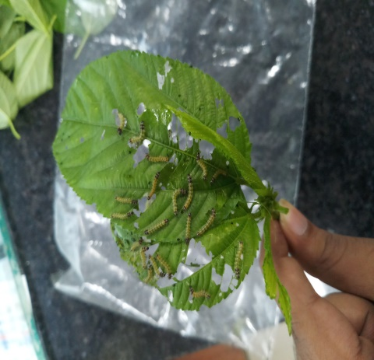
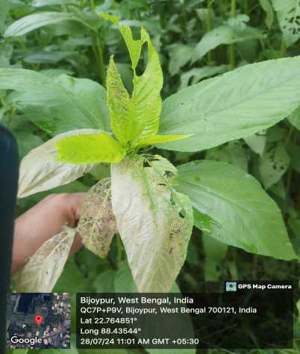
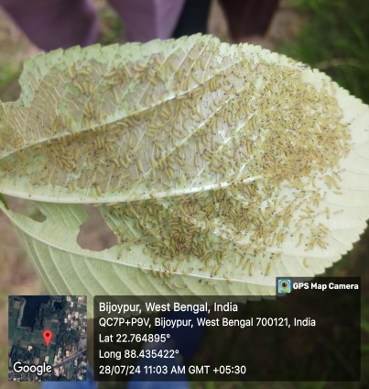
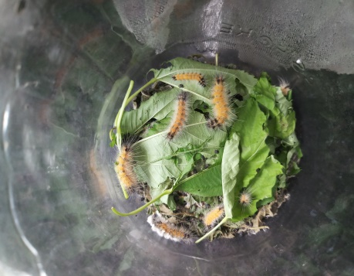
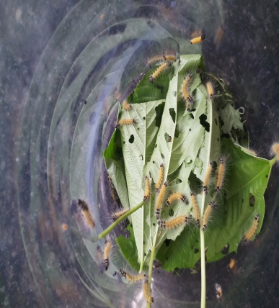
Figure-S4: Different stages of Spilosoma obliqua

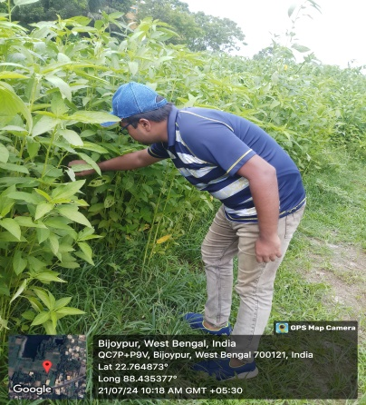
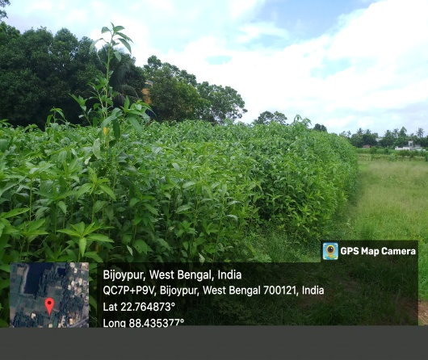
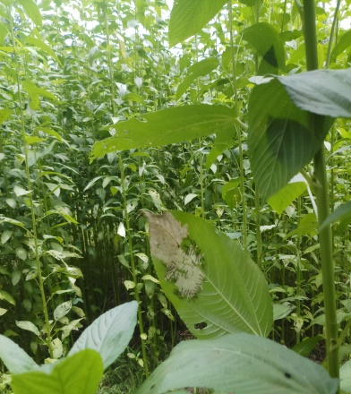
Figure-S5: Field visit and jute hairy caterpillar larva collection. (The person in this picture is Avirup Ghosh, the first author of this manuscript.)

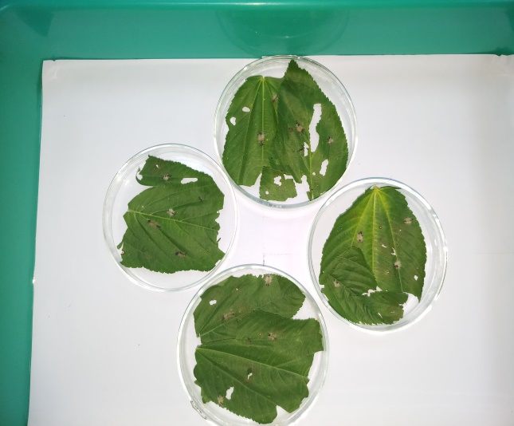
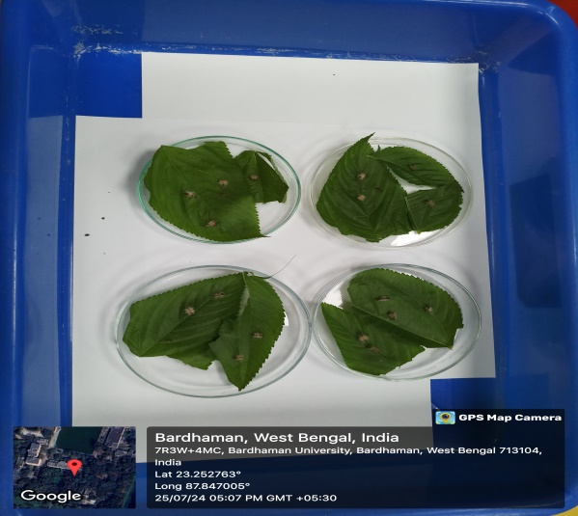
Figure-S6: Experimental analysis of treatment of the larvae with the nano-biopesticide formulation (inside laboratory)

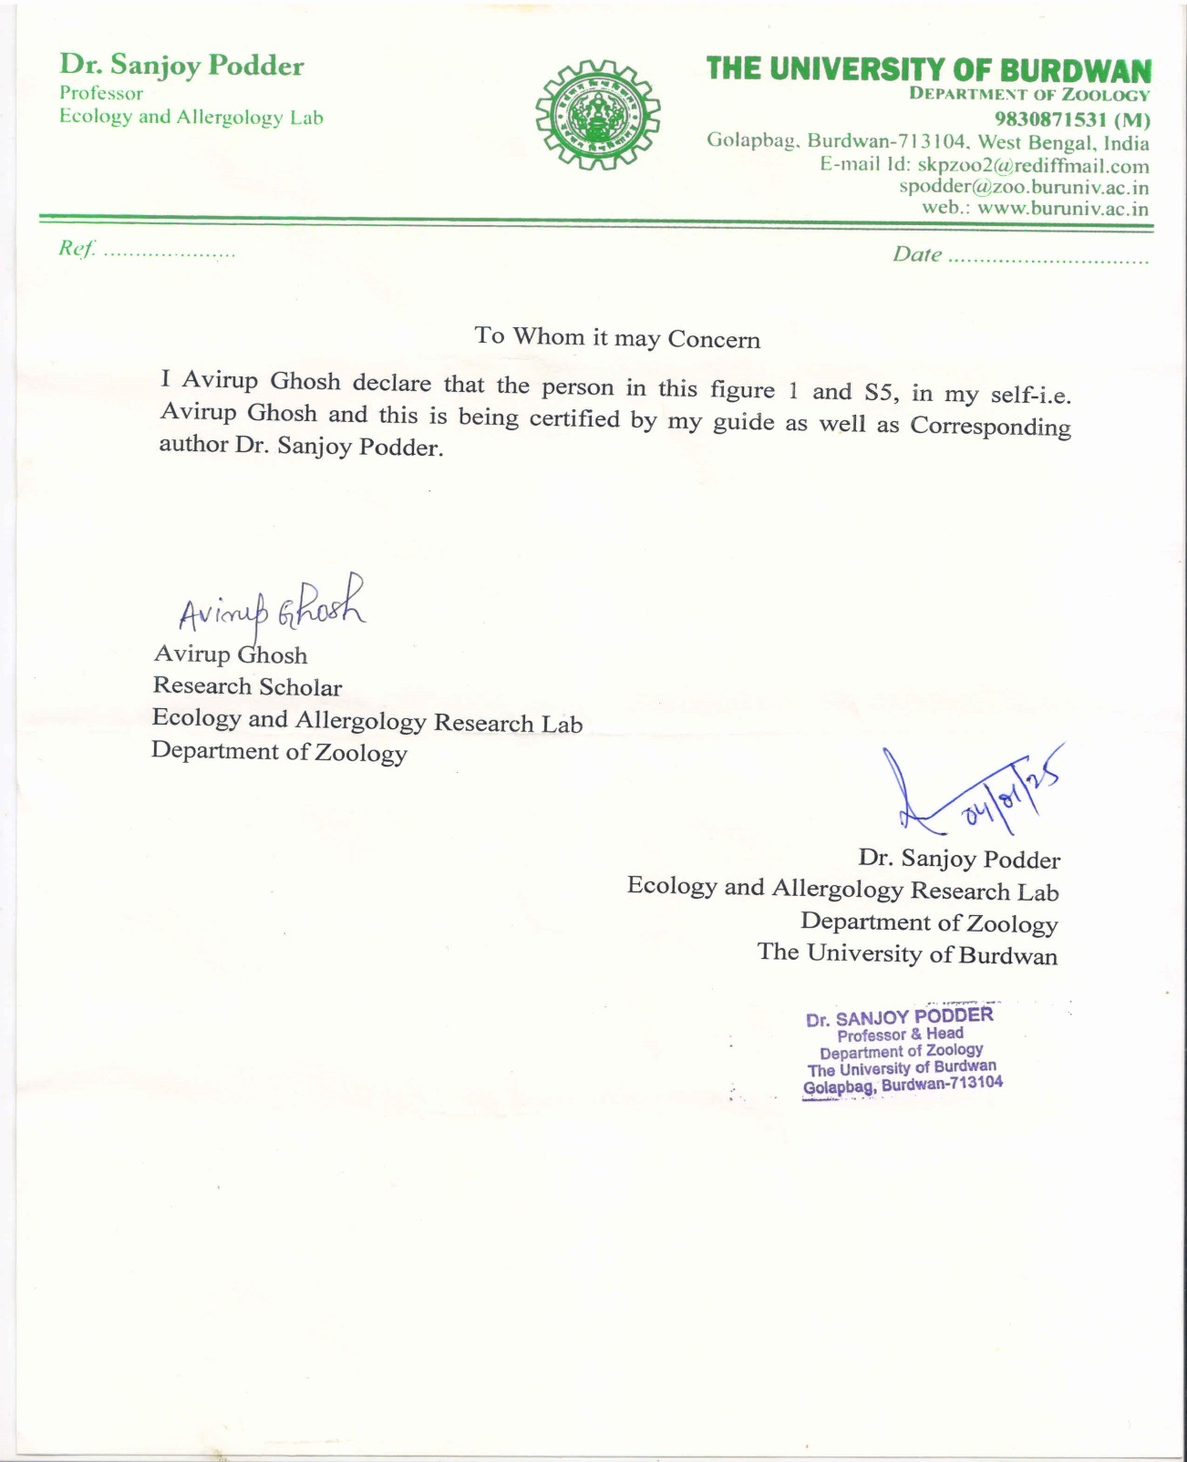
Figure-S7: Statement attesting to informed consent from my guide.

