Supplementary Table S1: Average roughness parameters obtained from AFM measurements from top to bottom
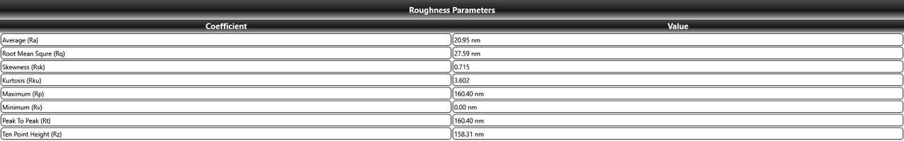
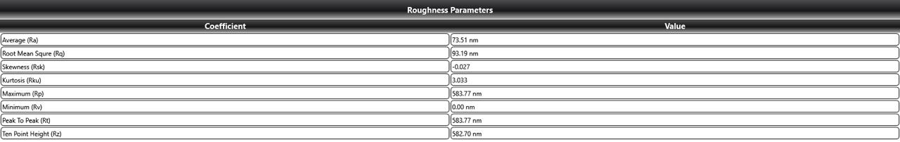
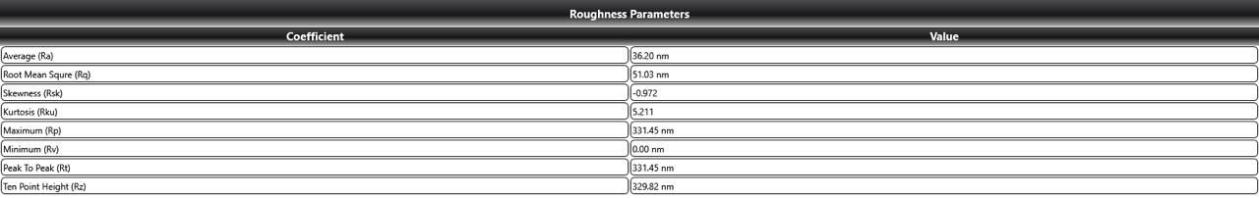
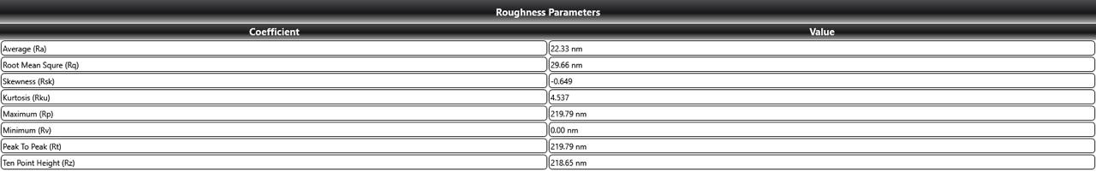
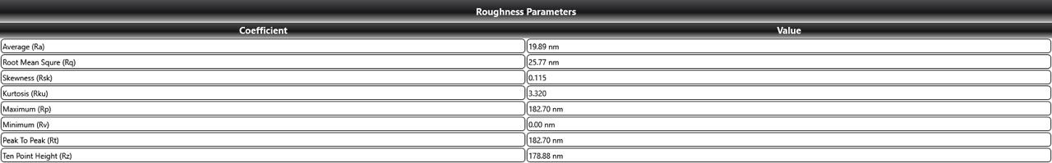
Quail (CCJ), Partridge (AC), Chicken (DH), Goose (AA) and Ostrich (SC). CCJ: Coturnix Coturnix Japonica, AC: Alectoris Chukar, DH: Denizli Hen, AA: Anser Anser, SC: Struthio Camelus

