Supplementary data
Table S1. Synthesis of chromenes.
Entry | Salicylaldehyde  derivatives | 1,3-cyclohexanedione  derivatives | Nucleophiles | Chromenes
1 | 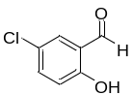  5-Chlorosalicyladehyde  0.32 mmole | 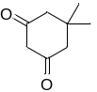  Dimedone  0.32 mmole | 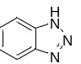  Benzotriazole  0.32 mmole | 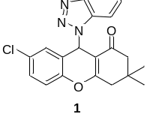  0.13 mmole  (41.0 % yield)
2 | 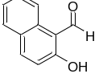  2-Hydroxy-1-napthaldehyde  0.38 mmole | 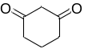  1,3-Cyclohexanedione  0.38 mmole | 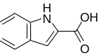Indole-2-  carboxylic acid  0.38 mmole | 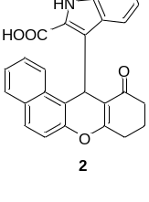  0.21 mmole  (56.1% yield)
3 | 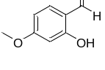  2-hydroxy-4-methoxybenzaldehyde  0.33 mmole | Dimedone  0.34 mmole | Indole-2-  carboxylic acid  0.34 mmole | 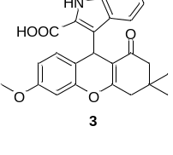  0.19 mmole  (57.7% yield)
4 | 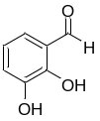  2,3-Dihydroxybenzaldehyde  0.59 mmole | Dimedone  0.59 mmole | 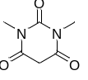  1,3-Dimethyl-  barbituric acid  0.59 mmole | 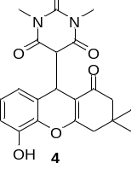  0.32 mmole  (55.2% yield)
5 | 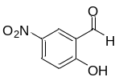  2-Hydroxy-5-nitrobenzaldehyde  0.31 mmole | 1,3-cyclohexanedione  0.31 mmole | 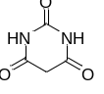  Barbituric acid  0.30 mmole | 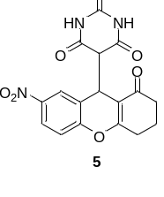  0.20 mmole  (65.5% yield)
Table S2. Raw data of lipid content measurement by Oil Red O
1. Anti-adipogenesis
 |  |  | OD492
sample | 1 | 2 | 3 | 4 | 5 | mean
Control | 0.816 | 0.724 | 0.683 | 0.795 | 0.741 | 0.752
4 | 0.617 | 0.547 | 0.596 | 0.586 | 0.573 | 0.584
5 | 0.601 | 0.492 | 0.501 | 0.578 | 0.510 | 0.536
6 | 0.745 | 0.761 | 0.816 | 0.702 | 0.741 | 0.753
16 | 0.703 | 0.695 | 0.797 | 0.721 | 0.632 | 0.710
17 | 0.716 | 0.721 | 0.732 | 0.711 | 0.716 | 0.719
18 | 0.675 | 0.711 | 0.664 | 0.693 | 0.692 | 0.687
20 | 0.994 | 0.972 | 0.976 | 0.978 | 0.917 | 0.967
21 | 0.605 | 0.651 | 0.643 | 0.647 | 0.668 | 0.643
22 | 0.835 | 0.874 | 0.799 | 0.785 | 0.821 | 0.823
23 | 0.845 | 0.791 | 0.758 | 0.734 | 0.812 | 0.788
25 | 0.513 | 0.485 | 0.495 | 0.496 | 0.501 | 0.498
26 | 0.644 | 0.615 | 0.603 | 0.591 | 0.625 | 0.616
27 | 0.915 | 1.004 | 1.045 | 1.064 | 1.072 | 1.020
29 | 0.874 | 0.956 | 0.741 | 0.935 | 0.823 | 0.866

2. Lipolysis
 |  |  | OD492
Sample | 1 | 2 | 3 | 4 | 5 | mean
Control | 0.421 | 0.745 | 0.603 | 0.694 | 0.753 | 0.643
Iso | 0.735 | 0.483 | 0.694 | 0.802 | 0.674 | 0.678
4 | 0.647 | 0.683 | 0.751 | 0.641 | 0.603 | 0.665
5 | 0.722 | 0.604 | 0.683 | 0.691 | 0.745 | 0.689
6 | 0.653 | 0.662 | 0.704 | 0.668 | 0.687 | 0.675
16 | 0.765 | 0.641 | 0.681 | 0.7 | 0.794 | 0.716
17 | 0.651 | 0.655 | 0.643 | 0.667 | 0.669 | 0.657
18 | 0.633 | 0.654 | 0.654 | 0.612 | 0.651 | 0.641
20 | 0.601 | 0.594 | 0.597 | 0.579 | 0.597 | 0.594
21 | 0.723 | 0.703 | 0.751 | 0.742 | 0.733 | 0.730
22 | 0.615 | 0.575 | 0.601 | 0.543 | 0.675 | 0.602
23 | 0.569 | 0.595 | 0.596 | 0.611 | 0.611 | 0.596
25 | 0.741 | 0.723 | 0.744 | 0.705 | 0.711 | 0.725
26 | 0.665 | 0.667 | 0.674 | 0.663 | 0.654 | 0.665
27 | 0.655 | 0.574 | 0.642 | 0.674 | 0.564 | 0.622
29 | 0.703 | 0.845 | 0.624 | 0.722 | 0.721 | 0.723

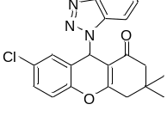
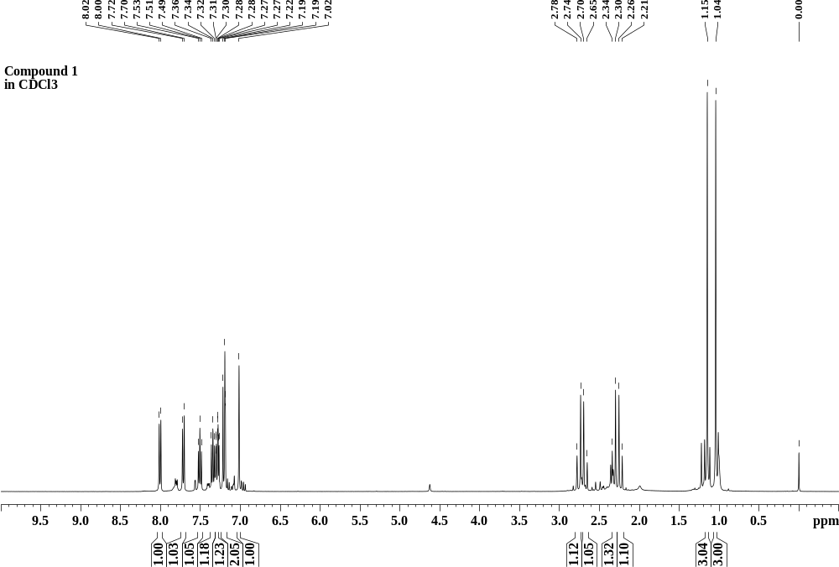
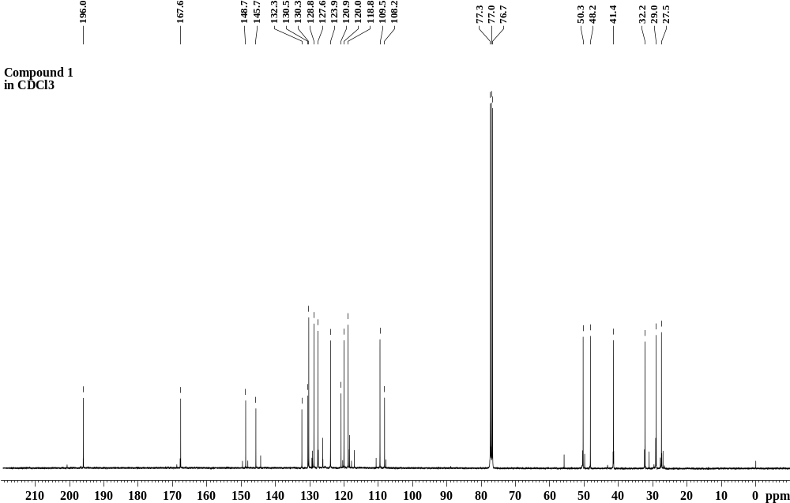
Figure S1 ¹H- and ¹³C-NMR spectra of 1.
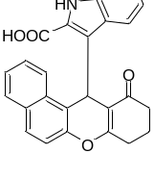
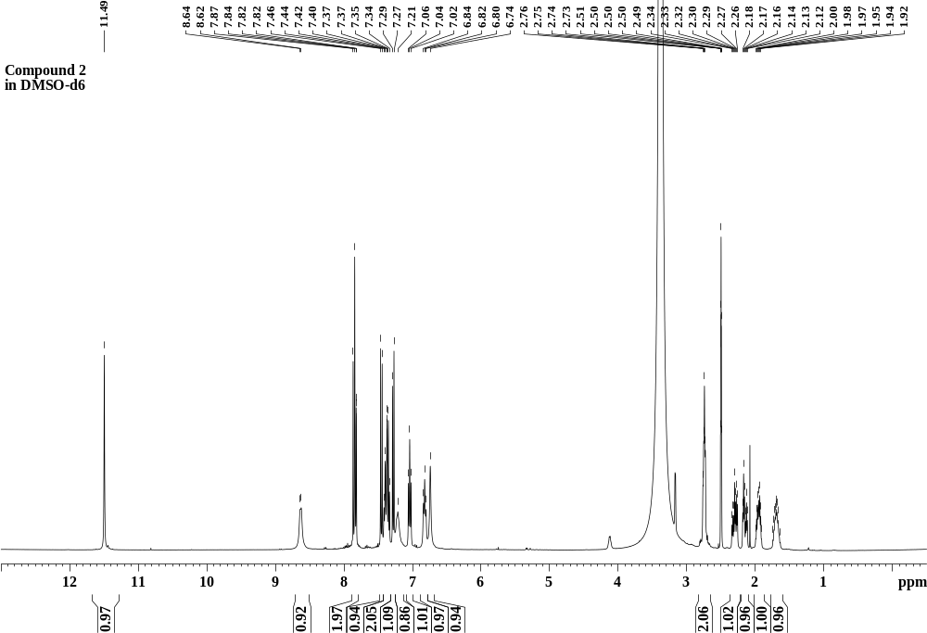
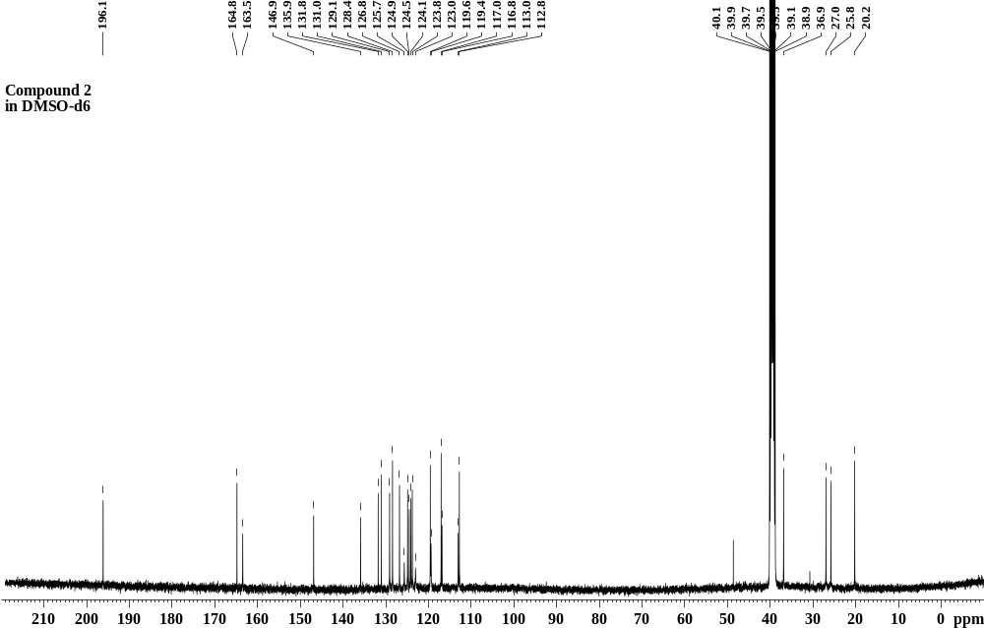
Figure S2 ¹H- and ¹³C-NMR spectra of 2.
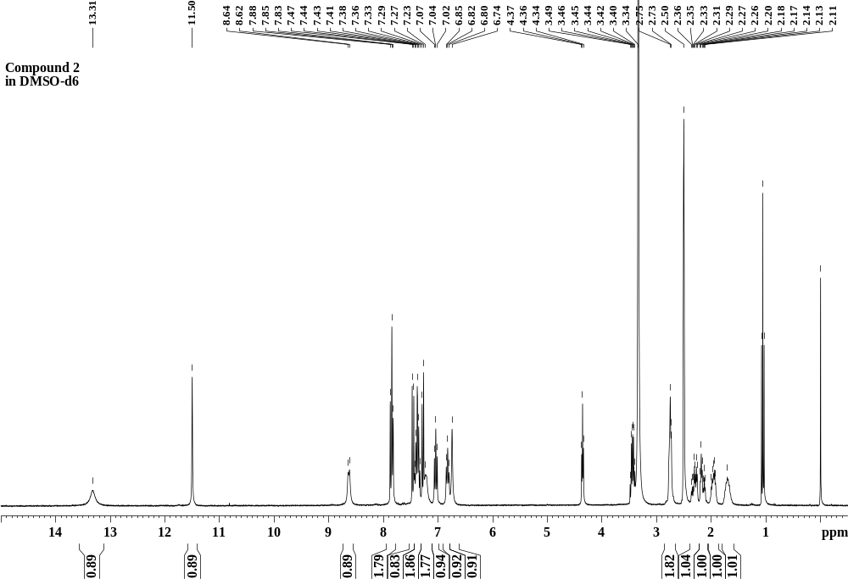
Figure S3 ¹H-NMR spectrum of 2 shows a peak for an exchangeable proton of a carboxylic acid at δ_{H} 13.31 ppm and peaks of residual ethanol at δ_{H} 4.35, 3.44, and 1.06 ppm in DMSO-d6.

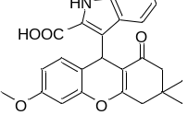
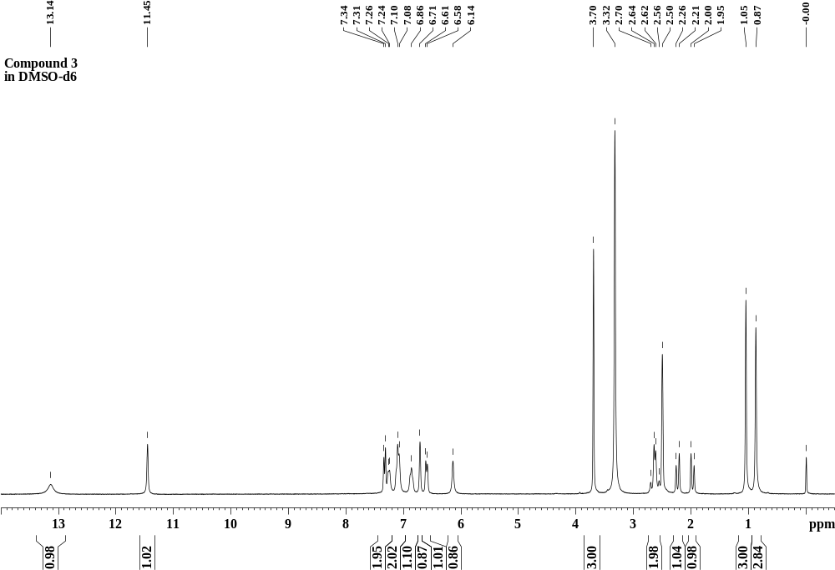
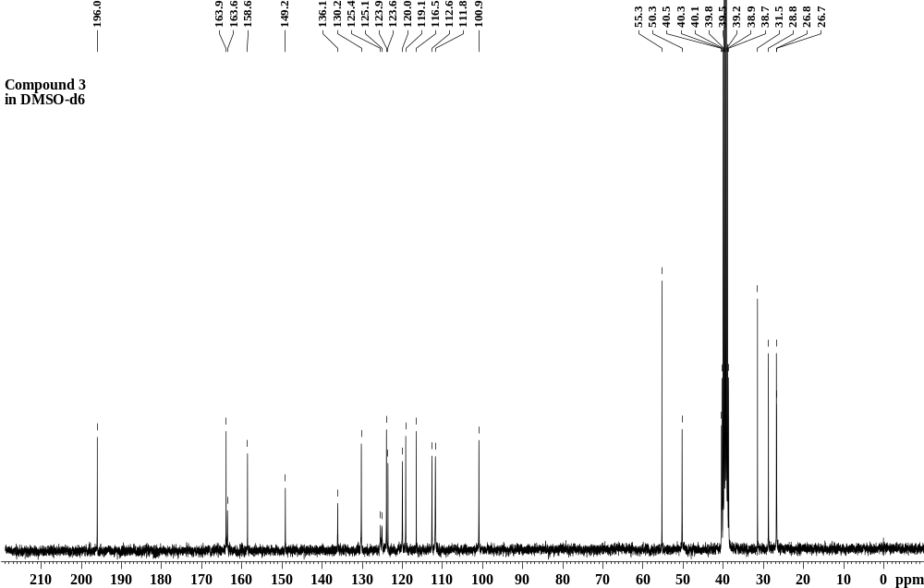
Figure S4 ¹H- and ¹³C-NMR spectra of 3.
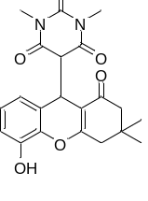
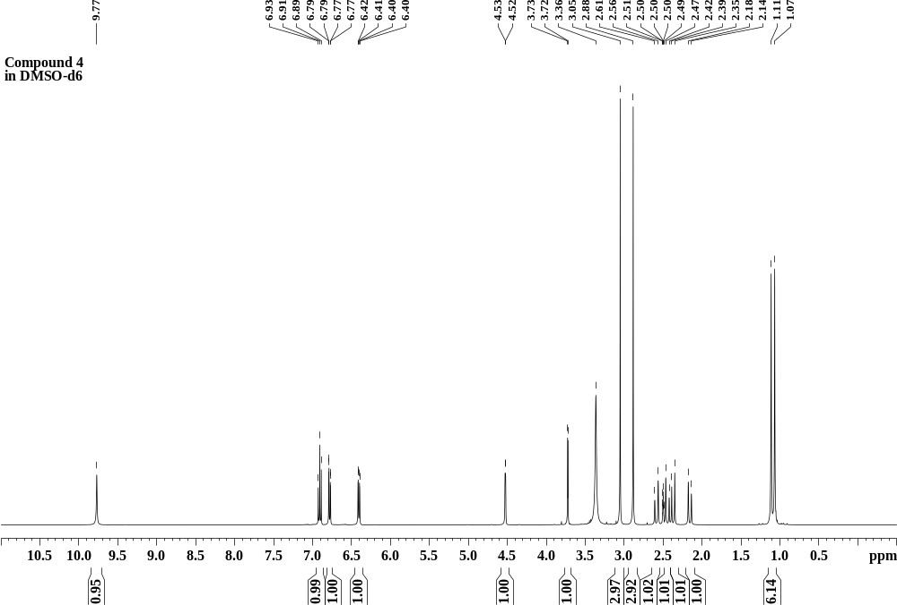
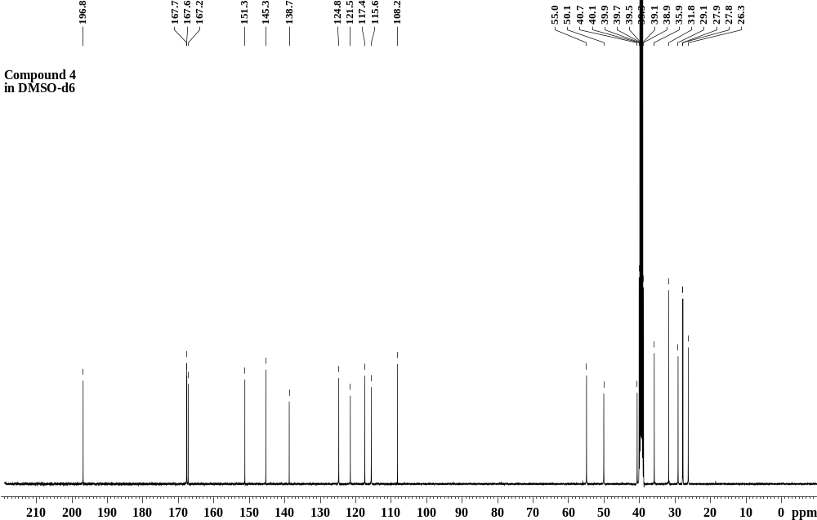
Figure S5 ¹H- and ¹³C-NMR spectra of 4.
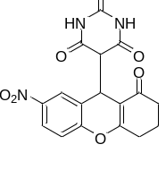
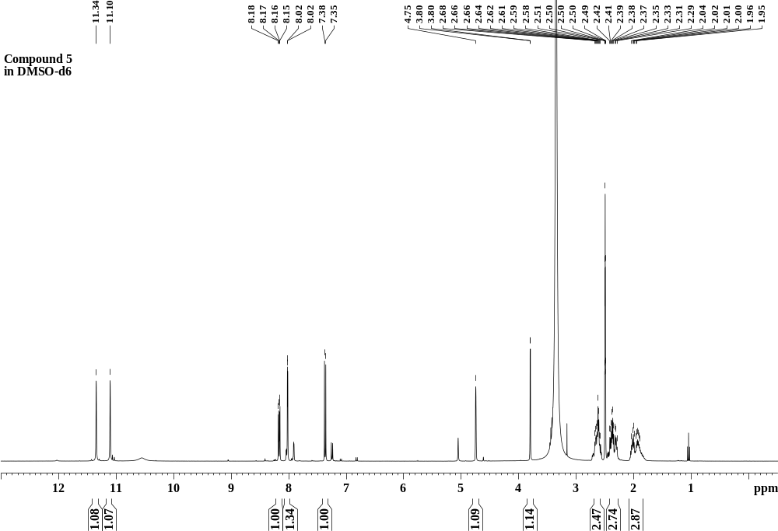
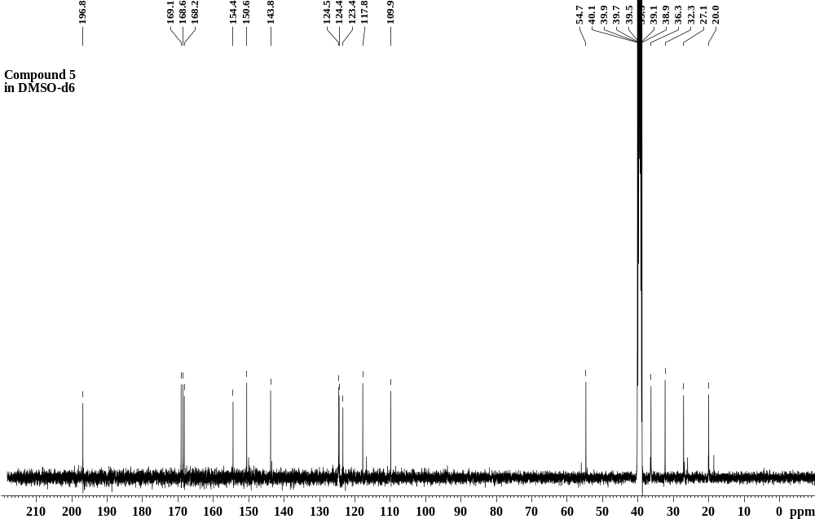
Figure S6 ¹H- and ¹³C-NMR spectra of 5.
Figure S7 Mass spectra of 1. ESI-TOF MS (m/z): [M+Na]⁺ calculated for C₂₁H₁₈ClN₃O₂Na, 402.0985; found 402.0978
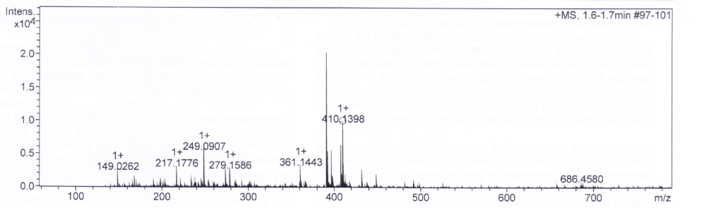
Figure S8 Mass spectra of 2. ESI-TOF MS (m/z): [M+H]⁺ calculated for C₂₆H₂₀NO₄, 410.1392; found 410.1398.
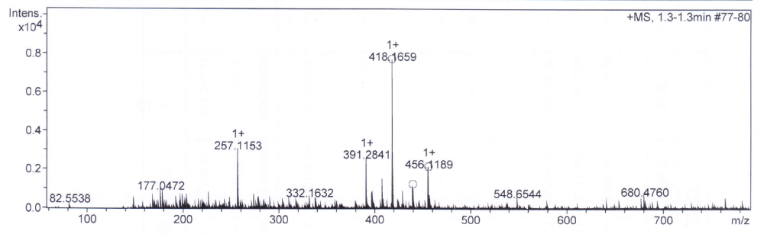
Figure S9 Mass spectra of 3. ESI-TOF MS (m/z): [M+H]⁺ calculated for C₂₅H₂₄NO₅, 418.1654; found 418.1659.
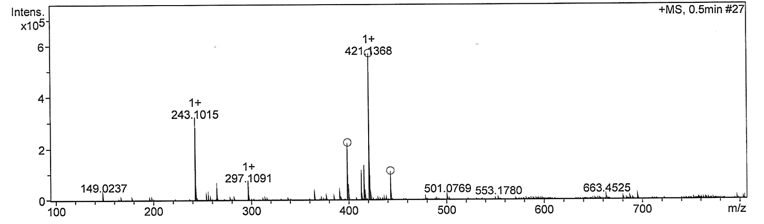
Figure S10 Mass spectra of 4. ESI-TOF MS (m/z): [M+Na]⁺ calculated for C₂₁H₂₂N₂O₆Na, 421.1376; found 421.1368.

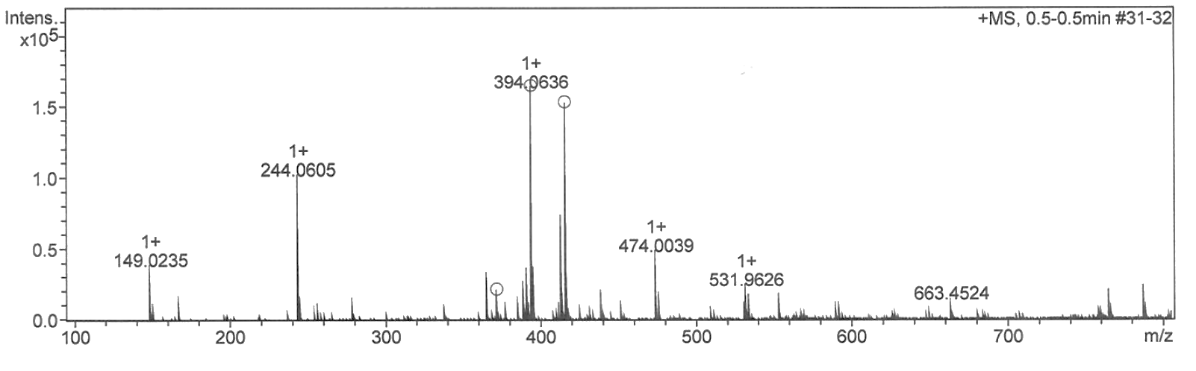
Figure S11 Mass spectra of 5. ESI-TOF MS (m/z): [M+Na]⁺ calculated for C₁₇H₁₃N₃O₇Na, 394.0651; found 394.0636.

