Appendix 1 Search strategy

Database Searched | Number of Articles | Search Terms | Search Fields
Web of Science | 876 | Search String 1: "running economy*" OR "VO₂" OR "oxygen consumption*" OR "metabolic cost*"  Search String 2: "footwear*" OR "shod*" OR "barefoot*" OR "minimalist*"  Search String 3: "run*" OR "jog*" OR "treadmill*" OR "overground*" OR "marathon*"  No Limits | Topic 'TS'  (title, abstract and indexing)
PubMed | 174 | Search String 1: "running economy*" OR "VO₂" OR "oxygen consumption*" OR "metabolic cost*"  Search String 2: "footwear*" OR "shod*" OR "barefoot*" OR "minimalist*"  Search String 3: "run*" OR "jog*" OR "treadmill*" OR "overground*" OR "marathon*"  No Limits | Title 'TI' Abstract 'AB'
SPORTdiscus (EBSCOhost) | 160 | Search String 1: "running economy*" OR "VO₂" OR "oxygen consumption*" OR "metabolic cost*"  Search String 2: "footwear*" OR "shod*" OR "barefoot*" OR "minimalist*"  Search String 3: "run*" OR "jog*" OR "treadmill*" OR "overground*" OR "marathon*"  No Limits | Title 'TI' Abstract 'AB'
SCOPUS | 117 | Search String 1: "running economy*" OR "VO₂" OR "oxygen consumption*" OR "metabolic cost*"  Search String 2: "footwear*" OR "shod*" OR "barefoot*" OR "minimalist*"  Search String 3: "run*" OR "jog*" OR "treadmill*" OR "overground*" OR "marathon*"  No Limits | Title Abstract  Keywords
CNKI | 9 | Search String 1: "running economy*" OR "VO₂" OR "oxygen consumption*" OR "metabolic cost*"  Search String 2: "footwear*" OR "shod*" OR "barefoot*" OR "minimalist*"  Search String 3: "run*" OR "jog*" OR "treadmill*" OR "overground*" OR "marathon*"  No Limits | Topic 'TS'  (title, abstract and indexing)
TOTAL | 1336

Appendix 2 PEDro rating levels of the included studies
 | PEDro ratings
Study | Eligibility criteria were specified | Random group allocation | Allocation was concealed | Intervention groups were similar | Blinding of all subjects | Blinding of all therapists | Blinding of all assessors | 85% obtained outcome | Intention to treat method | Between group comparison | Point measure & variability | PEDro score
Barnes et al. 2019 | Yes | 1 | 0 | 1 | 0 | 0 | 0 | 1 | 1 | 1 | 1 | 6
Berrones et al. 2016 | Yes | 1 | 0 | 1 | 0 | 0 | 0 | 1 | 1 | 1 | 1 | 6
Cochrum et al. 2019 | Yes | 1 | 0 | 1 | 0 | 0 | 0 | 1 | 1 | 1 | 1 | 6
Dinato et al. 2021 | Yes | 1 | 0 | 1 | 1 | 0 | 0 | 1 | 0 | 1 | 1 | 6
Divert et al. 2008 | Yes | 1 | 0 | 1 | 0 | 0 | 0 | 1 | 1 | 1 | 1 | 6
Franz et al. 2012 | Yes | 1 | 0 | 1 | 0 | 0 | 0 | 1 | 1 | 1 | 1 | 6
Fuller et al. 2017 | Yes | 1 | 0 | 1 | 1 | 0 | 0 | 1 | 0 | 1 | 1 | 6
Hébert-Losier et al. 2022 | Yes | 1 | 1 | 1 | 1 | 0 | 0 | 1 | 1 | 1 | 1 | 8
Hunter et al. 2019 | Yes | 1 | 0 | 1 | 0 | 0 | 0 | 1 | 1 | 1 | 1 | 6
Hunter et al. 2022 | Yes | 1 | 0 | 1 | 0 | 0 | 0 | 1 | 1 | 1 | 1 | 6
Jaén-Carrillo et al. 2022 | Yes | 1 | 0 | 1 | 0 | 0 | 0 | 1 | 1 | 1 | 1 | 6
Knoepfli-Lenzin et al. 2014 | Yes | 1 | 0 | 1 | 0 | 0 | 0 | 1 | 1 | 1 | 1 | 6
Knopp et al. 2023 | Yes | 1 | 0 | 1 | 0 | 0 | 0 | 1 | 1 | 1 | 1 | 6
Lindorfer et al. 2020 | Yes | 1 | 0 | 1 | 0 | 0 | 0 | 1 | 1 | 1 | 1 | 6
Lussiana et al. 2013 | Yes | 1 | 0 | 1 | 0 | 0 | 0 | 1 | 1 | 1 | 1 | 6
Pace et al. 2020 | Yes | 1 | 0 | 1 | 0 | 0 | 0 | 1 | 1 | 1 | 1 | 6
Paulson et al. 2014 | Yes | 1 | 0 | 1 | 0 | 0 | 0 | 1 | 1 | 1 | 1 | 6
Rodrigo-Carranza et al. 2020 | Yes | 1 | 0 | 1 | 0 | 0 | 0 | 1 | 1 | 1 | 1 | 6
Rodrigo-Carranza et al.2023 | Yes | 1 | 0 | 1 | 1 | 0 | 0 | 1 | 0 | 1 | 1 | 6
Sanno et al. 2021 | Yes | 1 | 0 | 1 | 0 | 0 | 0 | 1 | 1 | 1 | 1 | 6
Sinclair et al. 2016 a | Yes | 1 | 0 | 1 | 0 | 0 | 0 | 1 | 1 | 1 | 1 | 6
Sinclair et al. 2016 b | Yes | 1 | 0 | 1 | 0 | 0 | 0 | 1 | 1 | 1 | 1 | 6
Vercruyssen et al. 2016 | Yes | 1 | 0 | 1 | 0 | 0 | 0 | 1 | 1 | 1 | 1 | 6
Vincent et al. 2014 | Yes | 1 | 0 | 1 | 0 | 0 | 0 | 1 | 1 | 1 | 1 | 6
Warne et al. 2015 | Yes | 1 | 0 | 1 | 0 | 0 | 0 | 1 | 1 | 1 | 1 | 6
Whiting et al. 2022 | Yes | 1 | 0 | 1 | 0 | 0 | 0 | 1 | 1 | 1 | 1 | 6

Appendix 3 Forest plots of subgroup analysis

Figure 8. Subgroup analysis of the effect of barefoot running (BR) and shod running (SR) on RE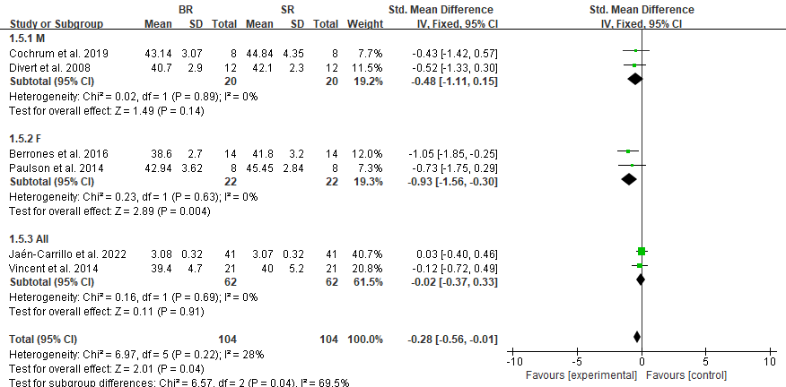

Figure 9. Exploring the reasons for high heterogeneity of minimalist running (MR) vs shod running (SR) on RE after excluding study one by one.
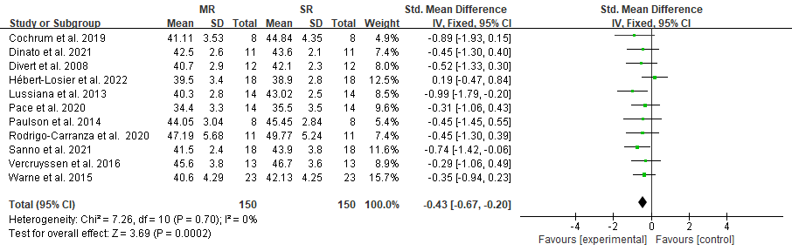

Figure 10. Exploring the reasons for high heterogeneity of barefoot running (BR) vs minimalist running (MR) on RE after excluding study one by one.
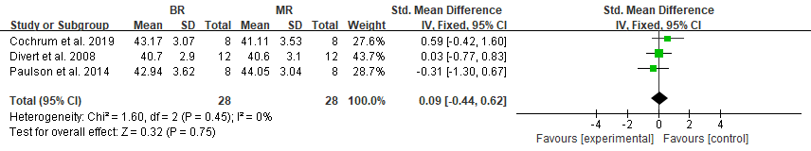

Appendix 4 Funnel plots of publication bias

Figure 11. Funnel plot to assess publication bias in (A) the effect of barefoot running (BR) and shod running (SR) on RE, (B) the effect of minimalist running (MR) and shod running (SR) on RE, and (C) the effect of barefoot running (BR) and minimalist running (MR) on RE.
A
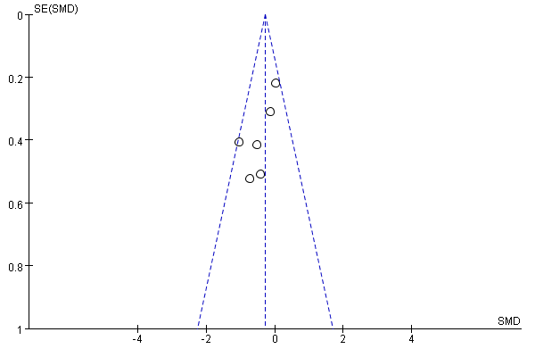
B
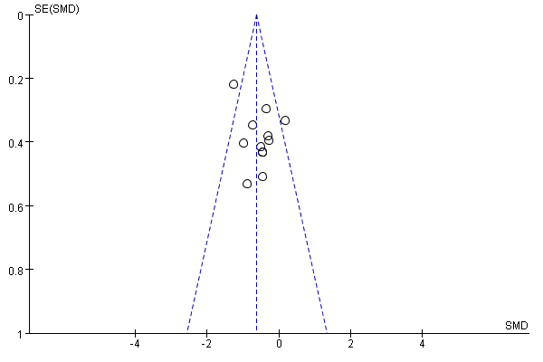
C
