Supplementary Table 1. Protocol HER2 Therapy for women
year of  diagnose | HER2-low  cases | Targeted HER2 Therapy |  |  | HER2-  positive  cases | Targeted HER2 Therapy
year of  diagnose | HER2-low  cases | Trastuzumab | Pertuzumab | other/  unknown | HER2-  positive  cases | Trastuzumab | Pertuzumab | other/  unknown
2000 | 298 | <5 |  |  | 141 | 9 (6.4%)
2001 | 1200 | 7 (0.6%) |  | <5 | 632 | 42 (6.6%) |  | <5
2002 | 1792 | 8 (0.4%) |  | 5 (0.3%) | 976 | 77 (7.9%) |  | <5
2003 | 2389 | <5 |  | 7 (0.3%) | 1177 | 104 (8.8%) |  | <5
2004 | 3479 | 5 (0.1%) |  | 14 (0.4%) | 1644 | 158 (9.6%) |  | 7 (0.4%)
2005 | 4474 | 18 (0.4%) |  | 16 (0.4%) | 2106 | 507 (24%) |  | <5
2006 | 5117 | 31 (0.6%) |  | 22 (0.4%) | 2312 | 831 (36%) |  | 6 (0.2%)
2007 | 5447 | 31 (0.6%) |  | 53 (1.0%) | 2115 | 885 (42%) |  | 12 (0.6%)
2008 | 5685 | 31 (0.5%) |  | 56 (1.0%) | 1974 | 840 (43%) |  | 14 (0.9%)
2009 | 6591 | 42 (0.6%) |  | 80 (1.2%) | 2107 | 925 (44%) |  | 29 (1.3%)
2010 | 7585 | 50 (0.7%) |  | 102 (1.3%) | 2429 | 1 131 (47%) |  | 32 (1.3%)
2011 | 7012 | 40 (0.6%) |  | 113 (1.6%) | 2200 | 1 206 (55%) |  | 15 (0.7%)
2012 | 7157 | 33 (0.5%) |  | 138 (1.9%) | 2246 | 1 289 (57%) | 6 (0.3%) | 32 (1.4%)
2013 | 7415 | 47 (0.6%) |  | 141 (1.9%) | 2258 | 1 275 (56%) | 22 (1.0%) | 19 (0.8%)
2014 | 7010 | 44 (0.6%) | <5 | 119 (1.7%) | 2133 | 1 176 (55%) | 18 (0.8%) | 19 (0.8%)
2015 | 6883 | 57 (0.8%) | <5 | 167 (2.4%) | 2220 | 1 189 (54%) | 59 (2.7%) | 17 (0.7%)
2016 | 6339 | 58 (0.9%) | <5 | 220 (3.5%) | 2321 | 1 265 (55%) | 86 (3.7%) | 18 (0.8%)
2017 | 5959 | 59 (1.0%) | <5 | 245 (4.1%) | 2334 | 1 260 (54%) | 57 (2.4%) | 18 (0.7%)
2018 | 3111 | 44 (1.4%) | <5 | 168 (5.4%) | 969 | 640 (66%) | 41 (4.2%) | 12 (1.2%)
2019 | 3195 | 41 (1.3%) |  | 172 (5.4%) | 1018 | 742 (73%) | 12 (1.2%) | 19 (1.9%)
2020 | 3186 | 34 (1.1%) |  | 194 (6.1%) | 973 | 662 (68%) | 7 (0.7%) | 27 (2.8%)

Supplementary Figure 1. Selection of patients with HER2 phenotype from the 10th nationwide oncological quality conference in Germany.
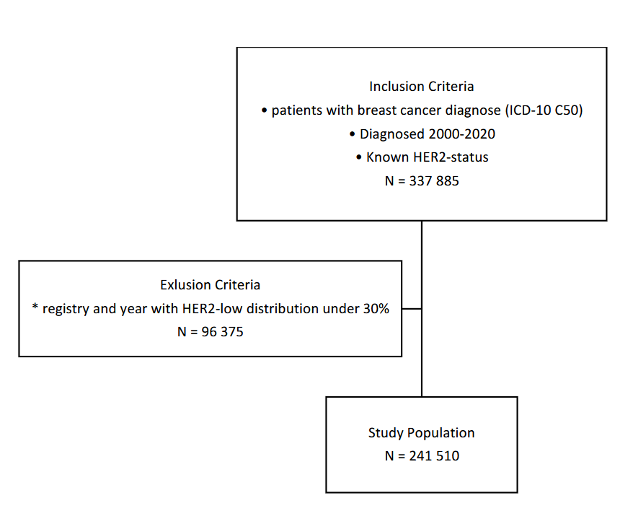
Supplementary Figure 2. Metastasis localisation by HER2-status (HER2 zero blue, HER2-low green and HER2-positive orange) for a) hormone receptor negative and b) hormone receptor positive.
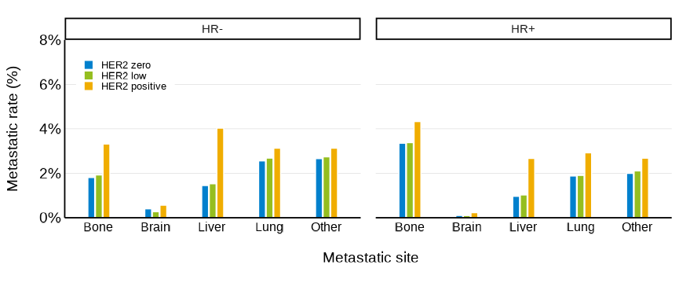
Supplementary Figure 3. Pathological complete remission for patients who received chemotherapy with Anthraxycline/Paclitaxel protocol, by HER2-status.
