Experimental results of the proposed model (CNN-LSTM) according to third dataset that available public at https://www.kaggle.com/datasets/tommyngx/inbreast2012
Table 1 displays the performance of the proposed model and several DL on the third dataset.
Table1. Performance of CNN-LSTM model and several DL models on third dataset.
Models | Accuracy | Sensitivity | Specificity | F-score | AUC
CNN-LSTM | 97.91% | 97.92% | 97.91% | 97.93% | 0.993
CNN | 95.53% | 95.52% | 95.53% | 95.54% | 0.972
LSTM | 94.72% | 94.72% | 94.74% | 94.73% | 0.958
GRU | 92.47% | 92.47% | 92.46% | 92.45% | 0.949
VGG16 | 89.58% | 89.57% | 89.58% | 89.59% | 0.922
ResNet50 | 88.18% | 88.15% | 88.16% | 88.18% | 0.904

Figure 1displays the training and testing for both loss and accuracy using CNN-LSTM model on third dataset.

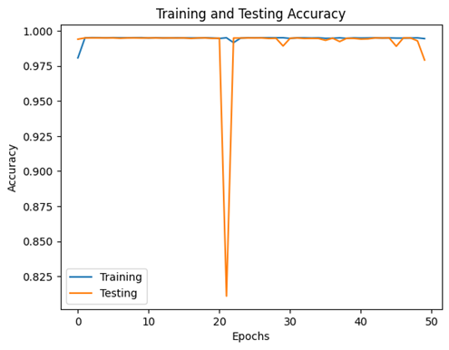 | 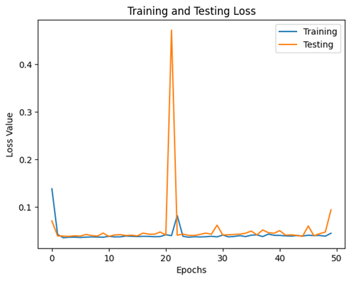

Figure 1: Training and testing for both loss and accuracy using CNN-LSTM model on third dataset.

Figure 2 displays the plot of actual and predicted values using the proposed model on the third dataset.
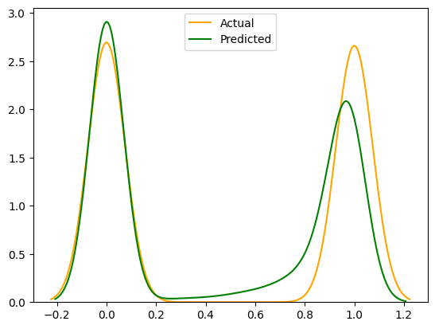

Figure 2: Plot for actual and predicted values using CNN-LSTM on the third dataset.

Figure 3 displays the AUC value for CNN-LSTM model on the third dataset.

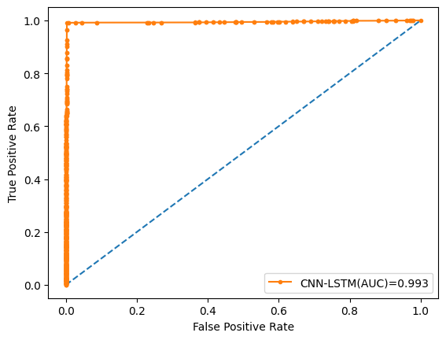

Figure 3: AUC value for CNN-LSTM model on the third dataset.

