Dual-task effects of walking-speed on inhibitory

control and decision-making under risk
Carlotta Maiocchi, Marta Milanesi, Nicola Canessa, Stefania Sozzi, Giulia Mattavelli, Antonio Nardone, Claudia Gianelli

Supplementary Materials
Here are reported the demographics of participants (the full sample used in LA analyses is shown) and full data of the exploratory analyses carried out to evaluate possible modulations of risk aversion when performing the task at three different walking speeds, and to investigate a possible modulation on kinematic parameters during dual-task performance. A further analysis was performed to evaluate the possible role of the order of the session as a covariate on the observed effects.

- Demographics
Table S1. Demographics for LA sample

 | Mean | SD
Age | 25.08 | 3.71
Height _{cm} | 170.14 | 8.54
Mass _{Kg} | 63.44 | 9.67
Sex (Male/Female) | 13/38

- Risk Aversion (RA) – DESCRIPTIVE STATISTICS
Table S2. Descriptive statistics of Bayesian t-tests comparing ρ across different speeds

ρ | N | Mean | SD | Coefficient of variation | 95% Credible Interval
DTE_MEDIUM | 38 | 2.100 | 23.159 | 3.757 | (-5.512 9.712)
DTE_FAST | 38 | 3.803 | 20.555 | 5.404 | (-2.953 10.560)
DTE_SLOW | 38 | 6.707 | 30.788 | 4.590 | (-3.413 16.827)

Table S3. Descriptive statistics of Bayesian factors for comparing ρ across different speeds

 | N | BF₁₀ | Error %
DTE_Medium vs Fast | 38 | 0.192 | 0.047
DTE_Medium vs Slow | 38 | 0.277 | 0.041

Figure S1. Effect of Treadmill speed on inhibitory control and decision-making (DTE (%) in slow, medium and fast speed.

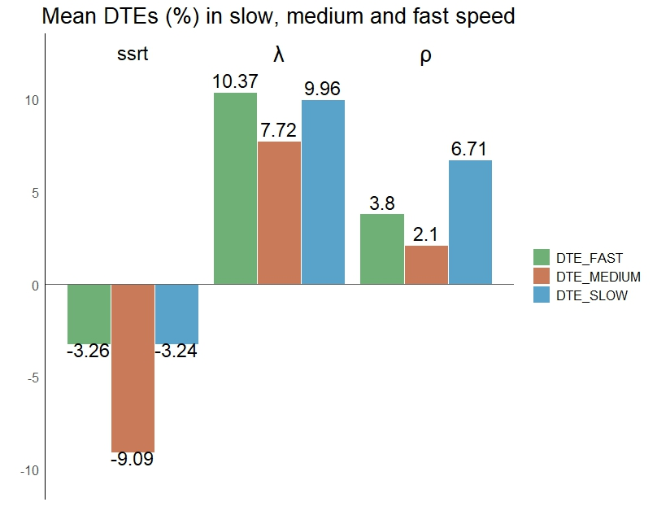

- MOTOR ANALYSES

One sample t-tests
A directional Bayesian one-sample t-test was used to assess absolute DTE values against a test value of 0.

Table S4. Descriptive statistics of Bayesian factors for comparing ρ across different speeds

 |  | N | DTE_slow | DTE_Medium | DTE_fast
Cadence | BF₁₀ | 43 | 6.88x10⁹ | 1.97x10⁹ | 8.1x10⁷
 | Error % | 43 | 3.55x10⁻¹⁴ | 1.78x10⁻¹² | 2.18x10⁻¹³
GCL | BF₁₀ | 43 | 3.65x10⁶ | 4.77x10⁷ | 1.32x10⁸
 | Error % | 43 | 2.76x10⁻¹² | 1.91x10⁻¹³ | 2.17x10⁻¹³
GCT | BF₁₀ | 43 | 8.45x10⁷ | 1.62x10⁹ | 8.95x10⁷
 | Error % | 43 | 2.18x10⁻¹³ | 1.04x10⁻¹¹ | 2.18x10⁻¹³
SSP | BF₁₀ | 43 | 3.32x10⁶ | 2.26x10⁸ | 66965
 | Error % | 43 | 2.99x10⁻¹² | 1.97x10⁻¹³ | 8.32x10⁻¹¹
StP | BF₁₀ | 43 | 1.04x10⁶ | 1.83x10⁷ | 201778
 | Error % | 43 | 1.24x10⁻¹¹ | 1.58x10⁻¹³ | 3.85x10⁻¹¹
SwP | BF₁₀ | 43 | 2.69x10⁶ | 5.83x10⁷ | 70168
 | Error % | 43 | 4.09x10⁻¹² | 2.04x10⁻¹³ | 8.03x10⁻¹¹
RF | BF₁₀ | 43 | 518183 | 119815 | 165588
 | Error % | 43 | 2.26x10⁻¹¹ | 5.43x10⁻¹¹ | 4.37x10⁻¹¹
LF | BF₁₀ | 43 | 251114 | 101878 | 107392
 | Error % | 43 | 3.37x10⁻¹¹ | 6.09x10⁻¹¹ | 5.86x10⁻¹¹

Paired sample t-tests
The effect of each task on spatiotemporal gait parameters was assessed through Bayesian paired t-tests, comparing DTEs% calculated for each motor variable during SST, LA and RA across (1) medium and faster than normal speed, (2) medium and slower than normal speed. Here are reported the Bayesian paired samples t-tests and the descriptives for each DTE of motor variables.

Cadence
Table S5. Bayesian Paired Samples T-Test

Measure 1 | Measure 2 | BF₁₀ | Error %
DTE_LA_med | DTE_LA_slow | 0.179 | 0.055
DTE_LA_med | DTE_LA_fast | 0.513 | 0.034
DTE_RA_med | DTE_RA_slow | 0.239 | 0.049
DTE_RA_med | DTE_RA_fast | 2.329 | 1.101×10⁻⁶
DTE_SST_med | DTE_SST_slow | 3.154 | 7.677×10⁻⁷
DTE_SST_med | DTE_SST_fast | 0.387 | 0.039

Table S6. Descriptive statistics of cadence
 |  |  |  |  |  | 95% Credible Interval
Measure | N | Mean | SD | SE | Coefficient of variation | Lower | Upper
DTE_LA_med | 43 | 1.074 | 4.551 | 0.694 | 4.237 | -0.327 | 2.475
DTE_LA_slow | 43 | 1.325 | 4.120 | 0.628 | 3.109 | 0.057 | 2.593
DTE_LA_fast | 43 | 0.231 | 2.639 | 0.402 | 11.410 | -0.581 | 1.043
DTE_RA_med | 43 | 1.283 | 4.360 | 0.665 | 3.398 | -0.059 | 2.625
DTE_RA_slow | 43 | 1.676 | 4.918 | 0.750 | 2.935 | 0.162 | 3.189
DTE_RA_fast | 43 | -0.146 | 3.291 | 0.502 | -22.561 | -1.159 | 0.867
DTE_SST_med | 43 | 1.099 | 4.409 | 0.672 | 4.011 | -0.258 | 2.456
DTE_SST_slow | 43 | 2.524 | 5.337 | 0.814 | 2.115 | 0.881 | 4.166
DTE_SST_fast | 43 | 0.283 | 3.578 | 0.546 | 12.636 | -0.818 | 1.384

Gait Cycle Length (GCL)
Table S7. Bayesian Paired Samples T-Test

Measure 1 | Measure 2 | BF₁₀ | Error %
DTE_LA_med | DTE_LA_slow | 0.232 | 0.049
DTE_LA_med | DTE_LA_fast | 0.258 | 0.047
DTE_RA_med | DTE_RA_slow | 0.214 | 0.051
DTE_RA_med | DTE_RA_fast | 0.210 | 0.052
DTE_SST_med | DTE_SST_slow | 1.401 | 0.019
DTE_SST_med | DTE_SST_fast | 0.173 | 0.056

Table S8. Descriptive statistics of GCL

 |  |  |  |  |  | 95% Credible Interval
 | N | Mean | SD | SE | Coefficient of Variation | Lower | Upper
DTE_LA_med | 43 | -1.340 | 6.265 | 0.955 | -4.675 | -3.268 | 0.588
DTE_LA_slow | 43 | -2.394 | 7.866 | 1.200 | -3.285 | -4.815 | 0.027
DTE_LA_fast | 43 | -0.184 | 7.579 | 1.156 | -41.211 | -2.516 | 2.149
DTE_RA_med | 43 | -0.947 | 8.002 | 1.220 | -8.455 | -3.409 | 1.516
DTE_RA_slow | 43 | -1.804 | 8.892 | 1.356 | -4.929 | -4.541 | 0.933
DTE_RA_fast | 43 | 0.089 | 7.473 | 1.140 | 84.144 | -2.211 | 2.389
DTE_SST_med | 43 | -2.130 | 5.291 | 0.807 | -2.483 | -3.758 | -0.502
DTE_SST_slow | 43 | -3.816 | 6.975 | 1.064 | -1.828 | -5.963 | -1.670
DTE_SST_fast | 43 | -2.385 | 5.669 | 0.865 | -2.377 | -4.130 | -0.640

Gait Cycle Time (GCT)
Table S9. Bayesian Paired Samples T-Test Table

Measure 1 | Measure 2 | BF₁₀ | Error %
DTE_LA_med | DTE_LA_slow | 0.184 | 0.054
DTE_LA_med | DTE_LA_fast | 0355 | 0.041
DTE_RA_med | DTE_RA_slow | 0.329 | 0.042
DTE_RA_med | DTE_RA_fast | 1.075 | 0.022
DTE_SST_med | DTE_SST_slow | 1.955 | 0.015
DTE_SST_med | DTE_SST_fast | 0.333 | 0.042

Table S10. Descriptive statistics of GCT

 |  |  |  |  |  | 95% Credible Interval
 | N | Mean | SD | SE | Coefficient of Variation | Lower | Upper
DTE_LA_med | 43 | -0.903 | 4.675 | 0.713 | -5.180 | -2.341 | 0.536
DTE_LA_slow | 43 | -1.189 | 4.012 | 0.612 | -3.374 | -2.424 | 0.046
DTE_LA_fast | 43 | -0.183 | 2.685 | 0.409 | -14.707 | -1.009 | 0.644
DTE_RA_med | 43 | -0.940 | 4.237 | 0.646 | -4.510 | -2.244 | 0.364
DTE_RA_slow | 43 | -1.463 | 4.825 | 0.736 | -3.298 | -2.948 | 0.022
DTE_RA_fast | 43 | 0.253 | 3.383 | 0.516 | 13.396 | -0.789 | 1.294
DTE_SST_med | 43 | -0.882 | 4.351 | 0.664 | -4.932 | -2.221 | 0.457
DTE_SST_slow | 43 | -2.161 | 4.992 | 0.761 | -2.310 | -3.697 | -0.625
DTE_SST_fast | 43 | -0.138 | 3.591 | 0.548 | -26.077 | -1.243 | 0.967

Single Stance Phase (SSP)
Table S11. Bayesian Paired Samples T-Test

Measure 1 | Measure 2 | BF₁₀ | Error %
DTE_LA_med | DTE_LA_slow | 0.262 | 0.046
DTE_LA_med | DTE_LA_fast | 0.165 | 0.057
DTE_RA_med | DTE_RA_slow | 7.340 | 2.431x10⁻⁷
DTE_RA_med | DTE_RA_fast | 0.197 | 0.053
DTE_SST_med | DTE_SST_slow | 0.438 | 0.036
DTE_SST_med | DTE_SST_fast | 0.174 | 0.054

Table S12. Descriptive statistics of SSP

 |  |  |  |  |  | 95% Credible Interval
 | N | Mean | SD | SE | Coefficient of Variation | Lower | Upper
DTE_LA_med | 43 | -0.118 | 2.965 | 0.452 | -25.189 | -1.030 | 0.795
DTE_LA_slow | 43 | -0.704 | 3.781 | 0.583 | -5.374 | -1.882 | 0.475
DTE_LA_fast | 43 | -0.105 | 4.001 | 0.610 | -38.142 | -1.336 | 1.126
DTE_RA_med | 43 | -0.530 | 3.136 | 0.478 | -5.920 | -1.495 | 0.435
DTE_RA_slow | 43 | -1.691 | 3.260 | 0.516 | -1.929 | -2.733 | -0.648
DTE_RA_fast | 43 | -0.118 | 4.570 | 0.697 | -38.822 | -1.524 | 1.289
DTE_SST_med | 43 | -0.128 | 3.198 | 0.493 | -25.029 | -1.124 | 0.869
DTE_SST_slow | 43 | -1.084 | 2.749 | 0.424 | -2.536 | -1.941 | -0.228
DTE_SST_fast | 43 | -0.001 | 3.977 | 0.606 | -3918.108 | -1.225 | 1.223

Stance Phase (StP)
Table S13. Bayesian Paired Samples T-Test

Measure 1 | Measure 2 | BF₁₀ | Error %
DTE_LA_med | DTE_LA_slow | 0.378 | 0.039
DTE_LA_med | DTE_LA_fast | 0.172 | 0.056
DTE_RA_med | DTE_RA_slow | 7.041 | 2.586x10⁻⁷
DTE_RA_med | DTE_RA_fast | 0.176 | 0.055
DTE_SST_med | DTE_SST_slow | 0.520 | 0.033
DTE_SST_med | DTE_SST_fast | 0.168 | 0.055

Table S14. Descriptive statistics of StP

 |  |  |  |  |  | 95% Credible Interval
 | N | Mean | SD | SE | Coefficient of Variation | Lower | Upper
DTE_LA_med | 43 | 0.053 | 1.953 | 0.298 | 36.549 | -0.548 | 0.654
DTE_LA_slow | 43 | 0.548 | 2.385 | 0.368 | 4.353 | -0.195 | 1.291
DTE_LA_fast | 43 | 0.148 | 2.649 | 0.404 | 17.949 | -0.668 | 0.963
DTE_RA_med | 43 | 0.355 | 2.132 | 0.325 | 6.013 | -0.302 | 1.011
DTE_RA_slow | 43 | 1.132 | 2.085 | 0.330 | 1.842 | 0.465 | 1.799
DTE_RA_fast | 43 | 0.190 | 2.994 | 0.457 | 15.739 | -0.731 | 1.112
DTE_SST_med | 43 | 0.087 | 2.028 | 0.313 | 23.410 | -0.545 | 0.719
DTE_SST_slow | 43 | 0.769 | 1.811 | 0.283 | 2.356 | 0.197 | 1.340
DTE_SST_fast | 43 | 0.077 | 2.533 | 0.386 | 33.019 | -0.703 | 0.856

Swing Phase (SwP)
Table S15. Bayesian Paired Samples T-Test

Measure 1 | Measure 2 | BF₁₀ | Error %
DTE_LA_med | DTE_LA_slow | 0.283 | 0.045
DTE_LA_med | DTE_LA_fast | 0.166 | 0.057
DTE_RA_med | DTE_RA_slow | 0.503 | 0.034
DTE_RA_med | DTE_RA_fast | 0.187 | 0.054
DTE_SST_med | DTE_SST_slow | 0.546 | 0.033
DTE_SST_med | DTE_SST_fast | 0.165 | 0.057

Table S16. Descriptive statistics of SwP

 |  |  |  |  |  | 95% Credible Interval
 | N | Mean | SD | SE | Coefficient of Variation | Lower | Upper
DTE_LA_med | 43 | -0.066 | 3.005 | 0.458 | -45.533 | -0.991 | 0.859
DTE_LA_slow | 43 | -0.682 | 3.638 | 0.555 | -5.332 | -1.802 | 0.437
DTE_LA_fast | 43 | -0.120 | 4.038 | 0.616 | -33.784 | -1.362 | 1.123
DTE_RA_med | 43 | -0.469 | 3.218 | 0.491 | -6.865 | -1.459 | 0.522
DTE_RA_slow | 43 | -1.395 | 3.959 | 0.604 | -2.839 | -2.613 | -0.176
DTE_RA_fast | 43 | -0.116 | 4.680 | 0.714 | -40.352 | -1.556 | 1.324
DTE_SST_med | 43 | -0.001 | 3.159 | 0.482 | -2617.778 | -0.973 | 0.971
DTE_SST_slow | 43 | -0.972 | 2.969 | 0.453 | -3.055 | -1.885 | -0.058
DTE_SST_fast | 43 | -0.010 | 4.030 | 0.615 | -392.717 | -1.251 | 1.230

Step Left (LF)
Table S17. Bayesian Paired Samples T-Test

Measure 1 | Measure 2 | BF₁₀ | Error %
DTE_LA_med | DTE_LA_slow | 0.0395 | 0.039
DTE_LA_med | DTE_LA_fast | 3.301 | 7.264x10⁻⁷
DTE_RA_med | DTE_RA_slow | 0.185 | 0.054
DTE_RA_med | DTE_RA_fast | 0.174 | 0.056
DTE_SST_med | DTE_SST_slow | 0.220 | 0.051
DTE_SST_med | DTE_SST_fast | 1.174 | 0.021

Table S18. Descriptive statistics of LF

 |  |  |  |  |  | 95% Credible Interval
 | N | Mean | SD | SE | Coefficient of Variation | Lower | Upper
DTE_LA_med | 43 | -0.418 | 1.731 | 0.264 | -4.138 | -0.951 | 0.114
DTE_LA_slow | 43 | 0.202 | 2.531 | 0.386 | 12.527 | -0.577 | 0.981
DTE_LA_fast | 43 | 0.351 | 2.323 | 0.354 | 6.621 | -0.364 | 1.066
DTE_RA_med | 43 | 0.095 | 2.625 | 0.400 | 27.612 | -0.713 | 0.903
DTE_RA_slow | 43 | 0.342 | 2.815 | 0.429 | 8.236 | -0.525 | 1.208
DTE_RA_fast | 43 | 0.225 | 2.443 | 0.373 | 10.879 | -0.527 | 0.976
DTE_SST_med | 43 | -0.282 | 2.070 | 0.316 | -7.337 | -0.919 | 0.355
DTE_SST_slow | 43 | 0.060 | 1.920 | 0.293 | 32.151 | -0.531 | 0.651
DTE_SST_fast | 43 | 0.410 | 1.917 | 0.292 | 4.673 | -0.180 | 1.000

Step Right (RF)
Table S19. Bayesian Paired Samples T-Test

Measure 1 | Measure 2 | BF₁₀ | Error %
DTE_LA_med | DTE_LA_slow | 0.0372 | 0.040
DTE_LA_med | DTE_LA_fast | 3.456 | 6.871x10⁻⁷
DTE_RA_med | DTE_RA_slow | 0.176 | 0.055
DTE_RA_med | DTE_RA_fast | 0.172 | 0.056
DTE_SST_med | DTE_SST_slow | 0.218 | 0.051
DTE_SST_med | DTE_SST_fast | 1.285 | 0.020

Table S20. Descriptive statistics of RF

 |  |  |  |  |  | 95% Credible Interval
 | N | Mean | SD | SE | Coefficient of Variation | Lower | Upper
DTE_LA_med | 43 | 0.428 | 1.754 | 0.267 | 4.096 | -0.112 | 0.968
DTE_LA_slow | 43 | -0.166 | 2.459 | 0.375 | -14.842 | -0.992 | 0.591
DTE_LA_fast | 43 | -0.336 | 2.350 | 0.358 | -6.997 | -1.059 | 0.387
DTE_RA_med | 43 | -0.102 | 2.650 | 0.404 | -25.866 | -0.918 | 0.713
DTE_RA_slow | 43 | -0.285 | 2.774 | 0.423 | -9.748 | -1.138 | 0.569
DTE_RA_fast | 43 | -0.219 | 2.470 | 0.377 | -11.287 | -0.979 | 0.541
DTE_SST_med | 43 | 0.306 | 2.120 | 0.323 | 6.923 | -0.346 | 0.958
DTE_SST_slow | 43 | -0.034 | 1.911 | 0.291 | -55.554 | -0.622 | 0.554
DTE_SST_fast | 43 | -0.407 | 1.917 | 0.292 | -4.709 | -0.997 | 0.183

Two-way Bayesian repeated measure ANOVA
A two-way (task-by-speed) Bayesian repeated measure ANOVA was performed on all kinematic outcome variables to evaluate possible interactions among cognitive tasks and motor variables. Further post-hoc comparisons were conducted with posterior odds corrected for multiple testing by fixing to 0.5 the prior probability that the null hypothesis holds across all comparisons. Individual comparisons are based on the default t-test with a Cauchy (0, r=1/sqrt(2)) prior.

Table S21. Results of Bayesian RM ANOVA on motor parameters considering the factor Task, Speed and Task by Speed.

 | Cadence | GCL | GCT | SSP | StP | SwP | RF | LF
Speed | 27.75 * | 1.20x10⁶ * | 11.41 * | 1.69 | 1.57 | 0.48 | 0.25 | 0.26
Task + Speed | 3.19 | 67170* | 0.97 | 0.11 | 0.1 | 0.04 | 0.01 | 0.01
Task | 0.11 | 1.99x10⁻⁴ | 0.08 | 0.06 | 0.06 | 0.08 | 0.06 | 0.06

Table S22. Post–Hoc Comparisons of Cadence, Gait Cycle Length and Gait Cycle Time.

 | Prior Odds | Posterior Odds | BF_{10, U} | Error %
Cadence
Slow - Normal | 0.59 | 0.618 | 1.052 | 0.02
Slow - Fast | 0.59 | 712.4 | 1212.8* | 1.37x10⁻⁹
Normal - Fast | 0.59 | 5.65 | 9.61* | 0.003
GCL
Slow - Normal | 0.59 | 0.36 | 0.61 | 0.035
Slow - Fast | 0.59 | 0.83 | 1.41 | 0.017
Normal - Fast | 0.59 | 0.09 | 0.15 | 0.12
LA - RA | 0.59 | 0.07 | 0.12 | 0.15
LA - SST | 0.59 | 5.85 | 9.96* | 0.003
RA - SST | 0.59 | 11.14 | 18.97* | 0.002
GCT
Slow - Normal | 0.59 | 0.06 | 0.1 | 0.17
Slow - Fast | 0.59 | 0.12 | 0.21 | 0.09
Normal - Fast | 0.59 | 0.12 | 0.2 | 0.09

- ANOVA to control the ORDER OF SESSIONS
Analysis of variance (ANOVA) on cognitive data (LA – SST) to assess the role of session order in modulating the observed effects. We considered the condition (single task, slower than normal speed, medium speed and faster than normal speed) as a fixed factor, while the order in which participants performed the session (I – II – III – IV day) as a random factor.

LA
Table S23. Results from ANOVA (Loss-Aversion)

 | Df | Sum of Squares | Mean Square | F | p-value
Session | 3 | 0.90 | 0.299 | 0.708 | 0.549
Condition | 3 | 0.68 | 0.225 | 0.53 | 0.662
Session * Condition | 4 | 2.78 | 0.695 | 1.652 | 0.164

Figure S2. Descriptive plots
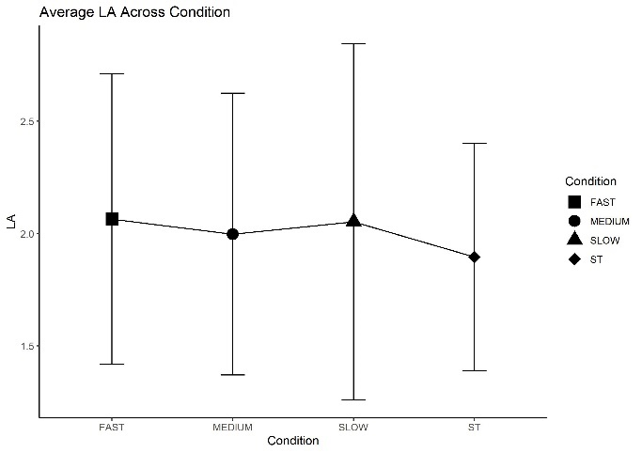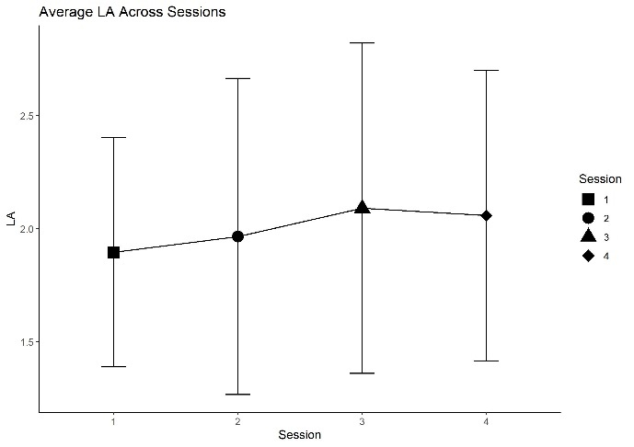
SST
Table S24. Results from ANOVA (Stop-Signal Task)

 | Df | Sum of Squares | Mean Square | F | p-value
Session | 3 | 1984 | 661.5 | 0.486 | 0.693
Condition | 3 | 1599 | 532.9 | 0.391 | 0.76
Session * Condition | 4 | 8485 | 2121.3 | 1.571 | 0.187

Figure S3. Descriptive plots
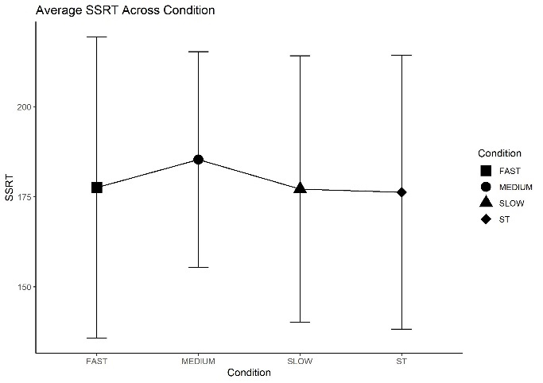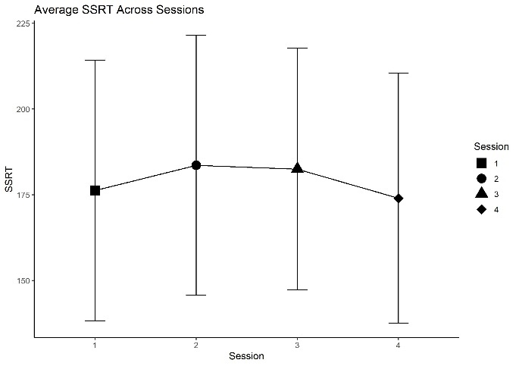

- CORRELATION ANALYSIS
To assess whether a linear relationship could occur between the decrease/increase of the motor performance and the concurrent increase/decrease of cognitive performance a Pearson correlation analysis was computed to measure the direction of this effect for SST and LA.

Table S25. Correlation results for DTE at medium speed for SST and DTE at medium speed for motor variables

Variable | Correlation | P_Value
Cadence | 0.393 | 0.039 *
Stride Length | -0.39 | 0.04 *
Gait Cycle Length | -0.13 | 0.51
Gait Cycle Time | -0.411 | 0.03 *
Single Stance Phase | 0.045 | 0.821
Stance Phase | -0.046 | 0.816
Swing Phase | 0.055 | 0.781
Step Left | 0.115 | 0.561
Step Right | -0.103 | 0.6

Table S26. Correlation results for DTE at medium speed for LA and DTE at medium speed for motor variables

Variable | Correlation | P_Value
Cadence | -0.05 | 0.783
Stride Length | 0.044 | 0.806
Gait Cycle Length | 0.423 | 0.014 *
Gait Cycle Time | 0.054 | 0.765
Single Stance Phase | 0.146 | 0.417
Stance Phase | -0.164 | 0.363
Swing Phase | 0.053 | 0.395
Step Left | 0.096 | 0.596
Step Right | -0.096 | 0.597

