Users’ experiences of park accessibility and attractiveness based on online review analytics
Abdelbaseer A. Mohamed^{1,2}
Jakub Kronenberg^{1,3}
1, Social-Ecological Systems Analysis Lab, University of Lodz
2 Urban Planning Department, Faculty of Engineering, Al-Azhar University
3 Department of Geography, University of Cambridge
Supplementary Material

Data Analysis and visualization

Content analysis
To prepare the data for analysis, our preprocessing steps involved several tasks. We removed duplicates, stop words (e.g., “I,” “the”), numbers, special characters, and extra spaces. We converted all text to lowercase, lemmatized words to their base forms (e.g., “enjoyed” to “enjoy”), and tokenized the text into single words (unigrams) such as “park,” “entry,” or “clean.” Additionally, we identified meaningful word pairs (bigrams) like “ticket price” or “needs attention,” which provide greater context by linking related terms. In other words, this process helped detect notable two-word phrases. Then, we identified the most frequent unigrams across all parks and within each individual park. We normalized the frequencies by the total word count in each park to enable comparison. To measure the diversity of vocabulary used to describe experiences, we applied Simpson’s λ Index, treating unigrams as features and their frequencies as abundance measures. We also evaluated whether users used similar language across different parks by calculating the correlation of unigram frequencies between parks using Spearman’s rank test, focusing on unigrams that appeared at least once in all parks. Using Sentence-BERT ¹, we computed the cosine similarity between sentence embeddings of reviews from different parks and visualized the results with word clouds to compare Google reviews across eight parks.
Then, we used the R-based topicmodels library to uncover themes. We counted word occurrences using a bag-of-words model and applied TF-IDF (Term Frequency-Inverse Document Frequency) to weigh word importance. This approach reduced the influence of common terms like “park” or “good.” The resulting TF-IDF matrix served as the input for Latent Dirichlet Allocation (LDA) topic modeling ².
To identify the optimal number of topics, we used the FindTopicNumber function from the R-based ldatuning library. This function evaluates metrics such as coherence ^{3,4} and uniqueness ^{5,6}. Coherence measures the relatedness of words within a topic, while uniqueness evaluates the separation between topics. We determined the optimal number of topics by maximizing coherence and minimizing uniqueness. We also considered model perplexity, which measures how well the LDA model fits the data by evaluating the average certainty the model provides for each keyword. A lower perplexity score indicates a better model fit, resulting in more meaningful and interpretable topics. Frequently occurring unigrams and bigrams shaped the topics, with overlaps revealing thematic similarities such as park cleanliness, pricing, or family-friendliness.

Sentiment analysis
We employed the NRC Word-Emotion Lexicon ⁷ to explore emotions and opinions related to park visitation experiences. We classified the textual data based on a predefined dictionary of English words annotated with sentiment polarity (positive, negative, or neutral) and eight basic emotions: anger, fear, anticipation, trust, surprise, sadness, joy, and disgust. We applied the syuzhet R package ⁸ to calculate sentiment scores and emotional values for each review by summing the occurrences of relevant words.
For each review, we calculated sentiment polarity as follows: scores > 0 indicated positive sentiment (e.g., “affordable entry fee,” “great facilities”), < 0 negative sentiment (e.g., “expensive,” “poor maintenance”), and =0 neutral sentiment. Emotion scores were derived from words linked to specific emotions. For instance, reviews like “I loved the park’s atmosphere” would contribute to joy, while “I feel frustrated by the crowded areas” would reflect anger. We excluded words not in the lexicon, such as brand names or irrelevant terms.
We averaged sentiment and emotion values across parks. We also used the Kruskal-Wallis and Tukey post hoc tests to examine whether users perceived park accessibility and attractiveness differently, identifying stronger sentimental responses in certain parks.
To ensure accuracy, we manually annotated a random sample of 400 reviews (about 5% of the dataset) into positive, neutral, and negative categories. We then compared the manual annotations with the automated predictions using the F1-score, which combines precision (i.e., correct predictions within a class) and recall (i.e., correctly identified reviews from the total in a class) ⁹. Finally, we used the Chi-square (χ2) test to assess differences in sentiment and emotion proportions across parks compared to overall averages. This approach highlighted variations in user experiences and emotions related to park visitation experiences in Cairo.

Controversy, complaint, and dissatisfaction indices
Analyzing park visitation experiences in terms of accessibility and attractiveness involves comparing negative and positive feedback on various aspects of parks, treating each aspect as a topic. Sentiment labels apply to the words associated with each topic, producing three indices: controversy, complaint, and dissatisfaction ¹⁰. These indices help identify and emphasize key concerns raised by park users.
Controversy measures how frequently users discuss a topic, reflecting its prominence in their reviews. A high controversy score indicates that users frequently mention topics such as park cleanliness, entry fees, or amenities. As mentioned earlier, the process uses LDA topic modeling to extract n topics, each comprising m keywords. For a topic $t_{i}$, the keyword set is $k_{i}$= {$k_{1}^{i}$, $k_{2}^{i}$, ..., $k_{m}^{i}$}, and $c_{i}$ represents the total frequency of its keywords. The calculation for the controversy score $Controversy_{i}$ follows this formula:
$\begin{aligned}Controversy_{i}= s\left(\frac{\left(c_{i}- μ_{f}\right)}{σ_{f}}\right), s\left(x\right)= \frac{1}{1 + e^{-x}}\end{aligned}$ (1)
Where $μ_{f}$ and $σ_{f}$ represent the mean and standard deviation of all keyword frequencies {$c_{1}$, $c_{2}$, ..., $c_{n}$}. The sigmoid function $s\left(x\right)$ standardizes the frequencies, ensuring extreme values do not dominate the results.
Complaint assesses the severity of negative sentiments tied to specific topics, such as overpriced tickets, limited accessibility, or the impact of commercialization on park appeal. This metric measures how keywords co-occur with sentiment words. Positive co-occurrence ($p_{i}$) indicates how often topic keywords appear alongside positive words $W_{P}$, while negative co-occurrence ($n_{i}$) captures their association with negative words $W_{n}$. The calculation for the negative bias $b_{i}$ of a topic is:
$$b_{i}=\frac{n_{i}}{p_{i}}$$
The standardization of $b_{i}$ determines the complaint score $Complaint_{i}$:
$Complaint_{i}=s\left(\frac{\left(b_{i}- μ_{b}\right)}{σ_{b}}\right)$ (2)
Here, $μ_{b}$ and $σ_{b}$ denote the mean and standard deviation of all biases {$b_{1}$, $b_{2}$, ..., $b_{n}$}. Topics with high complaint scores indicate areas where users express strong dissatisfaction.
Dissatisfaction combines controversy and complaint to quantify the overall level of negative evaluations. Topics with high dissatisfaction scores, such as concerns about commercialization limiting public access or exclusive privatized areas, demand immediate attention. The calculation for the dissatisfaction score Dissatisfaction_i is:
$Dissatisfaction_{i}= Controversy_{i}× Complaint_{i}$ (3)
This metric highlights topics that users discuss frequently and criticize strongly.
To prioritize concerns, the analysis visualizes topics in a controversy-complaint quadrant. This plotting approach enables decision-makers to identify frequently discussed and highly criticized aspects, such as accessibility, affordability, or attractiveness. By using this structured method, park authorities can effectively address user concerns and balance commercialization with inclusivity and appeal ¹⁰.

Statistical models
We used a two-step analysis to examine the factors that influence park visitation sentiment.

Step 1: Robust regression model
Initially, we found that the residuals from the initial regression model were neither normally distributed nor independent (Kolmogorov-Smirnov statistic = 0.12, p-value < .001; Durbin–Watson statistic = 2.04). Therefore, we applied a robust regression model to reduce the impact of outliers and heteroskedasticity. This model evaluated how accessibility costs, commercial installations, landscape elements, and park attractiveness influenced overall sentiment scores (4):
$S_{c}= β_{0}+ \sum_{\left\{K=1\right\}}^{K}{\begin{aligned}β_{K} X_{KC}\end{aligned}} + ε_{c}$ (4)
Where $S_{c}$is the sentiment score for park visitation in city c, and $X_{KC}$is the independent variable k in city c, β_{k}​ are the model coefficients, β₀ is the intercept, and $ε_{c}$ is the random error term.

Step 2: Random forest regressor
To account for nonlinear relationships and identify variable importance,, we applied a Random Forest (RF) regressor, a supervised machine learning technique. The RF model helps estimate the relative importance of each explanatory variable on sentiment scores ¹¹. This tree-based ensemble approach builds multiple decision trees and combines their predictions to generate the final output ¹². Each decision tree is created by recursively splitting the data based on feature values, and the terminal nodes represent the predicted values of the response variable. Through bootstrapping—sampling with replacement—the RF model mitigates overfitting, unlike a single decision tree model. Each tree uses a random subset of features, which further reduces variance and improves robustness.
For regression tasks, the RF model generates predictions by averaging the outputs of all decision trees. The regression output can be calculated as follows:
$S_{c}^{\begin{aligned}^\end{aligned}}= \left(\frac{1}{M}\right) \sum_{\left\{m=1\right\}}^{\left\{M\right\}}{\begin{aligned}T^{\left\{\left(m\right)\right\}} \left(X_{c}\right)\end{aligned}}$ (5)
Where $S_{c}^{\begin{aligned}^\end{aligned}}$represents the predicted sentiment score, M denotes the number of decision trees, and $T^{\left\{\left(m\right)\right\}} \left(X_{c}\right)$is the prediction from each individual tree. The importance of each variable is determined by measuring changes in prediction accuracy or impurity when variables are permuted.

RF model tuning and evaluation
In this study, we implemented the RF regression model using the scikit-learn library in Python 3 (Pedregosa et al., 2011). We log-transformed the sentiment score for park visitation before fitting the model. We used the Optuna package ¹³ for hyperparameter optimization, which efficiently searches for optimal hyperparameters while minimizing computational costs. The hyperparameters optimized include the number of decision trees (n_{estimators}​), the number of features considered for each split (max_{features}​), the minimum number of samples required to split a node (min_{samples_split}​), the minimum number of samples for a leaf node (min _{samples_leaf}​), and the maximum depth of the trees (max_{depth​}).
To prevent overfitting and ensure model robustness, we used a 10-fold cross-validation procedure. This method splits the data into ten subsamples, training the model ten times with different combinations of nine training sets and one validation set per iteration. We evaluated model performance using the root mean square error (RMSE) to reduce prediction error. After 800 trials in Optuna, we determined the optimal hyperparameter values, yielding a final model with the best cross-validation score = 0.29, RMSE = 4.48, Mean Absolute Error (MAE) = 3.40, and R² = 0.39. Supplementary Figure S1 provides the scatterplot of predicted versus true values, along with the tuning curves. Additionally, Supplementary Table S2 shows the value ranges and the final parameter combination selected for the RF model in this study. Hyperparameter tuning resulted in a stable model with interpretable feature importance scores, which were further analyzed using SHAP values.

Variable importance: SHAP analysis
To further examine the contribution of each explanatory variable, we utilized Shapley Additive Explanations (SHAP) to explore the relative importance and marginal effects of accessibility and attractiveness variables on park visitation experiences. SHAP calculates the Shapley value for each feature, quantifying its contribution to predicting a given instance x ¹⁴. The Shapley value for feature $k$ is measured as follows:
$ϕ_{k}= \sum_{\begin{aligned}\left\{S ⊆N ∖\{k\}\right\} \end{aligned}}{\begin{aligned}\frac{∣S∣!(∣N∣-∣S∣-1)!​}{∣N∣!}\left.\left[ f_{\left\{S ∪\{k\}\right\}\left(x_{\left\{S ∪\{k\}\right\}}\right)}- f_{S\left(x_{S}\right)}\right.\right]\end{aligned}}$(6)
Where $f_{(S)}$ is the output of the RF model, S denotes a subset of features (in this case, park attributes), and N is the full set of features. A key feature of SHAP is its additive nature, which provides a clear breakdown of the contribution of each feature to the sentiment score. The Shapley value for feature k, denoted $ϕ_{k}$​, is the average of its contributions across all permutations of the feature set. This additive property allows each feature to be sequentially added to the model, and the change in the model output reflects its importance. Specifically, SHAP calculates the output for sample j as:
$f\left(x^{(j)}\right)= ϕ_{0}+ \sum_{k=0}^{i}{ϕ_{\begin{aligned}k\left({x_{k}}^{\left(j\right)}\right)\end{aligned}}}$ (7)
Where i is the number of input features, ϕ₀​ is the baseline value when all inputs are missing, and ϕ_{k}​(x_{k,j​}) represents the contribution of feature k to the prediction for sample j. If $ϕ_{\begin{aligned}k\left({x_{k}}^{\left(j\right)}\right)\end{aligned}}$ > 0, the feature has a positive influence on the predicted value; conversely, if $ϕ_{\begin{aligned}k\left({x_{k}}^{\left(j\right)}\right)\end{aligned}}$ < 0, the feature has a negative influence on the predicted value. Using the SHAP Python package, we computed the RF model output and SHAP values ¹⁴.
Table S1. Descriptive statistics of the analyzed reviews.
Park Name | Review count | Average review length | SD review_length
Al Horreya Park | 738 | 10.77 | 5.56
Al-Azhar Park | 1,074 | 11.54 | 6.07
Aquarium Grotto Park | 458 | 11.77 | 6.06
Child’s Park | 690 | 9.83 | 5.10
Family Park | 1,030 | 10.59 | 5.60
Merryland Park | 1,069 | 11.15 | 5.73
Safari Park | 676 | 10.62 | 6.06
International Park | 793 | 10.18 | 5.55
Total Reviews | 6,528 | 10.81 | 5.72
Note: SD=Standard Deviation.

Table S2. Hyperparameter summary.
Hyperparameter | Value Range | Optimal Value
n_estimators | [100, 200, 300, 400, 500, 800] | 800
max_depth | [None, 10, 20, 30, 40, 50] | 20
min_samples_split | [2, 5, 10] | 2
min_samples_leaf | [1, 2, 4] | 2
bootstrap | [True, False] | True

Table S3. Top 10 bigrams occurring in Google reviews across the parks.
Al Horreya Park | Al-Azhar Park | Aquarium Grotto | Child’s Park | Family Park | Merryland Park | Safari Park | International Park
beautiful quiet | beautiful view | need attention | restaurant cafe | suitable family | food drink | child adult | green space
suitable family | green space | fish tank | suitable child | green space | cafe restaurant | amusement park | need attention
ticket price | suitable family | beautiful need | suitable family | family child | suitable family | green space | suitable family
quiet beautiful | beautiful place | ticket price | cafe restaurant | nice family | restaurant cafe | suitable family | amusement park
need attention | recommend visiting | five pound | green space | entrance ticket | dancing fountain | suitable child | suitable child
opera house | ticket price | recommend visiting | need attention | child adult | green space | reasonable price | good family
nice family | beautiful wonderful | quiet beautiful | many restaurant | family outing | beautiful clean | amusement child | attention cleanliness
entrance ticket | family outing | need maintenance | family child | beautiful family | forbidden enter | ticket price | beautiful suitable
ticket pound | beautiful clean | ticket pound | ticket price | suitable child | beautiful family | game child | family outing
beautiful family | worth visit | worth visit | nice family | good family | entrance ticket | good family | green area

Table S4. The top 20 most frequent words in each topic in the corpus.
Topic 1 | Topic 2 | Topic 3 | Topic 4
excellent | child | price | tree
attention | time | expensive | restaurant
clean | day | food | fish
great | game | game | sit
crowd | family | pound | nice
service | visit | ticket | walk
development | enjoy | bad | cafe
toilet | wonderful | service | green
lack | fun | inside | lake
renovation | activity | entry | clean
space | experience | restaurant | quiet
good | excellent | pay | people
wonderful | crowd | family | drink
neglect | make | small | small
people | animal | cafe | beautiful
care | view | child | water
location | play | time | view
suitable | large | amusement_park | cafeteria
cafe | green | cafeteria | food
restaurant | big | activity | bad

Table S5. Tukey multiple comparisons of average sentiment scores across parks.
Group 1 | Group 2 | Mean Difference | p-Adjusted | Lower | Upper
Al Horreya Park | Al-Azhar Park | 0.1316 | 0* | 0.0757 | 0.1875
Al Horreya Park | Aquarium Grotto | -0.1479 | 0* | -0.2174 | -0.0784
Al Horreya Park | Child’s Park | -0.0575 | 0.091 | -0.1194 | 0.0044
Al Horreya Park | Family Park | 0.0093 | 0.9997 | -0.0471 | 0.0656
Al Horreya Park | Merryland Park | -0.0586 | 0.0323* | -0.1146 | -0.0027
Al Horreya Park | Safari Park | -0.0038 | 1 | -0.066 | 0.0585
Al Horreya Park | International Park | -0.0518 | 0.1465 | -0.1116 | 0.008
Al-Azhar Park | Aquarium Grotto | -0.2795 | 0* | -0.3448 | -0.2143
Al-Azhar Park | Child’s Park | -0.1892 | 0* | -0.2462 | -0.1321
Al-Azhar Park | Family Park | -0.1224 | 0* | -0.1734 | -0.0714
Al-Azhar Park | Merryland Park | -0.1903 | 0* | -0.2408 | -0.1397
Al-Azhar Park | Safari Park | -0.1354 | 0* | -0.1928 | -0.078
Al-Azhar Park | International Park | -0.1834 | 0* | -0.2382 | -0.1287
Aquarium Grotto | Child’s Park | 0.0904 | 0.0026** | 0.0199 | 0.1609
Aquarium Grotto | Family Park | 0.1572 | 0* | 0.0915 | 0.2228
Aquarium Grotto | Merryland Park | 0.0893 | 0.0009*** | 0.024 | 0.1546
Aquarium Grotto | Safari Park | 0.1441 | 0* | 0.0734 | 0.2149
Aquarium Grotto | International Park | 0.0961 | 0.0006*** | 0.0275 | 0.1647
Child’s Park | Family Park | 0.0668 | 0.0103* | 0.0093 | 0.1243
Child’s Park | Merryland Park | -0.0011 | 1 | -0.0582 | 0.056
Child’s Park | Safari Park | 0.0537 | 0.165 | -0.0095 | 0.117
Child’s Park | International Park | 0.0057 | 1 | -0.0551 | 0.0666
Family Park | Merryland Park | -0.0679 | 0.0014** | -0.1189 | -0.0168
Family Park | Safari Park | -0.013 | 0.9975 | -0.0709 | 0.0448
Family Park | International Park | -0.0611 | 0.0184* | -0.1163 | -0.0058
Merryland Park | Safari Park | 0.0548 | 0.0739 | -0.0026 | 0.1123
Merryland Park | International Park | 0.0068 | 0.9999 | -0.048 | 0.0616
Safari Park | International Park | -0.048 | 0.2516 | -0.1092 | 0.0132
Notes: “Difference” indicates differences between the means of the respective two groups. “Lower” and “upper” indicate the endpoint of the confidence interval at 95%. * p-adjusted < 0.05; ** p-adjusted < 0.01; *** p-adjusted < 0.001.

Table S6. Robust multiple regression profiles of sentiment values regarding commercial installations and landscape elements.
Variable | sCoef. | Std. Error | z | P>|z| | 95% Conf. Interval Lower | 95% Conf. Interval Upper
Const. | 4.2825 | 0.062 | 68.619 | 0.000 | 4.16 | 4.405
Location | 2.2414 | 0.461 | 4.865 | 0.000 | 1.338 | 3.144
Price | 0.355 | 0.177 | 2.011 | 0.044 | 0.009 | 0.701
Expensive | -1.1192 | 0.247 | -4.527 | 0.000 | -1.604 | -0.635
Pay | 6.2682 | 0.515 | 12.182 | 0.000 | 5.26 | 7.277
Entry | 1.3558 | 0.335 | 4.042 | 0.000 | 0.698 | 2.013
Ticket | 0.1829 | 0.208 | 0.88 | 0.379 | -0.224 | 0.59
Activity | 0.9199 | 0.37 | 2.488 | 0.013 | 0.195 | 1.645
Time | 3.0148 | 0.24 | 12.576 | 0.000 | 2.545 | 3.485
Game | 1.6862 | 0.179 | 9.401 | 0.000 | 1.335 | 2.038
Cafeteria | 1.6973 | 0.407 | 4.167 | 0.000 | 0.899 | 2.496
Restaurant | 0.4452 | 0.231 | 1.929 | 0.054 | -0.007 | 0.897
Cafe | 1.5494 | 0.271 | 5.725 | 0.000 | 1.019 | 2.08
Food | 4.2505 | 0.214 | 19.877 | 0.000 | 3.831 | 4.67
Toilet | 3.9888 | 0.312 | 12.796 | 0.000 | 3.378 | 4.6
Service | 0.7365 | 0.263 | 2.796 | 0.005 | 0.22 | 1.253
Clean | 3.8477 | 0.177 | 21.747 | 0.000 | 3.501 | 4.195
Green | 4.6838 | 0.223 | 20.999 | 0.000 | 4.247 | 5.121
Tree | 8.9125 | 0.317 | 28.127 | 0.000 | 8.291 | 9.534
Lake | 1.6603 | 0.424 | 3.915 | 0.000 | 0.829 | 2.491
Water | 1.0253 | 0.396 | 2.591 | 0.01 | 0.25 | 1.801
View | 0.7158 | 0.296 | 2.417 | 0.016 | 0.135 | 1.296
Fish | 1.2817 | 0.278 | 4.611 | 0.000 | 0.737 | 1.827
Animal | 3.1258 | 0.485 | 6.451 | 0.000 | 2.176 | 4.076
Large | 1.2513 | 0.251 | 4.99 | 0.000 | 0.76 | 1.743
Open | 2.0867 | 0.465 | 4.492 | 0.000 | 1.176 | 2.997

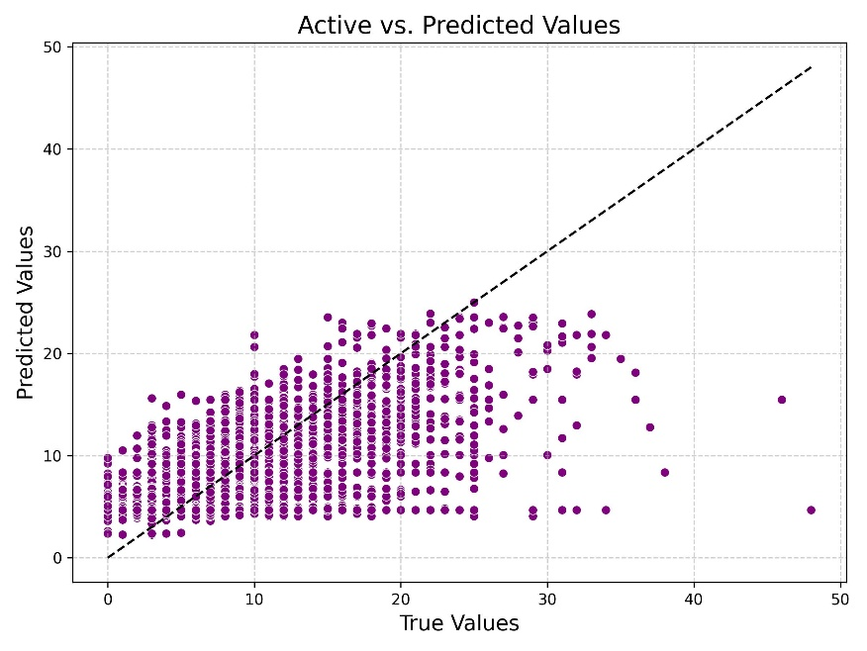
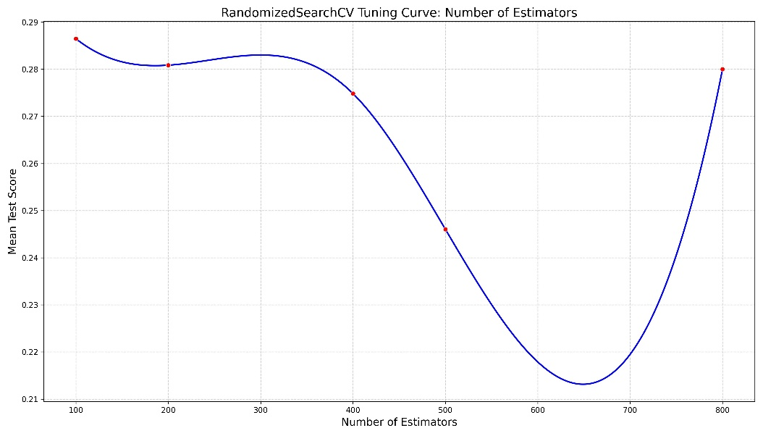
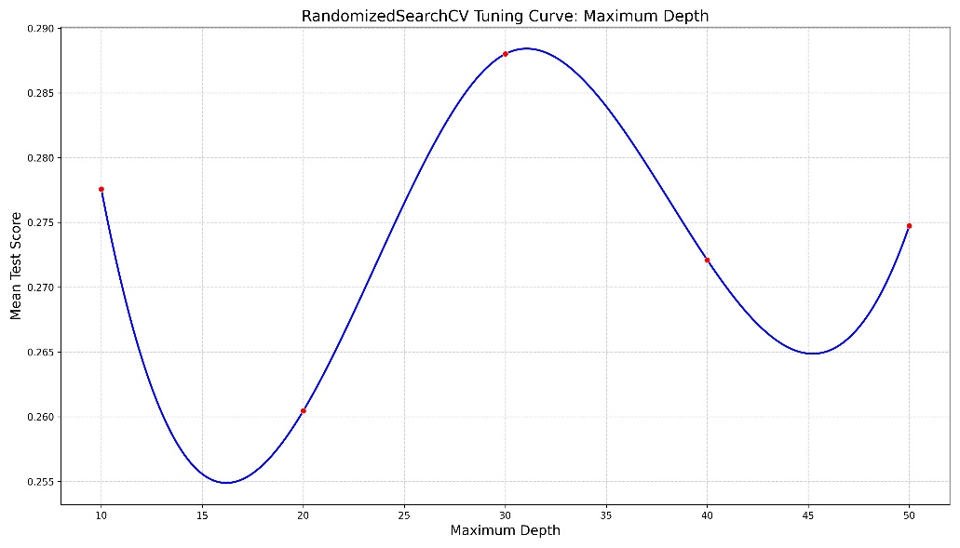
Figure S1. A scatterplot of predicted versus true values (top), and n_estimators (middle) and max_depth (bottom ) tuning curves for the Random Forest model.

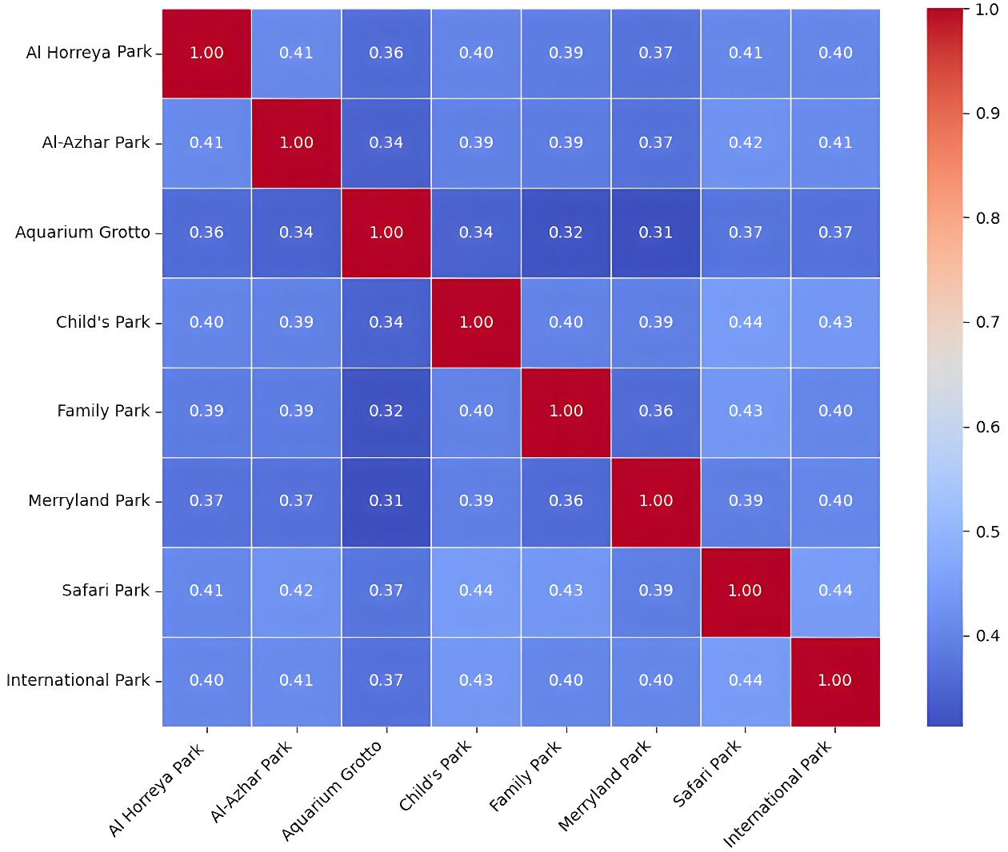
Figure S2. Spearman´s rank correlation matrix of words (frequencies of same vocabularies) used in Google reviews across the parks. All scores are statistically significant at p < 0.001.

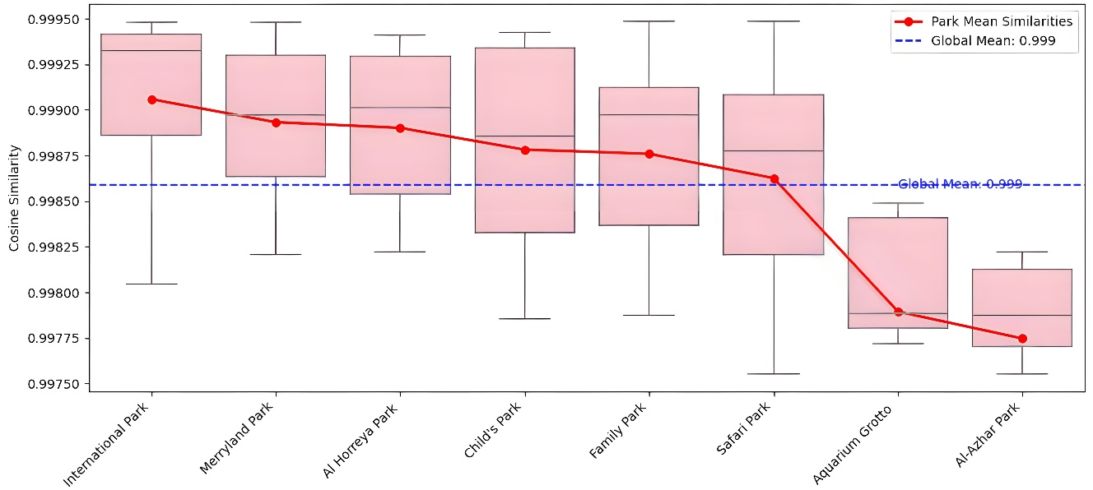
Figure S3. A box plot of cosine similarity between park reviews, sorted by mean similarity. The red line displays the mean similarity score of individual parks.
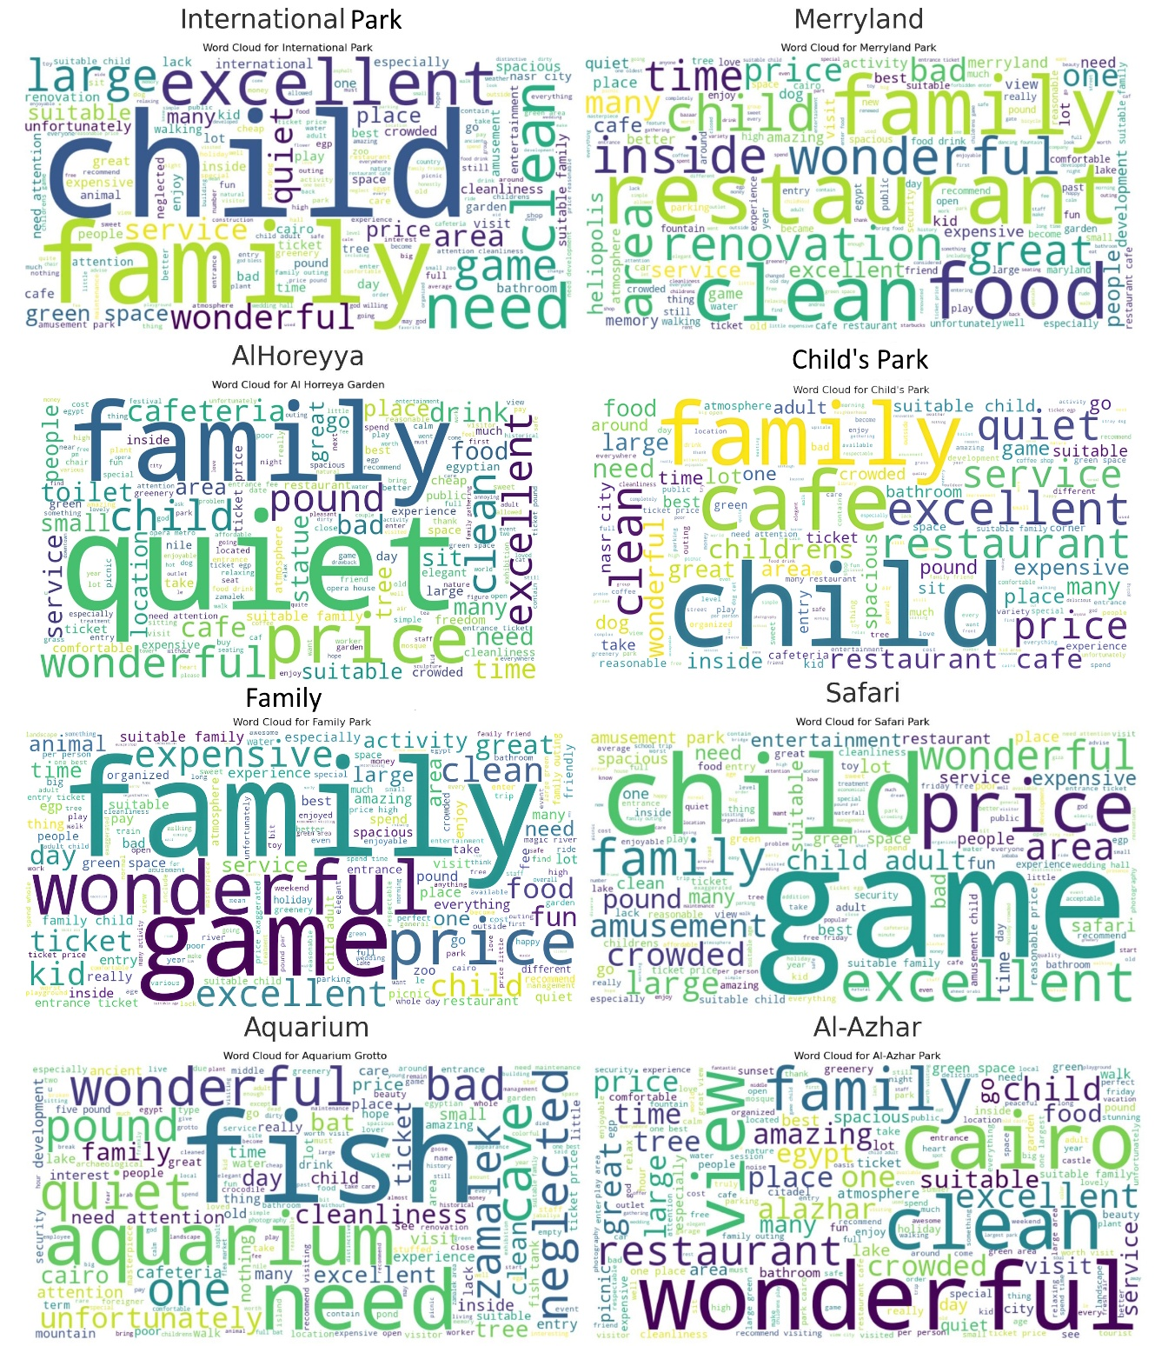
Figure S4. Comparison of word clouds between parks.

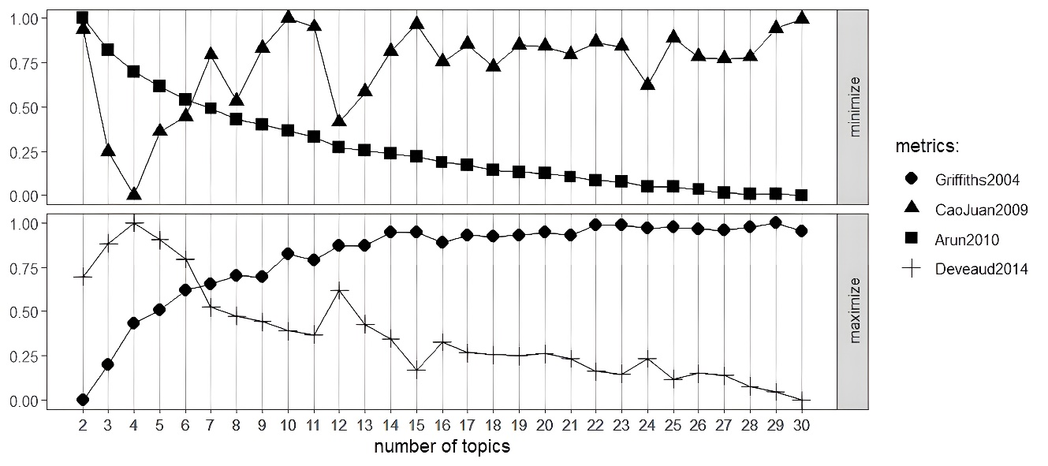
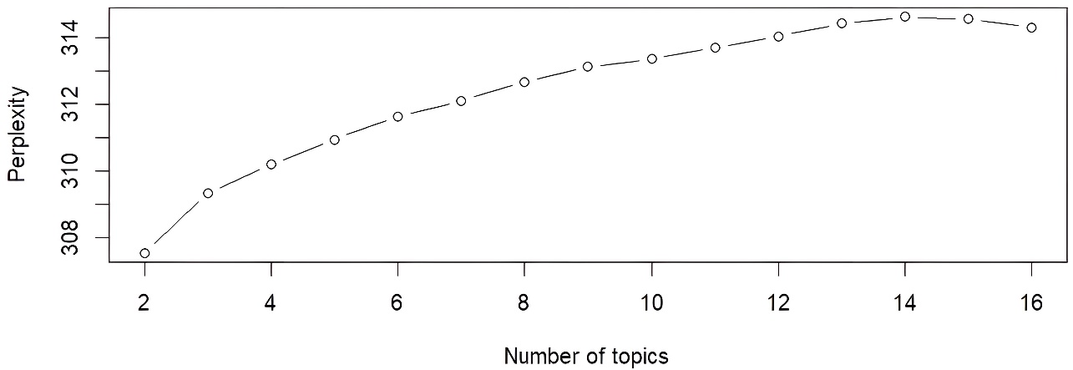
Figure S5. A line graph presenting four model fitness scores of k topics (top) and the Perplexity values for different numbers of the proposed LDA models (bottom).

References
1. Reimers, N. & Gurevych, I. Sentence-BERT: Sentence Embeddings using Siamese BERT-Networks. Preprint at https://doi.org/10.48550/arXiv.1908.10084 (2019).
2. Blei, D. M. Probabilistic topic models. Communications of the ACM 55, 77–84 (2012).
3. Deveaud, R., Sanjuan, E. & Bellot, P. Accurate and effective latent concept modeling for Ad Hoc information retrieval. Document numérique - Revue des sciences et technologies de l’information. Série Document numérique 61–84 (2014) doi:10.3166/DN.17.1.61-84.
4. Griffiths, T. L. & Steyvers, M. Finding scientific topics. Proc. Natl. Acad. Sci. U.S.A. 101, 5228–5235 (2004).
5. Arun, R., Suresh, V., Veni Madhavan, C. E. & Narasimha Murthy, M. N. On finding the natural number of topics with Latent Dirichlet Allocation: Some observations. in Advances in Knowledge Discovery and Data Mining (eds. Zaki, M. J., Yu, J. X., Ravindran, B. & Pudi, V.) vol. 6118 391–402 (Springer Berlin Heidelberg, Berlin, Heidelberg, 2010).
6. Cao, J., Xia, T., Li, J., Zhang, Y. & Tang, S. A density-based method for adaptive LDA model selection. Neurocomputing 72, 1775–1781 (2009).
7. Mohammad, S. M. & Turney, P. D. NRC Emotion Lexicon. National Research Council, Canada 2, 234 (2013).
8. Jockers, M. L. mjockers/syuzhet. (2024).
9. Ribeiro, F. N., Araújo, M., Gonçalves, P., André Gonçalves, M. & Benevenuto, F. SentiBench - a benchmark comparison of state-of-the-practice sentiment analysis methods. EPJ Data Sci. 5, 1–29 (2016).
10. Park, S., Cho, J., Park, K. & Shin, H. Customer sentiment analysis with more sensibility. Engineering Applications of Artificial Intelligence 104, 104356 (2021).
11. Xiao, Z., Zhang, C., Li, Y. & Chen, Y. Community park visits determined by the interactions between built environment attributes: An explainable machine learning method. Applied Geography 172, 103423 (2024).
12. Breiman, L. Random forests. Machine Learning 45, 5–32 (2001).
13. Akiba, T., Sano, S., Yanase, T., Ohta, T. & Koyama, M. Optuna: A Next-generation hyperparameter optimization framework. in Proceedings of the 25th ACM SIGKDD International Conference on Knowledge Discovery & Data Mining 2623–2631 (Association for Computing Machinery, New York, NY, USA, 2019). doi:10.1145/3292500.3330701.
14. Lundberg, S. M., Erion, G. G. & Lee, S.-I. Consistent individualized feature attribution for tree ensembles. Preprint at https://doi.org/10.48550/arXiv.1802.03888 (2019).

