Supplementary Material

Supplementary Table S1 Description of included variables
Variables | Variable symbol | Description of the assignment
All models
Daily admissions for IS | Y₁ | quantitative variable
temp | X₁ | quantitative variable
relahumidity | X₂ | quantitative variable
PM_{2.5}(μm/m³) | X₃ | quantitative variable
PM₁₀(μm/m³) | X₄ | quantitative variable
NO₂(μm/m³) | X₅ | quantitative variable
SO₂(μm/m³) | X₆ | quantitative variable
CO(mg/m3) | X₇ | quantitative variable
O₃(μm/m³) | X₈ | quantitative variable
hospitals | X₁₀ | quantitative variable
DOW | X₁₁ | Monday=1, Tuesday=2, Wednesday=3, Thursday=4, Friday=5, Saturday=6, Sunday (reference)=7
Holiday | X₁₂ | non-statutory holidays (reference)=0, statutory holidays=1
GDP | X₁₃ | quantitative variable
Model b
HW | X₁₄ | Non-heatwave days (reference)=0, heatwave days=1
Model c
HWD | X₁₅ | The 5th and subsequent days of the heatwave (reference)=0, The 1st-2nd day of the heatwave=1, The 3rd-4th days of the heatwave=2
HWT | X₁₆ | The third and subsequent heatwaves (reference)=0, The first heatwave=1, The second heatwave=2
HWRH | X₁₇ | Low RH during heatwaves (<70%, reference)=0, Medium RH during heatwaves (70%-77%)=1, High RH during heatwaves (>77%)=2
HWDTR | X₁₈ | High DTR during heatwaves (≥10℃, reference)=0, Low DTR during heatwaves (<10℃)=1
HWAT | X₁₉ | Low AT during heatwaves (<31℃, reference)=0, High AT during heatwaves (≥31℃)=1

Supplementary Table S2 Daily meteorological factors and air pollutant distribution in 122 district/county, Hunan ,2018-2019
Variables | Mean  (SD) | Min | 25th | 50th | 75th | Max |  | Distribution of heatwave period |  |  | Secondary concentration limits( (24-h/8-h)
 |  |  |  |  |  |  |  | 25th | 50th | 75th | Secondary concentration limits( (24-h/8-h)
Meteorological
Average temperature (℃) | 18.55(9.02) | -5.48 | 11.33 | 19.59 | 26.65 | 33.43 |  | 30.4 | 30.88 | 31.40 | —
Maximum temperature(℃) | 22.36(9.90) | -4.64 | 14.41 | 24.07 | 30.55 | 38.64 |  | 35.45 | 35.82 | 36.25 | —
Minimum temperature(℃) | 14.73(8.57) | -7.57 | 7.81 | 15.31 | 22.77 | 30.08 |  | 25.24 | 25.89 | 26.65 | —
Relative humidity(%) | 79.10(10.52) | 27.97 | 74.31 | 81.08 | 87.44 | 99.99 |  | 72.09 | 75.84 | 79.11 | —
DTR(℃) | 7.65(3.64) | 0.00 | 4.80 | 7.70 | 10.09 | 22.31 |  | 9.20 | 9.93 | 10.67 | —
Air pollutants
PM_{2.5} (μm/m³) | 36.87(22.65) | 1.83 | 21.35 | 31.22 | 46.54 | 945.22 |  | 17.74 | 21.86 | 26.53 | 75
PM₁₀ (μm/m³) | 61.06(33.37) | 6.89 | 38.25 | 52.20 | 75.27 | 363.26 |  | 34.36 | 40.27 | 47.47 | 150
NO₂ (μm/m³) | 20.26(9.95) | 1.61 | 13.11 | 17.75 | 25.09 | 100.32 |  | 10.65 | 13.05 | 15.46 | 80
SO₂ (μm/m³) | 9.73(4.40) | 1.36 | 6.67 | 9.08 | 11.94 | 48.53 |  | 7.25 | 9.36 | 11.29 | 150
CO (mg/m³) | 0.89(0.24) | 0.08 | 0.73 | 0.87 | 1.02 | 2.82 |  | 0.67 | 0.78 | 0.94 | 4.00
O₃ (μm/m³) | 95.20(40.27) | 3.95 | 64.83 | 94.68 | 123.06 | 250.42 |  | 106.02 | 121.85 | 143.21 | 160(8-h)
DTR is diurnal temperature range; PM_{2.5} indicates particulate matter with an aerodynamic diameter of 2.5 μm or less; PM₁₀ indicates particulate matter with an aerodynamic diameter of 10 μm or less; NO₂ indicates nitrogen dioxide; CO indicates carbon monoxide; O₃ indicates ozone; SD is standard deviation, Min is Minimum value, 25th indicates 25th centile, 50th indicates 50th centile, 75th indicates 75th centile, Max is Maximum value.
The secondary concentration limits (24-h/8-h), applicable to residential and commercial areas, are sourced from the "Ambient Air Quality Standards". (GB3095-2012); 24-h means 24-hour average pollutant concentration , 8-h means 8-hour average pollutant concentration .
“—”= there is no secondary concentration limits(24-h/8-h) for the variables.

Supplementary Table S3 The correlation of meteorological factors and air pollutants (r_{s})
Variables | PM_{2.5} | PM₁₀ | SO₂ | CO | NO₂ | O₃ | Average temperature | Maximum temperature | Minimum temperature | Relative humidity | DTR
PM_{2.5} | 1.00
PM₁₀ | 0.90 | 1.00
SO₂ | 0.33 | 0.40 | 1.00
CO | 0.27 | 0.30 | 0.08 | 1.00
NO₂ | 0.60 | 0.57 | 0.50 | 0.22 | 1.00
O₃ | -0.09 | 0.02 | 0.26 | -0.17 | -0.19 | 1.00
Average temperature | -0.50 | -0.41 | 0.07 | -0.21 | -0.54 | 0.64 | 1.00
Maximum temperature | -0.46 | -0.34 | 0.11 | -0.20 | -0.50 | 0.68 | 0.98 | 1.00
Minimum temperature | -0.53 | -0.46 | 0.02 | -0.21 | -0.56 | 0.58 | 0.98 | 0.94 | 1.00
Relative humidity | 0.24 | -0.08 | -0.26 | 0.06 | 0.03 | -0.32 | -0.32 | -0.36 | -0.25 | 1.00
DTR | 0.04 | 0.17 | 0.29 | -0.04 | 0.03 | 0.49 | 0.36 | 0.51 | 0.19 | -0.41 | 1.00
The correlation coefficients in the table are all statistically significant. The test level was α=0.05 (two-sided test).

Supplementary Table S4. RR(95%CI) in ischemic stroke admissions due to heatwaves characteristics in the sensitivity analysis of model c
Model c (the characteristics of heatwave) | RR(95%CI) | Model c (the characteristics of heatwave) | RR (95%CI)
The 1-2 day of heatwave |  | The first heatwave
other covariates: df =4 | 1.07(1.01, 1.13) | other covariates: df =4 | 1.27(1.19, 1.35)
other covariates: df =5 | 1.06(1.01, 1.12) | other covariates: df =5 | 1.27(1.19, 1.36)
The 3-4 day of heatwave |  | The second heatwave
other covariates: df =4 | 1.05(1.02, 1.10) | other covariates: df =4 | 1.24(1.16, 1.32)
other covariates: df =5 | 1.06(1.03, 1.10) | other covariates: df =5 | 1.24(1.17, 1.33)
The >5 day of heatwave |  | The third and subsequent heatwaves
other covariates: df =4 | Reference | other covariates: df =4 | Reference
other covariates: df =5 | Reference | other covariates: df =5 | Reference
Low DTR during heatwaves(＜10℃) |  | Low RH during heatwaves(＜70%)
other covariates: df =4 | 1.08(1.02, 1.14) | other covariates: df =4 | Reference
other covariates: df =5 | 1.07(1.01, 1.14) | other covariates: df =5 | Reference
High DTR during heatwaves(≥10℃) |  | Medium RH during heatwaves(70%-77%)
other covariates: df =4 | Reference | other covariates: df =4 | 1.23(1.16, 1.35)
other covariates: df =5 | Reference | other covariates: df =5 | 1.24(1.15, 1.35)
Low AT during heatwaves (＜31℃) |  | High RH during heatwaves(＞77%)
other covariates: df =4 | Reference | other covariates: df =4 | 1.25(1.16, 1.35)
other covariates: df =5 | Reference | other covariates: df =5 | 1.25(1.16, 1.35)
High AT during heatwaves (≥31℃)
other covariates: df =4 | 1.01(0.94, 1.07)
other covariates: df =5 | 1.01(0.95, 1.06)

Supplementary table S5 Results of the analysis of influencing factors in model a
Variables | b | S_{b} | t value |  | P value
Intercept | -0.062 | 0.082 | -0.759 | 0.447
“DOW” (Reference = Sunday) | -0.062 | 0.082 | -0.759 | 0.448
Tuesday | -0.108 | 0.010 | -11.187 | ＜0.001
Wednesday | -0.126 | 0.010 | -12.811 | ＜0.001
Thursday | -0.144 | 0.010 | -14.588 | ＜0.001
Friday | -0.178 | 0.010 | 17.951 | ＜0.001
Saturday | -0.305 | 0.010 | -29.579 | ＜0.001
Sunday | -0.284 | 0.010 | -27.934 | ＜0.001
holiday ( Reference =Non-statutory holidays ) | -0.134 | 0.012 | -10.720 | ＜0.001
GDP | -0.008 | 7.449×10⁻⁴ | -10.109 | ＜0.001
hospital | 0.001 | 5.942×10⁻⁶ | 96.266 | ＜0.001
ns(meanhumi,3)1 | 0.141 | 0.026 | 5.375 |  | ＜0.001
ns(meanhumi,3)2 | -0.356 | 0.103 | -3.459 |  | ＜0.001
ns(meanhumi,3)3 | -0.268 | 0.025 | -10.851 |  | ＜0.001
ns(PM_{2.5},3)1 | -0.454 | 0.083 | -5.472 |  | ＜0.001
ns(PM_{2.5},3)2 | -0.587 | 0.432 | -1.359 |  | 0.174
ns(PM_{2.5},3)3 | -0.102 | 0.885 | -0.115 |  | 0.909
ns(NO₂,3)1 | 0.745 | 0.031 | 24.343 |  | ＜0.001
ns(NO₂,3)2 | 1.327 | 0.073 | 18.079 |  | ＜0.001
ns(NO₂,3)3 | 0.452 | 0.086 | 5.278 |  | ＜0.001
ns(SO₂,3)1 | -0.092 | 0.027 | -3.413 |  | ＜0.001
ns(SO₂,3)2 | 0.380 | 0.072 | 5.286 |  | ＜0.001
ns(SO₂,3)3 | -0.254 | 0.107 | -2.365 |  | 0.018
ns(CO,3)1 | 0.427 | 0.024 | 17.836 |  | ＜0.001
ns(CO,3)2 | 0.909 | 0.107 | 8.457 |  | ＜0.001
ns(CO,3)3 | 0.245 | 0.100 | 2.445 |  | 0.014
ns(O₃,3)1 | 0.050 | 0.020 | 2.420 |  | 0.016
ns(O₃,3)2 | 0.208 | 0.053 | 3.903 |  | ＜0.001
ns(O₃,3)3 | 0.107 | 0.039 | 2.768 |  | 0.006
b means the parameter coefficient, S_{b} means the standard deviation of the parameter coefficient, t/Wald Z was the test statistic, P value less than 0.05 indicates a statistically significant difference

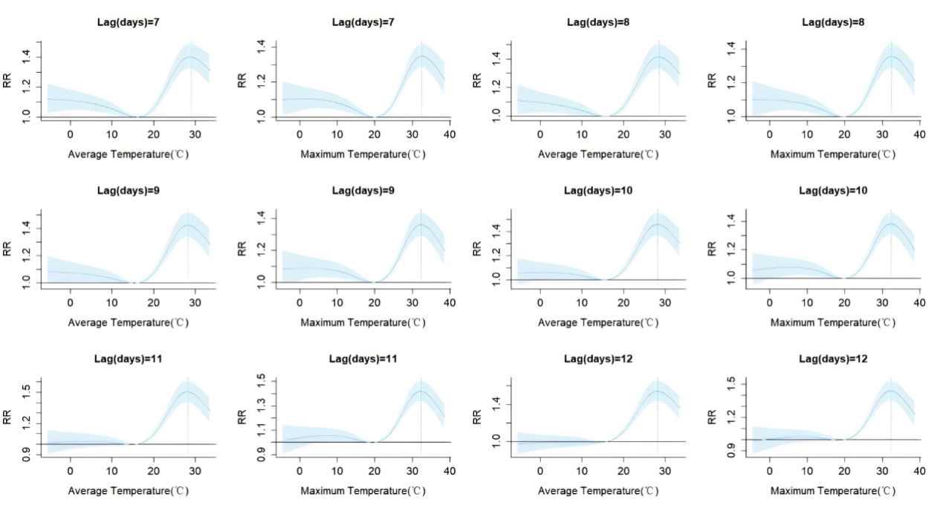
Supplementary Figure S1 Sensitivity analyses of the effects of model a, adjusting the maximum lag days within the range of 7 to 12 days

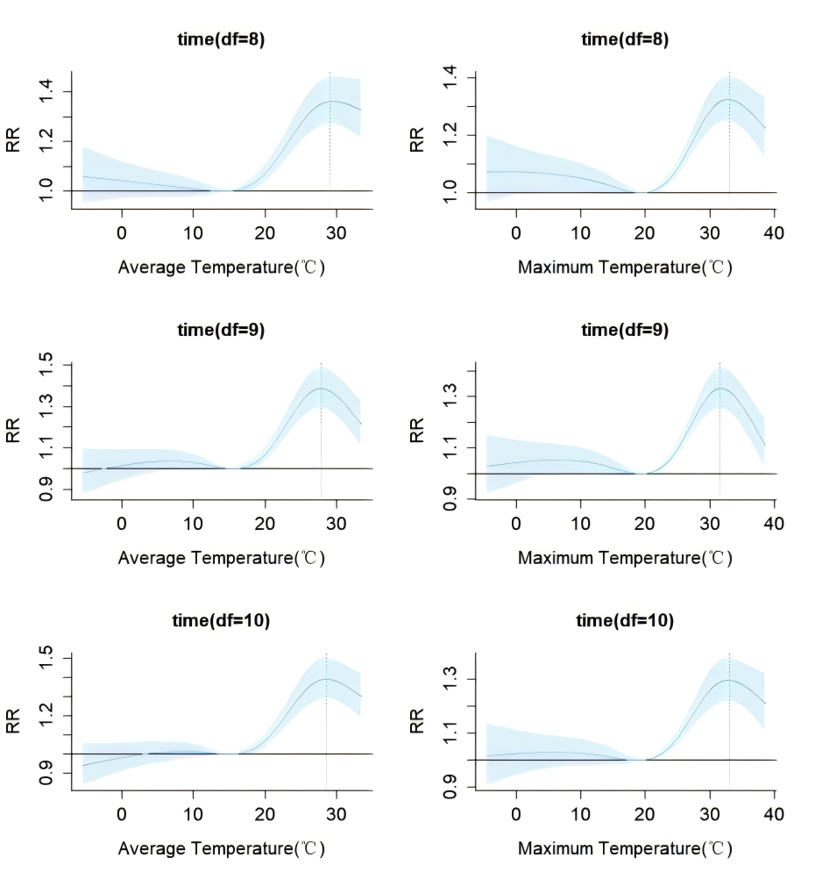
Supplementary Figure S2 Sensitivity analyses of the effects of model a , varying the df of time (ranging from 8 to 10 per year)
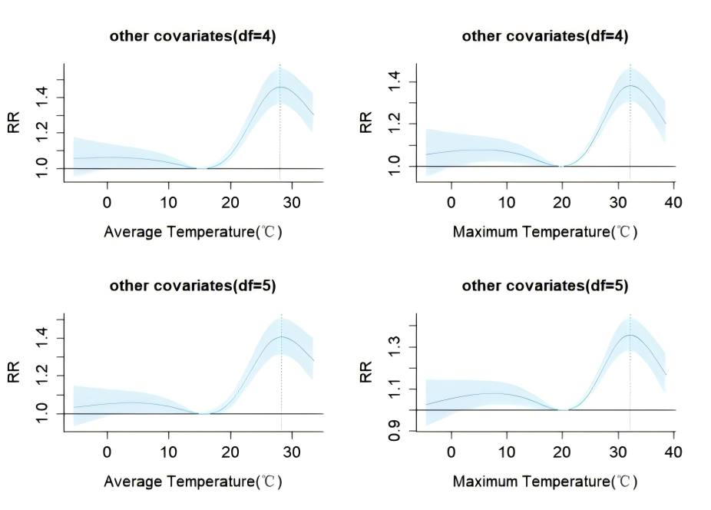
Supplementary Figure S3 Sensitivity analyses of the effects of model a , adjusting the df of other covariates(including: relahumidity, PM_{2.5}, NO₂, SO₂, CO, and O₃) within the range of 4 to 5

