Supplementary Figure 1. The hierarchical-tree clustering of the samples in the training set GSE59867.
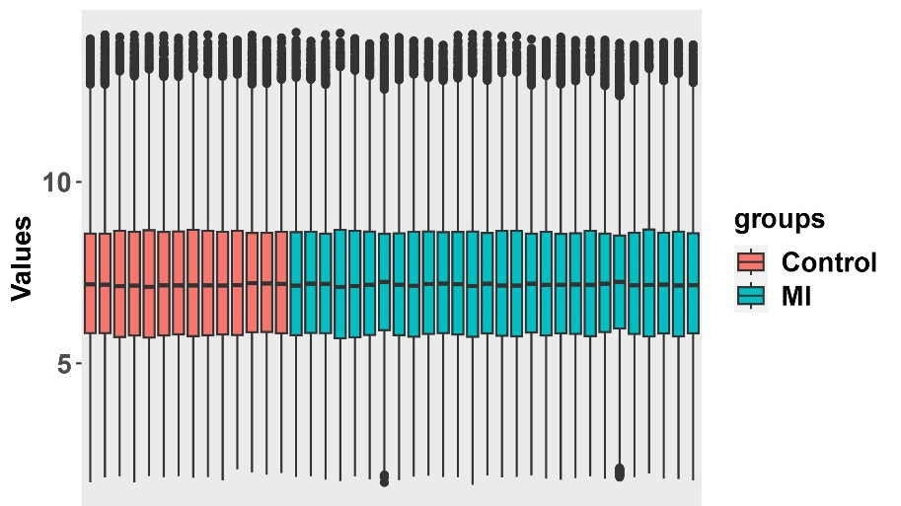
Supplementary Figure 2. The boxplot of the validation set GSE62646 after standardization.

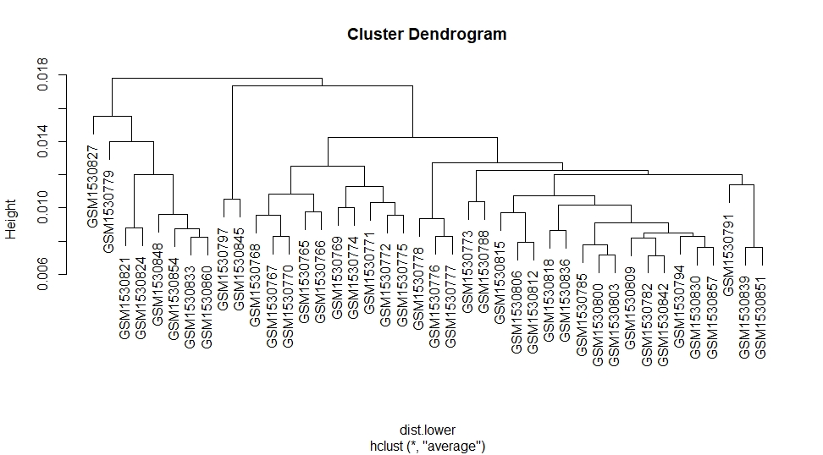

Supplementary Figure 3. The hierarchical-tree clustering of the samples in the validation set GSE62646.

Supplementary Table 1. The baseline characteristics of included patients.
Characteristics | STEMI  (n=16) | Control  (n=8) | P value
Age (years) | 62.7±14.1 | 65.5±11.7 | 0.632
Male (n, %) | 14(87.5) | 6 (75) | 0.578
SBP (mmHg) | 145.2±15.1 | 137.4±18.3 | 0.276
DBP (mmHg) | 68.4±19.2 | 69.5±13.7 | 0.884
Heart rate (bpm) | 74.3±9.9 | 73.8±9.6 | 0.896
Hyperlipidemia, n (%) | 12 (75) | 6 (75) | 1.0
Hypertension, n (%) | 11 (68.75) | 4 (50) | 0.412
Diabetes, n (%) | 7 (43.75) | 3 (37.5) | 1.0
ACEI/ARB, n (%) | 6(37.5) | 1 (12.5) | 0.352
β-blocker, n (%) | 7 (43.75) | 1 (12.5) | 0.189
Asprin/Clopidogrel, n (%) | 12(75) | 5 (62.5) | 0.647
Calcium antagonist, n (%) | 5 (31.25) | 2 (25) | 1.0
Statins, n (%) | 11 (68.75) | 4 (50) | 0.412
WBC (*10^9) | 7.52±1.98 | 6.96±1.71 | 0.503
CRP (mg/dL) | 2.84 (1.17, 4.92) | 0.14 (0.06, 0.96) | 0.003*
cTnT (ng/mL) | 1.47±0.82 | 0.022±0.028 | ＜0.001*
Uric acid (µmol/L) | 37.5.7±94.3 | 395.1±78.4 | 0.622
Creatinine (µmol/L) | 99.24±19.20 | 79.03±10.36 | 0.003*
NT-proBNP (pg/ml) | 1478.5 (1006.5 3276.3) | 317.5 (121.2, 557.0) | 0.001*
IL-6 (pg/ml) | 17.90 (4.11,39.45) | 2.24 (1.42, 3.07) | ＜0.001*
*P<0.05. Data are the mean (SD), n (%), or median (IQR). SBP, systolic blood pressure; DBP, diastolic blood pressure; ACEI, angiotensin-converting enzyme inhibitor; ARB, angiotensinogen receptor blocker; WBC, white blood cell count; CRP, C-reactive protein; cTnT, cardiac troponin-T; NT-proBNP, N-terminal pro-brain natriuretic peptide; IL-6, lnterleukin-6.

Supplementary Table 2. The primers information of genes in this study
Primer name | Base sequence (5 '-3') |  | Product length
AKT3 | sense | ACAGGTAGTATGATGCCTCCAG | 267
AKT3 | antisense | CAAACCACTGCTCAACGAAA | 267
GJC2 | sense | GCCAGGGCAGCTTTCGA | 146
GJC2 | antisense | AAGACCGTCTTTTCAGTAGGG | 146
HMGCL | sense | CTGGAGCCAAGGAAGTAGTCA | 167
HMGCL | antisense | GCAGCCAAGAGCACAGGAG | 167
RBM17 | sense | CAGGCAAAGAGCCAAAGG | 114
RBM17 | antisense | TGCTACATGCGGTGGAGTG | 114
GAPDH | sense | CACCCACTCCTCCACCTTTGA | 188
GAPDH | antisense | TCTCTCTTCCTCTTGTGCTCTTGC | 188

