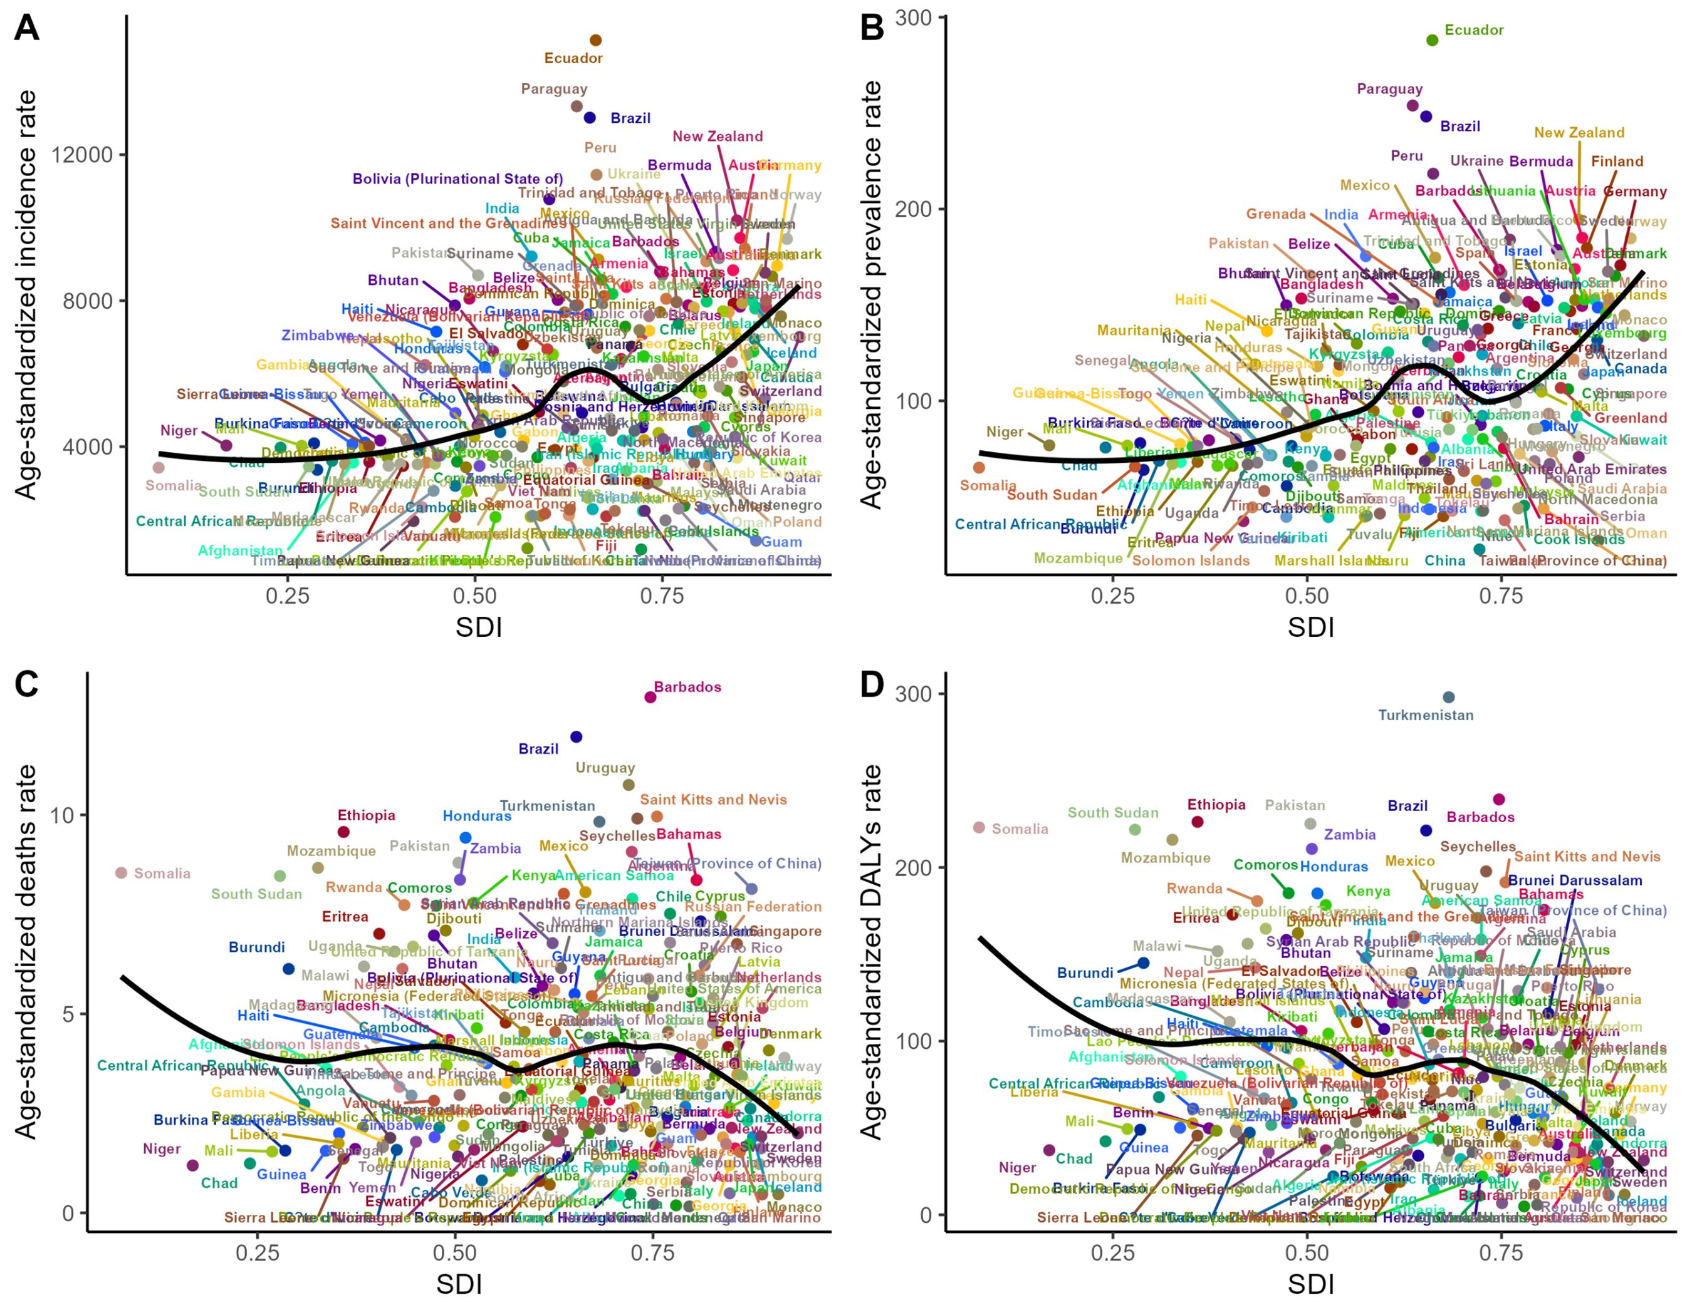 Supplementary Fig. S1: Relationship between the ASRs for urinary tract infections and SDI from 1990 to 2021 in the GBD regions. (A) Age-standardized incidence rates; (B) Age-standardized prevalence rates; (C) Age-standardized deaths rates; (D) Age-standardized DALYs rates.

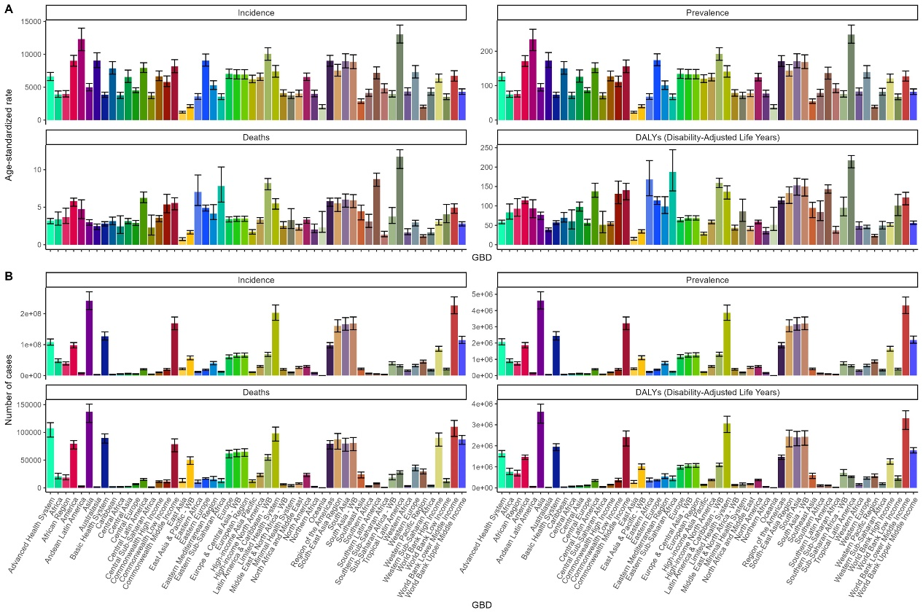 Supplementary Fig. S2: Regional distribution of urinary tract infections burden in 2021. (A) Age-standardized rates of incidence, prevalence, deaths and DALYs. (B) Number of incidence, prevalence, deaths and DALYs.

