Supplementary Material
Integrating Bioinformatics with Experimental Validation Unveils Immunological and Prognostic Significance of PVRIG in Pan-Cancer

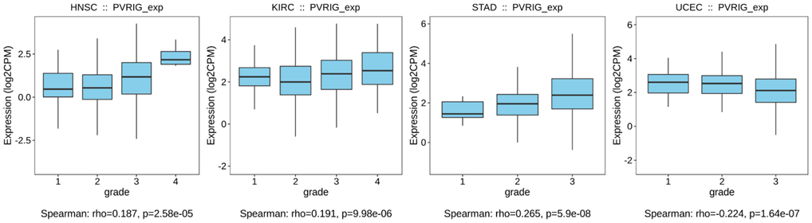
Figure S1. Box plots of correlation between the PVRIG expression level and histological grades of indicated tumor types based on TISIDB database.

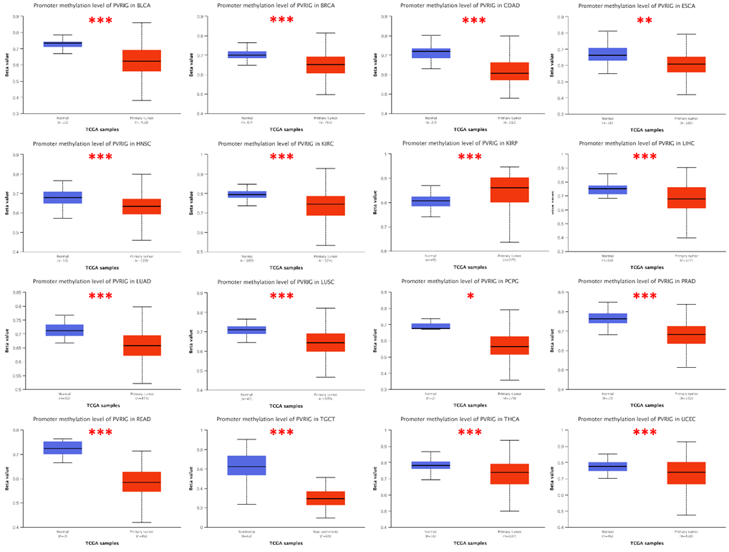
Figure S2. Analysis of PVRIG methylation levels in TCGA pan-cancer based on UALCAN database. *p < 0.05, **p < 0.01, and ***p < 0.001.

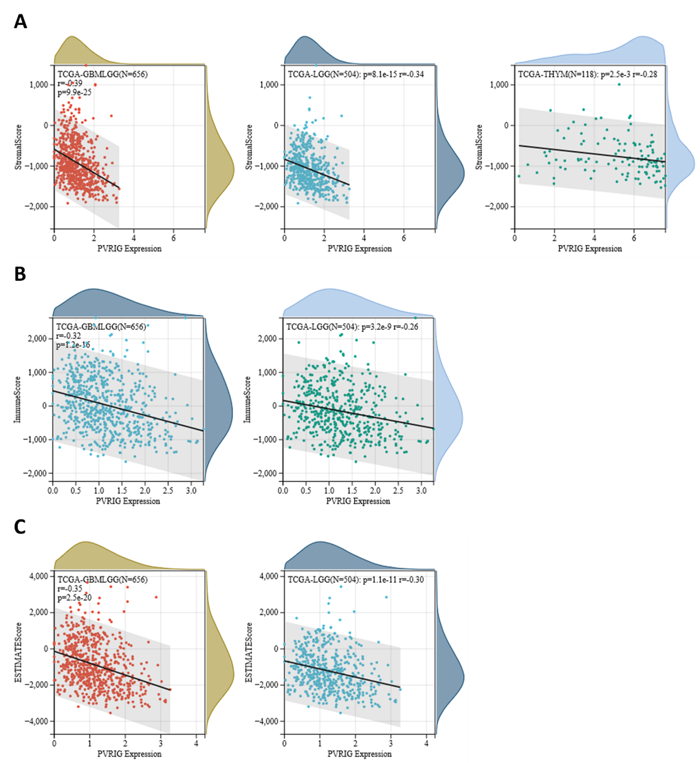
Figure S3. Correlation between PVRIG expression and tumor purity in TCGA pan-cancer. (A-C) Scatter plots of negative association between PVRIG expression and stromal score, immune score, and ESTIMATE score in indicated cancers.

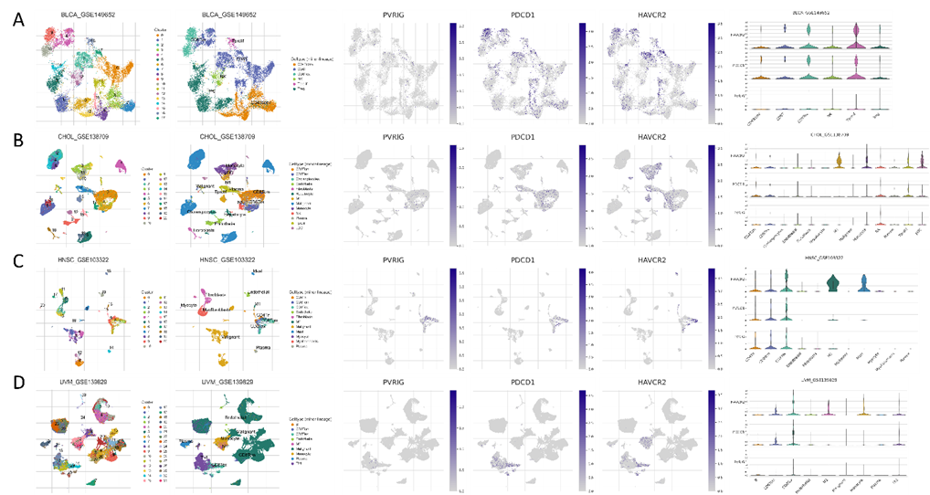
Figure S4. Single-cell sequencing analysis of PVRIG distribution in multiple cancer types. Single-cell sequencing analysis of PVRIG expression on different immune cell types in various cancer types, including BLCA (A), CHOL (B), HNSC (C), and UVM (D).

Figure S5. Flow cytometry gating scheme for Figure 7. (A) Flow cytometry gating scheme demonstrating the correlation between PVRIG expression and PD-1 and TIM-3 on CD8+ T cells. (B) Flow cytometry gating scheme illustrating the correlation between PVRIG expression and PD-1 and TIM-3 on NK1.1+ cells.

Figure S6. Flow cytometry analysis of PVRIG expression on CD8+ T cells transduced with shPVRIG or MSCV-PVRIG. (A) PVRIG expression on CD8+ T cells transduced with shControl or shPVRIG. (B) PVRIG expression on CD8+ T cells transduced with MSCV-Control or MSCV-PVRIG.

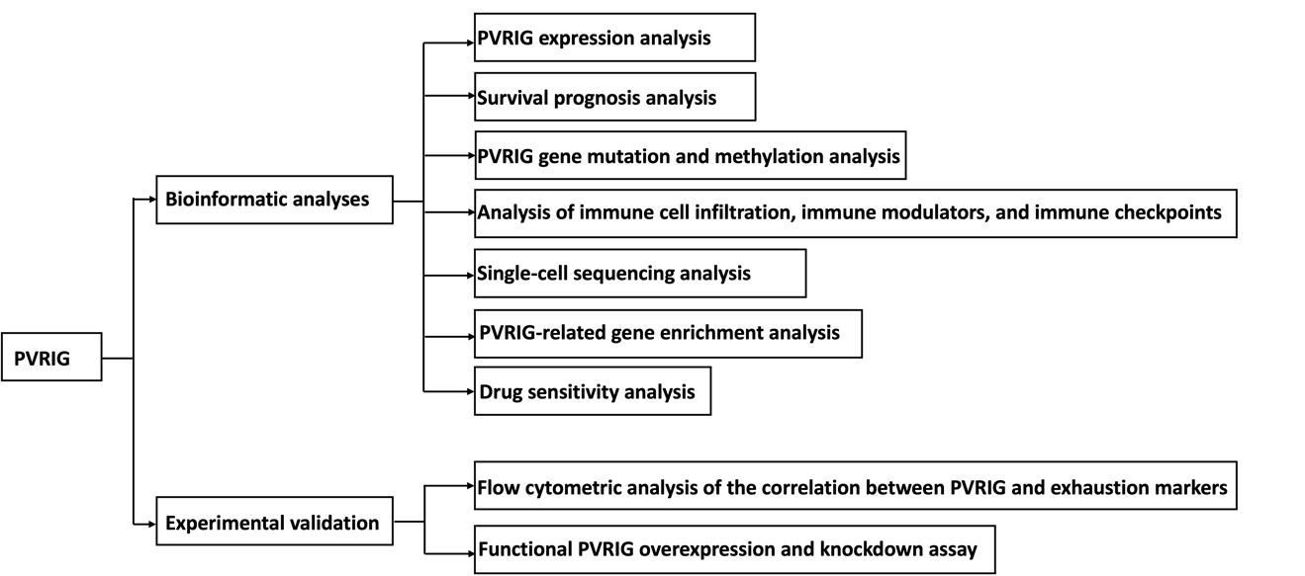
Figure S7. The flowchart illustrating the research methodology in this paper.

Table S1. Predicted drugs based on the PVRIG expression from the CCLE and CTRP datasets.

CCLE | Drug | t-value | p-value
CCLE | Palbociclib | 2.9085 | 0.003826
CCLE | Nilotinib | 5.28802 | 2.03E-07
CCLE | Topotecan | 5.97025 | 4.56E-09
CCLE | PLX4720 | 4.34614 | 1.69E-05
CCLE | Panobinostat | 4.71183 | 3.22E-06
CCLE | Panobinostat | 3.24687 | 0.001248
CCLE | Panobinostat | 2.90027 | 0.003899
CCLE | abraxane | 3.92425 | 9.95E-05
CTRP | Imatinib | 5.32158 | 1.36E-07
CTRP | MK-2206 | 7.63118 | 7.54E-14
CTRP | SMR000068650 | 7.23494 | 1.27E-12
CTRP | AZD8055 | 4.57992 | 5.40E-06
CTRP | GDC-0879 | 4.09365 | 4.70E-05
CTRP | PIK-93 | 3.07662 | 0.002169
CTRP | Belinostat | 5.47688 | 7.92E-08
CTRP | Belinostat | 3.61841 | 0.000337
CTRP | Belinostat | 6.87315 | 2.61E-11
CTRP | Apicidin | 8.51432 | 8.65E-17
CTRP | Apicidin | 4.30141 | 1.91E-05
CTRP | 3,5-bis(4-methylbenzylidene)piperidin-4-one | 6.50744 | 1.38E-10
CTRP | Apicidin | 6.72607 | 3.39E-11
CTRP | Bexarotene | 3.60084 | 0.000338
CTRP | Pubchem_72193861 | 5.7887 | 1.02E-08
CTRP | CHEMBL243659 | 4.64274 | 4.05E-06
CTRP | KU-0060648 | 5.71912 | 1.54E-08
CTRP | Rigosertib | 4.81279 | 1.81E-06
CTRP | BIBR1532 | 3.5906 | 0.000351
CTRP | TubastatinA | 5.19744 | 3.27E-07
CTRP | JQ-1 | 5.81094 | 9.05E-09
CTRP | 5-azacytidine | 3.72685 | 0.000208
CTRP | JQ-1 | 4.49587 | 7.98E-06
CTRP | 9-Fluoro-11,17,21-trihydroxy-16-methylpregna-1,4-diene-3,20-dione | 12.9377 | 9.14E-35
CTRP | Temsirolimus | 4.58673 | 5.99E-06
CTRP | Imatinib | 2.50122 | 0.012586
CTRP | NSC95397 | 7.76048 | 3.10E-14
CTRP | zebularine | 3.97867 | 7.58E-05
CTRP | BRD4770 | 5.53854 | 8.74E-08
CTRP | NVP-TAE684 | 2.49111 | 0.012949
CTRP | KPT-185 | 4.25592 | 2.44E-05
CTRP | LeptomycinB | 3.43559 | 0.000622
CTRP | YK-4-279 | 4.29058 | 2.01E-05
CTRP | SMR001317659 | 6.22035 | 8.09E-10
CTRP | Vorinostat | 6.81587 | 1.89E-11
CTRP | atav | 2.82106 | 0.004914
CTRP | Docetaxel | 3.36765 | 0.00084
CTRP | Gossypol | 4.21651 | 2.79E-05
CTRP | 660868-91-7 | 7.27154 | 9.35E-13
CTRP | BDBM50127227 | 9.0201 | 1.50E-18
CTRP | 112522-64-2 | 3.32594 | 0.000942
CTRP | SNX-2112 | 6.05721 | 2.15E-09
CTRP | RG108 | 3.91348 | 9.90E-05
CTRP | 112522-64-2 | 5.38426 | 1.09E-07
CTRP | SCHEMBL13737661 | 8.01554 | 4.40E-15
CTRP | CAY10603 | 7.9235 | 8.25E-15
CTRP | Nilotinib | 3.9871 | 7.34E-05
CTRP | Pazopanib | 3.40763 | 0.00069
CTRP | Doxorubicin | 5.78991 | 1.02E-08
CTRP | Doxorubicin | 3.11021 | 0.001937
CTRP | SMR001317659 | 7.4726 | 2.12E-13
CTRP | MLS000709026 | 5.2051 | 2.51E-07
CTRP | TG100-115 | 3.35099 | 0.000844
CTRP | Vorinostat | 6.03221 | 2.50E-09
CTRP | UNC0638 | 4.98092 | 7.85E-07
CTRP | PAC-1 | 8.38699 | 2.58E-16
CTRP | YK-4-279 | 5.14852 | 3.33E-07
CTRP | PF184 | 7.9777 | 5.59E-15
CTRP | N9-ISOPROPYL-OLOMOUCINE | 4.48513 | 8.45E-06
CTRP | Dabrafenib | 6.53307 | 2.12E-10
CTRP | Pubchem_92131101 | 6.54867 | 1.05E-10
CTRP | Pazopanib | 2.73587 | 0.006366
CTRP | SCHEMBL14981874 | 3.97599 | 7.99E-05
CTRP | SCHEMBL14981874 | 2.85107 | 0.004529
CTRP | SCHEMBL14981874 | 4.4761 | 9.33E-06
CTRP | Vorinostat | 3.89539 | 0.000107
CTRP | Sunitinib | 4.92613 | 1.03E-06
CTRP | MK-1775 | 6.92764 | 9.21E-12
CTRP | abraxane | 4.49842 | 7.90E-06
CTRP | SNX-2112 | 4.12832 | 4.05E-05
CTRP | ouabain | 4.38846 | 1.30E-05
CTRP | narciclasine | 7.60363 | 8.70E-14
CTRP | Gemcitabine | 4.4736 | 8.85E-06
CTRP | Gemcitabine | 5.90393 | 5.32E-09
CTRP | BI2536 | 7.4942 | 1.81E-13
CTRP | abraxane | 7.39053 | 3.81E-13
CTRP | AC1N20ZP | 7.41279 | 3.87E-13
CTRP | Flavopiridol | 3.47609 | 0.000569
CTRP | Sunitinib | 2.96951 | 0.003077
CTRP | Decitabine | 11.3879 | 6.53E-28
CTRP | KW-2449 | 3.67304 | 0.000256
CTRP | SCHEMBL13833463 | 2.87217 | 0.004198
CTRP | Elocalcitol | 5.39877 | 9.00E-08
CTRP | SCHEMBL12182311 | 3.99409 | 7.10E-05
CTRP | UNC0638 | 2.74766 | 0.006145
CTRP | Nutlin-3 | 4.63353 | 4.23E-06
CTRP | 4ly1 | 5.22896 | 2.20E-07
CTRP | BAS02002358 | 4.58826 | 5.22E-06
CTRP | 180002-83-9 | 6.52469 | 1.25E-10
CTRP | AT7867 | 6.72914 | 3.33E-11
CTRP | Pazopanib | 3.40076 | 0.000707
CTRP | WP1130 | 4.10525 | 4.49E-05
CTRP | 4CA-0620 | 7.51768 | 1.57E-13
CTRP | Spectrum_001549 | 6.47794 | 2.78E-10
CTRP | Etoposide | 7.97587 | 5.53E-15
CTRP | Etoposide | 4.76365 | 2.28E-06
CTRP | Spectrum_001549 | 3.12163 | 0.001932
CTRP | I-BET151 | 6.07295 | 1.97E-09
CTRP | Rigosertib | 6.17489 | 1.10E-09
CTRP | Nutlin-3 | 2.7765 | 0.00563
CTRP | I-BET151 | 6.4126 | 2.49E-10
CTRP | KU-55933 | 5.44884 | 6.85E-08
CTRP | SCHEMBL13833318 | 4.92767 | 1.02E-06
CTRP | CHEMBL408194 | 7.24844 | 1.02E-12
CTRP | SCHEMBL13833318 | 8.67449 | 2.55E-17
CTRP | ouabain | 3.70377 | 0.000227
CTRP | TW-37 | 3.57067 | 0.000378
CTRP | prima-1 | 11.4421 | 5.44E-28
CTRP | Entinostat | 6.19334 | 9.63E-10
CTRP | 345627-80-7 | 3.87845 | 0.000115
CTRP | Dinaciclib | 3.85653 | 0.000135
CTRP | Dinaciclib | 4.44134 | 1.18E-05
CTRP | 4ly1 | 10.5157 | 2.93E-24
CTRP | NVP-BSK805 | 3.2842 | 0.00107
CTRP | 345627-80-7 | 5.45601 | 6.71E-08
CTRP | Panobinostat | 3.61186 | 0.000324
CTRP | Gemcitabine | 5.99888 | 3.06E-09
CTRP | SCHEMBL13741284 | 4.32691 | 1.71E-05
CTRP | Vemurafenib | 2.79041 | 0.005396
CTRP | Sunitinib | 3.05848 | 0.002303
CTRP | SCHEMBL12182311 | 6.35002 | 3.63E-10
CTRP | PLX4720 | 3.40787 | 0.000689
CTRP | RITA | 2.75628 | 0.005989
CTRP | Masitinib | 3.96346 | 8.10E-05
CTRP | CHEMBL2058177 | 3.92861 | 9.31E-05
CTRP | CHEMBL2058177 | 5.62187 | 2.64E-08
CTRP | KU-60019 | 7.7883 | 2.18E-14
CTRP | Rapamycin | 8.81003 | 7.97E-18
CTRP | OSI-930 | 4.48483 | 8.67E-06
CTRP | BIX-01294 | 7.99265 | 4.94E-15
CTRP | Cyt387 | 5.92528 | 4.79E-09
CTRP | Axitinib | 2.57117 | 0.010322
CTRP | TPCA-1 | 6.11327 | 1.54E-09
CTRP | 722544-51-6 | 9.40932 | 5.38E-20
CTRP | ETP-46464 | 4.01694 | 6.75E-05
CTRP | GSK525762A | 6.03252 | 2.50E-09
CTRP | GSK525762A | 6.33639 | 3.99E-10
CTRP | Nelarabine | 8.29707 | 5.16E-16
CTRP | AZD7762 | 6.88816 | 1.16E-11
CTRP | Sotrastaurin | 4.47285 | 9.45E-06
CTRP | Masitinib | 4.45512 | 9.68E-06
CTRP | CHEMBL3186197 | 2.79282 | 0.005356
CTRP | BCP9000801 | 10.1637 | 9.09E-23
CTRP | CICLOPIROX | 11.5815 | 9.84E-29
CTRP | GSK461364 | 8.4426 | 1.58E-16
CTRP | PHA-793887 | 7.48323 | 1.97E-13
CTRP | Crizotinib | 3.76266 | 0.000181
CTRP | Tg-101348 | 4.4737 | 8.87E-06
CTRP | BRD-K53855319-001-01-2 | 7.9762 | 5.98E-15
CTRP | Ki8751 | 3.07023 | 0.002217
CTRP | SMER3 | 3.67255 | 0.00026
CTRP | Pluripotin | 3.12966 | 0.001815
CTRP | NSC373989 | 6.70077 | 4.08E-11
CTRP | Pevonedistat | 5.47034 | 6.15E-08
CTRP | Alisertib | 7.33436 | 5.69E-13
CTRP | MIRA-1 | 6.07196 | 2.38E-09
CTRP | CHEMBL520231 | 6.98896 | 6.75E-12
CTRP | Entinostat | 8.12323 | 1.83E-15
CTRP | Entinostat | 4.12779 | 4.07E-05
CTRP | BMS-754807 | 2.99571 | 0.002826
CTRP | Panobinostat | 6.20318 | 9.00E-10
CTRP | Tipifarnib | 4.99076 | 8.86E-07
CTRP | SCHEMBL13737661 | 4.1178 | 4.27E-05
CTRP | Panobinostat | 5.4572 | 6.51E-08
CTRP | PHA-793887 | 5.84843 | 7.31E-09
CTRP | Nsc23766 | 6.18582 | 1.01E-09
CTRP | OSI-027 | 5.18874 | 2.70E-07
CTRP | Topotecan | 8.92588 | 3.11E-18
CTRP | UNII-UZ77T1VFBM | 5.1149 | 4.06E-07
CTRP | BMS345541 | 3.79409 | 0.00016
CTRP | Tacrolimus | 2.61662 | 0.009064
CTRP | Tacrolimus | 2.9164 | 0.003649
CTRP | Cerulenin | 7.81354 | 1.86E-14
CTRP | TelomeraseInhibitorIX | 4.30954 | 1.85E-05

