Supplementary Table 1: Phenotypic antimicrobial resistance and biofilm production association (n=44)

Antimicrobial Agent | Phenotypic Resistance | Biofilm production |  |  |  | p value
Antimicrobial Agent | Phenotypic Resistance | Strong biofilm producers (n) | Moderate biofilm producers (n) | Weak biofilm producers (n) | Non-biofilm producers (n) | p value
Amoxicillin | Sensitive  Intermediate  Resistant | 0  0  12 | 0  0  23 | 0  0  9 | 0  0  0 | -
Amoxicillin/clavulanic acid | Sensitive  Intermediate  Resistant | 0  1  11 | 3  2  18 | 4  0  5 | 0  0  0 | 0.082
Cephalothin | Sensitive  Intermediate  Resistant | 0  0  12 | 0  0  23 | 0  0  9 | 0  0  0 | -
Imipenem | Sensitive  Intermediate  Resistant | 9  2  1 | 23  0  0 | 8  1  0 | 0  0  0 | 0.151
Gentamicin | Sensitive  Intermediate  Resistant | 4  2  6 | 15  4  4 | 9  0  0 | 0  0  0 | 0.022
Amikacin | Sensitive  Intermediate  Resistant | 4  3  5 | 18  2  3 | 7  2  0 | 0  0  0 | 0.043
Erythromycin | Sensitive  Intermediate  Resistant | 0  0  12 | 2  3  18 | 2  2  5 | 0  0  0 | 0.168
Ciprofloxacin | Sensitive  Intermediate  Resistant | 5  3  4 | 18  2  3 | 8  0  1 | 0  0  0 | 0.122
Norfloxacin | Sensitive  Intermediate  Resistant | 4  3  5 | 17  2  4 | 8  0  1 | 0  0  0 | 0.068
Nalidixic acid | Sensitive  Intermediate  Resistant | 3  0  9 | 7  4  12 | 4  3  2 | 0  0  0 | 0.134
Trimethoprim/ Sulphamethoxazole | Sensitive  Intermediate  Resistant | 2  1  9 | 10  3  10 | 7  1  1 | 0  0  0 | 0.055
Nitrofurantoin | Sensitive  Intermediate  Resistant | 0  0  12 | 2  3  18 | 3  1  5 | 0  0  0 | 0.086
Chloramphenicol | Sensitive  Intermediate  Resistant | 8  1  3 | 9  9  5 | 9  0  0 | 0  0  0 | 0.016
Colistin | Sensitive  Intermediate  Resistant | 9  2  1 | 21  0  2 | 8  0  1 | 0  0  0 | 0.228
Oxytetracycline | Sensitive  Intermediate  Resistant | 0  0  12 | 4  0  19 | 1  2  6 | 0  0  0 | 0.032

Supplementary Table 2: Phenotypic-genotypic antimicrobial resistance association (n=20)

Antimicrobial Agent | Genotypic Resistance | Phenotypic Resistance |  |  | p value
Antimicrobial Agent | Genotypic Resistance | Sensitive (n) | Intermediate (n) | Resistant (n) | p value
Amoxicillin | BlaTEM (+) | 0 | 0 | 20 | -
Amoxicillin | BlaTEM (-) | 0 | 0 | 0 | -
Amoxicillin/clavulanic acid | BlaTEM (+) | 0 | 1 | 19 | -
Amoxicillin/clavulanic acid | BlaTEM (-) | 0 | 0 | 0 | -
Cephalothin | BlaTEM (+) | 0 | 0 | 20 | -
Cephalothin | BlaTEM (-) | 0 | 0 | 0 | -
Imipenem | BlaTEM (+) | 17 | 2 | 1 | -
Imipenem | BlaTEM (-) | 0 | 0 | 0 | -
Ciprofloxacin | qnrA (+) | 3 | 1 | 5 | 0.218
Ciprofloxacin | qnrA (-) | 7 | 2 | 2 | 0.218
Norfloxacin | qnrA (+) | 2 | 1 | 6 | 0.205
Norfloxacin | qnrA (-) | 6 | 2 | 3 | 0.205
Nalidixic acid | qnrA (+) | 1 | 1 | 7 | 0.269
Nalidixic acid | qnrA (-) | 4 | 0 | 7 | 0.269
Trimethoprim/ Sulphamethoxazole | Sul1 (+) | 2 | 2 | 11 | 0.352
Trimethoprim/ Sulphamethoxazole | Sul1 (-) | 2 | 1 | 2 | 0.352
Oxytetracycline | tetA (+) | 0 | 0 | 11 | -
Oxytetracycline | tetA (-) | 0 | 0 | 9 | -

Supplementary Table 3: Genotypic antimicrobial resistance and biofilm production association (n=20)

Antimicrobial Resistance gene | Biofilm production |  |  |  | p value
Antimicrobial Resistance gene | Strong biofilm producers  (n) | Moderate biofilm producers (n) | Weak biofilm producers (n) | Non-biofilm producers (n) | p value
BlaTEM (+)  BlaTEM (-) | 8  0 | 10  0 | 2  0 | 0  0 | -
qnrA (+)  qnrA (-) | 5  3 | 3  7 | 1  1 | 0  0 | 0.383
Sul1 (+)  Sul1 (-) | 6  2 | 9  1 | 0  2 | 0  0 | 0.027
tetA (+)  tetA (-) | 7  1 | 4  6 | 0  2 | 0  0 | 0.034

Supplementary Table 4: Class 1 integron and genotypic antimicrobial resistance association (n=20)

Antimicrobial Resistance Gene | Class 1 Integron Gene |  | p value
Antimicrobial Resistance Gene | (-) (n) | (+) (n) | p value
BlaTEM (+)  BlaTEM (-) | 9  0 | 1  0 | -
qnrA (+)  qnrA (-) | 1  8 | 8  3 | 0.006
Sul1 (+)  Sul1 (-) | 7  2 | 8  3 | 0.795
tetA (+)  tetA (-) | 4  5 | 7  4 | 0.391

Supplementary Table 5: Class 2 integron and genotypic antimicrobial resistance association (n=20)

Antimicrobial Resistance Gene | Class 2 Integron Gene |  | p value
Antimicrobial Resistance Gene | (-) (n) | (+) (n) | p value
BlaTEM (+)  BlaTEM (-) | 20  0 | 0  0 | -
qnrA (+)  qnrA (-) | 9  11 | 0  0 | -
Sul1 (+)  Sul1 (-) | 15  5 | 0  0 | -
tetA (+)  tetA (-) | 11  9 | 0  0 | -

Supplementary Figures

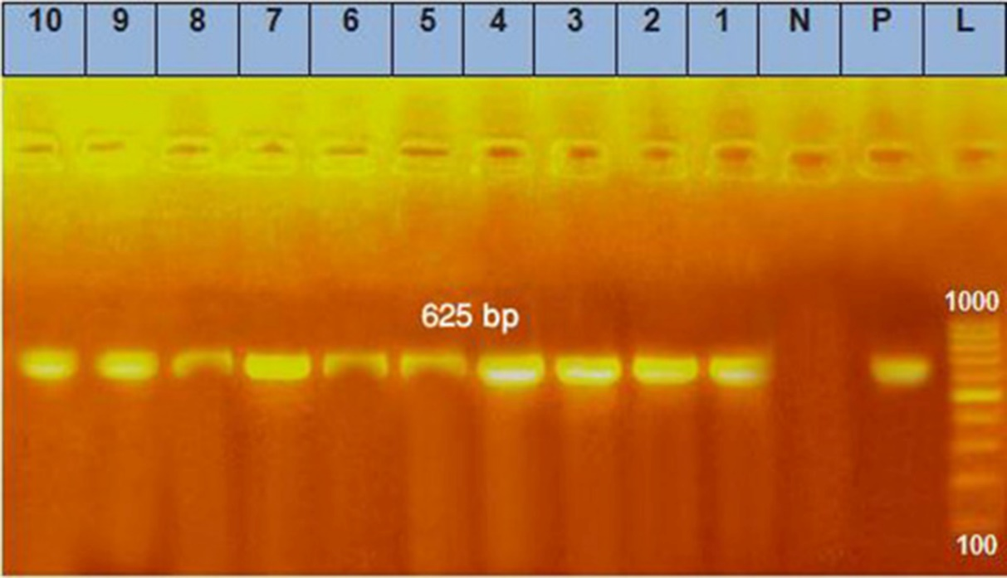

Supplementary Figure 1. Agarose gel electrophoresis for PCR products that targeted 16S rRNA gene in A. hydrophila isolates. Lane L: DNA ladder (100-1000 bp), Lane N: Negative control, Lane P: Positive control, and Lanes 1-10: PCR products of A. hydrophila isolates (C. gariepinus: Isolates 1, 6, 7, and 9; O. niloticus: Isolates 2-5, 8, and 10) with specific size showing positive bands at 625-bp in all the examined isolates.

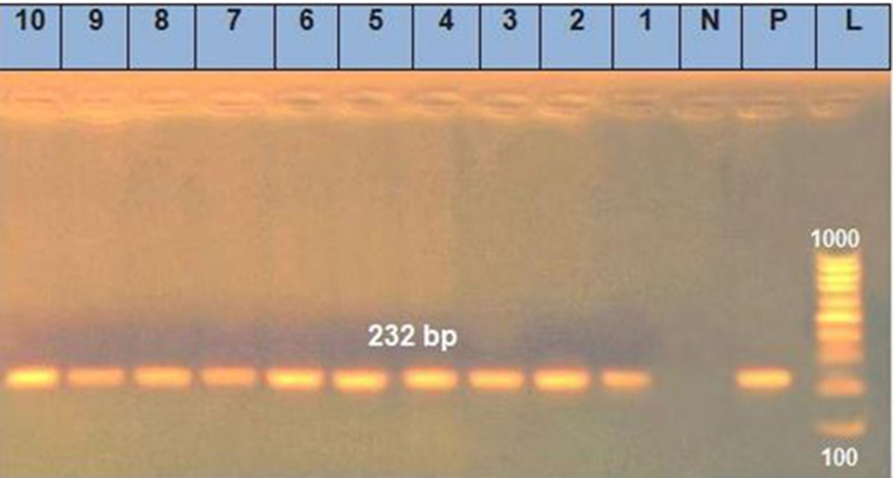

Supplementary Figure 2. Agarose gel electrophoresis for PCR products that targeted act gene in A. hydrophila isolates. Lane L: DNA ladder (100-1000 bp), Lane N: Negative control, Lane P: Positive control, and Lanes 1-10: PCR products of A. hydrophila isolates with specific size showing positive bands at 232-bp in all the examined isolates described in Supplementary Figure 1.

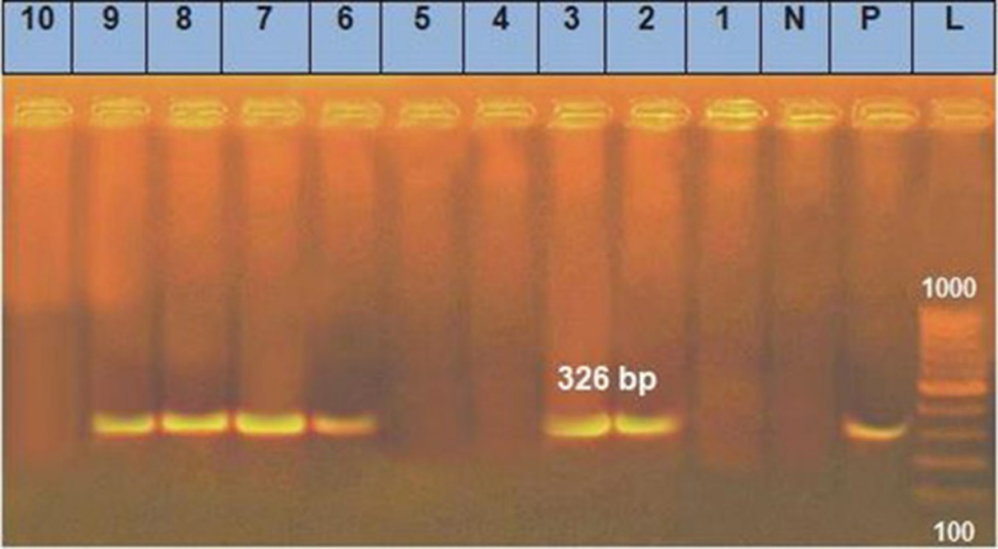

Supplementary Figure 3. Agarose gel electrophoresis for PCR products that targeted aer gene in A. hydrophila isolates. Lane L: DNA ladder (100-1000 bp), Lane N: Negative control, Lane P: Positive control, and Lanes 1-10: PCR products of A. hydrophila isolates with specific size showing positive bands at 326-bp in isolates 2, 3, 6, 7, 8 and 9 described in Supplementary Figure 1.

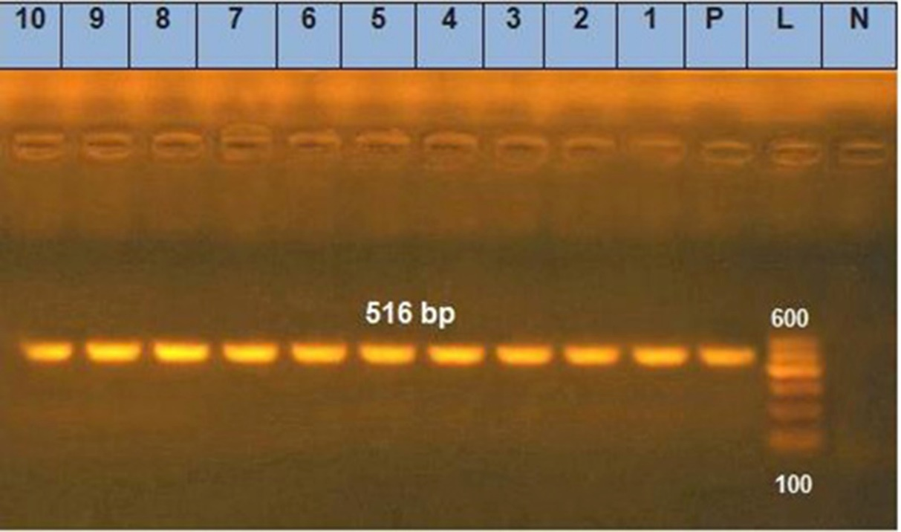

Supplementary Figure 4. Agarose gel electrophoresis for PCR products that targeted blaTEM gene in A. hydrophila isolates. Lane L: DNA ladder (100-600 bp), Lane N: Negative control, Lane P: Positive control, and Lanes 1-10: PCR products of A. hydrophila isolates with specific size showing positive bands at 516-bp in all the examined isolates described in Supplementary Figure 1.

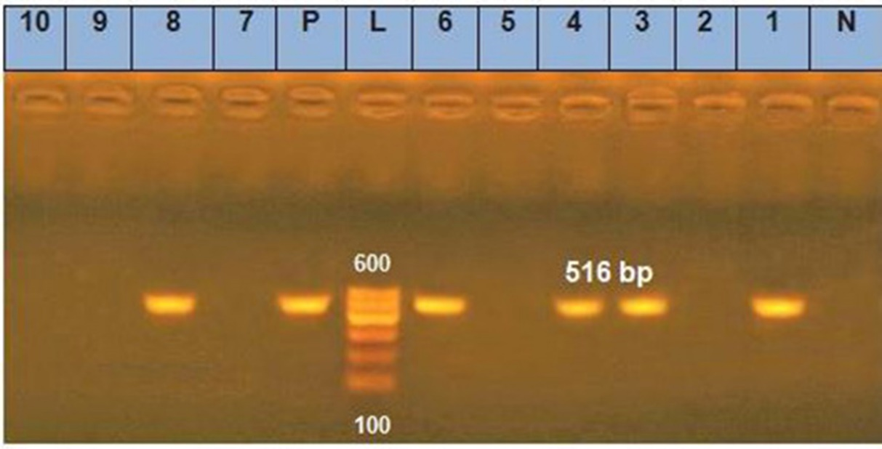

Supplementary Figure 5. Agarose gel electrophoresis for PCR products that targeted qnrA gene in A. hydrophila isolates. Lane L: DNA ladder (100-600 bp), Lane N: Negative control, Lane P: Positive control, and Lanes 1-10: PCR products of A. hydrophila isolates with specific size showing positive bands at 516-bp in isolates 1, 3, 4, 6 and 8 described in Supplementary Figure 1.

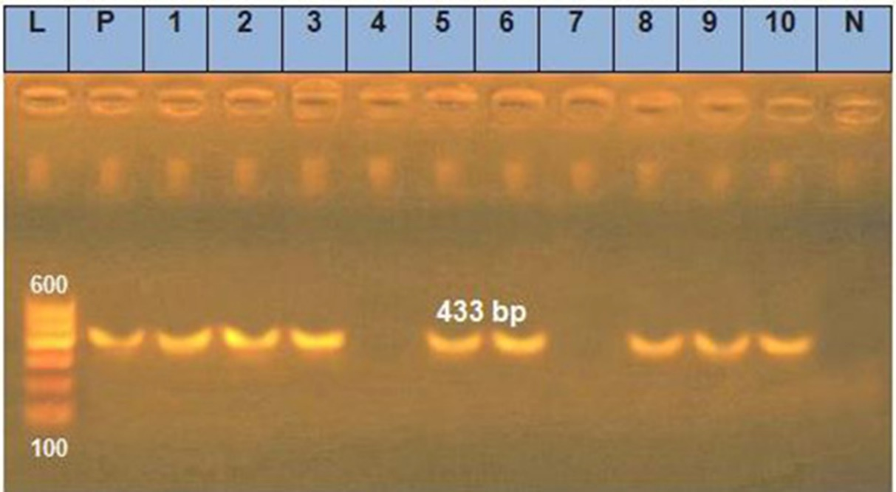

Supplementary Figure 6. Agarose gel electrophoresis for PCR products that targeted sul1 gene in A. hydrophila isolates. Lane L: DNA ladder (100-600 bp), Lane N: Negative control, Lane P: Positive control, and Lanes 1-10: PCR products of A. hydrophila isolates with specific size showing positive bands at 433-bp in isolates 1, 2, 3, 5, 6, 8, 9 and 10 described in Supplementary Figure 1.

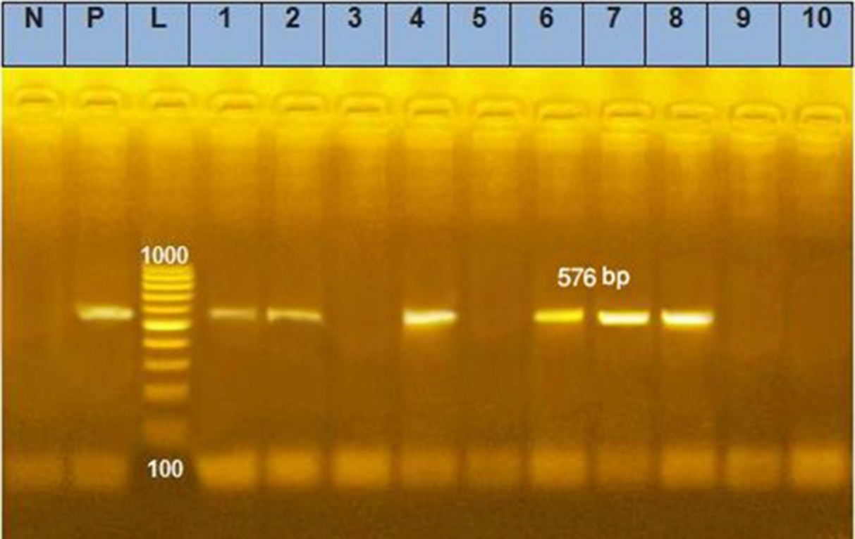

Supplementary Figure 7. Agarose gel electrophoresis for PCR products that targeted tetA gene in A. hydrophila isolates. Lane L: DNA ladder (100-1000 bp), Lane N: Negative control, Lane P: Positive control, and Lanes 1-10: PCR products of A. hydrophila isolates with specific size showing positive bands at 576-bp in isolates 1, 2, 4, 6, 7 and 8 described in Supplementary Figure 1.

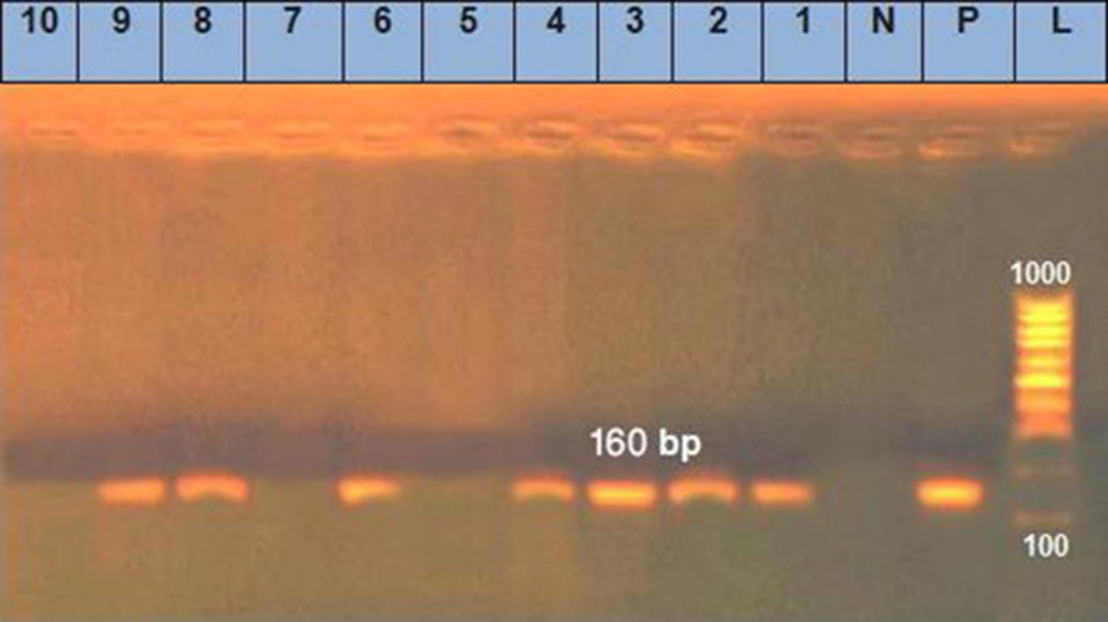

Supplementary Figure 8. Agarose gel electrophoresis for PCR products that targeted int1 gene in A. hydrophila isolates. Lane L: DNA ladder (100-1000 bp), Lane N: Negative control, Lane P: Positive control, and Lanes 1-10: PCR products of A. hydrophila isolates with specific size showing positive bands at 160-bp in isolates 1, 2, 3, 4, 6, 8 and 9 described in Supplementary Figure 1.

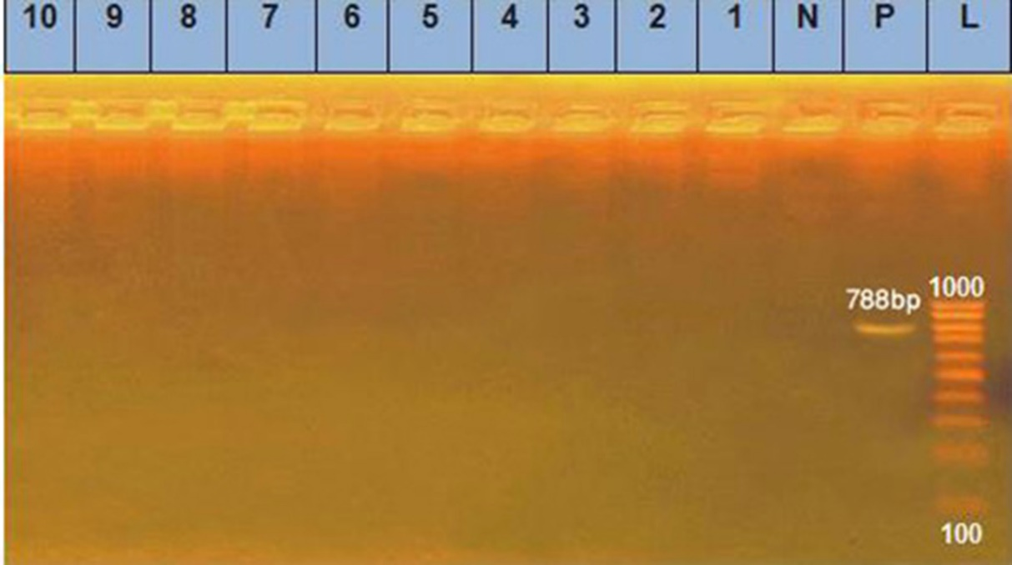

Supplementary Figure 9. Agarose gel electrophoresis for PCR products that targeted int2 gene in A. hydrophila isolates. Lane L: DNA ladder (100-1000 bp), Lane N: Negative control, Lane P: Positive control, and Lanes 1-10: PCR products of A. hydrophila isolates with specific size showing negative results in all the examined isolates described in Supplementary Figure 1.

