S. Figure 1 Haplotype accumulation curve
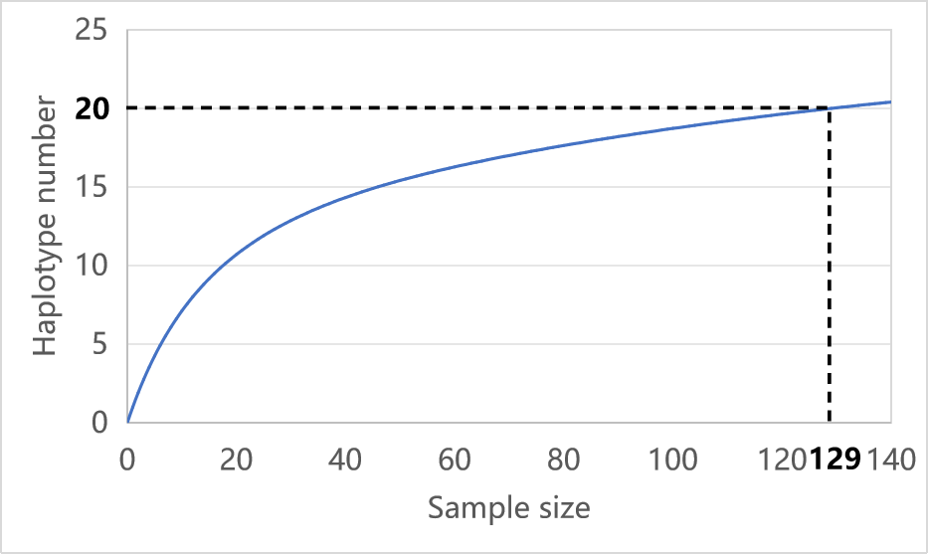

S. Figure 2 Polymorphic sites of 20 mtDNA haplotypes of wild forest musk deer in Shanxi Province.
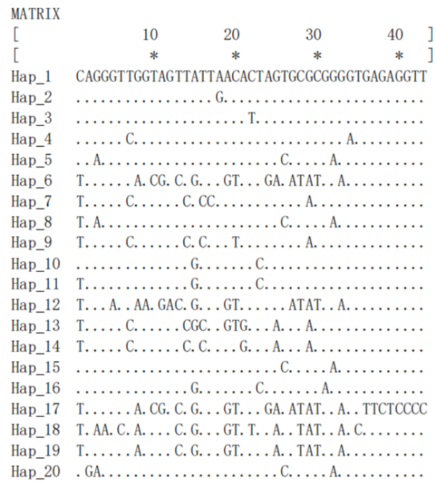

S. Figure 3 Neighbor-joining phylogenetic tree of 93 mtDNA D-loop haplotypes from wild and captive forest musk deer populations in Shaanxi and Sichuan Provinces, and wild population in Shanxi Province.
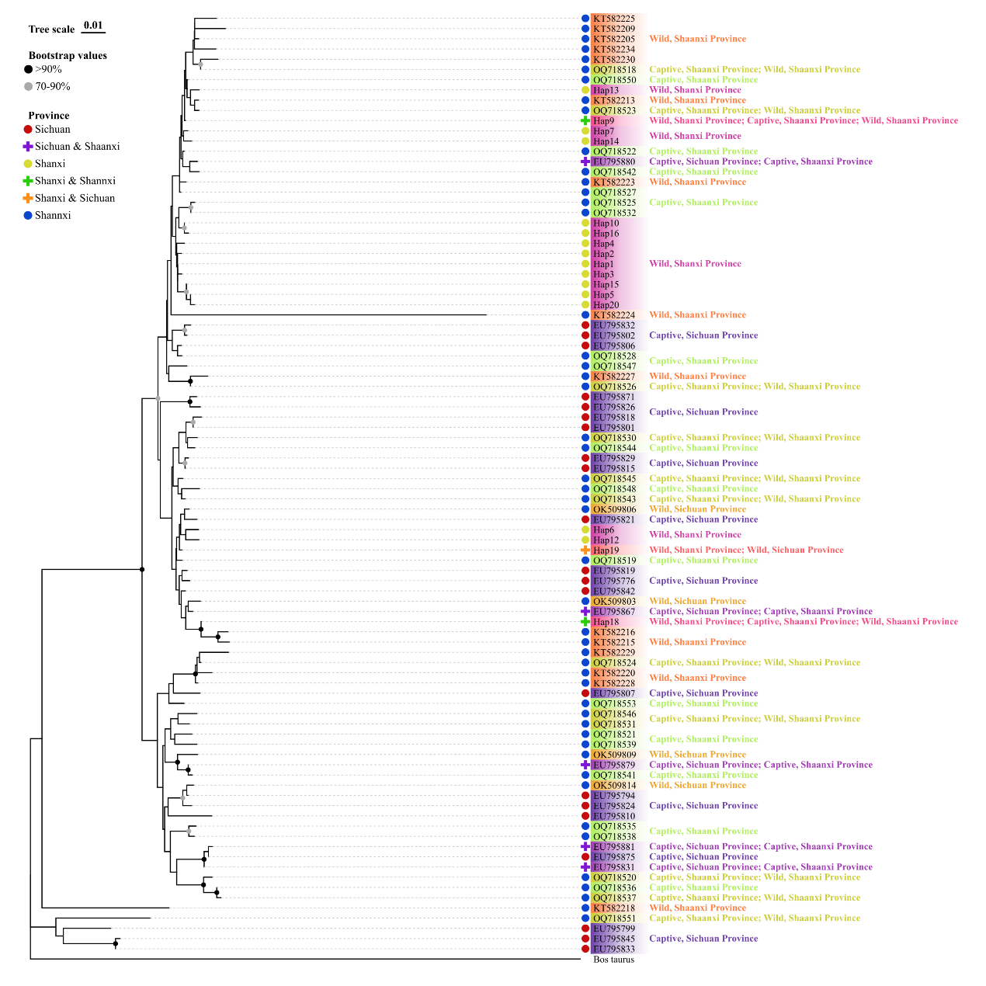

S. Table 1 Distribution and frequency of forest musk deer mtDNA CR haplotypes in Shanxi Province.
Haplotype | LL |  | TY | ZT
Haplotype | LYS | PQG | LKS | LS | MH | Total
Hap1 | 5 |  |  |  |  | 5
Hap2 |  | 1 | 6 |  |  | 7
Hap3 |  | 2 |  |  |  | 2
Hap4 |  | 2 |  |  |  | 2
Hap5 |  |  |  | 15 | 1 | 16
Hap6 |  |  |  | 16 | 7 | 23
Hap7 |  |  |  | 6 | 2 | 8
Hap8 |  |  |  | 1 |  | 1
Hap9 |  |  |  | 1 |  | 1
Hap10 |  |  |  | 3 | 4 | 7
Hap11 |  |  |  | 9 |  | 9
Hap12 |  |  |  | 9 |  | 9
Hap13 |  |  |  | 1 |  | 1
Hap14 |  |  |  | 15 |  | 15
Hap15 |  |  |  | 5 |  | 5
Hap16 |  |  |  | 4 |  | 4
Hap17 |  |  |  | 1 |  | 1
Hap18 |  |  |  | 2 |  | 2
Hap19 |  |  |  | 1 |  | 1
Hap20 |  |  |  |  | 10 | 10
Number of  unique haplotypes | 3 |  | 0 | 12 |  | 15
Number of  unique haplotypes | 1 | 2 | 0 | 11 | 1 | 15
Lüliang (LL) mountain range: Shanxi Luyashan National Nature Reserve (LYS), Shanxi Pangquangou National Nature Reserve (PQG); Taiyue (TY) mountain range: Shanxi Lingkongshan National Nature Reserve (LKS); Zhongtiao (ZT) mountain range: Shanxi Lishan National Nature Reserve (LS), Yangcheng Mangrove Gibbon National Nature Reserve (MH).

S. Table 2 Area and scope of the five nature reserves in Shanxi Province
Mountain Range | Nature Reserve | Area (hm2) | Longitude System | Latitude System
LL | LYS | 21,453.0 | 111°50′–112°06′ | 38°36′–38°45′
LL | PQG | 10,443.5 | 111°22′–111°33′ | 37°45′–37°55′
TY | LKS | 10,116.8 | 111°59′–112°08′ | 36°33′–36°43′
ZT | LS | 24,800.0 | 111°51′–112°06′ | 35°17′–35°27′
ZT | MH | 5,573.0 | 112°22′–112°32′ | 35°13′–35°17′
Lüliang (LL) mountain range: Shanxi Luyashan National Nature Reserve (LYS), Shanxi Pangquangou National Nature Reserve (PQG); Taiyue (TY) mountain range: Shanxi Lingkongshan National Nature Reserve (LKS); Zhongtiao (ZT) mountain range: Shanxi Lishan National Nature Reserve (LS), Yangcheng Mangrove Gibbon National Nature Reserve (MH).

S. Table 3 Haplotype names and corresponding sequences
Haplotype name |  | Frequence |  | Corresponding Sequence
EU795776.1 | 1 |  | EU795776.1
EU795794.1 | 3 |  | EU795794.1, EU795791.1, EU795790.1
EU795799.1 | 1 |  | EU795799.1
EU795801.1 | 1 |  | EU795801.1
EU795802.1 | 3 |  | EU795802.1, EU795797.1, EU795774.1
EU795806.1 | 13 |  | EU795806.1, EU795803.1, EU795798.1, EU795793.1,  EU795792.1, EU795789.1, EU795788.1, EU795787.1,  EU795785.1, EU795783.1, EU795782.1, EU795781.1,  EU795778.1
EU795807.1 | 2 |  | EU795807.1, EU795786.1
EU795810.1 | 1 |  | EU795810.1
EU795815.1 | 2 |  | EU795815.1, EU795811.1
EU795818.1 | 2 |  | EU795818.1, EU795817.1
EU795819.1 | 1 |  | EU795819.1
EU795821.1 | 1 |  | EU795821.1
EU795824.1 | 2 |  | EU795824.1, EU795809.1
EU795826.1 | 4 |  | EU795826.1
EU795829.1 | 1 |  | EU795829.1
EU795831.1 | 9 |  | EU795831.1, EU795828.1, EU795825.1, EU795820.1,  EU795808.1, EU795784.1, EU795780.1, EU795777.1,  OQ718534.1
EU795832.1 | 3 |  | EU795832.1, EU795800.1, EU795775.1
EU795833.1 | 1 |  | EU795833.1
EU795842.1 | 4 |  | EU795842.1, EU795839.1, EU795822.1, EU795816.1
EU795845.1 | 14 |  | EU795845.1, EU795844.1, EU795843.1, EU795841.1,  EU795840.1, EU795837.1, EU795838.1, EU795836.1,  EU795835.1, EU795834.1, EU795830.1, EU795827.1,  EU795814.1, EU795813.1
EU795867.1 | 2 |  | EU795867.1, OQ718552.1
EU795871.1 | 5 |  | EU795871.1, EU795862.1, EU795852.1, EU795850.1,  EU795849.1
EU795875.1 | 1 |  | EU795875.1
EU795879.1 | 15 |  | EU795879.1, EU795876.1, EU795873.1, EU795870.1,  EU795868.1, EU795866.1, EU795865.1, EU795864.1,  EU795863.1, EU795857.1, EU795856.1, EU795853.1,  EU795851.1, EU795847.1, OQ718529.1
EU795880.1 | 11 |  | EU795880.1, EU795877.1, EU795874.1, EU795872.1,  EU795869.1, EU795860.1, EU795859.1, EU795858.1,  EU795848.1, EU795846.1, OQ718533.1
EU795881.1 | 6 |  | EU795881.1, EU795878.1, EU795861.1, EU795855.1,  EU795854.1, OQ718540.1
GU947021.1 | 1 |  | GU947021.1
Hap1 | 1 |  | Hap1
Hap10 | 2 |  | Hap10, Hap11
Hap12 | 1 |  | Hap12
Hap13 | 1 |  | Hap13
Hap14 | 1 |  | Hap14
Hap15 | 1 |  | Hap15
Hap16 | 1 |  | Hap16
Hap18 | 3 |  | Hap18, OQ718516.1, KT582217.1
Hap19 | 7 |  | Hap19, EU795805.1, EU795804.1, EU795796.1, EU795795.1, EU795779.1, EU795773.1
Hap2 | 1 |  | Hap2
Hap20 | 1 |  | Hap20
Hap3 | 1 |  | Hap3
Hap4 | 1 |  | Hap4
Hap5 | 2 |  | Hap5, Hap8
Hap6 | 2 |  | Hap6, Hap17
Hap7 | 1 |  | Hap7
Hap9 | 5 |  | Hap9, OQ718515.1, OQ718517.1, KT582206.1, KT582203.1
KT582205.1 | 1 |  | KT582205.1
KT582209.1 | 1 |  | KT582209.1
KT582213.1 | 1 |  | KT582213.1
KT582215.1 | 1 |  | KT582215.1
KT582216.1 | 1 |  | KT582216.1
KT582218.1 | 1 |  | KT582218.1
KT582220.1 | 1 |  | KT582220.1
KT582223.1 | 1 |  | KT582223.1
KT582224.1 | 1 |  | KT582224.1
KT582225.1 | 1 |  | KT582225.1
KT582227.1 | 1 |  | KT582227.1
KT582228.1 | 1 |  | KT582228.1
KT582229.1 | 1 |  | KT582229.1
KT582230.1 | 1 |  | KT582230.1
KT582234.1 | 1 |  | KT582234.1
OK509803.1 | 2 |  | OK509803.1, OK509799.1
OK509806.1 | 8 |  | OK509806.1, OK509802.1, OK509801.1, OK509798.1,  OK509797.1, OK509796.1, OK509795.1, OK509794.1
OK509809.1 | 6 |  | OK509809.1, OK509808.1, OK509807.1, OK509805.1, OK509804.1, OK509800.1
OK509814.1 | 3 |  | OK509814.1, OK509811.1, OK509810.1
OQ718518.1 | 2 |  | OQ718518.1, KT582204.1
OQ718519.1 | 1 |  | OQ718519.1
OQ718520.1 | 2 |  | OQ718520.1, KT582231.1
OQ718521.1 | 1 |  | OQ718521.1
OQ718522.1 | 3 |  | OQ718522.1, KT582211.1, KT582210.1
OQ718523.1 | 2 |  | OQ718523.1, KT582222
OQ718524.1 | 2 |  | OQ718524.1, KT582214.1
OQ718525.1 | 1 |  | OQ718525.1
OQ718526.1 | 2 |  | OQ718526.1, KT582226.1
OQ718527.1 | 1 |  | OQ718527.1
OQ718528.1 | 1 |  | OQ718528.1
OQ718530.1 | 2 |  | OQ718530.1, KT582219.1
OQ718531.1 | 2 |  | OQ718531.1, KT582212.1
OQ718532.1 | 1 |  | OQ718532.1
OQ718535.1 | 1 |  | OQ718535.1
OQ718536.1 | 1 |  | OQ718536.1
OQ718537.1 | 2 |  | OQ718537.1, KT582208.1
OQ718538.1 | 1 |  | OQ718538.1
OQ718539.1 | 1 |  | OQ718539.1
OQ718541.1 | 1 |  | OQ718541.1
OQ718542.1 | 1 |  | OQ718542.1
OQ718543.1 | 2 |  | OQ718543.1, KT582207.1
OQ718544.1 | 1 |  | OQ718544.1
OQ718545.1 | 2 |  | OQ718545.1, KT582221.1
OQ718546.1 | 2 |  | OQ718546.1, KT582232.1
OQ718547.1 | 1 |  | OQ718547.1
OQ718548.1 | 1 |  | OQ718548.1
OQ718550.1 | 1 |  | OQ718550.1
OQ718551.1 | 2 |  | OQ718551.1, KT582233.1
OQ718553.1 | 1 |  | OQ718553.1

