Figure 1: Number of transcripts and unigen sequences in each interval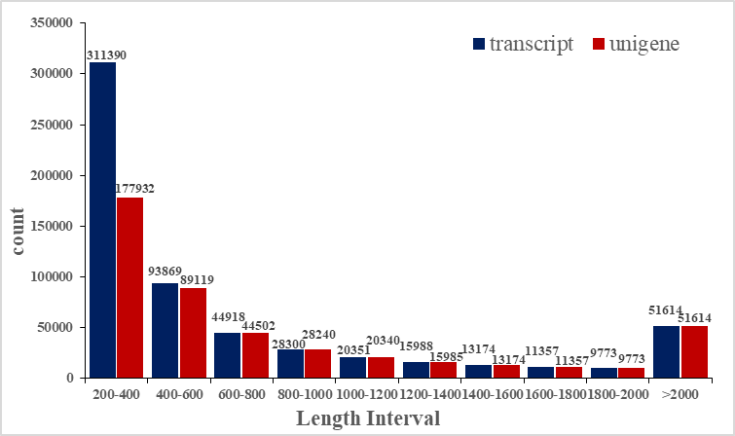
Note: Length Interval: The horizontal axis represents the length interval; Count: The vertical axis represents the number of transcripts or unigenes within the corresponding length range.
Figure.2 TF family prediction and classification
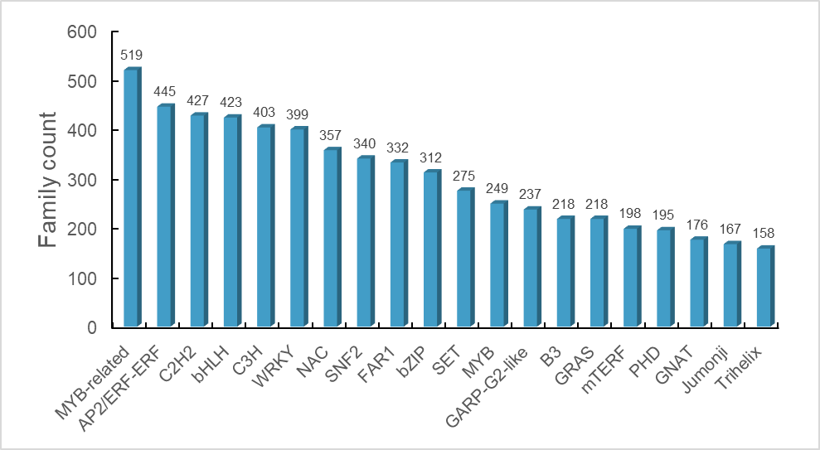
Figure.3 KEGG enriched the differential gene Wayne diagram of flavonoid biosynthesis pathway
