Changes of leucine-rich alpha 2 glycoprotein could be a marker of changes of endoscopic and histologic activity of ulcerative colitis

Short title: LRG as a serum marker for UC

Yuki Aoyama¹, Sakiko Hiraoka¹, Eriko Yasutomi¹, Toshihiro Inokuchi¹, Takehiro Tanaka², Kensuke Takei¹, Shoko Igawa¹, Keiko Takeuchi¹, Masahiro Takahara¹, Junki Toyosawa¹, Yasushi Yamasaki¹, Hideaki Kinugasa¹, Jun Kato³, Hiroyuki Okada⁴, Motoyuki Otsuka¹

1. Department of Gastroenterology and Hepatology, Okayama University Graduate School of Medicine, Dentistry and Pharmaceutical Sciences, Okayama, Japan
2. Department of Pathology, Okayama University Graduate School of Medicine, Dentistry and Pharmaceutical Sciences, Okayama, Japan
3. Department of Gastroenterology, Graduate School of Medicine, Chiba University, Chiba, Japan
4. Department of Gastroenterology, Japanese Red Cross Society Himeji Hospital, Himeji,
Japan

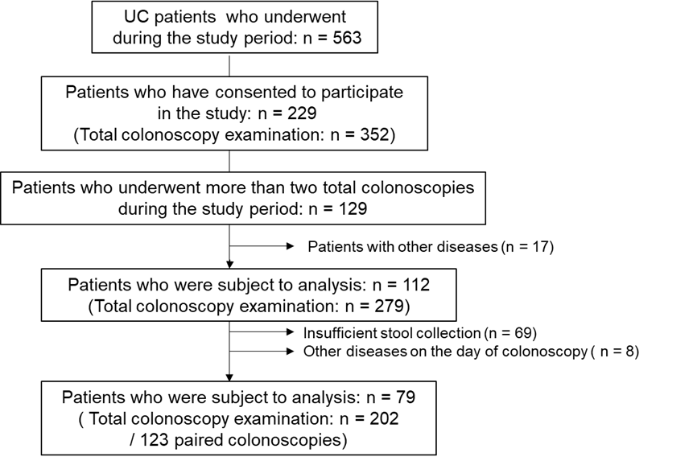

Supplemental Figure 1. Flowchart for enrollment

Supplemental Table 1. Medication changes between the precedent and subsequent colonoscopic tests

Medication changes between the precedent and  subsequent colonoscopic examinations | 48 (39.0)
Induction of immunosuppressive medication (including overlap)  Steroid oral agent / suppository  Immunomodulator  Biologics  Anti-tumor necrosis factor-α agents  Others  Janus kinase inhibitor | 14 (11.4)  7 (5.7)  3 (2.4)  7 (5.7)  5 (4.1)  2 (1.6)  1 (0.8)
Interruption of immunosuppressive medication (including overlap)  Steroid oral agent / suppository  Immunomodulator  Biologics (No anti-tumor necrosis factor-α agents)  Tacrolimus | 19 (15.4)  11 (8.9)  6 (4.9)  1 (0.8)  4 (3.3)

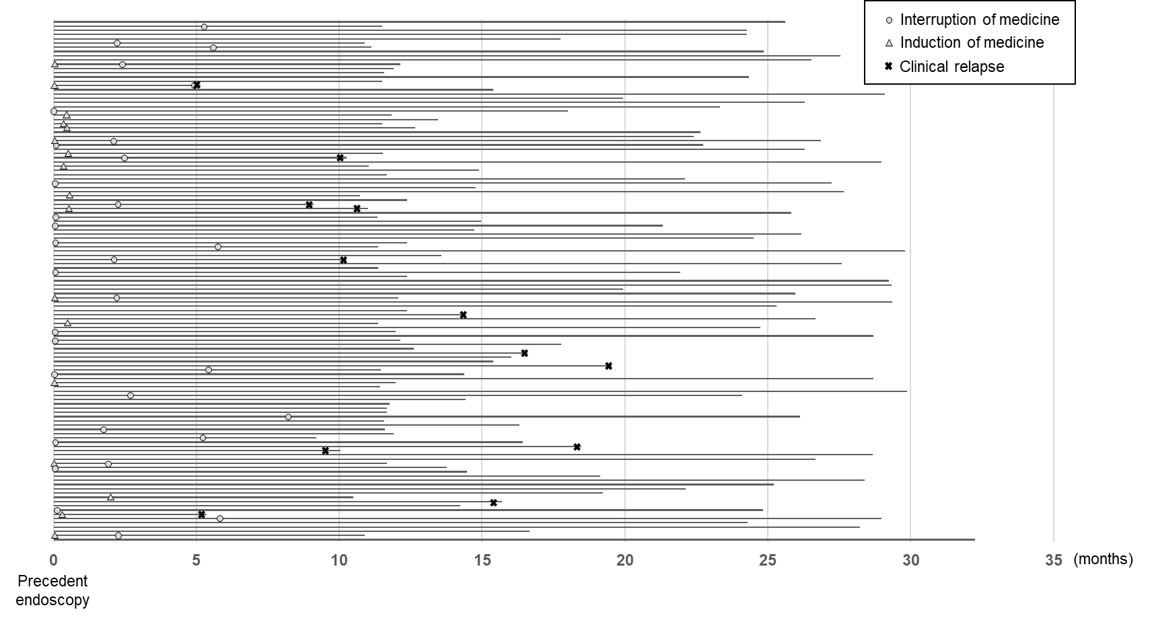

Supplemental Figure 2. Intervals for endoscopic examinations and timing of treatment modifications or clinical relapse
The intervals between the precedent colonoscopy and the subsequent colonoscopy in 123 paired cases. In the diagram, the interruption of medicine is indicated by ● (n = 32), the induction of medicine by ▲ (n = 17), and clinical relapse by × (n = 12).

Supplemental Table 2. The sensitivity, specificity, and predictive value of the changes of fecal/serum markers for endoscopic relapse

 | AUC | Cut-off | Sensitivity | Specificity | PPV | NPV | Accuracy
ΔFcal | 0.79 | 93 µg/g | 0.70 (0.46-0.88) | 0.83 (0.72-0.91) | 0.56 (0.35-0.76) | 0.90 (0.80-0.96) | 0.80 (0.70-0.88)
ΔFIT | 0.77 | 28 ng/mL | 0.70 (0.68-0.98) | 0.82 (0.70-0.90) | 0.54 (0.33-0.73) | 0.90 (0.80-0.96) | 0.79 (0.69-0.87)
ΔLRG | 0.81 | 0.79 µg/mL | 0.90 (0.53-0.72) | 0.65 (0.52-0.77) | 0.44 (0.29-0.60) | 0.96 (0.85-0.99) | 0.71 (0.60-0.80)
ΔCRP | 0.66 | 0.04 mg/dL | 0.50 (0.27-0.73) | 0.73 (0.60-0.83) | 0.36 (0.19-0.56) | 0.83 (0.70-0.91) | 0.67 (0.57-0.77)

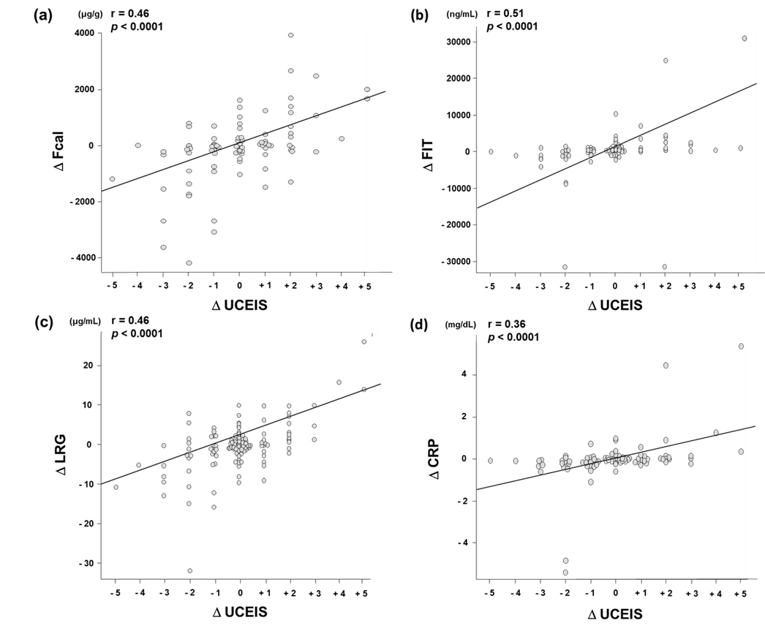

Supplemental Figure 3. Correlation between the changes in fecal/serum marker levels and the change in UCEIS
Correlation between the change in UCEIS and the changes in Fcal (a), FIT (b), serum LRG (c), and serum CRP (d) levels. UCEIS, Ulcerative Colitis Endoscopic Index of Severity; Fcal, fecal calprotectin; FIT, fecal immunochemical test; LRG, leucine-rich alpha 2 glycoprotein; CRP, C-reactive protein. Each Δ represents the amount of change. The line indicates the correlation coefficient between the changes of fecal/serum marker levels and the maximum UCEIS obtained by Spearman's rank correlation. The correlation values and P-values are shown in the upper left corner.

Supplemental Table 3. The sensitivity, specificity, and predictive value of fecal/serum markers for MES 0-1

 | AUC | Cut-off | Sensitivity | Specificity | PPV | NPV | Accuracy
Fcal | 0.79 | 251.2 µg/g | 0.72 (0.58-0.84) | 0.78 (0.71-0.85) | 0.52 (0.40-0.64) | 0.90 (0.83-0.94) | 0.77 (0.70-0.82)
FIT | 0.83 | 120 ng/mL | 0.78 (0.64-0.89) | 0.80 (0.72-0.86) | 0.56 (0.43-0.68) | 0.92 (0.86-0.96) | 0.79 (0.73-0.85)
LRG | 0.68 | 14.8 µg/mL | 0.50 (0.36-0.65) | 0.82 (0.75-0.88) | 0.48 (0.34-0.62) | 0.83 (0.76-0.89) | 0.74 (0.68-0.80)
CRP | 0.62 | 0.21 mg/dL | 0.44 (0.30-0.59) | 0.83 (0.76-0.89) | 0.46 (0.31-0.61) | 0.82 (0.75-0.88) | 0.73 (0.67-0.79)

Supplemental Table 4. The sensitivity, specificity, and predictive values of fecal/serum markers for Geboes score ( < 2.1 )
 | AUC | Cut-off | Sensitivity | Specificity | PPV | NPV | Accuracy
Fcal | 0.79 | 63.7 µg/g | 0.61 (0.51-0.70) | 0.89 (0.80-0.95) | 0.87 (0.78-0.94) | 0.64 (0.55-0.73) | 0.73 (0.67-0.79)
FIT | 0.75 | 51 ng/mL | 0.85 (0.77-0.91) | 0.64 (0.53-0.74) | 0.75 (0.67-0.82) | 0.77 (0.66-0.86) | 0.76 (0.69-0.82)
LRG | 0.67 | 12.6 µg/mL | 0.63 (0.53-0.72) | 0.65 (0.54-0.75) | 0.70 (0.60-0.78) | 0.58 (0.48-0.68) | 0.64 (0.57-0.71)
CRP | 0.62 | 0.08 mg/dL | 0.59 (0.50-0.68) | 0.60 (0.49-0.70) | 0.65 (0.55-0.74) | 0.54 (0.43-0.64) | 0.59 (0.52-0.66)

