Supplementary material:

Product titer variables preprocessing
The performance of the clones was evaluated after the 14 days fed batch. This is a point during the development pipeline that is considered to be quite accurate with respect to the performance of the cell lines to the later production stage. In this study we have collected several different measurements for evaluating the performance of the cell lines during the Ambr15 fermentation (Supplementary Table 1). We have collected 3 different titer analytics. On days 10, 12, and 14 of the fed batch fermentation, titer was measured using Cedex Bio HT Analyzer. The Cedex Bio HT Analyzer measurements were performed in several timestamps during the process in the unit of days. For example, measurements of day 10 were taken in a range of 9.5 to 10.5 days, similarly for day 12 in a range of 11.5 to 12.5 days. For day 14 since it was the last fermentation day the measurement span was in the range of 13 to 13.9 days. Therefore alignment of titer measurements across a specified set of timestamps across all samples is necessary. The titer measurements were recalculated using linear interpolation, by specifying the interpolation to take place in the timestamps days 0.5, 3, 5, 7, 10, 12 and day 13.5. For simplicity, later the day 13.5 is referred to as day 14. Supplementary Fig. 1, demonstrates how the measurements of the different days were linearly interpolated to the timestamps 0.5, 3, 5, 7, 10, 12 and 13.5 days.
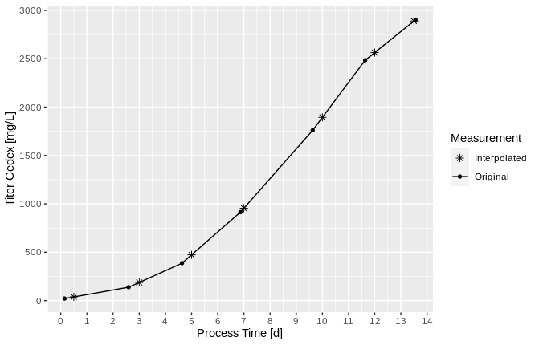
Supplementary Fig. 1: Example of original versus interpolated measurements of one sample during fermentation process.
Additional titer measurement was performed using analytical protein A chromatography on day 14. On the same day the main product quality was assessed using CE-SDS. The CE-SDS measurements give as output the amount of correctly assembled main product contained in a concentration of 100 mg/L product. Multiplying the titer measured by Cedex BioHT with the main product abundance percentage (assessed by CE-SDS or SEC) we created the measure of effective titer Cedex and similarly the effective titer Protein A. Additionally effective titer was measured directly by a native quantitative SEC-MS (qSEC-MS) chromatography and analysis of the main product amount in harvested cell culture supernatant. All these labels were used as labels to predict in the machine learning model.

Supplementary Table 1: Cell clone product titer analytics of fed-batch cultures in the Ambr15 bioreactor system.
Performance Metric | Technology | Fermentation Day | Unit | Label annotation
Titer | Cedex Bio HT Analyzer | Day 10 | mg/L | Titer Cedex Day 10
Titer | Cedex Bio HT Analyzer | Day 12 | mg/L | Titer Cedex Day 12
Titer | Cedex Bio HT Analyzer | Day 14 | mg/L | Titer Cedex Day 14
Titer | Protein A | Day 14 | mg/L | Titer Protein A
Main Product | CE-SDS (peak of main product) | Day 14 | % | MP CESDS
Effective Titer | qSEC-MS (peak of main product) | Day 14 | mg/L | Eff. Titer SECMS
Effective Titer | CE-SDS*Protein A | Day 14 | mg/L | Eff. Titer Protein A
Effective Titer | CE-SDS*Cedex Bio HT Analyzer | Day 14 | mg/L | Eff. Titer Cedex Day 14
Titer Cedex Day 10, Titer Cedex Day 12, Titer Cedex Day 14: product titer measurements acquired using Cedex Bio HT Analyzer during fed-batch fermentation days 10, 12 and 14, Titer Protein A: product titer measurements acquired from analytical protein A chromatography on fed-batch fermentation day 14. MP CESDS: product quality measurements acquired by main product quantification using capillary electrophoresis sodium dodecyl sulfate on fermentation day 14. Eff. Titer SECMS: effective titer measurements acquired using size exclusion chromatography coupled with mass spectrometry on fed-batch fermentation day 14. Eff. Titer Protein A and Eff. Titer Cedex Day 14 are effective titer measurements derived from multiplication of Titer Protein A by MP CESDS and Titer Cedex Day 14 by MP CESDS respectively.

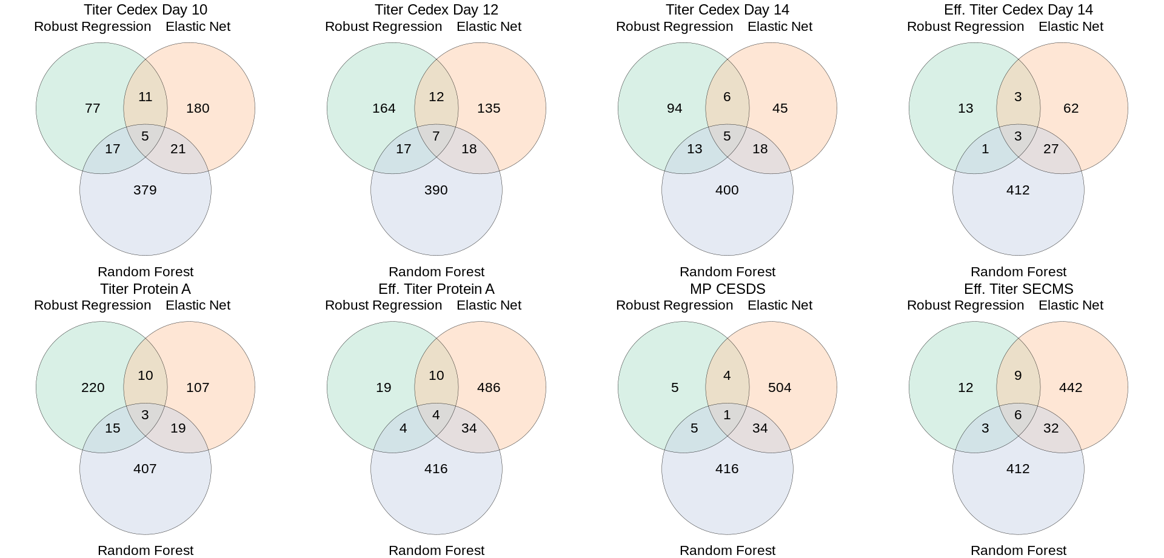
Supplementary Fig. 2: Venn-diagram for comparing the significant gene generated by in each statistical approach and each product titer variable.

Supplementary Table 2: Intersection genes of the three different statistical approaches. Pearson correlation coefficient between the gene levels and each product titer variable.
Titer.Cedex.Day.10 |  |  |  |  | Titer.Cedex.Day.12
 | Pearson correlation at a clonal level |  | Average value per project dataset |  |  | Pearson correlation at a clonal level |  | Average value per project dataset
Genes | r | r2 | r | r2 | Genes | r | r2 | r | r2
Cnpy3 | -0.57 | 0.32 | -0.97 | 0.94 | Cnpy3 | -0.55 | 0.3 | -0.96 | 0.92
Lamb1 | -0.43 | 0.18 | -0.87 | 0.76 | Lamb1 | -0.45 | 0.2 | -0.92 | 0.85
Hspa5 | -0.48 | 0.23 | -0.68 | 0.46 | LOC113834280 | 0.32 | 0.1 | 0.72 | 0.52
LOC107978477 | -0.28 | 0.08 | -0.48 | 0.23 | Hspa5 | -0.42 | 0.18 | -0.62 | 0.38
Runx2 | -0.25 | 0.06 | -0.33 | 0.11 | Igf2r | -0.29 | 0.08 | -0.53 | 0.28
 |  |  |  |  | Runx2 | -0.25 | 0.06 | -0.33 | 0.11
 |  |  |  |  | Hsf5 | -0.1 | 0.01 | -0.15 | 0.02
Titer.Cedex.Day.14 |  |  |  |  | Eff..Titer.Cedex.Day.14
 | Pearson correlation at a clonal level |  | Average value per project dataset |  |  | Pearson correlation at a clonal level |  | Average value per project dataset
Genes | r | r2 | r | r2 | Genes | r | r2 | r | r2
Cnpy3 | -0.53 | 0.28 | -0.95 | 0.9 | Ptgfrn | -0.43 | 0.18 | -0.8 | 0.64
Ppfibp1 | -0.41 | 0.17 | -0.77 | 0.59 | Igf2r | -0.28 | 0.08 | -0.6 | 0.36
Ppic | -0.3 | 0.09 | -0.63 | 0.4 | Rcor3 | 0.17 | 0.03 | 0.42 | 0.18
Igf2r | -0.3 | 0.09 | -0.57 | 0.32
Traf5 | 0.1 | 0.01 | -0.15 | 0.02
Titer.Protein.A |  |  |  |  | Eff..Titer.Protein.A
 | Pearson correlation at a clonal level |  | Average value per project dataset |  |  | Pearson correlation at a clonal level |  | Average value per project dataset
Genes | r | r2 | r | r2 | Genes | r | r2 | r | r2
Pofut1 | -0.25 | 0.06 | -0.57 | 0.32 | Apmap | -0.28 | 0.08 | -0.76 | 0.58
Xpnpep2 | 0.22 | 0.05 | 0.26 | 0.07 | Rcor3 | 0.18 | 0.03 | 0.49 | 0.24
Igf2r | -0.21 | 0.04 | -0.16 | 0.03 | Ppic | -0.25 | 0.06 | -0.44 | 0.19
 |  |  |  |  | Igf2r | -0.2 | 0.04 | -0.23 | 0.05
MP.CESDS |  |  |  |  | Eff..Titer.SECMS
 | Pearson correlation at a clonal level |  | Pearson correlation at a format level |  |  | Pearson correlation at a clonal level |  | Pearson correlation at a format level
Genes | r | r2 | r | r2 | Genes | r | r2 | r | r2
Galnt10 | -0.26 | 0.07 | -0.47 | 0.22 | Slc38a10 | -0.5 | 0.25 | -0.92 | 0.85
 |  |  |  |  | Cnpy3 | -0.4 | 0.16 | -0.75 | 0.56
 |  |  |  |  | Fkbp9 | -0.27 | 0.07 | -0.65 | 0.42
 |  |  |  |  | Igf2r | -0.24 | 0.06 | -0.37 | 0.14
 |  |  |  |  | Gpatch2 | 0.2 | 0.04 | 0.28 | 0.08
 |  |  |  |  | Tp63 | 0.17 | 0.03 | 0.1 | 0.01
Statistical methods used for the identification of biomarkers: Robust regression, Elastic Net Regression and Random Forest regression. Pearson correlation at a clonal level: correlation between the gene expression levels versus each product titer analytics measurement in the complete set of the 9 different datasets (Datasets 1-9) consisting of clonal data points. Pearson correlation at a format level: correlation between the average gene expression levels versus the average of each product titer analytics measurement per format pool across the 9 project dataset (Datasets 1-9). Titer Cedex Day 10, Titer Cedex Day 12, Titer Cedex Day 14: product titer measurements acquired using Cedex Bio HT Analyzer during fed-batch fermentation days 10, 12 and 14, Titer Protein A: product titer measurements acquired from analytical protein A chromatography on fed-batch fermentation day 14. MP CESDS: product quality measurements acquired by main product quantification using capillary electrophoresis sodium dodecyl sulfate on fermentation day 14. Eff. Titer SECMS: effective titer measurements acquired using size exclusion chromatography coupled with mass spectrometry on fed-batch fermentation day 14. Eff. Titer Protein A and Eff. Titer Cedex Day 14 are effective titer measurements derived from multiplication of Titer Protein A by MP CESDS and Titer Cedex Day 14 by MP CESDS respectively.

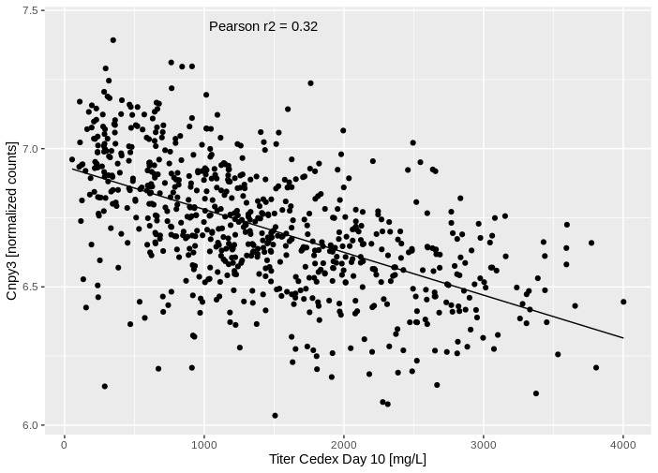
Supplementary Figure 3: Linear correlation of Titer Cedex Day 10 versus Cnpy3 gene expression using clonal data points. A negative correlation between the two variables is shown with Pearson r2 = 0.32.

Identification of additional genes from one or two statistical methods

Apart from the genes identified using the three different statistical methods, robust regression, elastic net regression and random forest regression, there are additional genes identified by one (Random Forest, Robust Regression, Elastic Net) or two methods (Random Forest-Elastic Net, Random Forest - Robust regression, Robust Regression - Elastic Net). We selected as top genes those that are in the top 10% of the R² values and are identified in three or more of the 8 product titer labels studied (Titer Cedex Day 10, Titer Cedex Day 12, Titer.Cedex.Day.14, Titer.Protein.A, Eff..Titer.SECMS, Eff..Titer Cedex.Day.14). We set as threshold the top 10 percentile of the genes R², to reduce the number of genes to a manageable number that prioritizes the genes that show the highest correlation to the product titer variables. In total, we identified 27 genes (Ppp6c, Cops2, Znf768, Trim46, C1qtnf1, LOC113835967, Alg6, Capza1, Mirlet7a, Nfe2l1, Tbc1d19, LOC100773044, Phyh, Syne3, Znf639, Chid1, Erp29, LOC103158671, LOC113833053, Tedc1, Arl8b, Sh3bgrl, Chpt1, Tlr4, LOC113831255, Plaur, LOC113833088) additional to those identified by all three statistical methods. Supplementary Table 1, shows the 27 genes among the correlation coefficients, the product titer variables they are detected and the statistical methods that detected them. Supplementary Figures 1-27, depict the correlation of the average gene expression to the average product titer variable along with the overlapping validation projects.

Supplementary Table 3: Genes identified by one or two statistical methods, detected to three or more product titer variables that represent the top 10% of highest R² values.

 | Genes | Titer variable with highest R2 | Pearson.r.at a clonal level | Pearson.r2.at a clonal level | Pearson.r.at a format level | Pearson.r2.at a format level | Models | Rest of titer variables detected
1 | Ppp6c | Titer Cedex Day 12 | 0.54 | 0.29 | 0.98 | 0.96 | Random Forest | Titer Cedex Day 10, Titer Cedex Day 14, Eff. Titer SECMS, Eff. Titer Cedex Day 14
2 | Cops2 | Titer Cedex Day 12 | 0.56 | 0.31 | 0.97 | 0.94 | Random Forest | Titer Cedex Day 10, Eff. Titer SECMS
3 | Znf768 | Titer Cedex Day 10 | -0.52 | 0.27 | -0.97 | 0.94 | Random Forest | Titer Cedex Day 12, Titer Cedex Day 14, Eff. Titer SECMS, Eff. Titer Protein A
4 | Trim46 | Titer Cedex Day 10 | -0.3 | 0.09 | -0.96 | 0.92 | Robust Regression | Titer Cedex Day 12, Titer Cedex Day 14
5 | C1qtnf1 | Titer Cedex Day 14 | -0.45 | 0.2 | -0.95 | 0.9 | Random Forest | Titer Cedex Day 10, Titer Cedex Day 12, Eff. Titer Cedex Day 14
6 | LOC113835967 | Titer Cedex Day 12 | 0.34 | 0.12 | 0.94 | 0.88 | Random Forest | Eff. Titer SECMS, Eff. Titer Protein A
7 | Alg6 | Titer Cedex Day 14 | 0.55 | 0.3 | 0.93 | 0.86 | Elastic Net, Random Forest | Titer Cedex Day 10, Titer Cedex Day 12, Titer Protein A
8 | Capza1 | Titer Cedex Day 12 | 0.56 | 0.31 | 0.93 | 0.86 | Random Forest | Titer Cedex Day 10, Titer Cedex Day 14, Titer Protein A, Eff. Titer SECMS, Eff. Titer Protein A, Eff. Titer Cedex Day 14
9 | Mirlet7a | Eff. Titer SECMS | 0.32 | 0.1 | 0.92 | 0.85 | Elastic Net, Random Forest | Titer Cedex Day 12, Titer Cedex Day 14, Titer Protein A, Eff. Titer SECMS, Eff. Titer Protein A, Eff. Titer Cedex Day 14
10 | Nfe2l1 | Titer Cedex Day 10 | -0.43 | 0.18 | -0.92 | 0.85 | Random Forest | Titer Cedex Day 10, Titer Cedex Day 14, Eff. Titer Cedex Day 14
11 | Tbc1d19 | Titer Cedex Day 10 | 0.48 | 0.23 | 0.92 | 0.85 | Random Forest | Titer Cedex Day 12, Titer Cedex Day 14
12 | LOC100773044 | Eff. Titer SECMS | 0.18 | 0.03 | 0.9 | 0.81 | Random Forest | Titer Cedex Day 10, Eff. Titer Cedex Day 14, MP CESDS
13 | Phyh | Titer Cedex Day 14 | 0.34 | 0.12 | 0.9 | 0.81 | Random Forest | Titer Cedex Day 12, Eff. Titer Cedex Day 14
14 | Syne3 | Titer Cedex Day 14 | -0.4 | 0.16 | -0.9 | 0.81 | Random Forest | Titer Cedex Day 10, Eff. Titer Cedex Day 14
15 | Znf639 | Titer Cedex Day 10 | 0.46 | 0.21 | 0.9 | 0.81 | Random Forest | Titer Cedex Day 12, Eff. Titer SECMS, Eff. Titer Cedex Day 14
16 | Chid1 | Titer Cedex Day 10 | -0.54 | 0.29 | -0.89 | 0.79 | Random Forest | Titer Cedex Day 12, Titer Cedex Day 14, Eff. Titer Cedex Day 14
17 | Erp29 | Eff. Titer Cedex Day 14 | -0.48 | 0.23 | -0.89 | 0.79 | Elastic Net, Random Forest | Titer Cedex Day 10, Titer Cedex Day 12
18 | LOC103158671 | Titer Cedex Day 14 | 0.18 | 0.03 | 0.89 | 0.79 | Random Forest | Titer Protein A, Eff. Titer Protein A, Eff. Titer Cedex Day 14
19 | LOC113833053 | Titer Cedex Day 10 | 0.5 | 0.25 | 0.89 | 0.79 | Elastic Net, Random Forest | Titer Cedex Day 12, Titer Cedex Day 14, Eff. Titer SECMS, Eff. Titer Protein A, Eff. Titer Cedex Day 14
20 | Tedc1 | Eff. Titer SECMS | -0.45 | 0.2 | -0.89 | 0.79 | Random Forest | Titer Cedex Day 12, Eff. Titer Cedex Day 14
21 | Arl8b | Titer Cedex Day 10 | 0.5 | 0.25 | 0.88 | 0.77 | Elastic Net | Titer Cedex Day 12, Titer Cedex Day 14, Titer Protein A, Eff. Titer SECMS, Eff. Titer Cedex Day 14
22 | Sh3bgrl | Eff. Titer SECMS | 0.47 | 0.22 | 0.88 | 0.77 | Random Forest | Titer Cedex Day 10, Eff. Titer Cedex Day 14
23 | Chpt1 | Titer Cedex Day 10 | 0.46 | 0.21 | 0.87 | 0.76 | Robust Regression | Titer Cedex Day 12, Titer Cedex Day 14, Titer Protein A
24 | Tlr4 | Titer Cedex Day 14 | 0.53 | 0.28 | 0.86 | 0.74 | Random Forest | Titer Cedex Day 10, Eff. Titer Cedex Day 14
25 | LOC113831255 | Titer Cedex Day 10 | -0.15 | 0.02 | -0.85 | 0.72 | Robust Regression | Titer Cedex Day 12, Titer Cedex Day 14, Titer Protein A
26 | Plaur | Eff. Titer Cedex Day 14 | -0.44 | 0.19 | -0.84 | 0.71 | Elastic Net, Random Forest | Titer Cedex Day 10, Titer Cedex Day 12, Titer Cedex Day 14, Eff. Titer SECMS, Eff. Titer Protein A, MP CESDS
27 | LOC113833088 | Titer Cedex Day 14 | -0.45 | 0.2 | -0.83 | 0.69 | Random Forest | Titer Cedex Day 10, Titer Cedex Day 12, Titer Protein A, Eff. Titer SECMS, Eff. Titer Cedex Day 14
Statistical methods used for the identification of biomarkers: Robust regression, Elastic Net Regression and Random Forest regression. Pearson correlation at a clonal level: correlation between the gene expression levels versus each product titer analytics measurement in the complete set of the 9 different datasets (Datasets 1-9) consisting of clonal data points. Pearson correlation at a format level: correlation between the average gene expression levels versus the average of each product titer analytics measurement per format pool across the 9 project dataset (Datasets 1-9). Titer Cedex Day 10, Titer Cedex Day 12, Titer Cedex Day 14: product titer measurements acquired using Cedex Bio HT Analyzer during fed-batch fermentation days 10, 12 and 14, Titer Protein A: product titer measurements acquired from analytical protein A chromatography on fed-batch fermentation day 14. MP CESDS: product quality measurements acquired by main product quantification using capillary electrophoresis sodium dodecyl sulfate on fermentation day 14. Eff. Titer SECMS: effective titer measurements acquired using size exclusion chromatography coupled with mass spectrometry on fed-batch fermentation day 14. Eff. Titer Protein A and Eff. Titer Cedex Day 14 are effective titer measurements derived from multiplication of Titer Protein A by MP CESDS and Titer Cedex Day 14 by MP CESDS respectively.

Supplementary Table 4: Significant genes identified by each of the three statistical methods for all of the product titer analytics.

SupplementaryTable4_Papadaki_et_al.xlsx

Statistical methods used for the identification of biomarkers: Robust regression, Elastic Net Regression and Random Forest regression. Thresholds applied per method: Robust regression: the genes with adjusted P-value < 0.05, Elastic net regression: the genes with a coefficient different from zero, Random forest regression: the genes that gather 5% of the cumulative feature importance. Pearson correlation at a clonal level: correlation between the gene expression levels versus each product titer analytics measurement in the complete set of the 9 different datasets (Datasets 1-9) consisting of clonal data points. Pearson correlation at a format level: correlation between the average gene expression levels versus the average of each product titer analytics measurement per format pool across the 9 project dataset (Datasets 1-9).
Each sheet includes the above information for each product titer variable measured: Titer Cedex Day 10, Titer Cedex Day 12, Titer Cedex Day 14, Titer Protein A, MP CESDS, Eff. Titer SECMS, Eff. Titer Protein A and Eff. Titer Cedex Day 14. For more information on the product titer analytics see Supplementary Table 1.

Supplementary Table 5: Comprehensive information about the genes identified as biomarkers associated with product titer analytics.

SupplementaryTable5_Papadaki_et_al.xlsx

Gene_Symbol: Primary gene name, Gene_Synonyms: additional gene names of the same gene, UniProt_Acc_Name: Primary accession name, Function: General function(s) of the protein encoded by the gene. GO_CellularComponent: A location of the product gene, relative to cellular compartments and structures, GO_BiologicalProcess: The larger processes, or ‘biological programs’ that the gene functions in. GO_MolecularFunction: Molecular-level activities performed by gene products. Gene_Symbol, Gene_Synonyms, UniProt_Acc_Name and Function information is retrieved from the UniProt database (https://www.uniprot.org/) using mus musculus as an organism. GO_CellularComponent, GO_BiologicalProcess and GO_MolecularFunction information is retrieved from g:Profiler and the R client library goProfiler2 (https://biit.cs.ut.ee/gprofiler/page/r)

Supplementary Table 6: Types of mAb formats collected and number of samples per data set. *Data set 8 consists of samples expressing a pentamer protein.
Dataset Name | mAb format | Number of transfection pools | Number of cell clones initially collected | Final number of cell clones | Loss percentage
Project 1 | 2+1 T cell bispecific antibody | 2 | 93 | 80 | 13.98
Project 2 | 2+1 T cell bispecific antibody | 2 | 82 | 73 | 10.98
Project 3 | 1+1 bispecific antibody | 2 | 89 | 83 | 6.74
Project 4 | 1+1 ectodomain fusion antibody | 2 | 96 | 93 | 3.13
Project 5 | 2+1 brain shuttle antibody | 2 | 96 | 84 | 12.50
Project 6 | 3+1 bispecific antibody | 3 | 91 | 63 | 30.77
Project 7 | bispecific dutaFab | 2 | 96 | 85 | 11.46
Project 8 | pentamer protein | 2 | 96 | 79 | 17.71
Project 9 | generic antibody | 2 | 95 | 88 | 7.37
Project 10 | 2+1 T cell bispecific antibody | 2 | 94 | 84 | 10.64
Project 11 | 2+1 bispecific antibody | 2 | 81 | 80 | 1.23
Average |  |  | 91.73 | 81.09 | 11.5
Total |  |  | 1009 | 892

Project 1-11: dataset collected per each different mAb format, mAb format: type of monoclonal antibody examined per project, Number of cell clones initially collected: number of clones collected during monoclonal CHO cell lines culture, Final number of cell clones: number of clones that survived after seed-train and fed-batch production assay, Loss percentage: percentage of clones lost per project due to technical issues.

