Supporting Information

Effects of organic salts of virucidal and antiviral compounds from Nelumbo nucifera and Kaempferia parviflora against SARS-CoV-2
Dan-Dan Yang, Nopporn Chutiwitoonchai, Feng Wang, Ping Tian, Sanya Sureram,
Xiaoguang Lei, Chulabhorn Mahidol, Somsak Ruchirawat, Prasat Kittakoop

Table of Contents Page
Figure S1. ¹H NMR spectrum of LotZ-H 1
Figure S2. ¹H NMR spectrum of LotZ-C1 1
Figure S3 ¹H NMR spectrum of LotZ-C2 2
Figure S4 ¹H NMR spectrum of LotZ-M 2
Figure S5 ¹H NMR spectrum of isolated compounds Lot A5C1 and Lot B4L1, and
neferine standard 3
Figure S6 ¹³C NMR spectrum of isolated compounds Lot A5C1 and Lot B4L1, and
neferine standard 4
Figure S7 ¹H NMR spectrum of neferine salt (2) 5
Figure S8 ¹³C NMR spectrum of neferine salt (2) 5
Figure S9 ¹H NMR spectrum of nuciferine salt (4) 6
Figure S10 ¹³C NMR spectrum of nuciferine salt (4) 6
Figure S11 ¹H NMR spectrum of compound (5) 7
Figure S12 ¹³C NMR spectrum of compound (5) 7
Figure S13 ¹H NMR spectrum of compound (6) 8
Figure S14 ¹³C NMR spectrum of compound (6) 8
Figure S15 ¹H NMR spectrum of compound (7) 9
Figure S16 ¹³C NMR spectrum of compound (7) 9
Figure S17 ¹H NMR spectrum of compound (8) 10
Figure S18 ¹³C NMR spectrum of compound (8) 10
Figure S19 ¹H NMR spectrum of compound (9) 11
Figure S20 ¹³C NMR spectrum of compound (9) 11
Figure S21 ¹H NMR spectrum of compound (10) 12
Figure S22 ¹³C NMR spectrum of compound (10) 12
Figure S23 ¹H NMR spectrum of compound (11) 13
Figure S24 ¹³C NMR spectrum of compound (11) 13
Figure S25 ¹H NMR spectrum of compound (12) 14
Figure S26 ¹³C NMR spectrum of compound (12) 14
Figure S27 ¹H NMR spectrum of compound (13) 15
Figure S28 ¹³C NMR spectrum of compound (13) 15
Table S1. Inhibitory activity of compounds (5) – (13) against SARS-CoV-2 3CL^{pro} 16

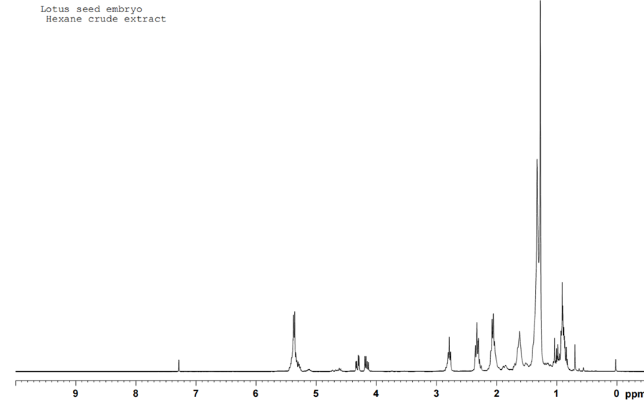
Figure S1. ¹H NMR spectrum (300 MHz, in CDCl₃) of a crude hexane extract (LotZ-H) from N. nucifera seed embryo

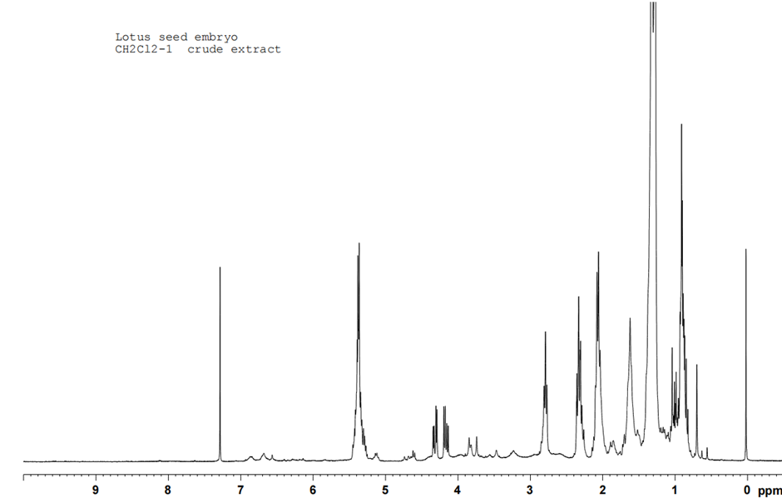
Figure S2. ¹H NMR spectrum (300 MHz, in CDCl₃) of a crude extract (LotZ-C1), the first extraction with dichloromethane, from N. nucifera seed embryo
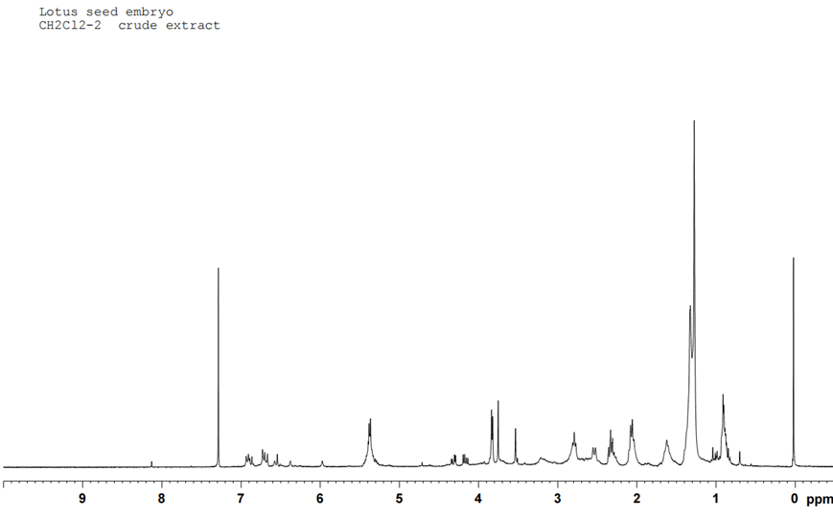
Figure S3. ¹H NMR spectrum (300 MHz, in CDCl₃) of a second crude extract (LotZ-C2), the second extraction with dichloromethane, from N. nucifera seed embryo

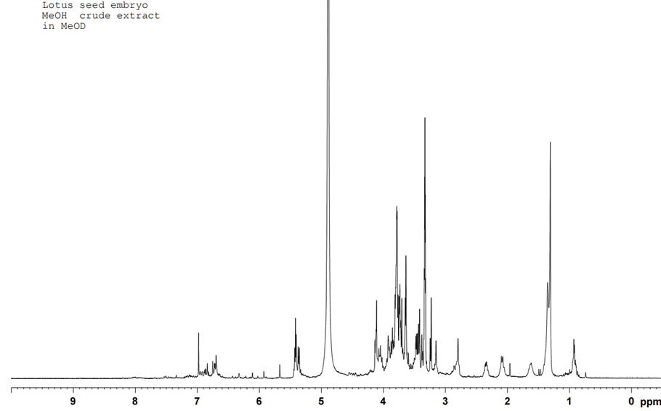
Figure S4. ¹H NMR spectrum (300 MHz, in CDCl₃) of a crude methanol extract (LotZ-M) from N. nucifera seed embryo
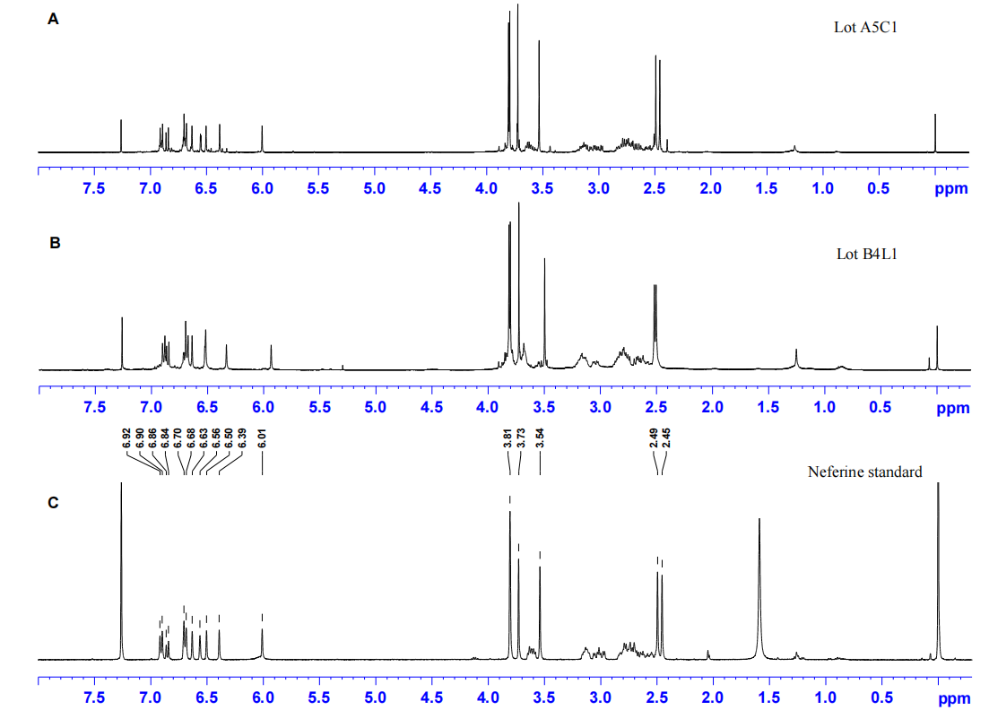
Figure S5. ¹H NMR spectrum (400 MHz, in CDCl₃) of two isolated compounds (A. Lot A5C1 and B. Lot B4L1) and (C) neferine standard.

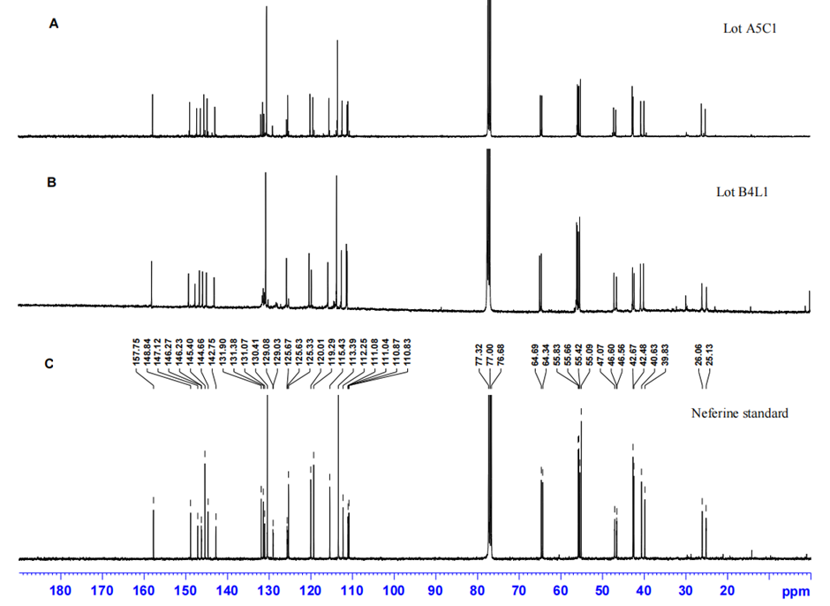
Figure S6. ¹³C NMR spectrum (400 MHz, in CDCl₃) of two isolated compounds (A. Lot A5C1 and B. Lot B4L1) and (C) neferine standard.

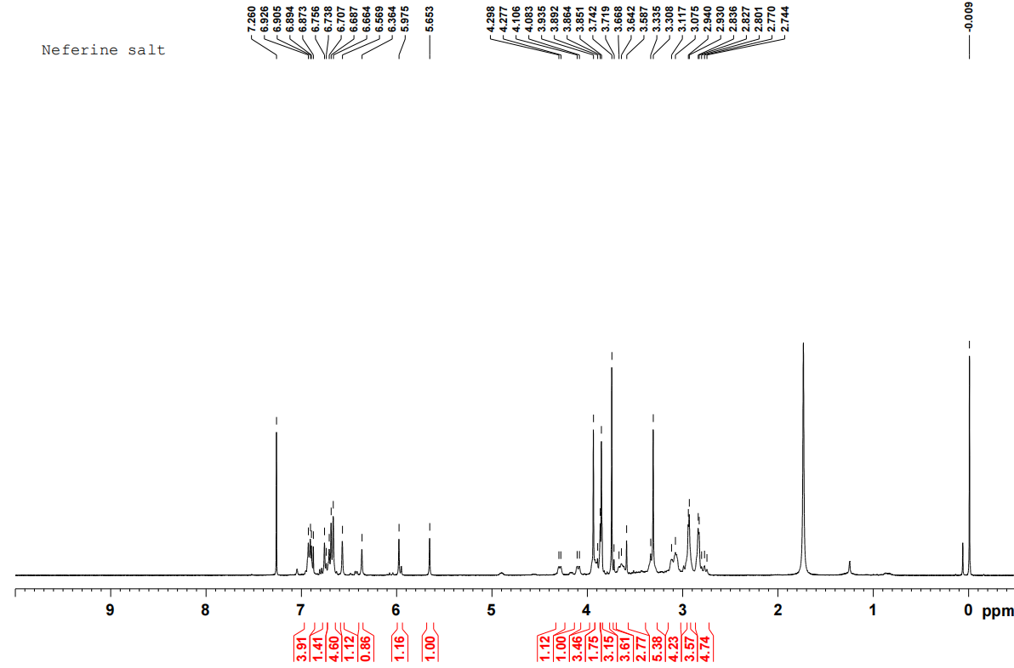
Figure S7. ¹H NMR spectrum (400 MHz, in CDCl₃) of neferine salt (2)
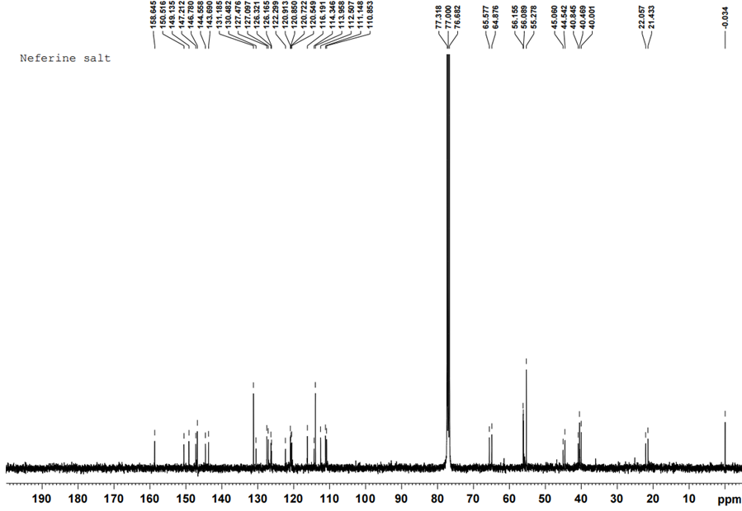
Figure S8. ¹³C NMR spectrum (400 MHz, in CDCl₃) of neferine salt (2)
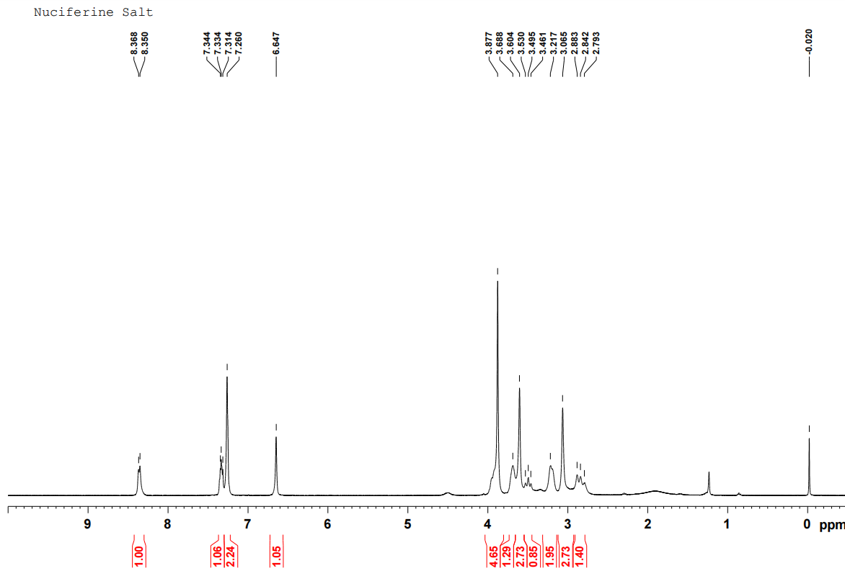 Figure S9. ¹H NMR spectrum (400 MHz, in CDCl₃) of nuciferine salt (4)
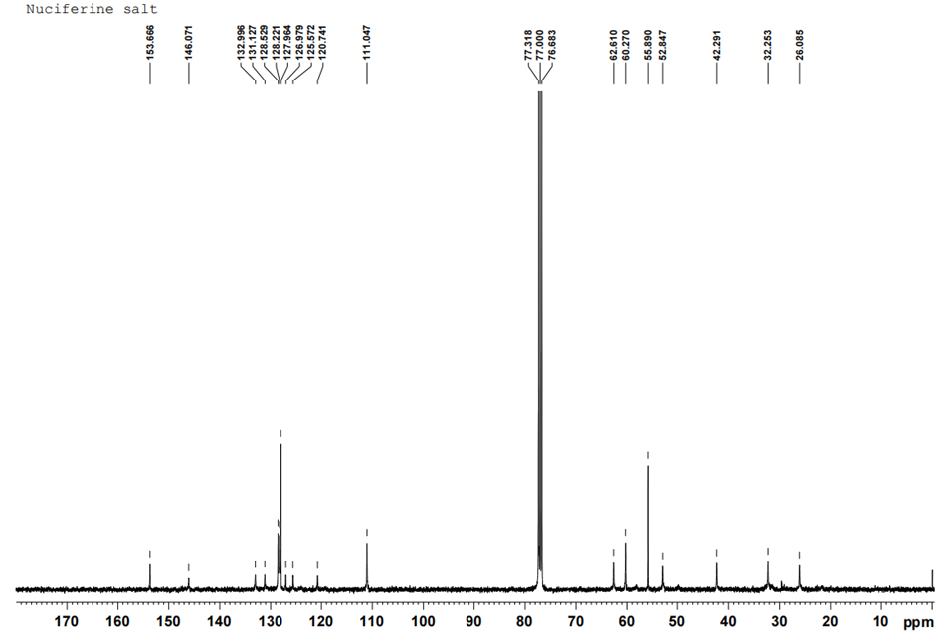
Figure S10. ¹³C NMR spectrum (400 MHz, in CDCl₃) of nuciferine salt (4)
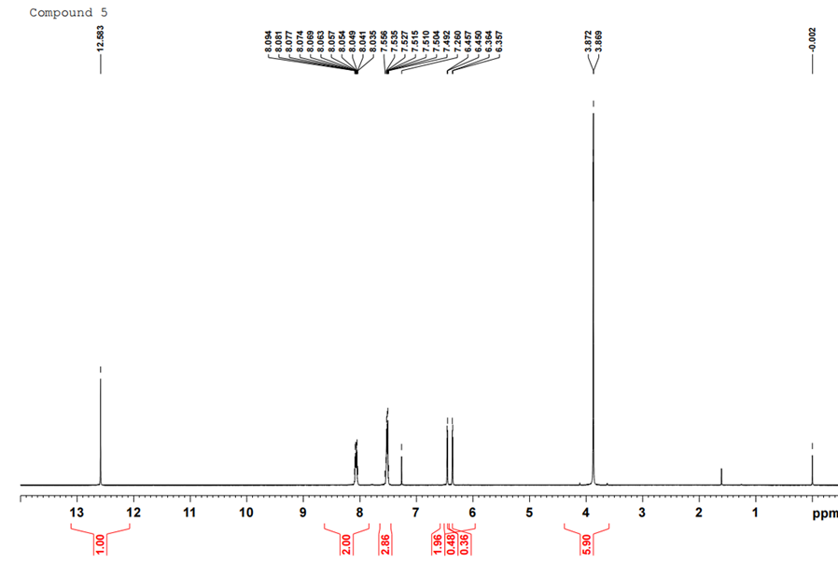
Figure S11. ¹H NMR spectrum (300 MHz, in CDCl₃) of 5-hydroxy-3,7-dimethoxyflavone (5)
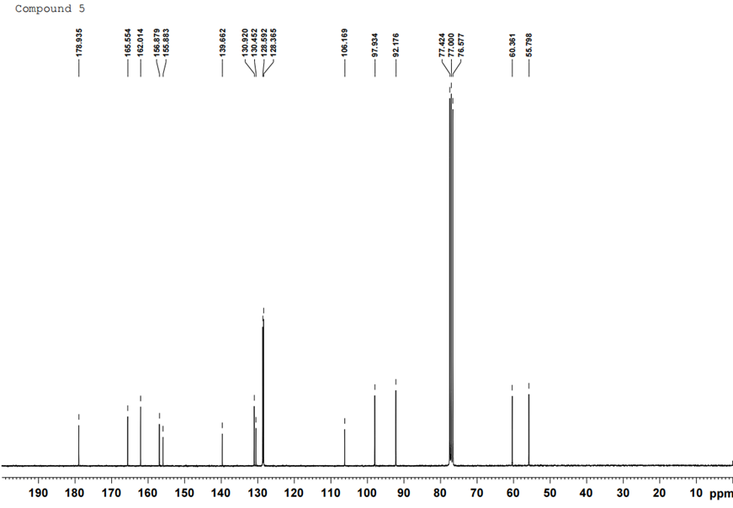
Figure S12. ¹³C NMR spectrum (300 MHz, in CDCl₃) of 5-hydroxy-3,7-dimethoxyflavone (5)

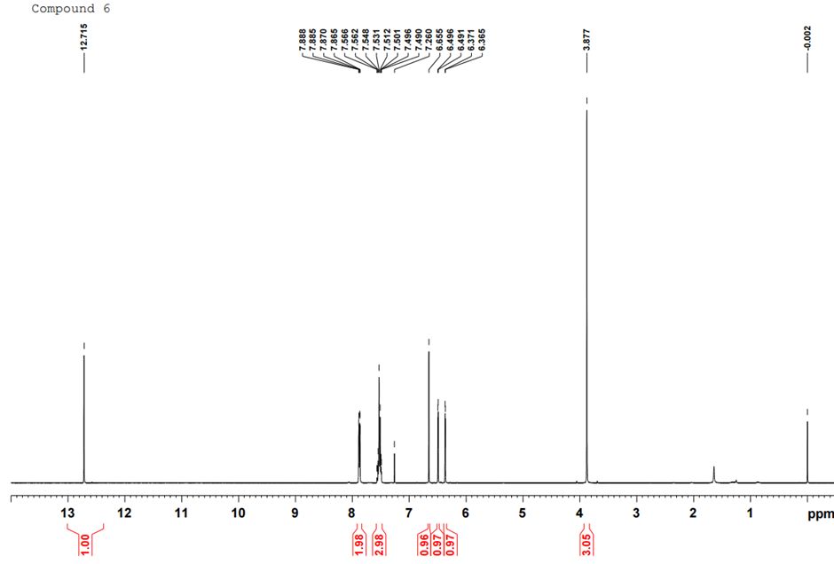
Figure S13. ¹H NMR spectrum (300 MHz, in CDCl₃) of 5-hydroxy-7-methoxyflavone (6)
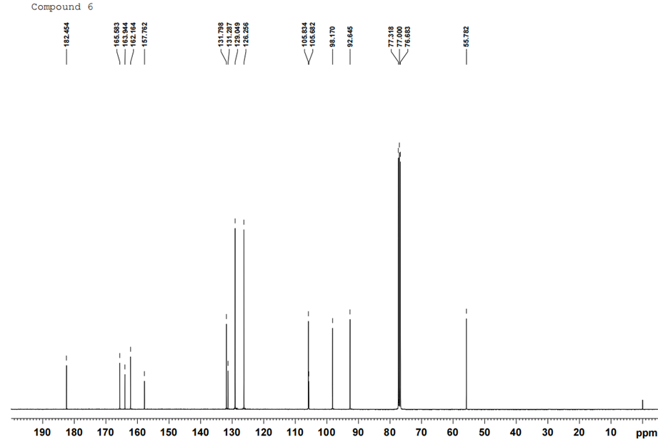Figure S14. ¹³C NMR spectrum (300 MHz, in CDCl₃) of 5-hydroxy-7-methoxyflavone (6)
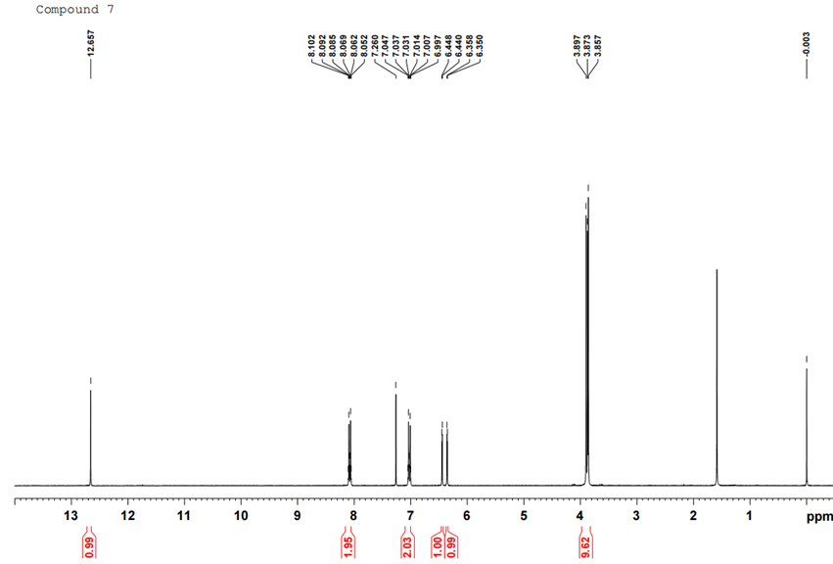
Figure S15. ¹H NMR spectrum (300 MHz, in CDCl₃) of 5-hydroxy-3,7,4'-trimethoxyflavone (7)

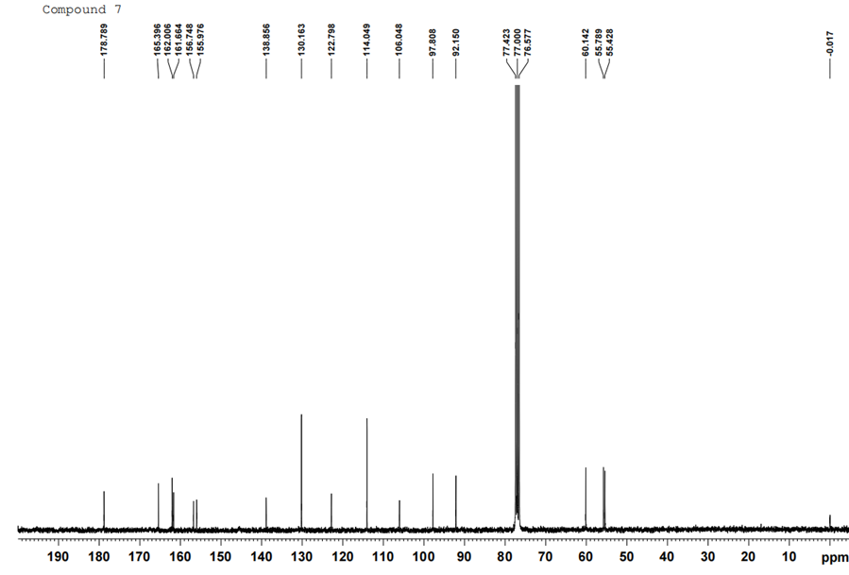
Figure S16. ¹³C NMR spectrum (300 MHz, in CDCl₃) of 5-hydroxy-3,7,4'-trimethoxyflavone (7)
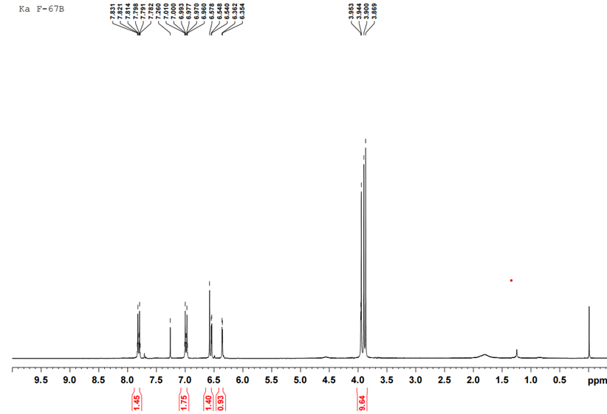
Figure S17. ¹H NMR spectrum (400 MHz, in CDCl₃) of 5,7,4'-trimethoxyflavone (8)
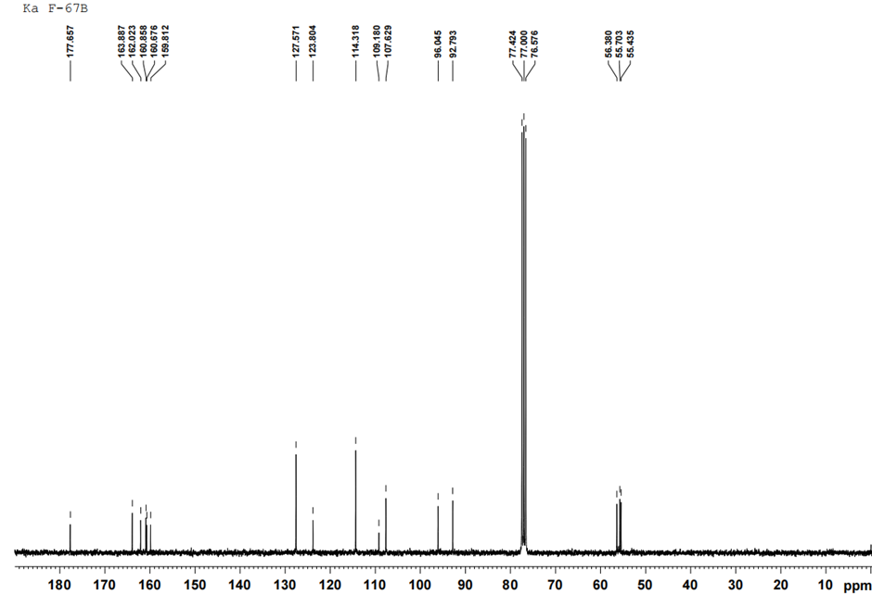Figure S18. ¹³C NMR spectrum (400 MHz, in CDCl₃) of 5,7,4'-trimethoxyflavone (8)
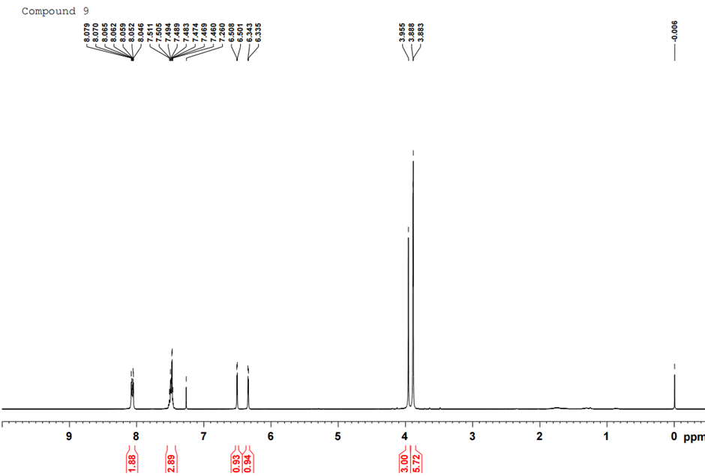
Figure S19. ¹H NMR spectrum (400 MHz, in CDCl₃) of 3,5,7- trimethoxyflavone (9)
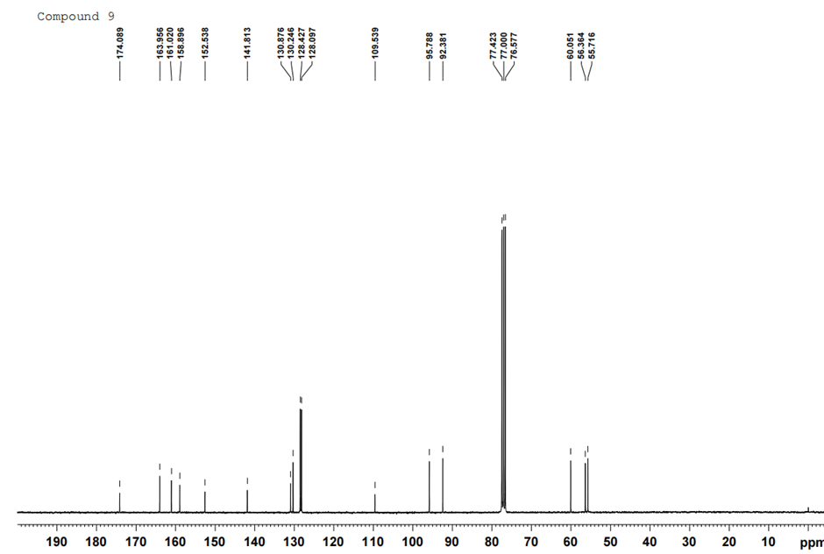Figure S20. ¹³C NMR spectrum (400 MHz, in CDCl₃) of 3,5,7- trimethoxyflavone (9)
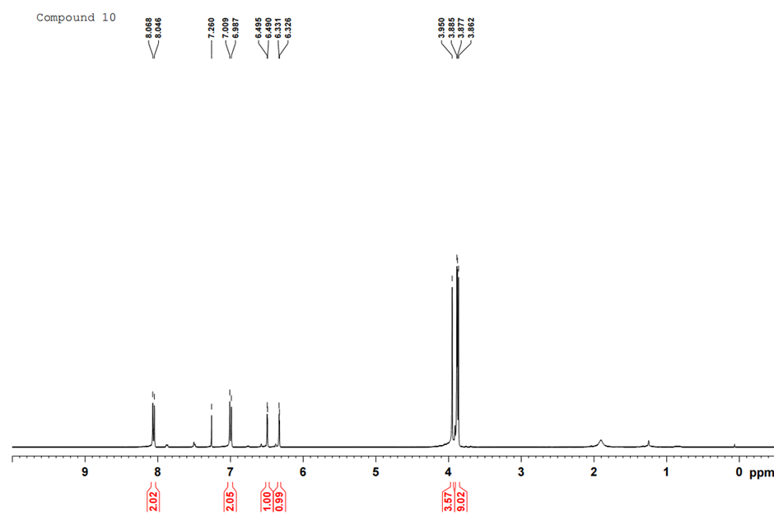
Figure S21. ¹H NMR spectrum (400 MHz, in CDCl₃) of 3,5,7,4'-tetramethoxyflavone (10)
Figure S22. ¹³C NMR spectrum (400 MHz, in CDCl₃) of 3,5,7,4'-tetramethoxyflavone (10)
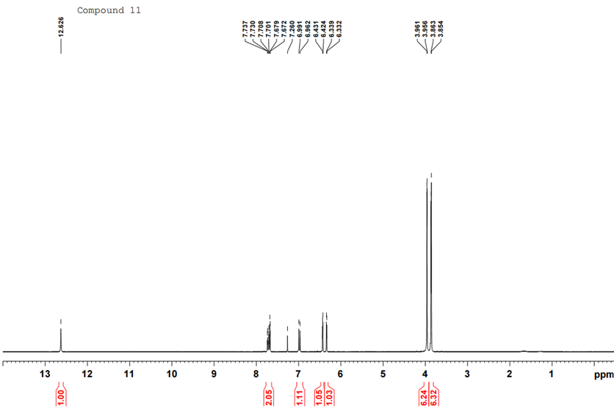
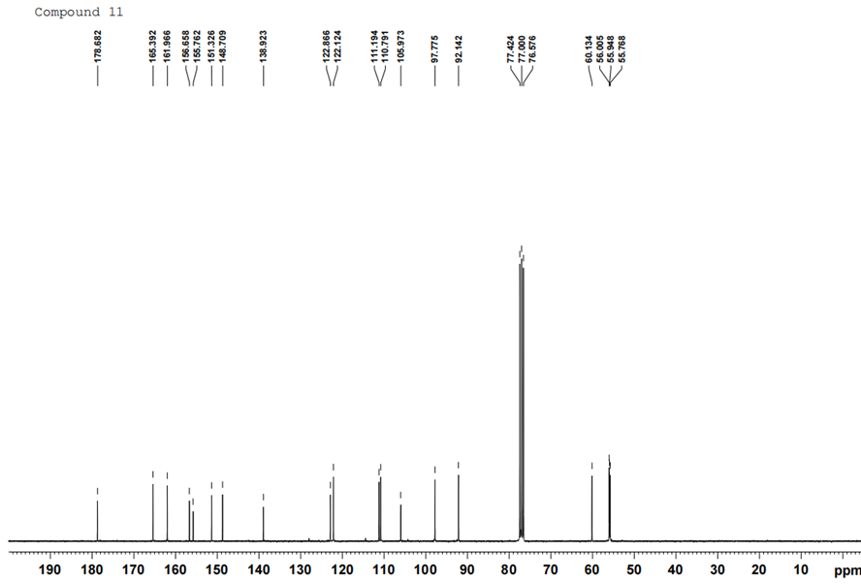
Figure S23. ¹H NMR spectrum (400 MHz, in CDCl₃) of 5-hydroxy-3,7,3',4' tetramethoxyflavone (11)
Figure S24. ¹³C NMR spectrum (400 MHz, in CDCl₃) of 5-hydroxy-3,7,3',4'-tetramethoxyflavone (11)
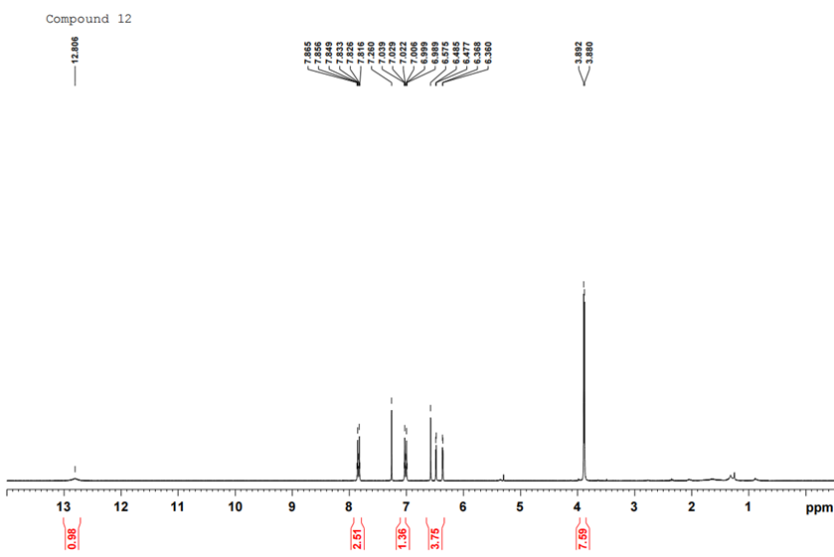
Figure S25. ¹H NMR spectrum (400 MHz, in CDCl₃) of 5-hydroxy-7,4'- dimethoxyflavone (12)
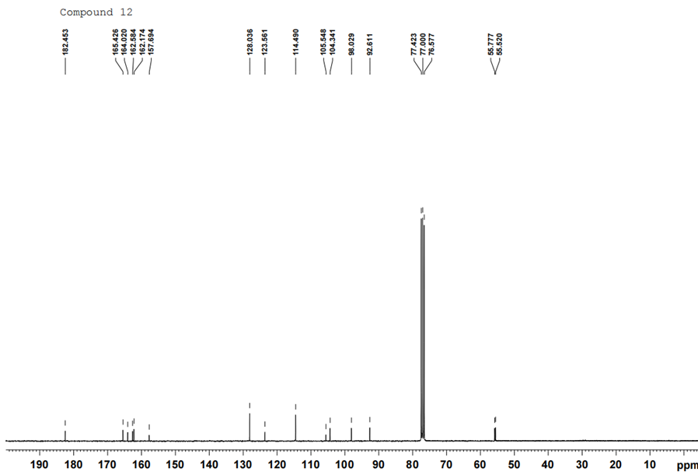
Figure S26. ¹³C NMR spectrum (400 MHz, in CDCl₃) of 5-hydroxy-7,4'- dimethoxyflavone (12)
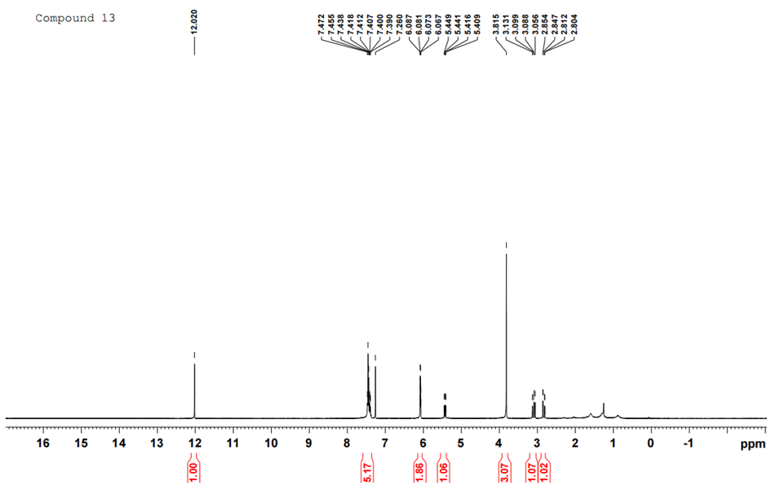
Figure S27. ¹H NMR spectrum (400 MHz, in CDCl₃) of pinostrobin (13)
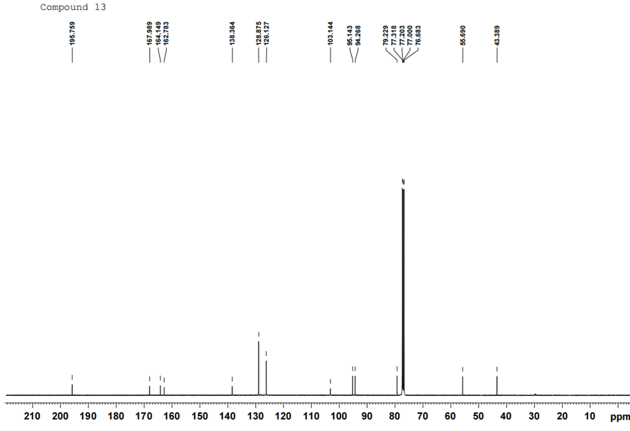Figure S28. ¹³C NMR spectrum (400 MHz, in CDCl₃) of pinostrobin (13)

Table S1. Inhibitory activity of nine flavonoids (5-13) isolated from K. parviflora rhizomes against SARS-CoV-2 3CL^{pro}
Compound. | SARS-CoV-2 3CL^{pro} inhibition activity (%)
Compound. | 100 μM | 10 μM
(5) | 7.44 ± 6.72 | 3.04 ± 5.46
(6) | 10.91 ± 6.64 | 2.12 ± 4.07
(7) | 12.50 ± 5.96 | 0.90 ± 4.87
(8) | / | -46.40 ± 7.63
(9) | -13.70 ± 7.16 | -9.08 ± 5.95
(10) | -6.57 ± 6.39 | 0.40 ± 4.89
(11) | 16.10 ± 6.47 | 5.84 ± 6.46
(12) | 10.64 ± 6.98 | 3.99 ± 5.17
(13) | 7.82 ± 6.30 | 1.28 ± 4.82
Myricetinª | 100.42 ± 1.95 | 99.74 ± 0.30
PF-07321332ª | 99.77 ± 0.25 | 99.47 ± 0.21
ª Myricetin and PF-07321332 were used as controls.

