Supplementary Figure 1. Representative flowchart illustrating the selection of patients for this study.

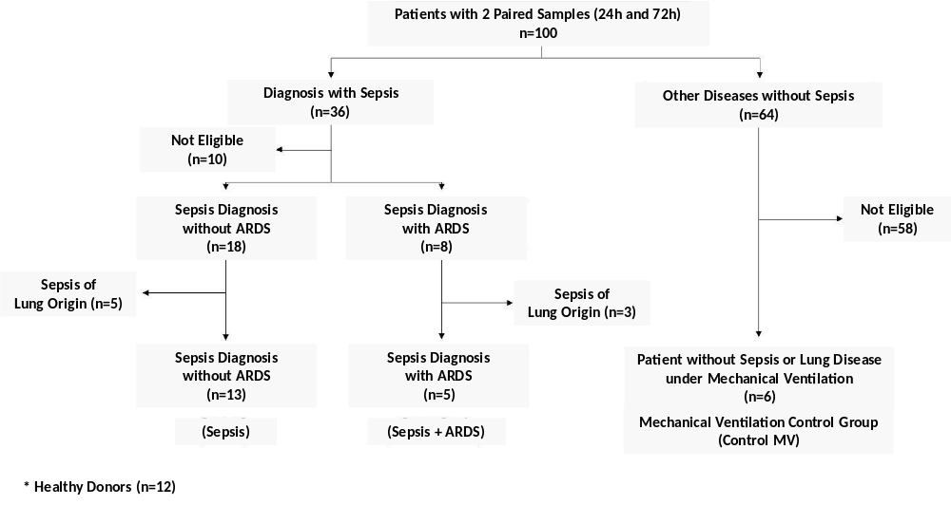

Supplementary Table 1. miRNAs selected for the present project based on the results obtained in the previous study and an updated review on lung tissue expression by the Tissue miRNA tool.

miRBase ID | Assay ID (ThermoFisher)
hsa-miR-25-3p | 00403
hsa-miR-1298-5p | 002861
hsa-miR-1262 | 002852
hsa-miR-339-3p | 002184
hsa-miR-340-5p | 002258
hsa-miR-199a-3p | 002304
hsa-miR-1260a | 002896
hsa-miR-194-5p | 000493
hsa-miR-221-3p | 002276
hsa-miR-127-3p | 000452
hsa-miR-192-5p | 000491
hsa-miR-1290 | 002863
hsa-miR-885-5p | 002296
hsa-miR-193a-5p | 002281
hsa-miR-744-5p | 002324
hsa-miR-99b-3p | 002196
hsa-miR-363-3p | 001271
hsa-miR-625-3p | 002432
hsa-miR-720 | 002895
hsa-miR-122-5p | 002245
hsa-miR-1825 | 002907
hsa-miR-340-3p | 002259
hsa-miR-758-3p | 001990
hsa-miR-1267 | 002885
hsa-miR-548a-3p | 001538
hsa-miR-618 | 001593
hsa-miR-133a-3p | 002246
hsa-miR-770-5p | 002002
hsa-miR-130a-3p | 000454
hsa-miR-148b-3p | 000471
hsa-miR-148a-3p | 000470
hsa-miR-324-3p | 002161
hsa-miR-598-3p | 001988
hsa-miR-766-3p | 001986
hsa-miR-29b-3p | 000413
hsa-miR-296-5p | 000527
hsa-miR-1183 | 002841
hsa-miR-1285-3p | 002822
hsa-miR-485-3p | 001277
hsa-miR-1243 | 002854
hsa-miR-518b | 001159
hsa-miR-875-5p | 002203
hsa-miR-549a | 001511
hsa-miR-520d-5p | 002393
hsa-miR-1233-3p | 002768
hsa-miR-17 | 002421
hsa-miR-20a | 002437
U6 snRNA | 001973

Supplementary Table 2 - MiRNAs expression levels in patients with sepsis associated with acute respiratory distress syndrome about the levels of patients with sepsis without pulmonary dysfunction.

miRBase ID | Relative Quantification | P value
hsa-miR-766-3p | -35.7 | 0.002
hsa-miR-127-3p | -23.8 | 0.001
hsa-miR-340-5p | -13.5 | 0.006
hsa-miR-29b-3p | -12.8 | 0.001
hsa-miR-744 | -7.1 | 0.05
hsa-miR-618 | -4.0 | 0.02
hsa-miR-598-3p | -3.8 | 0.035
hsa-miR-1260a | -2.5 | 0.035
hsa-miR-885-5p | 9.5 | 0.028

