Table S1. Small molecule targeted therapy evaluated in this study.

Drug | Dose and regimen | Class | Target | Number of dogs treated
Dasatinib | 0.5-0.7 mg/Kg every other day | Tyrosine kinase inhibitor | BRC-ABL, SRC family (SRC, LCK, YES, FYN), KIT, EPHA2, PDGFRβ | 16
Imatinib | 10 mg/Kg/ day | Tyrosine kinase inhibitor | BRC-ABL, KIT, PDGFR | 7
Lapatinib | 10-30 mg/Kg/day | Tyrosine kinase inhibitor | EGFR, ERBB2 | 7
Olaparib | 3 mg/Kg/day | Poly (ADP-ribose) polymerase (PARP) enzyme inhibitor | PARP1, PARP2 | 13
Palbociclib | 0.2 mg/Kg/day | Kinase inhibitor | CDK4, CDK6 | 6
Rapamycin | 0.1 mg/Kg/day | Macrocyclic immunosuppressive | mTOR | 216
Sorafenib | 3-5 mg/Kg/day | Tyrosine kinase inhibitor | KIT, FMS-like tyrosine kinase 3, RET, VEGFR-1, VEGFR-2, VEGFR-3, PDGFRβ | 20
Toceranib | 2.5-3.25 mg/Kg/day | Tyrosine kinase inhibitor | VEGFR, PDGFR, Kit, CSF-1, FLT3, RET | 19
Trametinib | 0.02-0.03 mg/Kg/day | Kinase inhibitor | MEK1, MEK2 | 128
Vorinostat | 15-30 mg/Kg every other day | Histone deacetylase inhibitor | HDAC1, HDAC2, HDAC3 | 73

Table S2. Chemotherapy evaluated in this study.

Drug | Chemotherapy Type | Dose | Interval | Number of dogs treated
Doxorubicin | High-dose chemotherapy | 25-30 mg/m² or 1 mg/Kg (in dogs <15Kg) | Every 3 weeks | 291
Carboplatin | High-dose chemotherapy | 240-300 mg/m² | Every 3 weeks | 7
Mitoxantrone | High-dose chemotherapy | 5-6 mg/m² | Every 3 weeks | 3

Table S3. Median survival and survival rates at 1 and 2 years by treatment group and clinical staging.

Treatment |  | Median Survival | 1 Year Survival | 2 Years Survival
Stage II
 | Splenectomy alone | 52 days | 4.3% (1/23) | 0% (0/23)
 | Splenectomy with chemotherapy | 118 days | 11.1% (5/45) | 0% (0/45)
 | Splenectomy with targeted therapy | 130 days | 17.1% (6/35) | 0% (9/35)
 | Splenectomy with chemotherapy and targeted therapy | 205.5 days | 20.8% (20/96) | 5.2% (5/96)
Stage III
 | Splenectomy alone | 75.5 days | 0% (0/12) | 0% (0/12)
 | Splenectomy with chemotherapy | 89 days | 0% (0/13) | 0% (0/13)
 | Splenectomy with targeted therapy | 181 days | 11.1% (1/9) | 0% (0/9)
 | Splenectomy with chemotherapy and targeted therapy | 128 days | 8% (2/25) | 0% (0/25)

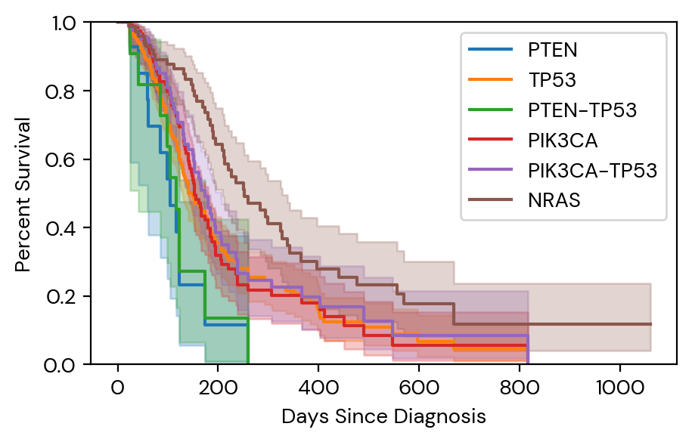
Figure S1. Kaplain-Meier comparison of overall survival (OS) for splenic HSA with PTEN (blue line), TP53 (orange line), PTEN-TP53 (green line), PIK3CA (red line), PIK3CA-TP53 (purple line) and NRAS (brown line) mutation containing tumors.

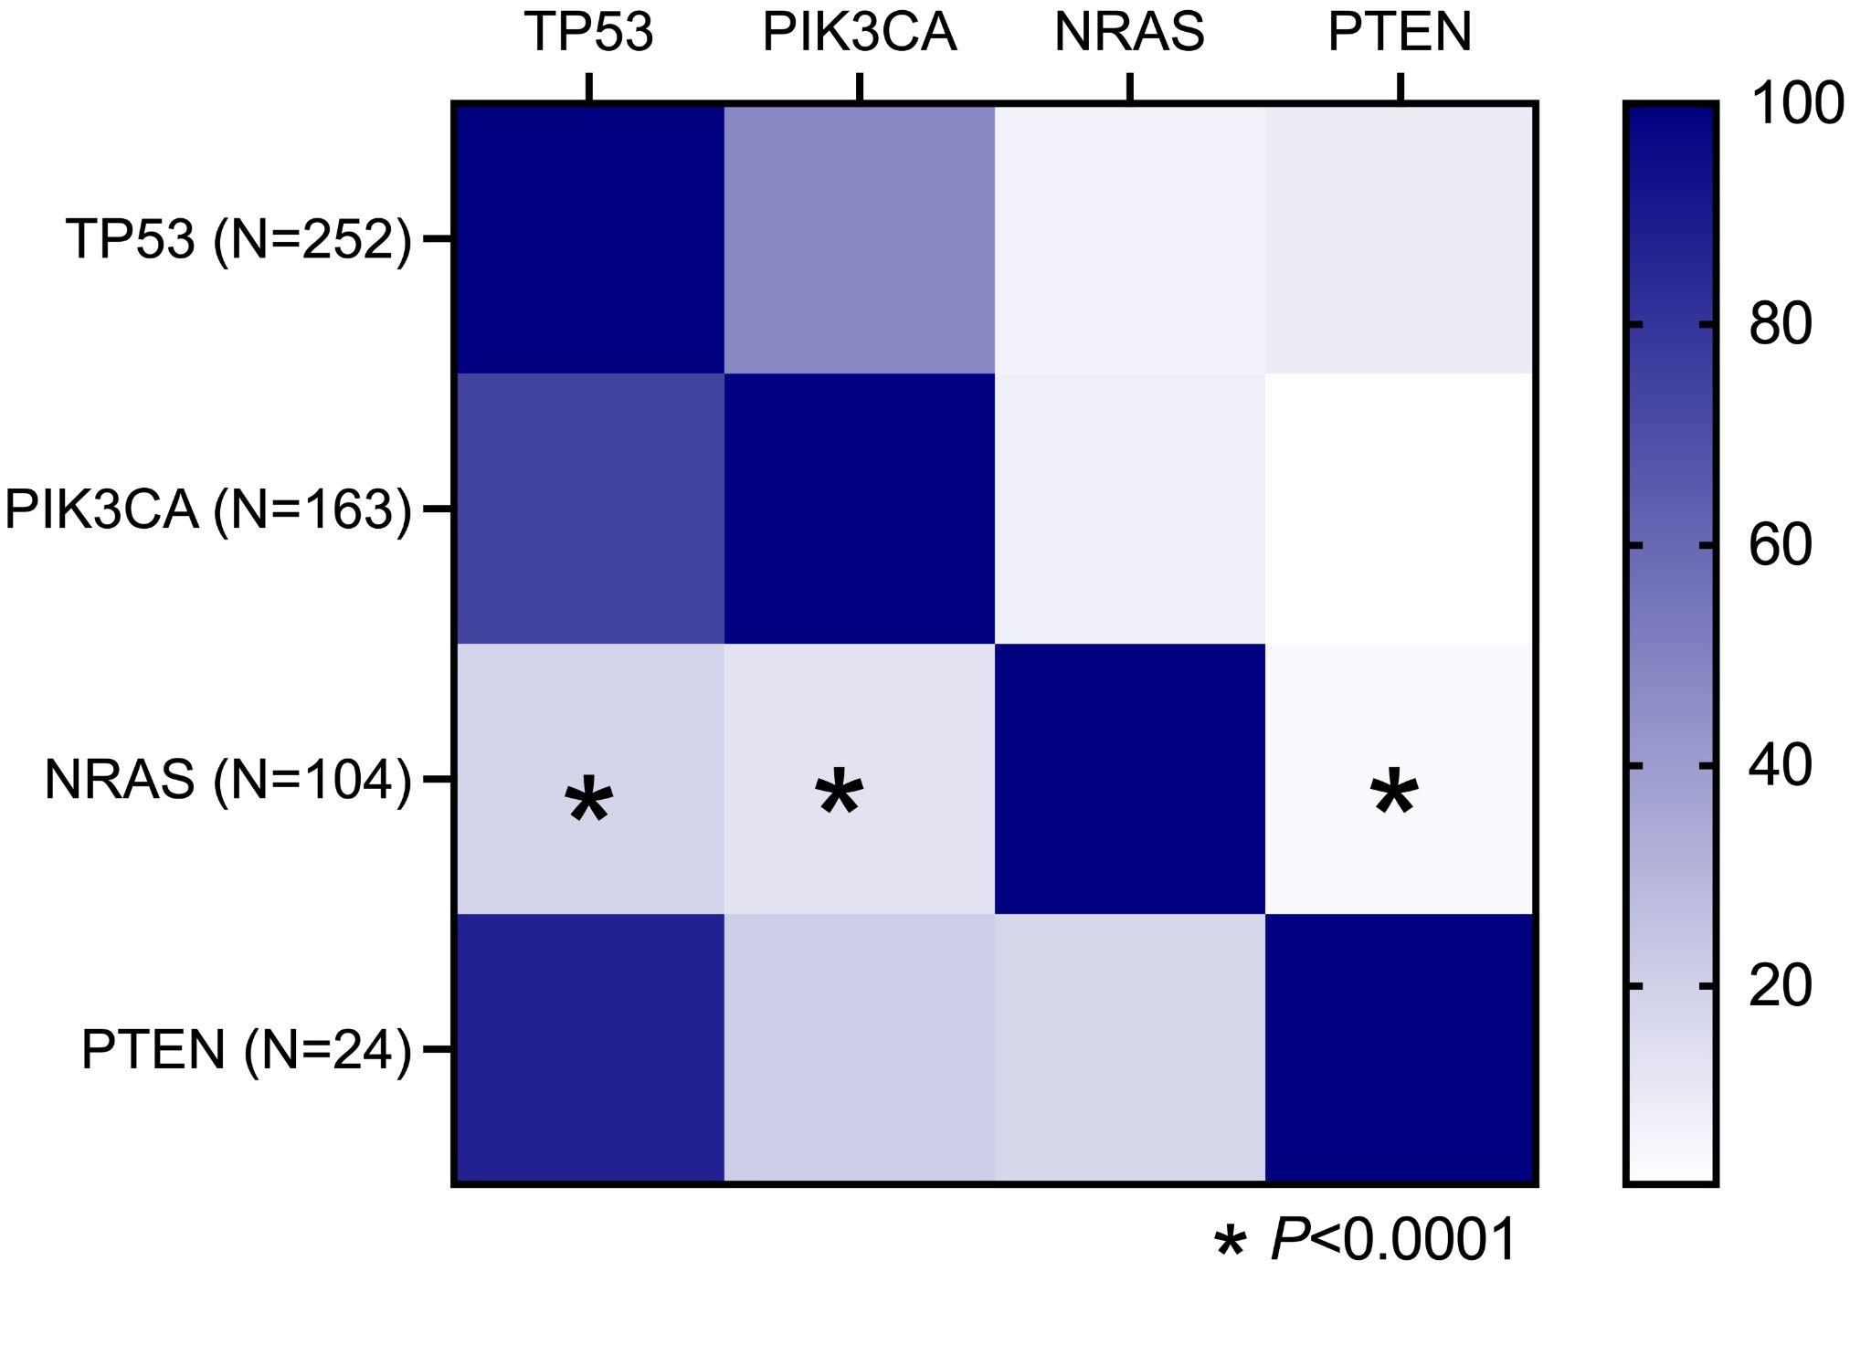
Figure S2. Heatmap indicating the percentage of tumors with overlapping mutations found with the FidoCure® cancer gene screen to be in the same sample.

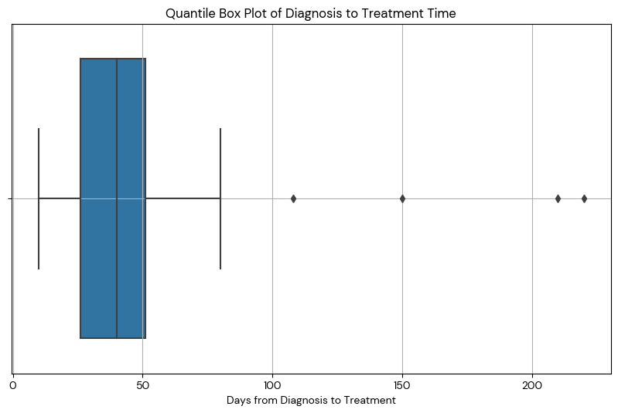

Figure S3. Distribution of days from diagnosis to targeted treatment. We report a median of 40 days from diagnosis to treatment for canines treated with splenectomy followed by a targeted therapy alone or in combination.

