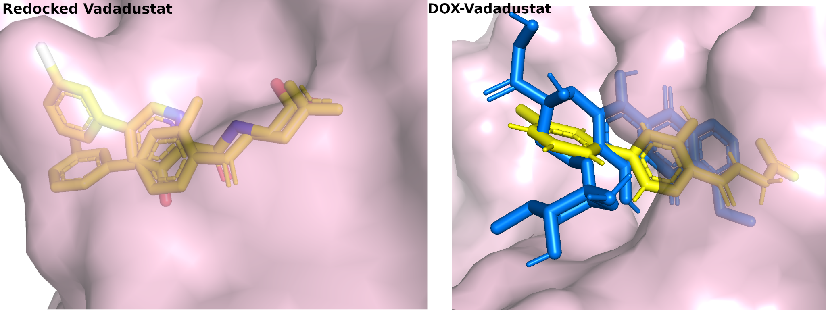
Fig. 1 (Left panel) Re-docked structure of co-crystallized Vadadustat. (Right panel) Superimposed Pose of DOX and Vadadustat

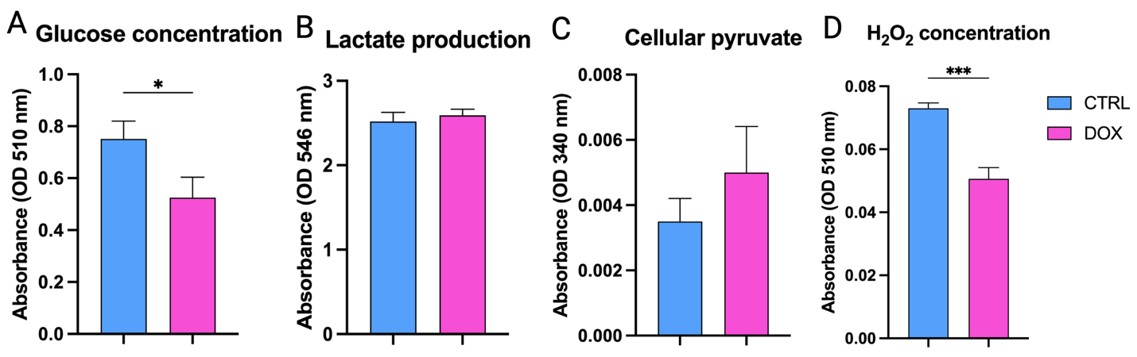
Fig. 2 Analysis of SH-SY5Y glycolytic metabolism to HIF1-α activation. A. Glucose concentration in SH-SY5Y conditioned medium. B. Lactate production. C. Intracellular pyruvate concentration. D. H₂O₂ quantification.
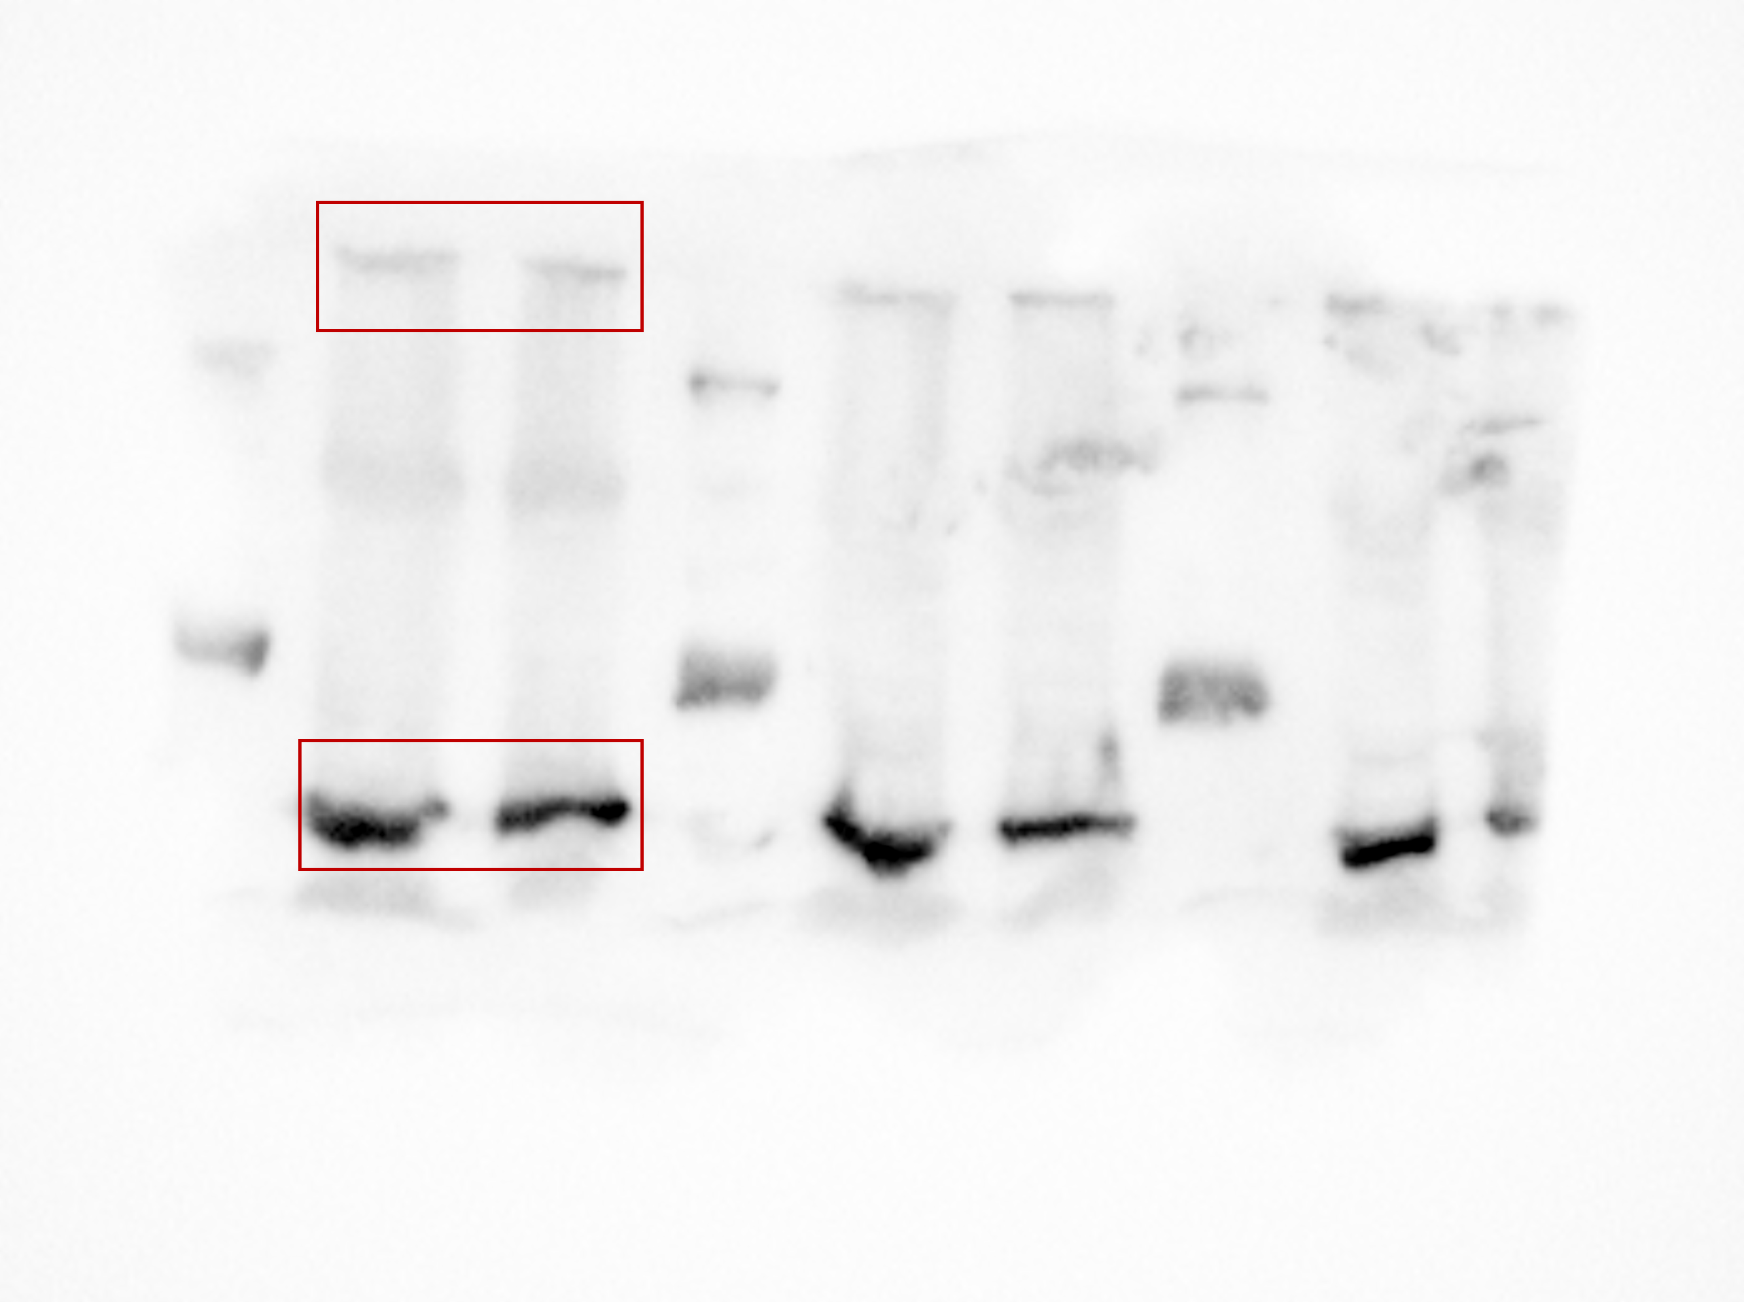
Fig. 3 Uncropped western blot for beta-actin and HIF-alpha

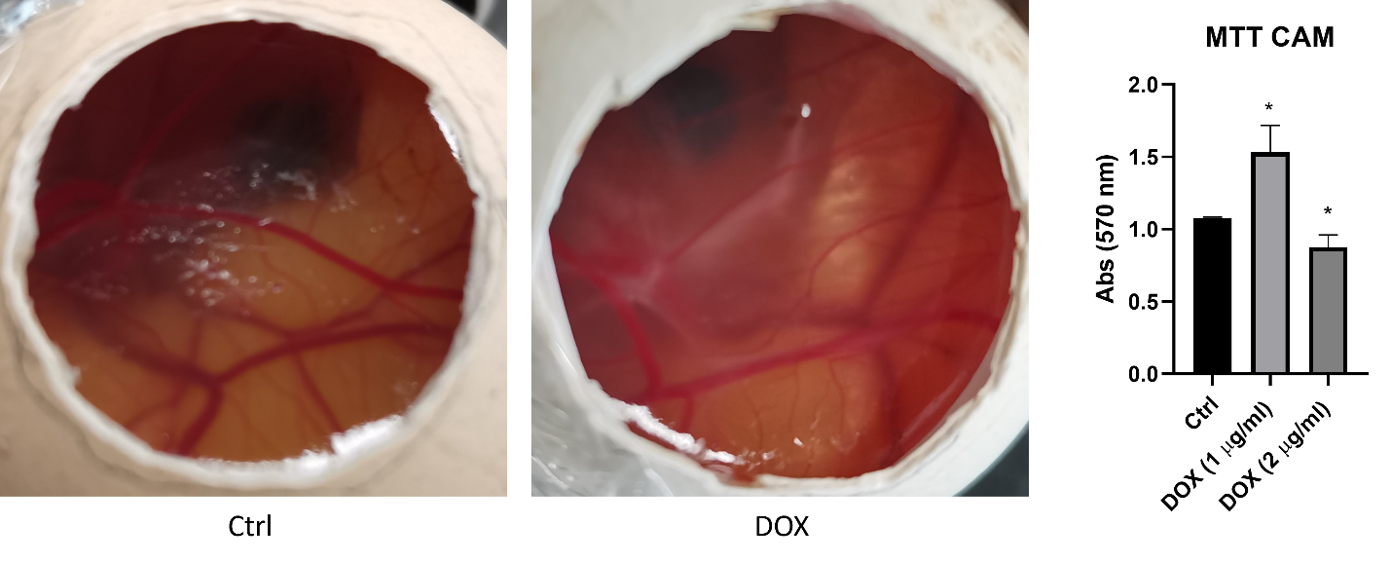
Fig. 4 Effect of doxorubicin on CAM vascular cells.

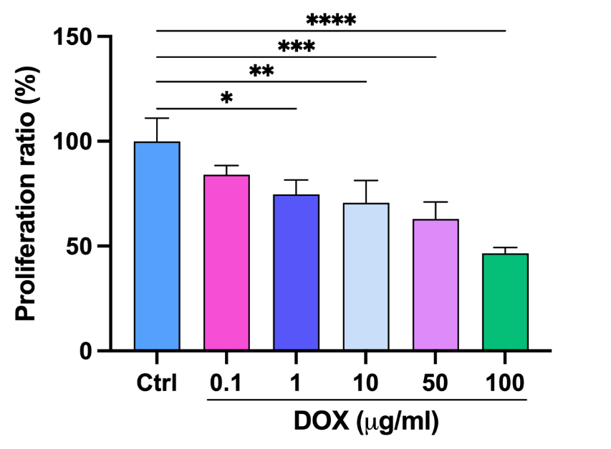
Fig. 5: SH-SY5Y proliferation rate upon doxorubicin treatment at 0.1, 1, 10, 50, and 100 µg/ml concentrations.

Table 1: RT-qPCR primer sequences.
Gene name | Forward primer (5’-3’) | Reverse primer (3’-5’)
GAPDH | GGTGAAGGTCGGAGTCAACG | CAAAGTTGTCATGGATGACC
c-MYC | GCGACTCTGAGGAGGAA | TGCGTAGTTGTGCTGATG
n-MYC | CGCAAAAGCCACCTCTCATTA | TCCAGCAGATGCCACATAAGG
PHOX2B | TCAGGGACCACCAGAGCAGT | GGTGAAAGTGGTGCGGATGC
hTERT | CGGAAGAGTGTCTGGAGCAA | GGATGAAGCGGAGTCTGGA
TOP1 | GGCACTGGTATCCTGAAAAGCC | GTGGCAGATTGCCACGAACAT
P21 | GATGGCACCAGAGGTGGTTA | TCCCGAAATATTGGGGAAAG
BAX | CAAACTGGTGCTCAAGGCCC | GAGACAGGGACATCAGTCGC
Caspase 3 | ACAGTGGAACTGACGATGATATG | TCCCTTGAATTTCTCCAGGAATAG
P53 | GGAAGAGAATCTCCGCAAGAA | AGCTCTCGGAACATCTCGAAG
Bcl-2 | GGATAACGGAGGCTGGGATG | TGACTTCACTTGTGGCCCAG
VEGF | ATCTGCATGGTGATGTTGGA | GGGCAGAATCATCACGAAGT
PDGF | GATACTTTGCGCGCACACAC | GGTTTTCTCTTTGCAGCGAGG
MMP2 | TTGCAGGAGACAAGTTCTGGAG | CGATGAGCTTAGGGAAAC
MMP3 | CACTCACAGACCTGACTCGGTT | AAGCAGGATCACAGTTGGCTGG
MMP13 | TTCGGCTTAGAGGTGACTGGC | TTCACCCACATCAGGAACCCC
HIF-alpha | CGATGAGCTTAGGGAAAC | CGATGAGCTTAGGGAAAC
AKT | CAGCTGATGAAGACGGAGCG | GTCTCCACATGGAAGGTGCG
Pi3K | CACTGTCCATTGGCATGGGG | GTTACTCAGTCCTGCGTGGG
CCNA1 | GCACACTCAAGTCAGACCTGCA | ATCACATCTGTGCCAAGACTGGA
ACTN1 | AACTGTCACTTGGCGGGCAGGG | AAGGGCATCAGCCAGGAGCAGAT
RAC1 | AAGCTGACTCCCATCACCTATCCG | CGAGGGGCTGAGACATTTACAACA
PTGS2 | CCCTTGGGTGTCAAAGGTAA | GCCCTCGCTTATGATCTGTC

