The Bangla Big Five Inventory-2: A Comprehensive Psychometric Validation
Mushfiqul Anwar Siraji¹, Fahria Karim¹, Christopher J. Soto², Shamsul Haque³*
¹ Department of History and Philosophy, School of Humanities and Social Sciences , North South University Bangladesh
² Department of Psychology, Colby College USA
³ Department of Psychology, Jeffrey Cheah School of Medicine and Health Sciences, Monash University Malaysia

* Corresponding author: Shamsul Haque (shamsul@monash.edu)

Supplementary Tables
Supplementary Table S1. Reliability Coefficients of the 15 facets of BFI-2-B
 | Alpha | Ordinal Alpha | Omega
BF-Extraversion
Sociability | .69 | .75 | .70
Assertiveness | .62 | .66 | .70
Energy Level | .47 | .52 | .54
BF-Agreeableness
Compassion | .60 | .69 | .60
Respectfulness | .60 | .71 | .60
Trust | .60 | .65 | .61
BF-Conscientiousness
Organization | .89 | .92 | .89
Productiveness | .65 | .68 | .66
Responsibility | .38 | .43 | .40
BF-Negative Emotionality
Anxiety | .67 | .71 | .68
Depression | .66 | .70 | .68
Emotional Volatility | .74 | .77 | .75
BF-Open-Mindedness
Intellectual Curiosity | .49 | .57 | .52
Aesthetic Sensitivity | .73 | .79 | .75
Creative Imagination | .68 | .73 | .68

Supplementary Table S2. Results of full measurement invariance testing across gender, education level, and language.
 | χ² | df | CFI | RMSEA | ΔCFI | ΔRMSEA
Measurement Invariance: Gender
M1: Configural Invariance | 167.02 | 72 | 0.968 | 0.064
M2: Weak Factorial Invariance | 235.17 | 126 | 0.963 | 0.052 | -0.005 | -0.012
M3 | 270.49 | 141 | 0.956 | 0.053 | -0.007 | 0.001
M4 | 255.90 | 141 | 0.961 | 0.05 | 0.005 | -0.003
M5: Strong Factorial Invariance | 287.79 | 136 | 0.948 | 0.059 | -0.013 | 0.009
M6 | 289.42 | 156 | 0.954 | 0.052 | 0.006 | -0.007
M7: Strict factorial Invariance | 322.23 | 151 | 0.941 | 0.059 | -0.013 | 0.007
M8 | 308.57 | 151 | 0.946 | 0.057 | 0.005 | -0.002
M9 | 341.09 | 166 | 0.94 | 0.057 | -0.006 | 0
M10 | 388.23 | 141 | 0.916 | 0.074 | -0.024 | 0.017
M11 | 423.47 | 156 | 0.909 | 0.073 | -0.007 | -0.001
M12 | 409.74 | 156 | 0.913 | 0.071 | 0.004 | -0.002
M13: Complete factorial Invariance | 443.23 | 171 | 0.907 | 0.07 | -0.006 | -0.001
Measurement Invariance: Education
M1: Configural Invariance | 144.32 | 72 | 0.974 | 0.056
M2: Weak Factorial Invariance | 226.84 | 126 | 0.964 | 0.05 | -0.01 | -0.006
M3 | 275.12 | 141 | 0.953 | 0.054 | -0.011 | 0.004
M4 | 280.63 | 141 | 0.951 | 0.055 | -0.002 | 0.001
M5: Strong Factorial Invariance | 244.47 | 136 | 0.962 | 0.05 | 0.011 | -0.005
M6 | 337.24 | 156 | 0.936 | 0.06 | -0.026 | 0.01
M7: Strict factorial Invariance | 291.89 | 151 | 0.95 | 0.054 | 0.014 | -0.006
M8 | 297.26 | 151 | 0.948 | 0.055 | -0.002 | 0.001
M9 | 352.38 | 166 | 0.934 | 0.059 | -0.014 | 0.004
M10 | 328.98 | 141 | 0.934 | 0.064 | 0 | 0.005
M11 | 373.83 | 156 | 0.923 | 0.066 | -0.011 | 0.002
M12 | 375.04 | 156 | 0.923 | 0.066 | 0 | 0
M13: Complete factorial Invariance | 423.56 | 171 | 0.911 | 0.068 | -0.012 | 0.002
Measurement Invariance: Language
M1: Configural Invariance | 135.08 | 72 | 0.982 | 0.033
M2: Weak Factorial Invariance | 290.27 | 126 | 0.954 | 0.04 | -0.028 | 0.007
M3 | 632.20 | 141 | 0.861 | 0.065 | -0.093 | 0.025
M4 | 1590.54 | 141 | 0.591 | 0.112 | -0.27 | 0.047
M5: Strong Factorial Invariance | 367.52 | 136 | 0.935 | 0.045 | 0.344 | -0.067
M6 | 2588.85 | 156 | 0.313 | 0.138 | -0.622 | 0.093
M7: Strict factorial Invariance | 813.92 | 151 | 0.813 | 0.073 | 0.5 | -0.065
M8 | 1634.45 | 151 | 0.581 | 0.109 | -0.232 | 0.036
M9 | 2687.53 | 166 | 0.288 | 0.136 | -0.293 | 0.027
M10 | 1533.39 | 141 | 0.607 | 0.11 | 0.319 | -0.026
M11 | 1931.01 | 156 | 0.499 | 0.118 | -0.108 | 0.008
M12 | 3355.13 | 156 | 0.097 | 0.158 | -0.402 | 0.04
M13: Complete factorial Invariance | 4356.38 | 171 | 0 | 0.172 | -0.097 | 0.014
Note. df= degrees of freedom; CFI=Comparative fit index; RMSEA= Root mean square error of approximation,. All Chi-Square values are significant at p<0.001.

Supplementary Table S3. IRT Parameters of the 60 items of BFI-2-B. Item discrimination is denoted by a and item difficulty is denoted by b1-b3.
 | a | b1 | b2 | b3 | b4 | Category | outfit | infit | S-χ² | df | RMSEA | p
BFI01 | 1.13 | -3.31 | -1.60 | -0.59 | 2.11 | Moderate | 0.97 | 0.94 | 26.31 | 22 | 0.02 | 0.24
RBFI16 | 2.69 | -1.01 | 0.14 | 0.63 | 1.62 | Very High | 0.51 | 0.53 | 22.88 | 19 | 0.02 | 0.24
RBFI31 | 1.15 | -1.23 | 1.75 | 2.36 | 4.12 | Moderate | 0.85 | 0.92 | 24.06 | 19 | 0.02 | 0.19
BFI46 | 1.91 | -2.19 | -0.99 | -0.23 | 1.31 | Very High | 0.70 | 0.74 | 30.98 | 19.00 | 0.03 | 0.04
BFI06 | 0.51 | -7.49 | -4.53 | -1.04 | 3.99 | Low | 0.96 | 0.97 | 39.84 | 24.00 | 0.03 | 0.02
BFI21 | 2.09 | -1.43 | 0.01 | 0.67 | 2.18 | Very High | 0.62 | 0.62 | 25.45 | 20.00 | 0.02 | 0.18
RBFI36 | 1.65 | -1.99 | -0.22 | 0.62 | 2.43 | High | 0.77 | 0.77 | 18.26 | 19.00 | 0.00 | 0.51
RBFI51 | 1.53 | -2.37 | -0.43 | 0.79 | 2.40 | High | 0.82 | 0.81 | 17.35 | 20.00 | 0.00 | 0.63
RBFI11 | 0.04 | -72.28 | -16.67 | 4.34 | 52.57 | Very low | 1.00 | 1.00 | 44.33 | 27.00 | 0.03 | 0.02
RBFI26 | 0.85 | -4.11 | -1.08 | -0.10 | 2.55 | Moderate | 1.01 | 0.97 | 68.33 | 22.00 | 0.06 | <0.001
BFI41 | 3.63 | -2.15 | -0.73 | 0.09 | 1.44 | Very High | 0.32 | 0.32 | 35.16 | 18.00 | 0.04 | 0.01
BFI56 | 1.50 | -3.74 | -2.07 | -0.75 | 1.82 | High | 0.87 | 0.89 | 31.06 | 17.00 | 0.04 | 0.02
BFI02 | 1.20 | -4.49 | -3.41 | -2.01 | 0.75 | Moderate | 0.89 | 0.92 | 30.03 | 17.00 | 0.03 | 0.03
RBFI17 | 1.65 | -2.49 | -1.66 | -1.33 | 0.48 | High | 0.90 | 0.93 | 34.56 | 18.00 | 0.04 | 0.01
BFI32 | 1.15 | -5.21 | -3.23 | -1.58 | 1.17 | Moderate | 0.87 | 0.90 | 14.68 | 15.00 | 0.00 | 0.48
RBFI47 | 1.69 | -2.93 | -1.73 | -1.10 | 0.53 | High | 0.79 | 0.82 | 16.05 | 18.00 | 0.00 | 0.59
BFI07 | 1.62 | -3.76 | -3.45 | -2.71 | 0.01 | High | 0.81 | 0.90 | 21.87 | 10.00 | 0.04 | 0.02
RBFI22 | 1.16 | -4.93 | -2.41 | -1.48 | 0.42 | Moderate | 0.86 | 0.89 | 9.38 | 11.00 | 0.00 | 0.59
RBFI37 | 1.15 | -3.23 | -0.57 | 0.09 | 2.10 | Moderate | 0.85 | 0.85 | 21.06 | 12.00 | 0.03 | 0.05
BFI52 | 1.93 | -4.29 | -3.52 | -2.25 | 0.52 | Very High | 0.74 | 0.78 | 12.20 | 7.00 | 0.03 | 0.09
RBFI12 | 1.12 | -3.67 | -1.16 | -0.29 | 1.51 | Moderate | 0.84 | 0.85 | 29.42 | 22.00 | 0.02 | 0.13
BFI27 | 0.91 | -5.01 | -3.11 | -1.78 | 1.06 | Moderate | 0.88 | 0.91 | 29.96 | 22.00 | 0.02 | 0.12
RBFI42 | 1.21 | -2.04 | 0.17 | 1.09 | 2.99 | Moderate | 0.80 | 0.82 | 14.14 | 19.00 | 0.00 | 0.78
BFI57 | 1.91 | -2.78 | -1.36 | -0.54 | 1.34 | Very High | 0.63 | 0.66 | 20.39 | 19.00 | 0.01 | 0.37
RBFI03 | 2.68 | -1.83 | -0.61 | -0.13 | 1.12 | Very High | 0.82 | 0.83 | 41.91 | 18.00 | 0.05 | 0.00
BFI18 | 2.90 | -2.08 | -1.10 | -0.39 | 1.13 | Very High | 0.82 | 0.85 | 31.80 | 13.00 | 0.05 | 0.00
BFI33 | 4.99 | -1.98 | -0.92 | -0.25 | 0.97 | Very High | 0.47 | 0.59 | 7.32 | 10.00 | 0.00 | 0.70
RBFI48 | 2.78 | -2.18 | -1.22 | -0.66 | 0.60 | Very High | 0.92 | 0.88 | 33.61 | 16.00 | 0.04 | 0.01
RBFI08 | 2.15 | -1.38 | -0.09 | 0.50 | 1.74 | Very High | 0.57 | 0.57 | 28.97 | 19.00 | 0.03 | 0.07
RBFI23 | 1.38 | -2.09 | -0.38 | 0.36 | 2.33 | High | 0.81 | 0.81 | 30.26 | 22.00 | 0.02 | 0.11
BFI38 | 0.94 | -5.87 | -3.09 | -0.92 | 2.59 | Moderate | 0.88 | 0.92 | 33.22 | 19.00 | 0.03 | 0.02
BFI53 | 1.14 | -3.65 | -1.87 | -0.71 | 1.72 | Moderate | 0.86 | 0.88 | 36.66 | 22.00 | 0.03 | 0.03
BFI13 | 0.25 | -14.11 | -7.44 | -3.01 | 6.55 | Very Low | 1.00 | 1.00 | 27.41 | 23.00 | 0.02 | 0.24
RBFI28 | 1.15 | -1.92 | 1.15 | 1.93 | 3.76 | Moderate | 0.84 | 0.89 | 22.77 | 16.00 | 0.03 | 0.12
BFI43 | 0.26 | -22.72 | -13.20 | -7.83 | 2.27 | Very Low | 0.98 | 0.99 | 22.42 | 19.00 | 0.02 | 0.26
RBFI58 | 1.99 | -1.91 | 0.02 | 0.55 | 2.04 | Very High | 0.52 | 0.50 | 25.46 | 18.00 | 0.03 | 0.11
RBFI04 | 1.16 | -2.15 | -0.19 | 1.04 | 2.75 | Moderate | 0.88 | 0.89 | 39.28 | 23.00 | 0.03 | 0.02
BFI19 | 1.37 | -2.29 | -0.36 | 0.52 | 2.37 | High | 0.86 | 0.86 | 30.07 | 22.00 | 0.02 | 0.12
BFI34 | 2.88 | -2.13 | -0.90 | -0.37 | 0.80 | Very High | 0.46 | 0.48 | 26.61 | 20.00 | 0.02 | 0.15
RBFI49 | 1.17 | -2.91 | -0.83 | 0.00 | 1.94 | Moderate | 0.95 | 0.94 | 33.03 | 25.00 | 0.02 | 0.13
RBFI09 | 0.71 | -2.55 | 0.93 | 2.65 | 5.11 | Moderate | 0.93 | 0.96 | 36.09 | 23.00 | 0.03 | 0.04
RBFI24 | 0.73 | -2.19 | 0.77 | 2.25 | 4.35 | Moderate | 0.94 | 0.95 | 23.96 | 25.00 | 0.00 | 0.52
BFI39 | 2.73 | -2.40 | -1.08 | -0.52 | 0.90 | Very High | 0.62 | 0.68 | 22.21 | 16.00 | 0.02 | 0.14
BFI54 | 3.14 | -1.91 | -0.84 | -0.37 | 1.02 | Very High | 0.50 | 0.56 | 25.16 | 17.00 | 0.03 | 0.09
BFI14 | 0.92 | -2.69 | -0.34 | 0.53 | 2.53 | Moderate | 0.95 | 0.94 | 25.28 | 26.00 | 0.00 | 0.50
RBFI29 | 2.42 | -1.73 | 0.05 | 0.76 | 1.83 | Very High | 0.71 | 0.71 | 19.59 | 18.00 | 0.01 | 0.36
RBFI44 | 1.53 | -1.48 | 0.43 | 1.25 | 2.70 | High | 0.84 | 0.87 | 34.97 | 22.00 | 0.03 | 0.04
BFI59 | 2.86 | -1.45 | -0.09 | 0.43 | 1.55 | Very High | 0.58 | 0.59 | 22.02 | 18.00 | 0.02 | 0.23
BFI10 | 1.56 | -4.43 | -2.40 | -1.30 | 0.89 | High | 0.75 | 0.81 | 25.35 | 14.00 | 0.04 | 0.03
RBFI25 | 1.80 | -2.79 | -1.51 | -0.79 | 0.89 | Very High | 0.66 | 0.72 | 15.81 | 16.00 | 0.00 | 0.47
BFI40 | 0.54 | -8.31 | -3.93 | -1.54 | 2.99 | Low | 0.99 | 0.98 | 24.59 | 18.00 | 0.02 | 0.14
RBFI55 | 0.83 | -6.00 | -2.08 | 0.18 | 2.96 | Moderate | 0.93 | 0.92 | 10.98 | 16.00 | 0.00 | 0.81
RBFI05 | 1.04 | -2.84 | -0.82 | -0.12 | 1.80 | Moderate | 1.01 | 0.98 | 60.81 | 23.00 | 0.05 | <0.001
BFI20 | 3.66 | -2.04 | -1.41 | -0.87 | 0.61 | Very High | 0.47 | 0.66 | 25.70 | 16.00 | 0.03 | 0.06
BFI35 | 2.88 | -2.94 | -2.11 | -1.28 | 0.57 | Very High | 0.61 | 0.75 | 44.71 | 13.00 | 0.06 | <0.001
RBFI50 | 1.49 | -2.28 | -1.39 | -0.70 | 0.91 | High | 0.94 | 0.94 | 33.27 | 23.00 | 0.03 | 0.08
BFI15 | 2.20 | -3.06 | -1.69 | -0.63 | 1.48 | Very High | 0.68 | 0.76 | 13.22 | 14.00 | 0.00 | 0.51
RBFI30 | 1.64 | -2.62 | -1.06 | -0.33 | 1.72 | High | 0.85 | 0.84 | 41.42 | 19.00 | 0.04 | 0.00
RBFI45 | 0.88 | -5.71 | -2.57 | -1.45 | 1.14 | Moderate | 0.89 | 0.93 | 24.59 | 19.00 | 0.02 | 0.17
BFI60 | 1.79 | -2.63 | -1.28 | -0.10 | 1.73 | Very High | 0.76 | 0.79 | 30.35 | 19.00 | 0.03 | 0.05

Supplementary Table S4. The coverage range of the Underlying trait and Marginal Reliability of the 15 Facets of BIF-2-B
Facet | Coverage Range (θ) | Marginal Reliability
Sociability | -3 to 3 | 0.77
Assertiveness | -3.1 to 3.5 | 0.72
Energy Level | -3.3 to 2.5 | 0.76
Compassion | -4.5 to 1.8 | 0.66
Respectfulness | -5.3 to 1.7 | 0.65
Trust | -4.1 to 2.7 | 0.65
Organization | -3 to 1.9 | 0.88
Productiveness | -3.1 to 3 | 0.70
Responsibility | -2.5 to 2.8 | 0.57
Anxiety | -3.5 to 3 | 0.75
Depression | -3.2 to 2 | 0.79
Emotional Volatility | -2.8 to 3 | 0.80
Intellectual Curiosity | -4.5 to 2 | 0.63
Aesthetic Sensitivity | -3.8 to 1.8 | 0.80
Creative Imagination | -4.1 to 2.8 | 0.73

Supplementary Figures
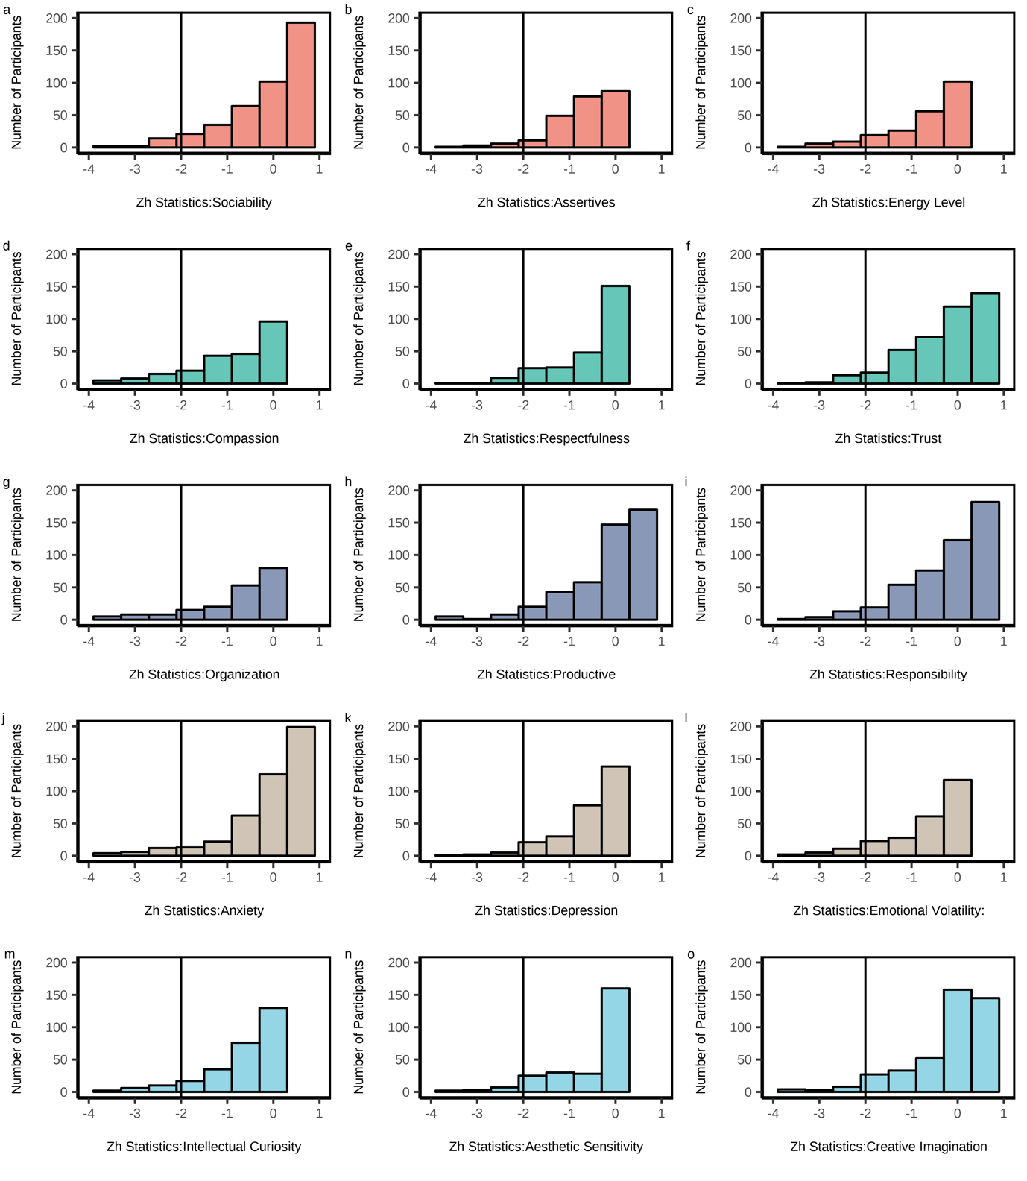
Supplementary Figure S1. Person fit of the fitted 15 facets of BFI-2-B. For all facets, Z_{h} statistics are larger than -2 for most participants.

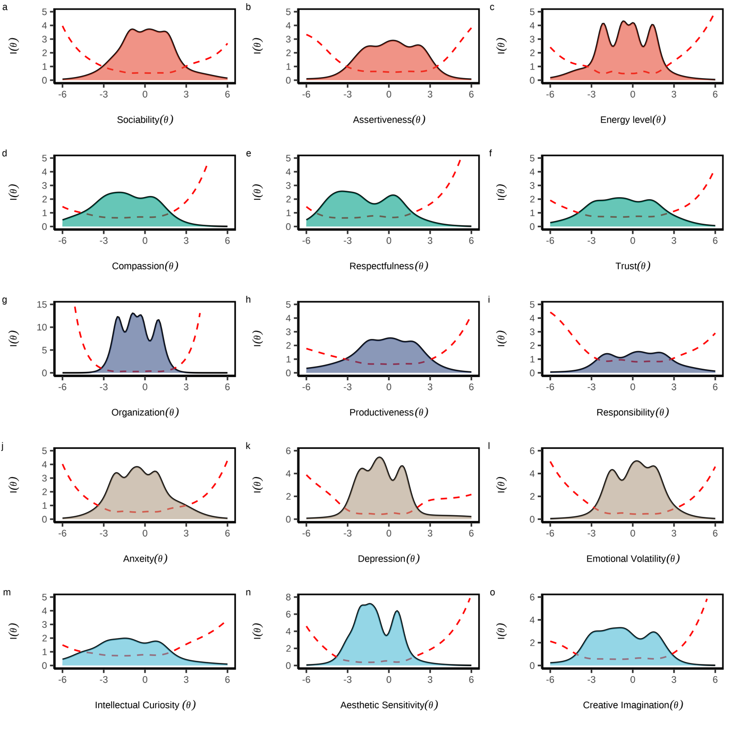
Supplementary Figure S2. Test information curves of the 15 facets of BFI-2-2B. Each facet had a good range of coverage across the underlying traits, with some facets, (d) Compassion, (e) Respectfulness, and (m) Intellectual Curiosity skewed toward lower trait levels

