Supplemental information
Table SI 1. Analysis of deviance (Wald chi-square tests) for the model constructed to test the total time spent emitting 22-kHz (18-32-kHz, > 100 ms long) calls by male Wistar rats according to the Day and Social Grouping, normalized by the number of animals present as offset. Bold P values denote statistical significance (α < 0.05).
Fixed factors | d.f. | X² | P
(Intercept) | 1 | 159.560 | <0.0001
Social Grouping | 2 | 1.130 | 0.568
Day | 2 | 66.317 | <0.0001
Social Grouping x Day | 4 | 24.309 | <0.0001

Table SI 2. Analysis of deviance (Wald chi-square tests) for the model constructed to test the time spent emitting 22-kHz (18-32-kHz, > 100 ms long) calls per 5-minute bins by male Wistar rats according to the Day and Social Grouping, normalized by the number of animals present as an offset. Bold P values denote statistical significance (α < 0.05).
Fixed factors | d.f. | X² | P
(Intercept) | 1 | 126.079 | < 0.0001
5-minute bin | 3 | 1.094 | 0.779
Social Grouping | 2 | 4.962 | 0.084
Day | 2 | 32.114 | <0.0001
Social Grouping x Day | 4 | 191.300 | < 0.0001
5-minute bin x Social Grouping | 6 | 5.451 | 0.487
5 minute bin x Day | 6 | 39.427 | <0.0001

Figure SI 1. Time spent emitting ~22-kHz (18-32-kHz, > 100 ms long) vocalizations per animal (Mean ± SE, log scale) during each Day according to Social Grouping: (A) Over the whole 20-minute trial; and (B) Per 5-minute segments over each trial. Data are normalized by the number of animals present. Points represent the raw data, and lines represent predicted values (Mean ± SE, shaded areas). Panels (A) and (B) share the same Y-axis. Superscripts represent Dunn–Šidák corrected pairwise comparisons to habituation (baseline): p<0.001 '***'; p<0.01 '**'; p<0.05 '*'.

Table SI 3. Analysis of deviance (Wald chi-square tests) for the model constructed to test the total time spent emitting ~50-kHz (35-72-kHz) calls by male Wistar rats according to the Day and Social Grouping, normalized by the number of animals present as an offset. Bold P values denote statistical significance (α < 0.05).
Fixed factors | d.f. | X² | P
(Intercept) | 1 | 7.545 | 0.006
Day | 2 | 19.690 | <0.0001
Social Grouping | 2 | 41.647 | <0.0001
Day x Social Grouping | 4 | 9.249 | 0.055

Table SI 4. Analysis of deviance (Wald chi-square tests) for the model constructed to test the time spent emitting ~50-kHz (35-72-kHz) calls per 5-minute bin by male Wistar rats according to the Day and Social Grouping, normalized by the number of animals present as an offset. Bold P values denote statistical significance (α < 0.05).
Fixed factors | d.f. | X² | P
(Intercept) | 1 | 13.451 | <0.0001
(Intercept) | 3 | 3.120 | 0.373
5-minute bin | 2 | 3.110 | 0.211
Social Grouping | 2 | 27.224 | <0.0001
Day | 4 | 161.664 | < 0.0001
Social Grouping x Day | 6 | 10.955 | 0.090
5-minute bin x Social Grouping | 6 | 32.144 | <0.0001

Figure SI 2. Time spent emitting ~50-kHz (35-72-kHz) vocalizations per animal (Mean ± SE, log scale) during each Day according to social grouping: (A) Over the whole 20-minute trial; and (B) Per 5-minute bins over each trial. Data are normalized by the number of animals present. Points represent the raw data, and lines represent predicted values (Mean ± SE, shaded areas). Panels (A) and (B) share the same Y-axis. Superscripts represent Dunn–Šidák corrected pairwise comparisons to habituation (baseline): p<0.001 '***'; p<0.01 '**'; p<0.05 '*'.

Figure SI 3. Example spectrogram of (A) ~22kHz (18-32kHz, > 100 ms long) and (B) ~50-kHz (35-72-kHz) vocalizations recorded during Exposure and Habituation days, respectively.
A | B
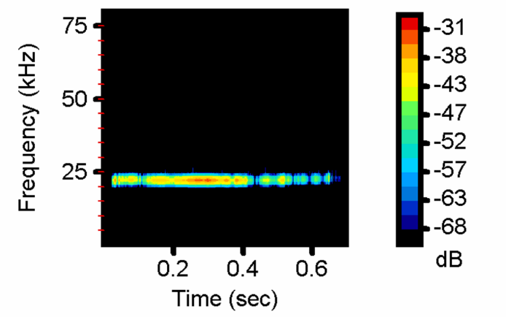

Supplementary Video 1: Examples of ~22kHz (18-32kHz, > 100 ms long) calls emitted by male Wistar during exposure to cat fur (file name: 20250130 22-kHz Calls examples.mp4).
Example sequences of ultrasonic vocalizations ~22kHz (18-32kHz, > 100 ms long) emitted by male Wistar rats and matched to video recordings of their behavioural response during exposure to cat fur individually, in pairs and trios.
Supplementary Video 2: Examples of ~50-kHz (35-72-kHz) calls emitted by male Wistar before cat fur exposure (file name: 20250130 50-kHz Calls examples.mp4).
Example sequences of ultrasonic vocalizations ~50-kHz (35-72-kHz) emitted by male Wistar rats and matched to video recordings of their behavioural response before exposure to cat fur individually, in pairs and trios.

