Metabolic profiling and transcriptome analysis of Sinomenium acutum provide insights into the biosynthesis of structurally diverse benzylisoquinoline alkaloids

Xiuyu Liu^{1,2}, Jicong Chen¹, Rui Ma^{1,2}, Le Zhao¹, Conglong Lian^{1,2*}, Suiqing Chen^{1*}, Ying Ma^{3*}

¹ School of Pharmacy, Henan University of Chinese Medicine, 156 Esat Jin-shui Rd, Zhengzhou 450046, PR China.
² Henan Key Laboratory of Chinese Medicine Resources and Chemistry, 156 Esat Jin-shui Rd, Zhengzhou 450046, PR China.
³ State Key Laboratory for Quality Ensurance and Sustainable Use of Dao-di Herbs, China Academy of Chinese Medical Sciences, NO.16 Neinanxiaojie, Dongcheng district, Beijing 100700, China

E-mail addresses: liuxiuyuzy@163.com (XY. Liu), chenjicong3210@163.com (JC. Chen), 18237146168@163.com (R. Ma), zhaole1983@126.com (L. Zhao), liancl00@163.com (CL. Lian), suiqingchen0371@163.com (SQ. Chen), xiaoma1110@126.com (Y. Ma)

Corresponding author:
Conglong Lian, School of Pharmacy, Henan University of Chinese Medicine, 156 Esat Jin-shui Rd, Zhengzhou 450046, PR China. Email: liancl00@163.com

Suiqing Chen, School of Pharmacy, Henan University of Chinese Medicine, 156 Esat Jin-shui Rd, Zhengzhou 450046, PR China. Email: chsq@hactcm.edu.cn

Ying Ma, State Key Laboratory for Quality Ensurance and Sustainable Use of Dao-di Herbs, China Academy of Chinese Medical Sciences, NO.16 Neinanxiaojie, Dongcheng district, Beijing 100700, China. Email: xiaoma1110@126.com

Supplementary information for qualitative and quantitative analysis of metabolites:
A broad-target qualitative and quantitative approach was employed for the metabolomic sequencing of S. acutum. High-resolution mass spectrometry using the AB Sciex TripleTOF 6600 was utilized for the qualitative analysis of mixed samples, followed by quantitative determination with the AB Sciex 4500 QTRAP. This combined approach capitalized on the strengths of both non-targeted and targeted metabolomics, with high-resolution mass spectrometry offering precise qualitative analysis.
The metabolome data was identified using a combination of a self-built database and multiple reaction monitoring (MRM). By analyzing the exact mass of metabolites, MS2 fragments, isotopic distribution of MS2 fragments, and retention time (RT), the secondary spectra and RT of metabolites in the sample were systematically matched with those in the database. The mass spectrometry (MS) tolerance and MS2 tolerance were set to 20 ppm, while the RT tolerance was established at 0.2 minutes. The database was manually constructed using standard products, public database, and literature reports. It summarizes and analyzes the fragmentation patterns of various metabolites based on these sources.
The term “Level” refers to the identification level of the substance. Level 1 indicates that the matching score of the secondary mass spectrum (all fragment ions of the substance), retention time (RT), and the material in the database exceeds 0.7. Level 2 indicates that the secondary mass spectrum (all fragment ions of the substance), RT, and the compound matching score from the database range from 0.5 to 0.7. Level 3 indicates that the Q1, Q3, RT, DP, and CE values of the sample compounds are consistent with those in the database. Detailed information is provided in Supplemental Tables.

Fig.S1. Distribution of CDS lengths.
The horizontal axis represents the length of CDS, the vertical axis denotes the number of CDS within each specified length range. The red dashed line indicates the N50 length threshold.

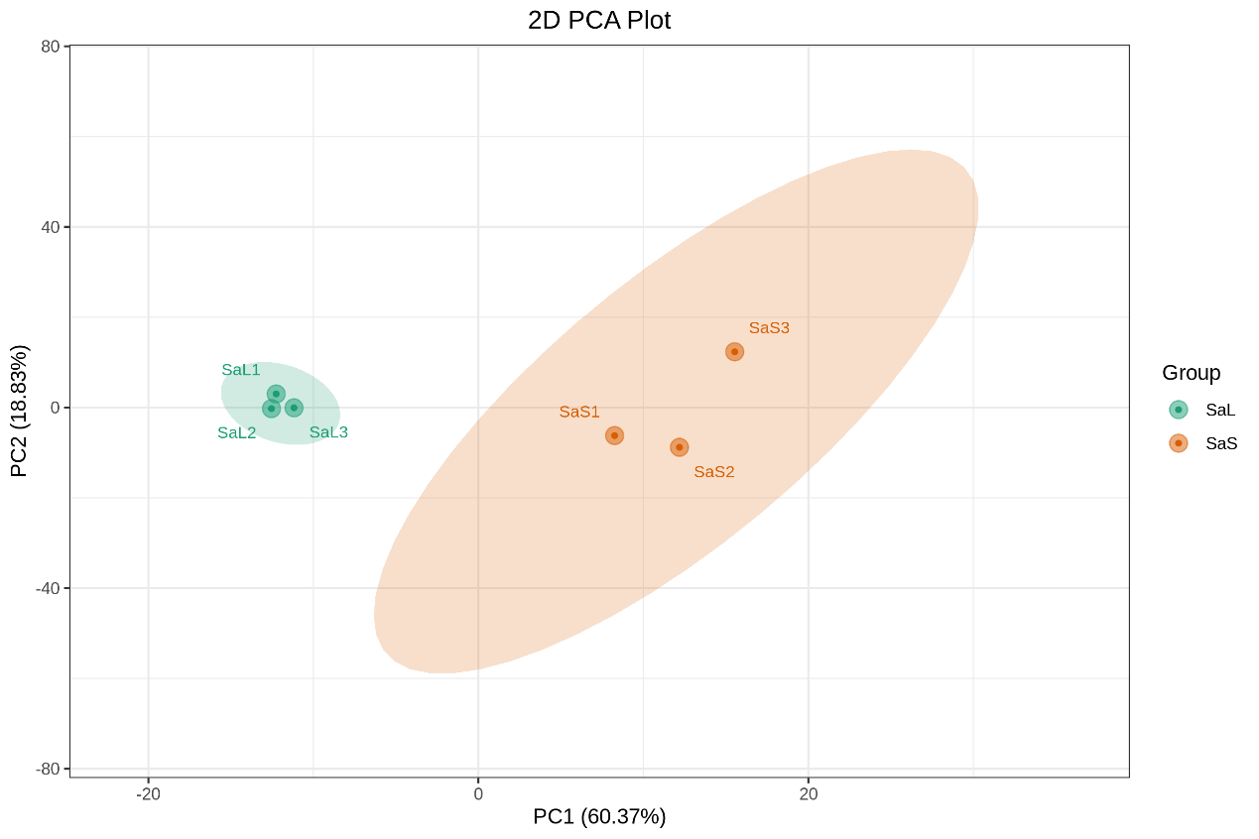
Fig.S2. 2D PCA plot depicting stems and leaves in S. acutum.
PC1 represents the first principal component, and the PC2 represents the second principal component. The percentage reflects the interpretation rate of this principal component to the data set. Each point in the diagram corresponds to an individual sample, with samples belonging to the same group represented by a uniform color. SaL stands for the stem of S. acutum, SaS stands for the leaf of S. acutum.

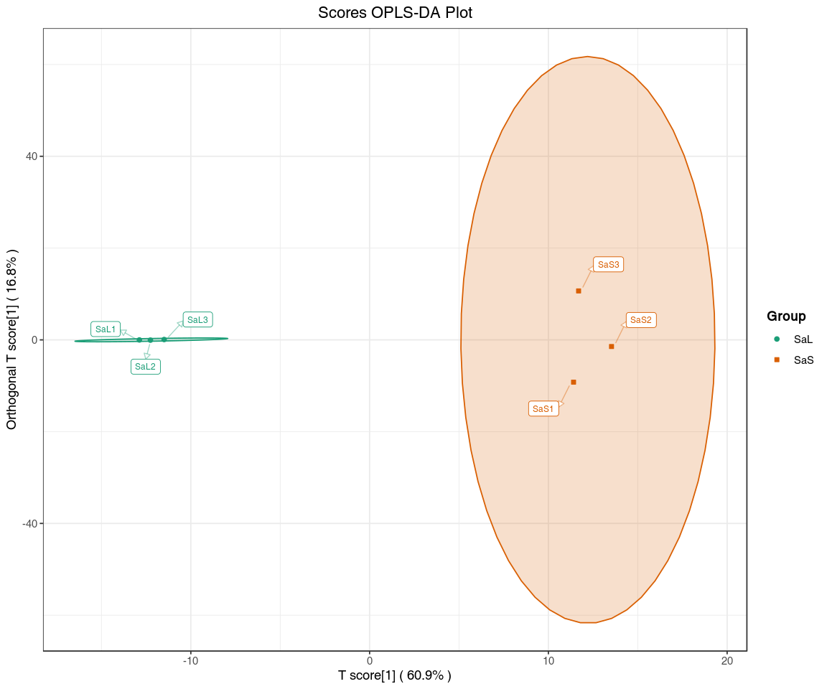
Fig.S3. OPLS-DA scores plot illustrating stems and leaves in S. acutum.
The horizontal axis represents the principal component of prediction, with its direction indicating the differences between groups. The vertical axis denotes the orthogonal principal component, with its direction illustrating the difference within groups. The percentage represents the interpretation rate of the component to the data set. Each point in the diagram corresponds to an individual sample, with samples from the same group represented by a consistent color.
Fig.S4. Relative accumulation of (S)-reticuline, sinoacutine and sinomenine in the stems and leaves of S. acutum. Data are reported as the means ± SDs of triplicate measurements. ***: p < 0.001; ****: p < 0.0001, and statistical analysis indicates that the samples have significant differences.

