Sex-specific variation in breeding-ground departure decisions and detection rates during southbound migration in West Atlantic Flyway Whimbrels (Numenius phaeopus)
Anne N.M.A. Ausems, Hannah MacKellar, Glen S. Brown, Erica Nol

SUPPLEMENTAL MATERIAL
Extended results
Table S1 Small sample size corrected Akaike Information Criterion for PERMANOVA models estimating differences in breeding-ground departure dates of Whimbrels (Numenius phaeopus) breeding in the Hudson Bay Lowlands in northern Ontario (Burntpoint) and Manitoba (Churchill), Canada. The full model included a three-way interaction between sex, nest fate, and breeding location. The most parsimonious model (italic) was selected based on the assumption that each added interaction and additive effect is significant if it improves the AICc score by 2 points [1].
Model | AICc | ΔAICc
Sex:Nest Fate + Breeding Location | -219.448 | 0
Sex:Nest Fate + Nest Fate:Breeding Location | -218.670 | 0.778
Nest Fate + Breeding Location | -217.412 | 2.036
Sex:Nest Fate + Sex:Breeding Location | -217.324 | 2.124
Breeding Location | -217.146 | 2.302
Nest Fate:Breeding Location | -216.806 | 2.642
Breeding Location + Nest Fate + Sex | -216.557 | 2.891
Sex + Breeding Location | -216.256 | 3.192
Sex:Nest Fate + Nest Fate:Breeding Location + Sex:Breeding Location | -215.553 | 3.895
Nest Fate:Breeding Location + Sex | -214.767 | 4.681
Sex:Nest Fate:Breeding Location | -213.990 | 5.458
Sex:Breeding Location + Nest Fate | -213.924 | 5.524
Sex:Breeding Location | -213.427 | 6.021
Sex:Breeding Location + Nest Fate:Breeding Location | -212.104 | 7.344
Intercept | -205.630 | 13.818
Sex | -205.331 | 14.117
Sex:Nest Fate | -203.641 | 15.807
Nest Fate | -203.501 | 15.947
Sex + Nest Fate | -203.111 | 16.337

Table S2 Model selection results for detection probability of Whimbrels (Numenius phaeopus) breeding in the Hudson Bay Lowlands in northern Ontario (Burntpoint) and Manitoba (Churchill), Canada. The effects of days after departure (DD), nest fate (F), breeding location (L), and sex (S) on detection probability were estimated using a Generalised Linear Mixed Effects model (GLMER) including band number as random effect with variable slopes and intercepts. All models included an intercept, and the other variables included are denoted by a filled cell (the model estimate for a continuous variable or a + for a categorical variable), or an empty cell when not included.
Intercept | DD | F | L | S | F:L | F:S | L:S | F:L:S | AICc | ΔAICc
0.594 | -0.414 | + | + | + | + |  | + |  | 574.130 | 0.000
1.328 | -0.417 | + | + | + |  |  | + |  | 574.453 | 0.323
0.274 | -0.414 | + | + | + | + | + | + |  | 575.086 | 0.956
0.927 | -0.413 | + | + | + |  | + | + |  | 575.156 | 1.026
-0.176 | -0.410 | + |  | + |  | + |  |  | 576.154 | 2.024
-0.402 | -0.408 | + | + | + | + | + |  |  | 576.697 | 2.567
0.407 | -0.413 | + | + | + | + | + | + | + | 576.839 | 2.709
-0.069 | -0.406 | + | + | + | + |  |  |  | 576.973 | 2.842
0.236 | -0.410 | + | + | + |  | + |  |  | 577.096 | 2.965
0.187 | -0.408 | + |  | + |  |  |  |  | 577.274 | 3.143
0.667 | -0.409 | + | + | + |  |  |  |  | 577.410 | 3.279
-0.222 | -0.396 |  |  | + |  |  |  |  | 577.699 | 3.569
0.437 | -0.397 |  | + | + |  |  | + |  | 577.942 | 3.812
-0.497 | -0.416 | + | + |  | + |  |  |  | 578.607 | 4.477
0.063 | -0.395 |  | + | + |  |  |  |  | 578.763 | 4.632
0.315 | -0.421 | + | + |  |  |  |  |  | 579.802 | 5.672
-0.199 | -0.423 | + |  |  |  |  |  |  | 579.812 | 5.682
-0.771 | -0.410 |  |  |  |  |  |  |  | 581.285 | 7.154
-0.462 | -0.407 |  | + |  |  |  |  |  | 582.290 | 8.160
-1.234 |  | + | + | + | + |  | + |  | 617.852 | 43.722
-0.288 |  | + | + | + |  |  | + |  | 618.446 | 44.315
-1.376 |  | + | + | + | + | + | + |  | 618.982 | 44.852
-0.627 |  | + | + | + |  | + | + |  | 619.240 | 45.109
-1.868 |  | + |  | + |  | + |  |  | 620.476 | 46.345
-2.308 |  | + | + | + | + | + |  |  | 620.584 | 46.453
-1.970 |  | + | + | + | + |  |  |  | 620.731 | 46.600
-1.195 |  | + | + | + | + | + | + | + | 620.912 | 46.781
-1.454 |  | + | + | + |  | + |  |  | 621.319 | 47.188
-1.064 |  | + | + | + |  |  |  |  | 621.484 | 47.354
-1.535 |  | + |  | + |  |  |  |  | 621.517 | 47.387
-2.100 |  |  |  | + |  |  |  |  | 621.795 | 47.665
-1.413 |  |  | + | + |  |  | + |  | 621.967 | 47.836
-1.840 |  |  | + | + |  |  |  |  | 622.719 | 48.589
-2.325 |  | + | + |  | + |  |  |  | 622.996 | 48.866
-1.257 |  | + | + |  |  |  |  |  | 624.745 | 50.614
-1.764 |  | + |  |  |  |  |  |  | 624.946 | 50.816
-2.493 |  |  |  |  |  |  |  |  | 626.220 | 52.090
-2.200 |  |  | + |  |  |  |  |  | 627.068 | 52.938
Extended methods
We calculated detection probability using a binomial Generalised Linear Mixed-Effects Model with maximum likelihood fit with Laplace approximation (GLMER) using the glmer function from the lme4 package [2] in R (version 4.3.1; R Core Team 2022). We included daily detection after departure (0 for no detection on a given day, and 1 for a detection) for up to 56 days (i.e., the latest a tag was observed after departure) as the response variable. As predictor variables we included days after departure, sex, nest fate, and breeding location. We included band number as a random effect and let the slope of time vary across individuals to account for individuals being detected in the southern part of their range after not being detected during southbound migration (e.g., for those taking the oceanic route).
Table S3 Full generalized linear mixed model (GLMER) fit.
AIC |  |  | BIC |  |  |  |  | Log Likelihood |  |  |  |  | Deviance |  |  |  |  |  | DF Residuals
576.7 |  |  | 646.5 |  |  |  |  | -276.4 |  |  |  |  | 552.7 |  |  |  |  |  | 2463
Scaled Residuals
Minimum |  |  |  | 1st Quantile |  |  |  |  | Median |  |  |  |  | 3rd Quantile |  |  |  |  | Maximum
-2.1648 |  |  |  | -0.0993 |  |  |  |  | -0.0048 |  |  |  |  | -0.0001 |  |  |  |  | 8.4008
Random Effects
Groups |  | Name |  |  |  |  |  |  | Variance |  | Standard Deviation |  |  |  |  |  | Correlation Coefficient
Band Number |  | (intercept) |  |  |  |  |  |  | 1.999 |  | 1.414
 |  | Days after Departure |  |  |  |  |  |  | 0.090 |  | 0.300 |  |  |  |  |  | -0.78
Fixed Effects
 |  |  |  |  |  | Estimate |  |  |  | Standard Error |  |  |  |  |  | z-score |  |  |  | Pr(>|z|)
(intercept) |  |  |  |  |  | 0.406 |  |  |  | 0.937 |  |  |  |  |  | 0.434 |  |  |  | 0.664
Days_dept |  |  |  |  |  | -0.413 |  |  |  | 0.087 |  |  |  |  |  | -4.759 |  |  |  | 1.95⁻⁰⁶
Loc |  |  |  |  |  | -0.683 |  |  |  | 1.004 |  |  |  |  |  | -0.680 |  |  |  | 0.497
Sex |  |  |  |  |  | -1.757 |  |  |  | 1.252 |  |  |  |  |  | -1.404 |  |  |  | 0.160
Fate |  |  |  |  |  | 0.049 |  |  |  | 1.025 |  |  |  |  |  | 0.048 |  |  |  | 0.962
Loc:Sex |  |  |  |  |  | 2.257 |  |  |  | 1.476 |  |  |  |  |  | 1.530 |  |  |  | 0.126
Loc:Fate |  |  |  |  |  | 1.037 |  |  |  | 1.310 |  |  |  |  |  | -0.791 |  |  |  | 0.429
Sex:Fate |  |  |  |  |  | -0.402 |  |  |  | 1.525 |  |  |  |  |  | -0.264 |  |  |  | 0.792
Loc:Sex:Fate |  |  |  |  |  | -0.887 |  |  |  | 1.929 |  |  |  |  |  | -0.460 |  |  |  | 0.646
Correlation of Fixed Effects
 | Intercept |  |  |  | Days_dept |  | Loc |  |  | Sex |  | Fate |  |  | Loc:Sex |  |  | Loc:Fate |  |  | Sex:Fate
Days_dept | -0.344
Loc | -0.859 |  |  |  | 0.089
Sex | -0.674 |  |  |  | 0.079 |  | 0.614
Fate | -0.855 |  |  |  | 0.096 |  | 0.801 |  |  | 0.602
Loc:Sex | 0.608 |  |  |  | -0.123 |  | -0.694 |  |  | -0.853 |  | -0.562
Loc:Fate | 0.666 |  |  |  | -0.046 |  | -0.790 |  |  | -0.467 |  | -0.798 |  |  | 0.551
Sex:Fate | 0.564 |  |  |  | -0.055 |  | -0.524 |  |  | -0.817 |  | -0.652 |  |  | 0.715 |  |  | 0.516
Loc:Sex:Fate | -0.470 |  |  |  | 0.088 |  | 0.543 |  |  | 0.651 |  | 0.549 |  |  | -0.775 |  |  | -0.683 |  |  | -0.805
The full GLMER model (Table S3) was
$$\det{\sim days_dept}+\left(loc*sex*fate\right)+(days_dept|band_number)$$
with a bionomial family with logit link, where det is detection on a given day (0 for no, 1 for yes), days_dept is the number of days after departure, loc is breeding location (Burntpoint vs. Churchill), sex is female vs. male, fate is nest fate (failed vs. successful), and (days_dept|band_number) reflects the random effects structure allowing the slope of days after departure to vary across individuals. The number of observations was 2475, and the number of groups (band number) 45. The GLMER used the Nelder Mead optimizer with convergence code: 0 (OK). The full model failed to converge with max|grad| = 0.121566 (tol = 0.002, component 1), but the most parsimonious model described in the main text did converge.
We tested the GLMER model assumptions for the full model using the DHARMa (Residual Diagnostics for Hierarchical (Multi-Level / Mixed) Regression Models) package [4]. DHARMa uses a simulation-based approach to create readily interpretable scaled (quantile) residuals for fitted (generalized) linear mixed models. We simulated the residuals of the full GLMER model using the simulateResiduals function. We tested the assumption of uniformity with an asymptotic one-sample Kolmogorov-Smirnov test using the testUniformity function, which showed that the assumption was met (D = 0.024, p-value = 0.107; Figure S1).
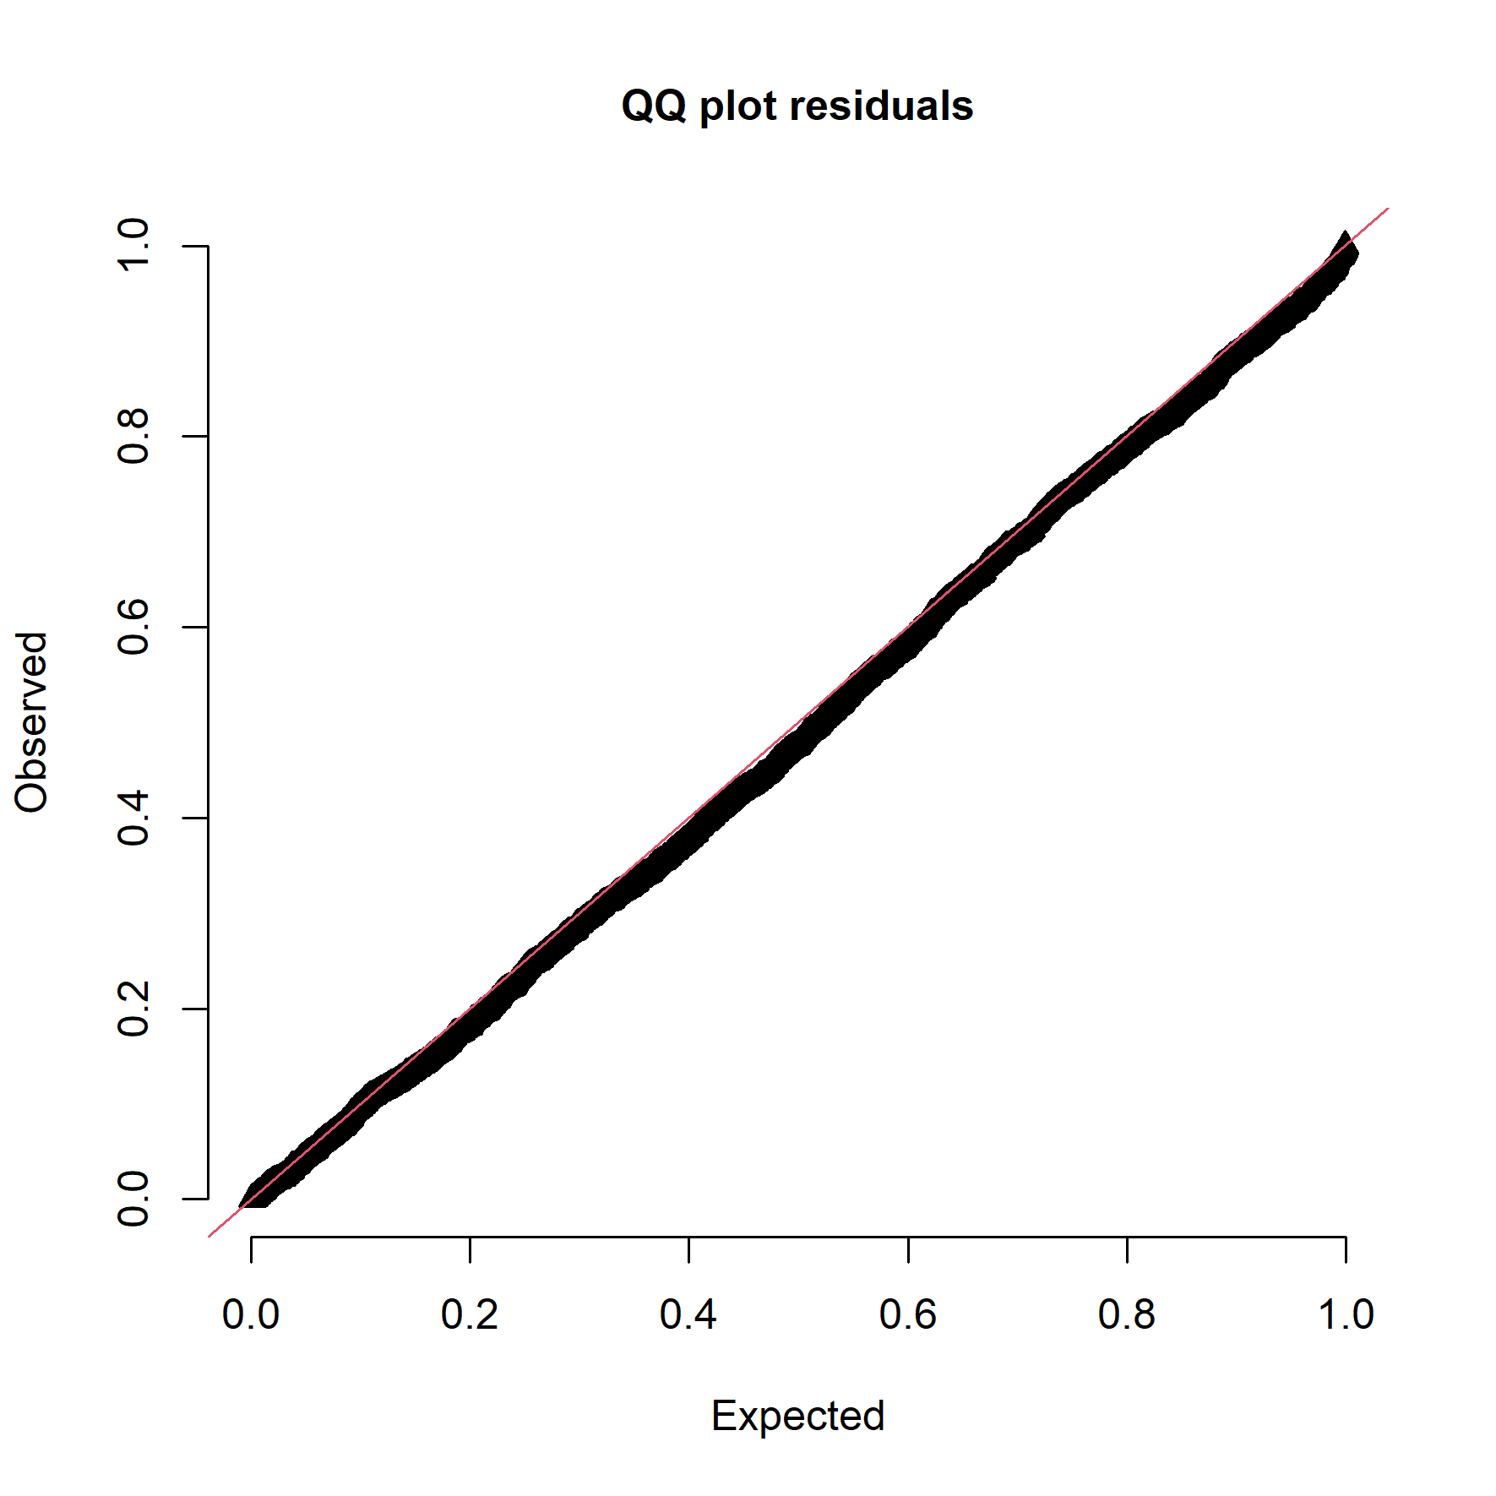
Figure S1. Quantile-Quantile plot for uniform distribution of DHARMa simulated residuals.
We tested whether the model was over- or underdispersed using a nonparametric dispersion test via standard deviation of residuals fitted vs. simulated (function: testDispersion), which showed that these assumptions were met as well (dispersion = 0.689, p-value = 0.376; Figure S2).
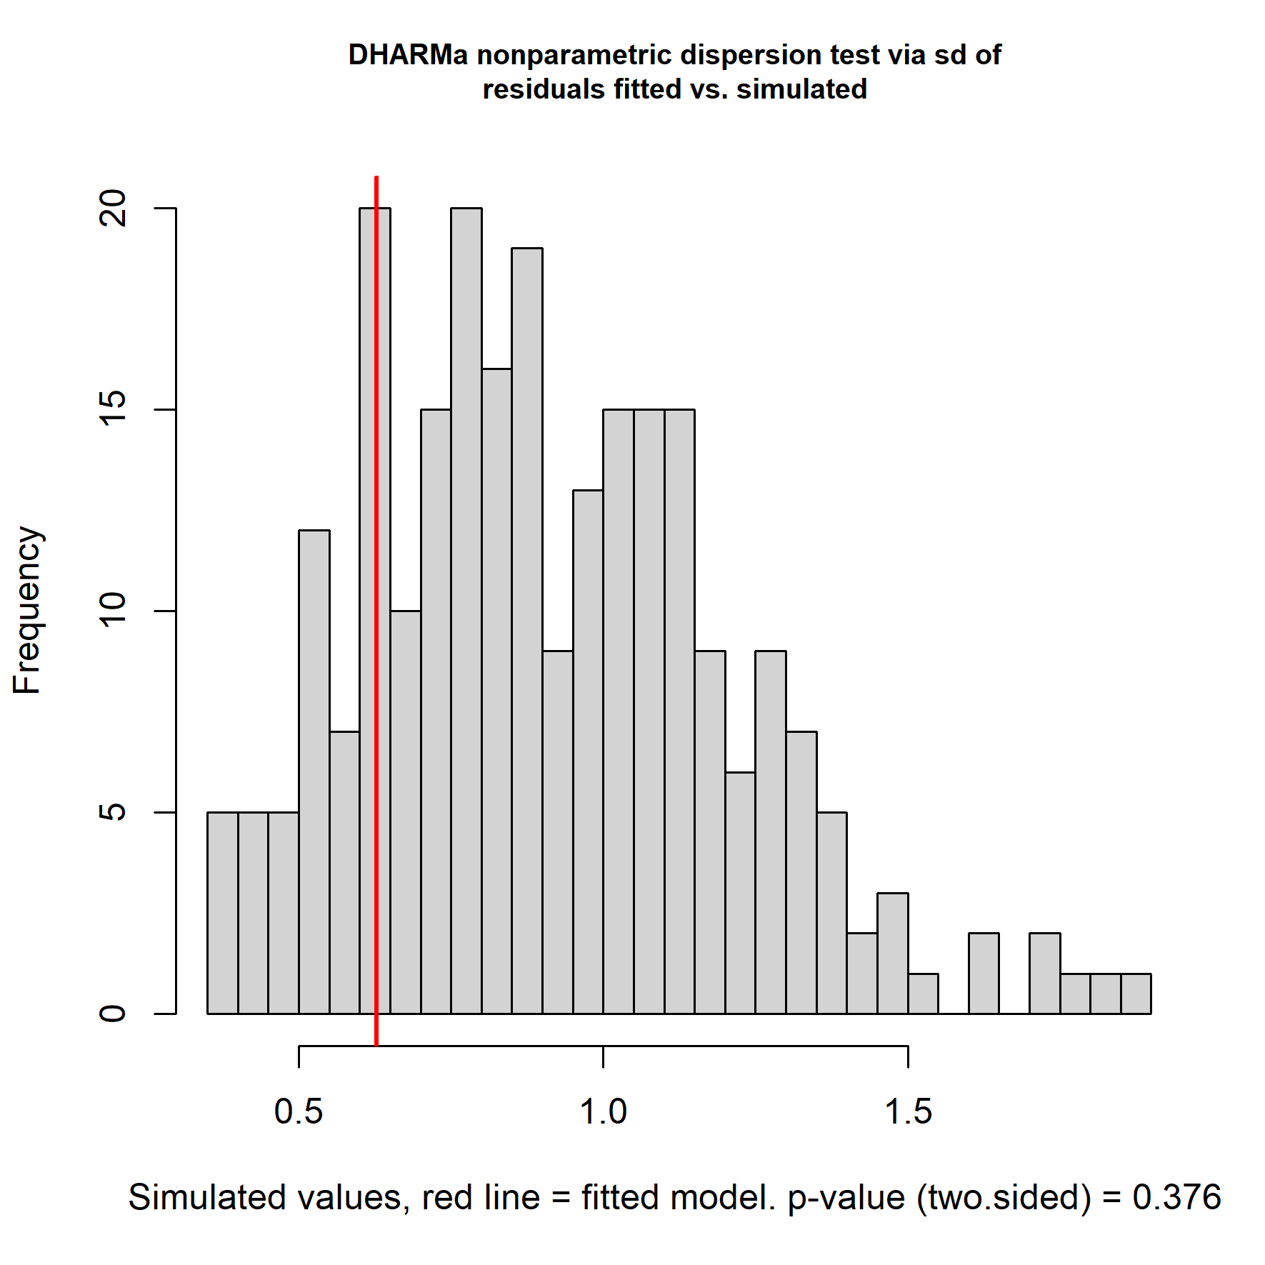
Figure S2. DHARMa nonparametric dispersion test results via standard deviation (sd) of residuals fitted vs. simulated.
Lastly, we checked for outliers using an outlier test based on exact binomial test with approximate expectations (function: testOutliers). The frequency of outliers was 0.006 (95% confidence interval 0.003; 0.009; 14 outliers at both margins out of 2475 observations, p-value = 0.256) which was lower than the expected frequency of 0.008 (Figure S3).
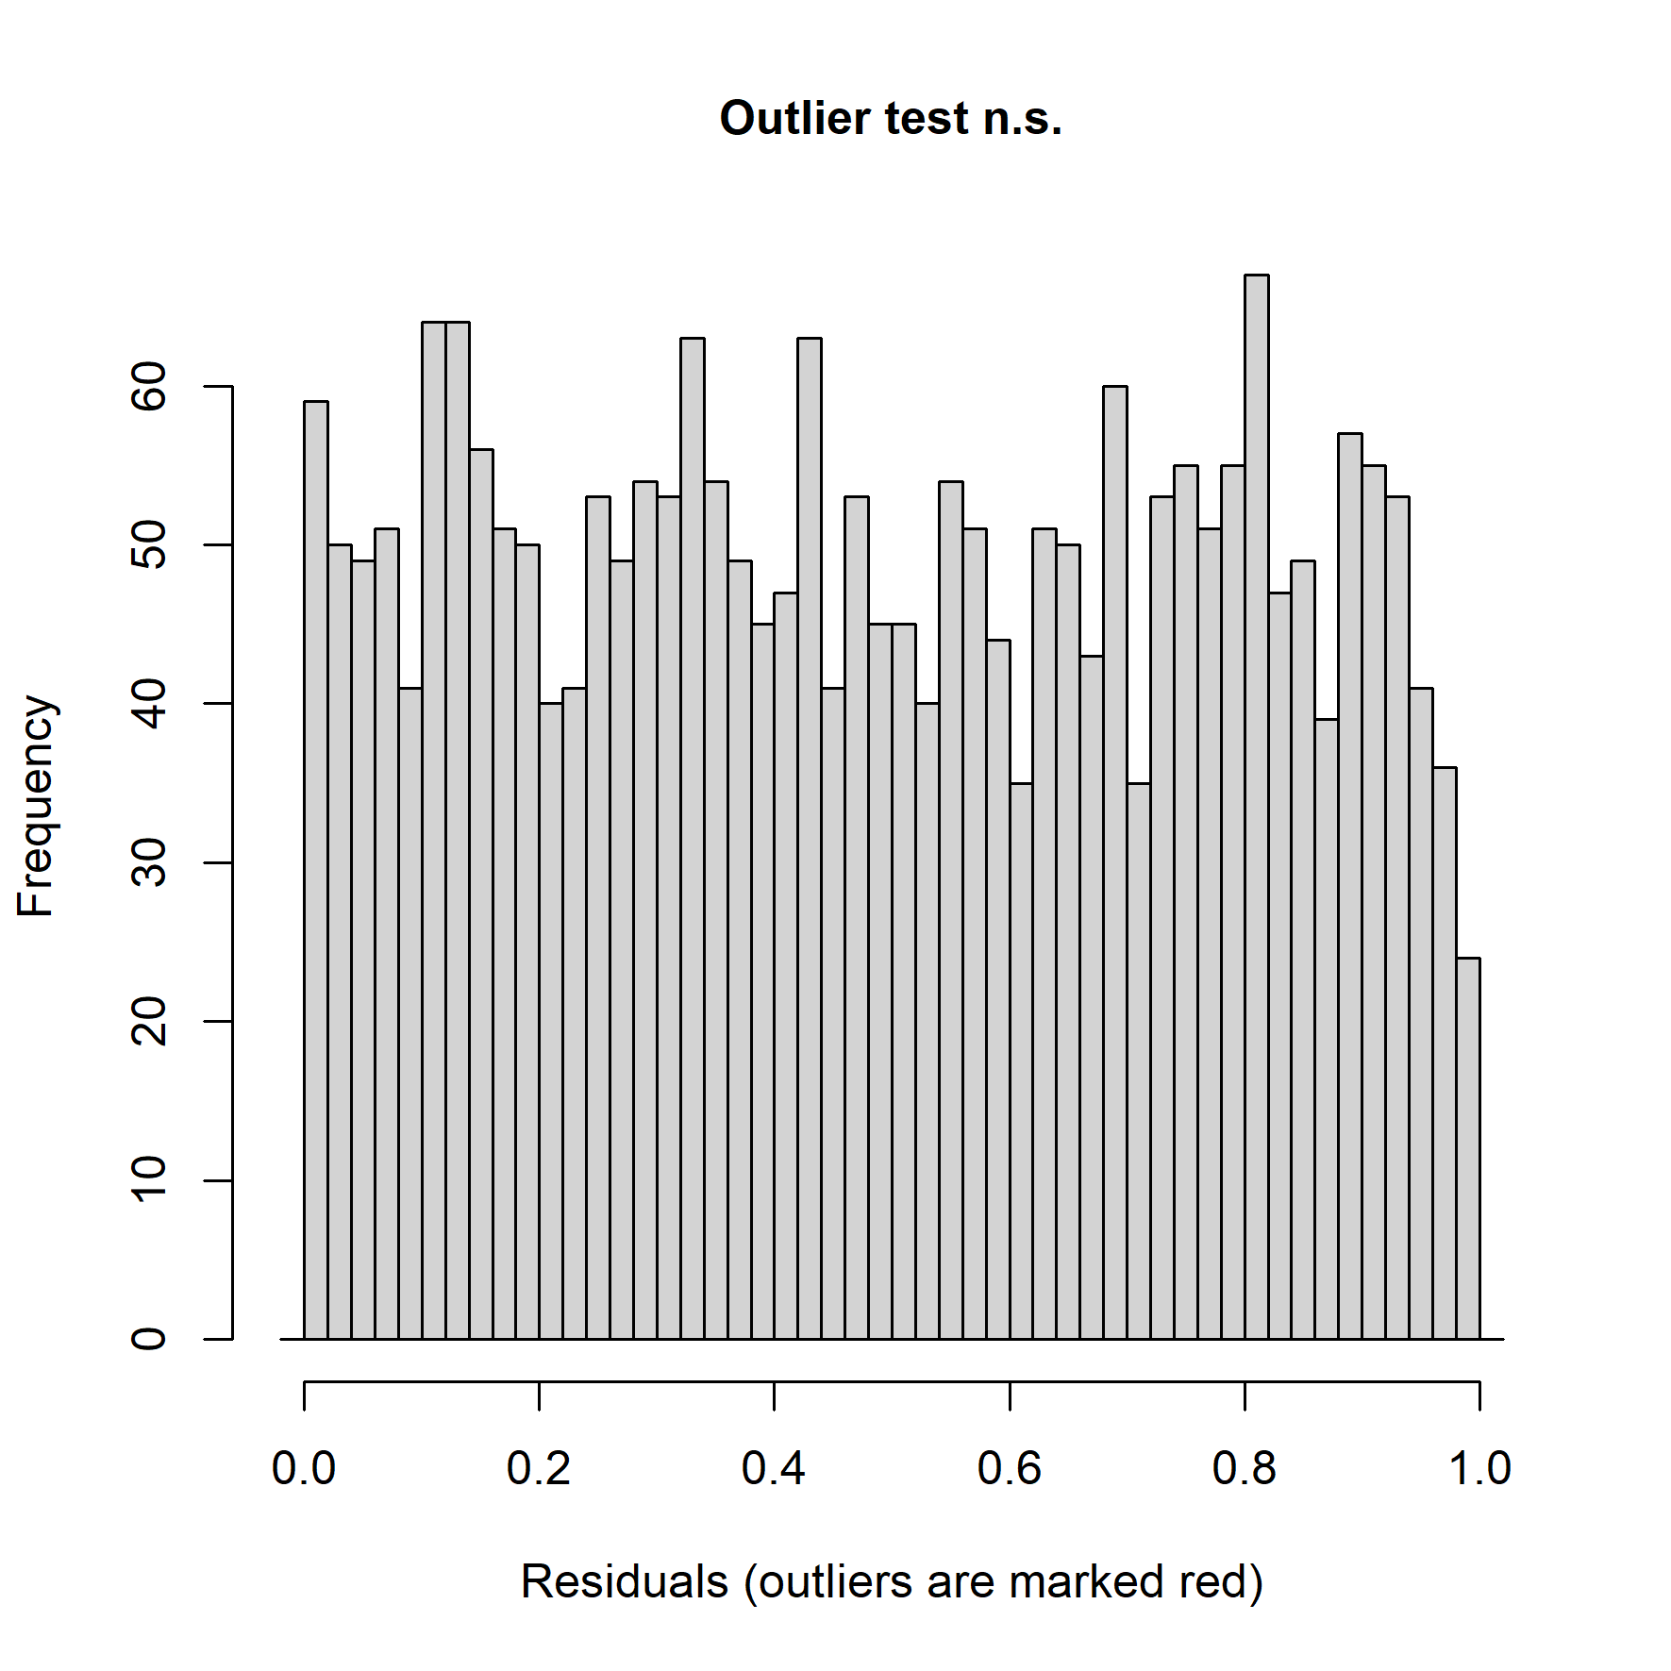
Figure S3. DHARMa outlier test based on exact binomial test with approximate expectations.
LITERATURE CITED
[1] T. W. Arnold, ‘Uninformative parameters and model selection using Akaike’s information criterion’, J. Wildl. Manag., vol. 74, no. 6, pp. 1175–1178, Aug. 2010, doi: 10.2193/2009-367.
[2] D. Bates, M. Mächler, B. Bolker, and S. Walker, ‘Fitting linear mixed-effects models using lme4’, J. Stat. Softw., vol. 67, no. 1, pp. 1–48, 2015, doi: 10.18637/jss.v067.i01.
[3] R Core Team, ‘R: A language and environment for statistical computing.’ R Foundation for Statistical Computing, Vienna, Austria, 2023. [Online]. Available: https://www.r-project.org
[4] F. Hartig, ‘DHARMa: Residual diagnostics for hierarchical (multi-level / mixed) regression models’, manual, 2022. [Online]. Available: https://CRAN.R-project.org/package=DHARMa

