Supplemental Material
Paternal Genetic Landscape of Contemporary Thai Populations in the Borderland Provinces of Thailand and Myanmar

The supplemental material consists of Supplementary Fig. S1-S4 and legends for Supplementary Tables S1-S8. The Tables are provided in a separate Excel file.

Supplementary Figures: Pages 2-5
Supplementary Tables Legends: Page 6
Supplementary Tables: see separated Excel files

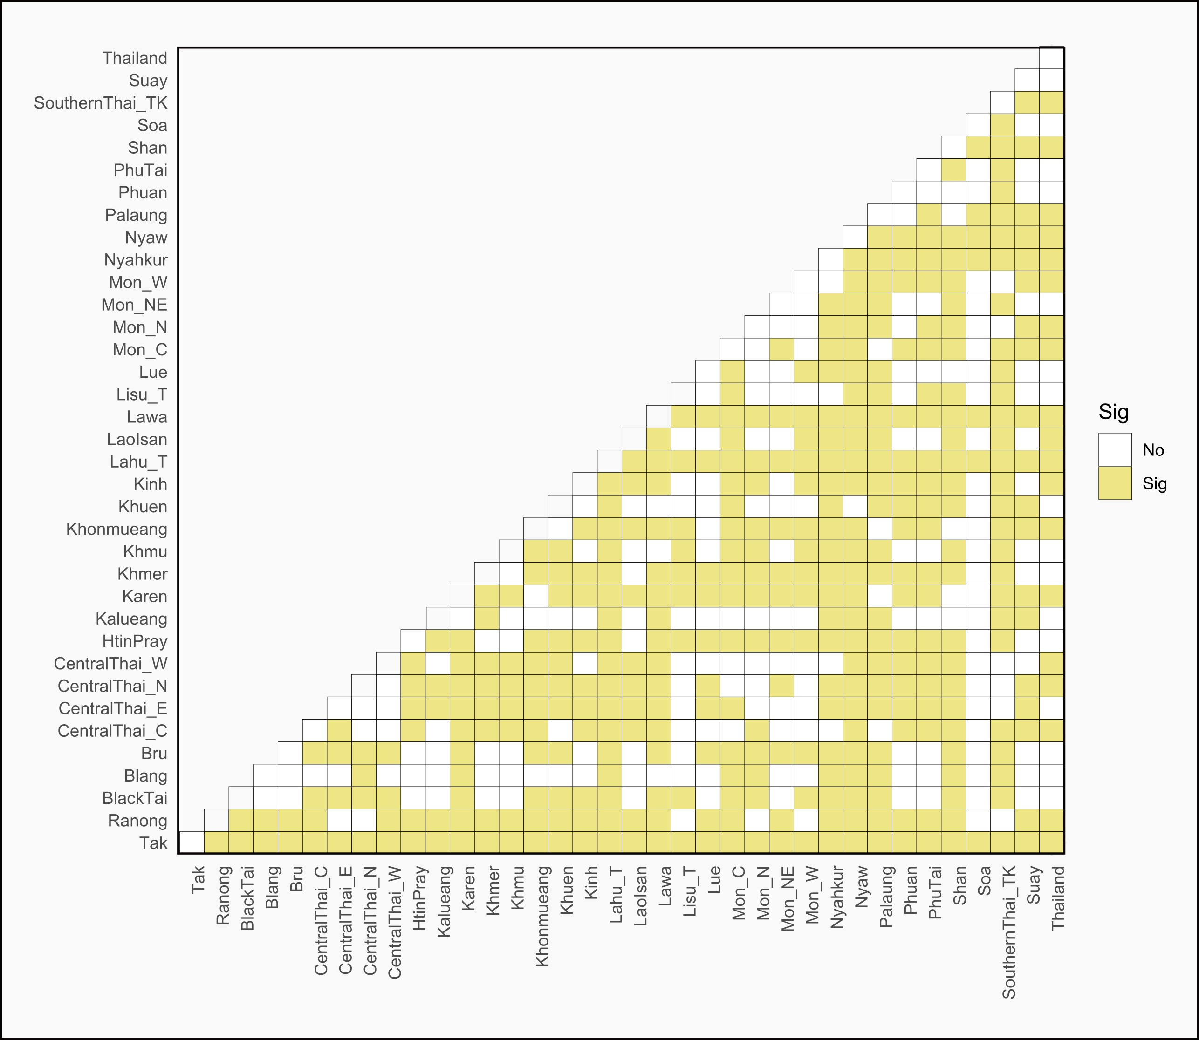

Supplementary Fig. S1: Figure 5. Fisher’s exact test results illustrating significant differences in haplogroup distribution among Thai populations, with significance set at p < 0.05. In the plot, "Thailand" represents the combined data from all populations within Thailand.
Supplementary Fig. S2: Three-dimensional NMDS plot derived from the Y-SNP genetic distance matrix of 126 populations. The plot displays Dimension 1 vs Dimension 3 and Dimension 2 vs Dimension 3

Supplementary Fig. S3: Three-dimensional NMDS plot derived from the 10 STR Rst genetic distance matrix of 127 populations. The plot displays Dimension 1 vs Dimension 3 and Dimension 2 vs Dimension 3
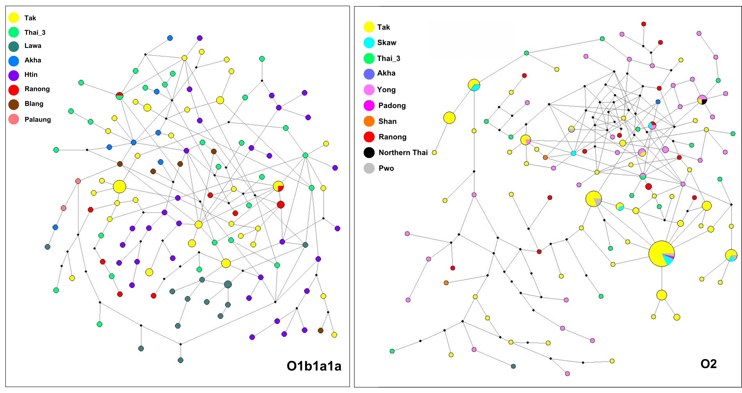

Supplementary Fig. S4: Median-Joining Network (MJ) of O1b1a1a and O2 haplotypes. The circle sizes are proportional to the haplotype frequencies

Supplementary Tables:
Supplementary Table S1. Details of the 327 samples from Tak and Ranong analyzed in this study, including sample ID, haplogroup, population, and Y-STR profiles.

Supplementary Table S2. General information for each population analyzed in this study, including population name, population code, language, country/region, number of samples, references for the studied populations, and corresponding Y-haplogroup frequencies.

Supplementary Table S3. AMOVA analysis of genetic variation in 7568 individuals from 5 countries and 126 populations.

Supplementary Table S4. Forensic statistical parameters of Y-STR markers employed in this study, including gene diversity (GD), discrimination power (PD), match probability (PM), probability of exclusion (PE), and polymorphism information content (PIC).

Supplementary Table S5. Time to Most Recent Common Ancestor (TMRCA) was determined using Y-STR data for male populations in Tak and Ranong.

Supplementary Table S6. Dataset of 8,108 Y-STR profiles from 127 populations of interest across 13 Asian countries, based on 10 shared Y-STR markers: DYS389I, DYS389II, DYS390, DYS391, DYS437, DYS438, DYS439, DYS448, YGATAH4, and DYS635.

Supplementary Table S7. Details of primer design for PCR amplification and single base extension (SBE), including the concentrations used in this study.

Supplementary Table S8. Compiled Y-STR profiles of 25,858 samples, including their general information.

