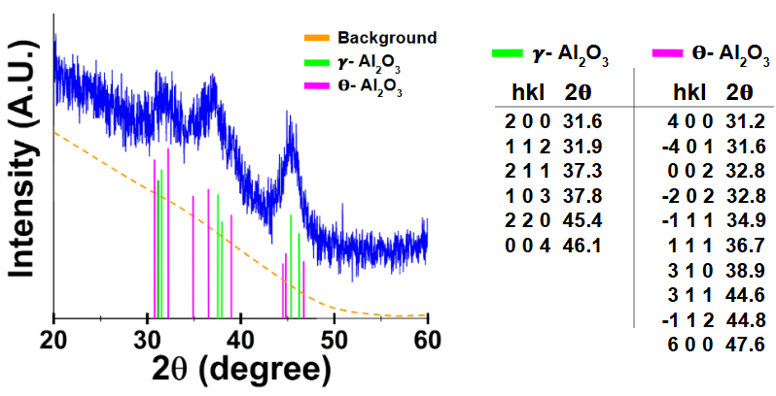
Supplemental Information
Supplementary Figure 1) Fully transformed to θ/γ-Al₂O₃ crystal peaks with both tetragonal γ-Al₂O₃ and monoclinic θ-Al₂O₃ structures present.
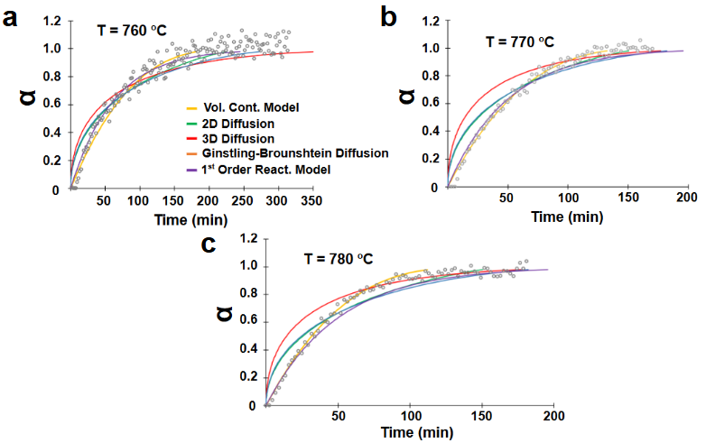
Supplementary Figure 2) Conversion factor alpha (α) vs time. a) Alpha (α) vs time for an isothermal temperature of 760 ºC compared to known solid phase change models. b) Alpha (α) vs time for an isothermal temperature of 770 ºC compared to known solid phase change models. c) Alpha (α) vs time for an isothermal temperature of 780 ºC compared to known solid phase change models.

